Indiatimes Sysadmin
Tech Support Center

User Guide

- Overview
- Feature List
- Hardware and Hosting
- Technical Specification
- Portal Information
- Application Workflow
- Flow Diagram

September 20, 2011
Written By Pranav Bhatnagar

Overview

This application provides an online ticketing system which helps to track the progress of a requested task and offers reporting functionality for all respective verticals.

Features list

- CRF Tracking: All the change requests will be stored in DB and therefore it will be easier to retrieve any detail at any point of time.
- Ticket ID: Each request will have a Ticket ID and that ID will contain all the information regarding that task.
- HOD Approval: Approval for any change into production environment will become mandatory.
- Dashboard: Historical data can be used for System Admin work dashboard.
- DNS Entries: Expiry tracking will help us to remove the expired domain entry.
- Firewall Entries: Expiry tracking will help us to remove expired records from firewall.
- Mailer Records: At the end of every month we can track the statistics of outgoing mails.
- Service Restart Request: This will help us to track the frequency of requests for service restart.
- Akamai: This will help us to track the frequency of requests for Cache Purge.

- Database Changes: This will help us to identify the preceding changes done on database layer.

Hardware and Hosting

The application has been deployed in VSNL datacenter on a virtual machine. Currently it has 4 GB RAM with a 2 processors Intel(R) Xeon(R).

The portal URL is publicly accessible from internet world.

http://sysadmin.indiatimes.com

Technical Specifications

This portal has been designed on LAMP platform.

The software versions are mentioned below:

- Red Hat Enterprise Linux 5 (64-bit)
- Apache 2.2.17
- MYSQL 5.0.77
- PHP Version 5.2.6

Portal Information

Online portal can be accessed through http://crfadmin.indiatimes.com URL which is behind login screen. The requester needs to contact SysAdmin team to get the login ID and password for accessing this application. The ID creation is a one time process and can be used for future usage.

Following Information would be required to create the login ID:

- Requester Name
- Requester Email ID
- Vertical Name
- Project Name
- HOD Name

Application Workflow

URL: http://sysadmin.indiatimes.com

Login Page

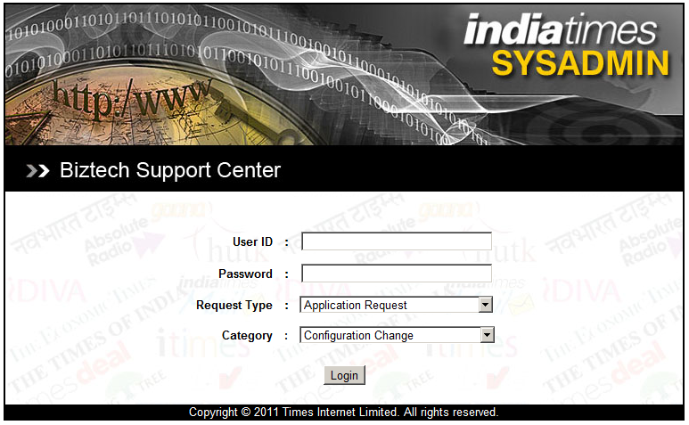

Requester needs to login with his credentials. The request type dropdown will have 7 types of requests as below:

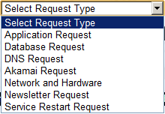

Select any one from above as per the requirement. This will display the new dropdown called “Category” according to the last selection. For example Application Request has 7 types of category.

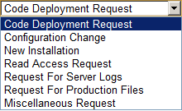

Request Type and Categories

Application Request : Code Deployment Request, Configuration Change, New
Installation, Read Access Request, Request of Log Files, Request of Production Files, Miscellaneous Request.
Database Request : Database Backup, Query Execution, Database Restore,
Optimization, New Installation, Schema Change, Slow Query Log, Access Request.
DNS Request : Record Addition, Record Deletion, Record Modification,
Domain Information, URL Redirection.
Akamai Request : Cache Purge, Configuration Changes, New
Requirement, Traffic Report Request.
Network and Hardware : VM Requirement, RAM Increase, CPU Increase, Public
IP Request, Virtual IP Request, Firewall Access Form, Server Health Report, Bandwidth Report, VIP Sessions Report, Bandwidth Report, VIP Sessions Report.
Newsletter Request : New Mailer Request, Mailer Report Request.
Service Restart Request : Application Server, Database Server, SMTP Server.

Selected request type will land you on the respective form page to fill the details regarding the task. For example: if requester has chosen the service restart request form, below is the screen which will be shown to the requester after selection.

Service Restart Request Form:

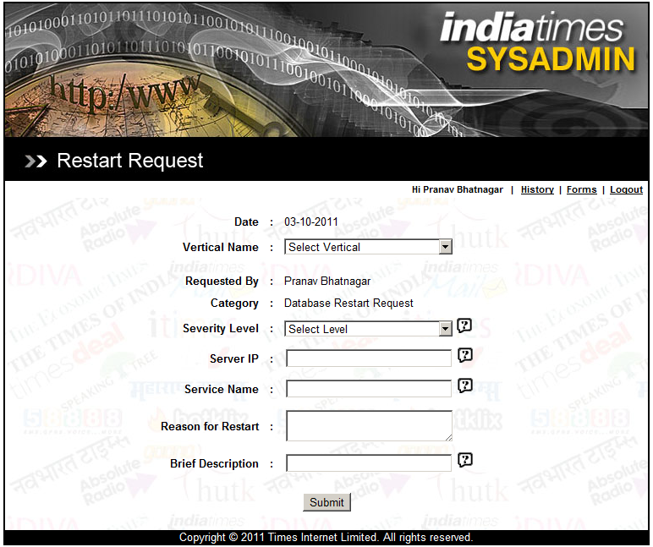

Requester has to choose the Vertical Name, Project Name and Approver Name from the drop down list. He also needs to mention the Server IP on which he wants to restart the service. Also has to mention the service name of the service. Reason for restart is mandatory and it should be filled with proper explanation.

Thank You Notification

After submitting the request, user will land on Thank you page where he can note down the Ticket ID for future reference.

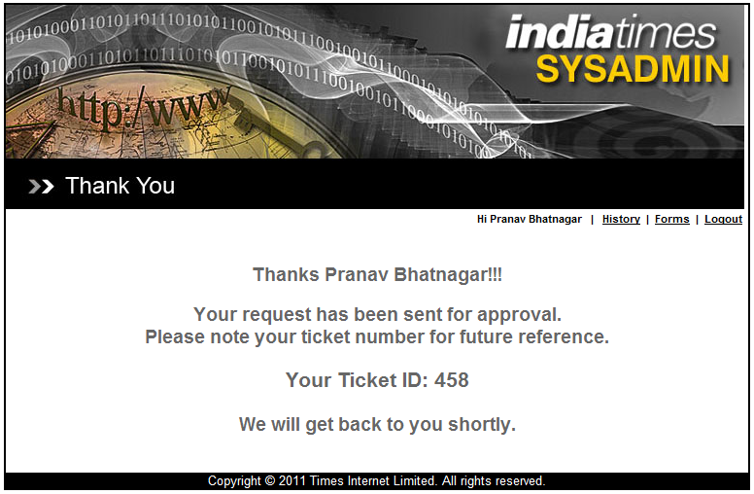

Archive Requests

Requester can see all his past requests by clicking on History link. The display page will show only those requests which were submitted by him only. Tickets’ current status will be displayed on this page also. The details of the request can be viewed by clicking on the ID Link.
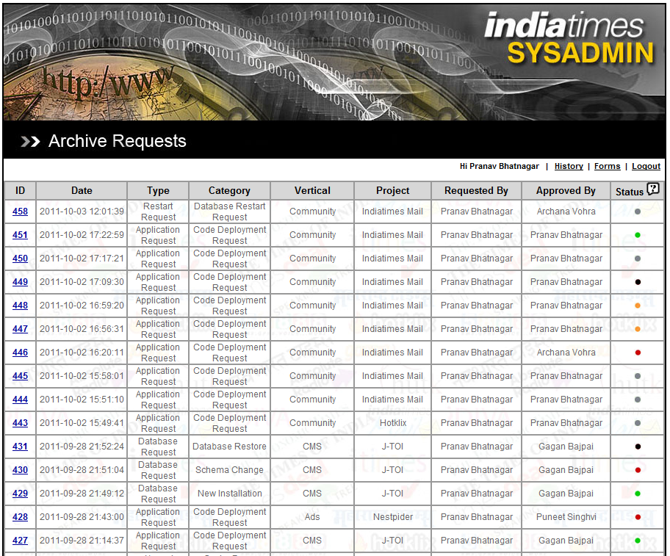

Status Icons
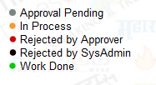

Approval Mail Content

A mail will be sent to approver for approval with the following content:

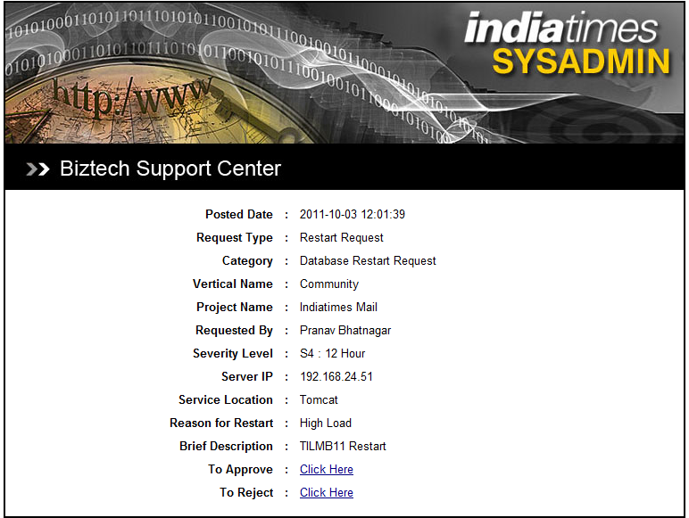

Approve Request Link

After clicking on approve request, a new pop-up window will be opened for comments. Comments are not mandatory and can be left blank. The objective of this pop-up is to provide comment on some preferred execution time.

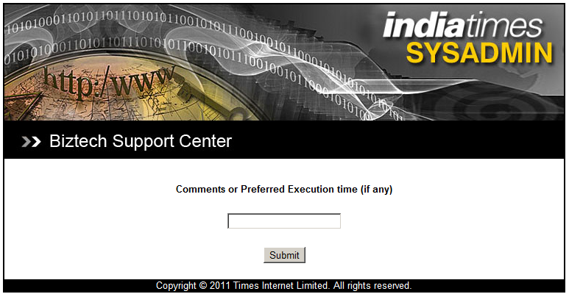

Thanks page will be shown after submitting the approval comments.

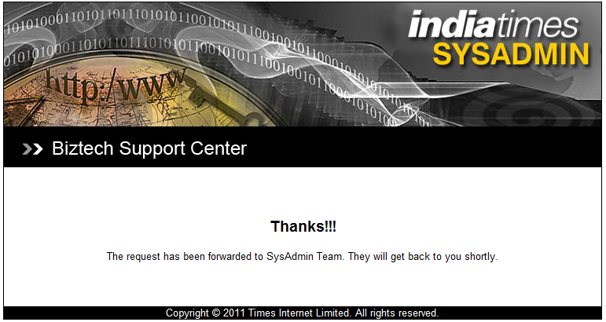

Reject Request Link

On clicking on reject request, approver will land on Rejection Comment page where he has to fill the reason. This area is compulsory and can not be left blank.

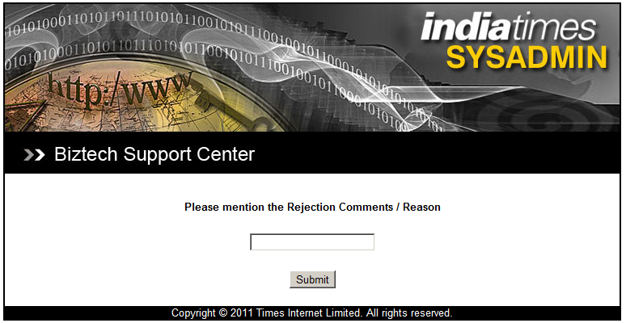

Rejection mail will be sent to requester with details including the rejection reasons.

Rejection notification will be displayed to approver after submitting the comments.

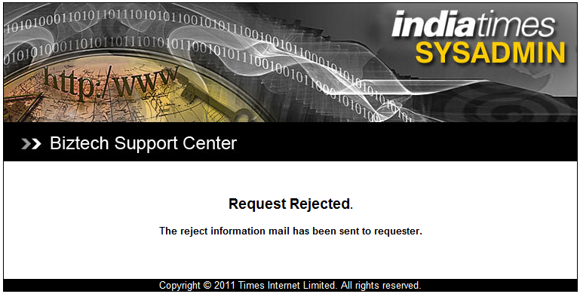

Confirmation Mail to Sysadmin

After the approval, mail will be forwarded to sysadmin team with Ticket ID. This mail can be used for deployment purpose as it will have all the details like requested by, approved by, vertical name, project name, approval comments (if any) and change request details.

Below is the sample image of deployment mail

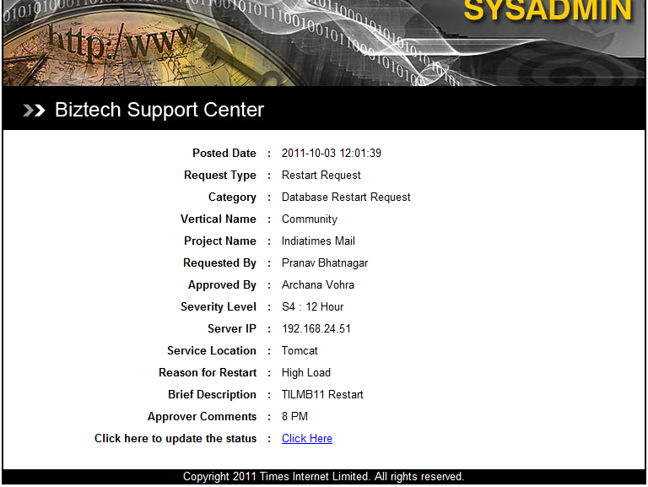

After executing the CRF steps, Sysadmin engineer will post his comments from this mail itself. Click here to update the status link will open a pop-up window (Update Status) where the engineer can comment saying “Task Successfully Executed”.

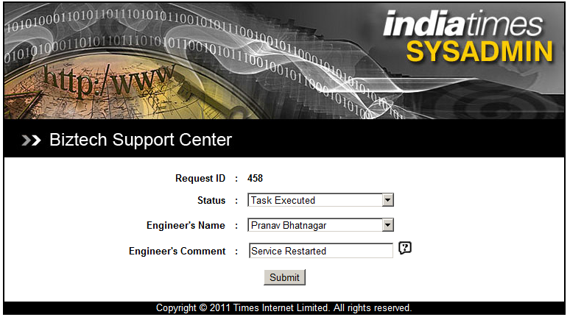

Deployment Confirmation

After engineer’s comment, a mail will be sent to the requester, approver and sysadmin with the status “Task Completed”.

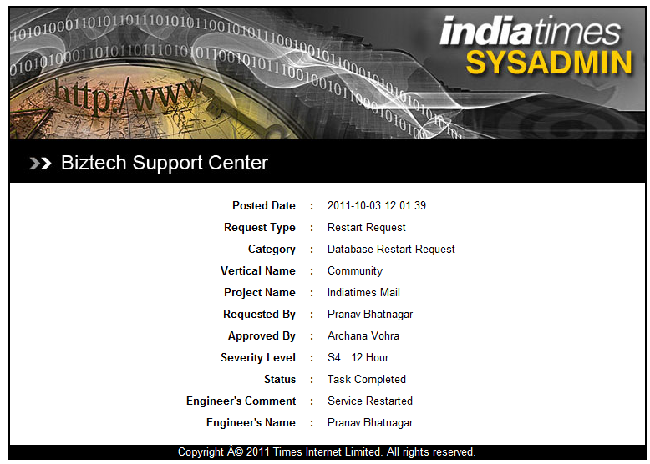

Flow Diagram

Application flow diagram is attached with this mail.

