Name: Harsh Seksaria

Reg. No.: 2048011

Class: 2 MDS

Date: 22-01-2021

R Lab

Program 1

Q1. Define the object "myobject" and assign the vector 1:10 in at least 3 different ways.

myobject <- 1:10

myobject

myobject <- c(1:10)

myobject

myobject <- seq(from=1, to=10, by=1)

myobject

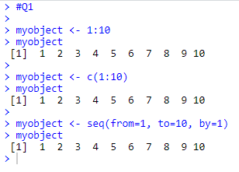

Q2. Get the sum of your object.

sum(myobject)



Q3. Create the following vector by using the paste function:

[1] "R is great 4 and I will love it"

[2] "R is great 7 and I will love it"

[3] "R is great 45 and I will love it"

a <- paste("R is great", 4, "and I will love it")

a

b <- paste("R is great", 7, "and I will love it")

b

c <- paste("R is great", 45, "and I will love it")

c

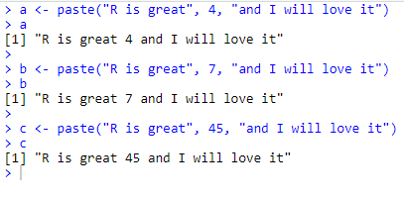

Q4. Vector of 1,2,3, repeat the vector to get 11 x 1, 10 x 2, and 10 x3.

a <- rep(c(1, 2, 3), times=c(11, 10, 10))

a

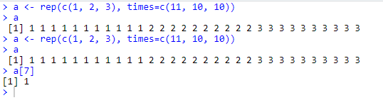

Q5. What is the value of this vector on position 7?

a[7]



Q6. Repeat the string “Hello R” thrice.

replicate(3, "Hello R")



Q7. Repeat the first element of a vector twice and the second element of the vector thrice.

a <- rep(c('A', 'B'), times=c(2, 3))

a

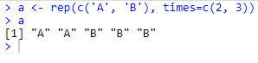

Q8. Create a matrix of two rows and three columns.

matrix(1:6, nrow=2, ncol=3)

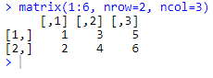

Q9. Create a matrix 3X3 by row-wise.

matrix(1:9, nrow=3, ncol=3, byrow=TRUE)

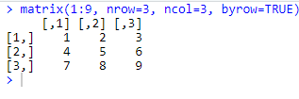

Q10. Build a vectors of random values with the sample( ) function. Find the min( ), max( ), range( ), length( ), sum( ), prod( ), mean( ), var( ).

randomvector <- sample(1:20, size = 15)

randomvector

min(randomvector)

max(randomvector)

range(randomvector)

length(randomvector)

sum(randomvector)

prod(randomvector)

mean(randomvector)

var(randomvector)

