ORIENTAL COLLEGE OF TECHNOLOGY
BHOPAL
DEPARTMENT OF ARTIFICIAL INTELLIGENCE & MACHINE LEARNING
MACHINE LEARNING
LAB MANUAL
LABORATORY RECORD / PRACTICAL FILE
STUDENT DETAILS
NAME
Akash Singh
ROLL NUMBER
07
SEMESTER
2
nd
BRANCH
AIML
ACADEMIC SESSION • 2026
Shivanshu Prasad Pandey
0126AL241115
4
th

Machine learning lab Manual
List of Experiment
S.no | Experiment | Date | Signature
1 | Write a python program to compute a) Central Tendency Measures:  Mean, Median, Mode  b) Measure of Dispersion: Variance, Standard Deviation
2 | Study of Python Basic Libraries such as Statistics, Math, NumPy and SciPy
3 | Study of Python Libraries for ML application such as Pandas and Matplotlib
4 | Write a Python program to implement Simple Linear Regression.
5 | Implementation of Multiple Linear Regression for House Price Prediction using sklearn.
6 | Implementation of Decision tree using sklearn and its parameter tuning.
7 | Implementation of KNN using sklearn.
8 | Implementation of Logistic Regression using sklearn.
9 | Implementation of K-Means Clustering.
10 | Mini Project: Performance Analysis of Classification Algorithms on the Iris Dataset.

1). Write a python program to compute
- Central Tendency Measures: Mean, Median, Mode
- Measure of Dispersion: Variance, Standard Deviation
Source code:-

# Prompt user to enter data
user_input = input("Enter numbers separated by commas: ")

# Convert the input string to a list of integers
numbers = [int(num) for num in user_input.split(',')]

# Calculate the number of elements count = len(numbers)

# Calculate the mean (average) sum_of_numbers = sum(numbers)
mean_value = sum_of_numbers / count

# Sort the list for median calculation
sorted_numbers = sorted(numbers)

# Calculate the median if count % 2 == 0: median_value = (sorted_numbers[count // 2 - 1] + sorted_numbers[count // 2]) / 2 else: median_value = sorted_numbers[count // 2]

# Calculate the mode frequency_dict = {}
highest_frequency = 0

for num in numbers: if num in frequency_dict: frequency_dict[num] += 1 else:
frequency_dict[num] = 1 if frequency_dict[num] > highest_frequency: highest_frequency = frequency_dict[num]

# Get all numbers with the highest frequency
modes = [num for num, freq in frequency_dict.items() if freq == highest_frequency]

# Calculate variance
squared_diff_sum = sum((num - mean_value) ** 2 for num in numbers) variance_value = squared_diff_sum / count

# Calculate standard deviation
std_deviation = variance_value ** 0.5

# Display results print(f"Mean = {mean_value}") print(f"Median = {median_value}")
print(f"Mode = {modes if len(modes) < count else 'No mode (all values are unique)'}") print(f"Variance = {variance_value}")
print(f"Standard Deviation = {std_deviation}")

OUTPUT

ample Run1:
-------------- $ python3 Stat_Measures.py Enter numbers separated by commas: 1,2,3,4,4,5,6 Mean = 3.5714285714285716 Median = 4 Mode = [4] Variance = 2.5306122448979593 Standard Deviation = 1.5907898179514348

Sample Run2:
-------------- $ python3 Stat_Measures.py Enter numbers separated by commas: 10,20,30,30,40,40 Mean = 28.333333333333332 Median = 30.0 Mode = [30, 40] Variance = 113.88888888888887 Standard Deviation = 10.671873729054747

2) Study of Python Basic Libraries such as Statistics, Math, Numpy and Scipy
Solution:-Python is a powerful programming language widely used for data analysis, scientific research, and statistical computing. Several libraries in Python make it particularly strong in these areas:
1. Statistics Library:
The statistics module provides functions to perform basic statistical operations like calculating the mean, median, mode, variance, and standard deviation.
Key Functions:
- mean(data): Returns the arithmetic mean of the data.
- median(data): Returns the median value.
- mode(data): Returns the mode (most frequent value).
- variance(data): Returns the variance of the data.
- stdev(data): Returns the standard deviation.

Source Code:-
import statistics # Input data from user
data=input("Enter data separated by comma:") data=[int(x) for x in data.split(',')]
# Compute Mean mean=statistics.mean(data) # Compute Median median=statistics.median(data)
# Compute Mode mode=statistics.mode(data) # Compute Standard Deviation std_dev=statistics.stdev(data) # Compute Variance variance=statistics.variance(data) # Output results print(f"Mean={mean}") print(f"Median={median}") print(f"Mode={mode}")
print(f"Standard Deviation={std_dev}") print(f"Variance={variance}") Output:
Sample Run:
--------------
$python3 Stat_Lib.py.py
Enter data separated by comma:1,2,3,4,4,5,6
Mean=3.5714285714285716
Median=4
Mode=4

Standard Deviation=1.7182493859684491

Variance=2.9523809523809526

2. Math Library:

The math module offers a range of mathematical functions that operate on numbers and perform tasks such as trigonometric calculations, logarithms, and square roots.

Key Functions:
- math.ceil(x): Returns the smallest integer greater than or equal to x.
- math.factorial(x): Returns the factorial of a non-negative integer x.
- math.exp(x): Returns exe^xex, where eee is the base of natural logarithms (approximately
2.718).
- math.sqrt(x): Returns the square root of x.
- math.floor(x): Returns the largest integer less than or equal to x.
- math.gcd(x, y): Returns the greatest common divisor (GCD) of two integers x and y.
- math.pow(x, y): Returns xyx^yxy (x raised to the power of y).
- math.radians(angle): Converts an angle from degrees to radians.
- math.sin(x): Returns the sine of x, where x is in radians.
- math.cos(x): Returns the cosine of x, where x is in radians.
- math.tan(x): Returns the tangent of x, where x is in radians.
Source code
import math x=int(input("Enter a number:")) result1=math.ceil(x) result2=math.factorial(x) result3=math.exp(x) result4=math.sqrt(x) result5=math.floor(x) n1=int(input("Enter number1:")) n2=int(input("Enter number2:")) result6=math.gcd(n1,n2) result7=math.pow(n1,n2) angle=int(input("Enter an angle:")) a=math.radians(angle) result8=math.sin(a) result9=math.cos(a) result10=math.tan(a)
print(f"Using math.ceil({x}): {result1}") print(f"Using math.factorial({x}):{result2}") print(f"Using math.exp({x}):{result3}") print(f"Using math.sqrt({x}):{result4}") print(f"Using math.floor({x}):{result5}") print(f"Using math.gcd({n1},{n2}):{result6}") print(f"Using math.pow({n1},{n2}):{result7}") print(f"Using math.sin({angle}):{result8}") print(f"Using math.cos({angle}):{result9}") print(f"Using math.tan({angle}):{result10:.15f}") OUTPUT
Sample Run:
--------------
$python3 Math_Lib.py.py
Enter a number:4
Enter number1:3
Enter number2:2
Enter an angle:1
Using math.ceil(4): 4
Using math.factorial(4):24
Using math.exp(4):54.598150033144236
Using math.sqrt(4):2.0
Using math.floor(4):4
Using math.gcd(3,2):1
Using math.pow(3,2):9.0
Using math.sin(1):0.01745240643728351
Using math.cos(1):0.9998476951563913
Using math.tan(1):0.017455064928218
3. Numpy Library:
NumPy is a library for numerical computing in Python. It is used for working with arrays and matrices, along with a collection of mathematical functions to operate on these data structures.
Key Functions:
- np.array(data): Creates a numpy array from the given list of elements.
- reshape(rows, cols): Reshapes an array into the specified number of rows and columns.
- np.ones((rows, cols)): Creates an array filled with ones of the specified shape (number of rows and columns).
- np.zeros((rows, cols)): Creates an array filled with zeros of the specified shape (number of rows and columns).
- np.transpose(array): Returns the transpose of the given array, flipping rows into columns and vice versa.
- np.min(array): Finds the minimum value in the array.
- np.max(array): Finds the maximum value in the array.
Source Code:-

import numpy as np
# Get number of rows and columns from user rows=int(input("Enter number of rows:")) cols=int(input("Enter number of columns:"))
# Get array elements from user
elements=list(map(float, input(f"Enter {rows*cols} elements separated by spaces:").split()))
# Create an array from user input
user_array=np.array(elements).reshape(rows,cols)
# Create an array of ones and zeros ones_array=np.ones((rows, cols)) zeros_array=np.zeros((rows, cols)) # Transpose the user array
transposed_array=np.transpose(user_array)
# Reshape the user array (to a flat array and back to the original shape for demonstration) reshaped_array = user_array.reshape(rows * cols) min_value=np.min(elements) max_value=np.max(elements)
# Display the results print("User Array:\n",user_array) print("Ones Array:\n",ones_array) print("Zeros Array:\n",zeros_array) print("Transposed Array:\n",transposed_array) print("Reshaped Array (flattened):\n",reshaped_array) print("Minimum Value:",min_value) print("Maximum Value:",max_value) Output
Sample Run:
--------------
$python3 Numpy_Lib.py
Enter number of rows:2
Enter number of columns:2
Enter 4 elements separated by spaces:1 2 3 4 User Array:
[[1. 2.]
[3. 4.]]
Ones Array:
[[1. 1.]
[1. 1.]]
Zeros Array:
[[0. 0.]
[0. 0.]]
Transposed Array:
[[1. 3.]
[2. 4.]]
Reshaped Array (flattened):
[1. 2. 3. 4.]
Minimum Value: 1.0
Maximum Value: 4.0

4. Scipy Library:
Scipy builds on numpy and provides a wide range of advanced mathematical, scientific, and engineering functions, including optimization, integration, interpolation, and statistical operations.
Key Functions:
From scipy.constants:
- constants.minute: Returns the number of seconds in a minute (60.0).
- constants.hour: Returns the number of seconds in an hour (3600.0).
- constants.inch: Returns the length of an inch in meters (0.0254).
- constants.liter: Returns the volume of a liter in cubic meters (0.001).
From scipy.special:
- special.exp10(x): Calculates 10x, where x is the exponent provided by the user.
- special.sindg(angle): Returns the sine of an angle (in degrees).
- special.cosdg(angle): Returns the cosine of an angle (in degrees).
From scipy.linalg:
- linalg.det(matrix): Calculates the determinant of a square matrix. If the input matrix is not square, the determinant cannot be calculated.
From numpy:
- np.array(data): Creates a NumPy array from the provided list of elements.
- reshape(rows, cols): Reshapes the array into the specified number of rows and columns.

Source Code:-
from scipy import linalg import numpy as np from scipy import special from scipy import constants
# Print constants
print("Seconds in a minute:",constants.minute) # 60.0 print("Seconds in an hour:",constants.hour) # 3600.0 print("Length of an inch in meters:",constants.inch) # 0.0254 print("Volume of a liter in cubic meters:",constants.liter) # 0.001
# Dynamic input for exponentiation
exp_input = float(input("Enter the exponent for 10^x:")) print(f"10^{exp_input} =",special.exp10(exp_input))
# Dynamic input for angles in degrees
angle=float(input("Enter an angle for sine and cosine(in degrees):"))
#Calculate sine and cosine of the input angles print(f"sin({angle} degrees):",special.sindg(angle)) print(f"cos({angle} degrees):",special.cosdg(angle))
# Dynamic input for matrix
rows = int(input("Enter the number of rows for the matrix:"))
cols = int(input("Enter the number of columns for the matrix:")) mat = list(map(float, input(f"Enter {rows * cols} elements separated by spaces:").split()))
# Convert the flat list into a 2D NumPy array mat=np.array(mat).reshape((rows, cols))
# Calculate the determinant if the matrix is square if rows == cols:
x = linalg.det(mat)
print(f'Determinant of the matrix\n{mat}\n is: {x}') else:
print("Determinant can only be calculated for square matrices.")

Output
Sample Run:
$python Scipy_Lib.py
Seconds in a minute: 60.0
Seconds in an hour: 3600.0
Length of an inch in meters: 0.0254
Volume of a liter in cubic meters: 0.001
Enter the exponent for 10^x:2
10^2.0 = 100.0
Enter an angle for sine and cosine(in degrees):90 sin(90.0 degrees): 1.0 cos(90.0 degrees): -0.0
Enter the number of rows for the matrix:2
Enter the number of columns for the matrix:2
Enter 4 elements separated by spaces:2 3 4 5
Determinant of the matrix
[[2. 3.] [4. 5.]]
is: -2.0000000000000004

3) Study of Python Libraries for ML application such as Pandas and Matplotlib

Solution :-
- Pandas
Pandas is a fast, powerful, and flexible library used for data analysis and manipulation. It provides data structures like DataFrames and Series that are widely used in ML for managing structured data.
Key Features of Pandas
- Data Handling: Create, modify, and process structured data efficiently.
- File Input/Output: Read from and write to formats like CSV, Excel, JSON,SQL, etc.
- Data Cleaning: Handle missing data, filter rows/columns, and apply transformations.
- Data Aggregation: Group data for summarization and analysis.
Key Functions:
1. pandas.read_csv(file_path)
  - Reads a CSV file into a Pandas DataFrame. b. Parameters: i. file_path: The path of the CSV file. c. Returns: A Pandas DataFrame.
- df.loc[[row_indices]]
  - Accesses specified rows (and optionally columns) in the DataFrame using labels or indices.
  - Parameters:
i. row_indices: A list of row indices to fetch.
- df.head(n)
  - Displays the first n rows of the DataFrame (default is 5).
- df.tail(n)
  - Displays the last n rows of the DataFrame (default is 5).
- df.isnull()
  - Returns a DataFrame of the same shape, indicating the presence of missing values.
- df.info()
  - Prints a summary of the DataFrame, including data types, non-null values, and memory usage.

CSV file : "students.csv"
Student_NO,Name,Branch,Year,Contact_NO
1201,Raghu,IT,III,1234
1202,Sai,IT,III,1234
1203,Sravan,IT,III,1234
1204,Karthik,IT,III,1234
1205,Gaanesh,IT,III,1234
1206,Vamshi,IT,III,1234
1207,Shiva,IT,III,1234
1208,Racha,IT,III,1234
1209,Abu,IT,III,1234
1210,Nithish,IT,III,1234
To Download above CSV file : Click Here
Source Code:-
import pandas df=pandas.read_csv('students.csv') print(df) print(df.loc[[0,1]]) print(df.head()) print(df.tail()) print(df.isnull()) print(df.info())

Output:-
Sample Run:
--------------
$python3 Pandas_Lib.py
Student_NO Name Branch Year Contact_NO
- 1201 Raghu IT III 1234
- 1202 Sai IT III 1234
- 1203 Sravan IT III 1234 3 1204 Karthik IT III 1234
- 1205 Gaanesh IT III 1234
- 1206 Vamshi IT III 1234
- 1207 Shiva IT III 1234
- 1208 Racha IT III 1234
- 1209 Abu IT III 1234
- 1210 Nithish IT III 1234
Student_NO Name Branch Year Contact_NO
- 1201 Raghu IT III 1234
- 1202 Sai IT III 1234
Student_NO Name Branch Year Contact_NO
- 1201 Raghu IT III 1234
- 1202 Sai IT III 1234
- 1203 Sravan IT III 1234 3 1204 Karthik IT III 1234
- 1205 Gaanesh IT III 1234
Student_NO Name Branch Year Contact_NO
- 1206 Vamshi IT III 1234
- 1207 Shiva IT III 1234
- 1208 Racha IT III 1234
- 1209 Abu IT III 1234
- 1210 Nithish IT III 1234
Student_NO Name Branch Year Contact_NO
- False False False False False
- False False False False False
- False False False False False
- False False False False False
- False False False False False
- False False False False False
- False False False False False
- False False False False False
- False False False False False 9 False False False False False

RangeIndex: 10 entries, 0 to 9
Data columns (total 5 columns):
# Column Non-Null Count Dtype
--- ------ -------------- -----
- Student_NO 10 non-null int64
- Name 10 non-null object
- Branch 10 non-null object
- Year 10 non-null object 4 Contact_NO 10 non-null int64 dtypes: int64(2), object(3) memory usage: 532.0+ bytes
None

2.Matplotlib:
Matplotlib is a plotting library used for creating static, interactive, and animated visualizations. It is commonly used in ML for data exploration and model evaluation through plots.
Machine Learning & Artificial Intelligence
Key Features of Matplotlib
  - Visualization Types: Create line plots, bar plots, scatter plots, histograms,etc.
  - Customization: Customize plot styles, labels, legends, and colors.
  - Interactive Plots: Zoom and pan to explore data visually.
Key Functions:
plt.plot(x, y, marker='o')
  - Plots x vs. y as a line graph, with markers at each data point.
  - Parameters:

    - x: Data for the x-axis. o y: Data for the y-axis.
    - marker: (optional) Defines the marker style (e.g., 'o' for circles).
  - Returns: A plot object. plt.xlabel('X-axis')
  - Sets the label for the x-axis.
  - Parameters: A string for the x-axis label.
  - Returns: None.
plt.ylabel('Y-axis')
  - Sets the label for the y-axis.
  - Parameters: A string for the y-axis label.
  - Returns: None. plt.title('User Input Plot') • Sets the title of the plot.
  - Parameters: A string for the title.
  - Returns: None. plt.grid(True)
  - Adds a grid to the plot.
  - Parameters: True to enable the grid.
  - Returns: None.
plt.show()
  - Displays the plot to the user.
  - Parameters: None.
  - Returns: None.

Source code :-
• | import matplotlib.pyplot as plt
• | import numpy as np
• | # Taking user inputs for x and y coordinates
• | x_input = input("Enter the x coordinates separated by spaces: ")
• | y_input = input("Enter the y coordinates separated by spaces: ")
• | # Splitting the input string into a list of strings, then convertin g them to float
• | x = np.array([float(i) for i in x_input.split()])
• | y = np.array([float(i) for i in y_input.split()])
• | # Checking if the number of x and y coordinates match
• | if len(x) != len(y):
• | print("Error: The number of x and y coordinates must be the same." )
• | else:
• | plt.plot(x, y, marker='o') # Plot with markers at data points
• | plt.xlabel('X-axis')
• | plt.ylabel('Y-axis')
• | plt.title('User Input Plot')
• | plt.grid(True) # Adding a grid for better visualization
• | plt.show()

OUTPUT
Sample Run:
$python3 Matplot_Lib.py
Enter the x coordinates separated by spaces: 3 5 7 8
Enter the y coordinates separated by spaces: 3.2 5.3 8.4 9.3
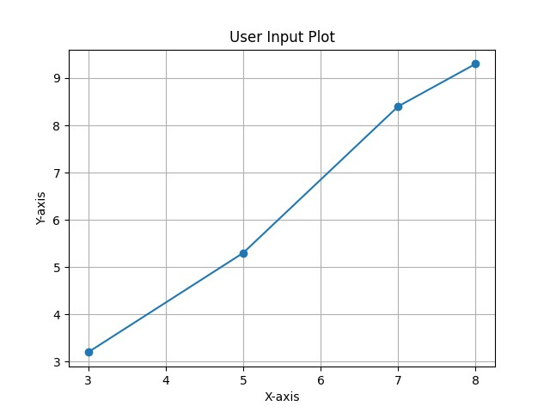
4) Write a Python program to implement Simple Linear Regression.
Solution :
Linear regression is a statistical method used to model the relationship between a dependent variable and one or more independent variables. It provides valuable insights for prediction and data analysis. This article will explore its types, assumptions, implementation, advantages, and evaluation metrics.
Simple Linear Regression:
Simple linear regression is the simplest form of linear regression and it involves only one independent variable and one dependent variable.
The equation for simple linear regression is:
y = β0 + β1 X

where:
y is the dependent variable X is the independent variable β0 is the intercept β1 is the slope

Step-1: Data Pre-processing
The first step for creating the Simple Linear Regression model is data pre-processing
Scripting Languages
Step-2: Fitting the Simple Linear Regression to the Training Set:
Now the second step is to fit our model to the training dataset. To do so, we will import the LinearRegression class of the linear_model library from the scikit learn.
Step: 3. Prediction of test set result:
dependent (salary) and an independent variable (Experience). So, now, our model is ready to predict the output for the new observations. In this step, we will provide the test dataset (new observations) to the model to check whether it can predict the correct output or not.
Step: 4. visualizing the results:
Now in this step, we will visualize the training set result. To do so, we will use the scatter() function of the pyplot library, which we have already imported in the pre-processing step. The scatter () function will create a scatter plot of observations.

CSV file : "salary_data.csv" age,salary 22,30000
25,35000
30,45000
35,50000
40,60000
45,65000
50,70000
55,80000
To Download above CSV file : Click Here

Output:-
import pandas as pd import matplotlib.pyplot as plt
from sklearn.model_selection import train_test_split from sklearn.linear_model import LinearRegression
from sklearn.metrics import mean_absolute_error,mean_squared_error,r2_score
#Load the data from the CSV file data = pd.read_csv('salary_data.csv') x= data[['age']] # Independent variable y = data['salary'] # Dependent variable #Split the data into training and testing sets
x_train, x_test, y_train, y_test = train_test_split(x, y, test_size=0.2,random_state=1) model=LinearRegression() model.fit(x_train, y_train) y_pred=model.predict(x_test) #Model coefficients
print(f"Intercept (a0): {model.intercept_}") print(f"Slope (a1): {model.coef_}") r2=r2_score(y_test, y_pred) #Print evaluation metrics print (f"R-squared Score: ",r2) #User input for age
user_age = float(input("Enter age to predict salary: "))
#Predict salary for the given age
predicted_salary = model.predict(pd.DataFrame([[user_age]], columns=['age'])) print (f"The predicted salary for age {user_age} is:",predicted_salary) plt.scatter (x_test, y_test, color='blue')
plt.plot(x_test, y_pred, color='red', linewidth=2, label='Predicted line')
plt.scatter (user_age, predicted_salary, color='green', s=100, label='User Prediction') plt.xlabel('Age') plt.ylabel('Salary')
plt.title('Simple Linear Regression: Age vs Salary') plt.legend() plt.show()

Output;-
Sample Run:
--------------
$ python3 Linear_Regression.py
Intercept (a0): -1522.5102319235884
Slope (a1): [1470.66848568]
R-squared Score: 0.9899167950543547
Enter age to predict salary: 43
The predicted salary for age 43.0 is: [61716.23465211]
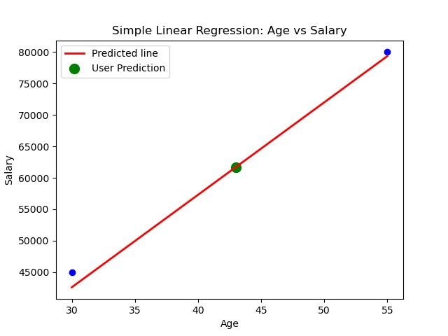

5) Implementation of Multiple Linear Regression for House Price Prediction using sklearn.
Solution :
Multiple Linear Regression attempts to model the relationship between two or more features and a response by fitting a linear equation to observed data. The steps to perform multiple linear Regression are almost similar to that of simple linear Regression. The Difference Lies in the evaluation. We can use it to find out which factor has the highest impact on the predicted output and how different variables relate to each other.
Y = b0 + b1 * x1 + b2 * x2 + b3 * x3 + …… bn * xn Y = Dependent variable x1, x2, x3, …… xn = multiple independent variables
Step-1: Data Pre-processing
Step-2: Fitting our MLR model to the Training set
Step-3: Prediction of test set result Step-4: visualizing the results CSV file : "house_data.csv" price,area,bedrooms,floors,age
4500000,1500,3,2,5
7000000,2500,4,3,4
3000000,1200,2,1,2
5500000,1800,3,2,4
9000000,3000,5,4,5
3500000,1400,3,2,5
6000000,2200,4,3,1
10000000,3500,5,4,4
4000000,1600,3,2,3
6500000,2000,4,3,4
To Download above CSV file : Click Here

Source Code-
import pandas as pd import numpy as np import matplotlib.pyplot as plt
from sklearn.model_selection import train_test_split from sklearn.linear_model import LinearRegression from sklearn.metrics import mean_squared_error, r2_score from matplotlib.ticker import FuncFormatter

data = pd.read_csv('house_data.csv') X = data.drop('price', axis=1) y = data['price']

X_train, X_test, y_train, y_test = train_test_split(X, y, test_size=0.2,random_state=42) model = LinearRegression().fit(X_train, y_train) y_pred = model.predict(X_test)

print(f"Mean Squared Error: {mean_squared_error(y_test, y_pred):.2f}") print(f"R^2 Score: {r2_score(y_test, y_pred):.2f}") print(f"Model Coefficients: {model.coef_}") print(f"Model Intercept: {model.intercept_}")

area = float(input("Enter area (sq ft): ")) bedrooms = int(input("Enter number of bedrooms: ")) floors = int(input("Enter number of floors: ")) age = int(input("Enter age of the house: "))
input_data = pd.DataFrame([[area, bedrooms, floors, age]], columns=['area', 'bedrooms', 'floors',
'age'])
input_data_encoded = input_data.reindex(columns=X.columns, fill_value=0) predicted_price = model.predict(input_data_encoded)

print(f"Predicted price for the house: ₹{predicted_price[0]:,.2f}") plt.figure(figsize=(12, 8)) # Adjusted size
plt.scatter(y_test, y_pred, alpha=0.7, label="Predicted Prices", color='blue', marker='o') plt.plot([0, max(y_test)], [0, max(y_test)], color='red', linestyle='--', label="Prediction Line") plt.xlabel("Actual Prices (₹)") plt.ylabel("Predicted Prices (₹)") plt.title("Actual vs Predicted House Prices")

# Use safe formatter instead of set_xticklabels/set_yticklabels formatter = FuncFormatter(lambda x, pos: f'₹{int(x):,}') plt.gca().xaxis.set_major_formatter(formatter) plt.gca().yaxis.set_major_formatter(formatter)

plt.legend()
plt.xlim(0, max(y_test) * 1.1) plt.ylim(0, max(y_pred) * 1.1)
# Grid and display plt.grid(True) plt.show()

Output
Sample Run:
$ python3 Multiple_Linear_Regression.py
Mean Squared Error: 147133574968.89
R^2 Score: 0.93
Model Coefficients: [ 2518.89168766 198012.87433529 198012.87433529 94458.43828715]
Model Intercept: -818499.8600628739
Enter area (sq ft): 200
Enter number of bedrooms: 3
Enter number of floors: 2
Enter age of the house: 2
Predicted price for the house: ₹864,259.73

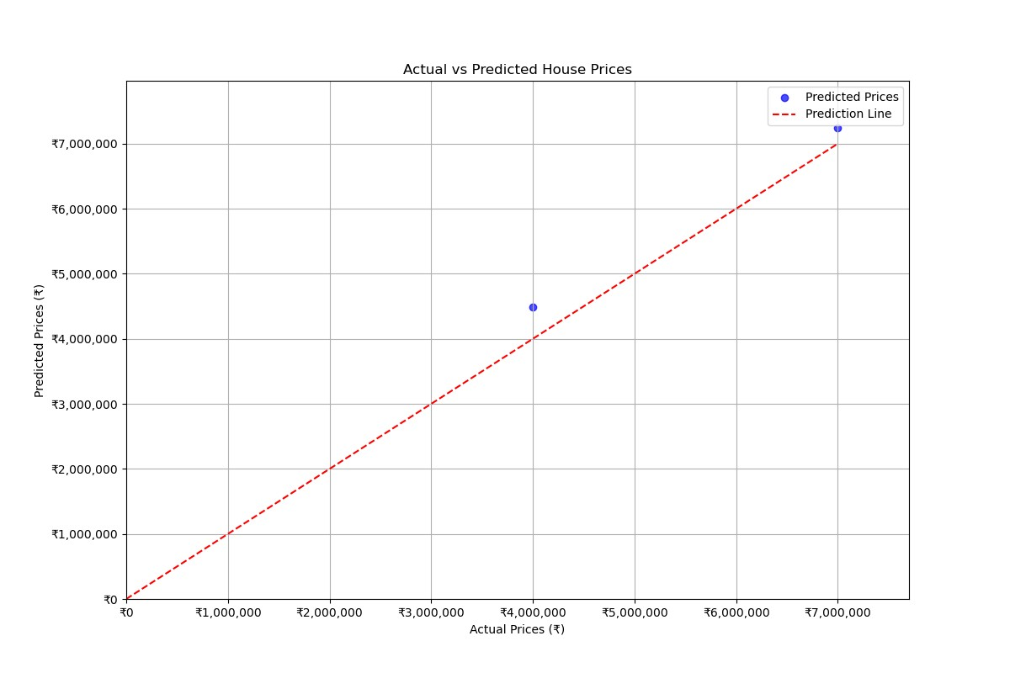

6) Implementation of Decision tree using sklearn and its parameter tuning.

Solution :

A Decision Tree is a supervised machine learning algorithm used for classification and regression tasks. It builds a tree-like model of decisions based on features of the data, splitting nodes based on conditions that maximize information gain or minimize impurity. Decision Trees are interpretable and useful for understanding the structure of data.
Dataset Overview
The Iris dataset is a well-known dataset in machine learning, containing 150 samples from three species of Iris flowers: setosa, versicolor, and virginica. Each sample has four features: sepal length, sepal width, petal length, and petal width.
Steps :
- Importing Required Libraries:
  - Libraries from sklearn are imported for data handling, model training, evaluation, and visualization.
  - matplotlib.pyplot is used for plotting the decision tree.
  - load_iris: To load the Iris dataset.
  - train_test_split: To split the dataset into training and testing subsets.
  - GridSearchCV: To perform hyperparameter tuning through grid search.
  - DecisionTreeClassifier: To create a Decision Tree model.
  - accuracy_score and classification_report: To evaluate model performance.
  - tree: For plotting the tree structure.
- Loading the Iris Dataset
  - The Iris dataset is loaded using load_iris().
  - X holds the feature data, and y holds the target labels (species of iris).
- Splitting the Dataset
  - Using train_test_split, 90% of the data is used for training and 10% for testing.
  - This ensures the model is evaluated on unseen data.
- Defining a Parameter Grid for Tuning
  - criterion: Function to measure split quality - 'gini' or 'entropy'.
  - max_depth: Max depth of the tree (1 to 4).
  - min_samples_split: Minimum samples to split an internal node.
  - min_samples_leaf: Minimum samples required at a leaf node.
- Initializing the Decision Tree Classifier
  - An instance of DecisionTreeClassifier is created with a fixed random state.
- Performing Grid Search for Parameter Tuning
  - GridSearchCV searches through the parameter grid using cross-validation (cv=3).
  - It identifies the best combination of parameters for optimal model performance.
- Getting the Best Model
  - best_estimator_ retrieves the best-performing classifier from the grid search.
- Fitting the Best Classifier on Training Data
  - The best classifier is trained using fit() on X_train and y_train.
- Making Predictions on the Test Set
  - Predictions are made using the best model from the grid search.
- Calculating Accuracy
  - accuracy_score is used to evaluate the model's prediction accuracy.
- Printing Classification Report
  - classification_report provides precision, recall, and F1-score for each iris species class.
- Visualizing the Best Decision Tree
  - plot_tree from sklearn.tree is used to visualize the tree structure.
  - It includes class names, feature names, and colored nodes for interpretability.
  - plt.show() displays the tree plot.

Source Code-
# Importing required libraries from sklearn.datasets import load_iris
from sklearn.model_selection import train_test_split, GridSearchCV from sklearn.tree import DecisionTreeClassifier
from sklearn.metrics import accuracy_score, classification_report import matplotlib.pyplot as plt from sklearn import tree # Load the Iris dataset iris = load_iris() X = iris.data # Features y = iris.target # Target labels
# Split the dataset into training and testing sets (90% train, 10% test)
X_train, X_test, y_train, y_test = train_test_split(X, y, test_size=0.1, random_state=42) # 10% test size
# Initialize the Decision Tree classifier with some tuning parameters
clf = DecisionTreeClassifier(max_depth=2, min_samples_split=2, min_samples_leaf=1, random_state=42)
# Fit the classifier on the training data clf.fit(X_train, y_train)
# Make predictions on the test set y_pred = clf.predict(X_test) # Calculate accuracy
accuracy = accuracy_score(y_test, y_pred) print(f'Accuracy: {accuracy:.2f}') # Print classification report print('Classification Report:')
print(classification_report(y_test, y_pred, target_names=iris.target_names))

# Visualize the Decision Tree plt.figure(figsize=(10, 8))
tree.plot_tree(clf, filled=True, feature_names=iris.feature_names,class_names=iris.target_names, rounded=True)
plt.title("Decision Tree Visualization") plt.show()

Output

Sample Run
$ python3 Dtree.py

Accuracy: 1.00
Classification Report:
precision recall f1-score support

setosa 1.00 1.00 1.00 6 versicolor 1.00 1.00 1.00 6 virginica 1.00 1.00 1.00 3

accuracy 1.00 15 macro avg 1.00 1.00 1.00 15 weighted avg 1.00 1.00 1.00 15

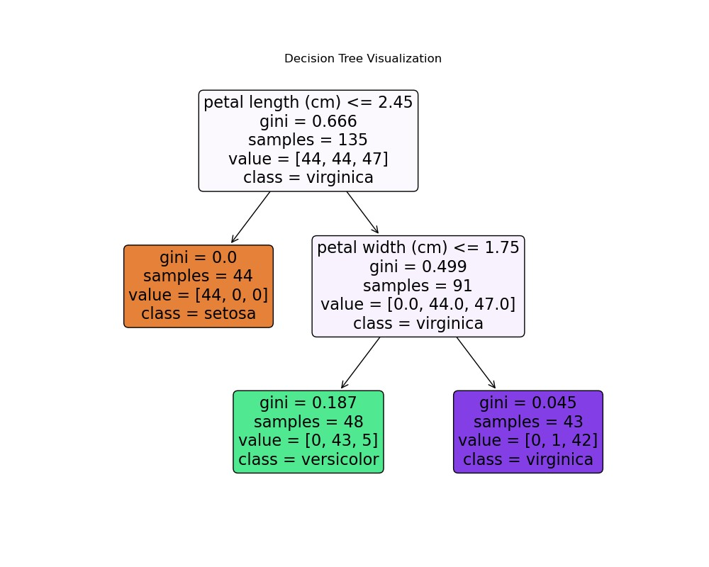
7) Implementation of KNN using sklearn.

Solution :

K-Nearest Neighbor(KNN) Algorithm:
The K-Nearest Neighbors (KNN) algorithm is a supervised machine learning method employed to tackle classification and regression problems.
K-NN algorithm assumes the similarity between the new case/data and available cases and put the new case into the category that is most similar to the available categories.
K-NN algorithm stores all the available data and classifies a new data point based on the similarity. This means when new data appears then it can be easily classified into a well suite category by using K- NN algorithm.
K-NN algorithm can be used for Regression as well as for Classification but mostly it is used for the Classification problems.
Developing Corporate Strategic Plans
In this program, we are going to use iris dataset.And this dataset Split into training(70%) and test set(30%).

The iris dataset conatins the following features

- sepal length (cm)
- sepal width (cm)
- petal length (cm)
- petal width (cm)

Source Code:
from sklearn.neighbors import KNeighborsClassifier from sklearn.model_selection import train_test_split from sklearn.datasets import load_iris import random

data_iris = load_iris()
label_target = data_iris.target_names
print()
print("Sample Data from Iris Dataset") print("*"*30) for i in range(10):
rn = random.randint(0,120)
print(data_iris.data[rn],"===>",label_target[data_iris.target[rn]])

X = data_iris.data y = data_iris.target
X_train, X_test, y_train, y_test = train_test_split(X, y, test_size = 0.3,random_state=1)

print("The Training dataset length: ",len(X_train)) print("The Testing dataset length: ",len(X_test)) try:
nn = int(input("Enter number of neighbors :")) knn = KNeighborsClassifier(nn) knn.fit(X_train, y_train) # to display the score
print("The Score is :",knn.score(X_test, y_test))
# To get test data from the user test_data = input("Enter Test Data :").split(",") for i in range(len(test_data)):
test_data[i] = float(test_data[i]) print()
v = knn.predict([test_data]) print("Predicted output is :",label_target[v]) except:
print("Please supply valid input......")
Output
Sample Run:
$ python3 Knn.py
Sample Data from Iris Dataset
******************************
[6.1 2.8 4. 1.3] ===> versicolor
[4.6 3.1 1.5 0.2] ===> setosa
[5.8 2.6 4. 1.2] ===> versicolor
[6.9 3.2 5.7 2.3] ===> virginica
[6.7 3.1 4.7 1.5] ===> versicolor
[4.7 3.2 1.3 0.2] ===> setosa
- 3. 1.6 0.2] ===> setosa
[6.4 2.9 4.3 1.3] ===> versicolor
[5.5 2.4 3.7 1. ] ===> versicolor
[5.8 2.6 4. 1.2] ===> versicolor
The Training dataset length: 105
The Testing dataset length: 45
Enter number of neighbors :9
The Score is : 0.9777777777777777
Enter Test Data :5.3,2.2,3.2,1.5

Predicted output is : ['versicolor']

8) Implementation of Logistic Regression using sklearn.
Solution :
Logistic regression:
Logistic regression is one of the most popular Machine Learning algorithms, which comes under the Supervised Learning technique. It is used for predicting the categorical dependent variable using a given set of independent variables. Logistic regression predicts the output of a categorical dependent variable. Therefore the outcome must be a categorical or discrete value. It can be either Yes or No, 0 or 1, true or False, etc. but instead of giving the exact value as 0 and 1, it gives the probabilistic values which lie between 0 and 1.
In this implementation, we use "Study Hours" as the independent variable and "Exam Results (0 or 1)" as the dependent variable.
Steps :
Step 1. Importing Required Libraries
- pandas: For loading and processing the dataset.
- numpy: For numerical computations, such as generating a range of values for plotting.
- matplotlib.pyplot: For creating the graph and visualizing the results.
- sklearn.model_selection: For splitting the dataset into training and testing subsets.
- sklearn.linear_model: For implementing the logistic regression model.
- sklearn.metrics: For evaluating the model’s performance using metrics like accuracy, confusion matrix, and classification report.
Step 2. Reading the Dataset
- pd.read_csv() reads the CSV file into a Pandas DataFrame.
- The file should contain columns for "Study Hours" and "Exam Result".
Step 3. Defining Features (X) and Target (y) • X stores the independent variable (Study Hours).
- y stores the dependent variable (Exam Result).
Step 4. Splitting the Dataset
- train_test_split() is used to split the data into training (80%) and testing (20%) sets.
- random_state=42 ensures the split is reproducible.
Step 5. Training the Logistic Regression Model
- LogisticRegression() initializes the logistic regression model.
- model.fit(X_train, y_train) trains the model on the training data.
Step 6. Making Predictions
- model.predict(X_test) uses the trained model to predict the exam results for the test set.
Step 7. Evaluating the Model
- Accuracy: The percentage of correct predictions, calculated by accuracy_score().
- Confusion Matrix: Shows TP, TN, FP, FN for insight into performance.
- Classification Report: Provides precision, recall, F1-score, and support for each class.
Step 8. Plotting the Data Points and Decision Boundary
- Scatter Plot: Displays training data in blue and test data in green (x-shaped).
- Decision Boundary: Red line showing model's predicted probabilities for class 1 across study hours.
CSV file : "study_hours.csv"
Study Hours,Exam Result
1,0
2,0
3,0
4,0
5,1
6,1
7,1
8,1
9,1
10,1
To Download above CSV file : Click Here

Source Code:
import pandas as pd import numpy as np import matplotlib.pyplot as plt
from sklearn.linear_model import LogisticRegression from sklearn.model_selection import train_test_split
from sklearn.metrics import accuracy_score, confusion_matrix, classification_report
# Step 1: Load the dataset data = pd.read_csv("study_hours.csv") # Ensure this file exists in the same directory X = data[['Study Hours']].values y = data['Exam Result'].values
# Step 2: Train-test split
X_train, X_test, y_train, y_test = train_test_split(
X, y, test_size=0.2, random_state=42)
# Step 3: Train logistic regression model model = LogisticRegression() model.fit(X_train, y_train)
# Step 4: Predict and evaluate y_pred = model.predict(X_test)
# Step 5: Print results print(f"Accuracy: {accuracy_score(y_test, y_pred):.1f}") print("\nConfusion Matrix:") print(confusion_matrix(y_test, y_pred))

print("\nClassification Report:") print(classification_report(y_test, y_pred))
# Step 6: Plotting decision boundary
X_range = np.linspace(X.min() - 1, X.max() + 1, 300).reshape(-1, 1)
y_prob = model.predict_proba(X_range)[:, 1]
plt.figure(figsize=(8, 6)) plt.scatter(X_train, y_train, color='blue', label='Training Data')
plt.scatter(X_test, y_test, color='green', marker='x', s=100, label='Testing Data') plt.plot(X_range, y_prob, color='red', linewidth=2, label='Decision Boundary') plt.xlabel("Study Hours") plt.ylabel("Exam Result")
plt.title("Logistic Regression - Study Hours vs Exam Result") plt.legend() plt.grid(True) plt.show()
Output:-
Sample Run:
$ python3 Logistic_Regression.py
Accuracy: 1.0

Confusion Matrix:
[[1 0]
[0 1]]

Classification Report:
precision recall f1-score support

- 1.00 1.00 1.00 1
- 1.00 1.00 1.00 1

accuracy 1.00 2 macro avg 1.00 1.00 1.00 2 weighted avg 1.00 1.00 1.00 2

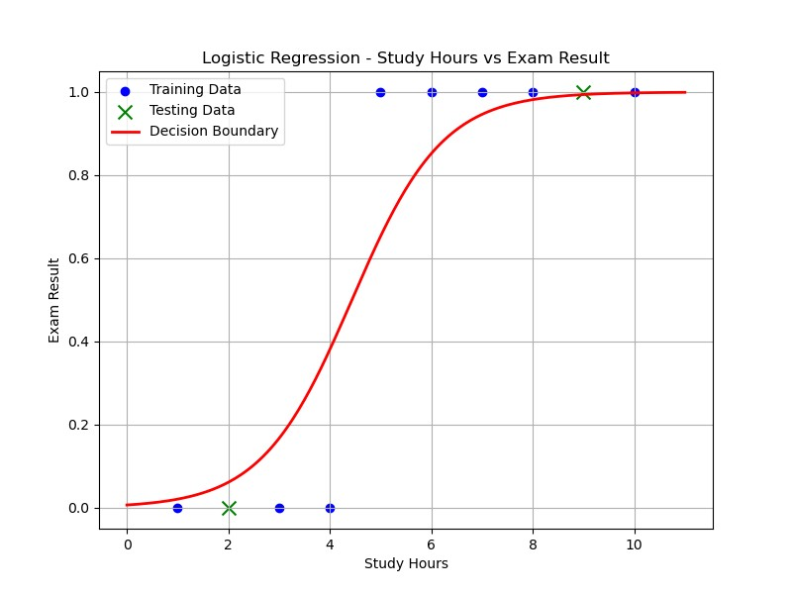

9) Implementation of K-Means Clustering.
Solution:-

K-Means Clustering:
K-Means is a popular unsupervised machine learning algorithm used for partitioning a dataset into K clusters based on the similarity of their features. It works by minimizing the variance within each cluster and is widely used in applications such as market segmentation, image compression, and pattern recognition.
K means clustering, assigns data points to one of the K clusters depending on their distance from the center of the clusters. It starts by randomly assigning the clusters centroid in the space. Then each data point assign to one of the cluster based on its distance from centroid of the cluster. After assigning each point to one of the cluster, new cluster centroids are assigned. This process runs iteratively until it finds good cluster. In the analysis we assume that number of cluster is given in advanced and we have to put points in one of the group.
Strategic Planning
ALGORITHM:
- Initialization:
  - Choose the number of clusters (k) to divide the data into.
  - Initialize the centroids (cluster centers) randomly or using specific techniques.
- Assignment:
  - Assign each data point to the nearest centroid based on the distance (e.g., Euclidean distance).
  - Each data point is labeled as belonging to one of the k clusters.
- Update:
  - Recalculate the centroids of the clusters by averaging the coordinates of all data points assigned to each cluster.
- Repeat:
  - Repeat the Assignment and Update steps iteratively until the centroids stabilize (i.e., no significant changes in their positions) or a predefined number of iterations is reached.
Steps for Program:
1. Import Necessary Libraries:
  - numpy: For numerical computations.
  - matplotlib.pyplot: For visualizing the data points and clustering results. o KMeans from sklearn.cluster: To implement the K-Means algorithm.
  - make_blobs from sklearn.datasets: To generate synthetic data for clustering.
2. Generate Synthetic Data:
  - The make_blobs function generates 300 data points with 4 clusters. The points are distributed with a standard deviation of 0.60 around the cluster centers.
  - The dataset consists of:
Features (X): A 2D array representing the data points' coordinates.
3. Visualize Raw Data:
  - A scatter plot is created to visualize the data points before clustering.
4. Apply K-Means Algorithm:
  - The K-Means model is initialized with n_clusters=4 to specify 4 clusters. o The model is fit to the data using the fit method.
- Retrieve Cluster Information:
  - Cluster Centers: The coordinates of the centroids for each cluster are stored in kmeans.cluster_centers_.
  - Cluster Labels: Each data point is assigned a cluster label using kmeans.labels_.
- Visualize Clustered Data:
  - A scatter plot shows the data points grouped into clusters, with colors representing different clusters.
  - Cluster centroids are displayed as red points to highlight their locations.

Source Code:-
#Necessary Libraries import numpy as np import matplotlib.pyplot as plt from sklearn.cluster import KMeans
from sklearn.datasets import make_blobs

#Generate Data
X, _ = make_blobs(n_samples = 300, centers = 4 , cluster_std = 0.60,random_state = 0)

#Plot the data points plt.scatter(X[:,0],X[:,1]) plt.title("Data Points") plt.show()

#KMeans clustering kmeans = KMeans(n_clusters = 4) kmeans.fit(X)

#Getting the cluster centers and labels centers = kmeans.cluster_centers_ #returns the coordinates of the

#cluster center found by the algorithm
labels = kmeans.labels_ #Returns the labels for each data point , indicating which cluster it has

#been assigned to. #Plot the clustered data plt.scatter(X[:,0],X[:,1],c = labels)
plt.scatter(centers[:,0],centers[:,1],alpha = 0.75,s=200,color = 'red') plt.title("Clustered Data") plt.show()

Output:
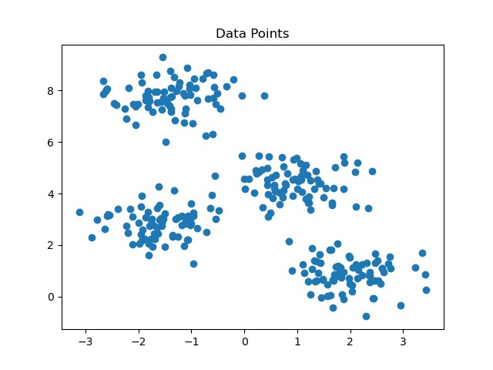

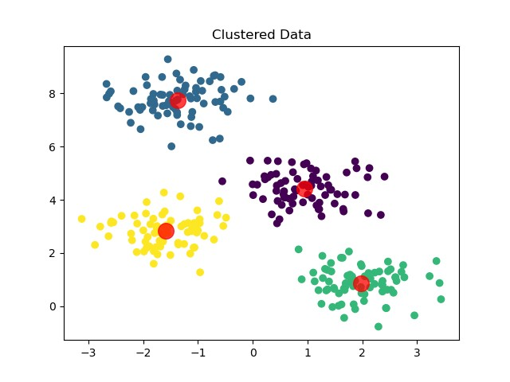
Mini Project : Performance Analysis of Classification Algorithms on the Iris Dataset.

Title:
Performance Analysis of Classification Algorithms on the Iris Dataset Objective:
To evaluate and compare the performance of various classification algorithms such as:
- Logistic Regression
- Decision Tree
- K-Nearest Neighbors (KNN)
- Support Vector Machine (SVM)
- Random Forest
using performance metrics like accuracy, confusion matrix, precision, recall, and F1-score.
Dataset:
- Dataset Name: Iris Dataset
- Source: sklearn.datasets.load_iris() or UCI Machine Learning Repository
- Features: Sepal Length, Sepal Width, Petal Length, Petal Width • Target: Iris species (setosa, versicolor, virginica)

Tools & Libraries: import numpy as np import pandas as pd from sklearn.datasets import load_iris from sklearn.model_selection import train_test_split from sklearn.preprocessing import StandardScaler from sklearn.linear_model import LogisticRegression from sklearn.tree import DecisionTreeClassifier from sklearn.neighbors import KNeighborsClassifier from sklearn.svm import SVC from sklearn.ensemble import RandomForestClassifier from sklearn.metrics import classification_report, confusion_matrix, accuracy_score

Step-by-Step Implementation:
- Load and Prepare
iris = load_iris() X = iris.data y = iris.target

# Train-test split
X_train, X_test, y_train, y_test = train_test_split(X, y, test_size=0.3, random_state=42)

# Feature scaling scaler = StandardScaler()
X_train = scaler.fit_transform(X_train)
X_test = scaler.transform(X_test)
- Initialize Models models = {
"Logistic Regression": LogisticRegression(),
"Decision Tree": DecisionTreeClassifier(),
"K-Nearest Neighbors": KNeighborsClassifier(),
"Support Vector Machine": SVC(),
"Random Forest": RandomForestClassifier()
}
- Train, Predict, and Evaluate for name, model in models.items():
print(f"\nModel: {name}") model.fit(X_train, y_train) y_pred = model.predict(X_test) print("Accuracy:", accuracy_score(y_test, y_pred)) print("Confusion Matrix:\n", confusion_matrix(y_test, y_pred)) print("Classification Report:\n", classification_report(y_test, y_pred)) Sample Output (for SVM):
Model: Support Vector Machine
Accuracy: 1.0
Confusion Matrix:
[[16 0 0]
[ 0 14 0]
[ 0 0 15]]
Classification Report:
precision recall f1-score support
- 1.00 1.00 1.00 16
- 1.00 1.00 1.00 14 2 1.00 1.00 1.00 15 accuracy 1.00 45

macro avg 1.00 1.00 1.00 45

weighted avg 1.00 1.00 1.00 45
Metrics Used for Comparison:
- Accuracy
- Confusion Matrix
- Precision
- Recall
- F1-score
Conclusion:
Based on the evaluation metrics, all models may perform well on this simple dataset, but on realworld data, metrics will vary. Random Forest and SVM generally provide better performance in complex datasets.
Scripting Languages
Optional Extensions:
- Use different datasets: Breast Cancer, Wine, Titanic (Kaggle)
- Add cross-validation
- Use AUC-ROC curves for binary classification
- Plot confusion matrix using seaborn heatmap
Complete Source Code:
import numpy as np import pandas as pd
from sklearn.datasets import load_iris from sklearn.model_selection import train_test_split from sklearn.preprocessing import StandardScaler from sklearn.linear_model import LogisticRegression from sklearn.tree import DecisionTreeClassifier from sklearn.neighbors import KNeighborsClassifier from sklearn.svm import SVC
from sklearn.ensemble import RandomForestClassifier
from sklearn.metrics import classification_report, confusion_matrix, accuracy_score

# Load dataset iris = load_iris() X = iris.data y = iris.target

# Train-test split
X_train, X_test, y_train, y_test = train_test_split(X, y, test_size=0.3, random_state=42)

# Feature scaling scaler = StandardScaler()
X_train = scaler.fit_transform(X_train)
X_test = scaler.transform(X_test)

# Define models models = { "Logistic Regression": LogisticRegression(),
"Decision Tree": DecisionTreeClassifier(),
"K-Nearest Neighbors": KNeighborsClassifier(),
"Support Vector Machine": SVC(),
"Random Forest": RandomForestClassifier()
}

# Train, Predict, and Evaluate for name, model in models.items():
print(f"\nModel: {name}") model.fit(X_train, y_train) y_pred = model.predict(X_test)

print("Accuracy:", accuracy_score(y_test, y_pred)) print("Confusion Matrix:\n", confusion_matrix(y_test, y_pred)) print("Classification Report:\n", classification_report(y_test, y_pred))

Output:
Sample Run:
--------------
$ python3 mini_project.py
Model: Logistic Regression Accuracy: 1.0 Confusion Matrix:
[[19 0 0] [ 0 13 0]
[ 0 0 13]]
Classification Report: precision recall f1-score support

- 1.00 1.00 1.00 19
- 1.00 1.00 1.00 13
- 1.00 1.00 1.00 13

accuracy 1.00 45
macro avg 1.00 1.00 1.00 45
weighted avg 1.00 1.00 1.00 45

Model: Decision Tree Accuracy: 1.0 Confusion Matrix:
[[19 0 0]
[ 0 13 0]
[ 0 0 13]]
Classification Report: precision recall f1-score support

- 1.00 1.00 1.00 19
- 1.00 1.00 1.00 13
- 1.00 1.00 1.00 13

accuracy 1.00 45 macro avg 1.00 1.00 1.00 45
weighted avg 1.00 1.00 1.00 45

Model: K-Nearest Neighbors Accuracy: 1.0 Confusion Matrix:
[[19 0 0]
[ 0 13 0]
[ 0 0 13]]
Classification Report: precision recall f1-score support

- 1.00 1.00 1.00 19
- 1.00 1.00 1.00 13
- 1.00 1.00 1.00 13

accuracy 1.00 45 macro avg 1.00 1.00 1.00 45
weighted avg 1.00 1.00 1.00 45

Model: Support Vector Machine Accuracy: 1.0 Confusion Matrix:
[[19 0 0]
[ 0 13 0]
[ 0 0 13]]
Classification Report: precision recall f1-score support

- 1.00 1.00 1.00 19
- 1.00 1.00 1.00 13
- 1.00 1.00 1.00 13

accuracy 1.00 45 macro avg 1.00 1.00 1.00 45
weighted avg 1.00 1.00 1.00 45

Model: Random Forest Accuracy: 1.0 Confusion Matrix:
[[19 0 0]
[ 0 13 0]
[ 0 0 13]]
Classification Report: precision recall f1-score support

- 1.00 1.00 1.00 19
- 1.00 1.00 1.00 13
- 1.00 1.00 1.00 13

accuracy 1.00 45 macro avg 1.00 1.00 1.00 45
weighted avg 1.00 1.00 1.00 45

