FlexMoney

Yoga Assignment

Harsh Gupta

https://www.youtube.com/watch?v=-SqnwemXI2w

**Installation**

We know recently heroku turned off free postgres data service. So I could not host my Backend on cloud.

I also tried to containerize my code by making a docker container but was running in an error with the postgres image.

So to demonstrate I have made a youtube video which may help you to go through the functionality. Youtube video link is: https://www.youtube.com/watch?v=-SqnwemXI2w

But you can surely set up the code on your system.

**Architecture**

We have Backend and frontend built in separate directories. Our Backend is built in Django and uses REST Apis made with the django rest framework to serve APIs. We are using the postgres database to store our data.

We have used Django inbuilt User model to store basic user details like name, username, password.

We also have a UserProfile model which is related to the User model. It stores information like mobile and age.

We have made the UserProfile model considering scalability, considering in future if we also wanted to have a section for instructors we could make an Instructor model and link it to the base user.

We then have a Batch model which stores information about the batches like their name and timings.

We then have a BatchUser model. Which is a model that stores batchusers and contains userProfile and batch as foreign keys. The functionality that was asked to be built in the assignment could be made without this model.

But considering scalability it is a nice idea to have a separate model. In future we could store information like transaction ids.

This is the ER diagram for our architecture

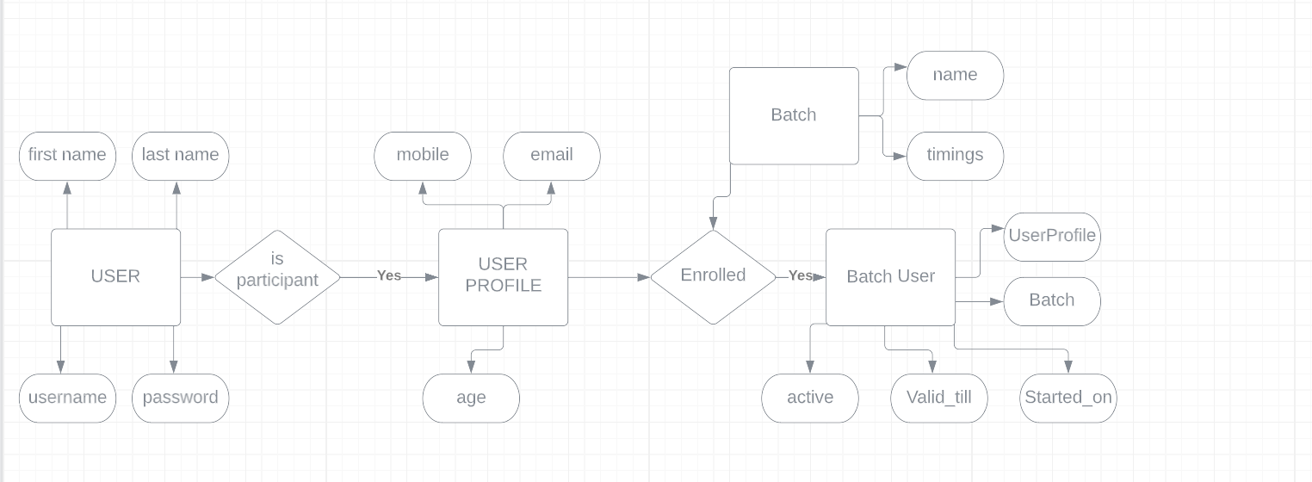

Our frontend was made with React. We have Login, Register, Home components and then we have navbar and footer which are consistent.

We have extensively used Material Ui to make our components. We have used sessionstorage because we had to make only a small application. I know it is not the best practice, but in a hurry I used it.

We have used a lot of React states to apply conditional rendering.

Thanks, If you have any more questions about the architecture you can call me or email me at:

9999537290

[hg070401@gmail.com](mailto:hg070401@gmail.com)

You can know more about me at: <https://www.theharshgupta.co.in/>

https://www.linkedin.com/in/harshhx/