FULL STACK DEVELOPMENT WITH MERN
PROJECT DOCUMENTATION
Project Title :ALUMNI MANAGEMENT SYSTEM

Team ID : LTVIP2026TMIDS78236

Team Size : 4

TeamMember : Harshitha K
Team Member : Kotakonda Vishnupriya
Team Member : Pabbisetty Kumara Sai Krishna Swamy
Team Member : Arisetty Hemanth Sai

Academic Year : 2025 - 2026

Submitted in partial fulfillment of the requirements for
Full Stack Development using MERN Stack

Date of Submission : 17 February 2026
TABLE OF CONTENTS

Chapter No. | Title | Page No.
1 | INTRODUCTION | 1-2
1.1 | Project Overview | 1
1.2 | Purpose | 2
2 | IDEATION PHASE | 3-4
2.1 | Problem Statement | 3
2.2 | Empathy Map Canvas | 3
2.3 | Brainstorming | 4
3 | REQUIREMENT ANALYSIS | 5-7
3.1 | Customer Journey Map | 5
3.2 | Solution Requirement | 6
3.3 | Data Flow Diagram | 7
3.4 | Technology Stack | 7
4 | PROJECT DESIGN | 8-9
4.1 | Problem Solution Fit | 8
4.2 | Proposed Solution | 8
4.3 | Solution Architecture | 9
5 | PROJECT PLANNING & SCHEDULING | 10-11
5.1 | Project Planning | 10
6 | FUNCTIONAL AND PERFORMANCE TESTING | 11
6.1 | Performance Testing | 12
7 | RESULTS | 13-19
7.1 | Output Screenshots | 13
8 | ADVANTAGES & DISADVANTAGES | 20
9 | CONCLUSION | 21
10 | FUTURE SCOPE | 22
11 | APPENDIX | 22-29

1. INTRODUCTION
The Alumni Management System is a web-based platform designed to establish and maintain strong relationships between alumni and their educational institution. The system centralizes alumni records, events, donations, networking opportunities, and communication channels within a secure digital environment.
Traditionally, alumni data is maintained manually or in fragmented databases, leading to inefficiencies in communication and engagement. This project aims to digitize and automate alumni interactions through a scalable and secure application.
The system follows a three-tier architecture consisting of presentation layer, business logic layer, and database layer to ensure modularity and maintainability.

Project Overview
The Alumni Management System is a web-based application developed to establish and maintain an organized, secure, and interactive platform for managing alumni information and institutional engagement. The system serves as a centralized digital repository that connects alumni, students, faculty members, and administrators through structured communication and networking features.
Traditionally, alumni data is maintained manually or through fragmented databases, resulting in outdated records, inefficient communication, and limited engagement. This project addresses these challenges by providing an integrated solution that automates alumni registration, profile management, event coordination, job postings, and donation tracking within a single unified platform.
The system is designed using a three-tier architecture:
- Presentation Layer (Frontend): Provides a user-friendly and responsive interface for alumni and administrators.
- Application Layer (Backend): Handles business logic, authentication, and data processing.
- Data Layer (Database): Stores and manages alumni records, events, job postings, and transactional data securely.
Key modules of the system include:
- Alumni Registration & Login Module
- Profile Management Module
- Event Management Module
- Job & Internship Portal
- Donation & Contribution Tracking
- Administrative Dashboard
The platform ensures data security through authentication mechanisms, encrypted password storage, and role-based access control. It is scalable, allowing institutions to manage thousands of alumni records efficiently.
Overall, the Alumni Management System enhances institutional connectivity, strengthens alumni relationships, improves communication efficiency, and supports long-term institutional development through structured digital transformation.

1.2 Purpose
The primary purpose of the Alumni Management System is to create a unified digital platform that enables seamless communication between alumni and the institution.
It facilitates event participation, professional networking, mentorship opportunities, and fundraising initiatives.
Additionally, the system enhances institutional branding and alumni engagement through structured digital communication.

IDENTATION PHASE

2.1 PROBLEM STATEMENT
Educational institutions often struggle to maintain updated alumni records and effective communication channels.
Manual record keeping leads to outdated information, reduced alumni participation, and limited fundraising opportunities.
There is a need for a centralized, automated, and secure system to manage alumni data efficiently.

2.2 EMPATHY MAP
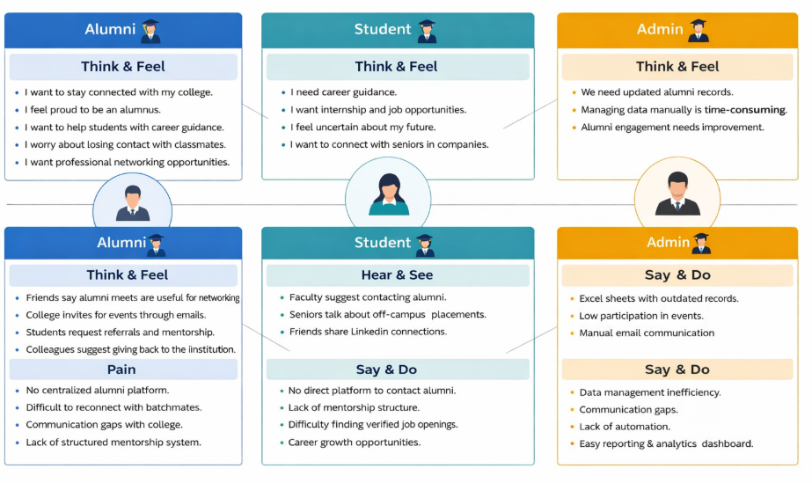
Figure 2.2: Empathy Map Canvas for College Alumni Management System
Figure 2.2 illustrates the Empathy Map Canvas developed for the College Alumni Management System. This empathy map represents the perspectives of three primary stakeholders: Alumni, Students, and Administrators. The purpose of this canvas is to understand the thoughts, feelings, challenges, and expectations of each user group in order to design a user-centered solution.
From the alumni perspective, the empathy map highlights their desire to stay connected with the institution, maintain professional relationships, and contribute through mentorship and job opportunities. However, they experience difficulties due to the absence of a centralized platform and structured communication system. Students, on the other hand, seek career guidance, internship opportunities, and mentorship support. They often rely on informal networks because there is no official channel to interact directly with alumni. Administrators focus on maintaining updated records and improving alumni engagement, but they face challenges related to manual data management, communication gaps, and lack of automation.
Overall, the empathy map helps in clearly identifying user pain points and expected gains. It provides valuable insights that guide the design and development of a centralized, secure, and efficient alumni management platform that addresses the needs of all stakeholders.

2.3 BRAINSTROMING
The brainstorming phase was conducted to generate innovative ideas and possible solutions to address the challenges identified in the empathy map and problem statement. During this stage, the team focused on understanding how a centralized system could improve communication, engagement, and data management for alumni, students, and administrators.
Initially, various solutions were discussed to solve the problem of fragmented alumni records and weak networking opportunities. The team proposed developing a secure web-based platform with role-based authentication to ensure controlled access for administrators, alumni, and students.
After evaluating the feasibility and impact of each idea, the final solution was defined as a MERN stack-based web application that centralizes alumni data, enhances networking, automates administrative tasks, and supports structured mentorship and career opportunities. This brainstorming process ensured that the proposed system directly addresses user pain points while delivering measurable value to all stakeholders.

REQUIREMENT ANALYSIS
Functional Requirements include user registration, login authentication, profile management, event creation, event registration, job postings, and donation management.
Non-Functional Requirements include scalability, security, usability, availability, and performance optimization.
The system must ensure data confidentiality and integrity through encryption and role-based access control.

Customer Journey Map:
The Customer Journey Map represents the step-by-step experience of users while interacting with the Alumni Management System. It helps understand how users engage with the platform and how the system addresses their needs at each stage.
The journey begins when the user visits the application and registers using role-based access as Admin, Alumni, or Student. After successful authentication, the user accesses a personalized dashboard. Alumni users update their professional profiles and may post job opportunities or register for events. Students browse alumni profiles, apply for mentorship, and explore job postings. Administrators manage user approvals, post announcements, and monitor system activity.
Throughout the journey, the system ensures smooth navigation, secure authentication, real-time updates, and easy communication. The overall experience is designed to be intuitive, efficient, and user-centered, reducing dependency on informal communication channels.

3.2 Proposed Solution
The proposed solution is a centralized web-based Alumni Management System developed using the MERN stack. The system provides a structured digital platform that connects alumni, students, and administrators through secure authentication and role-based dashboards.
The solution automates alumni data management, event coordination, job postings, and mentorship processes. It enables alumni to update their profiles and contribute to career development initiatives. Students gain access to verified job opportunities and structured mentorship programs. Administrators benefit from automated record management, reporting tools, and communication features.
This solution eliminates manual record-keeping, improves engagement, and strengthens institutional relationships through a scalable and secure digital architecture.

3.2 Data Flow Diagram (DFD)
Data Flow Diagrams(DFD)
A Data Flow Diagram (DFD) helps visualize the flow of data within a system. Here's a DFD for an Alumni Management System, showing the different processes, data stores, and data flows:
Level 0 DFD (Context Diagram)
This level provides an overview of the entire system as a single process.
Level 1 DFD (Detailed Diagram)
This level breaks down the main process into sub-processes, showing more detail about data flows and data stores.
ER Diagram:
Entity relationship diagram displays the relationships of entity set stored in a database. In other words, we can say that ER diagrams help you to explain the logical structure of databases. At first look, an ER diagram looks very similar to the flowchart. However, ER Diagram includes many specialized symbols, and its meanings make this model unique.
Components of the ER Diagram
This model is based on three basic concepts: Entities, Attributes, Relationships.
Entities: Entities represent real-world objects or concepts, such as people, places, or things, that are stored in a database. Each entity is depicted as a rectangle in the ER diagram, with its name written inside.
Attributes: Attributes describe the properties or characteristics of entities. They provide details about each entity and are represented as ovals connected to their respective entity rectangles in the ER diagram.
Relationships: Relationships illustrate how entities are connected or associated with each
other within the database. They depict the interactions and dependencies between entities.
Relationships are represented as diamond shapes connecting the related entities, and they
typically have names that describe the nature of the association
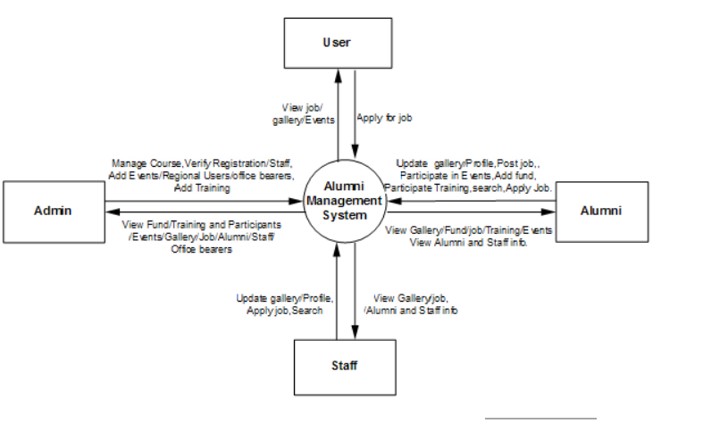

3.4 Technology Stack
Layer | Technology
Frontend | React.js
Backend | Node.js & Express.js
Database | MongoDB

The College Alumni Management System is developed using the MERN stack, which ensures scalability, flexibility, and efficient development.
The frontend is built using React.js, which provides a component-based architecture and dynamic user interface. React Router manages navigation, while Axios enables communication with backend APIs.
The backend is developed using Node.js and Express.js, which handle RESTful API development, request processing, authentication, and business logic implementation. JWT is used for secure authentication, and bcrypt is used for password encryption.
MongoDB is used as the database system to store user data, events, jobs, and announcements. Mongoose serves as the Object Data Modeling tool for schema definition and database interaction.
Additional technologies may include Bootstrap or Tailwind CSS for responsive design and Git for version control.

4. PROJECT DESIGN
The system architecture follows a modular approach separating frontend, backend, and database components.
Frontend is developed using modern JavaScript frameworks ensuring responsive user interfaces.
Backend APIs handle authentication, data processing, and database communication.
MongoDB is used as a NoSQL database to store alumni records efficiently.

4.1 Problem–Solution Fit
The College Alumni Management System is designed to directly address the key challenges identified during the ideation and problem analysis phases. The primary problem observed was the absence of a centralized and structured platform to manage alumni data, communication, mentorship, and job opportunities. Existing methods such as spreadsheets, social media groups, and manual emails resulted in fragmented data, inefficient coordination, and limited engagement.
The proposed system fits the problem by providing a secure, role-based digital platform that centralizes all alumni-related activities. Alumni can maintain updated professional profiles and share career opportunities. Students can access verified mentorship and job postings through an official channel. Administrators can manage records, events, and communications efficiently using automated tools.
The solution ensures alignment between user needs and system functionalities by focusing on usability, security, automation, and scalability. This strong alignment confirms an effective problem–solution fit.

4.2 Proposed Solution
The proposed solution is a web-based Alumni Management System developed using the MERN stack (MongoDB, Express.js, React.js, Node.js). The system is designed as a centralized platform where alumni, students, and administrators can interact seamlessly.
The solution includes role-based authentication to ensure secure access. Alumni can create and update their profiles, post job opportunities, and participate in events. Students can browse alumni directories, request mentorship, and apply for jobs. Administrators can approve registrations, post announcements, manage events, and generate reports.
The system emphasizes automation to reduce manual workload. It improves communication through structured dashboards and ensures data consistency using a centralized database. The solution is scalable and can be extended in the future with additional features such as mobile application support or third-party integrations.

4.3 Solution Architecture
The solution architecture follows a three-tier architecture consisting of the presentation layer, application layer, and database layer.
The presentation layer is built using React.js and provides an interactive user interface. It includes reusable components, role-based dashboards, and secure routing. The frontend communicates with the backend using RESTful APIs over HTTP/HTTPS.
The database layer uses MongoDB to store structured data in collections such as Users, Events, Jobs, Announcements, and Mentorship Requests. The backend interacts with MongoDB through Mongoose for performing CRUD operations and maintaining data relationships.
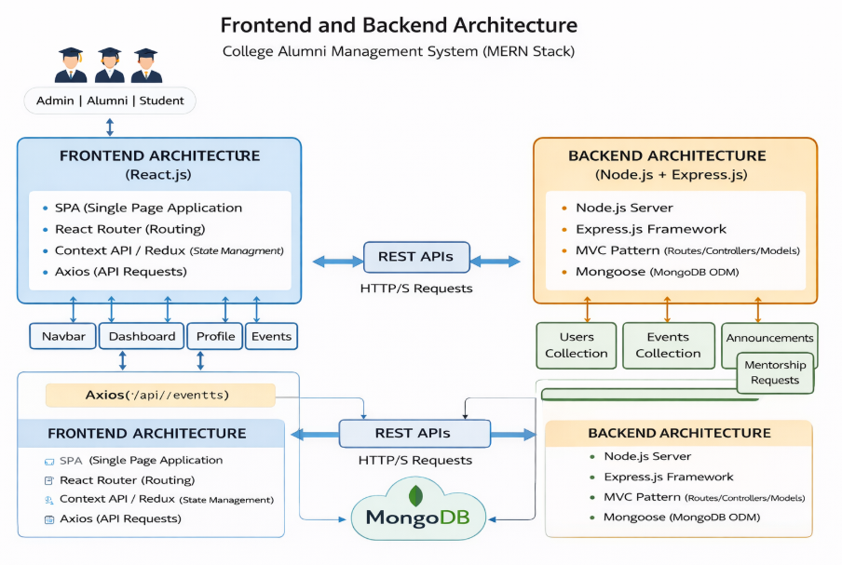

PROJECT PLANNING & SCHEDULING

Project Planning
Phase | Duration | Status
Requirement Analysis | 1 Week | Completed
Development | 3 Weeks | Completed
Testing | 1 Week | Completed

Project planning for the College Alumni Management System was carried out to ensure systematic development, timely completion, and efficient resource utilization. The planning phase.
Initially, the project requirements were gathered through problem analysis and stakeholder identification. Functional requirements such as user registration, profile management, job postings, event management, and mentorship features were clearly defined. Non-functional requirements including security, scalability, usability, and performance were also considered during planning.
Roles and responsibilities were distributed among team members to ensure smooth workflow. Version control tools such as Git were used to manage code changes and collaboration. Regular progress reviews were conducted to monitor milestones and address technical challenges.
A tentative project timeline was prepared to allocate sufficient time for each phase of development. Adequate buffer time was included for testing, debugging, and documentation. This structured planning approach ensured that the project progressed in an organized manner and met the intended objectives within the scheduled timeframe.

5.2 Project Scheduling
The project development of the College Alumni Management System was carried out over a period from December 16th to February 18th. The timeline was structured into multiple phases to ensure systematic progress and timely completion.
Project Timeline (December 16 – February 18)
Phase 1: Requirement Analysis (December 16 – December 22)
During this phase, the problem statement was defined, user requirements were identified, and stakeholder analysis was conducted. Functional and non-functional requirements were documented. The project scope and objectives were finalized.
Phase 2: System Design (December 23 – December 30)
In this phase, the system architecture, database schema, and module structure were designed. Use case diagrams, data flow diagrams, and solution architecture were prepared. Technology stack selection was finalized.
Phase 3: Frontend Development (January 1 – January 20)
The React.js frontend was developed during this period. Role-based dashboards for Admin, Alumni, and Student were created. Components such as login, registration, profile management, event pages, and job listings were implemented. Routing and state management were integrated.
Phase 4: Backend Development (January 10 – January 30)
Node.js and Express.js backend APIs were developed. Authentication using JWT was implemented. Controllers, routes, middleware, and business logic were created. Integration with MongoDB using Mongoose was completed.
Phase 5: Database Integration & Testing (January 25 – February 5)
All modules were integrated with MongoDB collections. CRUD operations were tested. Unit testing and debugging were performed to ensure proper data flow and system reliability.
Phase 6: System Integration & Final Testing (February 6 – February 12)
Frontend and backend were fully integrated. End-to-end testing was conducted. Security validation, performance checks, and bug fixing were completed.
Phase 7: Documentation & Final Deployment (February 13 – February 18)
Project documentation was prepared, including design diagrams and reports. Final refinements were made. The system was prepared for deployment and demonstration.

6. FUNCTIONAL AND PERFORMANCE TESTING
Functional testing ensures that all modules operate according to specified requirements.
Performance testing evaluates system response time under varying loads.
Security testing ensures protection against unauthorized access and data breaches.

6.1 Performance Testing
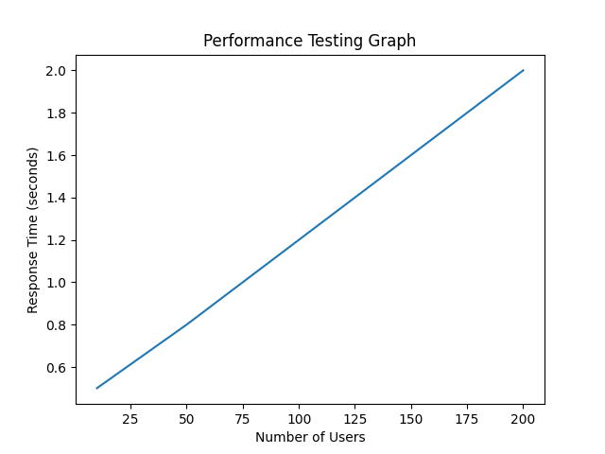

Figure 6.1: Performance Testing Graph
The performance testing graph illustrates the system’s response time as the number of users increases. The horizontal axis represents the number of concurrent users accessing the system, while the vertical axis represents the response time measured in seconds.
From the graph, it can be observed that as the number of users increases from 20 to 200, the response time gradually increases from approximately 0.5 seconds to 2.0 seconds. This indicates that the system scales proportionally under increased load. The response time growth is linear, showing that the application maintains stable performance without sudden spikes or system crashes.
The results demonstrate that the College Alumni Management System can efficiently handle moderate user traffic while maintaining acceptable response times. The consistent performance trend indicates proper backend request handling, efficient database queries, and optimized frontend–backend communication.

7. RESULTS
The implemented system successfully manages alumni records and facilitates event participation.
Performance testing demonstrates acceptable response times under simulated user loads.
User feedback indicates improved engagement and streamlined communication.

7.1 Output Screenshots
Screenshots of dashboard, registration page, and event management page can be inserted here.
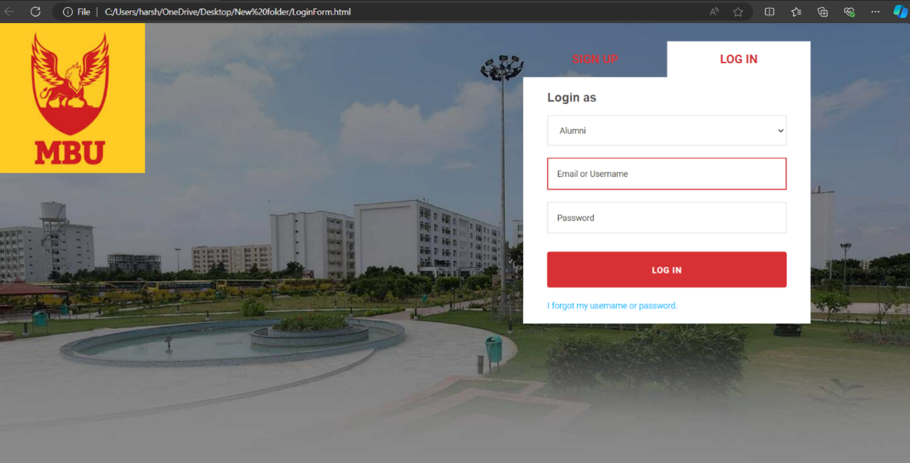
Fig 1.1 Login_page
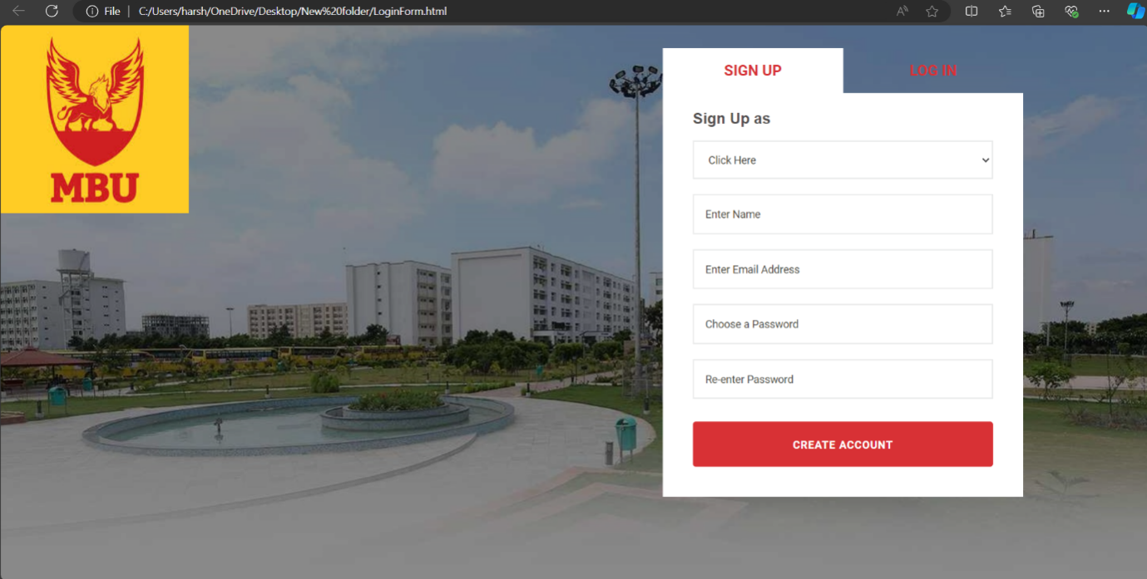
Fig 1.2 sign-in page

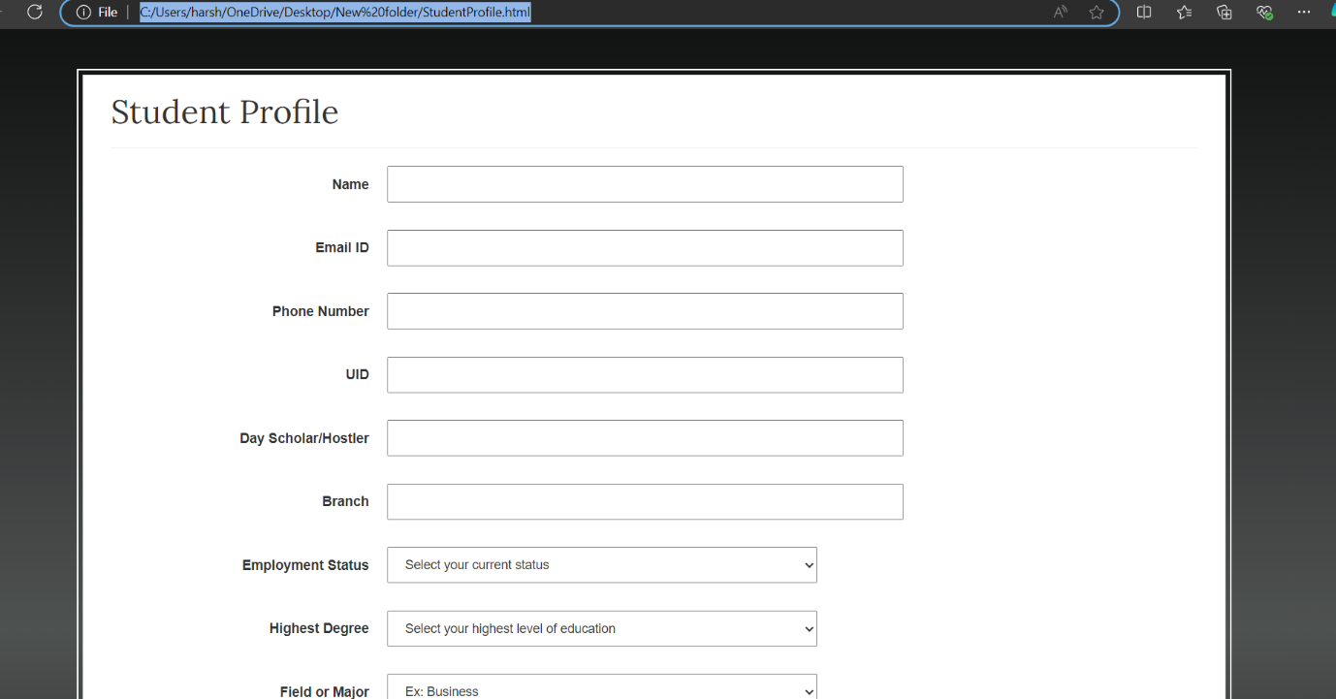
Fig : Student profile
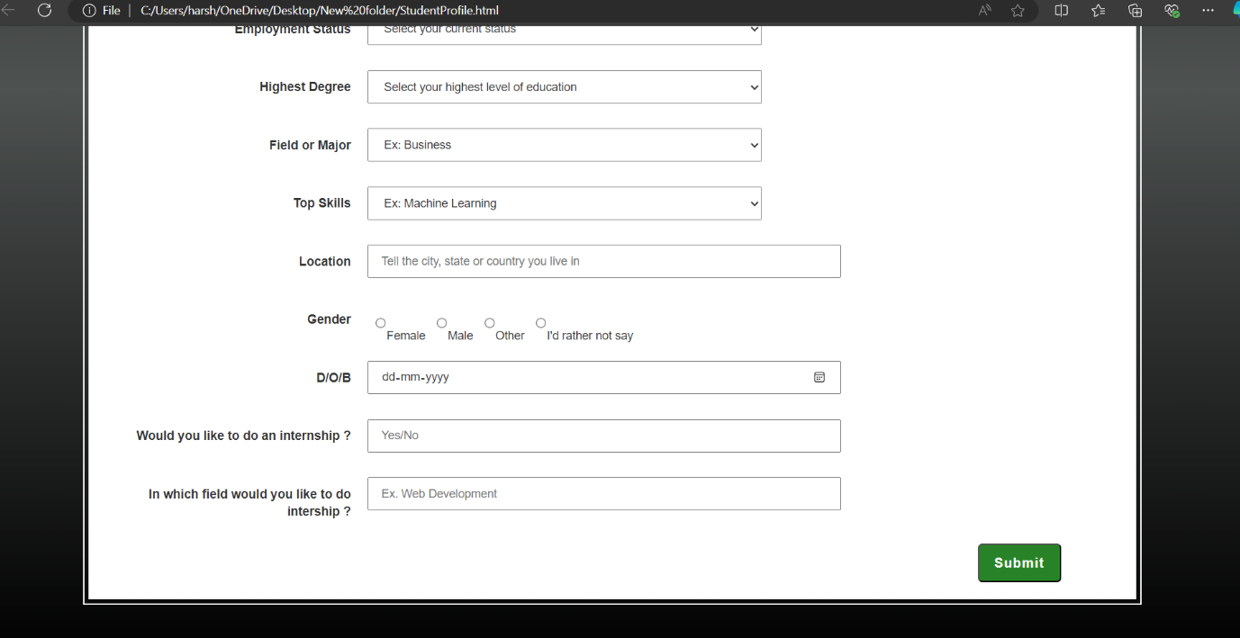
Fig 2.1 Student Profile

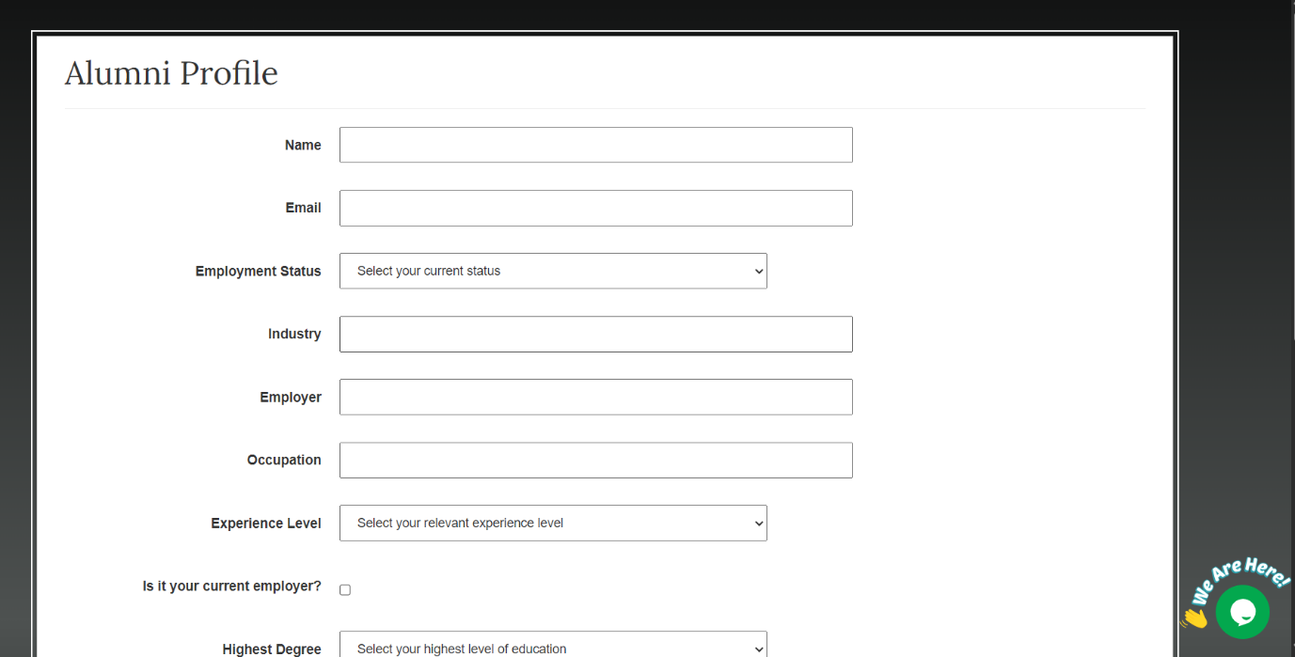
Fig: Alumni registration page

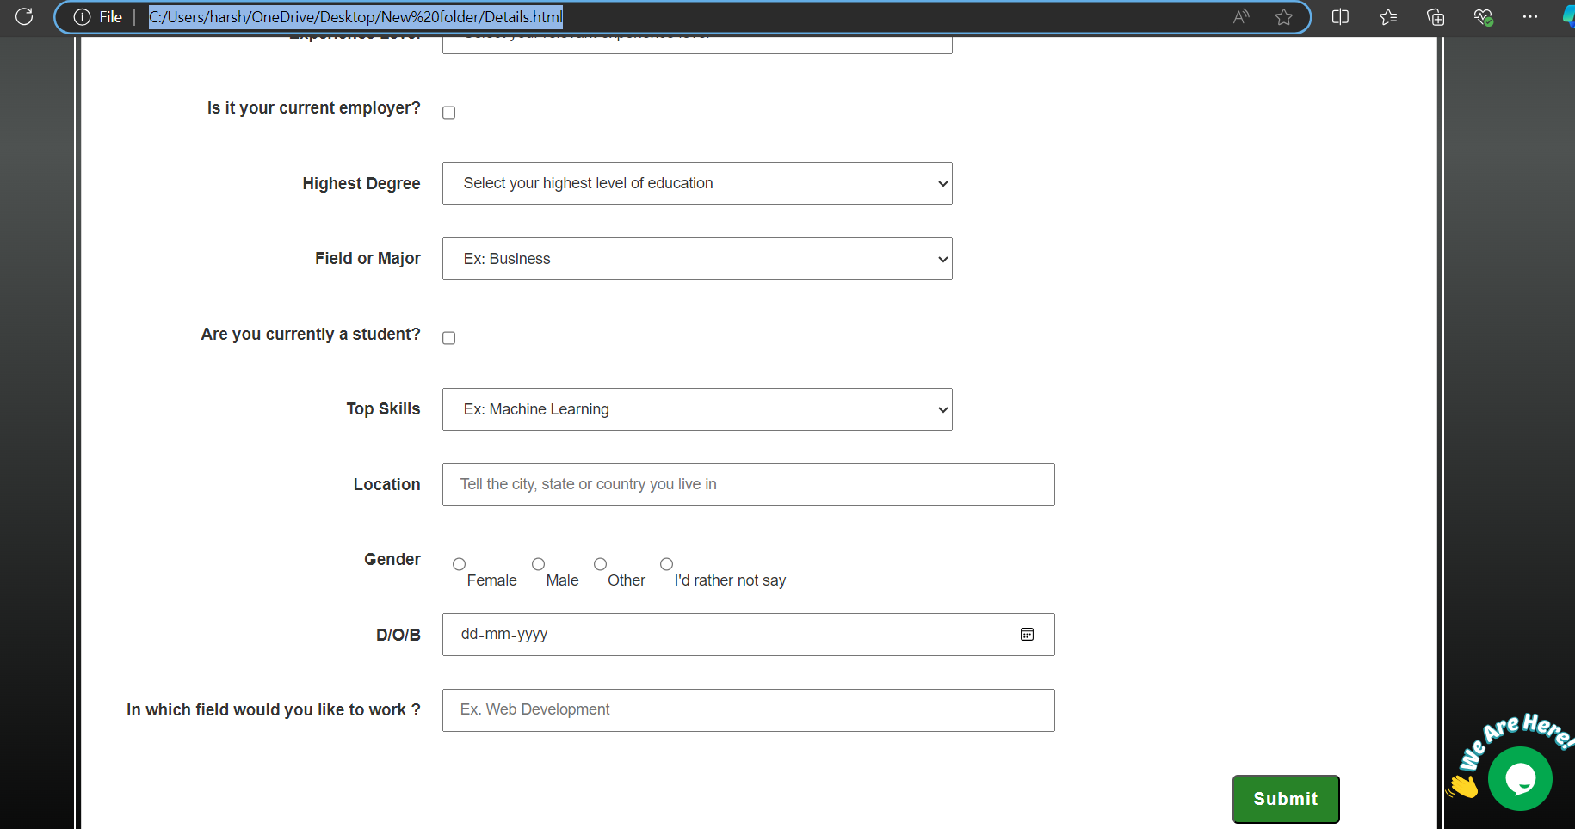
Fig 2.2 Alumni page

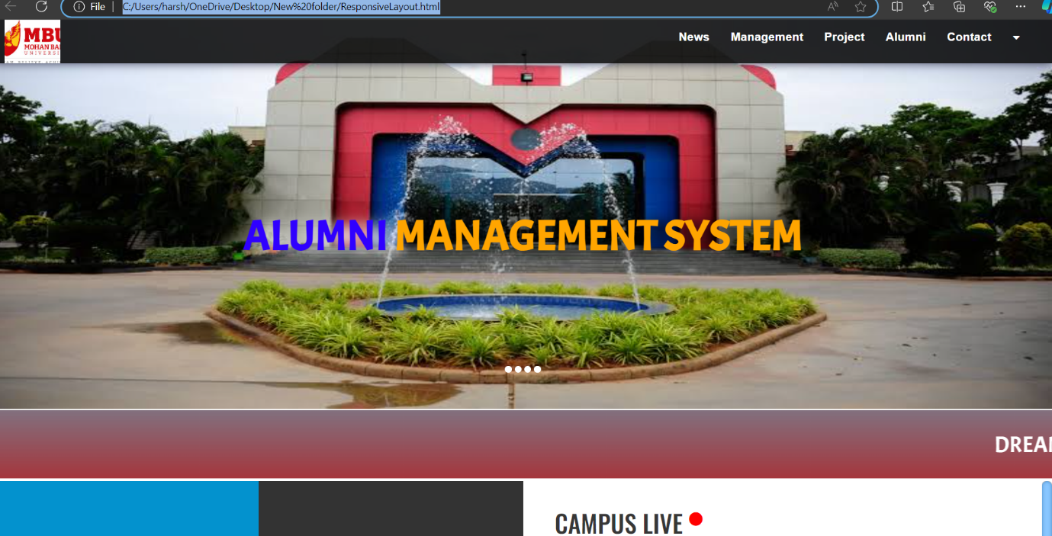
Fig: Main webpage

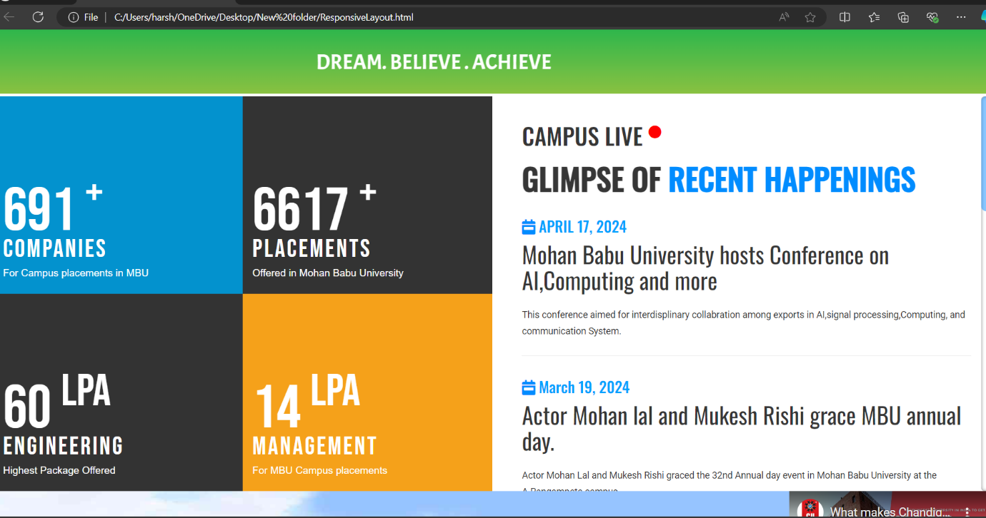
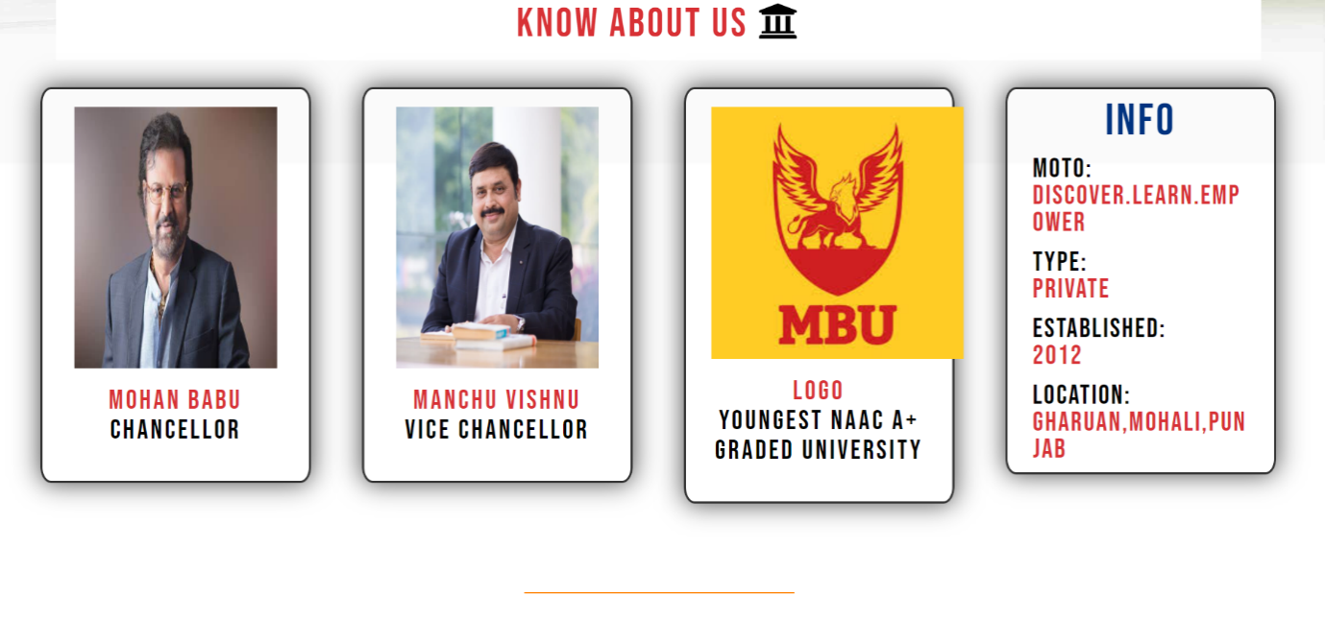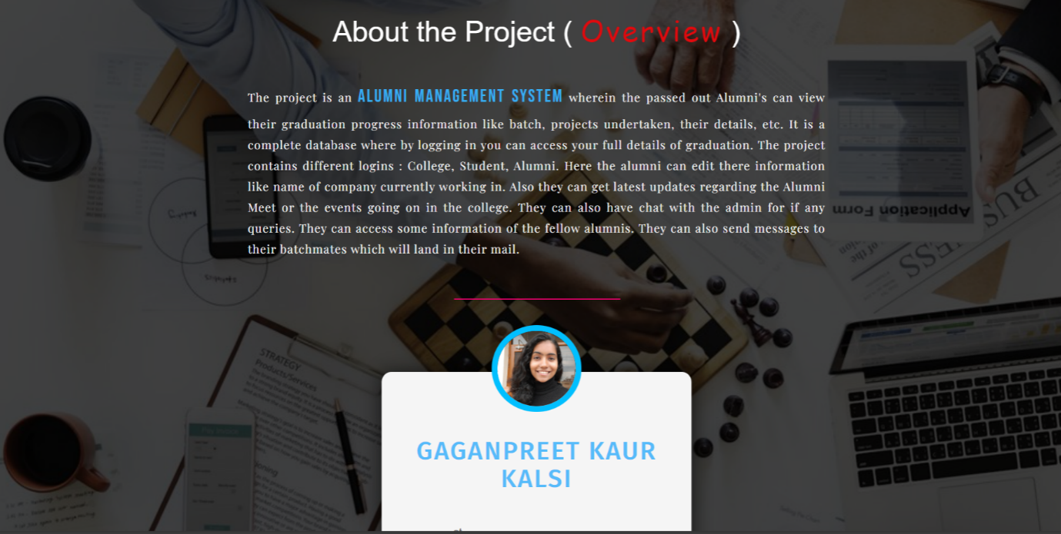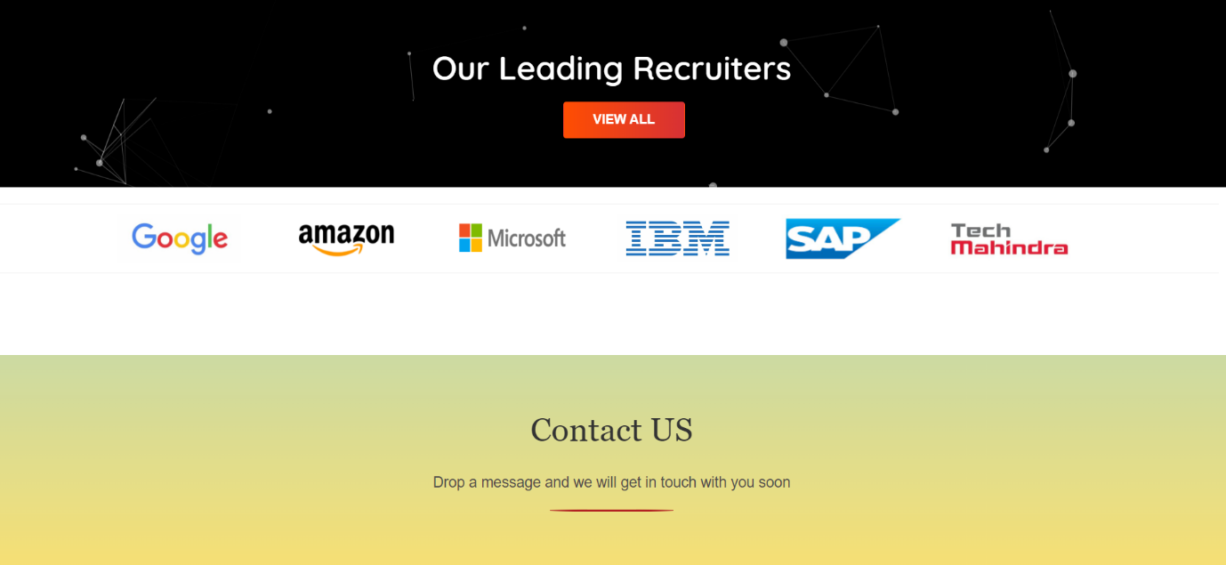

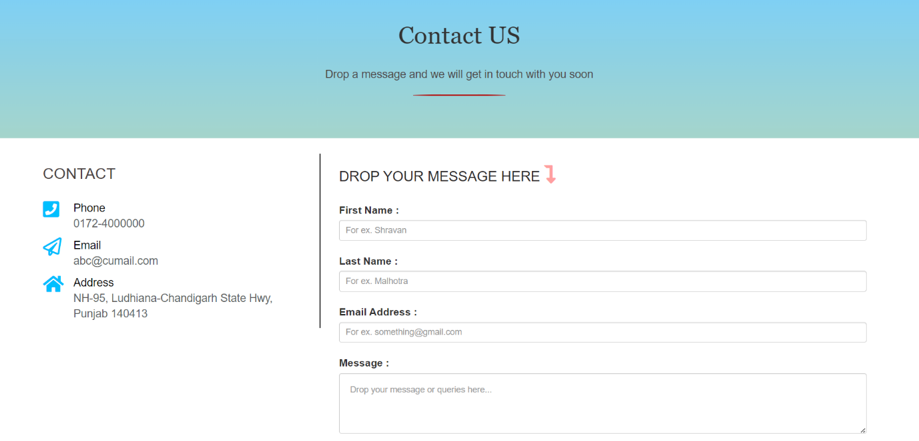

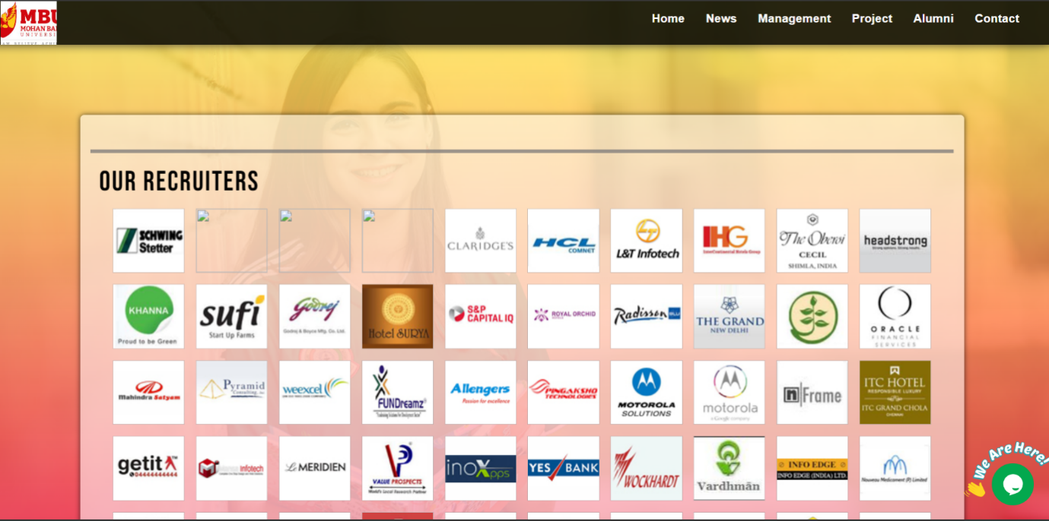
Fig: Recruiters page

8. ADVANTAGES & DISADVANTAGES

8.1 Advantages
The College Alumni Management System provides a centralized platform that improves communication and collaboration between alumni, students, and administrators. By replacing manual record-keeping methods with a digital solution, the system enhances data accuracy and reduces administrative workload.
The implementation of role-based authentication ensures secure access to information, protecting sensitive user data. Alumni can update their professional profiles and share job opportunities efficiently, which strengthens networking and career support for students. The structured mentorship feature enables meaningful academic and professional guidance.
The use of the MERN stack ensures scalability and flexibility, allowing the system to be enhanced with additional features in the future. Automation of event management, announcements, and reporting increases institutional efficiency and improves alumni engagement. The responsive web interface ensures accessibility across devices, improving overall user experience.

8.2 Disadvantages
Despite its advantages, the system may involve initial development and deployment costs, including hosting and maintenance expenses. Technical expertise is required to develop, manage, and update the application, which may be challenging for institutions without dedicated IT support.
The system depends on internet connectivity, which may limit access in areas with poor network availability. Additionally, data security and privacy must be carefully managed to prevent unauthorized access or breaches. Regular updates and monitoring are necessary to maintain system performance and security.
There may also be a learning curve for users who are not familiar with digital platforms, requiring proper guidance and training during implementation.

CONCLUSION
The College Alumni Management System was successfully designed and developed using the MERN stack to address the challenges associated with managing alumni data and strengthening institutional engagement. The system provides a centralized, secure, and user-friendly platform that connects alumni, students, and administrators through structured communication and networking features.
By implementing role-based authentication, automated record management, job posting modules, and mentorship support, the system effectively replaces manual processes and fragmented communication methods. It enhances administrative efficiency, improves alumni participation, and provides students with structured career guidance and verified opportunities.
The three-tier architecture ensures scalability, maintainability, and secure data handling. Performance testing results indicate that the system can handle increasing user loads with stable response times. The modular design also allows for future enhancements such as mobile application integration, advanced analytics, and AI-based recommendations.
Overall, the College Alumni Management System meets its intended objectives and provides a practical, scalable, and efficient solution for modern alumni relationship management.

10. FUTURE SCOPE
The College Alumni Management System provides a strong foundation for alumni networking and institutional engagement. However, the system can be further enhanced with advanced features and technological improvements in the future.
One potential enhancement is the development of a mobile application to improve accessibility and user engagement. A dedicated Android or iOS application would allow alumni and students to receive real-time notifications, event reminders, and job updates more conveniently.
The system can also be extended by integrating third-party platforms such as LinkedIn for automatic profile synchronization and professional networking expansion. Additionally, integrating email and SMS notification services would improve communication efficiency.
Artificial Intelligence-based features can be implemented in the future to provide personalized job recommendations, mentorship matching, and predictive analytics for alumni engagement trends. Data analytics dashboards can be enhanced to provide deeper insights into placement statistics and alumni contributions.
Another possible improvement is the inclusion of an online donation and fundraising module, enabling alumni to contribute to scholarships, infrastructure development, or institutional projects. Video conferencing integration could also be added to support virtual mentorship sessions and alumni webinars.
Cloud deployment and advanced security enhancements such as multi-factor authentication can further improve scalability and data protection.
Overall, the system has significant potential for expansion and modernization, making it adaptable to evolving institutional and technological needs.

APPENDIX
10.1 Code Snippets:
Snippets of codes include are:
1. Admin Dashboard
2. Admin and User Login
3. Home Page for Alumni(Alumni_home.php)
4. User Sign Up
5. Reset Password
6. Exam Creation and Modification
7. Taking Attendance for Events
8. Viewing Event Attendance
- Database Setup (MySQL)
CREATE DATABASE alumni_management_system;
USE alumni_management_system;
-- Users table
CREATE TABLE users (
id INT AUTO_INCREMENT PRIMARY KEY,
username VARCHAR (50),
email VARCHAR (100),
password VARCHAR (255),
role ENUM ('admin', 'alumni') DEFAULT 'alumni'
);
-- Alumni Profile table
CREATE TABLE alumni profiles (
id INT AUTO_INCREMENT PRIMARY KEY,
user_id INT,
graduation_year INT,
degree VARCHAR (100),
major VARCHAR (100),
current_position VARCHAR (100),
company VARCHAR(100),
bio TEXT,
FOREIGN KEY (user_id) REFERENCES users(id)
);
-- Events table
CREATE TABLE events (
id INT AUTO_INCREMENT PRIMARY KEY,
title VARCHAR(100),
description TEXT,
event_date DATE,
created_at TIMESTAMP DEFAULT CURRENT_TIMESTAMP
);
-- Attendance table
CREATE TABLE attendance (
id INT AUTO_INCREMENT PRIMARY KEY,
user_id INT,
event_id INT,
attendance_status ENUM('attending', 'not_attending') DEFAULT 'not_attending',
FOREIGN KEY (user_id) REFERENCES users(id),
FOREIGN KEY (event_id) REFERENCES events(id)
);
- Database Connection (db_connect.php)
<?php
$servername = "localhost";
$username = "root";
$password = "";
$dbname = "alumni_management_system";
$conn = new mysqli($servername, $username, $password, $dbname);
if ($conn->connect_error) {
die("Connection failed: " . $conn->connect_error);
}
?>
- User Sign Up (sign_up.php)
HTML Form
<form method="POST" action="sign_up.php">
<label>Username:</label>
<input type="text" name="username" required>
<label>Email:</label>
<input type="email" name="email" required>
<label>Password:</label>
<input type="password" name="password" required>
<button type="submit">Sign Up</button>
</form>
PHP Backend
<?php
include 'db_connect.php';
if ($_SERVER['REQUEST_METHOD'] == 'POST') {
$username = $_POST['username'];
$email = $_POST['email'];
$password = password_hash($_POST['password'], PASSWORD_BCRYPT);
$query = "INSERT INTO users (username, email, password, role) VALUES ('$username', '$email', '$password', 'alumni')";
if ($conn->query($query)) {
echo "Registration successful!";
} else {
echo "Error: " . $conn->error;
}
}
?>
- Login Page (login.php)
HTML Form
<form method="POST" action="login.php">
<label>Email:</label>
<input type="email" name="email" required>
<label>Password:</label>
<input type="password" name="password" required>
<button type="submit">Login</button>
</form>
PHP Backend
<?php
session_start();
include 'db_connect.php';
if ($_SERVER['REQUEST_METHOD'] == 'POST') {
$email = $_POST['email'];
$password = $_POST['password'];
$result = $conn->query("SELECT * FROM users WHERE email='$email'");
$user = $result->fetch_assoc();
if ($user && password_verify($password, $user['password'])) {
$_SESSION['user_id'] = $user['id'];
$_SESSION['role'] = $user['role'];
header("Location: " . ($user['role'] == 'admin' ? 'admin_dashboard.php' : 'alumni_home.php'));
} else {
echo "Invalid credentials!";
}
}
?>
- Admin Dashboard (admin_dashboard.php)
<?php
session_start();
if ($_SESSION['role'] !== 'admin') {
header("Location: login.php");
}
?>
<h2>Admin Dashboard</h2>
<a href="create_event.php">Create New Event</a> |
<a href="view_profiles.php">View Alumni Profiles</a> |
<a href="logout.php">Logout</a>
- Alumni Profile Creation (create_profile.php)
HTML Form
<form method="POST" action="create_profile.php">
<label>Graduation Year:</label>
<input type="number" name="graduation_year" required>
<label>Degree:</label>
<input type="text" name="degree" required>
<label>Major:</label>
<input type="text" name="major" required>
<label>Current Position:</label>
<input type="text" name="current_position" required>
<label>Company:</label>
<input type="text" name="company" required>
<label>Bio:</label>
<textarea name="bio"></textarea>
<button type="submit">Save Profile</button>
</form>
PHP Backend
<?php
include 'db_connect.php';
session_start();
$user_id = $_SESSION['user_id'];
if ($_SERVER['REQUEST_METHOD'] == 'POST') {
$graduation_year = $_POST['graduation_year'];
$degree = $_POST['degree'];
$major = $_POST['major'];
$current_position = $_POST['current_position'];
$company = $_POST['company'];
$bio = $_POST['bio'],
$query = "INSERT INTO alumni_profiles (user_id, graduation_year, degree, major, current_position, company, bio)
VALUES ('$user_id', '$graduation_year', '$degree', '$major', '$current_position', '$company', '$bio')";
if ($conn->query($query)) {
echo "Profile created!";
} else {
echo "Error: " . $conn->error;
}
}
?>
- Event Creation (create_event.php)
HTML Form
<form method="POST" action="create_event.php">
<label>Event Title:</label>
<input type="text" name="title" required>
<label>Description:</label>
<textarea name="description" required></textarea>
<label>Event Date:</label>
<input type="date" name="event_date" required>
<button type="submit">Create Event</button>
</form>
PHP Backend
<?php
include 'db_connect.php';
if ($_SERVER['REQUEST_METHOD'] == 'POST') {
$title = $_POST['title'];
$description = $_POST['description'];
$event_date = $_POST['event_date'];
$query = "INSERT INTO events (title, description, event_date) VALUES ('$title', '$description', '$event_date')";
if ($conn->query($query)) {
echo "Event created!";
} else {
echo "Error: " . $conn->error;
}
}
?>

- Alumni Attending Event (attend_event.php)
PHP Backend
<?php
include 'db_connect.php';
session_start();
$user_id = $_SESSION['user_id'];
$event_id = $_GET['event_id']; // Assume event_id is passed via URL
$query = "INSERT INTO attendance (user_id, event_id, attendance_status) VALUES ('$user_id', '$event_id', 'attending')";
if ($conn->query($query)) {
echo "You are attending the event!";
} else {
echo "Error: " . $conn->error;
}
?>
- View Alumni Profiles (view_profiles.php)
<?php
include 'db_connect.php';
$result = $conn->query("SELECT * FROM alumni_profiles JOIN users ON alumni_profiles.user_id = users.id");
while ($profile = $result->fetch_assoc()) {
echo "<h3>{$profile['username']}</h3>";
echo "<p>Graduation Year: {$profile['graduation_year']}</p>";
echo "<p>Degree: {$profile['degree']}</p>";
echo "<p>Current Position: {$profile['current_position']} at {$profile['company']}</p>";
echo "<p>Bio: {$profile['bio']}</p><hr>";
}
?>
- Logout (logout.php)
<?php
session_start();
session_destroy();
header("Location: login.php");
?>
Source Code: https://harshi-12367/Alumni-management-system
GitHub Link:https://harshi-12367/Alumni-management-system
Project demo link:https://harshi-12367.github.io/Alumni-management-system/ResponsiveLayout.html

