COMPUTER VISION ASSIGNMENT

Technical Report
Units 3, 4 and 5

Submitted by:
Harshit Jariwala

Course:
Master of Computer Applications (MCA)

Subject:
Computer Vision and Digital Image Processing

Assignment Coverage:
Unit 3: Image Restoration and Segmentation Unit 4: Feature Extraction and Feature Matching Unit 5: Object Detection and Video Motion Analysis

Programming Language:
Python

Libraries and Frameworks:
OpenCV, NumPy, Matplotlib, Scikit-image, Ultralytics YOLO, and Jupyter Notebook

GitHub Repository: https://github.com/harshi0958/Computer_Vision_Assignment

Submission Date: 20 October 2026

Submitted to: Rahul Inchal

Abstract
This assignment focuses on the practical implementation of computer vision techniques from Units 3, 4, and 5 using Python. The main objective is to understand how images can be processed, analysed, and interpreted using different computer vision algorithms.
Unit 3 covers image restoration and segmentation techniques, including Gaussian noise, salt-and-pepper noise, Gaussian filtering, median filtering, Otsu thresholding, morphological operations, Canny edge detection, and watershed segmentation. Image restoration quality is evaluated using Peak Signal-to-Noise Ratio (PSNR) and Structural Similarity Index (SSIM).
Unit 4 focuses on feature extraction and matching using Histogram of Oriented Gradients (HOG) and Scale-Invariant Feature Transform (SIFT). Feature matching is studied using images with different orientations and sizes.
Unit 5 covers object detection using Haar Cascade and YOLO, followed by video motion analysis using frame differencing, Gaussian Mixture Model-based background subtraction, and Lucas–Kanade optical flow.
The project uses Python libraries including OpenCV, NumPy, Matplotlib, Scikit-image, and Ultralytics. Generated output images and comparison CSV files are used to examine the results. The assignment demonstrates the practical applications, advantages, and limitations of different computer vision methods.

Project Overview
  - Introduction
Computer Vision is a field of artificial intelligence that enables computers to process and understand visual information from images and videos. It is used in applications such as object recognition, image enhancement, medical imaging, surveillance, robotics, and autonomous systems.
This assignment implements multiple computer vision algorithms through practical experiments using image and video inputs. Each technique is applied to understand its working principle and evaluate the results.
  - Objectives
The main objectives of this assignment are:
- To add noise to images and apply filtering techniques for image restoration.
- To evaluate restored images using PSNR and SSIM metrics.
- To perform image thresholding, morphological processing, edge detection, and watershed segmentation.
- To extract image features using HOG and SIFT.
- To perform SIFT feature matching and study the effect of image rotation and resizing.
- To compare Haar Cascade and YOLO object detection.
- To analyse video motion using frame differencing, MOG2 background subtraction, and Lucas–Kanade optical flow.
- To save output images and comparison metrics for analysis.
  - Tools and Technologies
- Python: Main programming language.

- OpenCV: Image processing, feature detection, object detection, and video analysis.
- NumPy: Numerical operations and image-array processing.
- Matplotlib: Visualisation of images and experimental results.
- Scikit-image: Image-quality metrics and image-processing utilities.
- Ultralytics YOLO: Deep-learning-based object detection.
- Jupyter Notebook: Interactive environment for implementing and documenting experiments.
  - Project Repository
The source notebook, supporting code, selected outputs, and project dependencies are organised in the GitHub repository:
https://github.com/harshi0958/Computer_Vision_Assignment
The original input images are stored in the project's data directory. The original self-recorded video is preserved separately in the local project folder and will be uploaded to Google Drive for submission.

UNIT 3 — IMAGE RESTORATION AND SEGMENTATION

Introduction
Image restoration and image segmentation are important techniques in computer vision and digital image processing. Image restoration aims to recover a better-quality image from a degraded or noisy input image. Image segmentation divides an image into meaningful regions or separates objects from the background.
In this unit, different noise models, filtering methods, thresholding techniques, morphological operations, edge detection, and watershed segmentation are studied using Python and OpenCV.

Objectives
The objectives of Unit 3 are:
- To understand the effects of Gaussian noise and salt-and-pepper noise on images.
- To apply Gaussian and median filters for image restoration.
- To evaluate restoration quality using PSNR and SSIM.
- To perform image segmentation using Otsu thresholding.
- To apply morphological operations for noise removal and shape refinement.
- To detect object boundaries using Canny edge detection.
- To separate touching or overlapping objects using watershed segmentation.

Image Restoration
Image restoration is the process of reducing image degradation caused by noise or other distortions. Noise may be introduced during image acquisition, transmission, or storage.

Gaussian Noise
Gaussian noise is random noise that follows a normal probability distribution. It affects pixel intensity values and can make an image appear grainy.
The noisy image can be represented as: I(x, y) = S(x, y) + N(x, y)
Where:
      - I(x, y) represents the observed noisy image.
      - S(x, y) represents the original image.
      - N(x, y) represents Gaussian noise.

In the experiment, Gaussian noise is added to an input image to study its effect on image quality. A Gaussian filter is then applied to reduce the noise.

Salt-and-Pepper Noise
Salt-and-pepper noise introduces randomly distributed white and black pixels into an image. It can occur because of faulty sensors, transmission errors, or other image acquisition problems.
This noise can be represented by replacing selected pixels with minimum or maximum intensity values.
A median filter is suitable for reducing salt-and-pepper noise because it replaces each pixel with the median value of the pixels in its neighbourhood. It can remove isolated noisy pixels while preserving edges better than simple averaging in many cases.

Image Filtering Techniques
    - Gaussian Filter
A Gaussian filter smooths an image using a Gaussian-weighted neighbourhood. Nearby pixels contribute to the output according to their weights.
The two-dimensional Gaussian function is:
G(x, y) = (1 / 2πσ²) exp(−(x² + y²) / 2σ²) Where:
      - G(x, y) is the Gaussian kernel.
      - σ represents the standard deviation.
      - x and y represent spatial coordinates.

Working procedure:
- Read the input image.
- Add Gaussian noise.
- Apply Gaussian blur using OpenCV.
- Display the noisy and filtered images.
- Compare the restored image with the original image.

Advantages:
  - Simple and computationally efficient.
  - Reduces Gaussian noise and small intensity variations.
  - Useful as a preprocessing step.

Limitations:
  - May blur edges and fine image details.

  - Strong smoothing can reduce important features.

Median Filter
A median filter is a nonlinear spatial filtering technique. It sorts the intensity values within a local neighbourhood and replaces the central pixel with the median.
For a neighbourhood containing pixel values (p_1, p_2, \ldots, p_n), the output is: Median Output = median((p_1, p_2, \ldots, p_n))

Working procedure:
- Read the input image.
- Introduce salt-and-pepper noise.
- Apply a median filter using OpenCV.
- Visualise the noisy and restored images.
- Evaluate the restoration quality using image-quality metrics.

Advantages:
  - Effective for removing isolated black and white noise.
  - Preserves edges better than many linear smoothing filters.
  - Works well with salt-and-pepper noise.

Limitations:
  - Large kernel sizes may remove fine details.
  - It may not be the best choice for every type of noise.

Image Restoration Evaluation Metrics
The restored images are evaluated by comparing them with their corresponding original images.

Peak Signal-to-Noise Ratio (PSNR)
PSNR measures the reconstruction quality of an image relative to the original image. A higher PSNR generally indicates lower reconstruction error.
First, Mean Squared Error (MSE) is calculated: MSE = (1 / MN) Σ[I(i,j) − K(i,j)]²
PSNR is then calculated as:
PSNR = 10 log₁₀(MAX² / MSE) Where:
      - M and N represent image dimensions.
      - I represents the original image.

      - K represents the restored image.
      - MAX represents the maximum possible pixel intensity, typically 255 for an 8-bit image.
A higher PSNR generally indicates better restoration, provided the images are aligned and compared consistently. If MSE is zero, the images are identical and PSNR is theoretically infinite.

Structural Similarity Index (SSIM)
SSIM measures the structural similarity between two images by considering luminance, contrast, and structural information.
Its standard formulation is:
SSIM(x,y) = [(2μₓμᵧ + C₁)(2σₓᵧ + C₂)] / [(μₓ² + μᵧ² + C₁)(σₓ² + σᵧ² + C₂)] Where:
      - μₓ and μᵧ are the mean intensities.
      - σₓ² and σᵧ² are the variances.
      - σₓᵧ is the covariance.
      - C₁ and C₂ are stabilising constants.
SSIM values closer to 1 generally indicate greater structural similarity.
Purpose of evaluation: PSNR and SSIM provide complementary information. PSNR focuses on pixel-level reconstruction error, whereas SSIM evaluates similarity in image structure, contrast, and luminance.

Image Segmentation
Image segmentation divides an image into regions based on properties such as intensity, colour, or boundaries. It helps identify objects and distinguish foreground regions from the background.

Otsu Thresholding
Otsu thresholding is an automatic threshold-selection technique used to separate an image into foreground and background regions.
It selects a threshold that minimises within-class variance, equivalently maximising between-class variance for a two-class grayscale histogram.

Working procedure:
- Convert the input image to grayscale.
- Analyse the grayscale intensity distribution.
- Apply Otsu's thresholding method.
- Generate a binary image.

- Display the original grayscale and segmented images.

Advantages:
  - Automatically determines the threshold.
  - Simple and computationally efficient.
  - Works well when foreground and background intensities are sufficiently distinct.

Limitations:
  - May perform poorly with uneven illumination.
  - Can struggle when foreground and background intensity distributions overlap substantially.

Morphological Operations
Morphological operations process image shapes using a structuring element. They are commonly applied to binary images to remove small regions, close gaps, and refine object boundaries.

Erosion
Erosion reduces the size of foreground regions. It can remove small white noise and separate objects connected by thin structures.

Dilation
Dilation expands foreground regions. It can fill small gaps and connect nearby foreground pixels.

Opening
Opening consists of erosion followed by dilation. It is useful for removing small foreground noise while approximately preserving the shape of larger objects.

Closing
Closing consists of dilation followed by erosion. It is useful for filling small holes and closing narrow gaps in foreground objects.

Working procedure:
- Create or obtain a binary image.
- Define a structuring element or kernel.
- Apply erosion, dilation, opening, or closing.
- Compare the resulting images to observe changes in object shape and noise.
The effectiveness of these operations depends on the kernel size, kernel shape, and characteristics of the input image.

Canny Edge Detection
Canny edge detection identifies significant intensity transitions that may correspond to object boundaries.
The algorithm generally consists of the following stages:
- Noise reduction: Apply Gaussian smoothing.
- Gradient calculation: Estimate the intensity gradient and edge direction.
- Non-maximum suppression: Thin the detected edges.
- Double thresholding: Classify pixels as strong, weak, or non-edge pixels.
- Edge tracking by hysteresis: Retain weak edges connected to strong edges. The final result is an edge map that highlights prominent boundaries in the image. Advantages:
  - Produces relatively thin and well-localised edges.
  - Reduces the effect of small amounts of noise through smoothing.
  - Supports object-boundary analysis.

Limitations:
  - Results depend on the selected threshold values.
  - Textured regions and noisy images may produce unwanted edges.

Watershed Segmentation
Watershed segmentation is a region-based technique that treats an image as a topographic surface. Intensity variations represent elevations, and the algorithm uses markers to identify regions associated with different objects.
It is particularly useful for separating touching objects when suitable foreground and background markers can be identified.

Working procedure:
- Convert the input image to grayscale.
- Apply thresholding to obtain an initial foreground-background separation.
- Perform morphological operations to reduce noise.
- Identify sure-background and sure-foreground regions.
- Use connected components and distance-transform information where appropriate to construct markers.
- Apply the watershed algorithm.
- Visualise the resulting object boundaries.
In OpenCV, watershed boundaries are represented by marker value −1.

Advantages:
  - Can separate touching or overlapping objects.
  - Uses region and boundary information.
  - Useful in object counting and scientific image analysis.

Limitations:
  - Poor marker selection may cause over-segmentation.
  - Noise can affect the boundaries.
  - Preprocessing and marker construction are important for reliable results.

Experimental Methodology
The Unit 3 experiments follow a systematic procedure:
- Load the selected input image.
- Convert it to the required format, such as grayscale, where necessary.
- Add the specified noise for restoration experiments.
- Apply the corresponding filtering technique.
- Calculate PSNR and SSIM where restoration metrics are applicable.
- Apply thresholding and morphological operations for segmentation experiments.
- Perform Canny edge detection and watershed segmentation.
- Display the original, processed, and resulting images for comparison.
- Save the generated outputs and relevant metric data.
- Analyse the observed results and limitations of each technique.
The specific images, parameter values, output filenames, and numerical results should be documented using the actual project notebook and generated files.

Applications
The techniques covered in Unit 3 have several practical applications:
- Image restoration: Improving noisy photographs and scientific images.
- Medical imaging: Supporting image enhancement and preliminary region extraction.
- Industrial inspection: Identifying defects and separating objects.
- Document processing: Enhancing scanned documents and extracting foreground content.
- Object counting: Separating individual objects using thresholding and watershed segmentation.

- Computer vision preprocessing: Preparing images for feature extraction and object recognition.

UNIT 3 — EXPERIMENTAL RESULTS AND DISCUSSION

Overview of Experiments
The experiments in Unit 3 evaluate image restoration and segmentation techniques using Python and OpenCV. The restoration experiments examine the effects of noise and the performance of filtering methods. The segmentation experiments demonstrate how thresholding, morphological processing, edge detection, and watershed algorithms identify meaningful image regions.
The results are analysed using visual comparisons and quantitative image-quality metrics wherever applicable.

Image Restoration Results
    - Gaussian Noise Removal Using Gaussian Filtering
Gaussian noise was introduced into an input image to simulate image degradation. A Gaussian filter was then applied to reduce unwanted intensity variations.
Expected observation: The filtered image should appear smoother than the noisy image. The effectiveness of the filter depends on the noise level and the selected kernel size and standard deviation. Excessive smoothing may blur object boundaries and fine details.
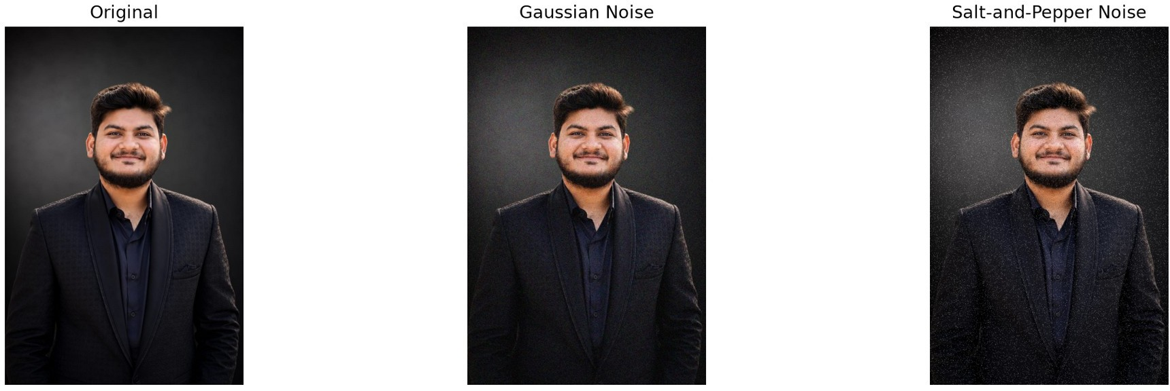
Figure 3.1: Gaussian noise removal
      - Original image
      - Image corrupted by Gaussian noise
      - Image restored using Gaussian filtering
Discussion: The comparison demonstrates the role of Gaussian smoothing in reducing random noise. The original and restored images should be examined together to assess both noise reduction and the preservation of important image details.

Salt-and-Pepper Noise Removal Using Median Filtering
Salt-and-pepper noise was introduced by replacing selected pixel values with black or white intensities. A median filter was applied to suppress these isolated noisy pixels.
Expected observation: The median-filtered image should contain fewer isolated black and white pixels. Compared with simple averaging, median filtering often preserves sharp boundaries more effectively when removing salt-and-pepper noise.

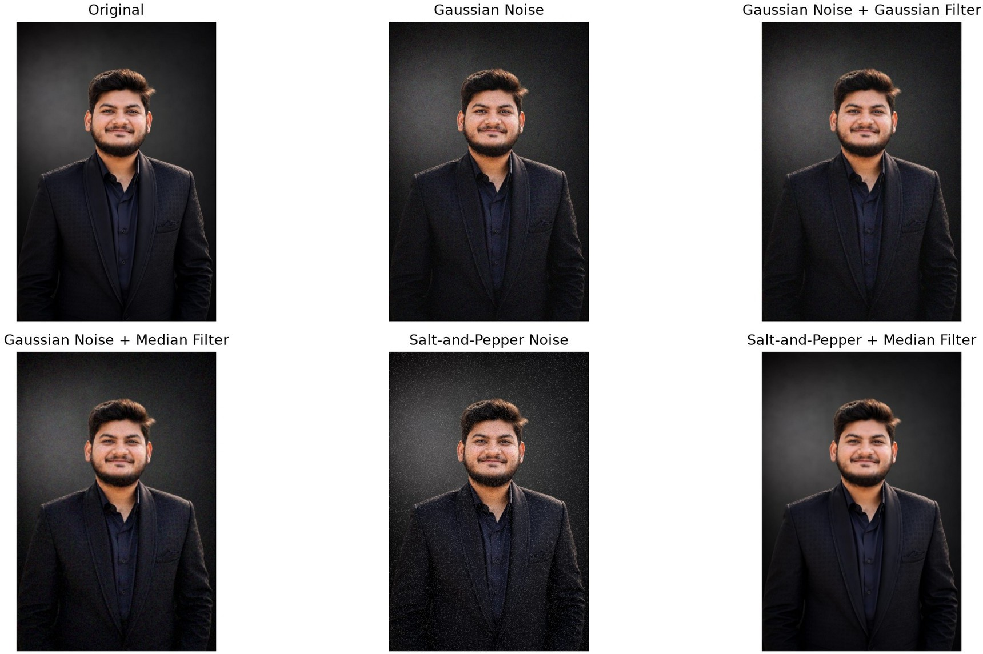
Figure 3.2: Salt-and-pepper noise removal
      - Original image
      - Image corrupted by salt-and-pepper noise
      - Image restored using median filtering
Discussion: This experiment illustrates why the choice of filtering technique should depend on the noise model. Median filtering is particularly suitable for impulse noise, although larger neighbourhoods may remove fine image details.

Quantitative Evaluation of Image Restoration
    - PSNR and SSIM Comparison
PSNR and SSIM are used to compare restored images against their corresponding original images. PSNR evaluates reconstruction error, while SSIM evaluates structural similarity.

Table 3.1: Image Restoration Quality Metrics

Experiment | Image Type | PSNR (dB) | SSIM
Gaussian noise | Noisy image | 22.938 | 0.2145
Gaussian filtering | Gaussian-restored image | 32.456 | 0.7392

Gaussian noise + median filter | Median-restored image | 32.159 | 0.7485
Salt-and-pepper noise | Noisy image | 17.094 | 0.2769
Median filtering | Median-restored image | 36.749 | 0.9516
Gaussian filtering (salt-and-pepper) | Gaussian-restored image | 27.174 | 0.5397

Interpretation guidelines:
- A higher PSNR generally indicates lower pixel-level reconstruction error.
- An SSIM value closer to 1 generally indicates greater structural similarity.
- Compare each noisy image with its corresponding restored image and original reference.
- Use identical reference images and consistent image dimensions for valid comparisons.
- Report the actual values generated by the notebook instead of estimating or inventing metrics.
Discussion: The comparison helps determine how effectively each filter restores image quality. The final conclusion should be based on the recorded PSNR and SSIM values, supported by visual inspection of the images.

Image Segmentation Results
    - Otsu Thresholding
Otsu thresholding was applied to a grayscale image to obtain a binary representation that separates foreground and background pixels using an automatically selected threshold.


Figure 3.3: Otsu thresholding

      - Original image
      - Grayscale image, if generated separately
      - Binary image obtained using Otsu thresholding
Discussion: The resulting binary image demonstrates how intensity-based thresholding can isolate regions with different brightness levels. Segmentation quality depends on the intensity distribution, contrast, and illumination conditions of the input image.

Morphological Operations
Morphological operations were applied to binary image data to modify foreground regions and improve their shapes.

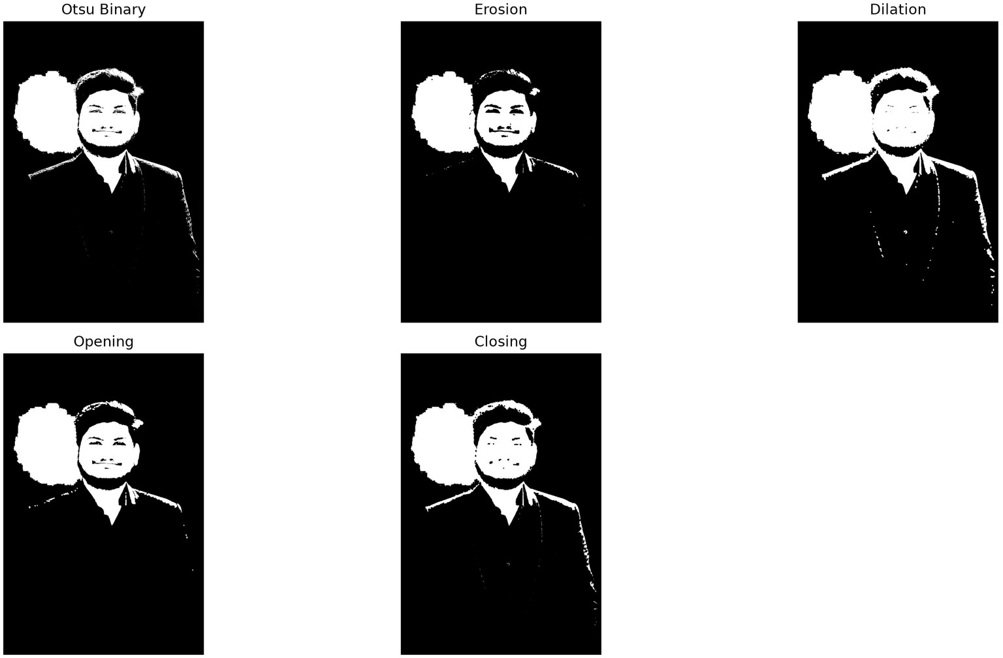
Figure 3.4: Morphological operations
Discussion: Erosion reduces foreground regions, whereas dilation expands them. Opening can remove small foreground noise, while closing can fill small holes and narrow gaps. Their effects depend on the structuring element and the input image.

Canny Edge Detection
Canny edge detection was used to identify significant intensity transitions in the input image.
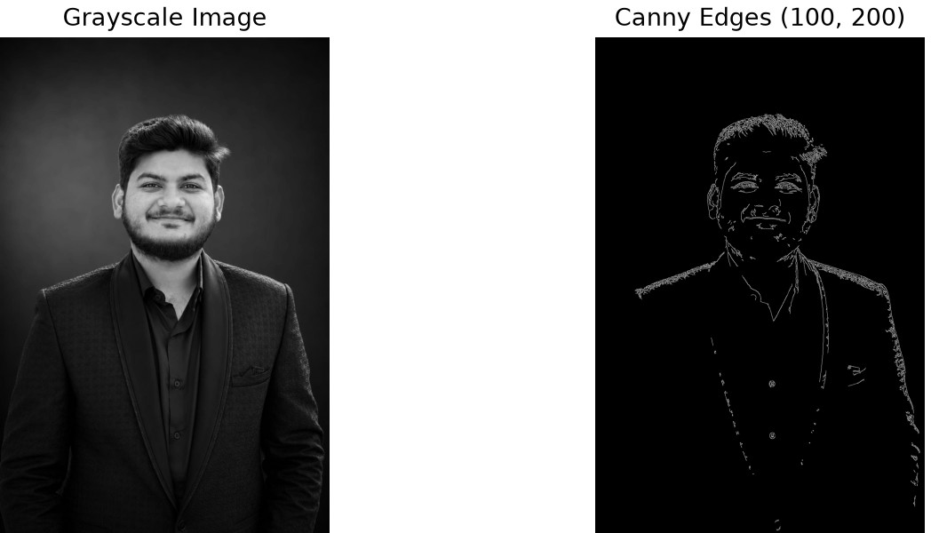
Figure 3.5: Canny edge detection
      - Original or grayscale input image
      - Canny edge map

Discussion: The detected edges highlight prominent boundaries in the image. Threshold selection and image noise influence the number, continuity, and quality of the detected edges.

Watershed Segmentation
Watershed segmentation was applied to identify distinct image regions using marker information.
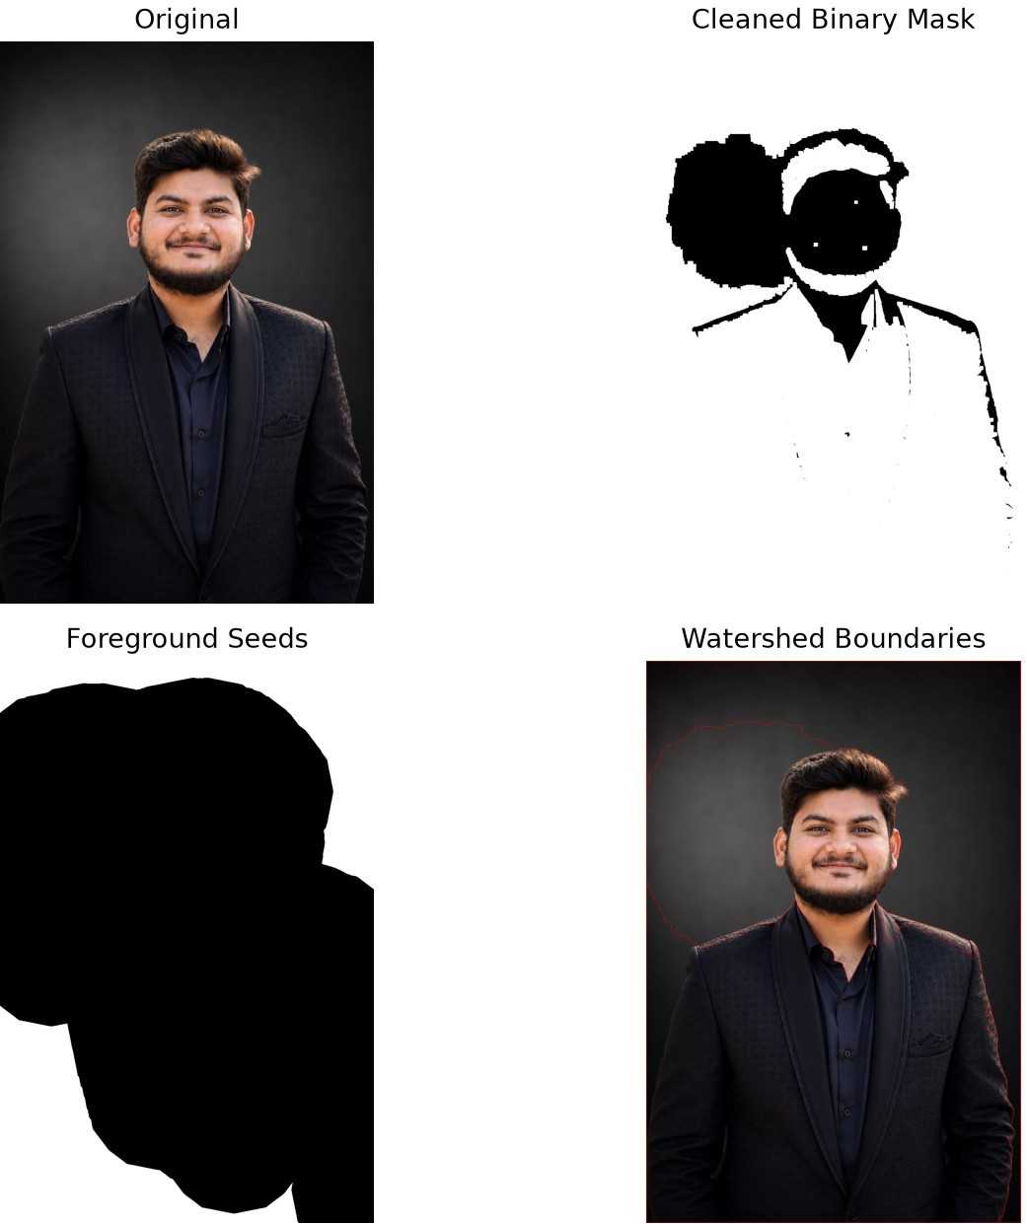
Figure 3.6: Watershed segmentation
      - Input image
      - Preprocessed or thresholded image, if available
      - Final watershed segmentation with boundaries
Discussion: Watershed segmentation can separate touching objects when appropriate markers are available. The quality of separation depends on preprocessing, marker generation, and the characteristics of the input image.

Summary of Unit 3 Experiments
Table 3.2: Summary of Image Processing Techniques

Technique | Primary Purpose | Evaluation Method
Gaussian noise | Simulate random image degradation | Visual comparison and PSNR/SSIM
Gaussian filtering | Reduce Gaussian noise | Visual comparison and PSNR/SSIM
Salt-and-pepper noise | Simulate impulse noise | Visual comparison and PSNR/SSIM
Median filtering | Reduce impulse noise | Visual comparison and PSNR/SSIM
Otsu thresholding | Separate foreground and background | Binary image inspection
Morphological operations | Refine binary image regions | Shape and noise comparison
Canny edge detection | Identify prominent boundaries | Edge-map inspection
Watershed segmentation | Separate image regions and touching objects | Segmentation-boundary inspection

UNIT 4 — FEATURE EXTRACTION AND FEATURE MATCHING

Introduction
Feature extraction is an important process in computer vision that identifies useful information from images, such as edges, corners, gradients, and distinctive local patterns. These features help computer vision systems recognise objects, compare images, and understand visual similarities.
Feature matching identifies corresponding features between two images. It is commonly used in image registration, object recognition, image stitching, panorama creation, and visual tracking.
This unit focuses on Histogram of Oriented Gradients (HOG) and Scale-Invariant Feature Transform (SIFT). HOG represents the distribution of local gradient directions, whereas SIFT detects distinctive keypoints and generates descriptors designed to be robust to changes in image scale and rotation.

Objectives
The main objectives of Unit 4 are:
- To understand the concept of feature extraction in computer vision.
- To extract image features using Histogram of Oriented Gradients.
- To detect distinctive keypoints using SIFT.
- To generate local feature descriptors for image representation.
- To match SIFT descriptors between two images.
- To examine the effects of rotation and resizing on feature matching.
- To compare HOG and SIFT in terms of their purpose, characteristics, and applications.

Feature Extraction
Feature extraction converts image information into a representation that can be used for further analysis. Instead of comparing every pixel directly, a feature-based approach focuses on important visual characteristics.
Common image features include:
- Edges: Locations where image intensity changes significantly.
- Corners: Points where intensity changes in multiple directions.
- Gradients: Measures of the direction and magnitude of intensity changes.
- Keypoints: Distinctive image locations that can be detected and described.
- Descriptors: Numerical representations of local or regional image characteristics.
Feature extraction can reduce the complexity of image comparison and provide useful information for recognition and matching tasks.

Histogram of Oriented Gradients (HOG)
    - Definition
Histogram of Oriented Gradients is a feature descriptor that represents the distribution of gradient orientations within local image regions. It is particularly useful for describing object shape and appearance.
HOG is widely associated with pedestrian detection and can also be used in object classification and image analysis.

Working Principle
The HOG descriptor is generally calculated through the following stages:
- Image preprocessing: Convert the input image to an appropriate representation, often grayscale, and resize it if required.
- Gradient computation: Calculate horizontal and vertical intensity gradients.
- Gradient magnitude and orientation: Determine the strength and direction of local intensity changes.
- Cell formation: Divide the image into small spatial regions called cells.
- Orientation histograms: Accumulate gradient magnitudes into orientation bins within each cell.
- Block normalisation: Normalise groups of neighbouring cell histograms to reduce sensitivity to illumination and contrast variations.
- Descriptor generation: Concatenate the normalised histograms into a feature vector.
The resulting feature vector describes the distribution of local edge directions across the image.

Advantages of HOG
      - Represents object shape and edge structure effectively.
      - Provides a structured numerical representation of image appearance.
      - Can perform well for object categories with characteristic shapes.
      - Is useful for traditional machine-learning-based detection systems.

Limitations of HOG
      - Performance depends on cell size, block size, orientation bins, and image dimensions.
      - It may be sensitive to significant changes in object orientation and viewpoint.
      - It does not inherently identify corresponding local keypoints between two images.
      - Its performance may be limited when appearance changes substantially.

Applications of HOG
      - Pedestrian detection.
      - Shape-based object classification.
      - Human detection in surveillance systems.
      - Traditional computer vision classification pipelines.
      - Image representation for machine-learning models.

Scale-Invariant Feature Transform (SIFT)
    - Definition
Scale-Invariant Feature Transform is a local feature detection and description method used to identify distinctive points in images. It detects keypoints and computes descriptors designed to remain useful under changes in scale and rotation.
SIFT is particularly suitable for matching two images containing the same scene or object under different viewing conditions.

Keypoint Detection
A keypoint is a distinctive location in an image that can be detected reliably. SIFT searches for candidate keypoints across multiple image scales.
Its keypoint detection process uses a Difference of Gaussians (DoG) scale-space representation to identify candidate extrema. Candidate points are then refined to improve their location and stability, while low-contrast and edge-sensitive points may be rejected.
This process helps identify repeatable image locations at different scales.

Orientation Assignment
SIFT assigns a dominant orientation to each keypoint based on local image gradients. This orientation information helps make the descriptor more robust to image rotation.

Descriptor Generation
For each selected keypoint, SIFT constructs a descriptor based on local gradient information around the keypoint.
The standard SIFT descriptor is a 128-dimensional vector formed from gradient-orientation histograms in a local neighbourhood.
These descriptors can be compared numerically to identify potential correspondences between images.

Advantages of SIFT
      - Provides distinctive local keypoints and descriptors.
      - Is designed to be robust to changes in scale and rotation.
      - Can match images despite moderate changes in viewing conditions.
      - Supports object recognition, image registration, and image stitching.

Limitations of SIFT
      - May require more computation than simpler feature descriptors.
      - Can produce fewer reliable matches in textureless regions.
      - Significant illumination, viewpoint, blur, or occlusion changes may reduce matching quality.
      - Descriptor matching can generate incorrect correspondences that require filtering.

Applications of SIFT
      - Image stitching and panorama creation.
      - Object recognition.
      - Image registration.
      - Landmark identification.
      - Visual localisation and image retrieval.

SIFT Feature Matching
    - Concept
Feature matching establishes correspondences between descriptors extracted from two images. When both images contain the same object or scene, some of their local descriptors may be similar.

SIFT descriptors are commonly compared using Euclidean distance. A nearest-neighbour matching method can identify candidate correspondences between the two descriptor sets.

Matching Procedure
The general feature-matching procedure is:
- Load the two input images.
- Convert the images to grayscale where required.
- Create a SIFT detector and descriptor extractor.
- Detect keypoints in both images.
- Compute SIFT descriptors for the detected keypoints.
- Compare descriptors using a suitable matcher, such as a brute-force matcher.
- Apply a filtering strategy, such as Lowe's ratio test, where implemented.
- Visualise the selected matches between the two images.
- Examine the number and distribution of detected keypoints and accepted matches.
Lowe's ratio test compares the distances of the two nearest descriptor matches. It helps reject ambiguous matches, although the threshold must be selected appropriately.

Interpretation of Feature Matches
A feature-matching visualisation generally shows the two images side by side, with lines connecting matched keypoints.
A larger number of matches does not automatically indicate better matching quality. Match accuracy, spatial distribution, and consistency are also important. Incorrect matches may occur when images contain repetitive patterns or visually similar regions.

Effect of Image Rotation
Image rotation changes the orientation of image content while retaining much of its underlying visual information.
SIFT assigns a dominant orientation to detected keypoints, helping its descriptors remain robust to image rotation.

Experimental procedure:
- Select an input image.
- Generate a rotated version of the image using the implemented rotation procedure.
- Extract SIFT keypoints and descriptors from both images.
- Match the descriptors.
- Visualise the accepted correspondences.
- Examine the number and quality of matches.

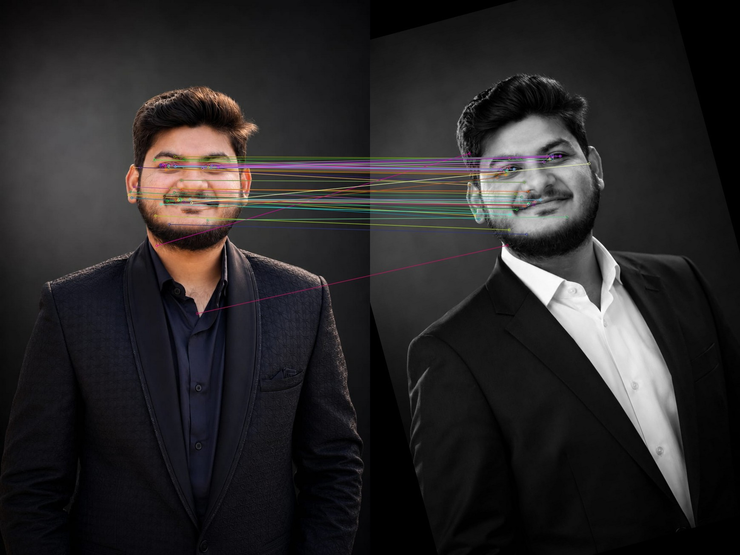
Figure 4.1: SIFT matching under rotation
Expected observation: Many distinctive features may remain matchable after rotation. However, the number of reliable matches depends on the rotation angle, cropping, interpolation, image content, and matching thresholds.

Effect of Image Resizing
Image resizing changes the dimensions of an image and therefore changes the apparent scale of its features.
SIFT detects features across multiple scales, allowing it to match corresponding keypoints between images of different sizes under suitable conditions.

Experimental procedure:
- Select an input image.
- Create a resized version using the implemented scaling factor.
- Detect SIFT keypoints and descriptors in both images.
- Match the descriptors using the selected matching procedure.
- Visualise and inspect the resulting matches.
- Compare the observed matching behaviour with the rotation experiment.

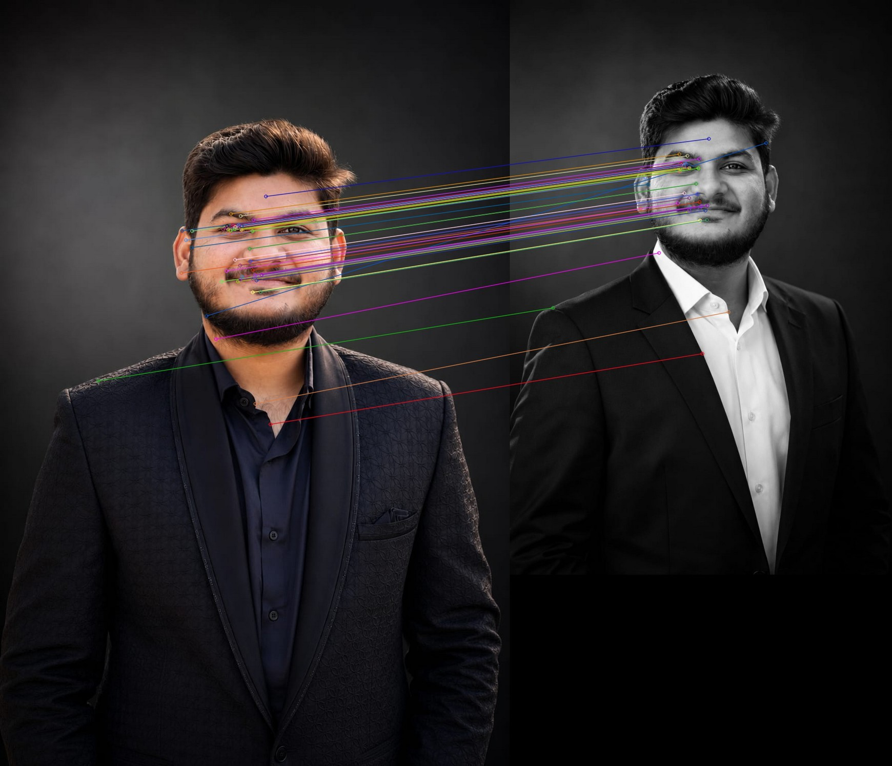
Figure 4.2: SIFT matching under resizing
Expected observation: Corresponding local features may be matched even when image dimensions differ. Matching quality depends on the scaling factor, image resolution, interpolation, feature distinctiveness, and matching strategy.

Experimental Results and Discussion
    - HOG Feature Extraction

Figure 4.3: HOG feature visualisation

SIFT Keypoint Detection
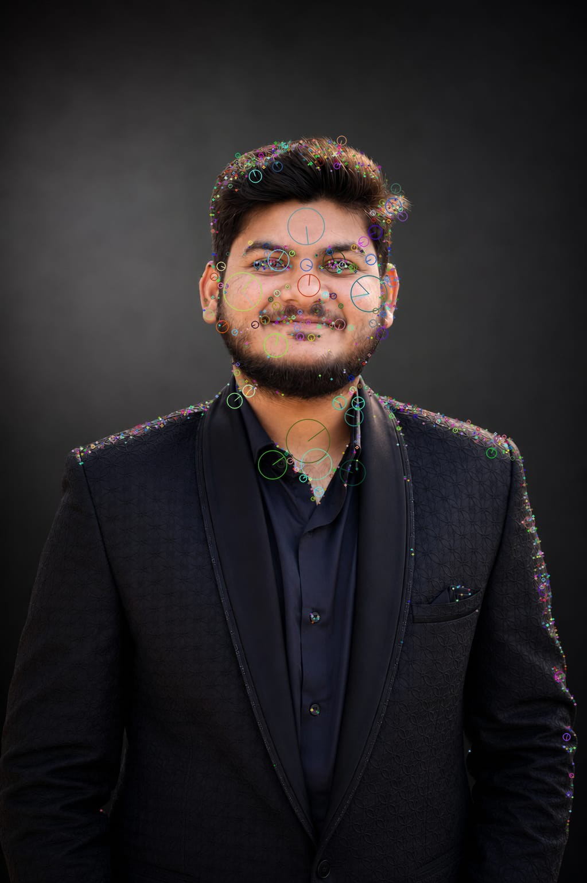
Figure 4.4: SIFT keypoint detection
Discussion: The detected keypoints indicate image locations that have distinctive local structures. Their number and distribution depend on image content, contrast, and the SIFT detector configuration.

Feature-Matching Results
Table 4.1: Feature Extraction and Matching Comparison

Criterion | HOG | SIFT
Primary purpose | Shape and appearance representation | Local keypoint detection and description
Feature representation | Gradient-orientation histograms | Local gradient-based descriptors
Typical output | Feature vector | Keypoints and descriptors
Local keypoint detection | Not inherent to standard HOG | Yes
Rotation robustness | Limited in standard configurations | Designed for rotation robustness
Scale robustness | Depends on preprocessing and configuration | Designed for scale robustness

Criterion | HOG | SIFT
Direct keypoint matching | Not its standard purpose | Commonly used
Typical applications | Pedestrian detection and classification | Image matching, registration, and stitching

Quantitative Result Recording
If the notebook records feature counts or matching statistics, the following table can be completed using the actual output values.
Table 4.2: SIFT Matching Experiment Summary

Experiment | Keypoints in Image 1 | Keypoints in Image 2 | Accepted Matches
Original and rotated image | Not recorded in CSV | Not recorded in CSV | 73
Original and resized image | Not recorded in CSV | Not recorded in CSV | 76
The keypoint counts and accepted matches should be copied from the actual notebook outputs. The accepted-match count depends on the descriptor matcher and any filtering conditions used.

Applications of Feature Extraction and Matching
Feature extraction and matching are useful in several computer vision applications:
- Image stitching: Matching overlapping regions to create panoramas.
- Object recognition: Identifying objects from distinctive visual patterns.
- Image registration: Aligning images captured at different times or viewpoints.
- Robotics: Supporting visual localisation and scene understanding.
- Augmented reality: Identifying visual reference points for object placement.
- Visual inspection: Comparing products or components for identifying corresponding structures.

UNIT 5 — OBJECT DETECTION AND VIDEO MOTION ANALYSIS

Introduction
Object detection and video motion analysis are important areas of computer vision. Object detection identifies and locates objects within an image, while video motion analysis examines changes between video frames to identify moving objects or estimate their movement.
This unit explores Haar Cascade and YOLO-based object detection techniques. It also covers frame differencing, Gaussian Mixture Model-based background subtraction using MOG2, and Lucas–Kanade optical flow for analysing motion in video sequences.
These methods demonstrate different approaches to visual analysis, ranging from traditional image-processing algorithms to deep-learning-based object detection.

Objectives
The main objectives of Unit 5 are:
- To understand the fundamental concepts of object detection.
- To detect objects using the Haar Cascade classifier.
- To perform object detection using the YOLO deep-learning framework.
- To compare traditional and deep-learning-based detection approaches.
- To identify moving regions using frame differencing.
- To apply MOG2 background subtraction for foreground detection.
- To estimate local motion using Lucas–Kanade optical flow.
- To compare the capabilities and limitations of the implemented techniques.

Object Detection
Object detection is the process of identifying objects in an image and determining their locations. A detection system may output object categories, bounding boxes, and confidence scores.
A bounding box represents the approximate location of a detected object. Deep-learning-based detectors may also assign a confidence score to each detection.
Object detection is used in surveillance, autonomous systems, traffic monitoring, industrial inspection, and robotics.

Haar Cascade Object Detection
    - Definition
Haar Cascade is a traditional object detection method that uses Haar-like features and a cascade of trained classifiers. It is commonly used for detecting faces and certain other object categories.
The method evaluates intensity differences between rectangular image regions. A trained classifier combines these features to identify patterns associated with the target object.

Working Principle
The Haar Cascade detection process generally includes the following stages:
- Image preprocessing: Load the input image or video frame and convert it to grayscale when required.
- Feature calculation: Evaluate Haar-like rectangular features that represent local intensity differences.
- Integral image: Use an integral-image representation to calculate rectangular feature responses efficiently.
- Cascade classification: Pass candidate image regions through a sequence of trained classifiers.
- Detection output: Retain regions classified as containing the target object.
- Visualisation: Draw bounding boxes around the detected regions.
The cascade structure rejects many irrelevant regions at early stages, reducing unnecessary computation.

Advantages
      - Relatively lightweight for supported detection tasks.
      - Can operate without a GPU.
      - Useful for simple, predefined detection categories.
      - Available through OpenCV's pretrained cascade classifiers.

Limitations
      - Detection quality depends on the trained classifier.
      - Performance can decline with difficult lighting, unusual poses, occlusion, and substantial scale or orientation changes.
      - A face detector cannot automatically detect arbitrary object categories.
      - It may produce false positives or miss objects in complex scenes.

Experimental Methodology
- Load the input image or video frame.
- Initialise the appropriate pretrained Haar Cascade classifier.
- Convert the input to grayscale if required.
- Run the detector using the selected parameters.
- Draw bounding boxes around detected objects.
- Display and save the resulting output.

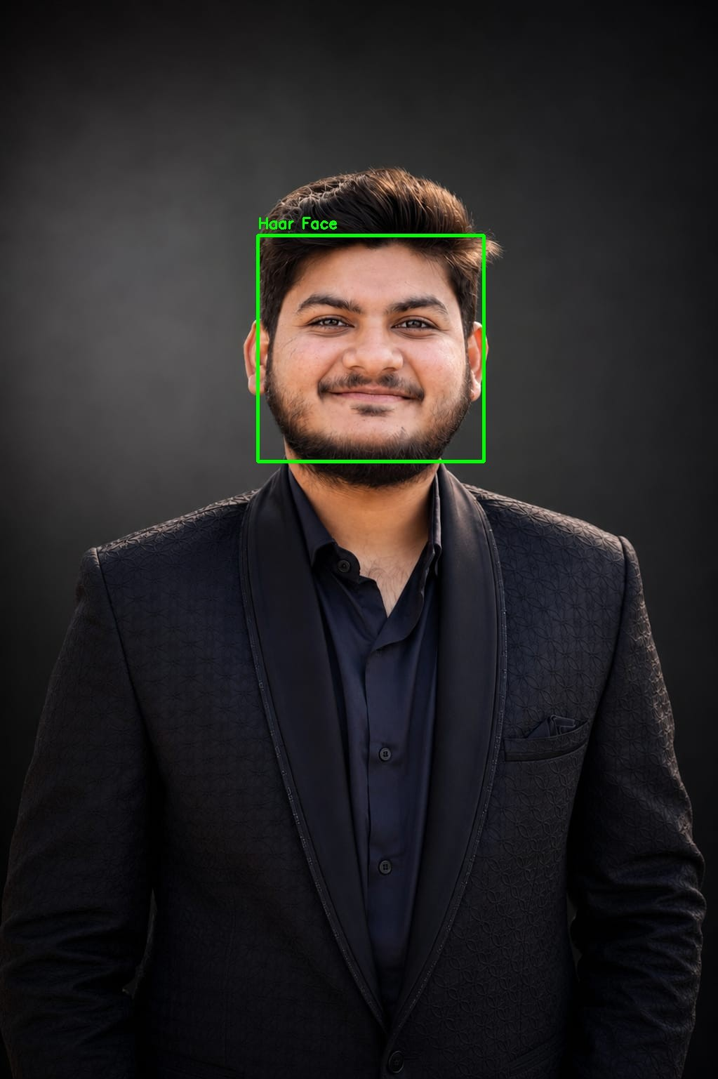
Figure 5.1: Haar Cascade detection
Discussion: The result demonstrates how a pretrained cascade classifier locates objects belonging to its supported detection category. Detection performance depends on the input quality, classifier, and selected parameters.

YOLO Object Detection
    - Definition
YOLO, which stands for You Only Look Once, is a family of deep-learning-based object detection models. YOLO models process images to predict object locations and class probabilities, allowing multiple objects to be detected in a single inference process.
Depending on the model version and configuration, outputs may include bounding boxes, class labels, and confidence scores.

Working Principle
A typical YOLO detection pipeline includes:
- Input preparation: Load an image or video frame and prepare it for model inference.
- Feature extraction: A neural network extracts hierarchical visual features.
- Detection prediction: The model predicts candidate object locations and class scores.
- Post-processing: Confidence filtering and non-maximum suppression or other model-specific post-processing remove unsuitable or overlapping detections.
- Output generation: The final detections are returned with their locations, categories, and confidence values.
- Visualisation: Bounding boxes and labels are drawn on the image or video frame.
The exact architecture and post-processing details depend on the YOLO version being used.

Advantages
      - Can detect multiple object categories using a suitably trained model.
      - Produces bounding boxes, class labels, and confidence scores.
      - Supports image and video inference.
      - Modern model variants can provide efficient inference for real-time applications.

Limitations
      - Requires a suitable trained model and its dependencies.
      - Computational requirements vary by model size and hardware.
      - Accuracy depends on training data, model selection, and scene conditions.
      - Small, occluded, or visually ambiguous objects may be missed.
      - Model weights may need to be downloaded before the first inference.

Experimental Methodology
- Load the input image or video.
- Initialise the YOLO model used in the implementation.
- Run inference on the input.
- Obtain the predicted classes, bounding boxes, and confidence scores.
- Apply the model's configured post-processing.
- Visualise and save the detections.
- Examine the number, location, and confidence of detected objects.

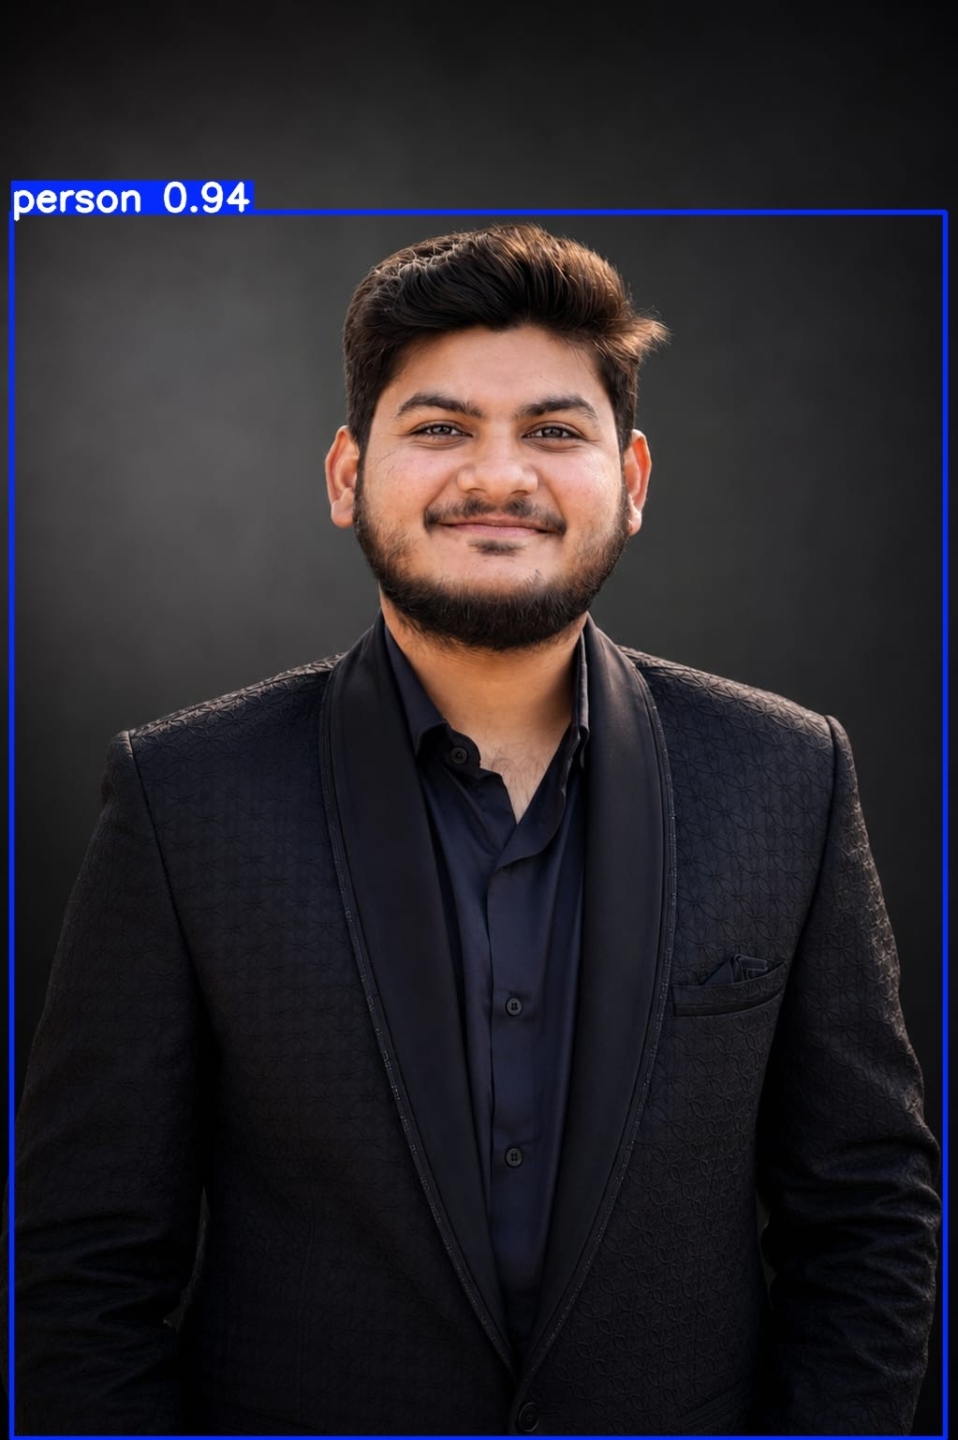
Figure 5.2: YOLO object detection
Discussion: YOLO provides a flexible framework for detecting multiple object categories. Its observed performance should be evaluated using the actual detections and the model configuration used in the experiment.

Comparison of Haar Cascade and YOLO
Table 5.1: Comparison of Object Detection Techniques

Criterion | Haar Cascade | YOLO
Approach | Traditional feature-based cascade classifier | Deep-learning-based detector
Detection categories | Limited to categories supported by the trained classifier | Categories supported by the trained model
Output | Detected regions or bounding boxes | Bounding boxes, classes, and confidence scores
Training requirements | Uses a trained cascade classifier | Uses trained neural-network weights
Hardware requirements | Often suitable for CPU-based execution | Depends on model size and performance requirements
Multiple object categories | Requires suitable classifiers | Supported when included in the model's training
Typical applications | Face detection and other supported predefined targets | General object detection and video analytics
Main limitation | Restricted classifier capability and sensitivity to scene variation | Model-dependent computational cost and detection errors
Discussion: Haar Cascade is useful for lightweight detection of supported object categories, whereas YOLO provides a more flexible deep-learning-based approach to detecting multiple categories. A fair performance comparison requires the same test inputs and clearly defined evaluation criteria. Actual speed or accuracy differences should not be claimed without measurements.

Video Motion Analysis
    - Concept
Video motion analysis examines consecutive frames to identify changes caused by object movement or changes in the scene. Unlike single-image processing, video analysis uses temporal information to study how visual content changes over time.
Motion detection can support surveillance, activity monitoring, traffic analysis, and object tracking.

This unit examines three techniques:
      - Frame differencing.
      - MOG2 background subtraction.
      - Lucas–Kanade optical flow.

Frame Differencing
    - Definition
Frame differencing is a simple motion detection technique that compares consecutive video frames. Regions that change significantly between frames may correspond to moving objects.
For two consecutive frames (I_t) and (I_{t-1}), the absolute difference is:
[
D_t(x,y)=|I_t(x,y)-I_{t-1}(x,y)|
]
A binary motion mask can then be generated by applying a threshold: [
M_t(x,y)=
\begin{cases}
1, & D_t(x,y)>T\
0, & \text{otherwise}
\end{cases}
]
Here, (T) is the selected intensity-difference threshold.

Working Procedure
- Read the video and extract consecutive frames.
- Convert the frames to grayscale if required.
- Calculate the absolute difference between the current and previous frames.
- Apply a threshold to identify significant changes.
- Optionally apply morphological operations to reduce small isolated regions.
- Display or save the resulting motion mask.

Advantages
      - Simple and easy to implement.
      - Requires relatively little computation.
      - Does not require a pretrained deep-learning model.
      - Useful for demonstrating basic motion detection.

Limitations
      - Sensitive to camera movement and illumination changes.
      - May detect only portions of a moving object.
      - Small frame-to-frame changes may be difficult to distinguish from noise.
      - Performance depends on the selected threshold and frame interval.

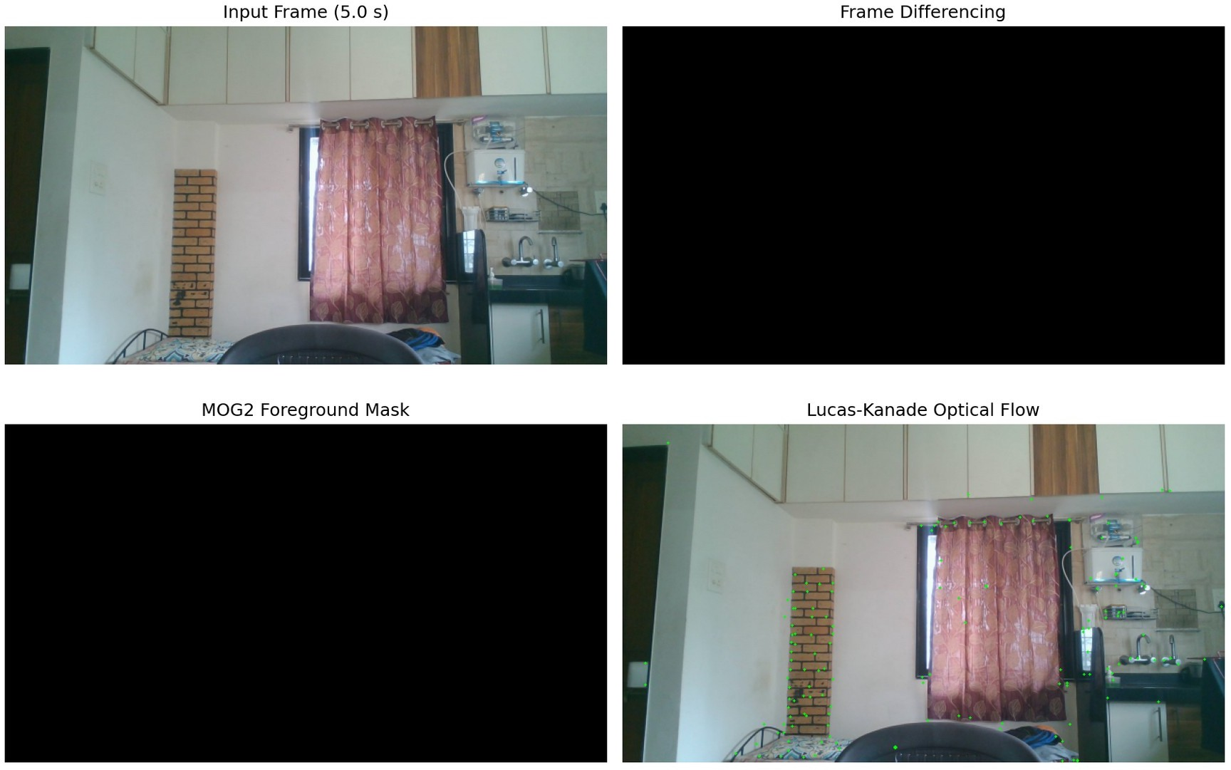
Figure 5.3: Frame differencing at 5 seconds
Discussion: Frame differencing highlights regions that change between consecutive frames. The detected regions may include moving objects as well as unwanted changes caused by lighting, camera movement, or background variation.

MOG2 Background Subtraction
    - Definition
MOG2 is an adaptive background subtraction method available in OpenCV. It models the background of a video sequence using a Gaussian mixture model and identifies pixels that differ sufficiently from the estimated background.
The model updates over time, helping it adapt to certain changes in the scene.

Working Principle
The main stages are:
- Background modelling: Build a statistical representation of background pixel behaviour.
- Frame processing: Compare incoming frames against the learned background model.
- Foreground classification: Classify pixels as background or foreground based on the model.
- Model adaptation: Update the background representation as new frames arrive.

- Mask generation: Produce a foreground mask for visualisation or further processing.
The generated mask may contain foreground pixels as well as shadows or noise, depending on configuration and scene conditions.

Experimental Methodology
- Load the input video.
- Initialise the MOG2 background subtractor.
- Process the video frames sequentially.
- Generate a foreground mask for each frame.
- Display the original frame and the foreground mask.
- Save selected output frames or a processed video when implemented.

Figure 5.4: MOG2 foreground mask at 5 seconds

Advantages
      - Adapts to gradual background changes.
      - Suitable for foreground extraction from a mostly stationary camera.
      - Does not require object-class labels or a deep-learning detector.
      - Can be used for basic motion analysis and surveillance prototypes.

Limitations
      - Camera movement can significantly affect foreground detection.
      - Dynamic backgrounds, such as moving trees or water, can cause false detections.
      - Stationary objects may gradually become part of the learned background.

      - Shadows and illumination changes can affect the mask.
      - Performance depends on model parameters and scene conditions.

Lucas–Kanade Optical Flow
    - Definition
Optical flow estimates apparent motion between consecutive images by examining how image intensity patterns move over time.
The Lucas–Kanade method is a local optical flow technique that estimates motion by assuming that nearby pixels have similar motion and that image intensity remains approximately constant over a short time interval.
It is commonly used to estimate motion around selected feature points.

Optical Flow Constraint
A simplified optical flow constraint equation is:
[
I_xu+I_yv+I_t=0
]
Where:
      - (I_x) is the horizontal image-intensity gradient.
      - (I_y) is the vertical image-intensity gradient.
      - (I_t) is the temporal intensity change.
      - (u) is the horizontal motion component.
      - (v) is the vertical motion component.
A single equation cannot uniquely determine both motion components at one pixel. Lucas–Kanade addresses this by combining information from a local neighbourhood and solving for the motion that best satisfies the constraints.

Working Procedure
- Read consecutive video frames.
- Convert the frames to grayscale.
- Detect suitable feature points in the first frame, if required by the implementation.
- Estimate the displacement of those points in the next frame.
- Filter invalid or unreliable tracking results.
- Draw motion vectors or trajectories on the frame.
- Repeat the process across the video sequence.

Advantages
      - Estimates the direction and magnitude of local image motion.
      - Can track selected feature points between frames.
      - Useful for short-term visual tracking.
      - Provides more detailed motion information than a binary foreground mask.

Limitations
      - Relies on assumptions about image brightness and local motion.
      - May struggle with large displacements, motion blur, occlusion, or low-texture regions.
      - Tracking quality depends on feature selection and frame interval.
      - Errors can accumulate over long sequences.
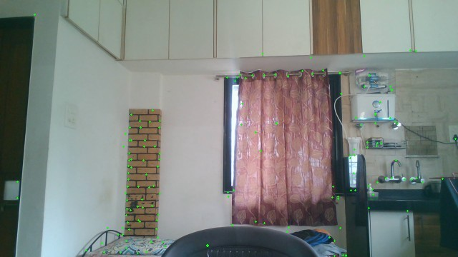
Figure 5.5: Lucas–Kanade optical fiow at 5 seconds
Discussion: The output illustrates the estimated displacement of selected image features between frames. The length and direction of the displayed vectors represent estimated image motion, subject to the implementation's visualisation scale and tracking quality.

Comparison of Video Motion Analysis Techniques
Table 5.2: Comparison of Motion Analysis Methods

Criterion | Frame Differencing | MOG2 Background Subtraction | Lucas–Kanade Optical Flow
Primary purpose | Detect changes between frames | Separate foreground from estimated background | Estimate local motion

Main input | Consecutive frames | Video frames processed over time | Consecutive frames and, commonly, feature points
Output | Difference image or binary motion mask | Foreground mask | Motion vectors or tracked points
Background model | Not required | Adaptive background model | Not required
Motion direction | Not directly estimated | Not directly estimated | Estimated for tracked points
Computational complexity | Generally low | Moderate and implementation-dependent | Depends on feature count and tracking configuration
Main limitation | Sensitive to scene changes | Sensitive to dynamic backgrounds and camera movement | Sensitive to tracking failures and large motion
Typical applications | Basic motion detection | Foreground extraction and surveillance | Feature tracking and motion estimation

Experimental Results and Discussion
The results for Unit 5 should be analysed using the output images and video frames produced by the implementation.

Object Detection Results
The Haar Cascade experiment demonstrates detection using a predefined trained classifier. The YOLO experiment demonstrates neural-network-based detection with model-supported classes and confidence scores.
Table 5.3: Object Detection Results

Evaluation Item | Haar Cascade | YOLO
Objects detected | 1 face detected | 1 person detected
Detection categories | Frontal face | Person
Confidence scores | Not provided by this detector | 0.942 (94.2%)
Processing time | Not measured | Not measured
The table should be completed using actual output data. If processing time was not measured, it should be reported as not measured rather than estimated.

Motion Analysis Results
The three motion analysis techniques provide different forms of information. Frame differencing highlights temporal changes, MOG2 estimates foreground regions relative to an adaptive background model, and Lucas–Kanade optical flow estimates the motion of selected image features.

Table 5.4: Summary of Video Motion Experiments

Technique | Result to Examine | Evaluation Approach
Frame differencing | Average detected pixels: 1.569% | Mean over 1,171 frames; inspect the motion masks.
MOG2 | Average foreground pixels: 7.781% | Mean over 1,171 frames; initial frame can be atypical.
Lucas–Kanade optical flow | Displacement of tracked feature points | Inspect motion vectors, tracking continuity, and valid points
A fair quantitative comparison would require a suitable reference or ground truth and consistent evaluation criteria. Visual inspection alone should not be presented as a measured accuracy score.

Practical Applications
The techniques covered in Unit 5 have several practical applications:
- Surveillance: Detecting moving regions and monitoring scenes.
- Traffic monitoring: Identifying vehicles and analysing their apparent movement.
- Smart transportation: Detecting supported object categories in road scenes.
- Industrial automation: Monitoring moving components and identifying objects.
- Robotics: Estimating visual motion and supporting navigation.
- Video analytics: Analysing changing scenes and tracking visual features.
- Human-computer interaction: Supporting systems that interpret visual movement.

OVERALL COMPARISON AND ANALYSIS

Overview
This assignment covers practical computer vision techniques from Units 3, 4, and
5. The experiments demonstrate how image restoration, segmentation, feature extraction, feature matching, object detection, and motion analysis can be implemented using Python and its computer vision libraries.
The techniques address different stages of visual processing. Image restoration improves degraded images, segmentation identifies meaningful regions, feature extraction represents distinctive visual information, object detection locates recognised objects, and motion analysis examines changes across video frames.

Comparison of Techniques Across All Units
Table 6.1: Overall Comparison of Implemented Techniques

Technique | Unit | Main Objective | Typical Output
Gaussian filtering | Unit 3 | Reduce Gaussian noise | Smoothed image
Median filtering | Unit 3 | Reduce salt-and-pepper noise | Restored image
PSNR and SSIM | Unit 3 | Evaluate restoration quality | Numerical metrics
Otsu thresholding | Unit 3 | Separate foreground and background | Binary image
Morphological operations | Unit 3 | Refine binary regions | Modified binary image
Canny edge detection | Unit 3 | Detect significant boundaries | Edge map
Watershed segmentation | Unit 3 | Separate image regions | Labelled regions and boundaries
HOG | Unit 4 | Describe shape and gradient patterns | Feature descriptor
SIFT | Unit 4 | Detect and describe distinctive keypoints | Keypoints and descriptors
SIFT feature matching | Unit 4 | Identify corresponding image features | Matched keypoints
Haar Cascade | Unit 5 | Detect objects supported by a trained classifier | Detection regions or bounding boxes
YOLO | Unit 5 | Detect model-supported object categories | Bounding boxes, classes, and confidence scores
Frame differencing | Unit 5 | Detect changes between frames | Difference image or motion mask
MOG2 | Unit 5 | Estimate foreground relative to the background | Foreground mask

Technique | Unit | Main Objective | Typical Output
Lucas–Kanade optical flow | Unit 5 | Estimate local image motion | Tracked points and motion vectors

Comparative Analysis
    - Image Restoration and Segmentation
Gaussian and median filtering address different noise characteristics. Gaussian filtering smooths local intensity variations, whereas median filtering is often more suitable for removing salt-and-pepper noise.
PSNR and SSIM complement visual inspection by measuring reconstruction error and structural similarity. Otsu thresholding, morphological operations, Canny edge detection, and watershed segmentation provide different ways to identify and refine image regions.
The appropriate technique depends on the image's noise characteristics, contrast, illumination, and segmentation requirements.

Feature Extraction and Matching
HOG and SIFT represent visual information differently. HOG describes regional gradient-orientation patterns and is useful for shape-based representation. SIFT detects local keypoints and generates descriptors that can be compared across images.
HOG is appropriate when a task requires a gradient-based appearance descriptor, while SIFT is more directly suited to matching distinctive local features between images. Their effectiveness depends on the input images, descriptor configuration, and intended application.

Object Detection and Motion Analysis
Haar Cascade and YOLO both support object detection, but they use different approaches. Haar Cascade relies on trained cascade classifiers, while YOLO uses a deep-learning model to predict object detections.
The motion analysis techniques also have distinct purposes. Frame differencing identifies changes between frames, MOG2 estimates foreground regions using an adaptive background model, and Lucas–Kanade optical flow estimates the apparent displacement of selected image features.
These methods should be selected according to whether the application requires object classification, foreground segmentation, or motion estimation.

Importance of Experimental Evaluation
The experiments demonstrate the importance of evaluating computer vision algorithms through appropriate evidence.
Visual comparisons help identify changes in image quality, segmentation boundaries, feature matches, object detections, and motion estimates. Quantitative measurements provide additional evidence where suitable metrics are available.
For image restoration, PSNR and SSIM can be calculated against the original reference image. For feature matching, keypoint counts and accepted matches can be recorded. For object detection, relevant measurements may include precision, recall, mean Average Precision (mAP), and inference time when suitable annotations and measurement procedures are available.
For motion analysis, evaluation may use foreground-mask quality, tracking continuity, or motion-estimation error when appropriate ground-truth data exists.
Numerical results should be reported only when they have been produced and verified by the actual implementation.

- LIMITATIONS

Image Restoration and Segmentation
- Gaussian and median filters may remove fine image details when unsuitable kernel sizes are selected.
- PSNR and SSIM require a suitable reference image and consistent image dimensions.
- Otsu thresholding may not perform well under uneven illumination or when foreground and background intensities overlap.
- Morphological operations depend on the structuring element and may alter object shapes.
- Canny edge detection is sensitive to threshold selection and image noise.
- Watershed segmentation may over-segment images when markers or preprocessing are unsuitable.

Feature Extraction and Matching
- HOG performance depends on cell dimensions, block configuration, orientation bins, and image size.
- SIFT may detect fewer reliable features in textureless or low-contrast regions.
- Significant blur, occlusion, or viewpoint changes can reduce matching quality.
- Repetitive patterns may produce incorrect feature correspondences.
- A large number of matches does not necessarily indicate high matching accuracy.

Object Detection
- Haar Cascade performance depends on the trained classifier and scene conditions.
- YOLO requires a suitable model and may need additional computational resources depending on the model size.
- Both approaches can miss objects or produce false detections.
- Detection quality can be affected by lighting, object size, occlusion, and image quality.
- Quantitative accuracy cannot be established from example images alone without suitable evaluation data.

Video Motion Analysis
- Frame differencing can be affected by lighting changes, noise, and camera movement.
- MOG2 may produce false foreground detections in dynamic backgrounds and can gradually absorb stationary objects into its background model.
- Lucas–Kanade optical flow relies on assumptions about local motion and brightness consistency.
- Large displacements, motion blur, and occlusion can cause tracking failures.
- The quality of motion analysis depends on video resolution, frame rate, parameter selection, and scene conditions.

- FUTURE SCOPE
The current assignment provides a foundation for exploring more advanced computer vision applications. The following improvements could be considered in future work.

Improved Image Restoration
More advanced denoising techniques, including non-local means and deep-learning-based restoration models, could be evaluated against Gaussian and median filtering. Additional noise levels and image-quality metrics could also be included.

Advanced Segmentation
The segmentation experiments could be extended using adaptive thresholding, contour analysis, and deep-learning-based segmentation models. These methods may help address images with complex backgrounds and uneven illumination.

Advanced Feature Matching
Future experiments could compare SIFT with other feature descriptors and modern learned feature-matching methods. Geometric verification using techniques such as RANSAC could be added to reject inconsistent correspondences.

Enhanced Object Detection
Object detection could be extended by comparing different YOLO model sizes and configurations. A labelled test dataset could be used to calculate precision, recall, and mAP, enabling a more systematic evaluation of detection performance.

Object Tracking and Motion Estimation
The video analysis module could be extended by combining object detection with multi-object tracking. Tracking methods could maintain object identities across frames, while camera-motion compensation and trajectory analysis could improve motion interpretation.

Real-Time Computer Vision Applications
The implemented techniques could be integrated into a single application that accepts images or video and provides selectable processing options. A user interface could display original and processed frames, detection results, feature matches, and evaluation metrics.

Performance Evaluation
Future work could include systematic experiments with different image resolutions, noise levels, model sizes, and parameter settings. Runtime, memory consumption, and task-specific quality metrics could be measured to support evidence-based comparisons.

CONCLUSION
This assignment explores practical computer vision and digital image processing techniques from Units 3, 4, and 5 using Python and relevant libraries.
Unit 3 focuses on image restoration and segmentation. Gaussian filtering and median filtering address different forms of image noise, while PSNR and SSIM support quantitative restoration evaluation. Otsu thresholding, morphological operations, Canny edge detection, and watershed segmentation demonstrate different approaches to extracting meaningful image regions and boundaries.
Unit 4 examines feature extraction and feature matching. HOG represents local gradient-orientation patterns, while SIFT detects distinctive keypoints and generates descriptors for matching corresponding features across images.
Rotation and resizing experiments illustrate the importance of robust image representations.
Unit 5 covers object detection and video motion analysis. Haar Cascade demonstrates traditional classifier-based detection, and YOLO provides a deep-learning-based detection approach. Frame differencing and MOG2 identify changing or foreground regions, while Lucas–Kanade optical flow estimates the apparent movement of selected image features.
Overall, the assignment demonstrates that different computer vision techniques solve different visual analysis problems. Their effectiveness depends on image characteristics, algorithm selection, parameter configuration, and evaluation methodology.
The practical implementation of these methods provides a foundation for more advanced applications involving image enhancement, object recognition, automated inspection, video analytics, and visual tracking.

REFERENCES
The following documentation and research references provide theoretical and implementation guidance for the techniques covered in this assignment.
- OpenCV. OpenCV Documentation. Available at: https://docs.opencv.org/
- NumPy Developers. NumPy Documentation. Available at: https://numpy.org/doc/
- Matplotlib Development Team. Matplotlib Documentation. Available at: https://matplotlib.org/stable/
- scikit-image Developers. scikit-image Documentation. Available at: https://scikit-image.org/docs/stable/
- Ultralytics. Ultralytics YOLO Documentation. Available at: https://docs.ultralytics.com/
- Dalal, N., and Triggs, B. (2005). “Histograms of Oriented Gradients for Human Detection.” Proceedings of the IEEE Computer Society Conference on Computer Vision and Pattern Recognition (CVPR), pp. 886–893.
- Lowe, D. G. (2004). “Distinctive Image Features from Scale-Invariant Keypoints.” International Journal of Computer Vision, 60, pp. 91–110.
- Otsu, N. (1979). “A Threshold Selection Method from Gray-Level Histograms.” IEEE Transactions on Systems, Man, and Cybernetics, 9(1), pp. 62–66.
- Canny, J. (1986). “A Computational Approach to Edge Detection.” IEEE Transactions on Pattern Analysis and Machine Intelligence, PAMI-8(6), pp. 679–698.
- Lucas, B. D., and Kanade, T. (1981). “An Iterative Image Registration Technique with an Application to Stereo Vision.” Proceedings of the 7th International Joint Conference on Artificial Intelligence (IJCAI), pp. 674–679.
- Zivkovic, Z. (2004). “Improved Adaptive Gaussian Mixture Model for Background Subtraction.” Proceedings of the 17th International Conference on Pattern Recognition (ICPR), Volume 2, pp. 28–31.
- OpenCV. Background Subtraction and Video Analysis Tutorials. Available at: https://docs.opencv.org/

PROJECT REPOSITORY
The source code, notebook, supporting files, and selected experimental outputs for this assignment are maintained in the project repository:
GitHub Repository: https://github.com/harshi0958/Computer_Vision_Assignment
The repository provides a reference for the practical implementation associated with this technical report. The final submitted report should correspond to the actual files, algorithms, and outputs contained in the submitted project version.

Consolidated Experimental Results
The following values were obtained from the generated CSV outputs. Unmeasured quantities are explicitly marked rather than estimated.

Unit 3: Image Restoration
Gaussian noise: PSNR 22.938 dB.
Gaussian noise after Gaussian filtering: PSNR 32.456 dB, SSIM 0.7392. Gaussian noise after median filtering: PSNR 32.159 dB, SSIM 0.7485. Salt-and-pepper noise: PSNR 17.094 dB, SSIM 0.2769.
Salt-and-pepper noise after median filtering: PSNR 36.749 dB, SSIM 0.9516. Salt-and-pepper noise after Gaussian filtering: PSNR 27.174 dB, SSIM 0.5397.

Unit 4 : Feature Detection and Matching
SIFT good matches: original pair 73; 15-degree rotated image 73; resized image 76. Individual keypoint counts were not available in the comparison CSV.

Unit 5 : Object Detection and Motion Analysis
Haar Cascade detected one face; no confidence score was provided. YOLOv8n detected a person with confidence 0.942 (94.2%).
Frame differencing: average 1.569% detected pixels; maximum 34.558%. MOG2: average 7.781% foreground pixels; maximum 100% in the initial frame.
Lucas–Kanade: average 92.10 tracked points; mean optical-flow magnitude 1.465 pixels.
The video analysis contains 1,171 frames; source duration 39.27 seconds, 29.82 FPS, resolution 1920 × 1080.
Interpretation: median filtering performed particularly well for the tested salt-and-pepper noise. SIFT retained similar accepted-match counts under the tested transformations.
Detection and motion results describe this specific input data and are not universal performance guarantees.

