1. Problem Statement

1.1 Background
Digital lending requires borrowers to provide identity, employment, banking and financial information before a lending decision can be made. Conventional workflows often involve repetitive document verification, manual assessment and disconnected stages between application, approval, payment and record-keeping.
At the same time, decentralized and Web3-oriented lending introduces additional concerns around privacy, borrower trust and the handling of sensitive financial information. A useful lending platform therefore needs to combine accessibility, intelligent assessment, document verification, privacy-aware processing and controlled execution in one coherent workflow.
TrustFi is proposed as an AI-powered privacy-preserving lending platform that connects AI credit assessment, Document AI/OCR, FHE-oriented privacy concepts, blockchain smart contracts, administrative approval and digital payment into a single lending workflow.

1.2 Problem Statement
The major problem addressed by TrustFi is the fragmentation and friction present in digital lending workflows, especially around borrower verification, risk assessment, privacy of sensitive information and controlled loan activation.
A conventional borrower may have to move through several disconnected activities:
- User registration and authentication
- KYC and identity-document submission
- Employment and banking information collection
- Manual document checking
- Credit/risk assessment
- Loan approval and administrative review
- Payment and loan activation
- Repayment, closure and future renewal
TrustFi aims to provide a structured workflow in which these activities are connected through a common application architecture.

1.3 Problems in the Existing Lending Workflow
Problem Area | Existing Challenge | Result
KYC / Verification | Repetitive checking of identity and financial documents | Slower application processing
Risk Assessment | Limited borrower-level intelligence in basic workflows | Less personalized lending decisions
Privacy | Sensitive financial and identity information requires careful handling | Trust and confidentiality concerns
Process Integration | Approval, payment and records may be separated | Disconnected user experience
Document Processing | Manual extraction and checking can be repetitive | Additional operational effort
Transparency | Loan-related actions may be difficult to track across systems | Reduced visibility
Renewal | Repayment history and fresh eligibility checks may be handled separately | Extra friction for repeat borrowers

1.4 Why an AI + Privacy + Blockchain Approach?
TrustFi combines several specialized capabilities because lending is not only a credit-scoring problem. The platform must also understand documents, protect sensitive information, maintain controlled approval and support reliable loan-related records.
- Document AI / OCR — extracts structured information from uploaded documents.
- AI Credit & Risk Engine — evaluates borrower/application signals and produces lending indicators.
- FHE / Privacy Layer — provides a direction for privacy-preserving computation of sensitive information.
- Blockchain / Smart Contracts — provides programmable and tamper-resistant transaction logic.
- Admin Control — retains human review before payment and activation.
- Digital Payment — Razorpay supports the payment step in the current prototype.

2. Project Scope

2.1 Overview of the Project Scope
The scope of TrustFi is to provide a centralized digital lending environment where a borrower can register, authenticate, submit a structured loan application, upload verification documents, receive AI-assisted risk outputs, pass through administrative approval, complete payment and track the resulting loan state.
The broader system scope includes:
- User registration and mobile OTP authentication
- Borrower dashboard and loan history
- Structured multi-step loan application
- KYC and Document AI/OCR verification
- AI-assisted credit/risk assessment
- Personal, Property and Gold loan journeys
- Administrative review and approval
- Razorpay payment integration
- PostgreSQL persistence through Prisma ORM
- FHE-oriented privacy layer
- Blockchain and smart-contract integration
- Loan lifecycle and renewal support

2.2 Main Modules

1. Authentication Module
Handles user registration, login and mobile OTP verification. Email/welcome communication can be associated with the registration and onboarding workflow.

2. Borrower Dashboard Module
Provides access to application status, loan information and loan history.

3. Loan Application Module
Collects personal, identity, employment, banking, loan and document information through a structured application flow.

4. Document AI / KYC Module
Processes uploaded identity and financial documents using OCR and validation logic.

5. AI Risk Assessment Module
Uses application and verification signals to generate credit score, eligibility, interest-rate and risk indicators.

6. Loan Product Module
Supports Personal, Property and Gold loan journeys with product-specific information.

7. Admin Module
Allows controlled human review of applications and approval/rejection before payment and activation.

8. Payment Module
Connects the approved loan journey with Razorpay for the payment step.

9. Privacy Module
Represents the FHE/Fhenix-oriented direction for privacy-preserving processing of sensitive data.

10. Blockchain Module
Uses Solidity/Web3-oriented components for programmable lending logic and tamper-resistant transaction records.

11. Database Module
Uses Prisma ORM with PostgreSQL to persist user, OTP, loan and verification records.

12. Loan Lifecycle & Renewal Module
Tracks application, approval, activation, repayment/closure and supports renewal as a fresh eligibility and reassessment process.

2.3 Current Prototype Scope
The current TrustFi prototype is positioned as an MVP / academic product prototype. The demonstrated workflow connects the frontend, backend, database, verification, AI assessment, admin approval and payment stages.
The current prototype path is:
- Landing page and user registration
- Mobile OTP login
- Dashboard access
- Eight-step loan application
- KYC / OCR verification
- AI risk assessment
- Admin review and approval
- Razorpay payment
- Loan activation and dashboard/loan-history state

2.4 Scope Boundary
TrustFi should be understood as a demonstrable academic MVP rather than a production-scale financial platform. The project demonstrates the integration of lending workflow, AI, document verification, privacy concepts, blockchain and payment components.

2.5 Out of Scope / Future Extensions
- Production-grade underwriting with validated real-world datasets
- Advanced fraud detection and broader document intelligence
- Large-scale financial institution integration
- Production security audits and regulatory certification
- Additional blockchain networks and production smart-contract hardening
- Automated repayment collection and notification at scale
- Decentralized identity (DID) integration
- Expansion toward a broader DeFi ecosystem

3. Proposed / Basic Design

3.1 Proposed System Architecture
TrustFi is organized into six primary software layers with supporting external services. The architecture separates presentation, application logic, intelligence, privacy, data and blockchain responsibilities.
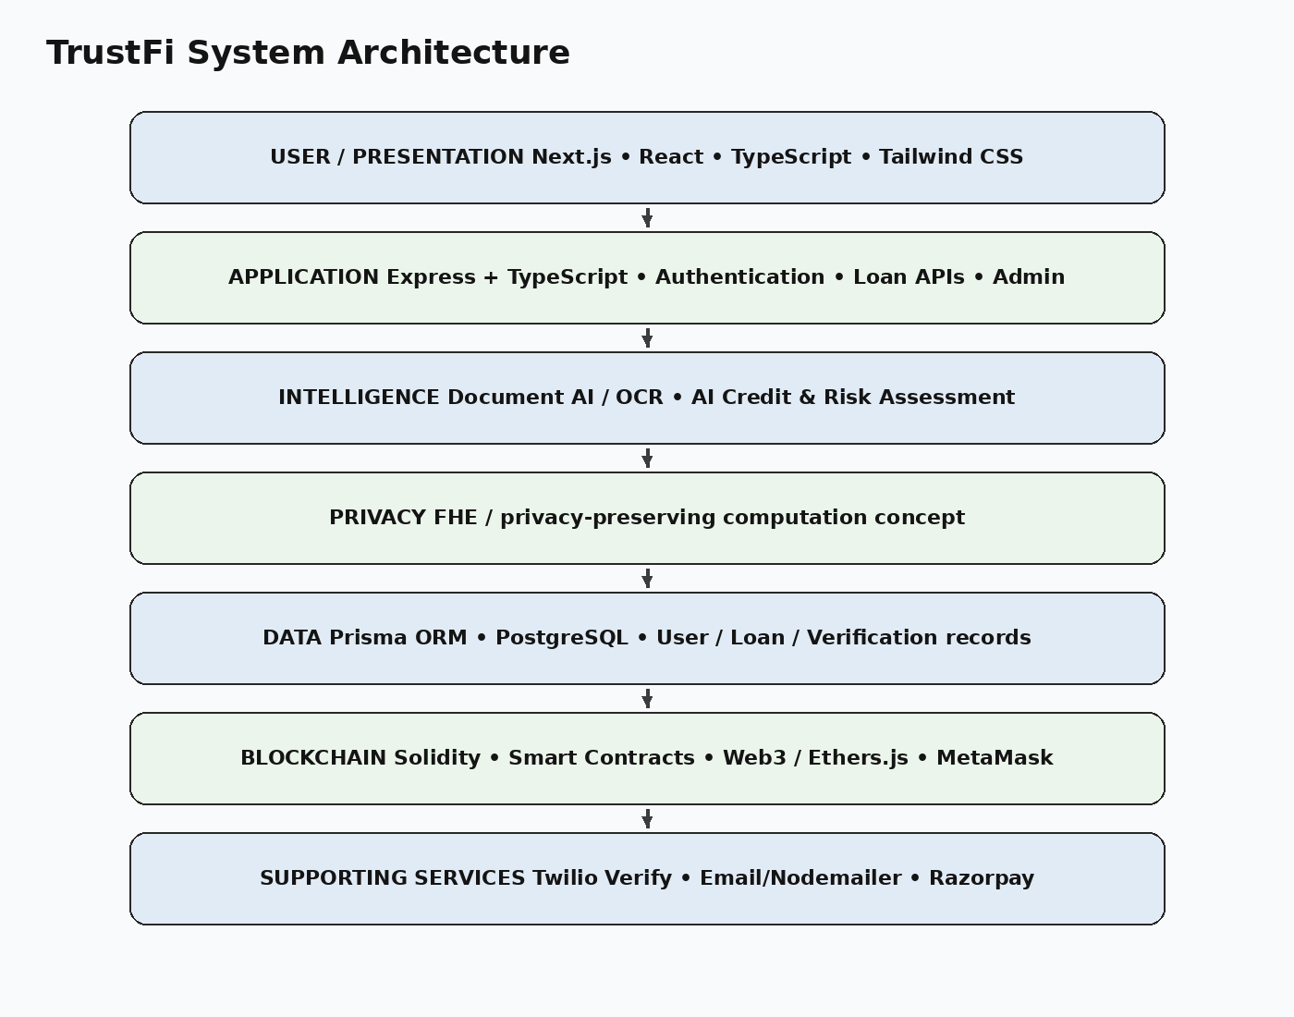
Figure 3.1 — TrustFi layered system architecture

3.2 User Interaction Flow
- User accesses the TrustFi web application.
- User registers and authenticates using mobile OTP.
- User opens the dashboard and starts a loan application.
- User completes the structured application and uploads required documents.
- Document AI/OCR extracts and validates relevant information.
- The AI risk layer evaluates application and verification signals.
- The application is presented for administrative review.
- After approval, the user proceeds to the Razorpay payment step.
- The loan is activated and the resulting state is reflected in the dashboard.

3.3 Basic Data Flow
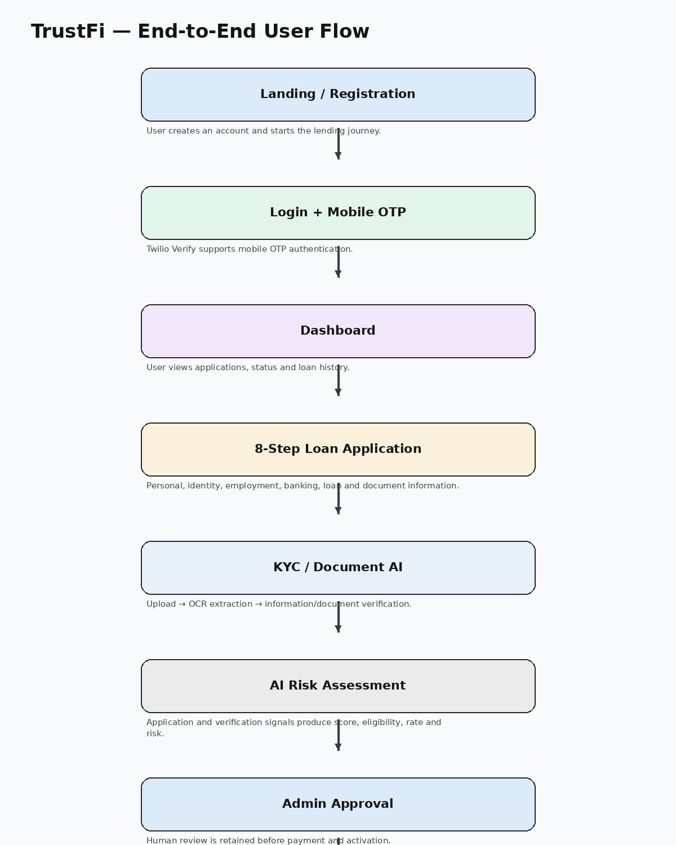
Figure 3.2 — TrustFi end-to-end data and user flow

3.4 Document AI / KYC Data Flow
The verification pipeline is designed to convert uploaded documents into usable structured signals. OCR is primarily responsible for extraction, while validation and matching logic determine whether the extracted information is consistent with the application.
- Document upload
- Document-type identification / validation
- OCR extraction using Tesseract OCR
- Required-field and information checks
- Identity/name matching with applicant information
- Verification result and risk flags
- Continue the loan workflow or route the case for review
Supported verification documents in the current workflow include Aadhaar front/back, PAN card, selfie or passport photo, salary slip and bank passbook.

3.5 AI Risk Assessment Flow
The AI stage converts borrower and application context into lending indicators. Inputs can include applicant profile, monthly income, loan amount, tenure, employment information and verification signals. Outputs include a credit score, eligibility result, interest-rate indication and risk level.
The project treats the AI output as decision support. Administrative approval remains part of the current prototype before payment and loan activation.

3.6 Loan Lifecycle & Renewal
The TrustFi lifecycle starts with registration and KYC, continues through application, assessment, approval, payment and activation, and then moves toward repayment and closure. Renewal is treated as a fresh eligibility and reassessment process using repayment history and current application conditions.
- Registration and identity verification
- Loan application
- Document verification
- AI risk assessment
- Admin approval
- Payment / activation
- Repayment tracking
- Closure or renewal eligibility review

4. Technology & Modules

4.1 Frontend Technologies
Next.js / React — provides the web application structure, routing and component-based user interface.
TypeScript — provides typed application logic and improves maintainability.
Tailwind CSS — supports consistent utility-based interface styling.

4.2 Backend Technologies
Node.js and Express.js with TypeScript are used for backend APIs, business logic and communication between the application layers in the current prototype.

4.3 Database
PostgreSQL is used for persistent relational storage. Prisma ORM provides the database access layer.
Core persisted information includes user records, OTP/authentication information, loan applications, verification information and payment-related state.

4.4 Artificial Intelligence & Document AI
Tesseract OCR is used for document text extraction. The AI/risk layer uses application and verification signals to generate lending indicators such as credit score, eligibility, interest rate and risk level.
A key architectural boundary is maintained between OCR extraction and AI assessment: OCR extracts information from documents, while the AI stage uses structured application/verification signals for intelligent assessment.

4.5 Privacy Technology
TrustFi incorporates a Fully Homomorphic Encryption (FHE) / Fhenix-oriented privacy direction. The core idea is to enable computation over encrypted sensitive information so that confidential financial data does not need to be handled as ordinary plaintext throughout the intended privacy-preserving computation flow.
This layer is part of the project's privacy-oriented architecture and future production hardening would require deeper implementation, validation and security review.

4.6 Blockchain & Web3 Layer
The blockchain direction uses Solidity smart contracts with Web3/Ethers.js and MetaMask-oriented interaction. Smart contracts are intended to encode programmable lending logic and maintain relevant tamper-resistant transaction records.
Sensitive borrower documents and application records remain primarily off-chain in the system architecture, while blockchain is intended for appropriate loan-related transaction/state information.

4.7 Supporting Integrations
Technology / Service | Role in TrustFi
Twilio Verify | Mobile OTP authentication
Email / Nodemailer | Registration / welcome communication workflows
Razorpay | Digital payment step after admin approval
MetaMask | Web3 wallet interaction
Solidity | Smart-contract implementation
Ethers.js | Web3 / contract interaction
Git / GitHub | Version control and source-code management
Vercel / Render | Deployment direction for frontend/backend components

4.8 Functional Module Summary
Module | Primary Responsibility
Authentication | Registration, mobile OTP login and session access
KYC / Document AI | Document upload, OCR extraction and verification
AI Credit Engine | Credit/risk evaluation and lending indicators
Loan Management | Personal, Property and Gold loan application flow
Admin Control | Application review and approval
Payment | Razorpay payment processing step
Database | Persistent application and loan records
Privacy Layer | FHE-oriented confidential computation direction
Blockchain | Smart-contract and tamper-resistant transaction logic
Lifecycle | Activation, repayment/closure and renewal flow

5. Development Direction & Expected Outcome

5.1 Current TrustFi Prototype
The current TrustFi system represents an MVP / academic product prototype that demonstrates an integrated lending journey rather than a collection of isolated technology experiments.
- Frontend lending interface
- User registration and mobile OTP authentication
- Structured loan application
- KYC / OCR document processing
- AI credit/risk assessment
- Admin approval workflow
- Razorpay payment step
- PostgreSQL persistence through Prisma
- Privacy-preserving computation direction
- Blockchain / smart-contract direction

5.2 Development Direction
The project can be progressively extended from the current MVP toward a stronger product architecture through the following stages.

Stage 1 — Strengthen Core Lending Workflow
- Improve application validation
- Improve KYC and document checks
- Strengthen authentication and session security
- Improve borrower and admin dashboards

Stage 2 — AI & Fraud Intelligence
- Improve credit/risk evaluation
- Introduce stronger fraud detection
- Expand document validation rules
- Improve explainability of lending indicators

Stage 3 — Privacy Integration
- Deepen FHE/Fhenix integration
- Validate encrypted computation workflows
- Separate sensitive off-chain information from on-chain state
- Perform privacy and security testing

Stage 4 — Blockchain & Smart Contracts
- Harden Solidity contracts
- Expand Web3 transaction handling
- Add appropriate loan lifecycle contract functions
- Evaluate additional blockchain networks

Stage 5 — Lifecycle, Repayment & Renewal
- Automate repayment tracking and notifications
- Build stronger loan-history analytics
- Introduce renewal eligibility checks
- Support repeat-borrower workflows

5.3 Expected Final Outcome
The expected outcome is a demonstrable AI-powered lending platform in which a borrower can move from identity verification to loan activation through one connected workflow.
- Register and authenticate
- Complete KYC and submit required documents
- Receive document verification results
- Submit a Personal, Property or Gold loan request
- Receive AI-assisted risk/eligibility indicators
- Pass through administrative approval
- Complete digital payment
- Activate and track the loan
- Continue toward repayment, closure or renewal

5.4 Expected Innovation
The primary innovation of TrustFi is not simply the use of AI, OCR or blockchain individually. The proposed innovation is their combination into a controlled lending workflow:
AI Risk Assessment + Document AI/OCR + Privacy-Preserving Computation + Blockchain + Admin Control + Digital Payment
This combination aims to create a lending experience that is more connected, explainable and privacy-aware while retaining human oversight.

5.5 Expected Benefits
- Reduced repetitive document-processing effort
- Structured borrower onboarding and loan application
- Faster availability of AI-assisted risk indicators
- Improved visibility of application and loan status
- Privacy-oriented handling of sensitive financial information
- Programmable and tamper-resistant blockchain transaction logic
- Controlled human review before final activation
- Digital payment integration
- Clearer path for future loan repayment and renewal workflows

5.6 Human-in-the-Loop Approach
TrustFi is not intended to replace human lending judgment. The current workflow retains an administrative approval stage after verification and AI assessment.
- Review application information
- Review verification results
- Evaluate AI-generated indicators
- Approve or reject the application
- Authorize progression to payment and activation
- Apply final operational judgment

6. CONCLUSION
TrustFi proposes an integrated digital lending workflow that combines AI-assisted risk assessment, Document AI/OCR, privacy-preserving computation concepts, blockchain smart contracts, administrative control and digital payment.
The project addresses several friction points in conventional lending: repetitive verification, fragmented process stages, limited risk intelligence and privacy concerns around sensitive financial information.
The current MVP demonstrates a connected path from registration and mobile OTP authentication through structured loan application, KYC/OCR verification, AI assessment, admin approval, Razorpay payment and loan activation. Personal, Property and Gold loan journeys are included in the current product direction.
The longer-term development direction focuses on stronger fraud detection, deeper FHE integration, hardened smart contracts, improved security, repayment tracking, renewal workflows and production readiness. TrustFi therefore demonstrates how AI, privacy technology and blockchain can be combined into a practical lending product architecture while keeping human approval in the decision loop.

REFERENCES
- 1. Next.js Documentation
- 2. React Documentation
- 3. Node.js Documentation
- 4. Express.js Documentation
- 5. PostgreSQL Documentation
- 6. Prisma Documentation
- 7. Tesseract OCR Documentation
- 8. Twilio Verify Documentation
- 9. Razorpay Documentation
- 10. Solidity Documentation
- 11. Ethers.js Documentation
- 12. MetaMask Documentation
- 13. Fhenix / Fully Homomorphic Encryption documentation and technical material
- 14. GitHub Documentation
- 15. Vercel Documentation
- 16. Render Documentation
- 17. Research literature on AI-assisted credit assessment, privacy-preserving computation and decentralized finance.

