**OBSERVATIONS MADE IN DATA ANALYTICS MINI PROJECT**

Reg No: 21112041

Class: 3BSc DS

Date: 11th December 2022

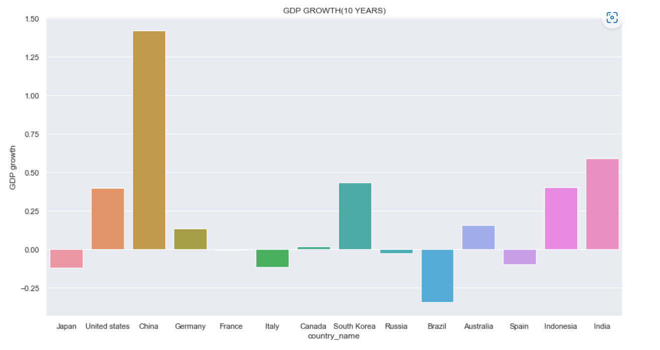

OBS: China has the most growth rate in the last 10 years by 2020 whereas Brazil had its GDP drop a lot during the same time period.

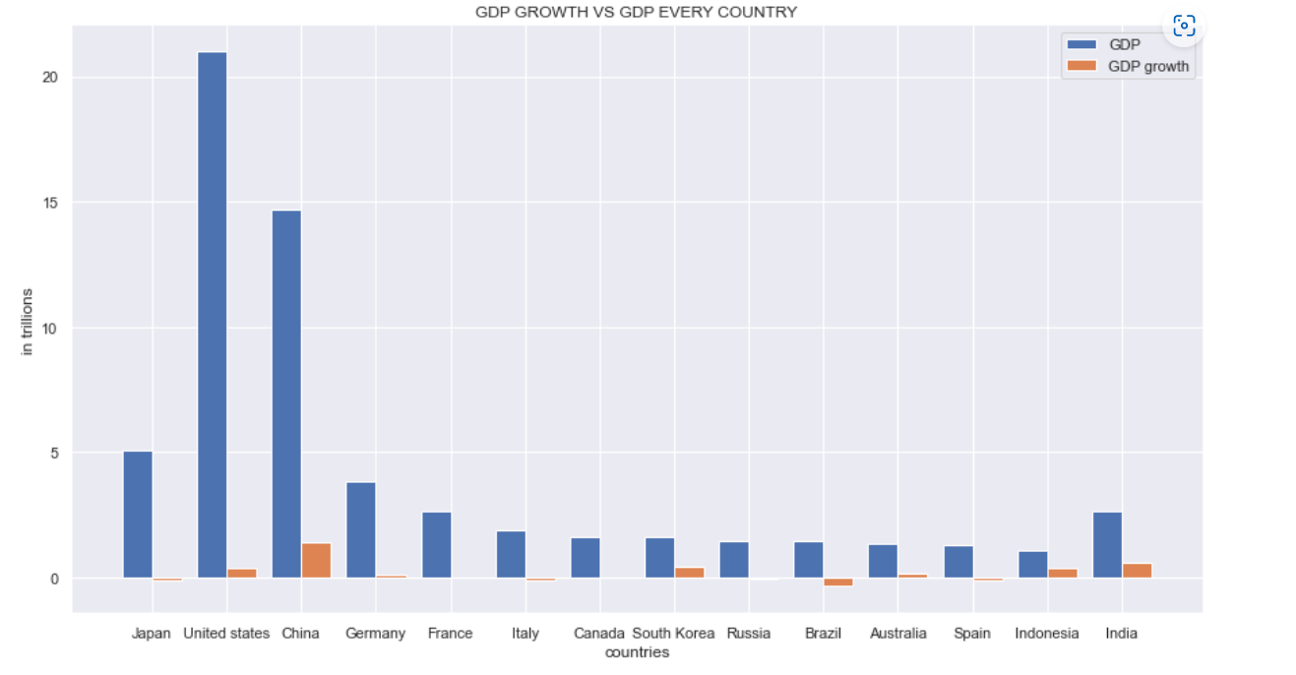

OBS: Although being the country that has the highest GDP, the United States had lesser GDP growth than other countries such as China, India, and South Korea.

Although being the second in GDP, China had observed a high GDP growth rate compared to other countries in the top list.

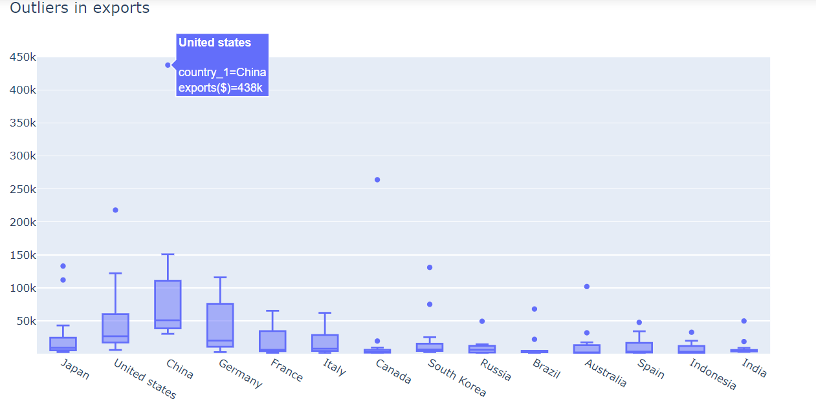

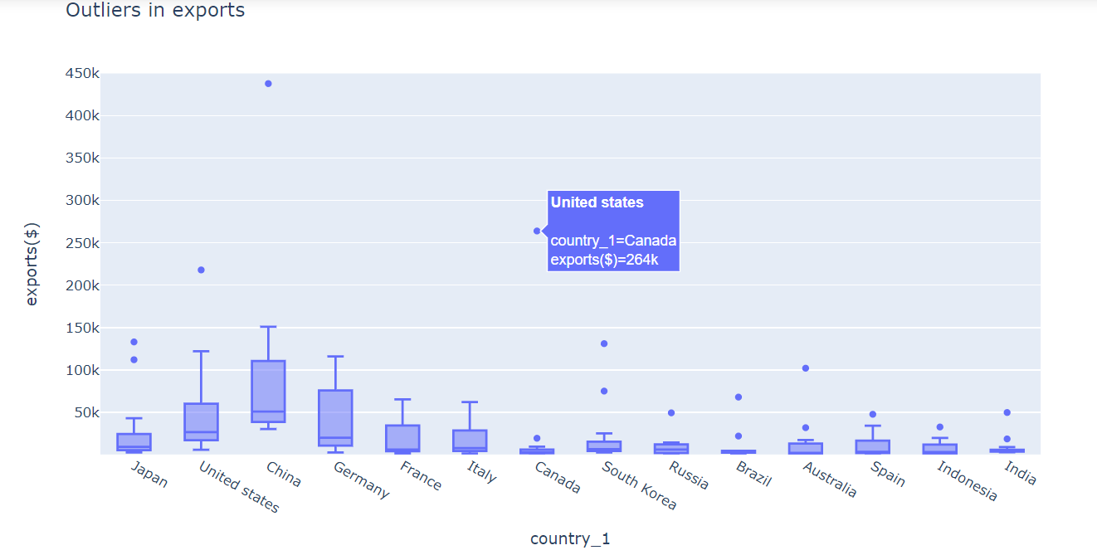

OBS: China had the biggest outlier which was the amount of exports to the United States.

The second biggest was also Canada’s exports to the United States.

The United States imports a lot compared to other countries. Maybe this is the reason why its GDP growth is average in comparison with its high GDP.

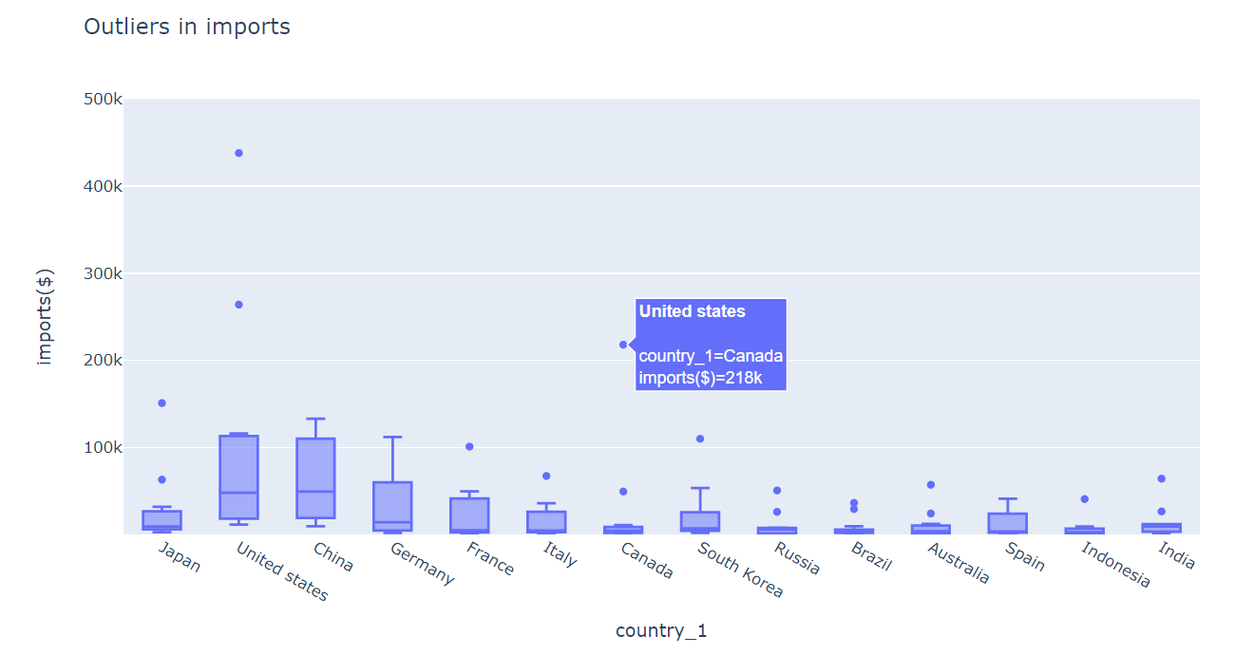

OBS: Canada also imports quite a high amount from the United States so there is a high trade connection between the two countries.

Canada is also a good trading partner for China.

India for China and United States.

Most of the countries have high trade (exports or imports or both) with the United States and China.

France, Italy, and Russia have a good (high) amount of imports from Germany

Final OBS: Most of the countries which have high GDPs depend upon their trade with the United States or China or both of them.

Germany is the biggest trading partner after the United States and China.

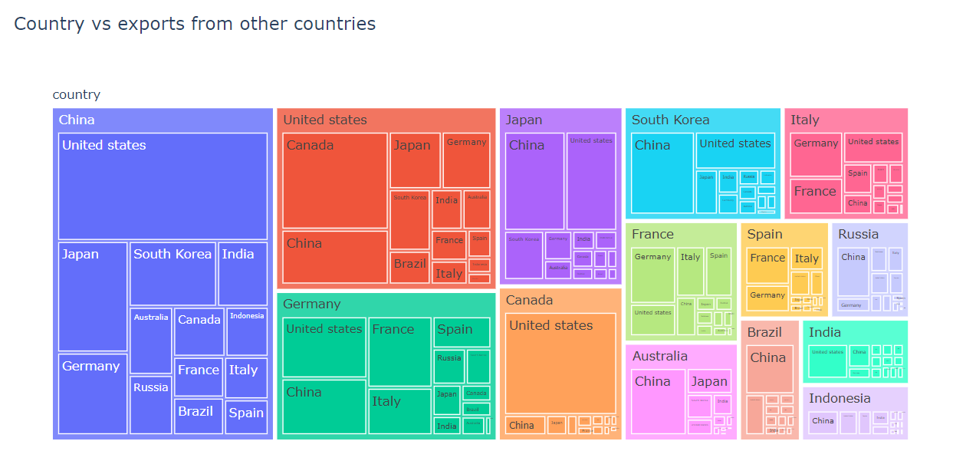

OBS: The exports from the United States and Germany put together could add up to the exports from China.

The three biggest exporters were China, the United States, and Germany.

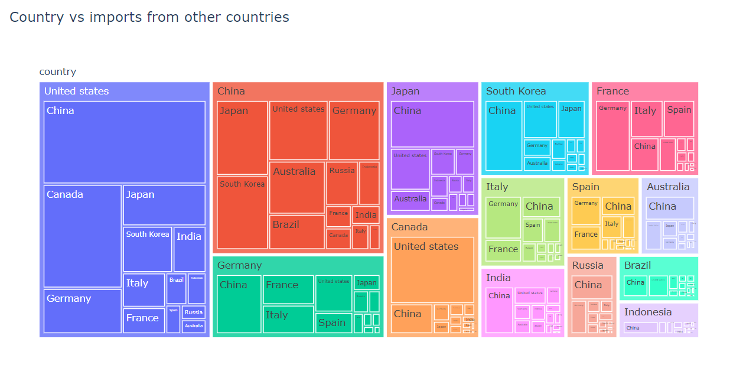

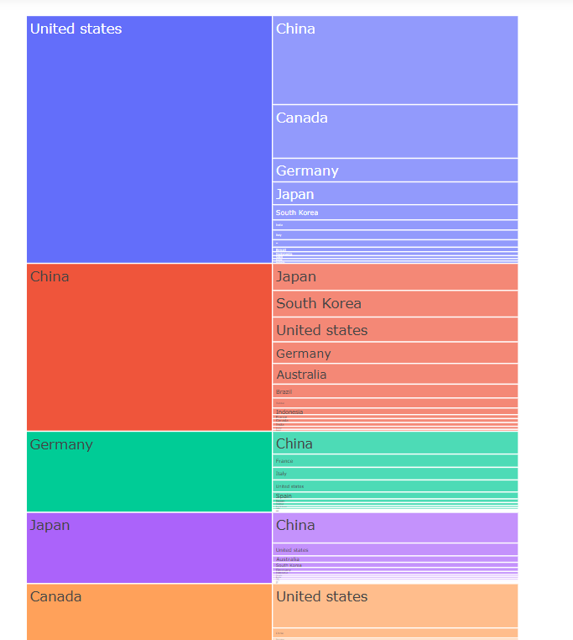

OBS: Unlike in exports, the United States is the biggest importer followed by China and Germany.

India imports > exports

France and Italy imports = exports

Australia imports < exports

FINAL OBS: China imports lesser than it exports which shows why is it ranked 1st in GDP growth.

The United States and India import a lot more than how much they export.

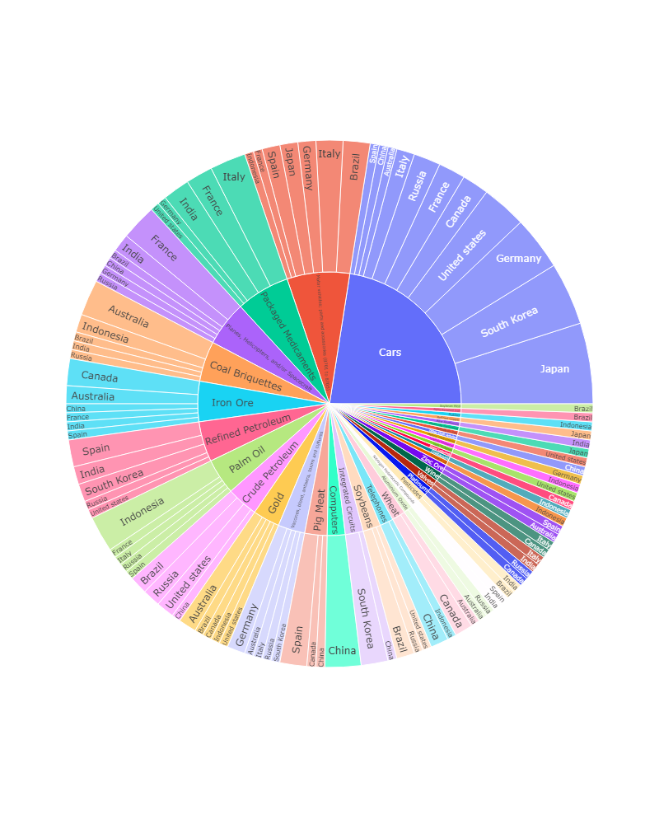

OBS: Cars were the most exported top product among the top GDP countries followed by Motor Vehicles, Packaged Medicaments, and raw minerals.

Japan got most of its revenue from exported by exporting cars.

Except for cars, the United States mostly did not have the same top exported products as others.

Indonesia got its top revenue from other top countries by exporting Palm oil and coal briquettes

Whereas France got it from planes and helicopters, and Australia from Iron Ore and Coal briquettes.

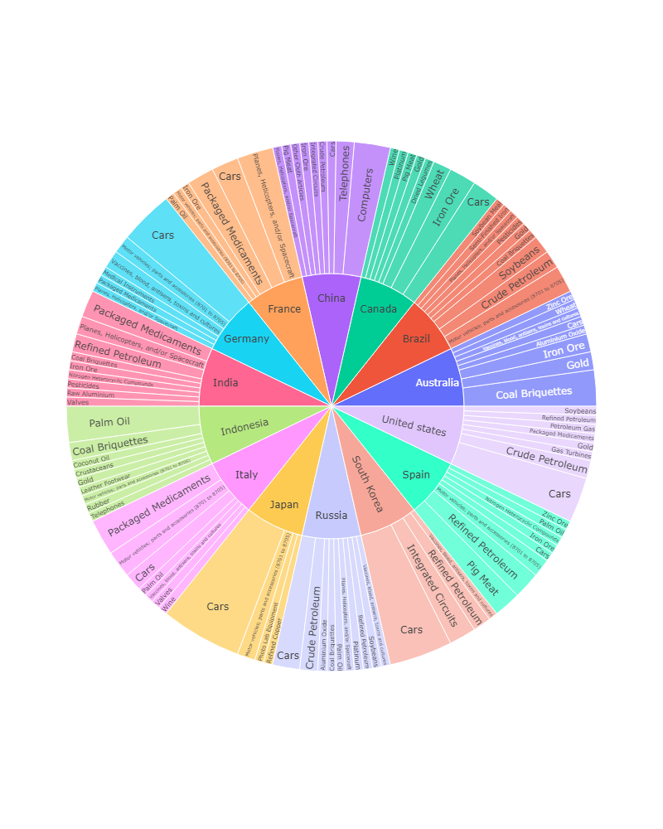

OBS:

Interesting ones: top product exported

India and Italy – Packaged Medicaments

China – Computers and Telephones

Spain – Pig Meat

Brazil – Soybeans

South Korea – Integrated circuits

Only Australia, the United States, and Indonesia had one of their exported top products as Gold.

FINAL OBS:

Most of the top countries exported cars as their top product although there were some with interesting products too.

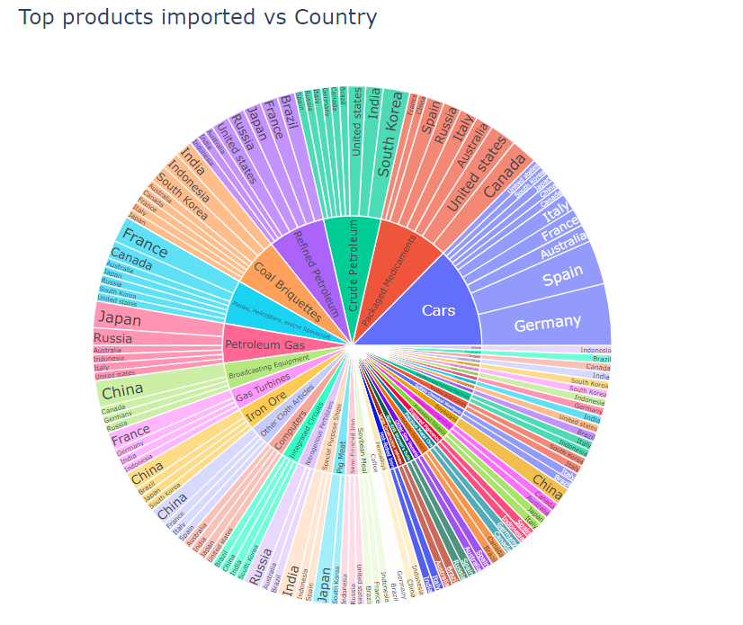

OBS: Germany imports a lot of cars than it exports whereas Japan imports a very less amt of cars compared to how many cars it exports.

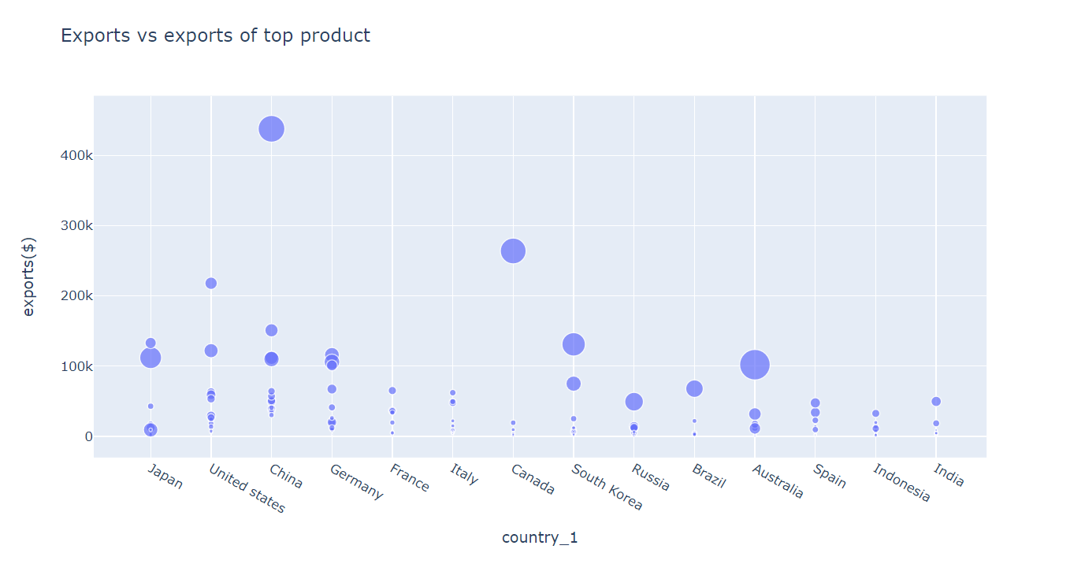

OBS: In most cases, the more the exports from the top product the higher the country’s exports are.

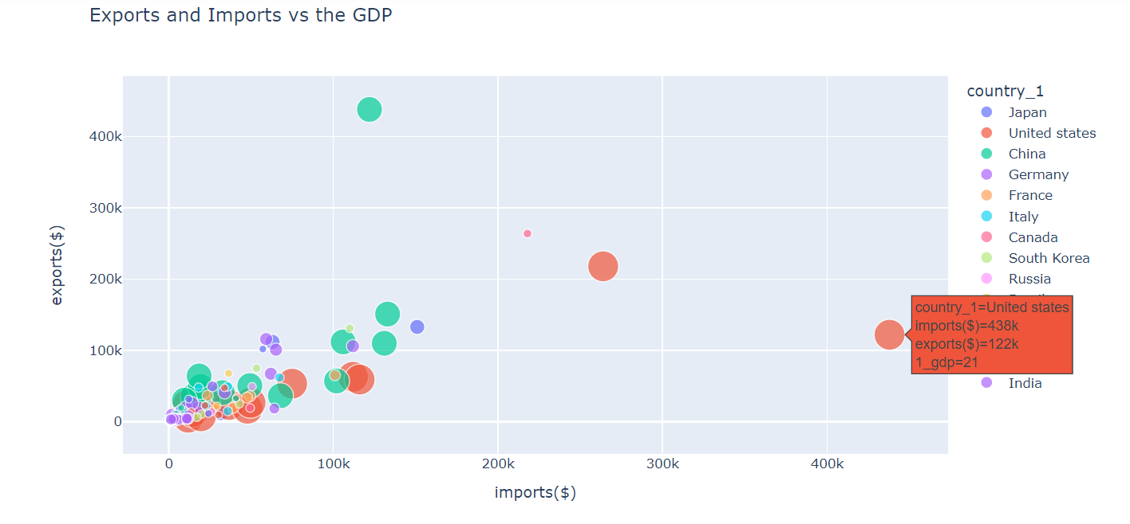

OBS: United States imports a lot more than its exports but still has the highest GDP.

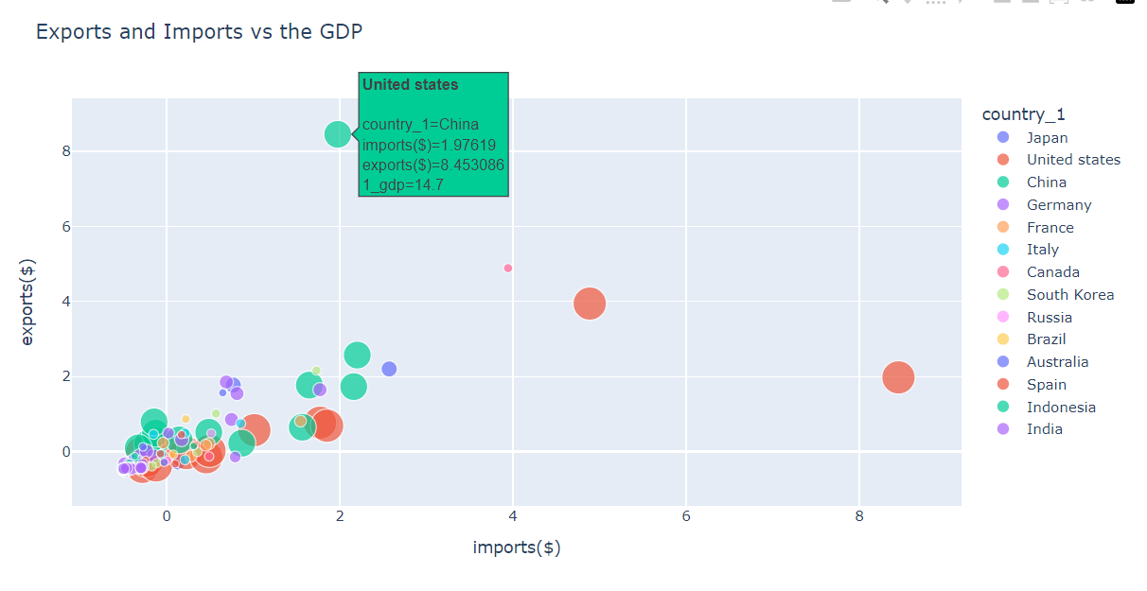

OBS: China’s exports are balanced with the imports with the only outlier being its exports to the United States.

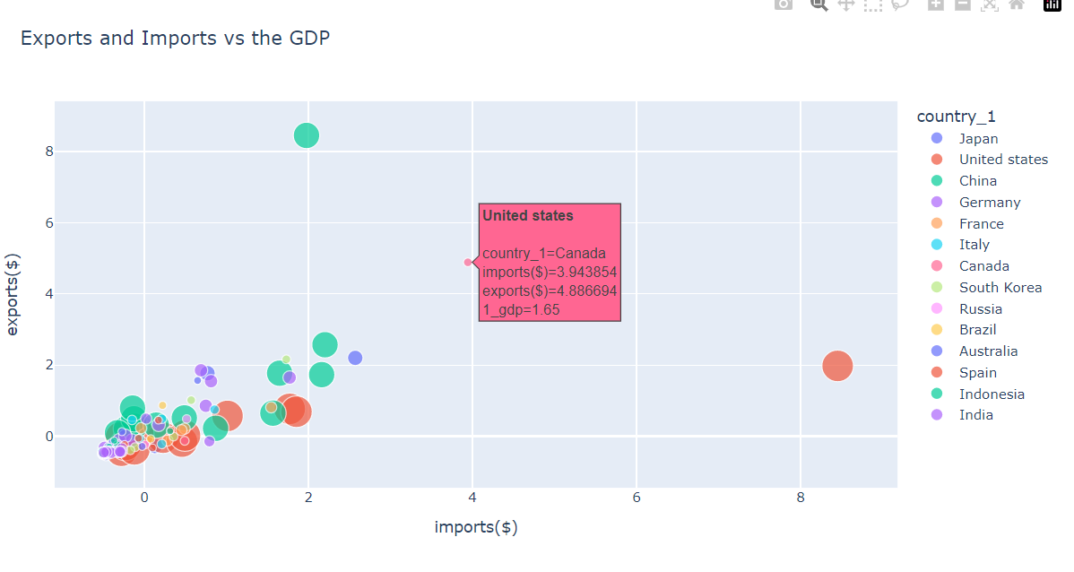

OBS: Canada’s exports are balanced with the imports with the only outlier being its exports to the United States.

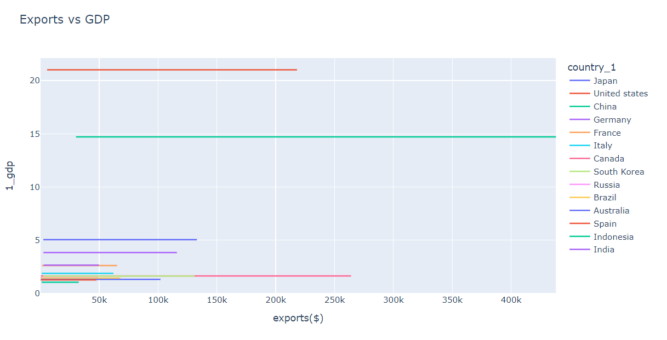

OBS: The more exports are, the greater the GDP of a country although there are some exceptions found such as the United States, Spain, and Australia.

Although Spain and Australia export a lot, their GDP remains low.

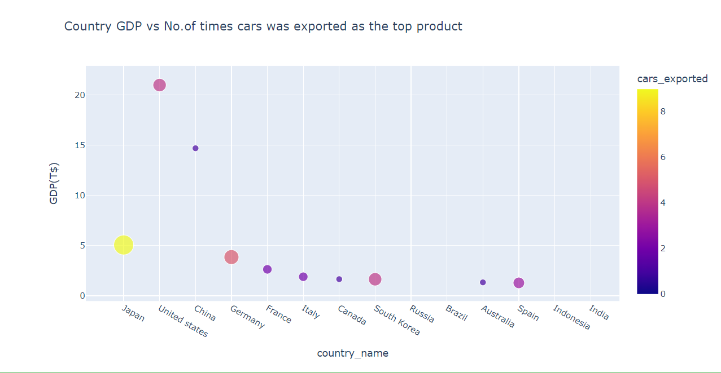

OBS: Expect Japan and China, most of the other countries are dependent on getting the most exports from cars.

Although China’s exports are higher than any other country, its GDP is not dependent on getting the most exports from cars, unlike Japan.

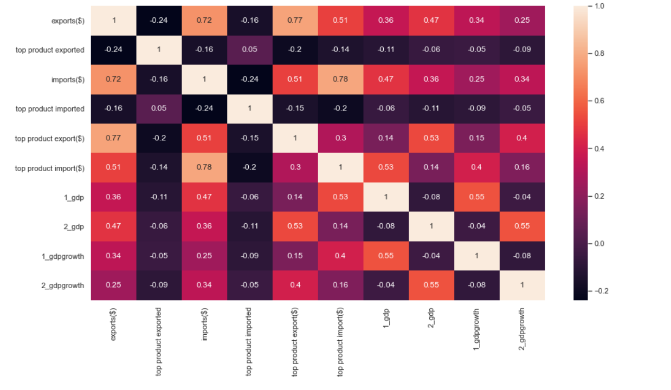

OBS: The exports between the two countries have around 0.5 correlation with how much a GDP country which is being exported to has and around 0.4 correlation with how much of a GDP the country which is exporting has.

The type of top product imported or exported does not affect any other features.

MODELING:

The best fit model for this dataset is Random Forest with an accuracy of 0.78.