Rooftop Plant-Forward Café, Manish Nagar, Nagpur
Harshita Chopda
AI disclosure: this report was prepared with AI assistance, as permitted by the course instructor for this submission on 9 November 2026.

1. Business idea
I want to open a cute, aesthetic rooftop café in Manish Nagar, Nagpur, in a building I own that is already under construction. My father will invest only if the plan is concrete, so this project tests whether the idea can stand up to scrutiny.
The café would be 70% vegan and 30% regular vegetarian, with no meat, eggs or alcohol. Vegan food and rooftop cafés each already exist in Nagpur, so the difference is the combination: a plant-forward rooftop destination where nobody feels excluded, with local signatures such as Nagpur orange matcha and orange tart. I took inspiration from how Mokai in Mumbai creates memorable moments, not from its menu.

2. Survey and mock data
Before paying for a real consumer survey, I designed 30 questions (listed in the appendix) and created 1,020 mock responses, so the models are ready when real data arrives. As suggested in class, I added intentional noise and outliers. Cleaning removed 20 duplicates and 18 careless straight-line responses, standardised 70 labels, blanked 44 impossible values such as an age of 150, and filled 395 missing answers. That left 972 usable responses.
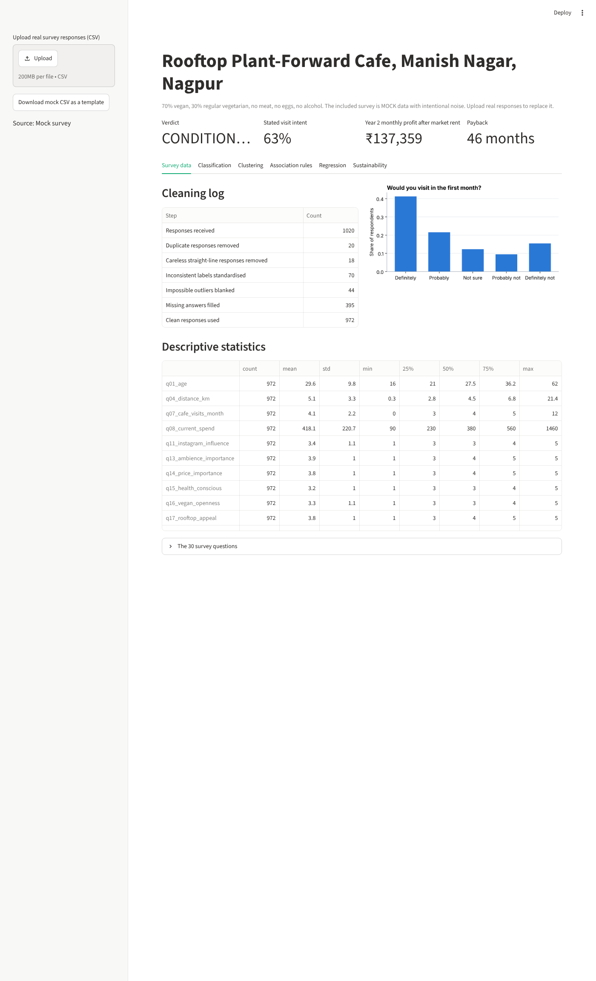

3. Classification: will this person visit?
I predicted whether someone answers "Definitely" or "Probably" to visiting in the first month, using only profile, habits and attitudes. Menu choices and expected spend were left out because they come after someone has already decided they are interested. Logistic Regression performed best in cross-validation.
On 243 unseen respondents, the confusion matrix shows 127 likely visitors correctly identified and 73 non-visitors correctly excluded. 17 non-visitors were wrongly targeted, which wastes marketing money, and 26 likely visitors were missed, which loses customers. Accuracy is 82.3% against 63.0% for always guessing the larger group, precision is 88.2%, recall is 83.0% and ROC-AUC is 0.897.
Tier | People | Stated intent | Expected spend | Action
High | 436 | 88% | ₹536 | Target first with launch offers
Medium | 212 | 71% | ₹470 | Nurture with reels and tasting events
Low | 324 | 24% | ₹361 | No paid marketing
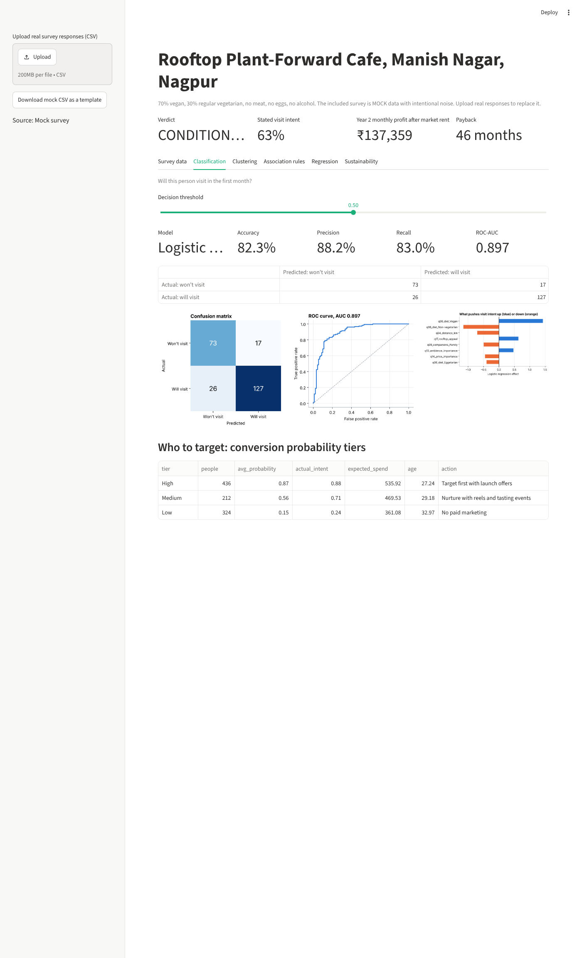

4. Clustering: who are the customers?
I used K-Means on age, café habits and attitudes. The silhouette favoured 3 clusters, and I chose 3. At 0.18, the silhouette is low, which means the groups overlap, as survey attitudes usually do. I would use them as a guide and not as hard boxes.
The segments are: Budget Trend Students (499 people, 77% intent, ₹419 expected spend); Comfort-Seeking Families (317 people, 69% intent, ₹642 expected spend); Unconvinced Regulars (156 people, 5% intent, ₹242 expected spend). Paid marketing should go first to the high-intent groups, while the low-intent group should not receive paid marketing. Together with the probability tiers above, this answers whom to target and whom not to target.
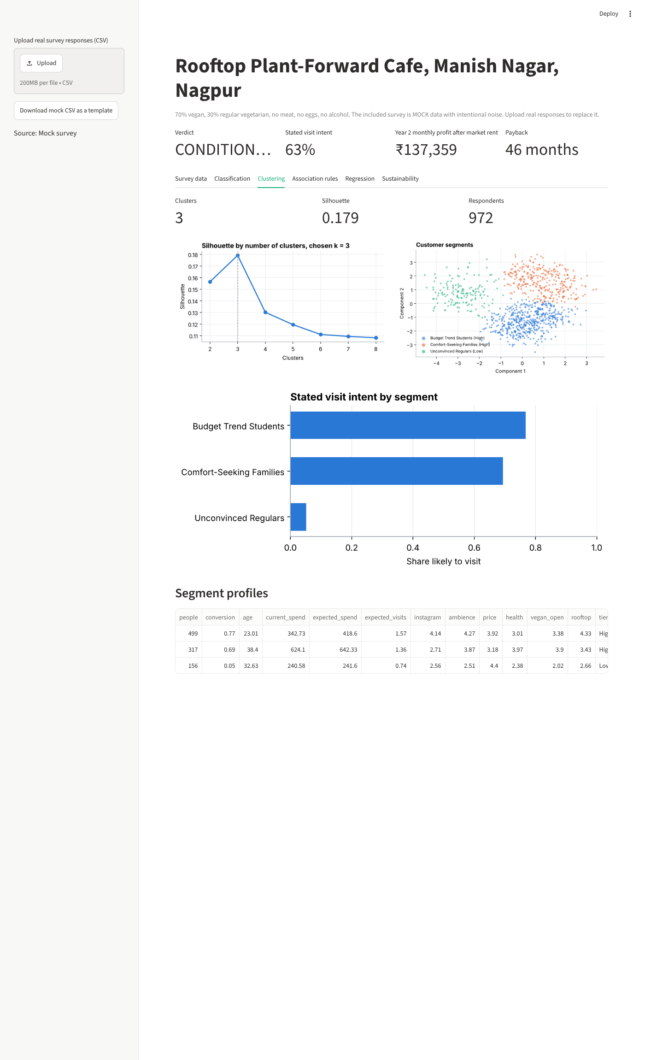

5. Association rules: what to launch with
Rather than opening with every idea, I want to start small. Apriori was run on the 611 interested respondents; 220 of 390 rules kept their lift on responses held back for testing. A seven-item menu of orange cooler, cheese pizza, orange tart, orange matcha, oat latte, regular ice cream, paneer sandwich gives 84% of interested people at least two things they want.
The rules also show that people interested in orange matcha + orange tart also expect vegan cheesecake (61% on unseen responses), so that item should be added or tested early. This addresses the point raised in class: if customers want A and B and immediately look for C, launching only A and B creates a poor experience. The most wanted features are sunset seating, plant wall, private celebrations.
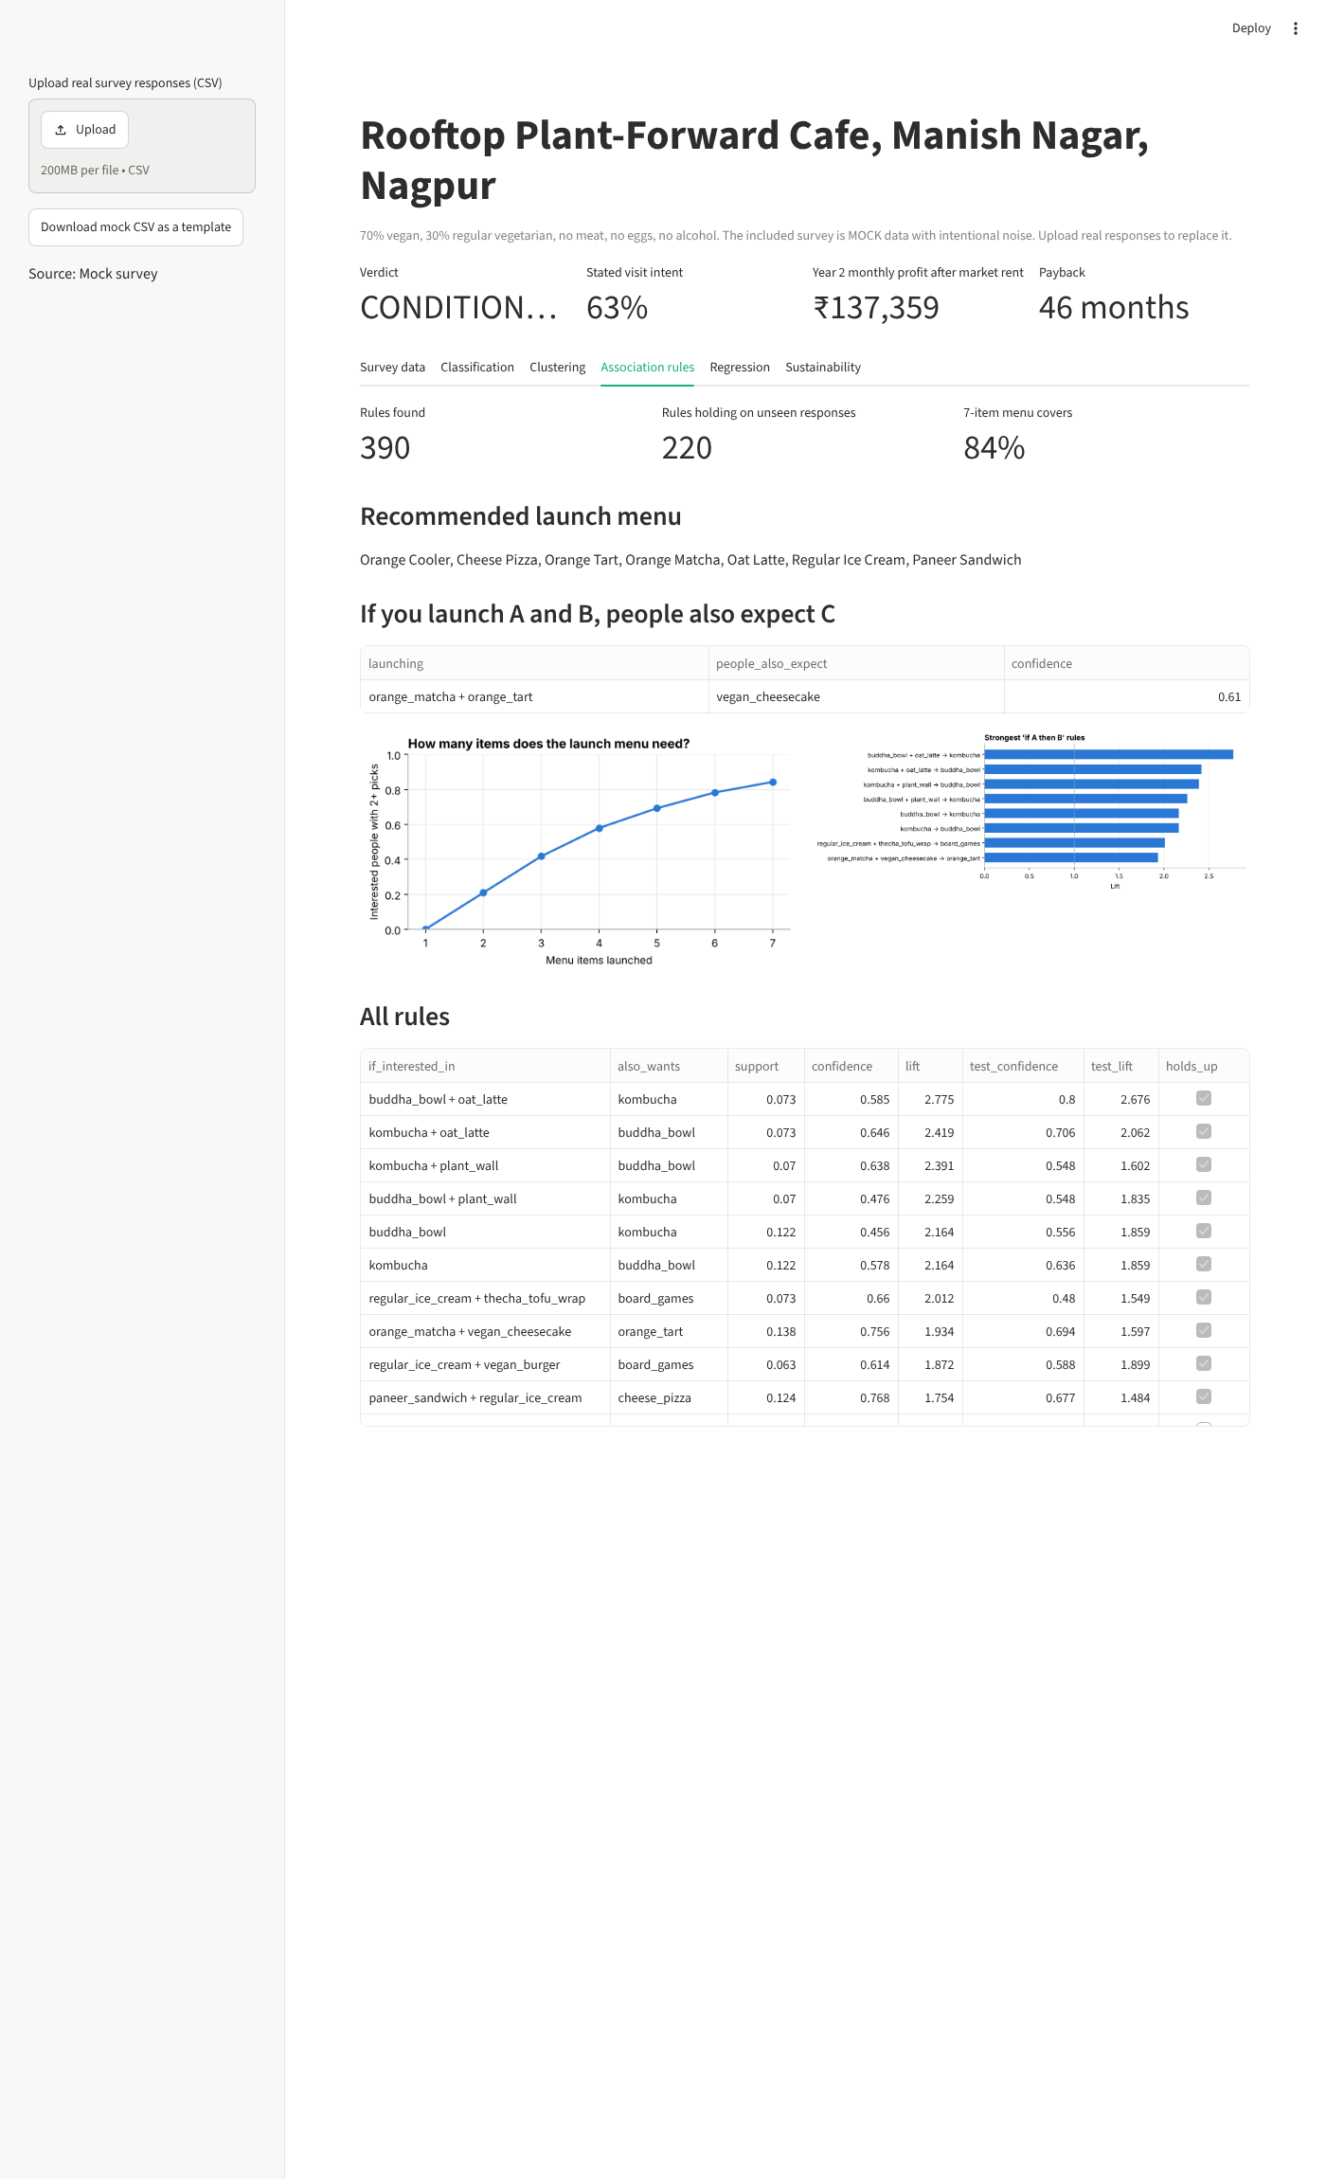

6. Regression: how much will they spend?
Ridge Regression predicts expected spend per visit from the same profile data. Its average error is ₹65 (15.3%), R² is 0.85, and it is 65% better than guessing the average. Current café spend and income are the main drivers. The average expected spend among interested people is ₹512, which guides a menu priced around that level per person.
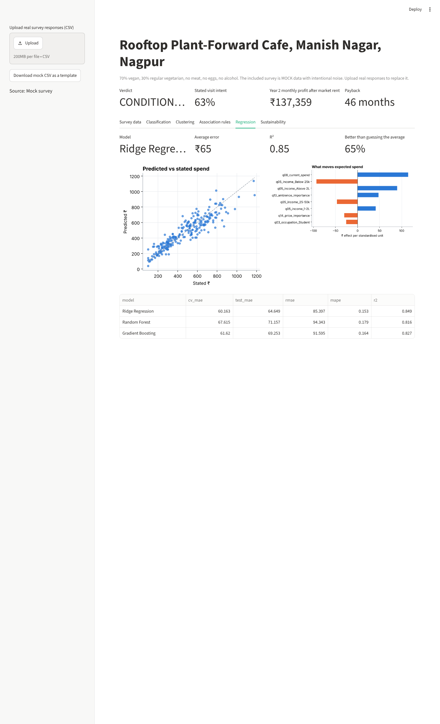

7. Is it sustainable?
I fixed three gates before looking at the outcome: margin of safety of at least 20%, at least a 75% probability of monthly profit, and payback within 48 months. A stated "Definitely" is not a real customer, so only 35% of Definitely answers, 12% of Probably and 3% of Not sure are counted, and stated visit frequency is halved.
Measure | Result
Verdict | CONDITIONAL GO
Year 2 monthly revenue | ₹10,82,454
Year 2 monthly profit after market rent | ₹1,37,359
Same profit before market rent | ₹2,87,359
Monthly fixed costs | ₹5,50,000
Break-even customers per day | 56
Margin of safety (required 20%) | 19.98%
Probability of monthly profit (required 75%) | 76.0%
Payback on ₹45,00,000 investment (limit 48) | 46 months
Seat utilisation at modelled demand | 42%
Average April-June monthly profit in year 2 | ₹-50,103
The verdict is CONDITIONAL GO: the margin of safety narrowly misses its gate, so I would not call this a clear go. I charged ₹1,50,000 a month in market rent even though the space is owned, because it could otherwise be rented out. The summer months are weak for a rooftop, so a cooled section is part of the plan.
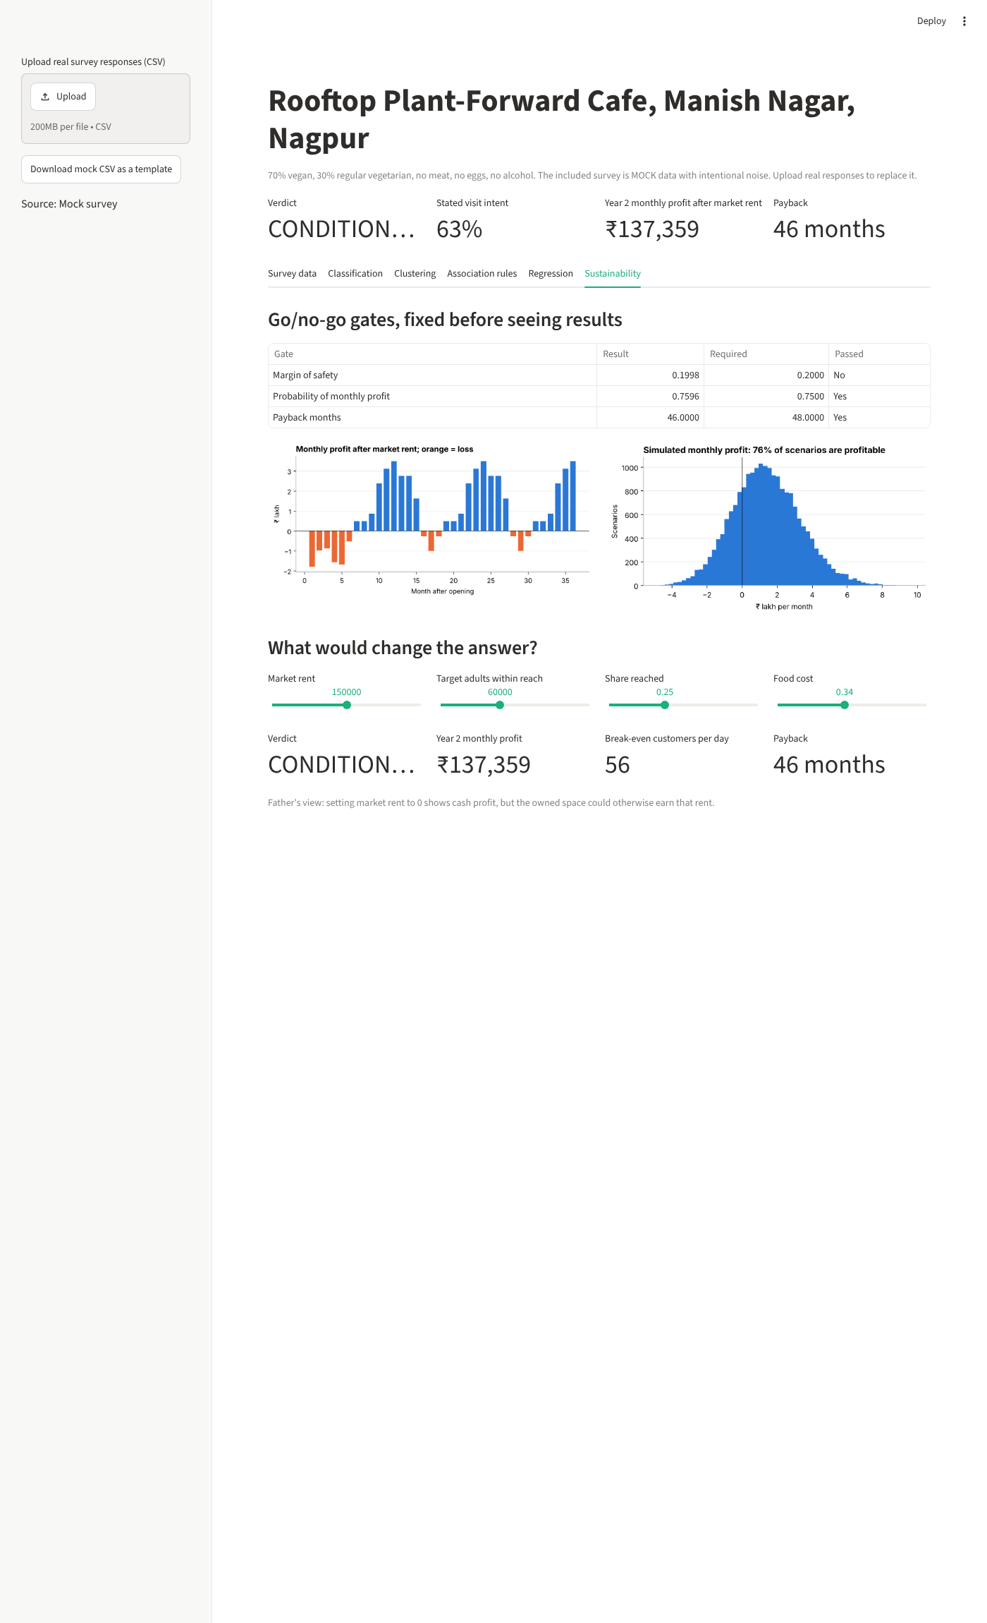

8. Decisions and limits
My decisions are to launch the seven-item menu, target the high-intent tier first, build a cooled indoor section with the rooftop, and run the real survey before my father commits money.
The major limitation is that this is mock data, so it reflects my assumptions and cannot prove real demand. The catchment, reach, costs and conversion percentages are estimates. The value of this work is that the model is ready: when real responses arrive, I can upload them to the live dashboard and see whether the verdict holds. Text analytics on the open-ended comments can be added next.

Appendix: the 30 survey questions
No. | Question
1 | What is your age?
2 | What is your gender?
3 | What is your occupation?
4 | About how far do you live or work from Manish Nagar, in km?
5 | What is your monthly personal or household income?
6 | Which best describes your diet?
7 | How many times a month do you visit cafes?
8 | How much do you usually spend per person at a cafe, in rupees?
9 | Who do you usually go with?
10 | When do you usually go?
11 | Instagram influences which cafes I visit.
12 | How do you usually discover new cafes?
13 | Ambience and aesthetics matter to me when choosing a cafe.
14 | Price matters to me when choosing a cafe.
15 | I actively look for healthier food.
16 | I would try vegan food if it tasted good.
17 | A rooftop setting would make me more likely to visit.
18 | I would visit in summer if a cooled indoor section were available.
19 | A pure-vegetarian, alcohol-free cafe feels comfortable for me and my family.
20 | I prefer businesses that are environmentally responsible.
21 | Which drinks would you order? Select all that apply.
22 | Which food would you order? Select all that apply.
23 | Which desserts would you order? Select all that apply.
24 | Which features would make you visit? Select all that apply.
25 | What is a fair price for a signature drink, in rupees?
26 | How much would you expect to spend per person per visit here, in rupees?
27 | How many times a month would you visit?
28 | How much extra would you pay for plant milk, in rupees?
29 | If this cafe opened in Manish Nagar, would you visit in the first month?
30 | What would make you love or avoid this cafe?

