TELECOMM USECASE-----SPRINT1
DIM_TOWER IMPLEMENTATION:
It is created for the purpose of implementing SCD1 and to get distinct TowerID’s available.
Implementation Steps:
/----Sequence-Insert_tgt
SRC-ExpressionLookUpRouter-
\----Update_tgt

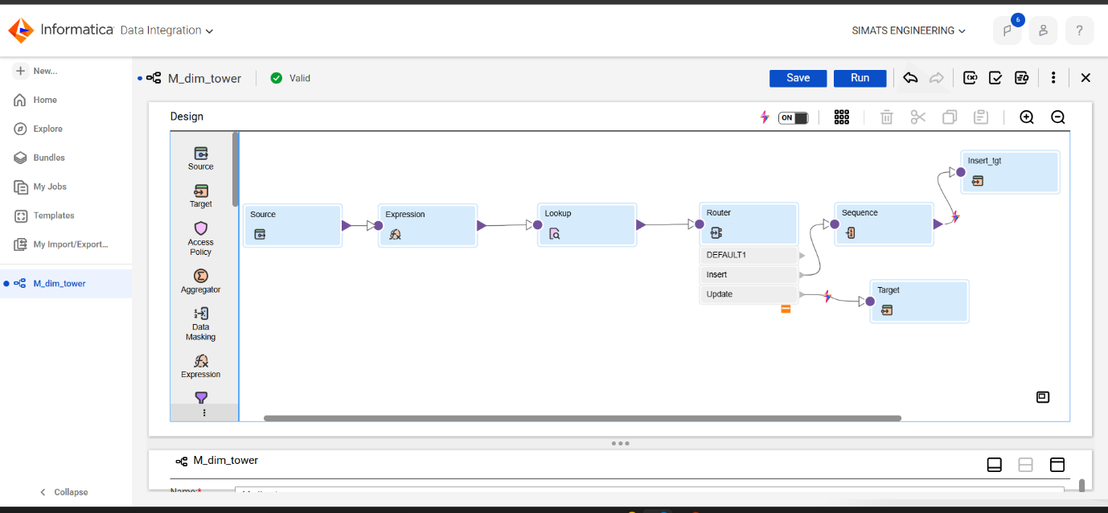

Expression Usage:
Expression is used for data cleaning by trimming the extra spaces and handling null values.
Expression Used:
1.Clean_TowerID = LTRIM(RTRIM(TowerID))
2.Clean_Region = IIF(ISNULL(Region), 'UNKNOWN', UPPER(LTRIM(RTRIM(Region))))
3.Clean_City = IIF(ISNULL(City), 'UNKNOWN', INITCAP(LTRIM(RTRIM(City))))

Lookup Transformation:
It is Used for looking and fetching required rows from tgt table
Lookup Condition Used:
Src.TowerID=lkp.Tower.ID

Router Transformation:
It is used for splitting the data as per required conditions. Here I had splitted data into two paths
1.Insert- ISNULL(TOWER_KEY)

2.Update-NOT ISNULL(TOWER_KEY)
AND (
Src_clean_Region != REGION OR
Src_Clean_City != CITY
)
Sequence Generator:
It is used for giving key numbering for newly inserted records with increment as 1 and intial as 1 with mapping field NEXTVAL to map in insert_tgt table to generate the key.
Insert_tgt:
This table contains inserted records and manages new insertions
Update_tgt:
This table manages the updations of records by overwriting them as per input.

