TELECOMM USECASE-----SPRINT1
DIM_TOWER IMPLEMENTATION:
It is created for the purpose of implementing SCD1 and to get distinct TowerID’s available.

SCD1 is used here to handle the overwriting of data whenever the src_input updates.

Why Not SCD2?
Because SCD2 handles history of data.Here we do not require any history of data.So we are going with SCD1 which will overwrites the existing records in existing row with updated records.
Implementation Steps:
/----Sequence-Insert_tgt
SRC-ExpressionLookUpRouter-
\----Update_tgt

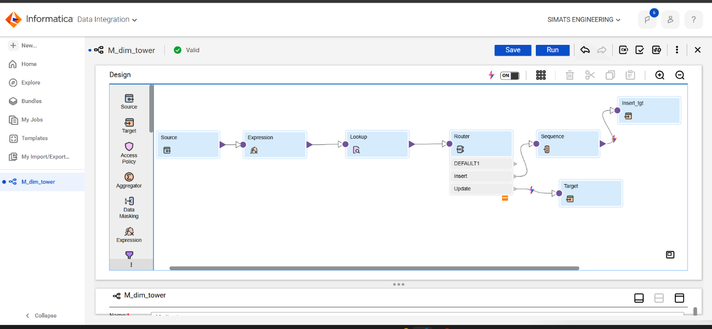

Expression Usage:
Expression is used for data cleaning by trimming the extra spaces and handling null values.
Expression Used:
1.Clean_TowerID = LTRIM(RTRIM(TowerID))
2.Clean_Region = IIF(ISNULL(Region), 'UNKNOWN', UPPER(LTRIM(RTRIM(Region))))
3.Clean_City = IIF(ISNULL(City), 'UNKNOWN', INITCAP(LTRIM(RTRIM(City))))

Lookup Transformation:
It is Used for looking and fetching required rows from tgt table
Lookup Condition Used:
Src.TowerID=lkp.Tower.ID

Router Transformation:
It is used for splitting the data as per required conditions. Here I had splitted data into two paths
1.Insert- ISNULL(TOWER_KEY)

2.Update-NOT ISNULL(TOWER_KEY)
AND (
Src_clean_Region != REGION OR
Src_Clean_City != CITY
)

Sequence Generator:
It is used for giving key numbering for newly inserted records with increment as 1 and intial as 1 with mapping field NEXTVAL to map in insert_tgt table to generate the key.
Insert_tgt:
This table contains inserted records and manages new insertions
Update_tgt:
This table manages the updations of records by overwriting them as per input.

