Infosys SpringBoard Internship
A scalable in memory key value pair store with persistence

Milestone 1

1.Introduction to python

Python is a high-level, interpreted, general-purpose programming language.
It is known for its simple syntax, readability, and versatility.

- Developed by Guido van Rossum
- First released in 1991
- Used in:
Web Development
Data Science
Artificial Intelligence
Automation
Software Development
Features of Python
- Easy to learn
- Platform independent
- Dynamically typed
- Large standard library
- Supports object-oriented programming
2.Output statements

- print() function is used to display output
- end=' ' prevents a new line after printing

3.Keywords in python
- Keywords are reserved words
- They cannot be used as variable names

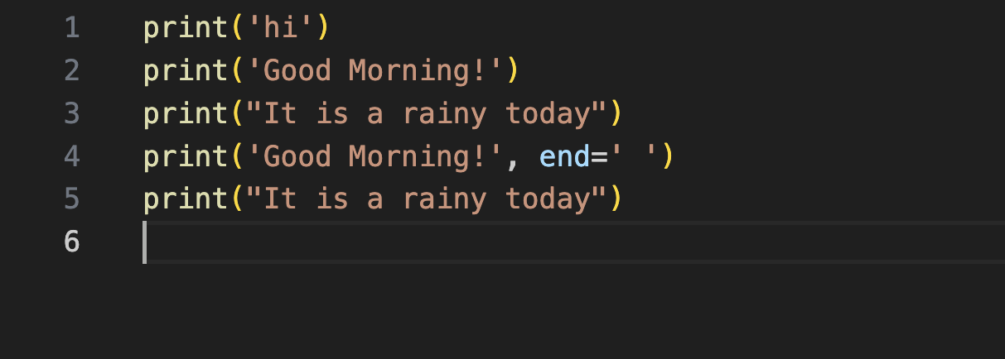
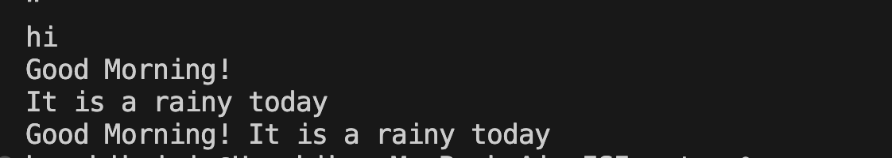
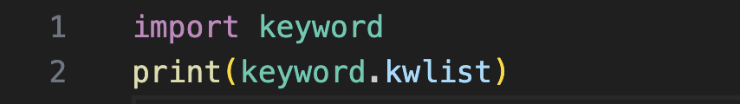
4.Variables
- Variables are containers for storing data values.

- Python allows dynamic reassignment

- One variable can store one value at a time

5.Data Type

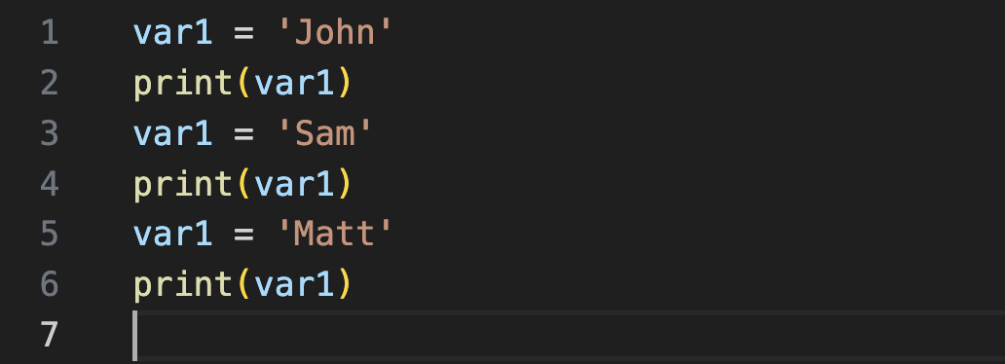
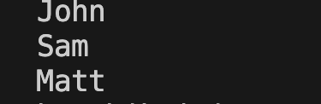
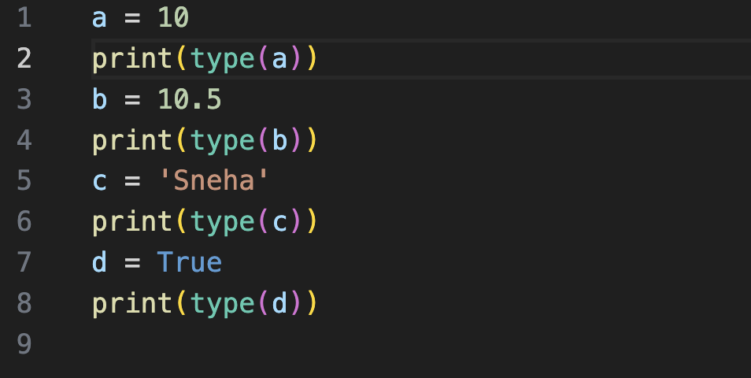
Python is dynamically typed, meaning you don't need to declare the type. We use type() to check the data category.
- int: Whole numbers
- float: Decimals
- str: Text
- bool: True/False

6.Input Statements
In Python, the input() function always accepts user input in string format.
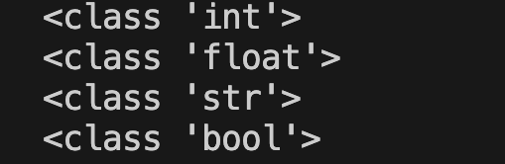

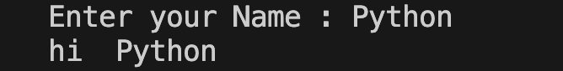
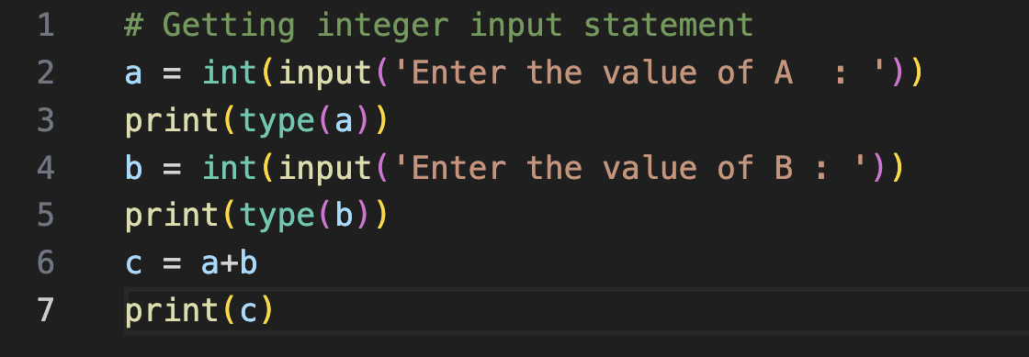
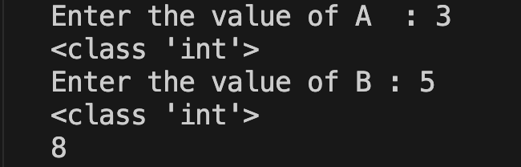
When numerical operations are required, the input must be converted into the appropriate data type using type casting.
This conversion can be done immediately by wrapping the input() function inside data type constructors such as int() or float().

String Input

Integer Input

Float Input

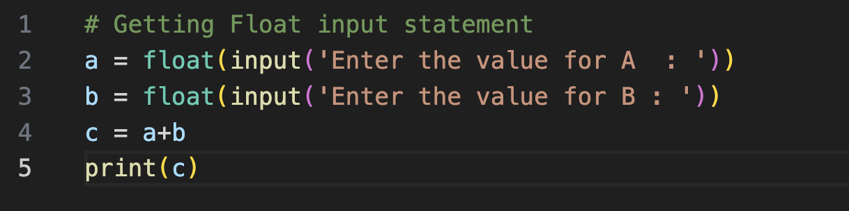
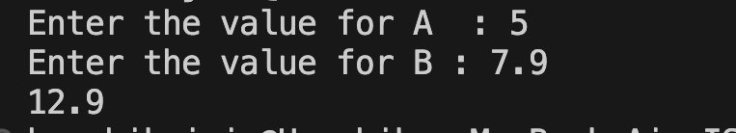
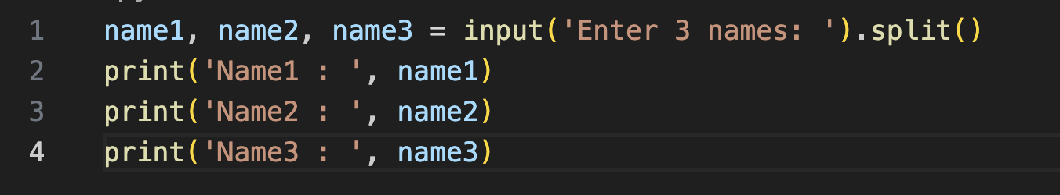
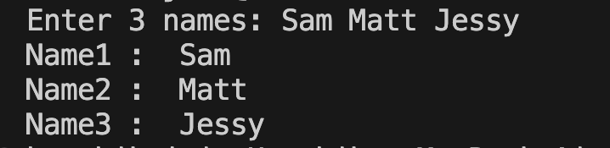
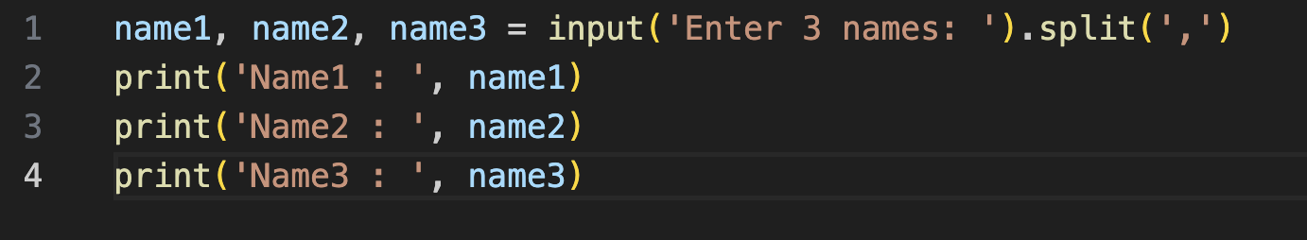
Multiple Inputs in a single line

7.Calender Module
- calendar is a built-in module
- Used to display month/year formats

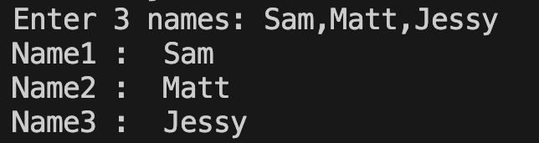
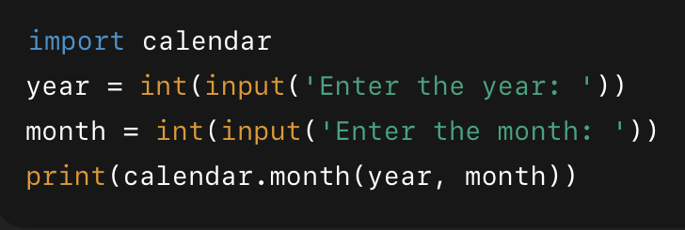
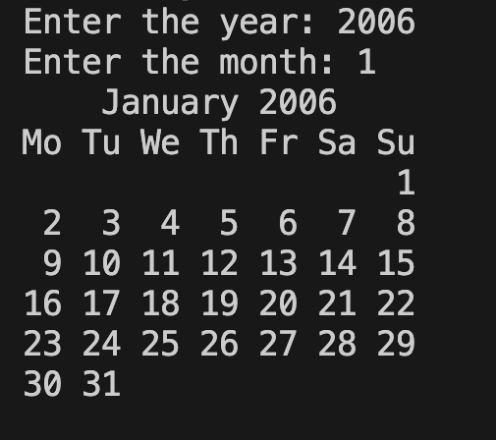
8.String Operations

Common String Functions
- in : output is boolean
- count()
- endswith() : output is boolean
- find()
- replace()

9.String Concatenation
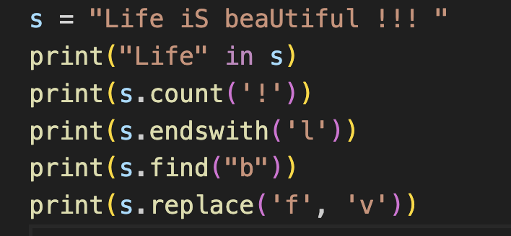
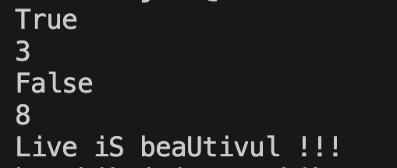
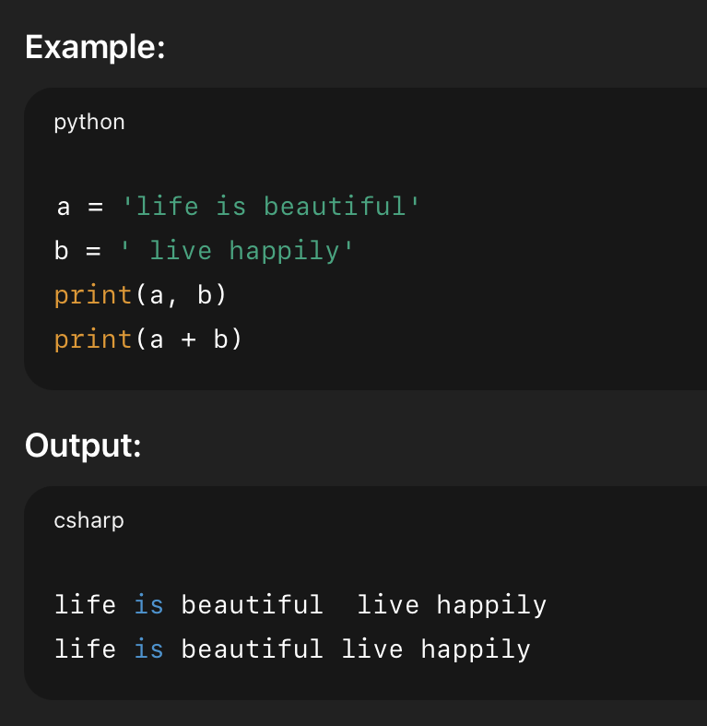
- a + b → concatenates (joins) strings
- print(a,b) → prints multiple strings separated by a space

10.String Formatting
- Using format()
- {} → values are filled in order
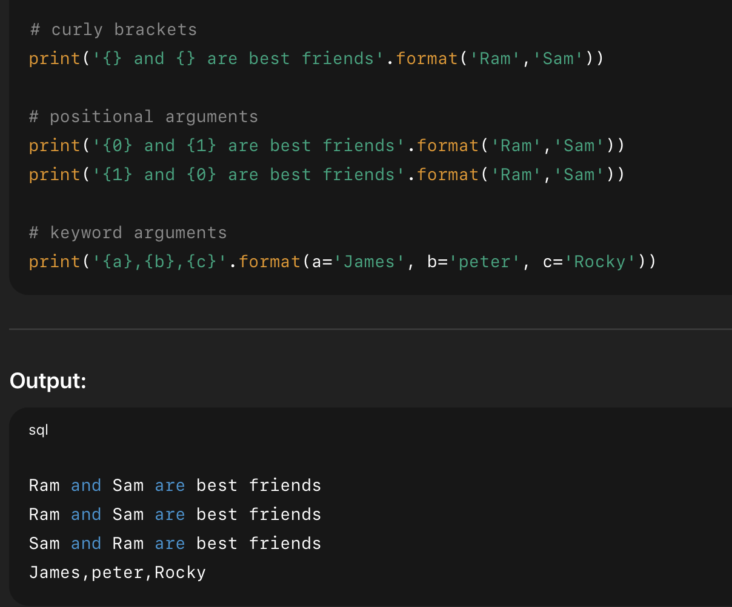
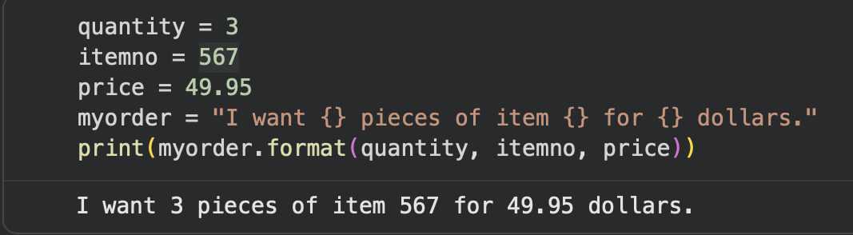
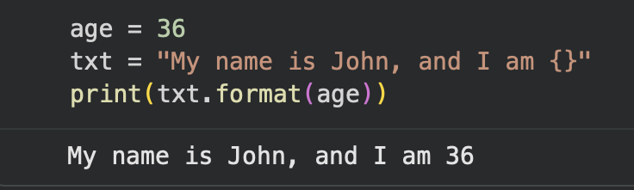
- {0}, {1} → values are filled by index
- {a}, {b}, {c} → values are filled by name (keywords)

11.Conditional Statements

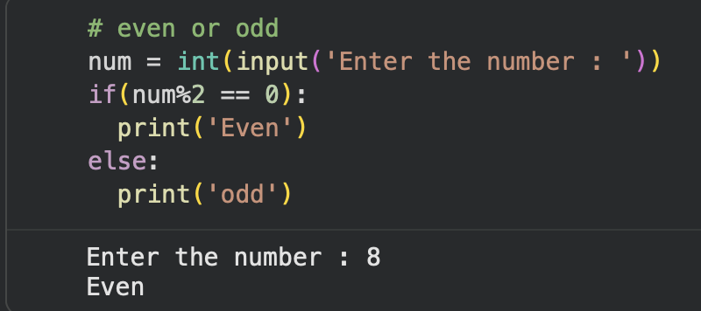
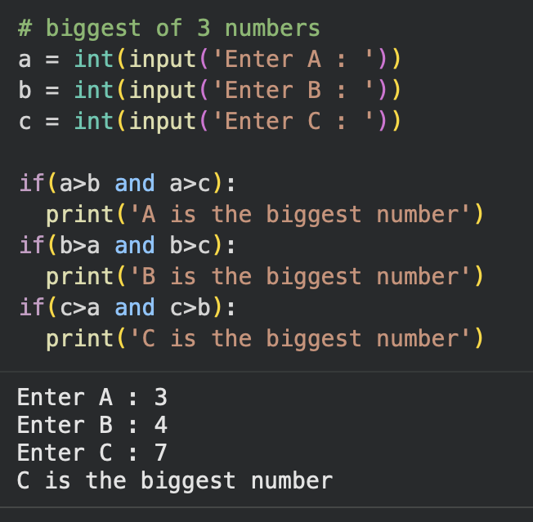
This program checks whether a given number is even or odd using the if–elseconditional statement.The number entered by the user is first converted from string to integer using int()The modulus operator % is used to find the remainder
- If a number is divisible by 2, it is Even
- Otherwise, it is Odd

