Experiment 7: Configuration Management with Ansible:
Basics of Ansible:Inventory, playbooks, and Modules, Automating server Configurations with playbooks, hands-on: Writting and Running a Basic Playbook.

Install Ansible on Ubuntu
Open a terminal and follow these steps:
step 1: Update package lists
sudo apt update

step 2: Install software-properties-common (optional but helpful)
sudo apt install software-properties-common -y

step 3: Add the Ansible PPA
sudo add-apt-repository --yes --update ppa:ansible/ansible

step 4: Fix the locale
sudo locale-gen en_US.UTF-8
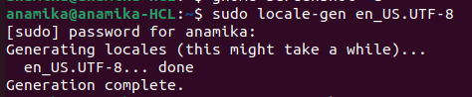

sudo update-locale LANG=en_US.UTF-8
export LANG=en_US.UTF-8
export LC_ALL=en_US.UTF-8
locale
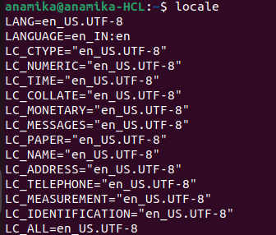

step 5: Install Ansible
sudo apt install ansible -y

step 6: Verify installation
ansible –version
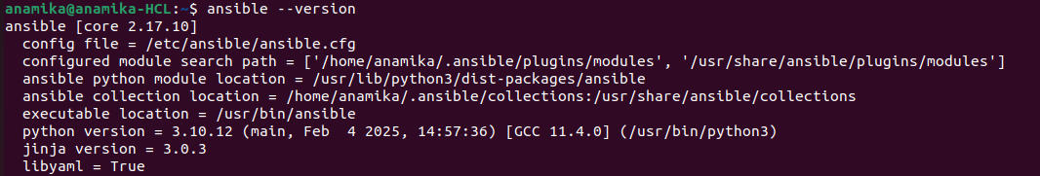
step 7: Create inventory file
vi inventory.ini

code:

[local]
localhost ansible_connection=local

save and exit.

step 8: create yml playbook
vi create-file.yml

code: (note:- indentation code)

---
- name: Create a file on remote hosts
hosts: all
become: true
tasks:
- name: Create a file called /tmp/hello.txt
file:
path: /tmp/hello.txt
state: touch

save and exit.

Run Command:
ansible-playbook -i inventory.ini create-file.yml

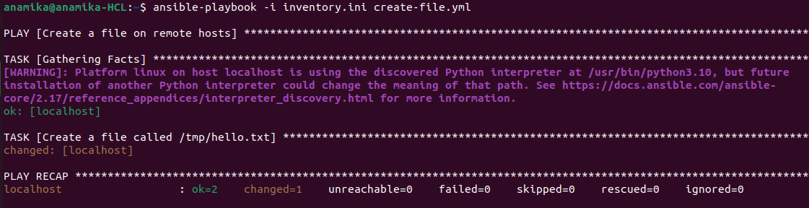

step 8: To verify the result manually

ls -l /tmp/hello.txt
(or)
cat /tmp/hello.txt

Experiment 8: Practical Excercise:
Set up a Jenkins CI Pipeline for a Maven Project, Use Ansible to deploy Artifacts generated by Jenkins
i) Jenkins setup (pipeline for Maven build)
ii) Ansible setup for deployment
iii) Integration between Jenkins and Ansible

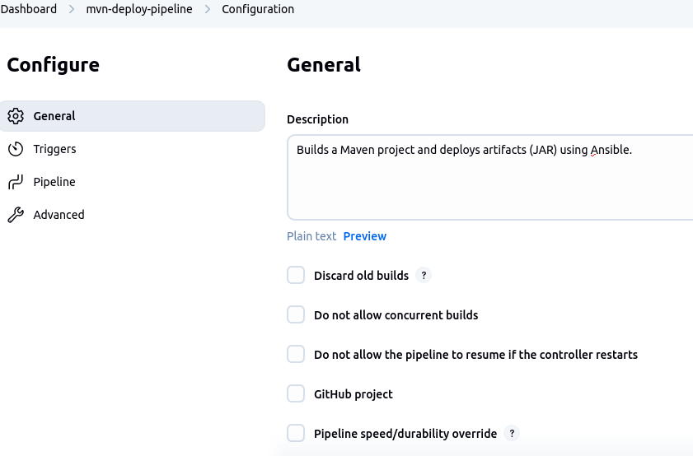

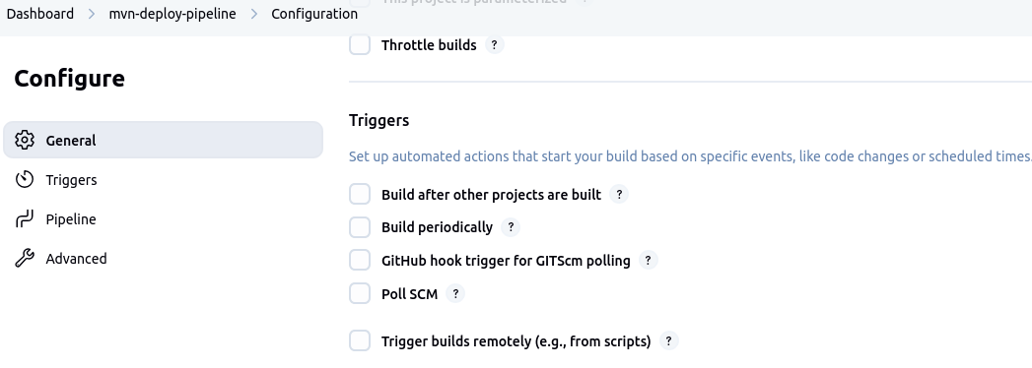
In the trigger section leave uncheck

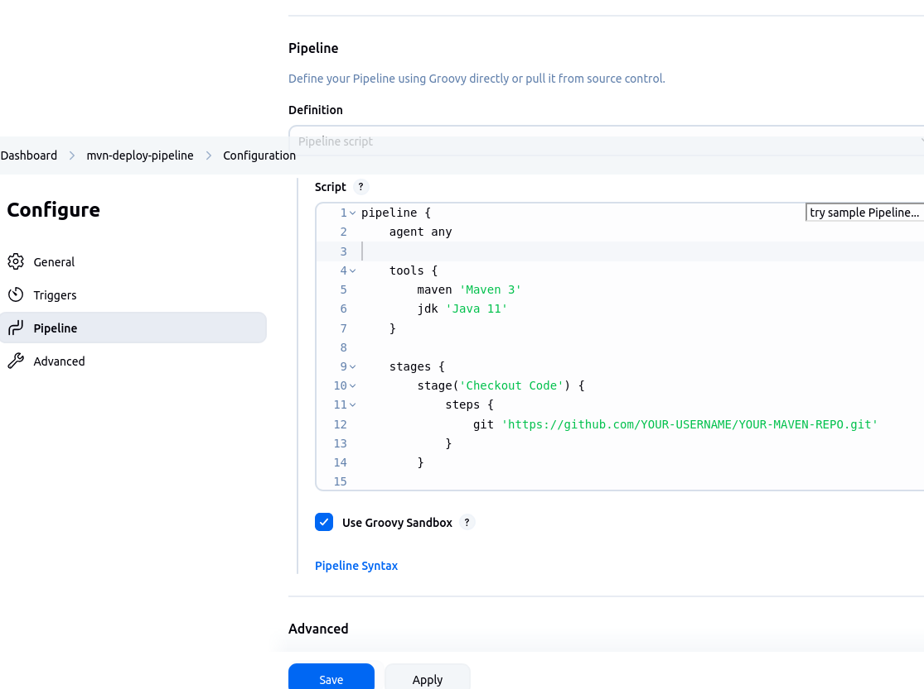
Save the configuration.

Pipeline script: Jenkinsfile
code:

pipeline {
agent any

tools {
maven 'Maven 3'
jdk 'Java 11'
}

stages {
stage('Checkout Code') {
steps {
git 'https://github.com/YOUR-USERNAME/YOUR-MAVEN-REPO.git'
}
}

stage('Build with Maven') {
steps {
sh 'mvn clean package'
}
}

stage('Archive JAR') {
steps {
archiveArtifacts artifacts: 'target/*.jar'
}
}

stage('Deploy using Ansible') {
steps {
sh 'ansible-playbook -i ansible/inventory.ini ansible/deploy.yml'
}
}
}
}

Steps to do in terminal :

1. Move to clean location:
cd ~
mkdir java-projects
cd java-projects

2.Run the Maven Archetype Command Again:
mvn archetype:generate \
-DgroupId=com.example \
-DartifactId=myapp \
-DarchetypeArtifactId=maven-archetype-quickstart \
-DinteractiveMode=false

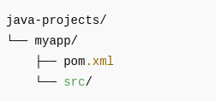

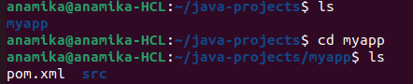

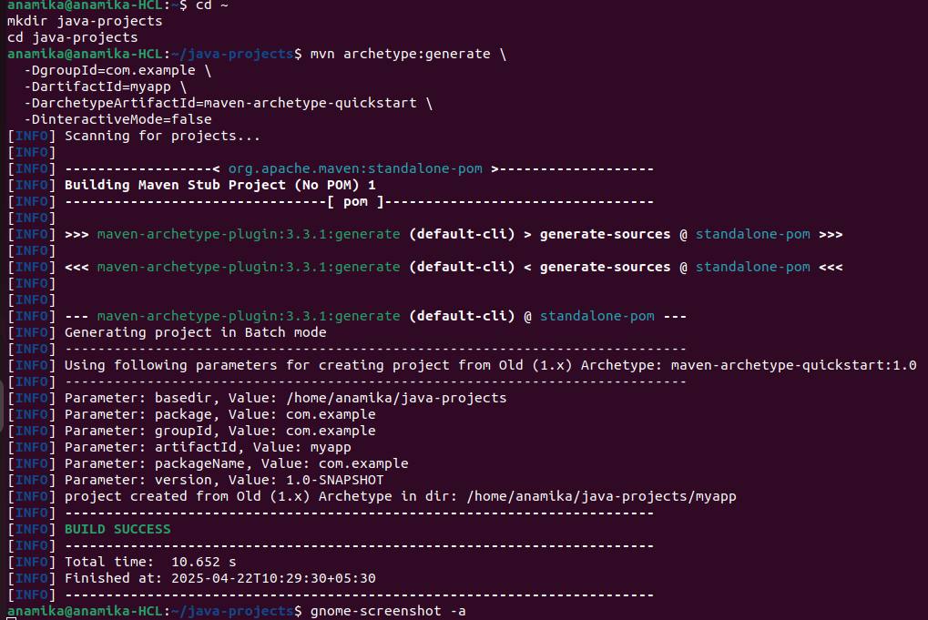

3.Create Jenkinsfile:
touch Jenkinsfile
nano Jenkinsfile

code:

pipeline {
agent any

tools {
maven 'Maven 3' // Make sure this name matches what you added in Jenkins tools
jdk 'Java 11'
}

stages {
stage('Build Maven Project') {
steps {
sh 'mvn clean package'
}
}

stage('Archive Artifact') {
steps {
archiveArtifacts artifacts: 'target/*.jar'
}
}

stage('Deploy with Ansible') {
steps {
sh 'ansible-playbook -i ansible/inventory.ini ansible/deploy.yml'
}
}
}
}

4.Create Ansible Directory and files:
mkdir ansible
cd ansible

5.Create inventory.ini:
nano inventory.ini

code:
[app]
localhost ansible_connection=local

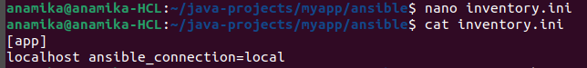

6.After running below command pom.xml should be like this:
mvn clean package

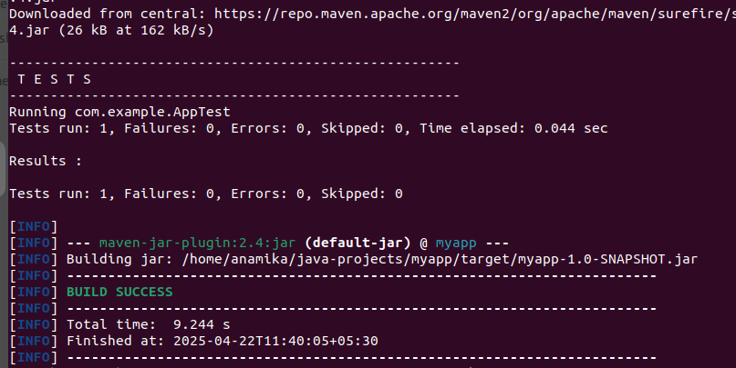
note: (pom.xml will auto cretae, just check properties is added or not. If not add properties)

code:
<project xmlns="http://maven.apache.org/POM/4.0.0"
xmlns:xsi="http://www.w3.org/2001/XMLSchema-instance"
xsi:schemaLocation="http://maven.apache.org/POM/4.0.0
http://maven.apache.org/maven-v4_0_0.xsd">

<modelVersion>4.0.0</modelVersion>
<groupId>com.example</groupId>
<artifactId>myapp</artifactId>
<packaging>jar</packaging>
<version>1.0-SNAPSHOT</version>
<name>myapp</name>
<url>http://maven.apache.org</url>

<properties>
<maven.compiler.source>1.8</maven.compiler.source>
<maven.compiler.target>1.8</maven.compiler.target>
</properties>

<dependencies>
<dependency>
<groupId>junit</groupId>
<artifactId>junit</artifactId>
<version>3.8.1</version>
<scope>test</scope>
</dependency>
</dependencies>

</project>

verify:
ls target
myapp-1.0-SNAPSHOT.jar should exist
7.Create deploy.yml:
cd myapp
(note: install jdk, if not installed
sudo apt install default-jdk )
jar xf target/myapp-1.0-SNAPSHOT.jar META-INF/MANIFEST.MF
cat META-INF/MANIFEST.MF
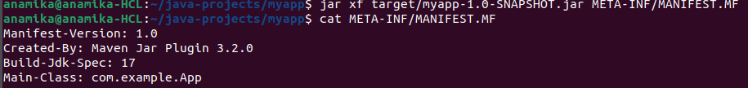
verify Main-Class as above screenshot it should be com.example.App

cp target/myapp-1.0-SNAPSHOT.jar /home/anamika/deploy/myapp.jar
java -jar /home/anamika/deploy/myapp.jar

cd ansible
nano deploy.yml

code:
- name: Deploy Maven JAR
hosts: app
tasks:
- name: Ensure target directory exists
file:
path: /opt/myapp
state: directory
mode: '0755'

- name: Copy JAR file
copy:
src: ../target/myapp-1.0-SNAPSHOT.jar
dest: /opt/myapp/myapp.jar

Save and exit
- - - - - - - - - -- - - - - - - - - - - - - - - - - - - - - - - - - - - - - - - -
nano hosts.ini
code:
[app]
localhost ansible_connection=local

save and exit
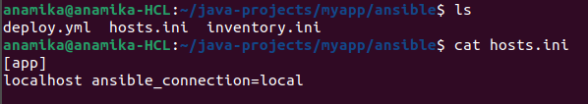

Run Ansible Playbook with below command:
ansible-playbook hosts.ini deploy.yml

