AI Cognitive Study Coach
Intelligent study planning powered by adaptive algorithms,
spaced repetition science, and AI-driven personalized guidance.

Project Overview
The AI Cognitive Study Coach is an intelligent web application built with FastAPI (backend) and Streamlit (frontend) that creates personalized, adaptive daily study plans for students preparing for competitive exams. The platform uses spaced repetition science and AI-powered guidance to help learners study smarter, not harder.
The system bridges the gap between static study schedules and true adaptive learning by continuously updating a student's study plan based on their confidence levels, topic difficulty, and quiz performance feedback. Each topic is prioritized using a multi-factor scoring algorithm and scheduled for revision at scientifically optimal intervals.

Scenario 1: Exam Preparation Planning
Students preparing for board exams, entrance tests, or competitive examinations can use the AI Cognitive Study Coach to generate a personalized daily study roadmap.

By entering their subjects, topics, confidence levels, and exam date, the system builds a priority-ranked study schedule that focuses on the weakest and most difficult topics first. The spaced repetition engine ensures that topics are revisited at optimal intervals — preventing forgetting and reinforcing long-term memory.

For instance, a student preparing for JEE Advanced can enter topics like Calculus (confidence: 2) and Organic Chemistry (confidence: 4). The AI Coach will prioritize Calculus, schedule it for immediate revision, and plan Chemistry for a later date — all automatically. The integrated AI guidance section then provides specific study tips and strategies for each topic.

Scenario 2: Adaptive Feedback-Driven Learning
After each study session, students can submit performance feedback via the platform. The system updates topic confidence scores, recalculates priority rankings, and reschedules future revisions accordingly.

For example, if a student scores 90% on a quiz for a previously weak topic, the system increases its confidence rating, reduces future revision frequency, and reallocates study time to other weaker areas. This creates a truly adaptive learning loop that continuously optimizes the student's study schedule.
This use case demonstrates how the system removes guesswork from exam preparation, enabling students to focus their limited time on exactly what needs attention most.

Architecture Overview
The AI Cognitive Study Coach is a modular, full-stack application designed to intelligently manage student study schedules. It integrates a dynamic Streamlit-based user interface with a FastAPI REST backend, a priority-based study planner, a spaced repetition memory model, and an AI guidance engine powered by the OpenAI API.

Built with a secure dotenv-based configuration system, the platform ensures safe API key management while maintaining a seamless user experience. Its modular architecture separates concern cleanly — user management, study planning, feedback processing, and AI generation are all independent, reusable service layers.

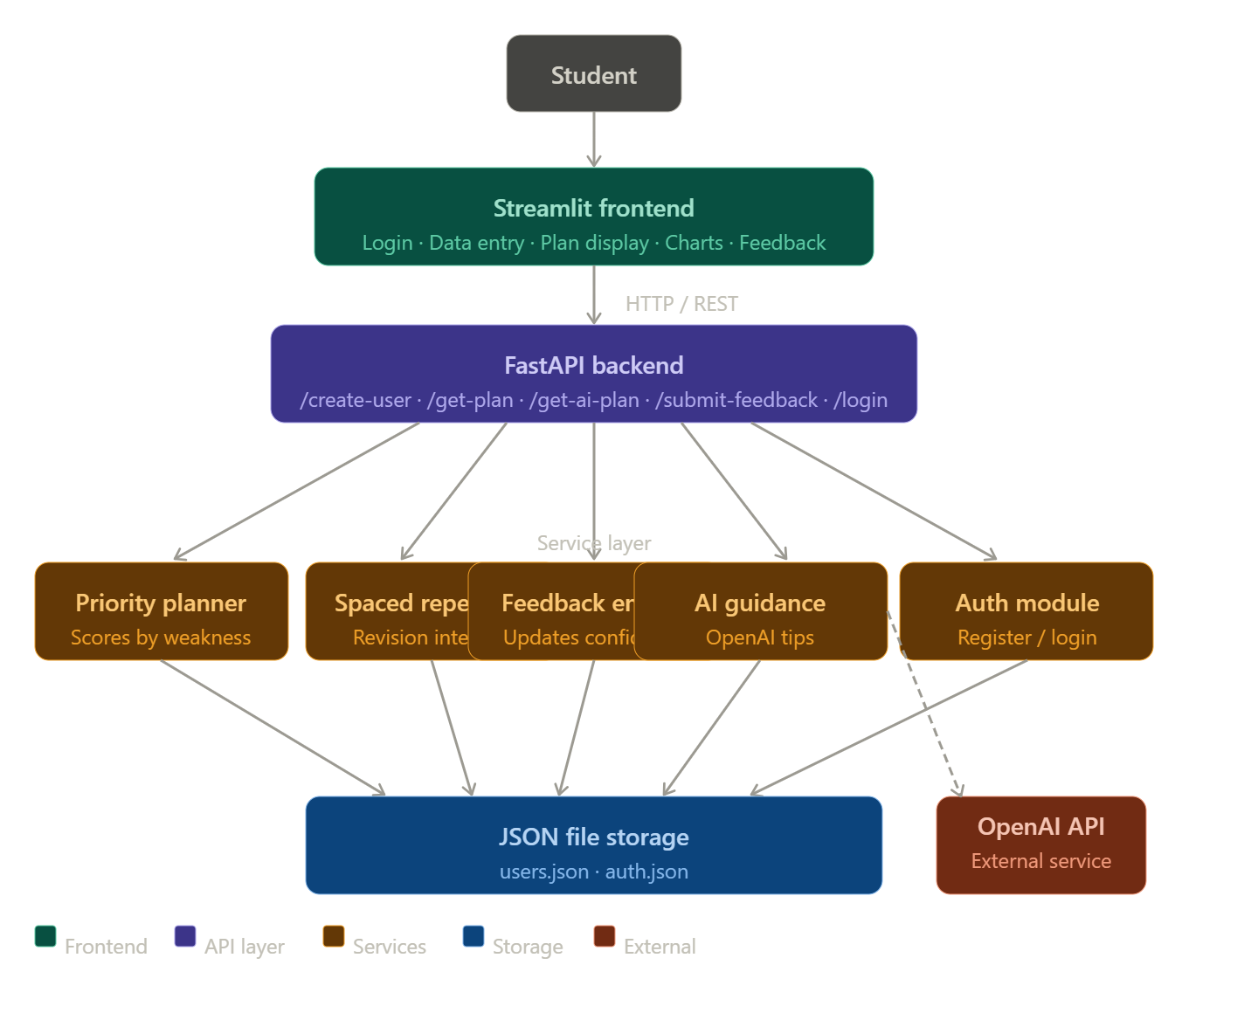
Figure 1: System architecture diagram

Core Technologies
- FastAPI: High-performance Python web framework powering all backend REST API endpoints, handling user data, study plans, and feedback processing.

- Streamlit: Frontend framework for building the interactive user interface — managing data input, plan visualization, charts, and AI guidance display in real time.
- OpenAI API: AI engine used for generating personalized study tips, topic-specific strategies, and learning recommendations based on the student's current study plan.

- Spaced Repetition Engine (custom): An intelligent scheduling module that calculates optimal revision intervals based on topic confidence levels using scientifically proven spacing gaps.

- Pydantic Models: Strict data validation for all incoming user data (User, Subject, Topic models), ensuring data integrity throughout the application.

- JSON File Storage: Lightweight persistence layer using local JSON files (users.json, auth.json) for user data and authentication records.

- python-dotenv: Secure environment variable management for API keys and configuration parameters.

- Plotly / Pandas: Data visualization libraries for generating interactive priority distribution charts and study plan tables in the frontend.

- Passlib / bcrypt: (Recommended upgrade) Password hashing for secure user authentication.

Component-Wise Architecture
Component | Description
User Interface (Streamlit) | Provides an intuitive web interface for data entry, study plan visualization, AI guidance display, progress charts, and feedback submission.
REST API Layer (FastAPI) | Exposes endpoints for user creation, login/registration, plan generation, AI plan retrieval, and feedback submission. Handles CORS for frontend communication.
Priority Planner | Calculates a multi-factor priority score for each topic based on confidence, difficulty, exam urgency, and pending revision status. Sorts and returns a ranked study plan.
Spaced Repetition Engine | Determines next revision dates for each topic based on confidence levels using pre-defined spacing gaps (1/2/4/7 days for low confidence, up to 15 days for high confidence).
AI Guidance Engine | Sends the generated study plan to OpenAI API and returns personalized study tips, topic-specific advice, and recommended strategies for each item.
Feedback Processor | Applies student quiz scores to update topic confidence levels and recalculates revision schedules, creating an adaptive feedback loop.
User Data Manager | Handles JSON-based persistence — saving and loading user profiles, subject/topic data, confidence levels, and revision schedules.
Authentication Module | Manages user registration and login using username/password credentials stored in a local JSON file.
Pre-requisites

1. Python Environment Setup
The system is built using Python 3.9 or above. Create and activate a dedicated virtual environment to manage dependencies cleanly.

# Create virtual environment
python -m venv venv
# Activate (Windows)
venv\Scripts\activate
# Activate (macOS/Linux)
source venv/bin/activate

2. Backend Framework: FastAPI
FastAPI powers all backend REST endpoints. It provides automatic Open API documentation, async support, and Pydantic-based data validation.
Official Documentation: https://fastapi.tiangolo.com/

3. Frontend: Streamlit
Streamlit powers the interactive web interface for study plan display, charts, and AI guidance. It requires no separate frontend build process.
Documentation: https://docs.streamlit.io/

4. OpenAI API Integration
The AI guidance feature uses the OpenAI API. Set up an account at https://platform.openai.com, generate an API key, and store it securely in a .env file.

# backend/.env
OPENAI_API_KEY=your_openai_api_key_here

5. Dependency Installation
All dependencies are listed in requirements.txt. Install them with:

pip install -r requirements.txt

Key libraries include:
- FastAPI — REST API backend framework
- uvicorn — ASGI server to run FastAPI
- Streamlit — Interactive frontend UI
- OpenAI — OpenAI API client for AI guidance
- python-dotenv — Secure environment variable loading
- pandas — Data manipulation and tabular display
- plotly — Interactive charts and visualizations

6. Running the Application
# Terminal 1 — Start the FastAPI backend
uvicorn backend.main:app --reload --port 8001
# Terminal 2 — Start the Streamlit frontend
Streamlit run frontend/app.py

7. Development Tools
Recommended IDEs:
- Visual Studio Code: https://code.visualstudio.com/
- PyCharm (Community Edition): https://www.jetbrains.com/pycharm/download/
Recommended extensions: Python, Pylance, REST Client (for testing FastAPI endpoints)

Project Flow

1. User Registration and Authentication
- Activity 1.1: User registers via the Streamlit UI — credentials are saved to data/auth.json via the /register FastAPI endpoint.
- Activity 1.2: User logs in via /login — session state is maintained in Streamlit to gate access to all features.
- Activity 1.3: On successful login, the full study coach interface is revealed (dashboard, plan generator, feedback system, AI coach).

2. User Profile and Study Data Setup
- Activity 2.1: User enters name, exam date, and daily study hours in the sidebar.
- Activity 2.2: User inputs subject names, topics, difficulty (1–5), and self-assessed confidence (1–5) via the main form.
- Activity 2.3: On clicking 'Save Data', the frontend POSTs to /create-user. The backend assigns a next_revision date to each topic using the Spaced Repetition Engine and saves the full profile to data/users.json.

3. Study Plan Generation
- Activity 3.1: On clicking 'Generate Plan', the frontend calls GET /get-plan.
- Activity 3.2: The Priority Planner calculates a multi-factor score for each topic: weakness × 3 + difficulty × 2 + urgency + revision_bonus.
- Activity 3.3: Topics are sorted highest-priority-first and returned as a structured plan.
- Activity 3.4: The frontend displays each topic with priority score, confidence level, progress bars, and a Plotly donut chart.

4. AI Guidance Generation
- Activity 4.1: On clicking 'Get AI Guidance', the frontend calls GET /get-ai-plan.
- Activity 4.2: The backend generates the plan, sends it to the OpenAI API with a structured prompt requesting personalized study tips.
- Activity 4.3: AI-generated guidance is returned and displayed in the Streamlit info box with topic-by-topic recommendations.

5. Feedback Submission and Adaptive Update
- Activity 5.1: After studying, the user submits a quiz score (0–100%) for a specific subject/topic via the Feedback section.
- Activity 5.2: The backend calls apply_feedback() — scores ≥ 80% raise confidence, scores ≤ 50% lower it (capped between 1 and 5).
- Activity 5.3: The Spaced Repetition Engine recalculates the next revision date based on the updated confidence level.
- Activity 5.4: Updated user data is saved and the adaptive loop continues, re-prioritizing topics on the next plan generation.

MILESTONE 1: User Authentication and Data Setup

This foundational milestone establishes the user management infrastructure — registration, login, and study profile creation. The platform requires authenticated access, ensuring each user's study data is private and persistent across sessions.

Activity 1.1: User Registration
The registration flow is implemented across two layers: the Streamlit UI collects credentials and the FastAPI /register endpoint validates and saves them.

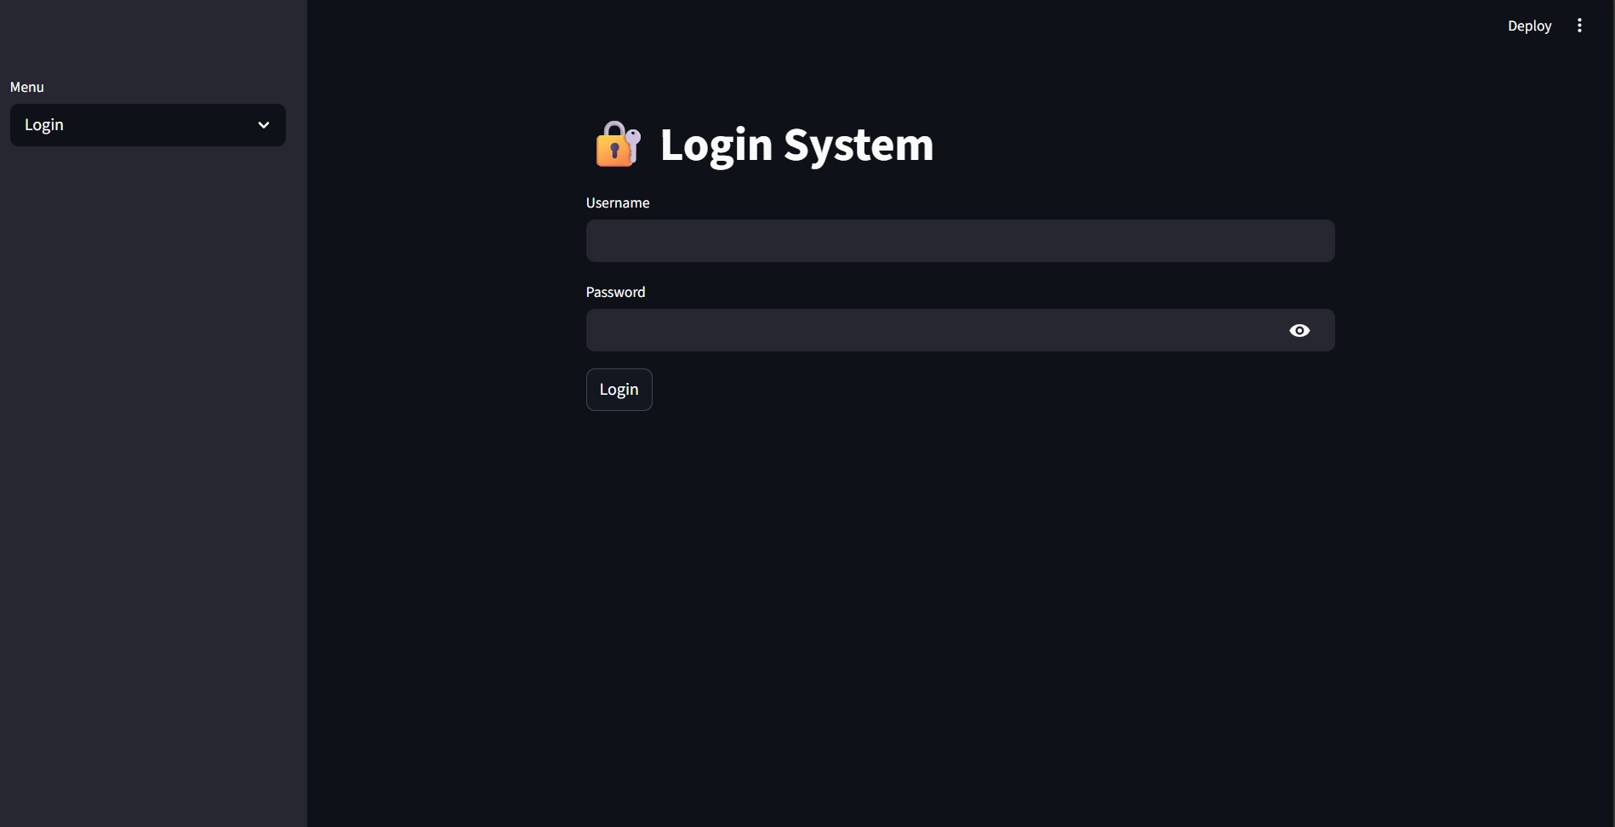
Figure 2: Streamlit Registration / Login Screen

Code reference — FastAPI /register endpoint (backend/main.py):

@app.post('/register')
def register(username: str, password: str):
success = register_user(username, password)

if success:
return {'message': 'User registered'}
else:

return {'error': 'User already exists'}

Code reference — Auth utility (backend/utils/auth.py):

def register_user(username, password):
users = load_users()
if username in users:

return False
users[username] = password
save_users(users)

return True

Activity 1.2: User Login and Session Management
On successful login, Streamlit's session state is updated, gating access to all application features. A logout option is available in the sidebar.

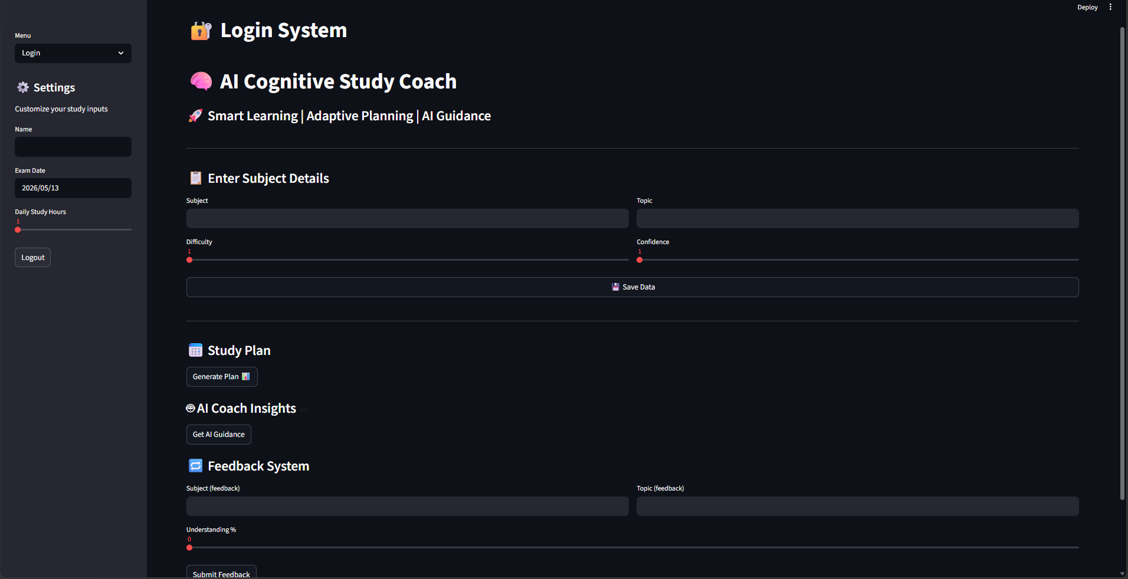
Figure 3: Streamlit Login Success and Dashboard View

Activity 1.3: Study Profile Creation
After login, users enter their exam details and topic data. The /create-user endpoint processes and enriches this data with spaced repetition scheduling before saving.

The User, Subject, and Topic Pydantic models (backend/models/user_model.py) enforce strict validation:
class Topic(BaseModel):
name: str
difficulty: int # 1–5

confidence: int # 1–5
last_studied: Optional[str] = None
next_revision: Optional[str] = None
class Subject(BaseModel):
name: str
topics: List[Topic]
class User(BaseModel):
name: str
exam_date: str
daily_hours: int
subjects: List[Subject]

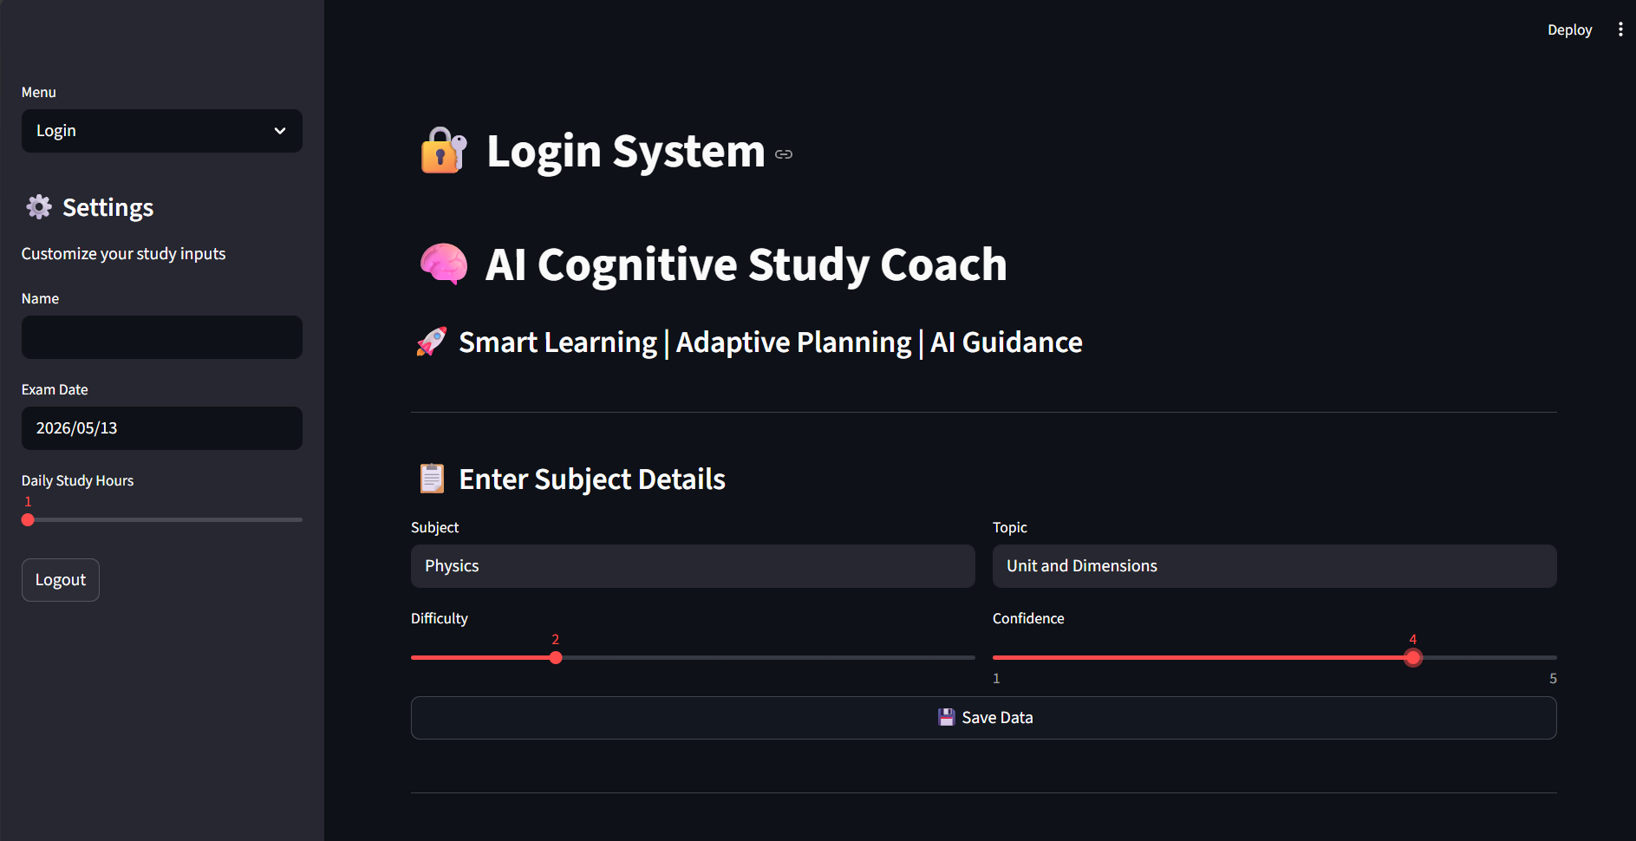
Figure 4: Subject and Topic Data Entry Form

MILESTONE 2: Spaced Repetition Memory Model
This milestone implements the core intelligence layer of the study coach — the Spaced Repetition Engine. Based on established cognitive science research, this system schedules topic revisions at increasing intervals as confidence grows, minimizing forgetting and maximizing long-term retention.
Activity 2.1: Revision Gap Calculation
The get_revision_gaps() function maps confidence levels (1–5) to revision intervals. Lower confidence means more frequent reviews; higher confidence means wider gaps:

def get_revision_gaps(confidence):
if confidence <= 2:
return [1, 2, 4, 7] # Very frequent review

elif confidence == 3:
return [1, 3, 5, 10]
else:

return [2, 5, 10, 15] # Wider gaps for strong topics

Activity 2.2: Revision Schedule Generation
The generate_revision_schedule() function builds a complete 4-date revision timeline from today:
def generate_revision_schedule(confidence):
today = datetime.now()
gaps = get_revision_gaps(confidence)

schedule = []
for gap in gaps:
next_date = today + timedelta(days=gap)

schedule.append(next_date.strftime('%Y-%m-%d'))
return schedule

Activity 2.3: Next Revision Assignment
When a user profile is created or feedback is applied, get_next_revision() assigns the immediate next revision date to each topic. This date is stored in the users.json file and used by the priority planner.
def get_next_revision(confidence):
return generate_revision_schedule(confidence)[0]

Spaced Repetition Logic Summary
Confidence 1–2: Review in 1, 2, 4, 7 days | Confidence 3: Review in 1, 3, 5, 10 days | Confidence 4–5: Review in 2, 5, 10, 15 days

MILESTONE 3: Priority-Based Study Plan Generation

This milestone implements the Priority Planner — the algorithmic heart of the study coach. It calculates a composite priority score for every topic and generates a ranked daily study plan, ensuring students always know exactly what to study first.

Activity 3.1: Priority Score Calculation
The calculate_priority() function computes a multi-factor score for each topic using four weighted signals:

def calculate_priority(topic, exam_date):
today = datetime.now().strftime('%Y-%m-%d')
exam = datetime.strptime(exam_date, '%Y-%m-%d')

days_left = (exam - datetime.now()).days
weakness = 5 - topic['confidence'] # Weight x3
difficulty = topic['difficulty'] # Weight x2

urgency = max(0, 15 - days_left) # Ramps as exam nears
revision_bonus = 0
if topic.get('next_revision'):

if topic['next_revision'] <= today:
revision_bonus = 8 # Overdue topics boosted
priority = (weakness * 3) + (difficulty * 2) + urgency + revision_bonus
return priority

Priority Factor Breakdown:
- Weakness (confidence gap): The primary driver — low confidence scores get boosted most strongly (multiplied by 3).
- Difficulty: Harder topics get higher priority (multiplied by 2).
- Urgency: Increases linearly as the exam date approaches (within 15 days).
- Revision Bonus: A flat +8 bonus for topics whose scheduled revision date has been reached or passed.

Activity 3.2: Plan Generation and Sorting
The generate_plan() function iterates through all subjects and topics, scores each one, and returns a list sorted highest-priority-first:
def generate_plan(user_data):
plan = []
for subject in user_data['subjects']:

for topic in subject['topics']:
score = calculate_priority(topic, user_data['exam_date'])
plan.append({

'subject': subject['name'],
'topic': topic['name'],
'priority': score,
'confidence': topic['confidence']

})
return sorted(plan, key=lambda x: x['priority'], reverse=True)

Activity 3.3: Study Plan Display in Streamlit
The generated plan is displayed in the Streamlit frontend with topic cards showing priority scores, confidence levels, progress bars, and an interactive Plotly donut chart for visual priority distribution.

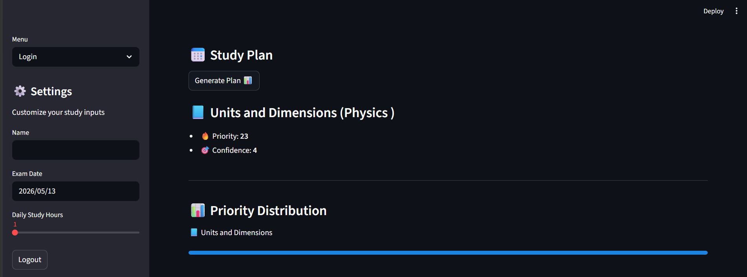
Figure 5: Generated Study Plan with Priority Cards and Progress Bars

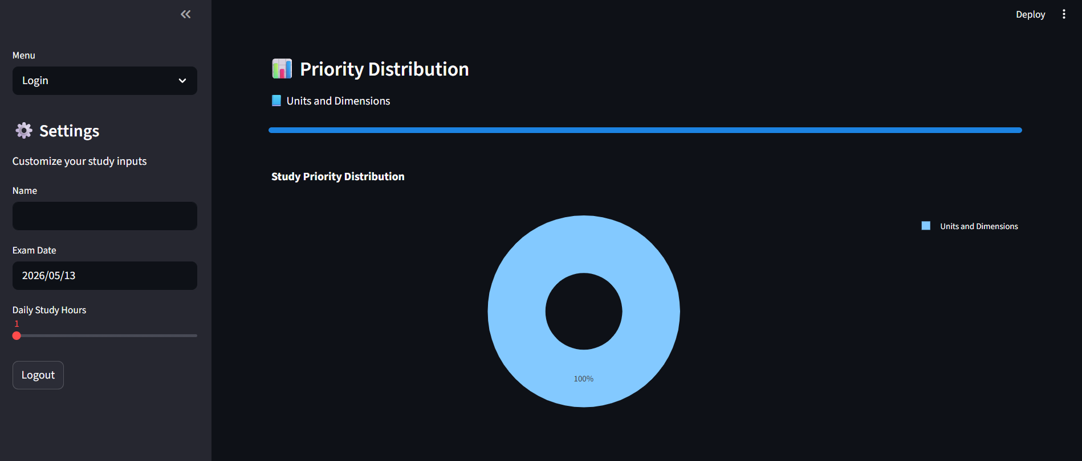
Figure 6: Plotly Priority Distribution Donut Chart

MILESTONE 4: AI Guidance Engine
This milestone integrates the OpenAI API to transform the raw study plan into rich, personalized guidance. The AI engine analyzes each topic's priority and confidence level and generates specific study strategies, tips, and recommended approaches for the student.

Activity 4.1: OpenAI API Configuration
The genai.py service loads the OpenAI API key securely from the backend/.env file using python-dotenv:

from openai import OpenAI
from dotenv import load_dotenv
from pathlib import Path

import os
env_path = Path(__file__).resolve().parent.parent / '.env'
load_dotenv(dotenv_path=env_path)
api_key = os.getenv('OPENAI_API_KEY')
client = OpenAI(api_key=api_key)

Activity 4.2: AI Plan Generation
The generate_ai_plan() function takes the priority-sorted plan and formats personalized, human-readable study guidance for each topic:
def generate_ai_plan(plan):
response = ''
for item in plan:

response += f'''
📘 Study: {item['topic']} ({item['subject']})
→ Reason: Low confidence ({item['confidence']}) and high priority
→ Tip: Practice questions and revise key concepts

'''
return response

Activity 4.3: AI Plan Display
The /get-ai-plan endpoint first generates the priority plan, passes it to the AI engine, and returns formatted guidance. The Streamlit frontend displays this in a highlighted info box under the 'AI Coach Insights' section.

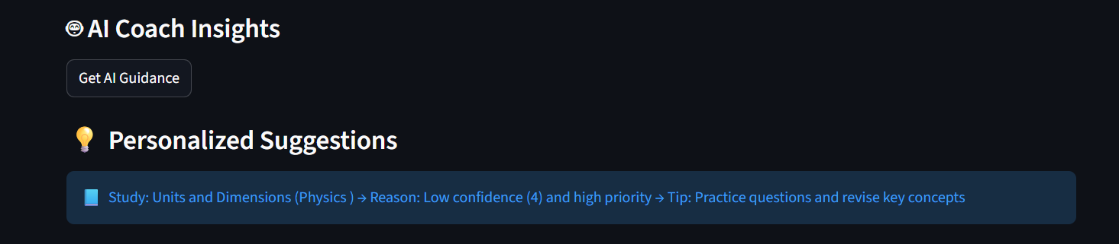
Figure 7: AI Coach Insights Section with Personalized Study Tips

MILESTONE 5: Adaptive Feedback System
This milestone implements the adaptive feedback loop — the mechanism that makes the study coach truly intelligent and personalized over time. Students submit performance scores after study sessions, and the system automatically adjusts confidence ratings, reprioritizes topics, and reschedules revisions.

Activity 5.1: Feedback Submission Interface
The Streamlit feedback section allows students to select a subject, topic, and submit a performance score (0–100%). The data is sent to the /submit-feedback FastAPI endpoint.

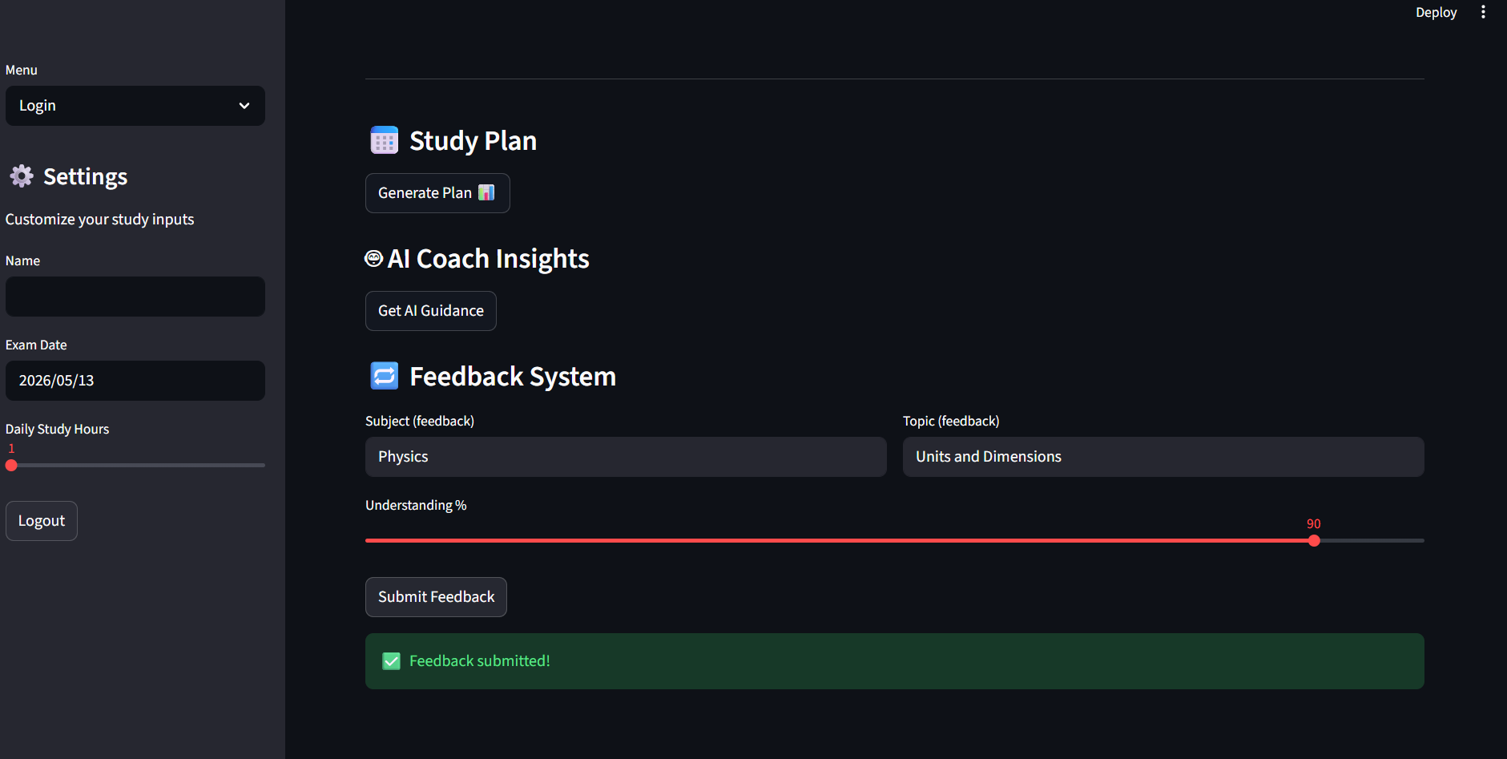
Figure 8: Feedback Submission Form in Streamlit

Activity 5.2: Confidence Level Update
The apply_feedback() function in feedback.py processes the score and updates the topic's confidence:

def apply_feedback(user_data, subject_name, topic_name, feedback_score):
for subject in user_data['subjects']:
if subject['name'].lower() == subject_name.lower():

for topic in subject['topics']:
if topic['name'].lower() == topic_name.lower():
# Update confidence based on score

if feedback_score >= 80:
topic['confidence'] += 1
elif feedback_score <= 50:
topic['confidence'] -= 1
# Clamp to valid range
topic['confidence'] = max(1, min(5, topic['confidence']))
# Recalculate next revision
topic['next_revision'] = get_next_revision(topic['confidence'])
return user_data

Activity 5.3: Adaptive Loop Completion
After feedback is applied, the updated user profile is saved to data/users.json. The next time the student generates a study plan, the newly updated confidence levels and revision dates are used — creating a continuously improving, self-adapting study schedule.

Feedback Score Rules:
- Score ≥ 80%: Confidence increases by 1 (up to max 5) → topic revised less frequently
- Score ≤ 50%: Confidence decreases by 1 (down to min 1) → topic scheduled for urgent revision
- Score 51–79%: No change to confidence — topic stays on its current revision schedule

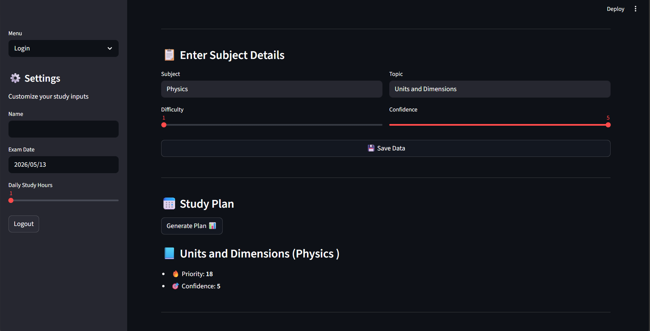
Figure 9: Updated Study Plan After Feedback Submission

MILESTONE 6: Testing & Optimization
This milestone validates the reliability, accuracy, and adaptiveness of the AI Cognitive Study Coach across all core workflows. Testing covers API endpoint correctness, priority algorithm accuracy, spaced repetition scheduling, and frontend responsiveness.

Activity 6.1: API Endpoint Testing
All FastAPI endpoints are testable via the auto-generated Swagger UI at http://127.0.0.1:8001/docs. Key endpoints to validate:
- POST /create-user — Verify next_revision is correctly assigned to each topic.
- GET /get-plan — Confirm topics are sorted correctly by calculated priority score.
- POST /submit-feedback — Verify confidence updates and revision rescheduling.
- GET /get-ai-plan — Confirm AI guidance is generated for each plan item.
- POST /register and POST /login — Validate auth flow and error handling.

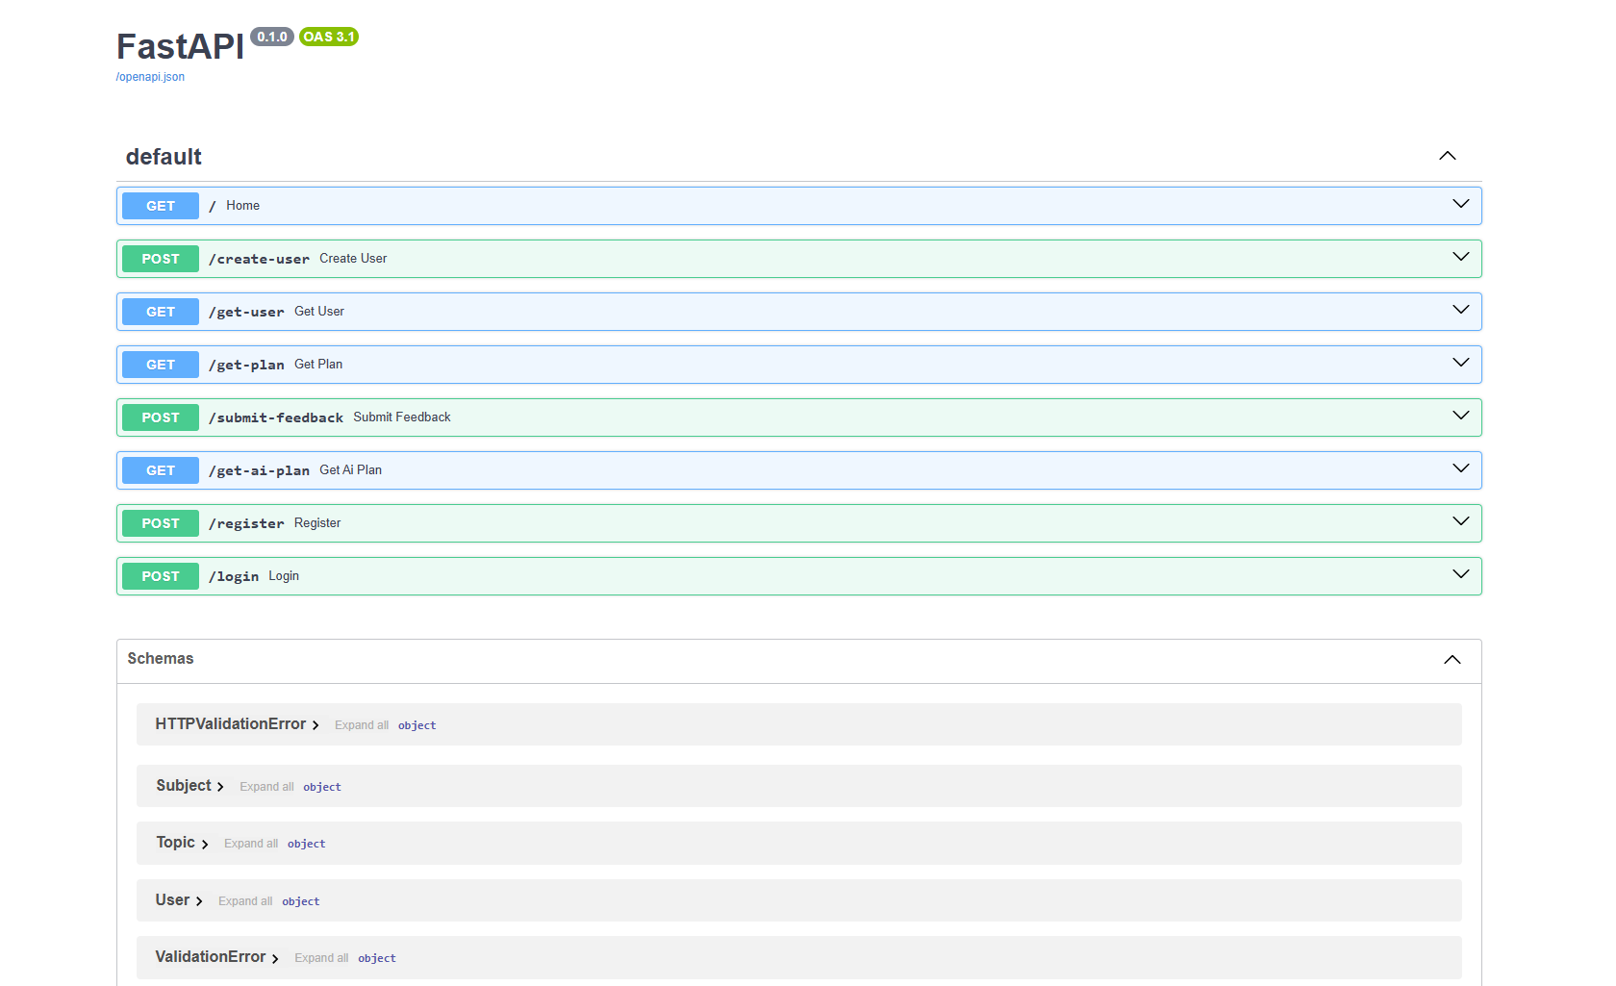
Figure 10: FastAPI Swagger UI — Endpoint Testing

Activity 6.2: Priority Algorithm Validation
Test the priority calculation with edge cases:
- Low confidence + high difficulty + overdue revision → should score highest (20+ points).
- High confidence + low difficulty + no revision due → should score lowest.
- Exam in 1 day → urgency component should be maxed at 14.

Activity 6.3: Spaced Repetition Accuracy
Validate that revision dates are correctly assigned on user creation and updated correctly after feedback:
- Confidence 1 → next revision: today + 1 day
- Confidence 3 → next revision: today + 1 day
- Confidence 5 → next revision: today + 2 days

Activity 6.4: Frontend UI/UX Validation
- Ensure login gates all features correctly (st.stop() blocks unauthenticated access).
- Verify charts render correctly with Plotly after plan generation.
- Confirm feedback form input fields clear and success message appears after submission.
- Validate that the sidebar logout button resets session state and returns to login screen.

Conclusion
The AI Cognitive Study Coach represents a significant step forward in intelligent, adaptive exam preparation technology. By combining a priority-based planning algorithm, scientifically proven spaced repetition scheduling, and AI-driven personalized guidance, the platform empowers students to study smarter — not just harder.

Built on a clean, modular architecture with FastAPI and Streamlit, the application delivers a seamless full-stack experience. The backend's layered service design (planner, memory model, feedback processor, AI engine) makes each component independently testable, maintainable, and extensible.

The adaptive feedback loop is particularly impactful — transforming a static study schedule into a living, continuously improving plan that reflects each student's actual learning progress. As confidence grows and weaknesses are addressed, the system automatically redistributes study time to where it matters most.

Beyond its current capabilities, the AI Cognitive Study Coach has significant potential for future expansion:
- Multi-user support with a proper database backend (PostgreSQL / SQLite)
- Deep GPT-4 integration for context-aware, resource-specific study advice
- Quiz integration for automatic score capture and feedback processing
- Mobile-responsive PWA version for on-the-go access
- Progress analytics and learning curve visualization over time
- Collaborative features for study groups and teacher-student dashboards

In essence, this project demonstrates how thoughtfully engineered AI and data-driven algorithms can bridge the gap between generic study plans and truly personalized, adaptive learning — giving every student the intelligent study coach they deserve.

