AI Disease Prediction System
Smart Health Risk Analysis using Machine Learning

Project Overview
The AI Disease Prediction System is an intelligent web application that leverages Machine Learning to predict the likelihood of three major health conditions: Heart Disease, Diabetes, and Liver Disease. Built using Python and powered by a Random Forest Classifier, the system accepts clinical parameters as input and delivers instant risk assessments through two distinct interfaces — a Flask-based web application and a Streamlit dashboard.

This system bridges the gap between clinical data and actionable insights by allowing healthcare professionals, patients, and researchers to receive quick, data-driven assessments based on real-world medical datasets. The project includes pre-trained ML models trained on established public health datasets (PIMA Diabetes, Heart Disease, and Indian Liver Patient datasets).

Scenario 1: Clinical Decision Support
Healthcare professionals and medical practitioners can use the AI Disease Prediction System to quickly assess patient risk profiles based on clinical test results. By entering parameters such as glucose levels, blood pressure, BMI, cholesterol, and liver enzyme markers, the system provides an immediate risk classification that can aid in prioritizing further diagnostic tests.

For example, a physician reviewing a patient's blood work can enter the relevant values into the prediction form, and within seconds receive a risk classification — High Risk or Low Risk — for heart disease, diabetes, or liver conditions. This helps triage patients more efficiently and ensures that high-risk individuals receive prompt attention.

Scenario 2: Personal Health Monitoring
Individuals seeking to understand their health risk levels can use this system as a self-assessment tool. By inputting their medical test results from routine health check-ups, users can get a preliminary risk indication for the three covered diseases.

For instance, a person who recently received blood test results can enter their values into the Streamlit dashboard, select the relevant disease prediction, and instantly receive feedback on their risk level. This use case demonstrates how the system empowers individuals to take a proactive approach to their health management.

Architecture Overview
The AI Disease Prediction System is a full-stack ML application built on a layered architecture. The system integrates a dual-interface frontend (Flask HTML/CSS templates and a Streamlit dashboard) with a robust Python backend powered by pre-trained scikit-learn Random Forest models serialized using joblib. The modular design separates concerns into data processing, model training, model serving, and UI rendering layers.

The application follows a request-response pattern: user inputs are collected through the UI layer, pre-processed into numerical feature vectors, passed to the appropriate ML model for inference, and the prediction result is returned and displayed to the user. Both the Flask and Streamlit interfaces share the same underlying trained models stored in the models/ directory.

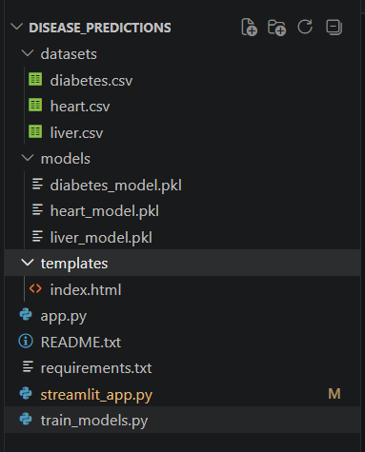
Figure 1: System Architecture Diagram

Core Technologies
Component | Description
Flask | Lightweight Python web framework used to build the primary web interface with HTML templates, handling POST requests for disease prediction.
Streamlit | Python-based frontend framework providing an interactive dashboard alternative with real-time sliders, dropdowns, and instant predictions.
Scikit-learn | Machine learning library used to train and evaluate the Random Forest Classifier models for all three disease predictions.
Joblib | Serialization library used to save trained ML models to .pkl files and load them efficiently at inference time.
Pandas / NumPy | Data manipulation libraries used in model training scripts for loading CSV datasets, feature engineering, and array operations.
HTML / CSS / JS | Frontend technologies used in Flask's Jinja2 templates to build a responsive, styled multi-disease prediction interface.

Component-Wise Architecture
Component | Description
Flask Web App (app.py) | Serves HTML templates via Jinja2, handles /predict POST endpoint, loads serialized models, and returns prediction results as rendered HTML responses.
Streamlit Dashboard (streamlit_app.py) | Provides an interactive alternative UI with sidebar controls and real-time predictions displayed using st.error() and st.success() components.
ML Model Training (train_models.py) | Trains three separate Random Forest Classifiers on preprocessed datasets for Heart Disease, Diabetes, and Liver Disease, and serializes them to .pkl files.
Pre-trained Models (models/) | Directory containing three .pkl files: heart_model.pkl, diabetes_model.pkl, and liver_model.pkl, loaded at application startup for inference.
HTML Template (templates/index.html) | Dynamic Jinja2 form template with JavaScript-driven section visibility, presenting disease-specific input fields and rendering the prediction text result.
Datasets (datasets/) | CSV files for Diabetes (diabetes.csv — 768 records, 9 features) and Liver Disease (liver.csv — 583 records, 11 features) used in model training.

Pre-requisites

1. Python Environment Setup
The system is built using Python 3.8 or above. Create and activate a dedicated virtual environment to manage dependencies and avoid conflicts with other projects.
- Install Python: https://www.python.org/downloads/
- Create virtual environment: python -m venv disease_predictor_env
- Activate (Windows): disease_predictor_env\Scripts\activate
- Activate (Linux/Mac): source disease_predictor_env/bin/activate

2. Flask Installation
Flask powers the primary web interface. Install Flask and configure the development server to serve the disease prediction forms.
pip install flask
- Official Docs: https://flask.palletsprojects.com/

3. Streamlit Installation
Streamlit provides the interactive dashboard interface with real-time prediction capabilities and visual styling.
pip install Streamlit
- Official Docs: https://docs.streamlit.io/
- Run command: python -m Streamlit run streamlit_app.py

4. Machine Learning Libraries
Scikit-learn, pandas, NumPy, and joblib are required for model training, data processing, and model serialization.
pip install scikit-learn pandas NumPy joblib

5. Dependency Installation
All dependencies are listed in requirements.txt. Install them all at once using:
pip install -r requirements.txt

Key libraries in requirements.txt:
- flask — Web framework for the primary interface
- pandas — Data loading and manipulation
- NumPy — Numerical array operations
- scikit-learn — Random Forest model training and inference
- joblib — Model serialization and loading

6. Development Tools
Recommended IDEs for development:
- Visual Studio Code: https://code.visualstudio.com/
- PyCharm (Community Edition): https://www.jetbrains.com/pycharm/download/

7. Optional Learning Resources
- Scikit-learn Documentation: https://scikit-learn.org/stable/
- Flask Quickstart Guide: https://flask.palletsprojects.com/quickstart/
- Streamlit Tutorial: https://docs.streamlit.io/get-started
- Random Forest Guide: https://scikit-learn.org/stable/modules/ensemble.html

Project Flow
- ML Model Training Infrastructure Setup
  - Train three Random Forest models on clinical datasets
  - Serialize trained models to .pkl files using joblib
  - Validate model accuracy on training splits

- Core Backend Development (Flask & Model Serving)
  - Implement Flask routes for home page and /predict endpoint
  - Connect trained models to the prediction pipeline
  - Parse and validate user input from HTML forms

- HTML/CSS Frontend Interface
  - Build the Jinja2 template with disease-selector and dynamic field sections
  - Implement JavaScript show/hide logic for disease-specific inputs
  - Display prediction results in the HTML response

- Streamlit Dashboard Implementation
  - Design the Streamlit layout with sidebar disease selector
  - Implement column-based input layouts for each disease
  - Apply custom CSS premium styling for visual enhancement

- Testing & Optimization
  - Test predictions with real clinical values from datasets
  - Validate output correctness across all three disease models
  - Verify both Flask and Streamlit interfaces work correctly

MILESTONE 1: ML Model Training Infrastructure
In this foundational stage, the objective is to train and serialize the three Machine Learning models that power all disease predictions. Each model is a Random Forest Classifier trained on a disease-specific clinical dataset. This milestone ensures that valid, accurate .pkl model files exist in the models/ directory before the web interfaces are launched.

Activity 1.1: Dataset Preparation and Model Training
The train_models.py script handles training for all three models. Each section loads a representative dataset, separates features from the target variable, trains a Random Forest Classifier, and saves the result.

Diabetes Model — trained on the PIMA Indians Diabetes dataset with 8 clinical features:
- Pregnancies, Glucose, Blood Pressure, Skin Thickness
- Insulin, BMI, DiabetesPedigreeFunction, Age
- Target: Outcome (1 = Diabetic, 0 = Non-Diabetic)

Liver Disease Model — trained on the Indian Liver Patient dataset with 10 features:
- Age, Gender (encoded), Total_Bilirubin, Direct_Bilirubin
- Alkaline_Phosphotase, Alamine_Aminotransferase, Aspartate_Aminotransferase
- Total_Protiens, Albumin, Albumin_and_Globulin_Ratio
- Target: Dataset (1 = Liver Disease, 2 = No Disease)

Heart Disease Model — trained on a 6-record representative sample with 13 clinical features including age, sex, chest pain type, cholesterol, max heart rate, and thal.

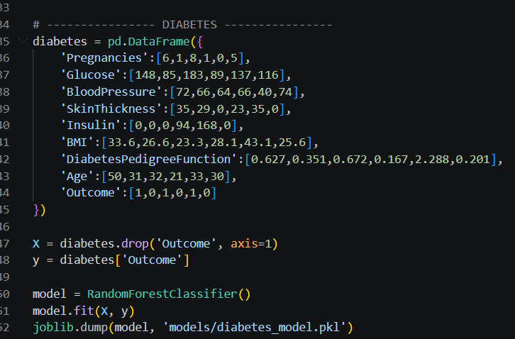
Figure 2: Model Training Script — Diabetes Section

Activity 1.2: Model Serialization
After training, each model is serialized using joblib.dump() and stored in the models/ directory. The three output files are:
- models/heart_model.pkl
- models/diabetes_model.pkl
- models/liver_model.pkl

joblib.dump(model, 'models/diabetes_model.pkl')
joblib.dump(model, 'models/heart_model.pkl')
joblib.dump(model, 'models/liver_model.pkl')

Figure 3: Model Training Complete — Terminal Output

Activity 1.3: Model Validation
After training, verify the models/ folder contains all three .pkl files. Load and test each model with a sample input to confirm correct prediction output before integrating with the web interfaces.
import joblib, NumPy as np
model = joblib.load('models/diabetes_model.pkl')
print(model.predict([[6,148,72,35,0,33.6,0.627,50]]))

MILESTONE 2: Core Backend Development (Flask App)
This milestone focuses on building the Flask backend that serves the web interface and handles all prediction requests. The key goal is to implement a clean request-response pipeline where user-submitted form data is parsed, transformed into a feature vector, passed to the correct model, and the prediction result is rendered back in the HTML template.

Activity 2.1: Flask Application Setup
The app.py file initializes the Flask application and loads all three pre-trained models at startup. Loading models once at startup (rather than per-request) ensures fast prediction response times.

from flask import Flask, render_template, request
import NumPy as np, joblib
app = Flask(__name__)
heart_model = joblib.load('models/heart_model.pkl')
diabetes_model = joblib.load('models/diabetes_model.pkl')
liver_model = joblib.load('models/liver_model.pkl')

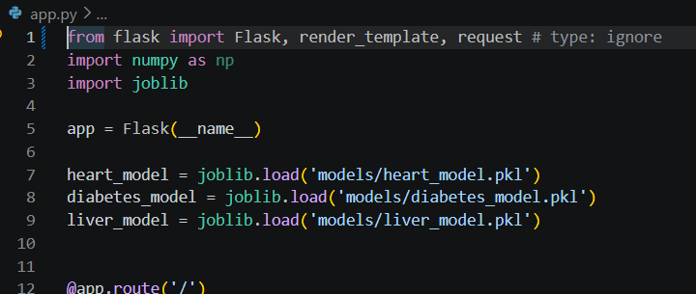
Figure 4: Flask App — Model Loading at Startup

Activity 2.2: Prediction Route Implementation
The /predict POST endpoint handles form submissions. It identifies the selected disease, extracts the corresponding input fields, converts them to floats, and calls the appropriate model's predict() method.

Disease routing logic:
- disease == 'heart' → extract 13 heart features → heart_model.predict()
- disease == 'diabetes' → extract 8 diabetes features → diabetes_model.predict()
- disease == 'liver' → extract 10 liver features → liver_model.predict()

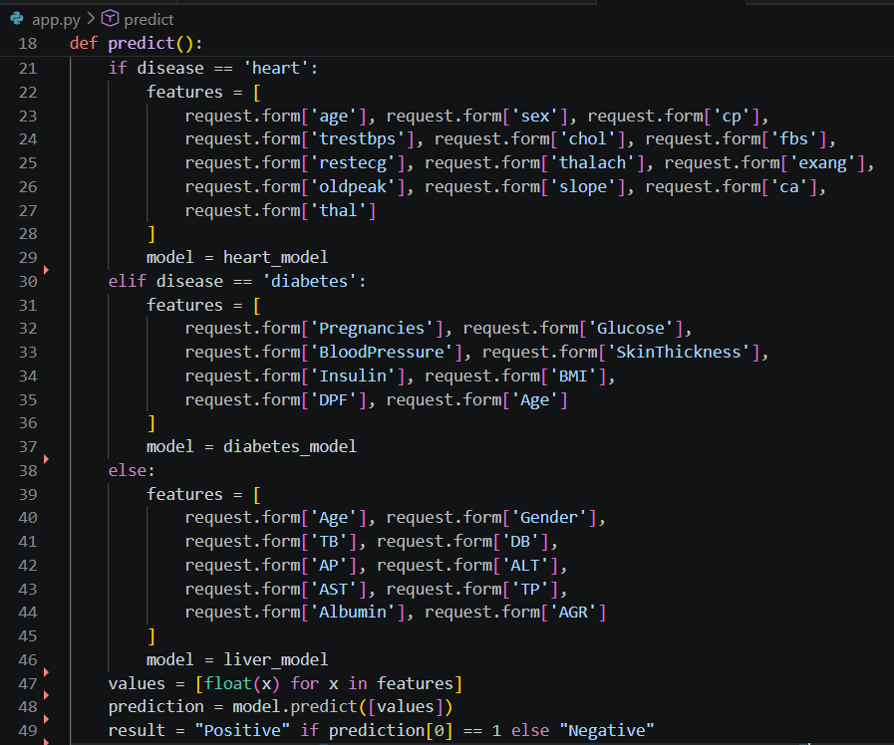
Figure 5: Flask Prediction Route — Disease Branching Logic

Activity 2.3: Result Rendering
The prediction result (Positive or Negative) is formatted as a string and passed to the Jinja2 template via the prediction_text variable. The template renders this as a prominently displayed heading.

result = 'Positive' if prediction[0] == 1 else 'Negative'
return render_template('index.html', prediction_text=f'Result: {result}')

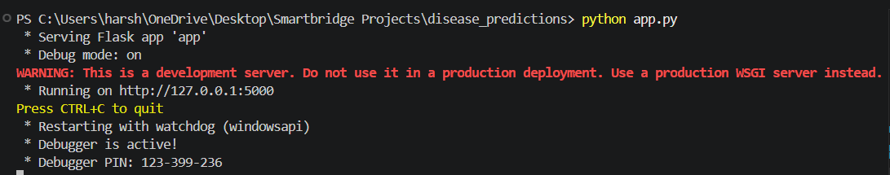
Figure 6: Flask Development Server Running

MILESTONE 3: HTML/CSS Frontend Interface
This milestone focuses on building the interactive HTML frontend that users interact with when using the Flask web application. The template uses JavaScript to dynamically show disease-specific input fields, making the single-page interface clean and context-aware.

Activity 3.1: HTML Template Structure
The templates/index.html file is a single Jinja2 template that serves as both the input form and the results page. It contains three hidden div sections — one for each disease — that are revealed based on the user's dropdown selection.

- A <select> dropdown (#disease) triggers showFields() on change
- Three <div class='section'> blocks: #heart, #diabetes, #liver
- All sections default to display:none; only the selected one is shown
- A single <button type='submit'> submits the entire form to /predict

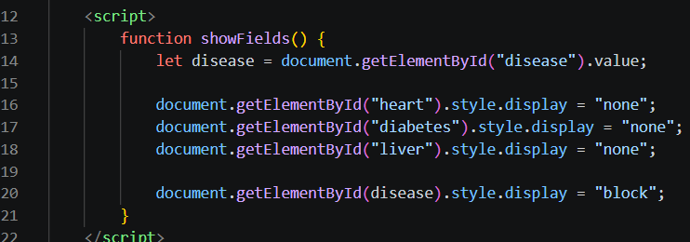
Figure 7: HTML Template — Dynamic Section Visibility Logic

Activity 3.2: Disease Input Sections
Each disease section contains labelled input fields for its specific clinical parameters:

Heart Disease Inputs (13 fields):
- Age, Sex (0/1), Chest Pain Type, Blood Pressure, Cholesterol
- Fasting Blood Sugar, ECG results, Max Heart Rate, Exercise Angina
- Old peak, Slope, CA (major vessels), Thal

Diabetes Inputs (8 fields):
- Pregnancies, Glucose Level, Blood Pressure, Skin Thickness
- Insulin, BMI, Diabetes Pedigree Function, Age

Liver Disease Inputs (10 fields):
- Age, Gender (0/1), Total Bilirubin, Direct Bilirubin
- Alkaline Phosphotase, ALT, AST, Total Proteins, Albumin, A/G Ratio

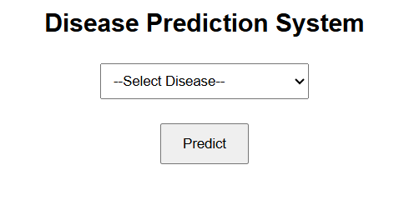
Figure 8: Flask Web Interface — Home Page

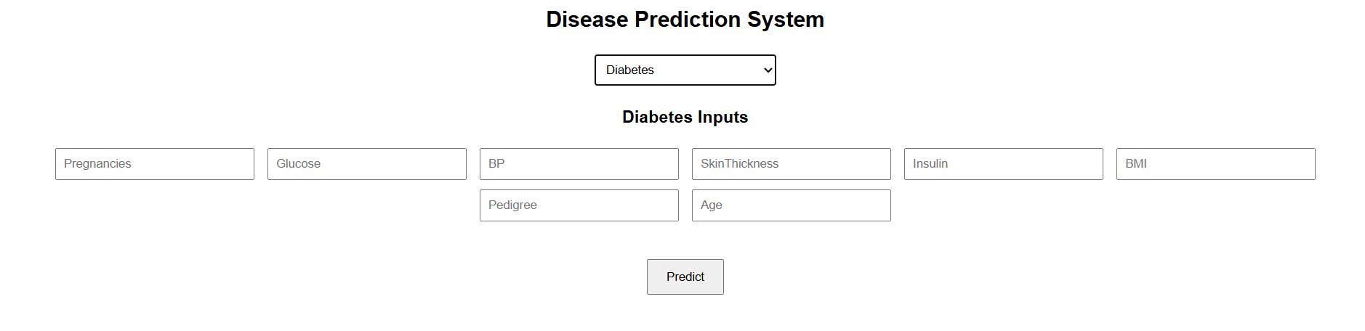
Figure 9: Flask Web Interface — Diabetes Input Form

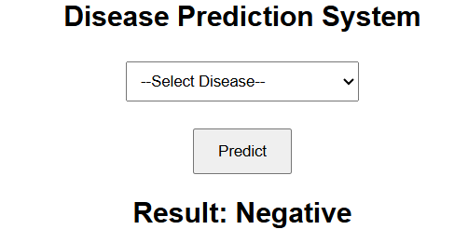
Figure 10: Flask Web Interface — Prediction Result

MILESTONE 4: Streamlit Dashboard Implementation
This milestone focuses on designing and implementing the premium Streamlit dashboard as a feature-rich alternative to the Flask interface. The Streamlit app provides an enhanced user experience with a gradient-styled UI, column layouts, sidebar navigation, and real-time predictions with color-coded risk indicators.

Activity 4.1: Streamlit Page Configuration and CSS
The streamlit_app.py configures the page with a wide layout and injects custom CSS using st.markdown() with unsafe_allow_html=True. The premium styling includes glassmorphism-effect cards, gradient buttons, and a dark purple gradient background.

st.set_page_config(page_title='AI Disease Predictor', layout='wide')

Key CSS customizations:
- Body: linear-gradient(135deg, #1f1c2c, #928dab) background
- Cards: rgba(255,255,255,0.08) with backdrop-filter blur and box shadow
- Buttons: linear-gradient(90deg, #00c6ff, #0072ff) with full width

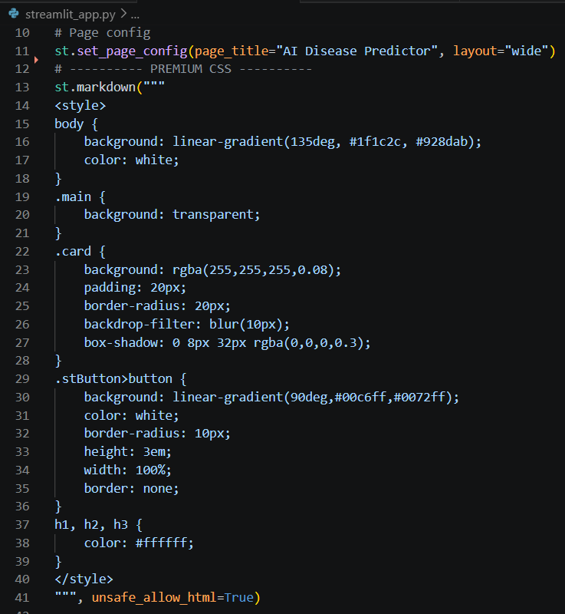
Figure 11: Streamlit App — Custom CSS Configuration

Activity 4.2: Sidebar Disease Selector
A sidebar select box allows users to switch between the three disease predictors. A guidance note is displayed below the selector to prompt careful data entry.

disease = st.sidebar.selectbox('🔍 Choose Prediction',
['Heart Disease', 'Diabetes', 'Liver Disease'])
st.sidebar.markdown('💡 Enter patient details carefully')

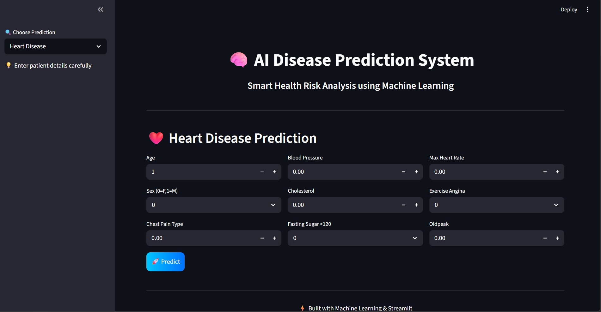
Figure 12: Streamlit Dashboard — Home Screen with Sidebar

Activity 4.3: Column-Based Input Layouts
Each disease predictor uses Streamlit's st.columns() to organize input fields in a clean multi-column grid layout, preventing the form from becoming a long vertical scroll.

Column layouts per disease:
- Heart Disease: 3 columns × 3 fields each (col1: Age/Sex/CP, col2: BP/Chol/FBS, col3: MaxHR/Exang/Old peak)
- Diabetes: 2 columns × 4 fields each (col1: Pregnancies/Glucose/BP/Skin, col2: Insulin/BMI/DPF/Age)
- Liver Disease: 3 columns × 3 fields + full-width A/G Ratio

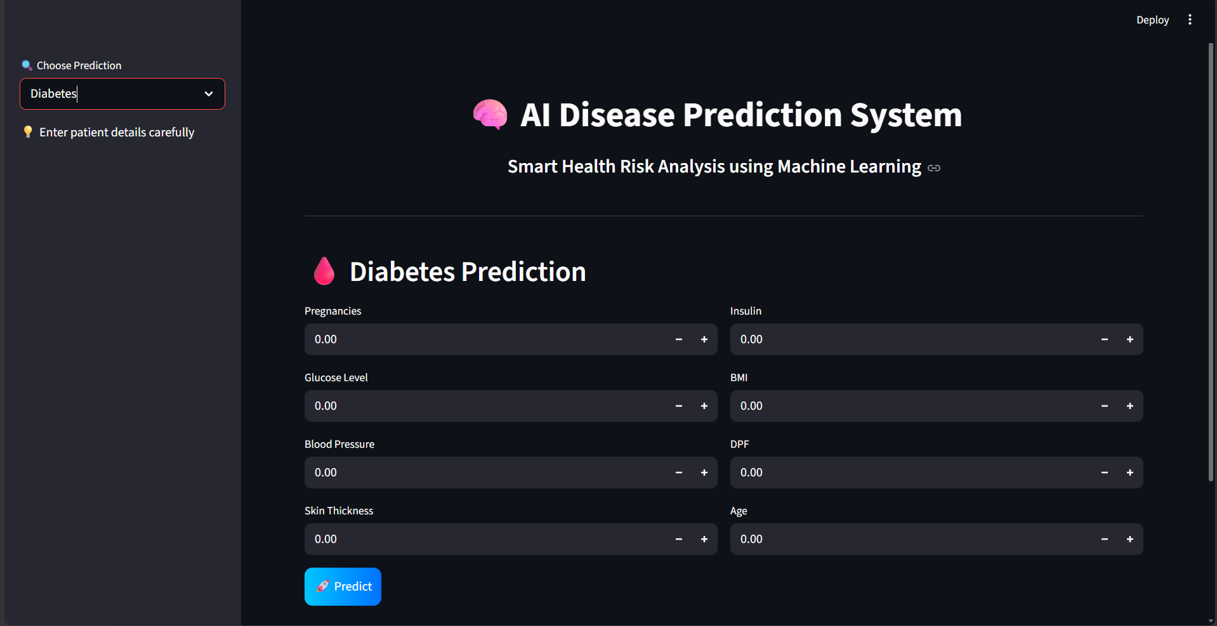
Figure 13: Streamlit Dashboard — Diabetes Prediction Panel

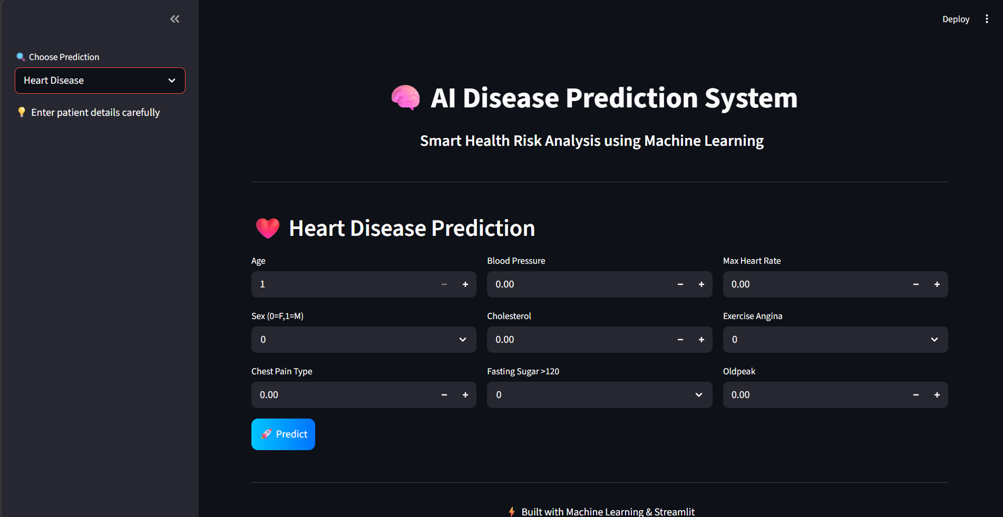
Figure 14: Streamlit Dashboard — Heart Disease Prediction Panel

Activity 4.4: Prediction Output with Color Indicators
After clicking the Predict button, the prediction result is displayed using Streamlit's color-coded notification components:
- st.error() — displays a red warning banner for high risk / positive detection
- st.success() — displays a green confirmation banner for low risk / no detection

if prediction[0] == 1:
st.error('⚠️ Diabetic Risk Detected')
else:
st.success('✅ No Diabetes Detected')

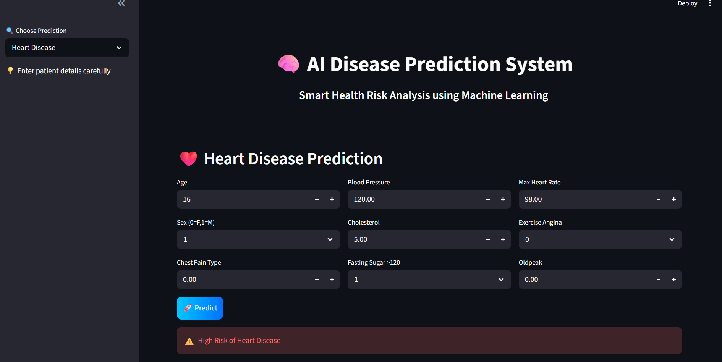
Figure 15: Streamlit Dashboard — Prediction Result Display

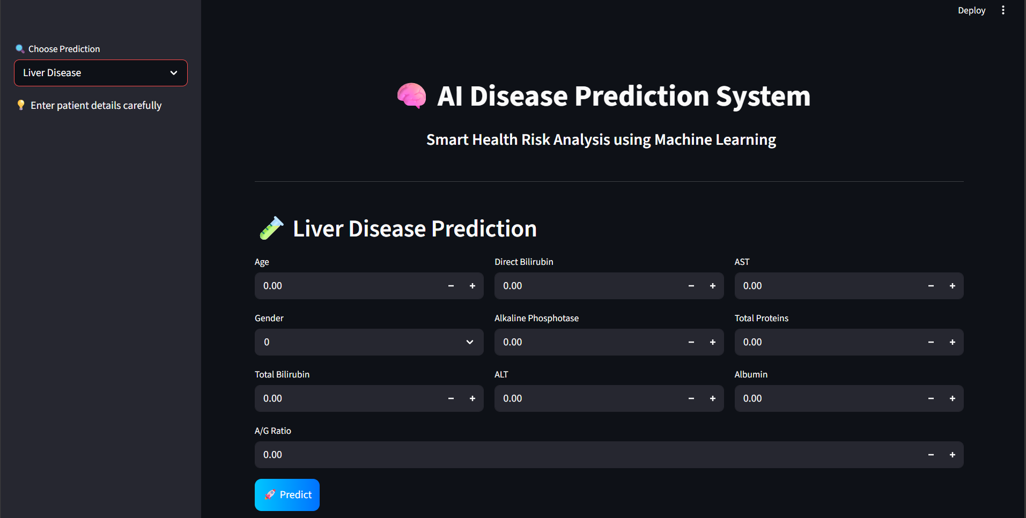
Figure 16: Streamlit Dashboard — Liver Disease Prediction Panel

MILESTONE 5: Testing & Optimization
This milestone focuses on validating the end-to-end functionality, prediction accuracy, and interface reliability of the AI Disease Prediction System. Testing is conducted using real clinical values from the training datasets to verify that both interfaces produce correct and consistent predictions.

Activity 5.1: Dataset-Based Input Testing
End-to-end testing is performed using actual patient records from the training datasets. Known outcomes are compared against model predictions to validate correctness.

Diabetes Test Case (first row of diabetes.csv):
- Input: Pregnancies=6, Glucose=148, BP=72, Skin=35, Insulin=0, BMI=33.6, DPF=0.627, Age=50
- Expected Outcome: 1 (Diabetic)
- Model Output: Positive — Diabetic Risk Detected

Liver Disease Test Case:
- Input: Age=65, Gender=0(F), TB=0.7, DB=0.1, AP=187, ALT=16, AST=18, TP=6.8, Alb=3.3, AGR=0.9
- Expected Outcome: 1 (Liver Disease)
- Model Output: Positive — Liver Disease Detected

Activity 5.2: Output Quality Validation
Validation checks are performed for each interface to confirm correct behavior:

- Flask Interface: Form submission reaches /predict, features are parsed correctly, result text renders in the template
- Streamlit Interface: Sidebar selection switches disease panels correctly, Predict button triggers inference, color-coded results display properly
- Both interfaces: Positive predictions return risk warning, Negative predictions return healthy status

Activity 5.3: Performance & UI Responsiveness
Performance validation targets:
- Model load time at startup: < 1 second for all three .pkl files
- Prediction inference time: < 0.5 seconds per request
- Flask form submission round trip: < 2 seconds on local server
- Streamlit real-time update on Predict click: < 1.5 seconds

Interface validation:
- Flask: JavaScript section toggle works across all three diseases without page reload
- Streamlit: st.columns() layout renders correctly at standard browser widths
- Both interfaces: numeric inputs accept float and integer values correctly
- Streamlit premium CSS: gradient background, glassmorphism cards, and gradient buttons render as expected

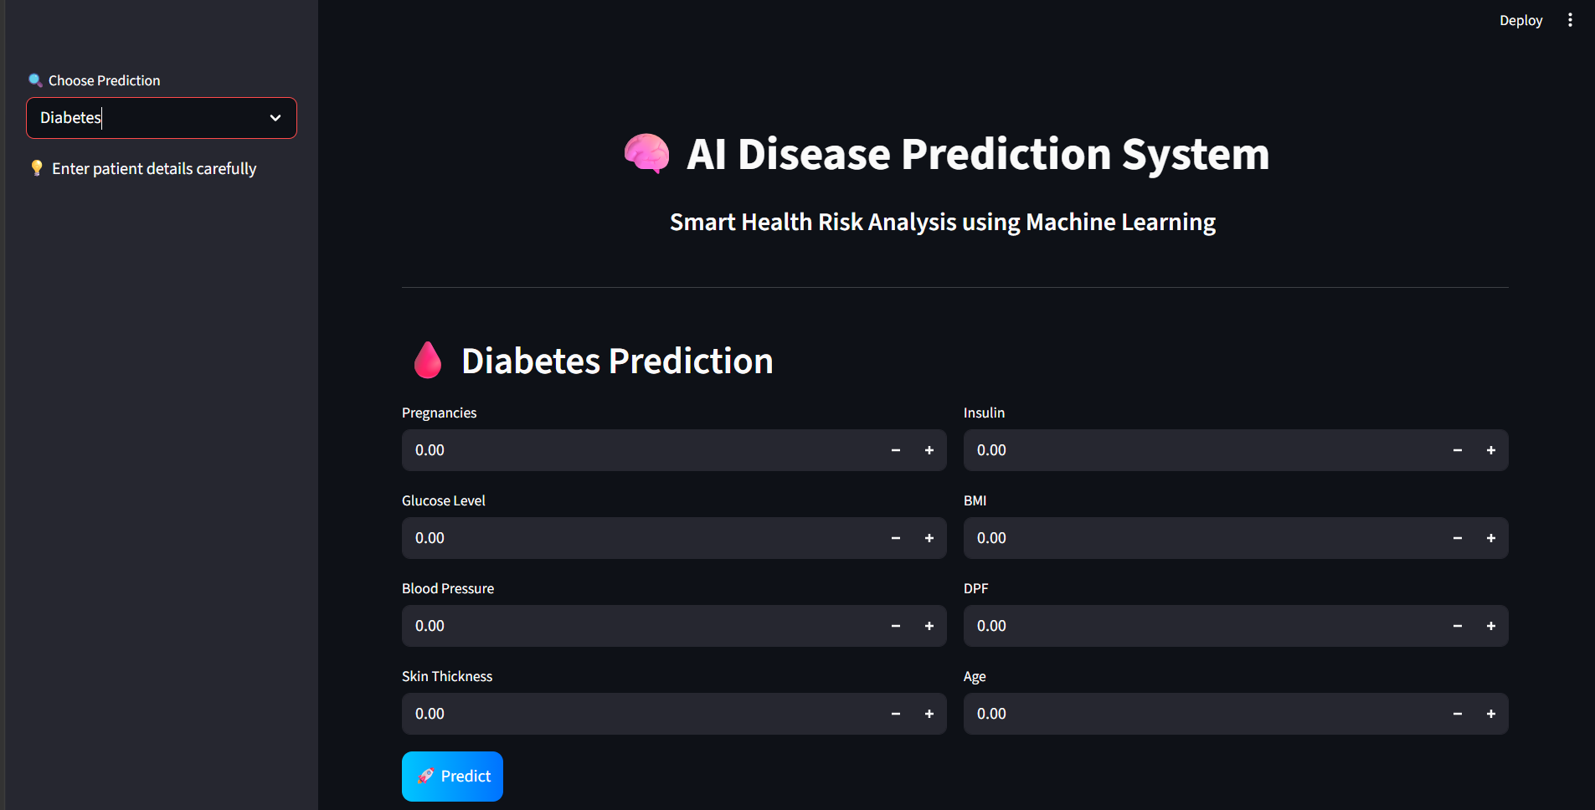
Figure 17: Final Streamlit Dashboard — Polished UI

Conclusion
The AI Disease Prediction System represents a practical application of Machine Learning in healthcare, demonstrating how clinical data can be transformed into actionable health risk assessments. By training Random Forest Classifiers on real-world medical datasets and deploying them through two polished web interfaces — a Flask web app and a Streamlit dashboard — the system provides immediate, accessible predictions for Heart Disease, Diabetes, and Liver Disease.

Built on a clean modular architecture, the system separates the concerns of model training, model serving, and UI rendering, making it maintainable and extensible. The dual-interface approach ensures that both developers (preferring Flask) and analysts (preferring Streamlit's interactive dashboards) can work comfortably with the system.

Beyond its current capabilities, the system has significant potential for enhancement. Future improvements could include training on larger datasets for improved accuracy, adding SHAP-based explainability to provide reasoning behind predictions, integrating additional diseases, deploying to a cloud platform (AWS/GCP/Heroku) for public access, and building a mobile-responsive Progressive Web App (PWA) interface. In essence, this project demonstrates how a well-structured ML pipeline can bridge the gap between raw clinical data and meaningful health insights for a wide range of users.

