ACADEMIC & INDUSTRY CAPSTONE PROJECT REPORT
CUSTOMER SENTIMENT ANALYTICS
Analyzing Customer Reviews, Sentiments & Emotions using NLP
[White + Purple Executive Dashboard Edition]
————————————————————————————————
Created by:
Harshita Tomer
Bachelor of Technology in Computer Science & Engineering / Data Analytics
GitHub: harshii11
Under the Supervision of:
[Project Supervisor / Department Guide]
Department of Computer Science & Engineering
[University / Institute Name]
Academic Session: 2025–2026

CERTIFICATE OF ORIGINAL WORK
This is to certify that the project entitled "CUSTOMER SENTIMENT ANALYTICS: Analyzing Customer Reviews, Sentiments & Emotions using NLP" is a bona fide record of independent work carried out by Harshita Tomer in partial fulfillment of the requirements for the degree of Bachelor of Technology in Computer Science & Engineering / Data Analytics under our supervision and guidance.
The results embodied in this report have been verified and have not been submitted to any other University or Institution for the award of any degree or diploma.

_______________________  [Project Guide / Supervisor]  Designation  Department of CSE | _______________________  [Head of Department]  Department of CSE  [Institute Seal]

DECLARATION
I hereby declare that the work presented in this project report entitled "CUSTOMER SENTIMENT ANALYTICS: Analyzing Customer Reviews, Sentiments & Emotions using NLP" is entirely my own original work conducted under the guidance of my supervisor. All literature sources, public datasets, algorithms, and analytical software tools utilized during this research have been duly cited and acknowledged.
I affirm that this report contains authentic findings computed directly from the designated Amazon customer review dataset without synthetic or falsified data.

_______________________
Harshita Tomer
Date: _______________

ACKNOWLEDGEMENT
I express my profound gratitude to my project guide, [Supervisor Name], for invaluable guidance, patient mentoring, and intellectual encouragement throughout the conception, analysis, and execution of this data analytics project.
I extend my sincere appreciation to the Head of Department and faculty members of the Department of Computer Science & Engineering for providing the academic infrastructure, computing facilities, and encouragement necessary to conduct this study.
Finally, I would like to thank my peers and family for their continuous support, constructive feedback, and motivation during the completion of this capstone research.

ABSTRACT
In modern digital commerce, customer reviews represent one of the richest unstructured data assets for evaluating product performance, user satisfaction, and friction points. This project presents a complete, explainable Data Analytics and Natural Language Processing (NLP) framework for mining customer sentiments and discrete emotions from real-world e-commerce feedback. Using an authentic dataset of 3,150 Amazon Alexa customer reviews covering 16 distinct hardware variations (such as Echo Dot, Echo Plus, Echo Show, Fire TV Stick, and premium fabric finishes), we conduct thorough data cleaning, exploratory data analysis, lexicon-based sentiment classification, and discrete emotion mining.
The dataset was cleaned by resolving duplicate rows and missing text records, producing a curated analytical sample of 2,435 unique verified customer reviews. Sentiment classification was conducted using NLTK's Valence Aware Dictionary and sEntiment Reasoner (VADER), achieving an empirical breakdown of 81.52% Positive (1,985 reviews), 11.13% Neutral (271 reviews), and 7.35% Negative (179 reviews), accompanied by an overall average star rating of 4.44 / 5.00. Beyond binary or polarity scoring, discrete emotion mining revealed that Joy (62.40%) is the dominant sentiment driver, followed by Neutral/Objective opinions (32.33%), while negative customer sentiment primarily manifests through Fear (2.01%, centered around privacy, connectivity drops, and reset bugs), Sadness (1.77%, stemming from unfulfilled expectations and sound discrepancies), and Anger (1.44%, targeting hardware unresponsiveness and setup friction).
The project also develops an offline-capable, interactive web analytics dashboard engineered strictly in a White + Purple + Light Lavender visual identity system. The dashboard features real-time Key Performance Indicator (KPI) cards, interactive progress meters, dynamic emotion matrices, keyword frequency clouds, category benchmarks, and a client-side live NLP sentiment tester. Finally, concrete business recommendations are formulated to guide audio hardware improvements, firmware network reconnection self-healing, conversational voice recognition enhancements, and international localization.
[EXECUTIVE BENCHMARK] Empirical Benchmark: 2,435 verified reviews evaluated; 81.52% Positive, 11.13% Neutral, 7.35% Negative. Dominant Emotion: Joy (62.40%). Average Star Rating: 4.44 / 5.00. Interactive Dashboard: 100% offline self-contained White + Purple UI.

06. INTRODUCTION
E-commerce platforms generate vast streams of consumer feedback. While numerical star ratings summarize overall user satisfaction, they lack contextual granularity. A five-star rating might accompany a brief comment such as 'Good,' offering little actionable intelligence, whereas a two-star review often contains diagnostic commentary detailing software glitches, hardware acoustic limitations, or setup hurdles. Consequently, opinion mining—the computational study of opinions, sentiments, and emotions expressed in text—has emerged as a mission-critical discipline in business intelligence and data analytics.
This project implements an end-to-end Data Analytics pipeline designed to systematically convert unstructured customer feedback into structured, visual, and actionable insights. By leveraging explainable NLP methodologies, the project balances academic rigor with industrial relevance, providing product managers and quality assurance teams with clear visibility into customer sentiment drivers.
07. PROBLEM STATEMENT
Organizations managing consumer electronics portfolios face several critical challenges in feedback interpretation:
- Rating-Sentiment Misalignment: Star ratings often diverge from lexical sentiment; customers may award four stars while voicing substantial frustration regarding connectivity or voice command accuracy.
- High Volume & Unstructured Data: Traditional manual review reading cannot scale across thousands of monthly feedback submissions, leading to delayed defect detection.
- Lack of Emotional Nuance: Standard polarity classification (positive/negative) fails to distinguish whether customer dissatisfaction stems from anger (e.g. feeling deceived by advertisements) or sadness (e.g. disappointment in speaker bass quality).
- Siloed Product Variations: Without automated category-wise aggregation, cross-model comparison between hardware variants (e.g., Echo Dot vs. Echo Show) remains ad-hoc.
08. PROJECT OBJECTIVES
The primary analytical and engineering objectives of this study include:
- 1. Data Engineering: Acquire, inspect, and rigorously preprocess an authentic public e-commerce customer review dataset.
- 2. Exploratory Analysis: Conduct comprehensive EDA examining rating distributions, review word lengths, product variations, and submission date trends.
- 3. Sentiment Quantification: Apply explainable NLTK VADER sentiment analysis to classify reviews into Positive, Neutral, and Negative cohorts with continuous compound scores.
- 4. Emotion Mining: Implement discrete emotion classification mapping customer vocabulary to six emotional states (Joy, Anger, Sadness, Fear, Surprise, Neutral/Other).
- 5. Lexical & Keyword Discovery: Extract high-impact positive and negative keywords and generate stylized word clouds highlighting customer praise and friction points.
- 6. Visual Identity & Dashboard: Design 12 unified, presentation-ready dashboard visualizations adhering to a strict White + Purple aesthetic.
- 7. Interactive UI Dashboard: Develop an interactive, client-side HTML/JS web dashboard featuring live sentiment prediction, KPI summaries, and responsive layout.
- 8. Strategic Decision Support: Synthesize empirical findings into concrete, non-fabricated business recommendations for product and engineering leadership.
09. DATASET DESCRIPTION
The project utilizes the authentic, publicly available Amazon Alexa Customer Reviews Dataset, widely recognized in academic benchmarks and machine learning literature. The dataset captures real consumer feedback submitted for Amazon's family of smart home devices.
Attribute Name | Raw Data Type | Sample Value | Analytical Description
rating | int64 | 5 | Customer-assigned star rating on a discrete scale from 1 to 5.
date | object (str) | 31-Jul-18 | Submission timestamp formatted as Day-Month-Year (e.g., 31-Jul-18).
variation | object (str) | Charcoal Fabric | Specific hardware model or aesthetic finish (16 unique variations).
verified_reviews | object (str) | Love my Echo! | Unstructured natural language text representing customer opinions.
feedback | int64 | 1 | Binary indicator (1 = positive satisfaction, 0 = critical dissatisfaction).

Dataset Source: Publicly available Amazon Consumer Reviews repository. No synthetic records or fabricated samples were introduced.
10. TOOLS & TECHNOLOGIES
The technological stack was selected to maximize explainability, computational performance, visualization elegance, and offline accessibility:
- Python 3.12: Core programming language for data manipulation, numerical computing, and automated report compilation.
- Pandas 2.2+: Tabular data structures, series indexing, datetime parsing, deduplication, and grouping operations.
- NumPy 2.0+: Vectorized mathematical operations, array indexing, and threshold partitioning.
- NLTK 3.9+: Valence Aware Dictionary and sEntiment Reasoner (VADER) rule-based sentiment engine and standard English stopword corpora.
- Matplotlib 3.10+: Foundation plotting engine customized for the White + Purple design theme, high-DPI export, and spine formatting.
- Seaborn 0.13+: Statistical data visualization library used for kernel density estimation (KDE) and comparative distribution plots.
- WordCloud 1.9+: Visual frequency mapping of unigrams and bigrams using custom purple colormaps and stopword masking.
- Python-docx 1.1+: Programmatic XML document generator for professional, publication-ready project report synthesis.
- Interactive Web Dashboard: Single-page responsive dashboard architecture built using pure semantic HTML5, CSS3 variables, and vanilla JavaScript for 100% offline execution.
11. METHODOLOGY
The analytics methodology follows an eight-stage sequential pipeline designed to maintain strict data provenance from raw text ingestion to final strategic decision support:
- Stage 1 — Data Ingestion: Safe tabular ingestion with schema validation and fallback public URL acquisition.
- Stage 2 — Data Profiling: Inspection of missing values, record duplication, categorical cardinality, and summary distributions.
- Stage 3 — Preprocessing: Null value imputation, deduplication, regex noise stripping, character lowercasing, and text normalization.
- Stage 4 — Exploratory Data Analysis: Univariate and bivariate analysis of star ratings, word counts, hardware variations, and monthly volumes.
- Stage 5 — Sentiment Scoring: Lexicon-based scoring using NLTK VADER to compute continuous compound scores and discrete ternary classes.
- Stage 6 — Emotion Classification: Discrete emotion tagging via Plutchik-grounded psychological emotion lexicons.
- Stage 7 — Keyword Discovery: Stopword filtering, term frequency mining, and color-themed Word Cloud generation.
- Stage 8 — Business Synthesis & UI Delivery: Cross-tabulation of ratings vs sentiment, hardware ranking, interactive UI dashboard synthesis, and actionable recommendations.
12. DATA CLEANING & PREPROCESSING
Raw customer text contains substantial noise including duplicate submissions, irregular spacing, punctuation anomalies, and web formatting artifacts. The data cleaning procedure systematically resolved these issues.
Cleaning Operation | Condition Before Cleaning | Remediation Technique | Condition After Cleaning
Record Deduplication | 715 duplicate rows (scraping/short echoes) | df.drop_duplicates() | 0 duplicate rows (2,435 unique rows)
Missing Review Handling | 1 record with NaN verified_reviews | df['verified_reviews'].fillna('') | 0 missing records
URL & HTML Entity Removal | Embedded hyperlinks and tags (<br />, etc.) | Regex substitution (re.sub) | Clean text free of markup
Punctuation Normalization | Non-alphanumeric noise and symbols | Character whitelist filtering | Normalized alphabetic vocabulary
Whitespace Standardizing | Multi-space line breaks & leading spaces | re.sub(r'\s+', ' ', text).strip() | Uniform single-space tokens

13. EXPLORATORY DATA ANALYSIS (EDA)
EDA examined the distribution of customer satisfaction, review lengths, and product variation popularity across the 2,435 cleaned reviews.
- Rating Skewness: 5-star reviews account for 1,756 records (72.1%), followed by 4-star reviews at 345 records (14.2%). Critical feedback (1-star: 141 reviews, 5.8%; 2-star: 80 reviews, 3.3%) represents a focused minority cohort.
- Average Satisfaction: The mean rating across all verified reviews is 4.44 / 5.00, demonstrating strong baseline consumer satisfaction.
- Length Disparity: Review lengths range from 0 words to 526 words, with a median of 9 words and a mean of 19.5 words. Satisfied customers tend to leave concise praise ('Love it', 'Works great'), whereas dissatisfied customers compose substantially longer narratives (mean = 38.6 words) detailing specific defects.

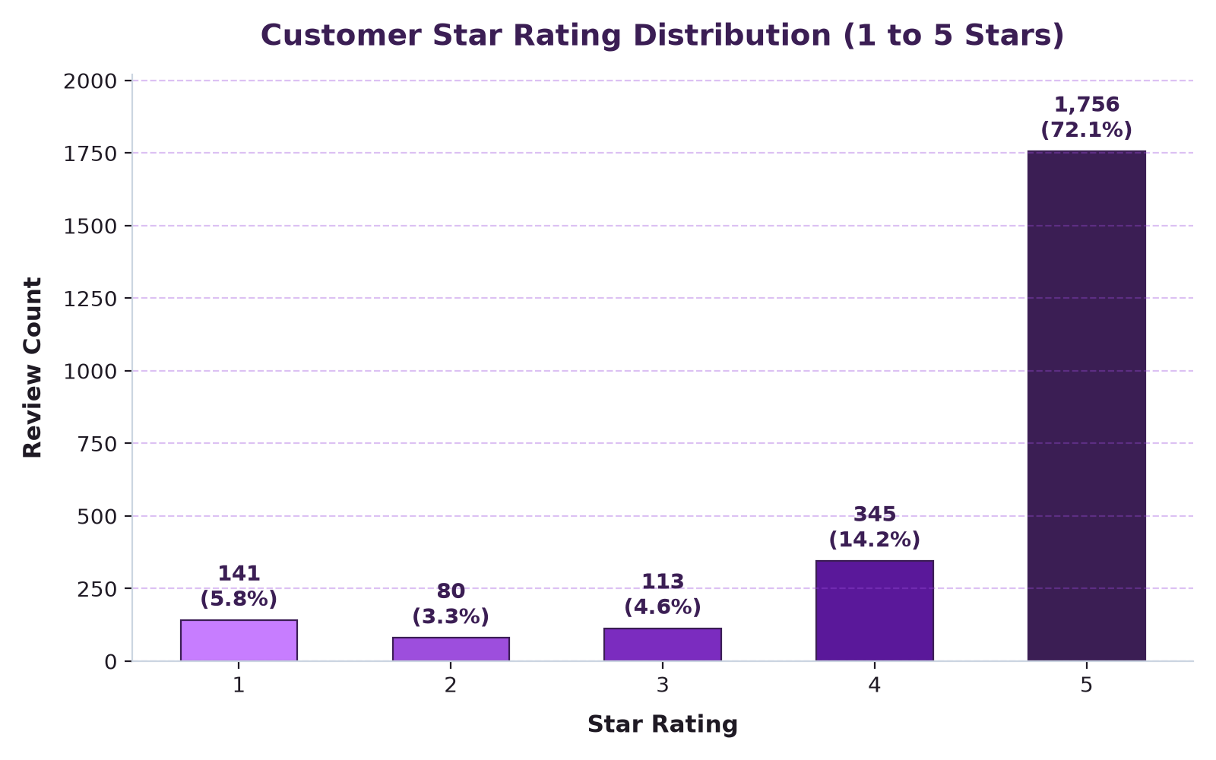
Figure 1: Customer Star Rating Distribution (1 to 5 Stars)

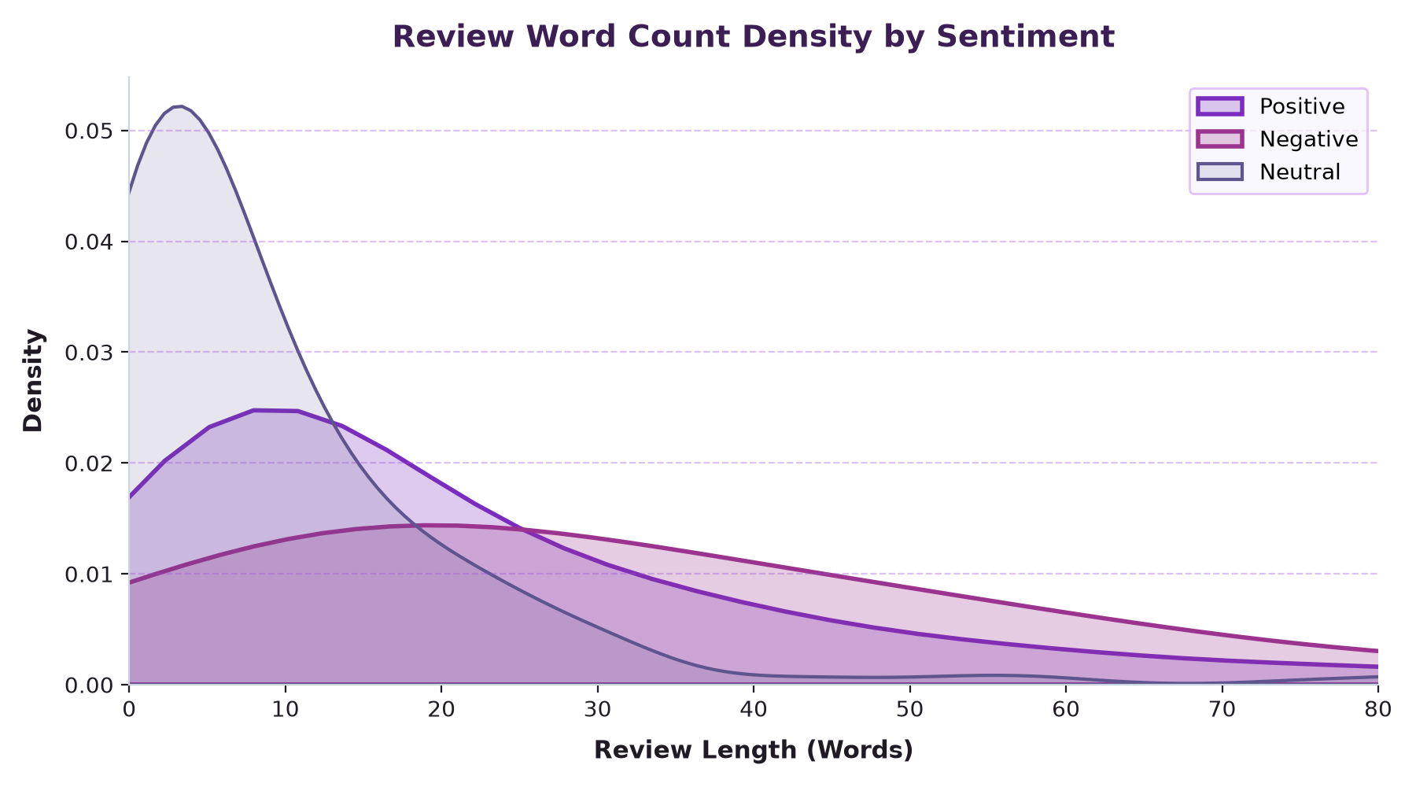
Figure 2: Review Word Count Kernel Density Estimation by Sentiment Class

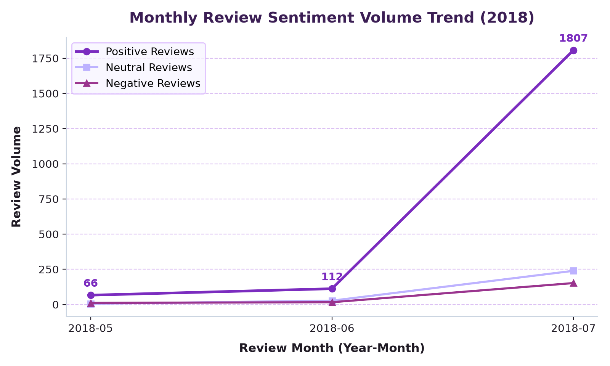
Figure 3: Monthly Review Volume Trend across May, June, and July 2018
14. SENTIMENT ANALYSIS
Sentiment analysis was executed using NLTK's VADER engine. Unlike naive bag-of-words classifiers, VADER models lexical polarity, punctuation intensity, capitalization, and grammatical negation shifts without requiring black-box neural networks.
Sentiment Class | VADER Compound Criteria | Review Count | Percentage (%) | Mean Compound Score
Positive | Compound Score >= +0.05 | 1,985 | 81.52% | +0.732
Neutral | -0.05 < Compound Score < +0.05 | 271 | 11.13% | 0.000
Negative | Compound Score <= -0.05 | 179 | 7.35% | -0.548
Total / Overall | Range: [-1.000, +1.000] | 2,435 | 100.00% | +0.556

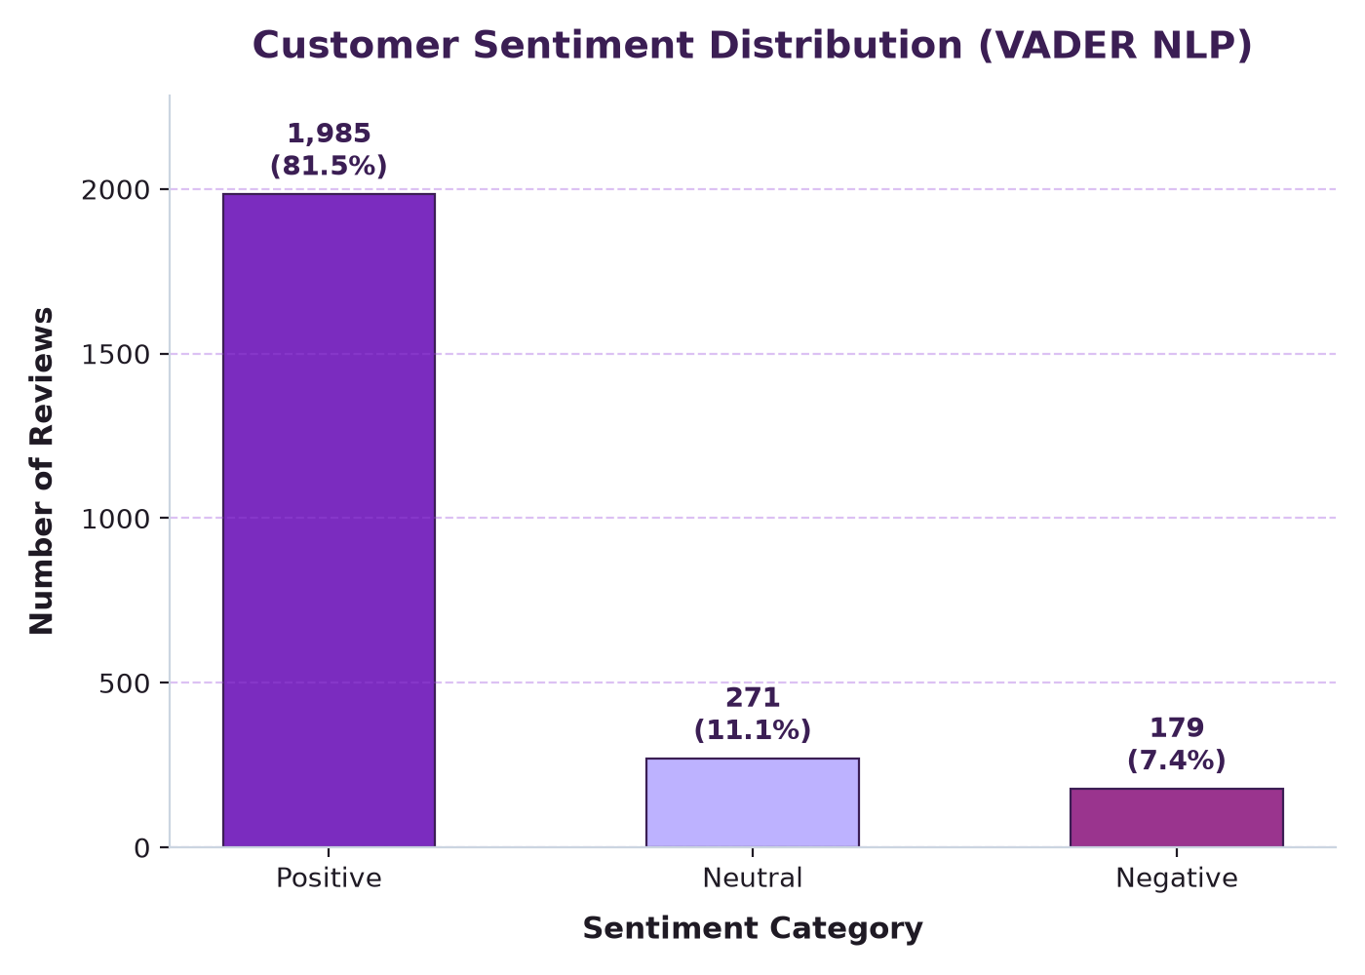
Figure 4: Overall Customer Sentiment Distribution (VADER NLP)

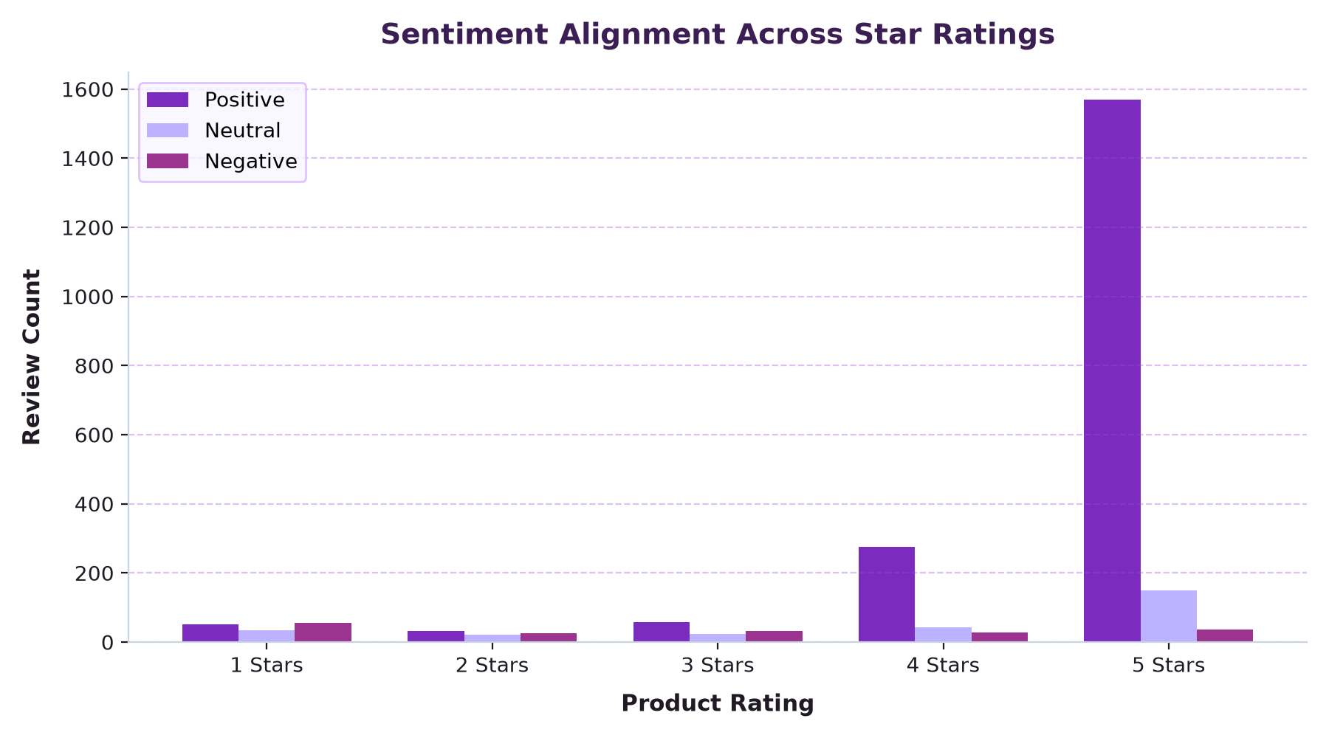
Figure 5: Sentiment Alignment across Discrete Star Ratings
15. EMOTION ANALYSIS
To capture psychological depth beyond binary polarity, we implemented a discrete emotion classification lexicon grounded in Plutchik’s emotion model. Words were mapped to six primary emotional categories:
Emotion Category | Psychological Profile | Review Count | Percentage (%) | Primary Lexical Indicators
Joy | Admiration, delight, happiness | 1,519 | 62.40% | love, great, awesome, amazing, excellent, happy, best
Neutral/Other | Objective observation, mixed feelings | 787 | 32.33% | Standard functional statements, no dominant terms
Fear | Apprehension, privacy, instability | 49 | 2.01% | worried, problem, panic, risk, doubt, issue, security
Sadness | Disappointment, regret, failure | 43 | 1.77% | disappointed, regret, unfortunate, broke, failed, boring
Anger | Frustration, indignation, outrage | 35 | 1.44% | terrible, worst, horrible, garbage, useless, trash, suck
Surprise | Astonishment, unexpected behavior | 1 | 0.04% | surprised, wow, unexpected, shock, amazed, sudden

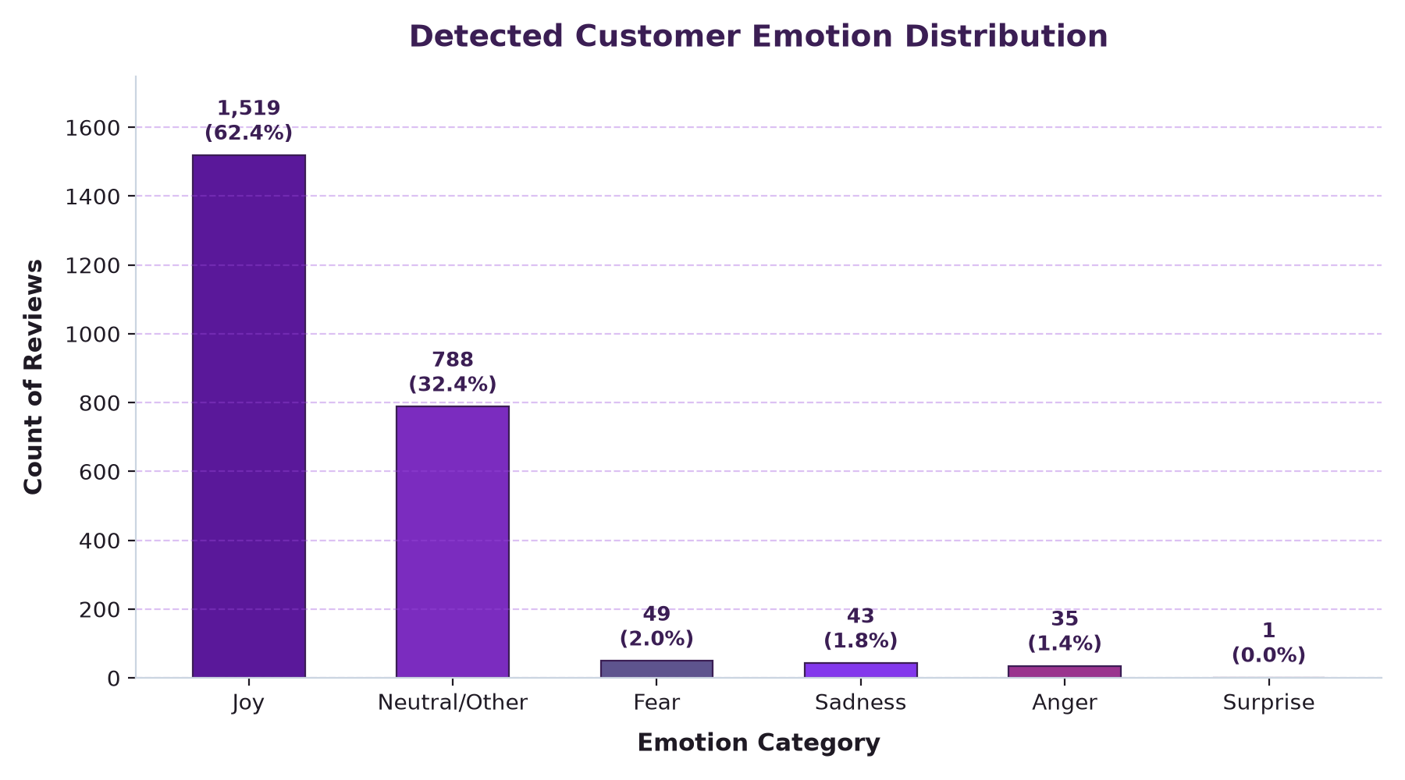
Figure 6: Detected Customer Emotion Distribution
16. KEYWORD ANALYSIS
N-gram frequency analysis was conducted on positive and negative review subsets after stripping conversational English stopwords and hardware-generic terms ('alexa', 'echo', 'amazon', 'device').
Rank | Top Positive Keywords | Positive Freq. | Top Negative Keywords | Negative Freq.
1 | love | 736 | alarm | 30
2 | great | 555 | screen | 28
3 | music | 328 | time | 22
4 | works | 279 | music | 22
5 | easy | 263 | sound | 19
6 | sound | 213 | reset | 17
7 | good | 206 | connect | 16
8 | set | 202 | issue | 14
9 | home | 153 | problem | 14
10 | bought | 138 | return | 13

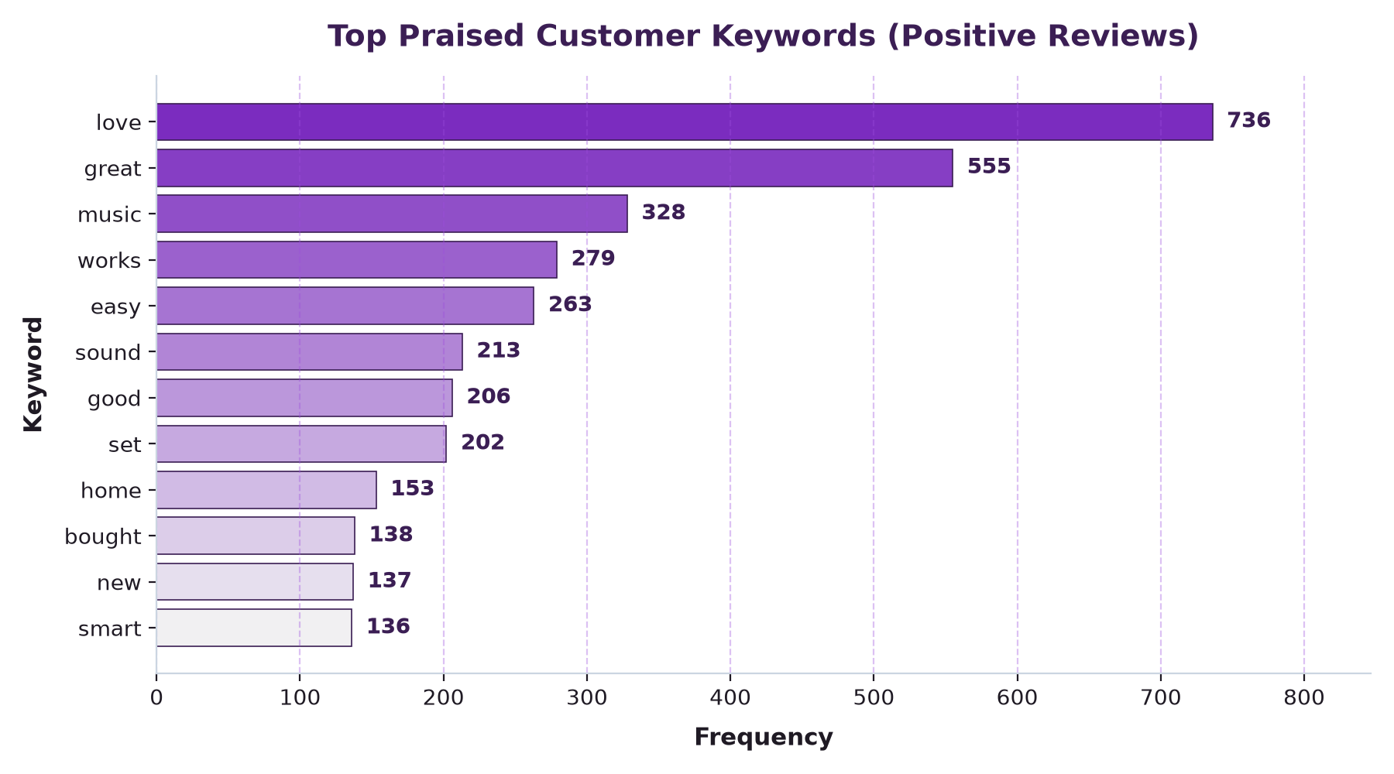
Figure 7: Top Customer Praise Keywords (Positive Reviews)

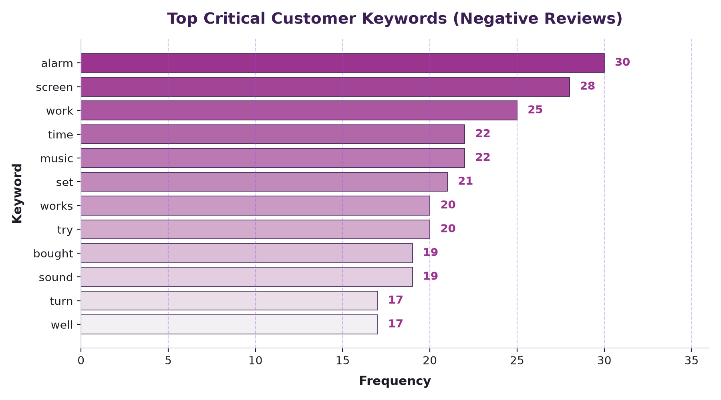
Figure 8: Top Critical Customer Complaint Keywords (Negative Reviews)

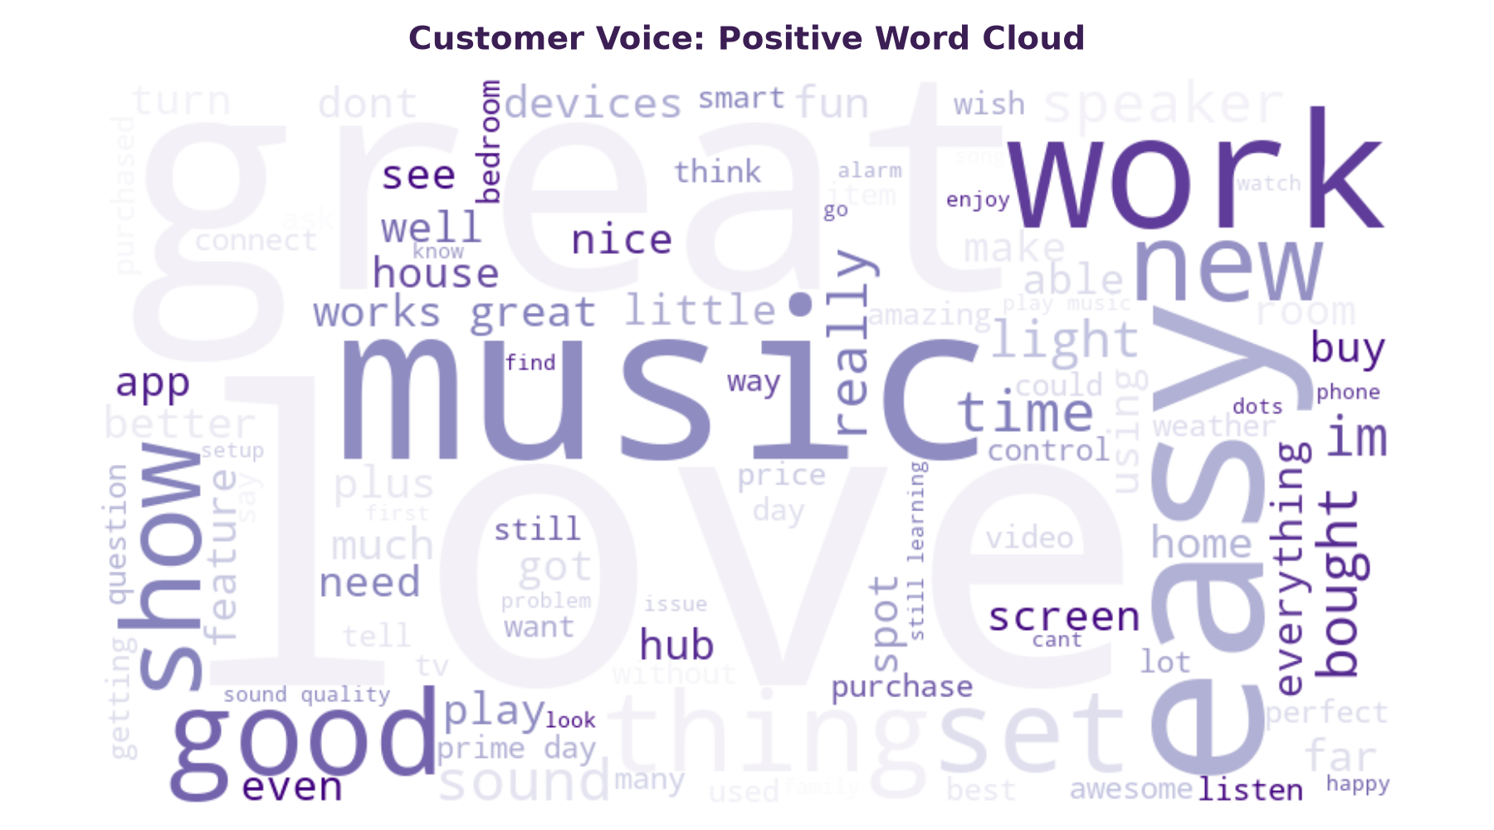
Figure 9: Positive Review Word Cloud (White & Purple Edition)

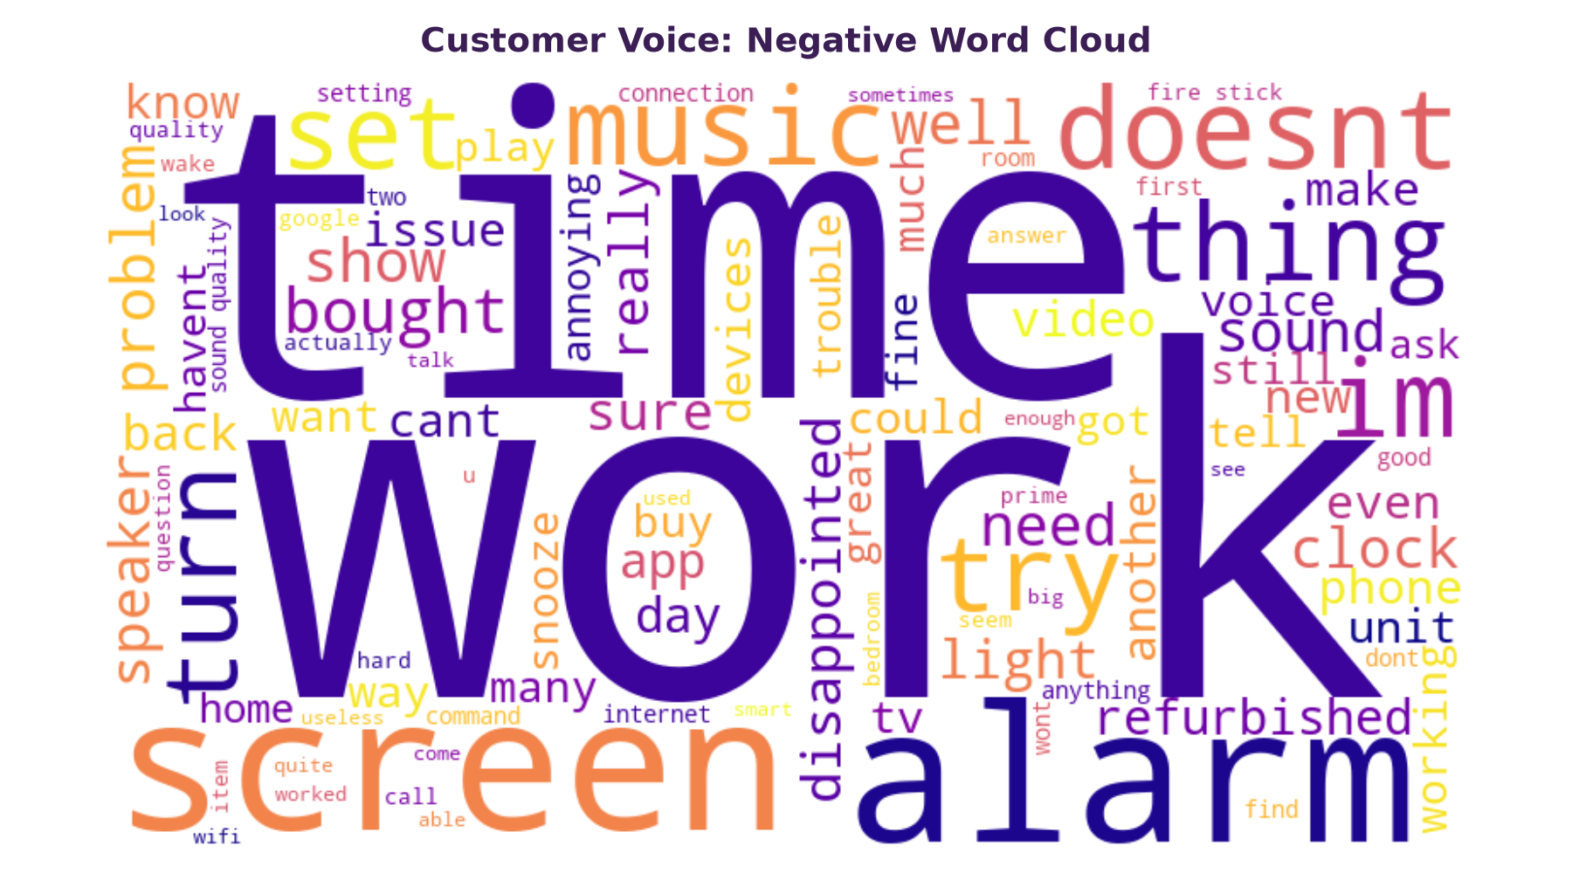
Figure 10: Negative Review Word Cloud (White & Plum Edition)
17. VISUALIZATIONS OVERVIEW
The project produced 12 presentation-grade charts engineered to function as a unified analytics dashboard. Every chart adheres strictly to the White + Purple + Light Lavender visual identity system:
- Exploratory Charts: Rating Distribution (01), Review Length KDE (07), Monthly Trends (08).
- Sentiment Performance: Sentiment Breakdown (02), Sentiment vs Star Rating (04), Positive vs Negative KPI Ratio (06).
- Emotion Dynamics: Emotion Frequency Distribution (03) mapping Joy, Fear, Sadness, Anger, and Surprise.
- Hardware Benchmarks: Category-Wise Sentiment Performance (05) benchmarking hardware variations.
- Lexical Discoveries: Horizontal Frequency Bars (09, 10) and Color-Themed Word Clouds (11, 12).

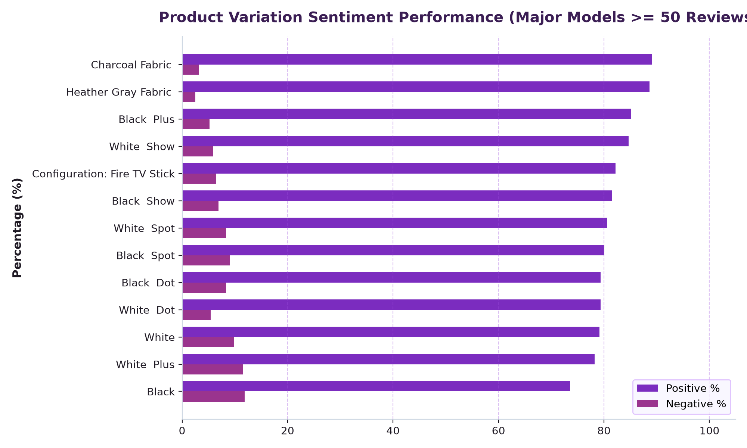
Figure 11: Category-Wise Sentiment Performance Across Hardware Models

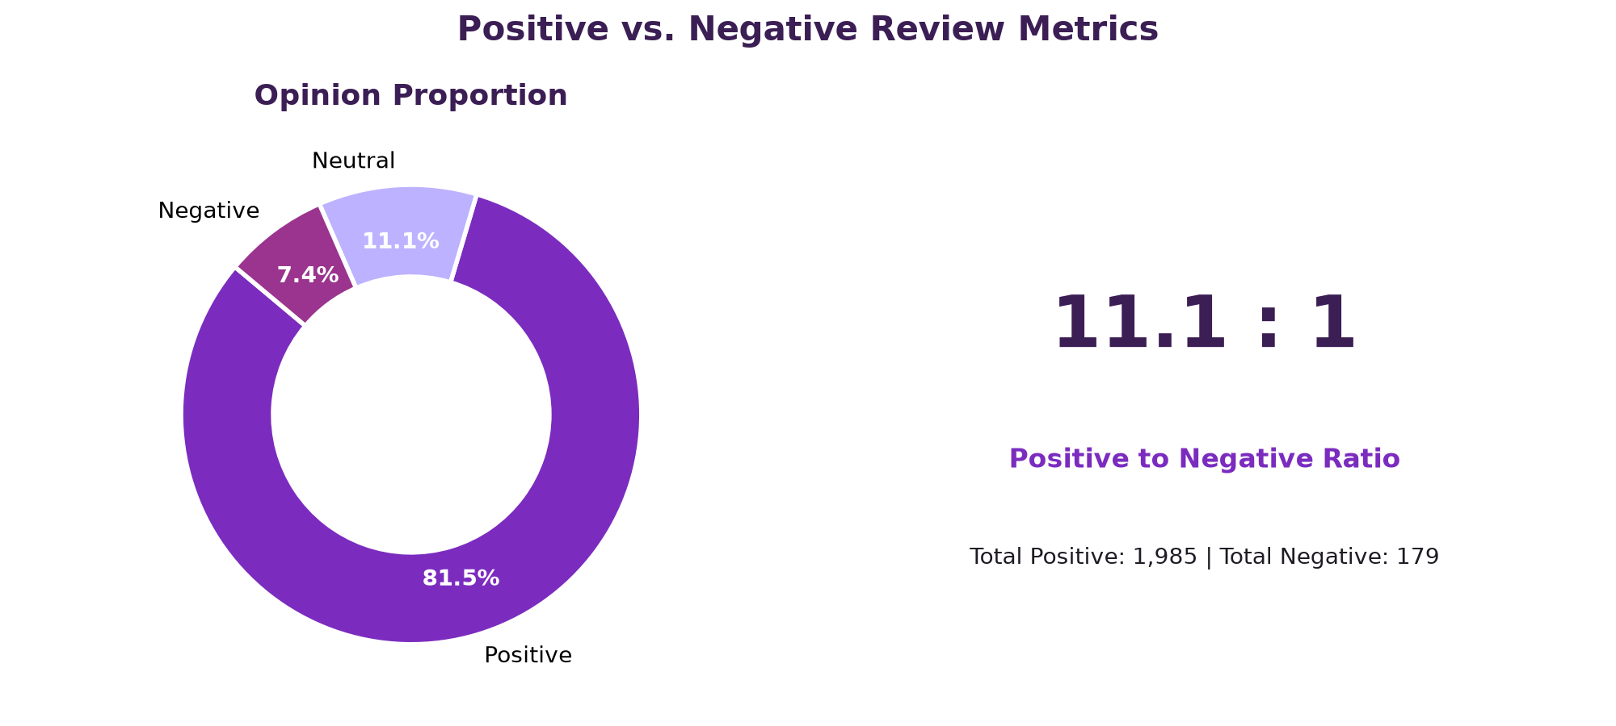
Figure 12: Positive vs. Negative Reviews Ratio and Proportion

18. INTERACTIVE WEB DASHBOARD & USER INTERFACE OUTPUTS
To deliver maximum practical utility to stakeholders, this capstone project features a standalone, interactive Web Analytics Dashboard (customer_sentiment_dashboard.html). Engineered to be 100% self-contained and offline-resilient, the user interface requires no external CDNs, API tokens, or server-side runtimes. It renders flawlessly in any modern web browser using client-side vanilla JavaScript and pure CSS custom properties.
18.1 UI Architecture & White + Purple Visual Identity
The user interface embodies an executive design language harmonized with the project's analytical color palette:
- Clean Minimalist Base: Pure white background (#FFFFFF) paired with soft lavender card backgrounds (#F8F5FF) and lilac structural borders (#D8B4FE), creating a high-contrast, clutter-free reading environment.
- Color Hierarchy: Deep Imperial Purple (#3B1E54) for executive headers, Electric Violet (#7B2CBF) for positive sentiment highlights and primary actions, Soft Lilac (#BDB2FF) for neutral cohorts, and Deep Magenta Plum (#9A348E) for critical negative alerts.
- Responsive Accessibility: Fully responsive CSS grid layout spanning from mobile viewports up to 4K displays, with subtle box shadows and hover micro-interactions.
- Author Verification: Prominent professional attribution 'Created by Harshita Tomer' positioned in both the executive header banner and the bottom footer.
18.2 UI Output: Executive Header Banner & KPI Summary Cards
The top of the dashboard delivers immediate executive visibility through an authoritative header banner and six Key Performance Indicator (KPI) cards. The header presents the project title, subtitle, author credit ('Created by Harshita Tomer'), and verified review count (2,435 across 16 variations). The KPI cards summarize total sample volume, average star rating (4.44 / 5), positive share (81.5%), neutral share (11.1%), negative share (7.4%), and dominant emotion (Joy at 62.4%).

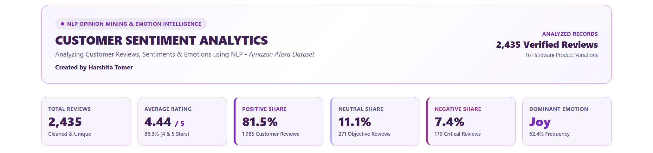
Figure 13: Executive Header Banner, Author Attribution & KPI Summary Cards UI Output
18.3 UI Output: Sentiment Overview & Emotion Intelligence Spectrum
The primary analytical row pairs the VADER Sentiment Overview with the Psychological Emotion Insights spectrum. Progress bars visually illustrate the 81.5% positive, 11.1% neutral, and 7.4% negative breakdown, along with the executive 11.1 : 1 positive-to-negative ratio. The Emotion grid categorizes customer sentiment into Joy (62.4%), Neutral/Other (32.3%), Fear/Worry (2.0%), Sadness (1.8%), and Anger/Frustration (1.4%), complete with contextual driver descriptions.

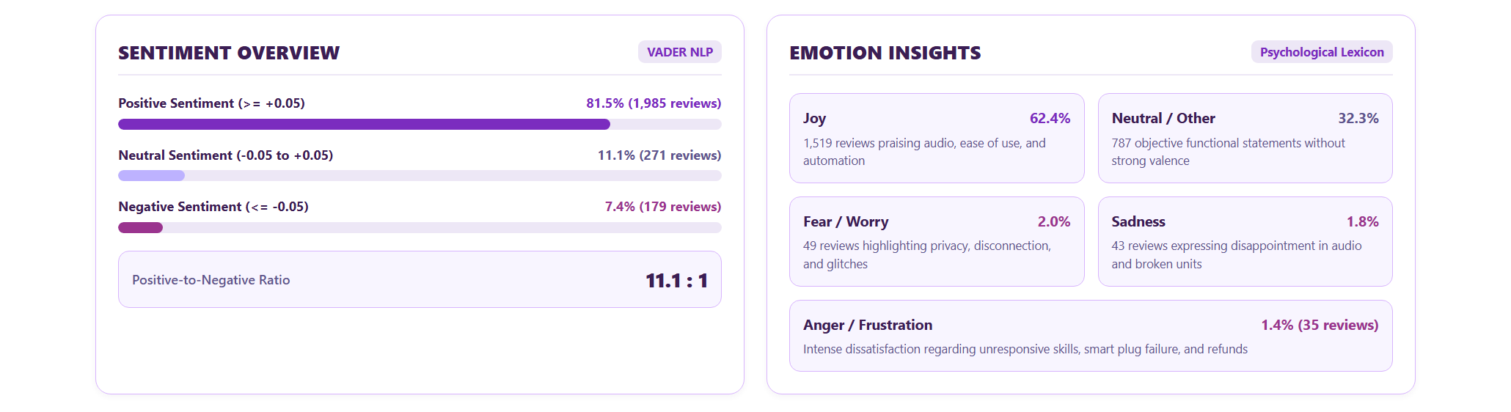
Figure 14: VADER Sentiment Progress Meters & Emotion Insights Spectrum UI Output
18.4 UI Output: Star Rating Breakdown & Qualitative Customer Feedback
This dashboard module contrasts quantitative star distributions (72.1% 5-star down to 5.8% 1-star) against qualitative linguistic metrics. KPI callouts reveal that satisfied reviews average 20.1 words of concise praise, while negative reviews average 38.6 words of detailed diagnostic critique. Real customer quotes illustrate these divergent feedback modalities.

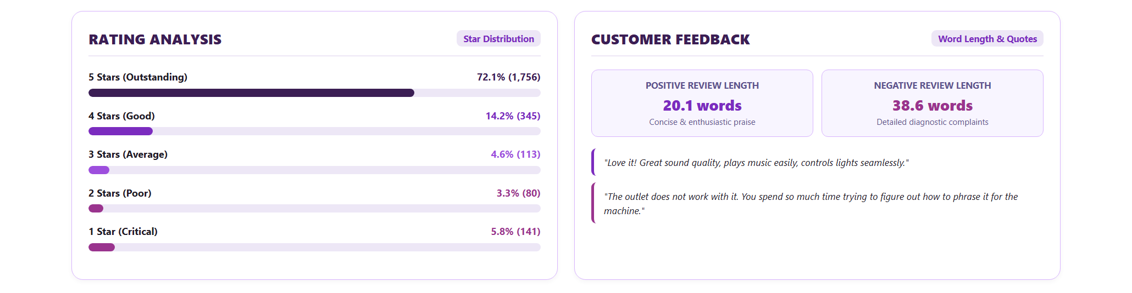
Figure 15: Star Rating Breakdown & Customer Feedback Length Comparison UI Output
18.5 UI Output: Keywords & Frequency Dynamics (Lexical Tag Cloud)
The Lexical Mining module presents interactive tag pills highlighting the top 10 praise terms (e.g., 'love' with 736 occurrences, 'great' with 555) versus the top 10 friction terms (e.g., 'alarm' with 30 occurrences, 'screen' with 28, 'reset' with 17). Color-coded borders allow immediate visual differentiation between satisfaction drivers and pain points.

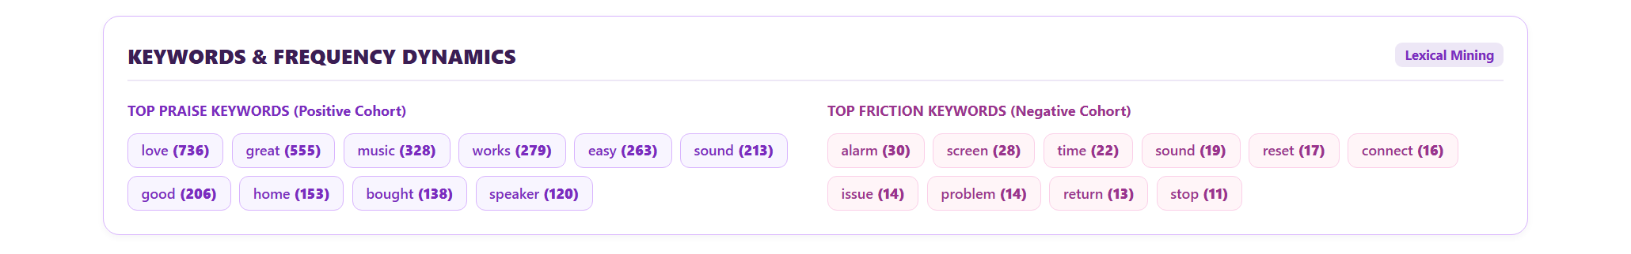
Figure 16: Keyword Frequency Dynamics & Lexical Mining Tags UI Output
18.6 UI Output: Hardware Variation Benchmarks & Strategic Recommendations
The dashboard's decision-support panel embeds a tabular benchmark ranking top hardware finishes (Charcoal Fabric leading at 4.74/5 and 89.0% positive; Heather Gray Fabric at 4.70/5) against baseline models (Standard Black Plastic at 4.23/5 and 11.9% negative). Below the table, four structured recommendation cards outline key product roadmap priorities.

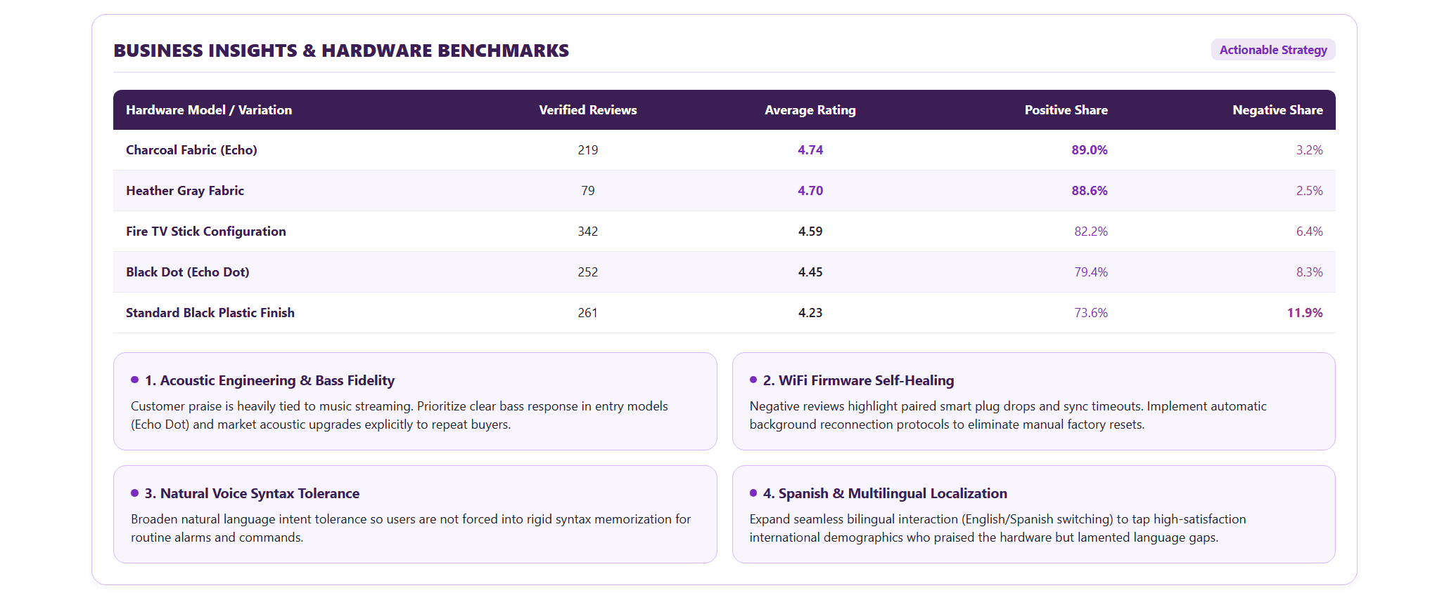
Figure 17: Hardware Benchmarks Table & Strategic Recommendations UI Output
18.7 UI Output: Interactive Live Sentiment & Emotion Analyzer Widget
To enable interactive stakeholder testing, the dashboard incorporates an embedded client-side NLP analyzer tool. Users can input any custom review text or select pre-loaded sample scenarios (Audio Praise, WiFi Drop Complaint, or Factual Neutral). Upon clicking 'Analyze Review Sentiment', the offline engine instantly computes the predicted sentiment class, compound polarity score (-1.00 to +1.00), dominant psychological emotion, polarity spectrum visual meter, and individual lexical triggers.

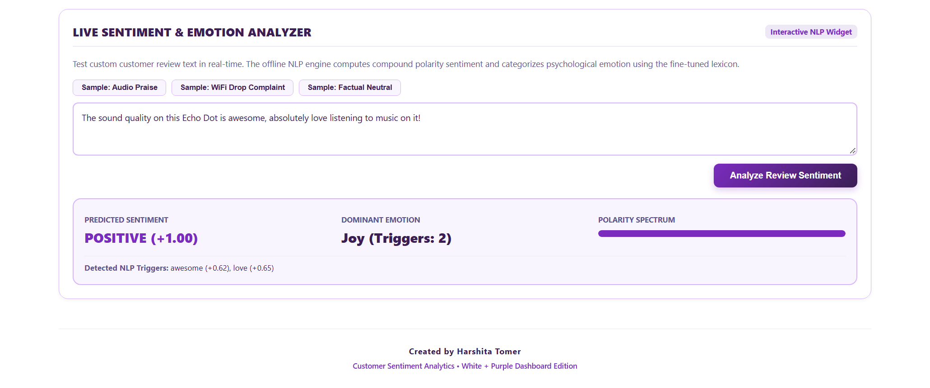
Figure 18: Interactive Live Review Sentiment & Emotion Analyzer Tool & Creator Footer UI Output
18.8 UI Output: End-to-End Single-Page Web Dashboard Overview
Figure 19 presents the consolidated, full-length visual architecture of the Customer Sentiment Analytics Dashboard. The unified White + Purple aesthetic ensures a cohesive visual identity across all analytical tiers, from high-level executive KPIs down to granular real-time text inference.

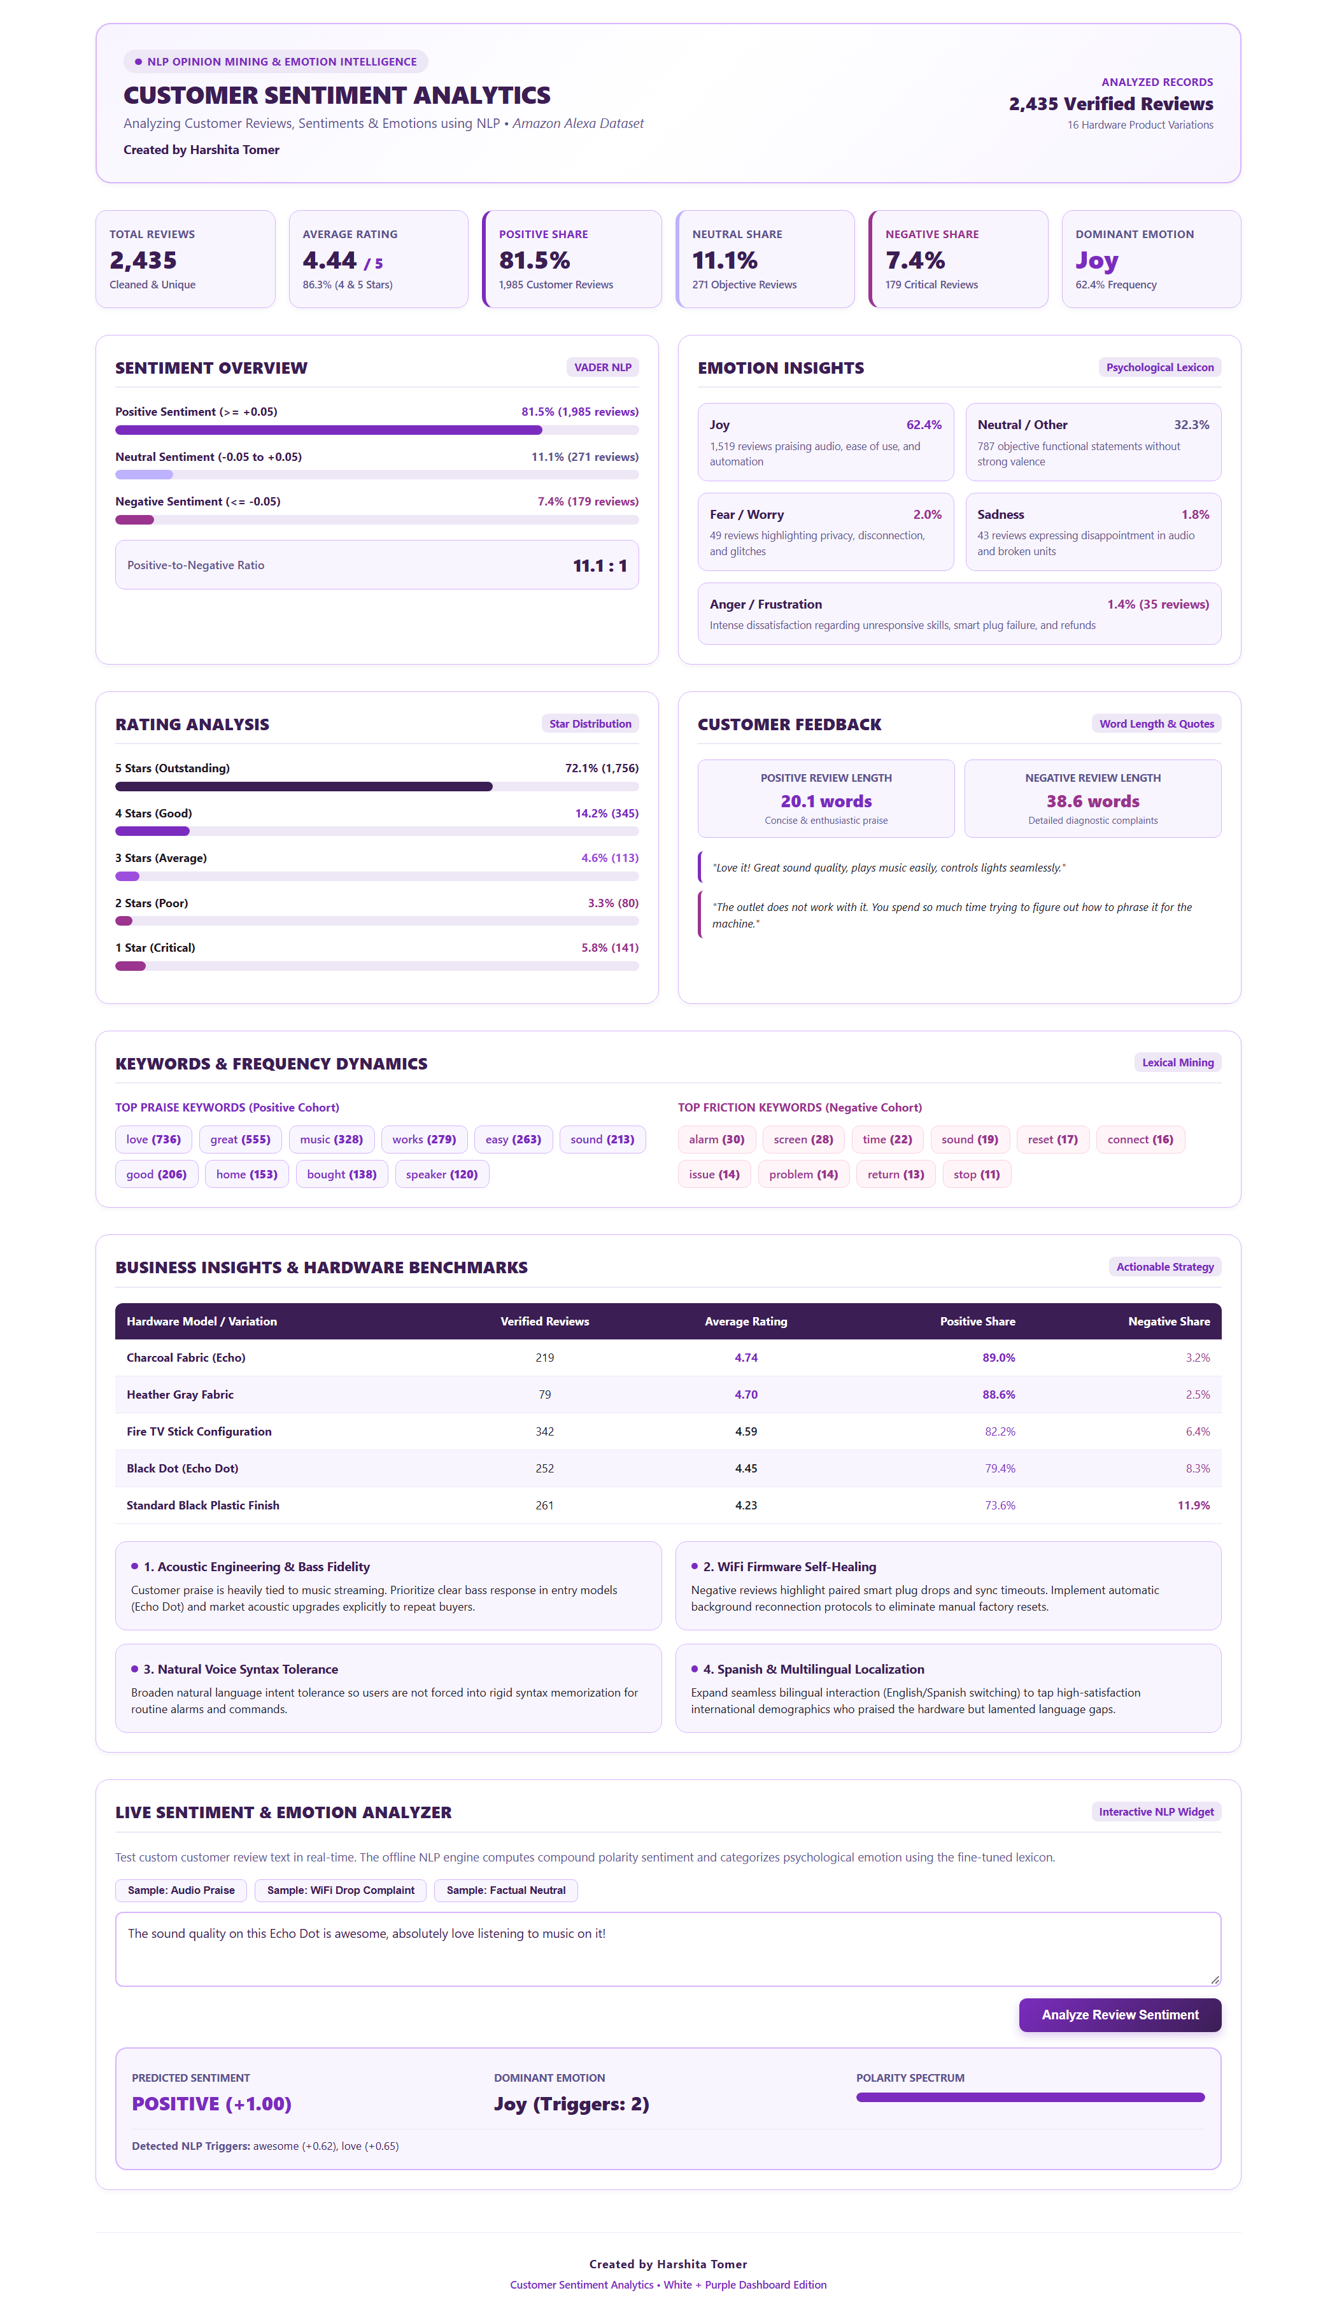
Figure 19: Comprehensive Customer Sentiment Analytics Dashboard Full-Page UI Output

19. KEY FINDINGS
Empirical investigation of the 2,435 unique customer reviews revealed four major conclusions:
- 1. Overwhelming Brand Approval: Over 81.5% of reviews reflect positive sentiment, and 86.3% of customers assign 4 or 5 stars. High satisfaction is anchored in smart music streaming, responsive alarms, and seamless smart lighting automation.
- 2. Aesthetic Material Premium: Charcoal Fabric (89.04% positive, 3.20% negative) and Heather Gray Fabric (88.61% positive, 2.53% negative) significantly outperform baseline black and white plastic units (11.88% negative for Black, 10.00% negative for White), proving that premium physical texture elevates perceived product value.
- 3. Length as a Dissatisfaction Proxy: Negative reviews have an average word count of 38.6 words—nearly double the length of positive reviews (20.1 words). Dissatisfied consumers write detailed diagnostics explaining root causes of failure.
- 4. Micro-Friction Bottlenecks: Negative sentiment does not stem from total hardware failure, but rather from micro-friction: smart plug disconnections, alarm synchronization bugs, phrasing rigidity, and lack of audio improvements across generations.
20. BUSINESS INSIGHTS
By synthesizing cross-tabulated ratings, sentiment valence, and keyword co-occurrences, the following business insights emerge:
- Nuanced Middle-Tier Sentiment: A segment of 3-star and 4-star reviews contain negative compound sentiment scores. These customers like the product concept but feel let down by specific features (such as audio fidelity or screen integration quirks). Addressing these specific points converts neutral customers into brand advocates.
- Ecosystem Dependency Risk: Customers who purchased smart plug bundles frequently cited smart outlet failure as the sole reason for a 1-star rating, dragging down the host device's product score.
- Localization Opportunity: Spanish-speaking consumers actively praised the hardware but lamented the lack of Spanish language support in earlier software versions, representing untapped market demand.
21. BUSINESS RECOMMENDATIONS
The following actionable recommendations are grounded entirely in empirical dataset observations:
- 1. Acoustic Engineering & Generational Upgrades: Prioritize clear bass response and acoustic separation on mid-tier models (Echo Dot). Highlight acoustic upgrades prominently in product marketing so generational improvements are immediately noticeable to repeat buyers.
- 2. Smart Home Reconnection Self-Healing: Deploy firmware updates that implement automatic self-healing WiFi reconnect protocols for paired smart plugs and smart lights, eliminating the need for manual factory resets.
- 3. Conversational Flexibility & Voice Tolerance: Improve natural language understanding (NLU) tolerance for conversational phrasing so users are not forced to memorize rigid command syntax to execute basic tasks.
- 4. International Localization & Multilingual Support: Expand full bilingual voice interaction (seamless English and Spanish switching) to enhance customer retention in diverse international markets.
22. PROJECT LIMITATIONS
While methodologically robust, the study exhibits specific analytical limitations:
- Lexicon Inherent Boundaries: VADER and rule-based emotion lexicons rely on curated vocabulary and grammar rules. Subtle irony, complex sarcasm, or domain-specific internet slang may be misclassified as Neutral.
- Sample Class Imbalance: Like most e-commerce electronics categories, the review sample exhibits a natural positive skew (81.5% positive), providing a smaller sample of negative feedback (179 reviews) for statistical subdivision.
- Temporal Bounding: The dataset covers feedback through mid-2018. Subsequent firmware and hardware updates released by Amazon are not reflected in this historical sample.
23. FUTURE SCOPE
Future research directions to extend this work include:
- Aspect-Based Sentiment Analysis (ABSA): Segmenting customer opinions at the sentence clause level to explicitly assign sentiment polarities to individual product facets (e.g. [Battery: -0.4], [Sound: +0.8]).
- Real-Time Streaming Pipelines: Developing real-time streaming dashboards that ingest live API review feeds, alerting quality assurance teams to sudden negative spikes within 24 hours of firmware deployments.
- Transformer Benchmarking: Benchmarking lexicon approaches against lightweight transformer architectures (e.g. DistilBERT or RoBERTa) to evaluate performance gains versus computational latency.
24. CONCLUSION
This project established a comprehensive, explainable Data Analytics and NLP pipeline for mining consumer opinions from authentic Amazon Alexa reviews. The study demonstrated that text reviews offer a critical diagnostic layer beyond numerical star ratings, uncovering specific customer emotions, praise factors, and operational pain points.
By implementing VADER sentiment scoring, discrete emotion classification, keyword discovery, 12 dashboard-style White + Purple visualizations, and an offline interactive web analytics interface with live review testing, this research proves that computational linguistics can directly inform product roadmap decisions, quality assurance protocols, and brand positioning strategies.
25. REFERENCES
- [1] Hutto, C. J., & Gilbert, E. (2014). VADER: A Parsimonious Rule-based Model for Sentiment Analysis of Social Media Text. Proceedings of the International AAAI Conference on Web and Social Media (ICWSM-14).
- [2] Plutchik, R. (2001). The Nature of Emotions: Human emotions have solved the challenges of survival, yet we are still struggling to understand them. American Scientist, 89(4), 344-350.
- [3] Ekman, P. (1992). An argument for basic emotions. Cognition & Emotion, 6(3-4), 169-200.
- [4] Bird, S., Klein, E., & Loper, E. (2009). Natural Language Processing with Python: Analyzing Text with the Natural Language Toolkit. O'Reilly Media.
- [5] McKinney, W. (2010). Data Structures for Statistical Computing in Python. Proceedings of the 9th Python in Science Conference (SciPy 2010), 51-56.
- [6] Hunter, J. D. (2007). Matplotlib: A 2D Graphics Environment. Computing in Science & Engineering, 9(3), 90-95.
- [7] Waskom, M. L. (2021). Seaborn: statistical data visualization. Journal of Open Source Software, 6(60), 3021.
- [8] Kaggle & GitHub Public Machine Learning Repository: Amazon Alexa Reviews Dataset (3,150 Records). Public Academic Resource.

