SIMATS ENGINEERING
Assessment Tool 2 — CO2: Social Engineering Simulation

Question 1 — OSINT Email Enumeration with theHarvester (20 Marks)

Command
# Basic scan across all free public sources
theHarvester -d tesla.com -b all -l 500
# Restrict to specific sources (faster, avoids rate limits)
theHarvester -d tesla.com -b bing,duckduckgo,crtsh,otx,hackertarget -l 500
# Save output to a report file
theHarvester -d tesla.com -b all -l 500 -f tesla_osint_report

Flag reference:
- -d : target domain to search
- -b : data source(s) — e.g. bing, crtsh (certificate transparency), hackertarget, otx, duckduckgo, or "all"
- -l : limit on number of results retrieved per source
- -f : filename to save results as HTML and XML
EXPLANATION
OSINT Email Enumeration with theHarvester is a technique used to collect publicly available email addresses related to a domain using Open Source Intelligence (OSINT).
theHarvester gathers emails, subdomains, hostnames, and other information from search engines and public data sources.
It helps security professionals perform reconnaissance and assess an organization's public exposure before security testing.
This process is commonly used in ethical hacking, penetration testing, and cybersecurity investigations.

OUTPUT

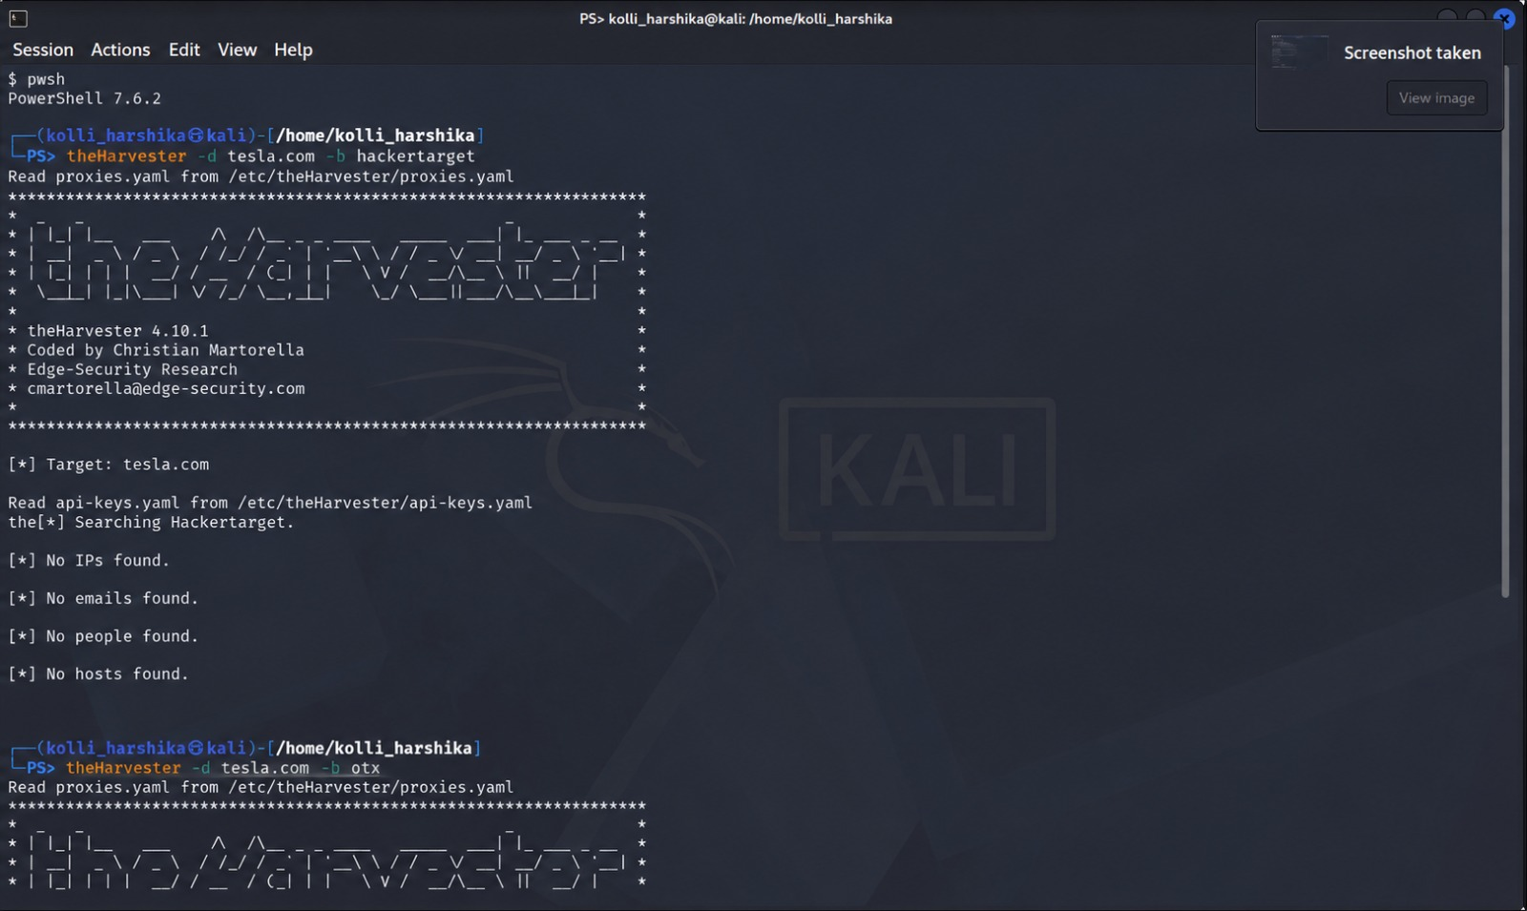

Question 2 — Phishing Awareness Simulation with GoPhish (20 Marks)

COMMAND
# Download & run GoPhish (lab machine, isolated network only)
wget https://github.com/gophish/gophish/releases/latest
unzip gophish-vX.X.X-linux-64bit.zip
cd gophish
sudo ./gophish
# Admin UI: https://127.0.0.1:3333
# Phishing listener: http://127.0.0.1:80 (or lab-assigned port)

Campaign Build Steps (inside the GoPhish admin UI)

a. Sending Profile
Settings this needs: SMTP host/port of the lab mail relay, an authenticated from-address (e.g. it-support@lab-simulation.local), and a friendly display name such as "IT Helpdesk".

b. Email Template
Write a plausible pretext (e.g. "Password Expiry Notice" or "Mandatory Policy Update"), include the GoPhish tracking pixel (added automatically), and a call-to-action link using the {{.URL}} template variable.

c. Landing Page
A cloned or mock internal-looking login page is imported or built in the Landing Pages tab; enable "Capture Submitted Data" only if the assignment calls for credential-capture metrics, and always show the "you have been phished" redirect/education page after submission.

d. Target Group
Import the dummy employee accounts (CSV: First Name, Last Name, Email, Position) provided in the lab.

e. Launch Campaign
Combine the sending profile, email template, landing page and group under Campaigns → New Campaign, set the launch date, and start it.

EXPLANATION
Phishing Awareness Simulation with GoPhish is a cybersecurity training method used to simulate phishing attacks in a safe and controlled environment.
GoPhish allows organizations to create and send realistic phishing emails to evaluate users' awareness and responses.
It helps identify employees who may be vulnerable to phishing attacks and provides opportunities for security training.
This tool is widely used by ethical hackers and security teams to improve organizational cybersecurity awareness.

OUTPUT
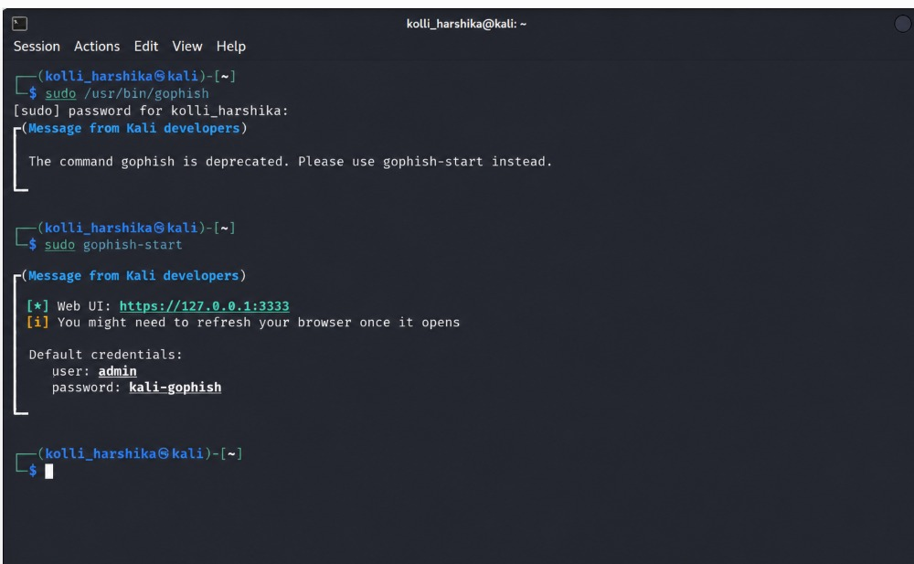

Question 3 — Nmap Aggressive Scan & Social Engineering Angle (10 Marks)

Command
nmap -A scanme.nmap.org
# Optional: save output to file for the report
nmap -A scanme.nmap.org -oN nmap_aggressive_report.txt

-A enables, in one flag:
- OS detection (-O)
- Version detection of services on open ports (-sV)
- Script scanning with default NSE scripts (-sC)
- Traceroute to the target (--traceroute)
EXPLANATION
Nmap Aggressive Scan & Social Engineering Angle combines advanced network scanning with awareness of human-focused security risks.
An Nmap Aggressive Scan (-A) detects open ports, running services, operating systems, and version information to assess a target's security posture.
The collected information can help demonstrate how attackers might identify publicly exposed systems and tailor phishing or impersonation attempts in authorized security assessments.
This approach is commonly used in ethical hacking and penetration testing to evaluate technical vulnerabilities alongside potential social engineering risks.

