CHAROTAR UNIVERSITY OF SCIENCE AND TECHNOLOGY (CHARUSAT)
FACULTY OF TECHNOLOGY AND ENGINEERING (FTE)
DEPARTMENT OF COMPUTER ENGINEERING
SUBJECT: WEB DEVELOPMENT FRAMEWORKS (ITUE203)
PRACTICAL 1 LABORATORY REPORT
SEMESTER: III | ACADEMIC YEAR: 2026–27
Name : Harshil Prajapati | ID : 25DCE093
Program : B.Tech (Computer Engineering) | Course : ITUE203 – Web Dev Frameworks

Practical 1: Project Initiation, Requirement Analysis, Sitemap, Wireframe, and GitHub Setup
CO Mapping | CO1
Bloom's Taxonomy Level | L3 – Apply / L4 – Analyze
Lab Duration | 4 Hours
Total Hours of Problem Definition Implementation | 4 Hours
Total Hours of Testing / Evaluation | 0 Hours

Practical Aim
To initiate the StudentHub web portal by conducting requirement analysis, creating a navigation sitemap, designing low-fidelity wireframes, and setting up a version-controlled GitHub repository.
Problem Definition
Initiate the semester-long StudentHub portal by identifying the problem scope, user roles, key modules, navigation flow, and minimum 10 pages. Create a sitemap, low-fidelity wireframe, project folder structure, README file, and GitHub repository.
Key Questions / Analysis / Interpretation to be Evaluated
Question 1: What is URL and parts of URL?
A URL (Uniform Resource Locator) is a global unique identifier used to locate and access resources on the World Wide Web.
The primary structural components of a URL include:
1. Protocol / Scheme (e.g., https://): Specifies the communication protocol governing the transaction. HTTPS encrypts data via TLS/SSL.
2. Subdomain (e.g., www or portal): Identifies a specific subdivision or server cluster under the parent domain.
3. Domain Name (e.g., charusat.edu.in): Human-readable address mapped to server IP address through Domain Name System (DNS).
4. Port Number (e.g., :443 for HTTPS, :80 for HTTP): Logical gateway on the host operating system that directs network packets to the appropriate web service.
5. Path (e.g., /studenthub/home.html): Exact hierarchical file or virtual route directory structure on the server filesystem.
6. Query String (e.g., ?dept=CE&year=3): Key-value parameters passed after '?' used for dynamic server-side filtering or client routing.
7. Fragment / Anchor (e.g., #contact): Internal bookmark prefixed by '#' instructing the browser to scroll directly to an element with that ID.
Question 2: How does HTML file processed in web browser?
Browsers parse and render an HTML file via the Critical Rendering Path (CRP):
1. Network Retrieval: Browser sends an HTTP GET request and receives HTML bytes.
2. Tokenization & DOM Tree Construction: Raw bytes are decoded to characters, parsed into tokens (tags, attributes), and converted into Node objects forming the Document Object Model (DOM) tree.
3. CSSOM Tree Construction: As external stylesheets (<link rel='stylesheet'>) are fetched, CSS rules are parsed into the CSS Object Model (CSSOM) tree.
4. Render Tree Synthesis: The DOM and CSSOM trees are merged into the Render Tree, discarding non-visible elements (such as <head> and display:none).
5. Layout (Reflow): The layout engine calculates exact geometric coordinates, widths, and heights for each box in the viewport.
6. Paint & Compositing: Vector shapes and text are rasterized into pixels on layers, and GPU layers are composited onto the screen display.
Question 3: How will page navigation flow managed among all HTML pages?
Navigation flow in StudentHub is structured around a centralized hierarchical architecture:
1. Universal Sticky Header: Every page includes an identical <header> and <nav> with explicit relative links to all major modules (home.html, about.html, events.html, dashboard.html, profile.html, contact.html, FAQs.html, login.php, register.html).
2. Breadcrumb Navigation: Secondary pages implement breadcrumbs (e.g., Home > Events > Workshop) allowing one-click back-tracing.
3. Mobile Responsive Toggle: A JavaScript-driven hamburger button collapses the navigation menu into an accessible slide-down drawer on mobile screens.
Question 4: How will GitHub commits be maintained after each practical?
GitHub repository version control follows standard Git flow conventions:
1. Semantic Commit Messages: Commits follow Conventional Commits standard (e.g., 'feat: add registration regex validation', 'fix: resolve navbar flex alignment on tablet').
2. Atomic Commit Strategy: Each practical is committed as an isolated unit with clean diffs containing related source code and documentation.
3. Milestone Tagging: Each completed practical is tagged (e.g., git tag -a practical-01 -m 'Practical 1 Submission') for traceability.
Key Skills, Applications & Learning Outcomes
• Key Skills: Requirement analysis, sitemap design, wireframing, Git/GitHub version control, README authoring, folder structuring.
• Applications: Web application architectural planning, enterprise portal scoping, maintainable open-source repository design.
• Learning Outcome: Students will be able to analyze user requirements, construct comprehensive sitemaps and wireframes, and establish professional Git repositories.
• Tools Used: VS Code, Git, GitHub, ASCII wireframing tools, Markdown.
Implementation / Source Code
# Project Folder Structure:
studenthub/
├── home.html, about.html, register.html, login.php, dashboard.html
├── events.html, profile.html, contact.html, FAQs.html, admin.html
├── styles.css (Universal Design System)
├── script.js (Interactive UI & Fetch API)
├── db_connect.php, studenthub.sql (Database Layer)
├── screenshots/ & docs/wireframe.md
# Wireframe ASCII Representation (Home Page):
+-------------------------------------------------------------+
| HEADER: Logo (StudentHub) | Nav Links | Theme Toggle Button |
+-------------------------------------------------------------+
| Notification: Welcome to StudentHub Campus Portal |
+-------------------------------------------------------------+
| HERO: Welcome Banner | Registration CTA | Sign In CTA |
+-------------------------------------------------------------+
| GRID: [Events] [Notices] [Dashboard] [Feedback] |
+-------------------------------------------------------------+
| FOOTER: About Summary | Quick Links | Support | Copyright |
+-------------------------------------------------------------+

Output & Verification Screenshots
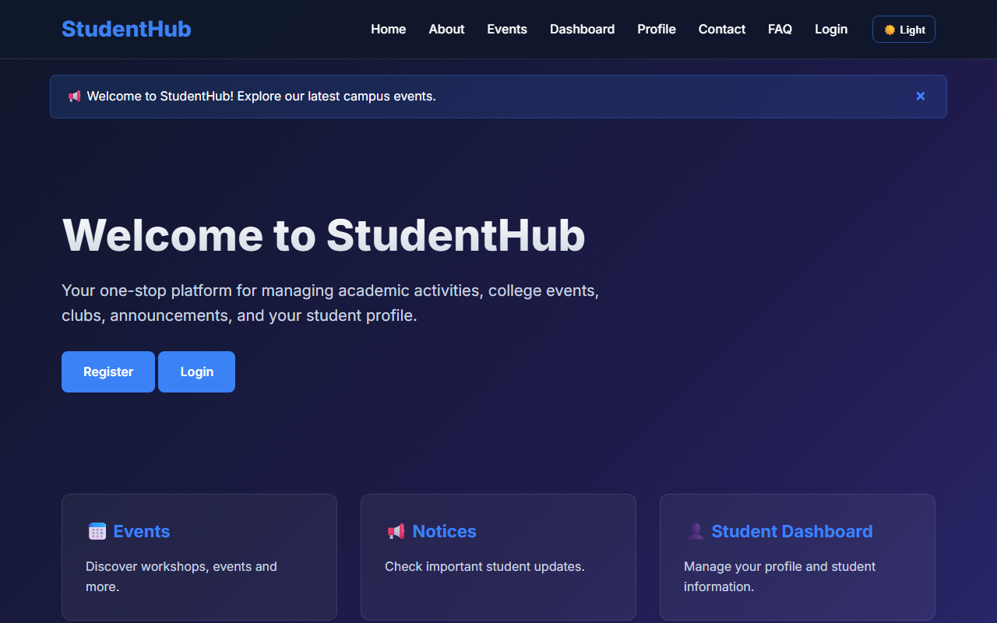
Figure 1: practical_01_wireframe.png - Verification Output
Post Laboratory Work / Evaluation Viva Questions
Viva Q1: What is the primary difference between low-fidelity and high-fidelity wireframes?
Answer: Low-fidelity wireframes focus on layout structure, user flow, and content placement using simple boxes or ASCII text without color or imagery. High-fidelity wireframes include pixel-perfect graphics, typography, branding, and color palettes.
Viva Q2: Why is a sitemap crucial before writing code?
Answer: A sitemap establishes the complete information architecture, page relationships, and navigation hierarchies, preventing broken user flows and scope creep during implementation.
Conclusion
With this practical we can conclude that proper architectural planning, requirement scoping, sitemap modeling, and structured Git version control provide an indispensable foundation for building large-scale, maintainable web applications.

