CHAROTAR UNIVERSITY OF SCIENCE AND TECHNOLOGY (CHARUSAT)
FACULTY OF TECHNOLOGY AND ENGINEERING (FTE)
DEPARTMENT OF COMPUTER ENGINEERING
SUBJECT: WEB DEVELOPMENT FRAMEWORKS (ITUE203)
PRACTICAL 5 LABORATORY REPORT
SEMESTER: III | ACADEMIC YEAR: 2026–27
Name : Harshil Prajapati | ID : 25DCE093
Program : B.Tech (Computer Engineering) | Course : ITUE203 – Web Dev Frameworks

Practical 5: Registration Form with Frontend Validation and User-Friendly Error Handling
CO Mapping | CO1, CO3
Bloom's Taxonomy Level | L3 – Apply / L4 – Analyze
Lab Duration | 4 Hours
Total Hours of Problem Definition Implementation | 4 Hours
Total Hours of Testing / Evaluation | 2 Hours

Practical Aim
To construct an accessible student registration form featuring comprehensive client-side Regular Expression validation, inline error spans, and an interactive password strength meter.
Problem Definition
Create a student registration form with HTML5 input types and JavaScript validation for name, email, mobile number, password, confirm password, course, year, gender, and terms acceptance. Use Regular Expression for validations.
Key Questions / Analysis / Interpretation to be Evaluated
Question 1: Are correct input types and attributes used?
Yes. The form utilizes specific HTML5 input types and constraint attributes:
• Full Name: <input type='text' required>
• Email: <input type='email' required>
• Mobile: <input type='tel' maxlength='10' required>
• Course: <select required> with predefined options
• Academic Year: <input type='number' min='1' max='4' required>
• Gender: Radio buttons grouped with name='gender'
• Password & Confirm Password: <input type='password' required>
• Terms Acceptance: <input type='checkbox' required>
Question 2: Are validation errors displayed near the relevant fields?
Yes. Every field possesses a dedicated <span class='error-msg' id='...Error'> immediately beneath the input box that populates with a specific error message upon validation failure. In addition, an #errorSummary box appears at the top summarizing all outstanding issues.
Question 3: Is password strength checked?
Yes. An input event listener evaluates password length, uppercase letters, digits, and special characters. The meter dynamically animates from Weak (red, 25%) to Medium (yellow, 50%) to Good (blue, 75%) to Strong (green, 100%).
Question 4: Is the form accessible using keyboard and screen-reader-friendly labels?
Yes. Every label uses the for attribute mapped to input IDs, aria-describedby links inputs to error messages, and tab navigation follows natural visual flow.
Key Skills, Applications & Learning Outcomes
• Key Skills: HTML forms, JavaScript regex validation, regular expressions, password strength meter, UX error messaging.
• Applications: User onboarding workflows, data integrity enforcement, registration portals.
• Learning Outcome: Students will design accessible forms with robust client-side validation and responsive UX feedback.
• Tools Used: HTML5, JavaScript ES6+, browser dev tools.
Implementation / Source Code
// Client-Side Regular Expression Validation from script.js
const nameRegex = /^[A-Za-z\s]{3,50}$/;
const emailRegex = /^[a-zA-Z0-9._%+-]+@[a-zA-Z0-9.-]+\.[a-zA-Z]{2,}$/;
const mobileRegex = /^[0-9]{10}$/;
const passwordRegex = /^(?=.*[A-Za-z])(?=.*\d)[A-Za-z\d@$!%*#?&]{8,}$/;
registerForm.addEventListener('submit', function (event) {
let isValid = true;
if (!nameRegex.test(nameInput.value.trim())) {
showError('name', 'nameError', 'Name must contain only letters (min 3 chars).');
isValid = false;
}
if (!emailRegex.test(emailInput.value.trim())) {
showError('email', 'emailError', 'Enter a valid institutional email.');
isValid = false;
}
if (!mobileRegex.test(mobileInput.value.trim())) {
showError('mobile', 'mobileError', 'Mobile number must be exactly 10 digits.');
isValid = false;
}
if (passwordInput.value !== confirmPasswordInput.value) {
showError('confirm_password', 'confirmPasswordError', 'Passwords do not match.');
isValid = false;
}
if (!isValid) event.preventDefault();
});

Output & Verification Screenshots
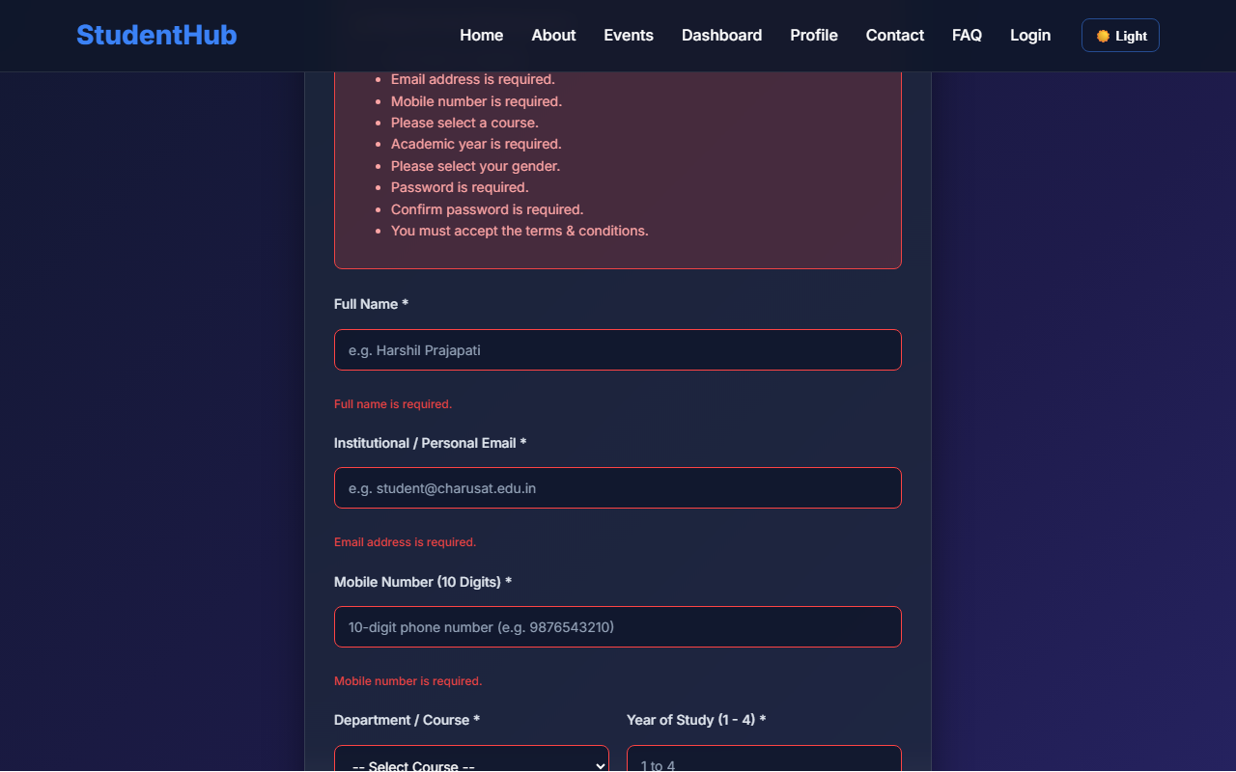
Figure 5: practical_05_form_validation_errors.png - Verification Output
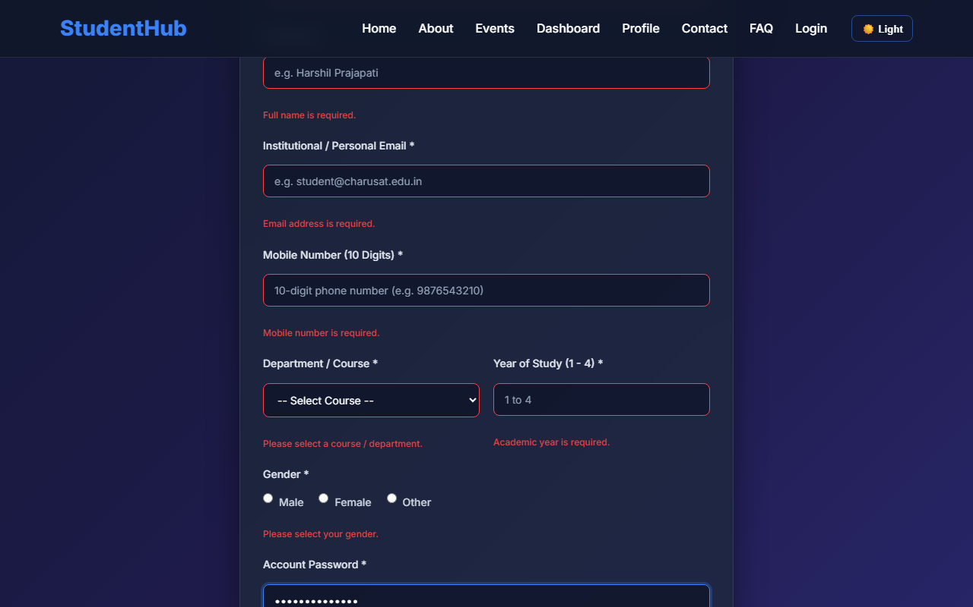
Figure 5: practical_05_password_strength.png - Verification Output
Post Laboratory Work / Evaluation Viva Questions
Viva Q1: Explain the regex: /^(?=.*[A-Za-z])(?=.*\d)[A-Za-z\d@$!%*#?&]{8,}$/
Answer: This regular expression uses positive lookaheads: '(?=.*[A-Za-z])' ensures at least one letter exists, '(?=.*\d)' ensures at least one digit exists, and '{8,}' requires the total string length to be at least 8 characters containing allowed characters.
Viva Q2: Why is client-side validation not sufficient on its own?
Answer: Client-side validation can be bypassed by disabling JavaScript or submitting directly via tools like Postman; therefore, server-side validation is required to ensure data integrity and security.
Conclusion
With this practical we can conclude that client-side form validation with Regular Expressions provides instantaneous feedback to users, reduces invalid server round-trips, and improves data entry accuracy.

