CHAROTAR UNIVERSITY OF SCIENCE AND TECHNOLOGY (CHARUSAT)
FACULTY OF TECHNOLOGY AND ENGINEERING (FTE)
DEPARTMENT OF COMPUTER ENGINEERING
SUBJECT: WEB DEVELOPMENT FRAMEWORKS (ITUE203)
PRACTICAL 9 LABORATORY REPORT
SEMESTER: III | ACADEMIC YEAR: 2026–27
Name : Harshil Prajapati | ID : 25DCE093
Program : B.Tech (Computer Engineering) | Course : ITUE203 – Web Dev Frameworks

Practical 9: Secure User Registration with Database Insert, Duplicate Email Check, and Password Hashing
CO Mapping | CO1, CO3, CO5
Bloom's Taxonomy Level | L3 – Apply / L4 – Analyze
Lab Duration | 4 Hours
Total Hours of Problem Definition Implementation | 4 Hours
Total Hours of Testing / Evaluation | 2 Hours

Practical Aim
To implement secure student account registration into MySQL, verifying email uniqueness via parameterized queries and encrypting passwords using BCRYPT hashing.
Problem Definition
Implement secure user registration by inserting user details into MySQL using MySQLi. Validate input on frontend and backend, check duplicate email/username, hash passwords using password_hash(), and display appropriate messages.
Key Questions / Analysis / Interpretation to be Evaluated
Question 1: Is password_hash() used before storing passwords?
Yes. Passwords are never stored in plain text. PHP's native password_hash($password, PASSWORD_BCRYPT) creates a secure 60-character one-way cryptographic hash with an automatically generated salt.
Question 2: Is duplicate email/username checked?
Yes. Prior to database insertion, a parameterized query (SELECT user_id FROM users WHERE email = ?) verifies that no account exists with that institutional email address. If found, a duplicate error alert is displayed.
Question 3: Are frontend and backend validations consistent?
Yes. The backend enforces identical constraints (Regex, mandatory values, string lengths) as the frontend JavaScript. Even if client-side validation is bypassed, the server rejects non-compliant inputs.
Key Skills, Applications & Learning Outcomes
• Key Skills: Secure user registration, password hashing, parameterized queries, duplicate prevention, backend error handling.
• Applications: User authentication, student profile creation, secure credential storage.
• Learning Outcome: Students will implement secure user registration following industry-standard web security practices.
• Tools Used: PHP 8.x, MySQLi / PDO, MySQL, XAMPP.
Implementation / Source Code
<?php
// Secure Registration Handler from process_registration.php
require_once 'db_connect.php';
$email = filter_var(trim($_POST['email']), FILTER_SANITIZE_EMAIL);
$password = $_POST['password'];
// 1. Check duplicate email
$stmt = mysqli_prepare($conn, "SELECT user_id FROM users WHERE email = ?");
mysqli_stmt_bind_param($stmt, "s", $email);
mysqli_stmt_execute($stmt);
mysqli_stmt_store_result($stmt);
if (mysqli_stmt_num_rows($stmt) > 0) {
die("Error: An account with this email address already exists.");
}
mysqli_stmt_close($stmt);
// 2. Hash password securely using BCRYPT
$passwordHash = password_hash($password, PASSWORD_BCRYPT);
// 3. Insert record using prepared statement
$insertStmt = mysqli_prepare($conn, "INSERT INTO users (username, email, password_hash, role) VALUES (?, ?, ?, 'student')");
mysqli_stmt_bind_param($insertStmt, "sss", $username, $email, $passwordHash);
mysqli_stmt_execute($insertStmt);
mysqli_stmt_close($insertStmt);
?>

Output & Verification Screenshots
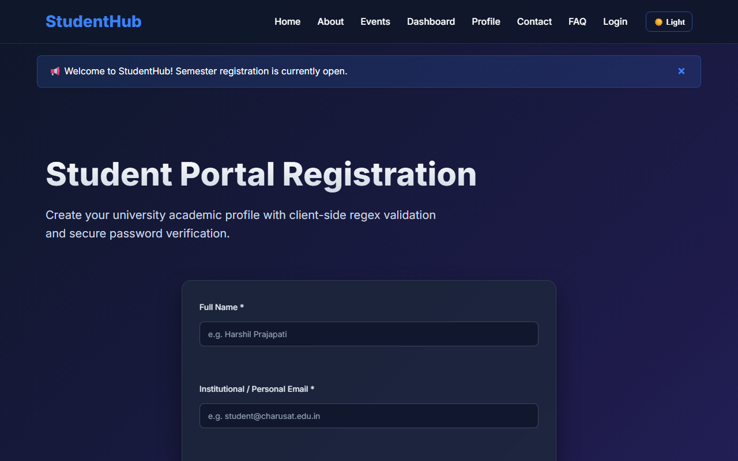
Figure 9: practical_09_secure_registration.png - Verification Output
Post Laboratory Work / Evaluation Viva Questions
Viva Q1: Why is MD5 or SHA1 not acceptable for password storage?
Answer: MD5 and SHA1 are general-purpose collision-prone checksums that are too fast, making them vulnerable to brute-force cracking with GPUs and rainbow tables. BCRYPT is an intentionally slow, salted, adaptive algorithm.
Viva Q2: What does the 'salt' accomplish in password hashing?
Answer: A salt is random data concatenated with the password before hashing, guaranteeing that two identical passwords produce completely different hash outputs, mitigating rainbow table attacks.
Conclusion
With this practical we can conclude that pre-insert uniqueness checks combined with BCRYPT password hashing and prepared statements provide a secure user registration workflow.

