CHAROTAR UNIVERSITY OF SCIENCE AND TECHNOLOGY (CHARUSAT)
FACULTY OF TECHNOLOGY AND ENGINEERING (FTE)
DEPARTMENT OF COMPUTER ENGINEERING
SUBJECT: WEB DEVELOPMENT FRAMEWORKS (ITUE203)
PRACTICAL 6 LABORATORY REPORT
SEMESTER: III | ACADEMIC YEAR: 2026–27
Name : Harshil Prajapati | ID : 25DCE093
Program : B.Tech (Computer Engineering) | Course : ITUE203 – Web Dev Frameworks

Practical 6: Rendering External JSON Data using Fetch API, Search and Filter
CO Mapping | CO3, CO4
Bloom's Taxonomy Level | L3 – Apply / L4 – Analyze
Lab Duration | 4 Hours
Total Hours of Problem Definition Implementation | 4 Hours
Total Hours of Testing / Evaluation | 2 Hours

Practical Aim
To asynchronously consume external JSON files using the JavaScript Fetch API, dynamically generating UI cards with real-time text searching, category filtering, and sorting.
Problem Definition
Display event lists, student profiles, notices, or FAQs from external JSON files using Fetch API. Implement dynamic rendering, search, filter, sorting, and pagination.
Key Questions / Analysis / Interpretation to be Evaluated
Question 1: How is JSON fetched, parsed, and rendered?
The Fetch API executes an asynchronous HTTP GET request:
fetch('events.json')
.then(response => { if (!response.ok) throw new Error(); return response.json(); })
.then(data => { eventsData = data; renderEvents(data); })
.catch(err => { showErrorMessage(err); });
The parsed JavaScript objects are converted into HTML cards using template literals and injected into the DOM container.
Question 2: Which array methods are used for search, filter, sort, and pagination?
1. Search & Filter: Array.prototype.filter() checks if event title includes the search string and matches category dropdown.
2. Sort: Array.prototype.sort() re-orders cards alphabetically by title or chronologically by date.
3. Pagination: Array.prototype.slice(startIndex, endIndex) isolates the slice of records for the active page.
Question 3: How are loading and error states handled?
Prior to fetch completion, an animated spinner element is displayed in the container. If the network promise rejects, the catch block renders a user-friendly error notice with a 'Retry' action.
Question 4: How is modularity maintained in JavaScript files?
Logic is divided into single-responsibility functions: loadData(), updateView(), filterData(), and renderCards().
Key Skills, Applications & Learning Outcomes
• Key Skills: JSON handling, Fetch API, array manipulation (map/filter/sort/slice), asynchronous JavaScript, pagination logic.
• Applications: Single-page application data rendering, dynamic catalog listings, headless API consumption.
• Learning Outcome: Students will consume external JSON data and render reusable, interactive frontend views asynchronously.
• Tools Used: JavaScript ES6+, JSON, HTML5, CSS3, browser dev tools.
Implementation / Source Code
// Fetch API & Dynamic Filter Pipeline from script.js
let allEvents = [];
async function loadEventsData() {
try {
const res = await fetch('events.json');
allEvents = await res.json();
updateEventsView();
} catch (e) {
document.getElementById('eventsContainer').innerHTML = '<p>Error loading data.</p>';
}
}
function updateEventsView() {
const query = document.getElementById('eventSearch').value.toLowerCase();
const category = document.getElementById('filterCategory').value;
const filtered = allEvents.filter(ev => {
const matchesSearch = ev.title.toLowerCase().includes(query) || ev.description.toLowerCase().includes(query);
const matchesCat = (category === 'All' || category === '' || ev.category === category);
return matchesSearch && matchesCat;
});
renderEvents(filtered);
}

Output & Verification Screenshots
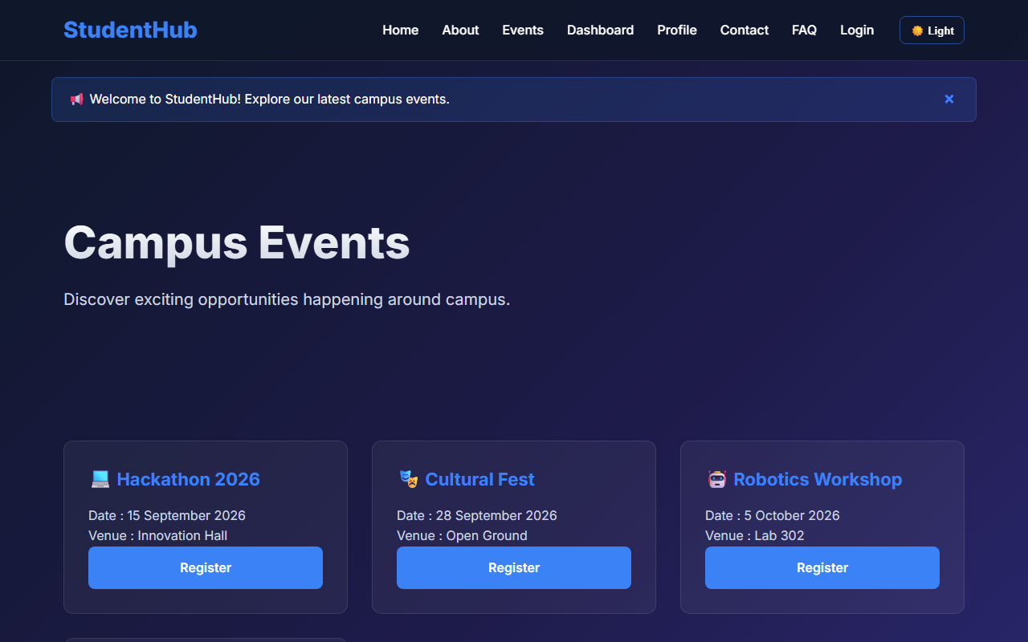
Figure 6: practical_06_fetch_api_cards.png - Verification Output
Post Laboratory Work / Evaluation Viva Questions
Viva Q1: What is the difference between synchronous XMLHttpRequest and Fetch API?
Answer: XMLHttpRequest relies on callback handlers and was historically synchronous or event-driven, whereas Fetch API returns native Promises, supports async/await, and offers cleaner request/response stream handling.
Viva Q2: What is JSON and why is it preferred over XML?
Answer: JSON (JavaScript Object Notation) is a lightweight, human-readable data-interchange format that directly maps to native JavaScript objects without requiring heavy XML parsing trees.
Conclusion
With this practical we can conclude that the JavaScript Fetch API enables seamless asynchronous retrieval of external JSON records, allowing dynamic card generation and responsive filtering without page reloads.

