CHAROTAR UNIVERSITY OF SCIENCE AND TECHNOLOGY (CHARUSAT)
FACULTY OF TECHNOLOGY AND ENGINEERING (FTE)
DEPARTMENT OF COMPUTER ENGINEERING
SUBJECT: WEB DEVELOPMENT FRAMEWORKS (ITUE203)
PRACTICAL 8 LABORATORY REPORT
SEMESTER: III | ACADEMIC YEAR: 2026–27
Name : Harshil Prajapati | ID : 25DCE093
Program : B.Tech (Computer Engineering) | Course : ITUE203 – Web Dev Frameworks

Practical 8: MySQL Schema Design, ER Model, PDO Connectivity, and Prepared Statements
CO Mapping | CO1, CO5
Bloom's Taxonomy Level | L3 – Apply / L4 – Analyze
Lab Duration | 4 Hours
Total Hours of Problem Definition Implementation | 4 Hours
Total Hours of Testing / Evaluation | 2 Hours

Practical Aim
To architect a normalized relational database schema for StudentHub, model entity relationships, and implement secure PHP database connections using MySQLi and PDO prepared statements.
Problem Definition
Design the database for StudentHub with students, events and registrations. Create PHP database connection using MYSQL statements (and PDO prepared statements).
Key Questions / Analysis / Interpretation to be Evaluated
Question 1: Is the schema normalized properly?
Yes. The database schema satisfies Third Normal Form (3NF):
• 1NF: Atomic columns with no repeating groups.
• 2NF: All non-key attributes fully depend on the entire primary key (elimination of partial dependencies).
• 3NF: Elimination of transitive dependencies. Entities are partitioned into discrete tables: users, students, events, registrations, and audit_logs.
Question 2: Are primary keys and foreign keys correctly defined?
Yes. Each table defines an auto-incrementing integer PRIMARY KEY. Relationships are enforced via FOREIGN KEY constraints:
• registrations.student_id REFERENCES students(student_id) ON DELETE CASCADE
• registrations.event_id REFERENCES events(event_id) ON DELETE CASCADE
• students.user_id REFERENCES users(user_id) ON DELETE SET NULL
Question 3: Is the database connection handled securely?
Yes. Connection parameters reside in db_connect.php. The PDO configuration sets PDO::ATTR_ERRMODE => PDO::ERRMODE_EXCEPTION, uses utf8mb4 encoding, and disables emulated prepares, preventing SQL injection.
Key Skills, Applications & Learning Outcomes
• Key Skills: Entity Relationship modeling, database normalization, MySQL schema authoring, PDO database abstraction, prepared statements.
• Applications: Enterprise database design, secure web data storage, transactional student information systems.
• Learning Outcome: Students will design and connect a normalized database securely using PHP PDO and MySQLi.
• Tools Used: MySQL, phpMyAdmin, PHP 8.x, XAMPP.
Implementation / Source Code
-- Normalized Table Schemas from studenthub.sql
CREATE TABLE students (
student_id INT AUTO_INCREMENT PRIMARY KEY,
user_id INT NULL,
name VARCHAR(100) NOT NULL,
email VARCHAR(100) NOT NULL UNIQUE,
mobile VARCHAR(15) NOT NULL,
course VARCHAR(60) NOT NULL,
year INT NOT NULL CHECK (year BETWEEN 1 AND 4),
gender ENUM('Male', 'Female', 'Other') NOT NULL,
status ENUM('active', 'inactive', 'deleted') NOT NULL DEFAULT 'active',
created_at TIMESTAMP DEFAULT CURRENT_TIMESTAMP,
FOREIGN KEY (user_id) REFERENCES users(user_id) ON DELETE SET NULL
) ENGINE=InnoDB DEFAULT CHARSET=utf8mb4;
CREATE TABLE registrations (
registration_id INT AUTO_INCREMENT PRIMARY KEY,
student_id INT NOT NULL,
event_id INT NOT NULL,
registration_date TIMESTAMP DEFAULT CURRENT_TIMESTAMP,
FOREIGN KEY (student_id) REFERENCES students(student_id) ON DELETE CASCADE,
FOREIGN KEY (event_id) REFERENCES events(event_id) ON DELETE CASCADE,
UNIQUE KEY unique_reg (student_id, event_id)
) ENGINE=InnoDB DEFAULT CHARSET=utf8mb4;

Output & Verification Screenshots
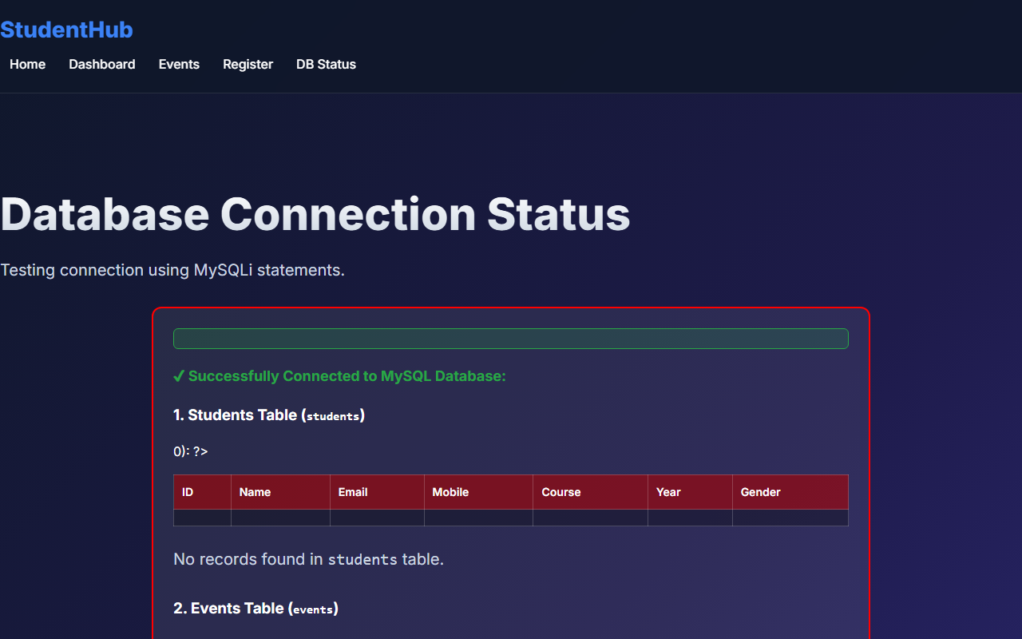
Figure 8: practical_08_database_connectivity.png - Verification Output
Post Laboratory Work / Evaluation Viva Questions
Viva Q1: What is the primary difference between PDO and MySQLi?
Answer: MySQLi works exclusively with MySQL databases, whereas PDO (PHP Data Objects) is a database-agnostic abstraction layer supporting 12+ database engines with unified error-handling.
Viva Q2: Why is 'utf8mb4' preferred over 'utf8' in MySQL?
Answer: 'utf8mb4' provides full 4-byte UTF-8 encoding support, accommodating emojis and extended multilingual plane characters, whereas MySQL's legacy 'utf8' only supports up to 3 bytes.
Conclusion
With this practical we can conclude that relational normalization to 3NF ensures structural integrity, while PHP PDO prepared statements eliminate SQL injection vulnerabilities.

