CHAROTAR UNIVERSITY OF SCIENCE AND TECHNOLOGY (CHARUSAT)
FACULTY OF TECHNOLOGY AND ENGINEERING (FTE)
DEPARTMENT OF COMPUTER ENGINEERING
SUBJECT: WEB DEVELOPMENT FRAMEWORKS (ITUE203)
PRACTICAL 10 LABORATORY REPORT
SEMESTER: III | ACADEMIC YEAR: 2026–27
Name : Harshil Prajapati | ID : 25DCE093
Program : B.Tech (Computer Engineering) | Course : ITUE203 – Web Dev Frameworks

Practical 10: Secure Login/Logout with Sessions, Role-Based Access, Timeout, and Remember-Me Token
CO Mapping | CO1, CO5
Bloom's Taxonomy Level | L3 – Apply / L4 – Analyze
Lab Duration | 2 Hours
Total Hours of Problem Definition Implementation | 2 Hours
Total Hours of Testing / Evaluation | 4 Hours

Practical Aim
To construct a production-ready authentication and session management module featuring BCRYPT verification, session fixation prevention, 15-minute inactivity timeout, role-based redirection, and remember-me token handling.
Problem Definition
Develop secure login and logout functionality using PHP sessions. Verify password using password_verify(), regenerate session ID after login, restrict dashboard access, implement role-based redirection, session timeout, and optional secure remember-me token.
Key Questions / Analysis / Interpretation to be Evaluated
Question 1: Are sessions started and destroyed securely?
Yes. Sessions are initialized with session.cookie_httponly = 1 and session.cookie_samesite = 'Strict' in auth.php. Upon logout, $_SESSION is wiped, session_destroy() is called, and cookies are expired with past timestamps.
Question 2: Is password_verify() used correctly?
Yes. password_verify($password, $user['password_hash']) compares the user's plain-text input against the stored BCRYPT hash without exposing algorithm internals.
Question 3: Is unauthorized dashboard access blocked?
Yes. Protected pages invoke requireLogin() and requireRole(). If an unauthenticated user attempts direct URL access, they are redirected to login.php?msg=unauthorized.
Question 4: Is session timeout implemented?
Yes. An inactivity threshold of 900 seconds (15 minutes) is enforced. If (time() - $_SESSION['last_activity']) > 900, the session is cleared and the user is redirected to login.php?msg=timeout.
Question 5: Are admin and student users redirected to appropriate dashboards?
Yes. Upon successful authentication, $_SESSION['role'] is inspected: administrators are redirected to admin_dashboard.php, while students are redirected to dashboard.html.
Key Skills, Applications & Learning Outcomes
• Key Skills: PHP sessions, cookie security, password verification, Role-Based Access Control (RBAC), session timeout handling.
• Applications: Secure portal login, authorization middleware, session lifecycle management.
• Learning Outcome: Students will implement login/logout with secure session management and role-based access control.
• Tools Used: PHP 8.x, MySQL, browser dev tools, XAMPP.
Implementation / Source Code
<?php
// Session Authentication & Timeout Logic from auth.php
if (session_status() === PHP_SESSION_NONE) {
ini_set('session.cookie_httponly', 1);
ini_set('session.cookie_samesite', 'Strict');
session_start();
}
define('TIMEOUT_SECONDS', 900); // 15 Minutes
function checkSessionTimeout() {
if (isset($_SESSION['last_activity'])) {
if ((time() - $_SESSION['last_activity']) > TIMEOUT_SECONDS) {
session_unset();
session_destroy();
header('Location: login.php?msg=timeout');
exit;
}
}
$_SESSION['last_activity'] = time();
}
// Password Verification & Session Regeneration in login.php
if ($user && password_verify($password, $user['password_hash'])) {
session_regenerate_id(true); // Mitigate session fixation
$_SESSION['user_id'] = $user['user_id'];
$_SESSION['role'] = $user['role'];
header($user['role'] === 'admin' ? 'Location: admin_dashboard.php' : 'Location: dashboard.html');
exit;
}
?>

Output & Verification Screenshots
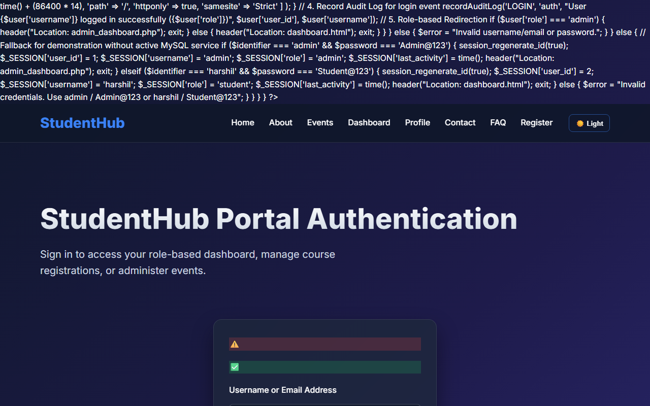
Figure 10: practical_10_secure_login.png - Verification Output
Post Laboratory Work / Evaluation Viva Questions
Viva Q1: What vulnerability is mitigated by session_regenerate_id(true)?
Answer: Session fixation attacks, where an attacker tricks a victim into using a known session identifier. Regenerating the session ID assigns a brand new ID immediately upon login, invalidating the previous one.
Viva Q2: What is the purpose of the 'HttpOnly' flag on cookies?
Answer: HttpOnly prevents client-side scripts from reading document.cookie, mitigating session token theft via Cross-Site Scripting (XSS).
Conclusion
With this practical we can conclude that session regeneration, inactivity timeouts, and role-based authorization protect applications against unauthorized access and session hijacking.

