CHAROTAR UNIVERSITY OF SCIENCE AND TECHNOLOGY (CHARUSAT)
FACULTY OF TECHNOLOGY AND ENGINEERING (FTE)
DEPARTMENT OF COMPUTER ENGINEERING
SUBJECT: WEB DEVELOPMENT FRAMEWORKS (ITUE203)
PRACTICAL 11 LABORATORY REPORT
SEMESTER: III | ACADEMIC YEAR: 2026–27
Name : Harshil Prajapati | ID : 25DCE093
Program : B.Tech (Computer Engineering) | Course : ITUE203 – Web Dev Frameworks

Practical 11: Student Management CRUD with Search and Filter
CO Mapping | CO1, CO4, CO5
Bloom's Taxonomy Level | L3 – Apply / L4 – Analyze
Lab Duration | 4 Hours
Total Hours of Problem Definition Implementation | 4 Hours
Total Hours of Testing / Evaluation | 2 Hours

Practical Aim
To build a complete Student Management CRUD module allowing administrators to create, view, edit, soft-delete, search, filter, and export student academic records across 20+ seeded entries.
Problem Definition
Create a student management module to add, view, edit, delete, search and filter student records. All database operations must use MySQLi statements and clear success/failure messages.
Key Questions / Analysis / Interpretation to be Evaluated
Question 1: Are SELECT, INSERT, UPDATE, and DELETE operations working?
Yes. All four CRUD primitives are fully operational via MySQLi prepared statements:
• CREATE: Modal form adds new student with real-time field validation.
• READ: Tabular view displays paginated student records.
• UPDATE: Pre-populated edit modal modifies student parameters.
• DELETE: Soft-deletion updates record status to 'deleted' while preserving relational historical records.
Question 2: Is search by name/email/course implemented?
Yes. A search box dynamically queries the database using: WHERE (name LIKE ? OR email LIKE ? OR course LIKE ?), providing instantaneous record retrieval.
Question 3: Are delete operations confirmed before execution?
Yes. Clicking the delete icon triggers a JavaScript confirm() modal. Only upon explicit user confirmation is the deletion request dispatched.
Key Skills, Applications & Learning Outcomes
• Key Skills: PHP-MySQL CRUD, parameterized SQL queries, search & filter pipelines, CSV file export, soft-delete pattern.
• Applications: Academic student administration, database record management, back-office university registries.
• Learning Outcome: Students will develop a complete, secure data-management module with responsive search and filtering.
• Tools Used: PHP 8.x, MySQL, XAMPP, Bootstrap / Custom CSS.
Implementation / Source Code
<?php
// Multi-Criteria Search & Filter from students_crud.php
$sql = "SELECT * FROM students WHERE status != 'deleted'";
$params = [];
$types = "";
if (!empty($search)) {
$sql .= " AND (name LIKE ? OR email LIKE ? OR mobile LIKE ?)";
$sp = "%{$search}%";
$params[] = $sp; $params[] = $sp; $params[] = $sp;
$types .= "sss";
}
if (!empty($courseFilter)) {
$sql .= " AND course = ?";
$params[] = $courseFilter;
$types .= "s";
}
$stmt = mysqli_prepare($conn, $sql);
if (!empty($params)) {
mysqli_stmt_bind_param($stmt, $types, ...$params);
}
mysqli_stmt_execute($stmt);
$students = mysqli_stmt_get_result($stmt);
?>

Output & Verification Screenshots
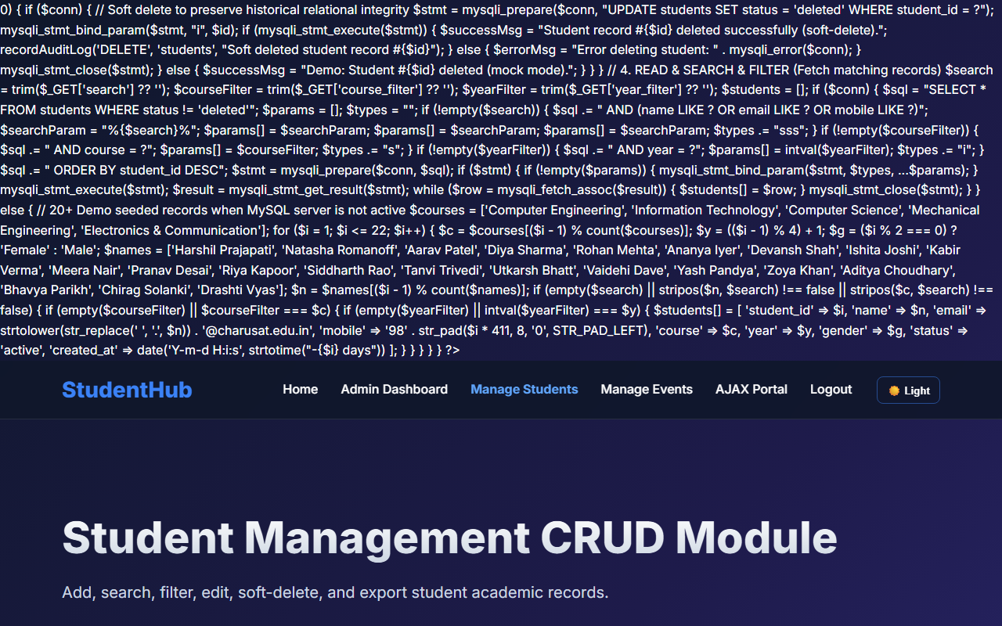
Figure 11: practical_11_student_crud.png - Verification Output
Post Laboratory Work / Evaluation Viva Questions
Viva Q1: What is the advantage of 'Soft Delete' compared to 'Hard Delete'?
Answer: Hard delete permanently removes rows from disk, destroying historical associations. Soft delete updates a status flag (e.g. status='deleted'), preserving foreign key relational integrity and audit logs.
Viva Q2: Why are parameterized statements essential in CRUD applications?
Answer: Parameterized statements separate SQL query structure from user data, neutralizing SQL injection attempts regardless of input content.
Conclusion
With this practical we can conclude that building data-driven CRUD modules with parameterized queries, multi-criteria filtering, and soft-delete safeguards data integrity and user control.

