CHAROTAR UNIVERSITY OF SCIENCE AND TECHNOLOGY (CHARUSAT)
FACULTY OF TECHNOLOGY AND ENGINEERING (FTE)
DEPARTMENT OF COMPUTER ENGINEERING
SUBJECT: WEB DEVELOPMENT FRAMEWORKS (ITUE203)
PRACTICAL 13 LABORATORY REPORT
SEMESTER: III | ACADEMIC YEAR: 2026–27
Name : Harshil Prajapati | ID : 25DCE093
Program : B.Tech (Computer Engineering) | Course : ITUE203 – Web Dev Frameworks

Practical 13: PHP JSON API and AJAX/Fetch-Based CRUD without Page Reload
CO Mapping | CO3, CO4, CO5
Bloom's Taxonomy Level | L3 – Apply / L4 – Analyze
Lab Duration | 4 Hours
Total Hours of Problem Definition Implementation | 4 Hours
Total Hours of Testing / Evaluation | 2 Hours

Practical Aim
To construct a RESTful PHP JSON API endpoint supporting GET, POST, and DELETE requests, and consume it asynchronously using JavaScript Fetch API without triggering full page reloads.
Problem Definition
Create simple PHP JSON API endpoints for events or students and consume them using Fetch API. Perform list, add, update, and delete operations asynchronously without full page reload.
Key Questions / Analysis / Interpretation to be Evaluated
Question 1: Do PHP endpoints return valid JSON responses?
Yes. Every response from api_events.php sets header('Content-Type: application/json; charset=UTF-8') and outputs data serialized via json_encode(), accompanied by appropriate HTTP status codes (200 OK, 201 Created, 400 Bad Request, 404 Not Found).
Question 2: Are GET and POST requests handled properly?
Yes. GET requests parse query parameters for filtering and output event lists; POST requests decode incoming JSON via json_decode(file_get_contents('php://input'), true), validate parameters, insert the event, and return HTTP 201.
Question 3: Are loading, success, and error states shown on the frontend?
Yes. The frontend displays an animated loading spinner during network round-trips and non-intrusive toast notification banners upon success or error.
Question 4: Is input validation performed before database operations?
Yes. The API verifies mandatory fields (title, event_date, venue) prior to database execution, returning HTTP 400 Bad Request with an itemized error message if any field is missing.
Key Skills, Applications & Learning Outcomes
• Key Skills: RESTful PHP JSON APIs, Fetch API, asynchronous CRUD, JSON response formatting, frontend-backend API integration, debouncing.
• Applications: Single-page applications (SPAs), mobile app backends, real-time interactive administrative dashboards.
• Learning Outcome: Students will integrate frontend JavaScript with PHP backends using RESTful JSON APIs.
• Tools Used: PHP 8.x, JavaScript Fetch API, MySQL, browser Network tab.
Implementation / Source Code
// RESTful JSON API Endpoint (api_events.php)
header('Content-Type: application/json; charset=UTF-8');
$method = $_SERVER['REQUEST_METHOD'];
if ($method === 'GET') {
$events = fetchAllEvents($conn);
http_response_code(200);
echo json_encode(['status' => 'success', 'data' => $events]);
} elseif ($method === 'POST') {
$input = json_decode(file_get_contents('php://input'), true);
if (empty($input['title']) || empty($input['event_date'])) {
http_response_code(400);
echo json_encode(['status' => 'error', 'message' => 'Missing required fields']);
exit;
}
$newId = insertEvent($conn, $input);
http_response_code(201);
echo json_encode(['status' => 'success', 'id' => $newId, 'message' => 'Event created successfully']);
}

Output & Verification Screenshots
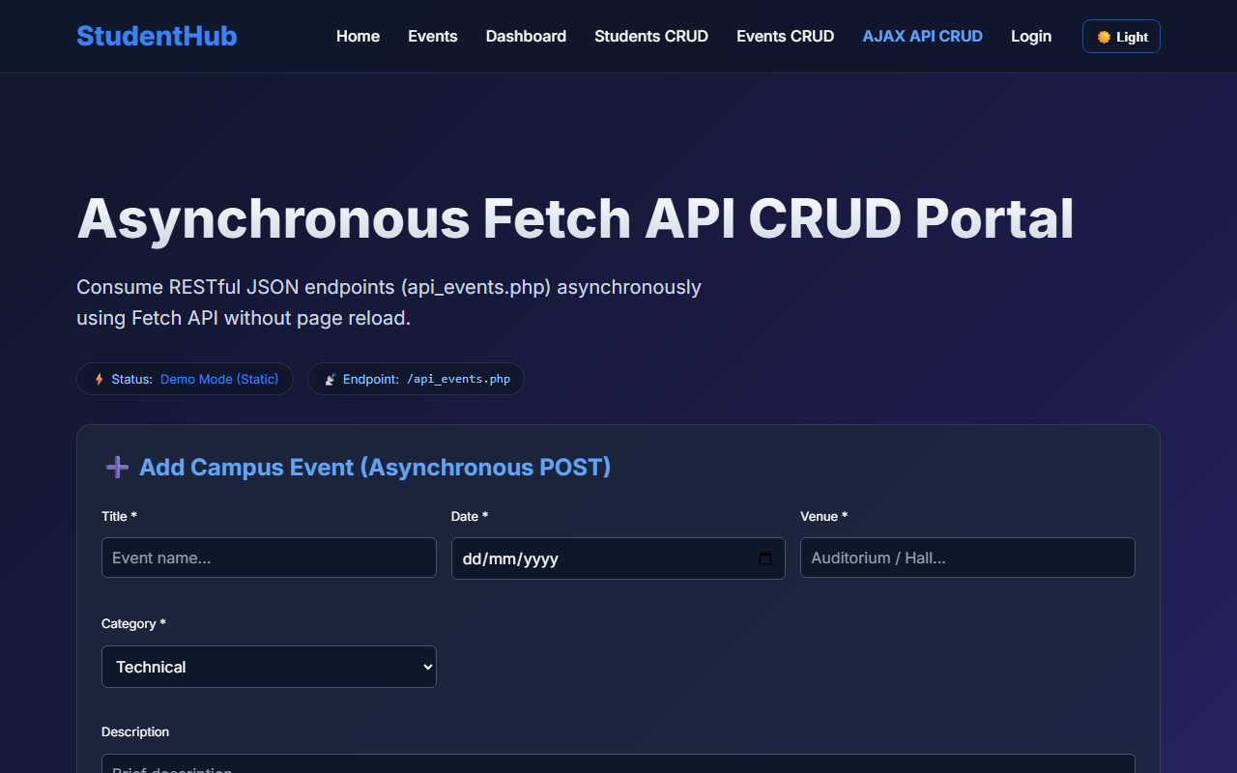
Figure 13: practical_13_ajax_crud.png - Verification Output
Post Laboratory Work / Evaluation Viva Questions
Viva Q1: What is the purpose of HTTP status codes 200, 201, 400, and 404 in REST APIs?
Answer: 200: Successful GET/PUT/DELETE request; 201: Successfully created new entity (POST); 400: Bad Request due to client-side validation failure; 404: Target resource not found.
Viva Q2: What is debouncing in client-side search?
Answer: Debouncing delays the execution of a function until a specified time interval (e.g. 300ms) has elapsed since the last keystroke, preventing redundant API calls on every character typed.
Conclusion
With this practical we can conclude that RESTful PHP JSON APIs combined with the JavaScript Fetch API enable asynchronous CRUD interactions without full page reloads, improving user experience and responsiveness.

