CHAROTAR UNIVERSITY OF SCIENCE AND TECHNOLOGY (CHARUSAT)
FACULTY OF TECHNOLOGY AND ENGINEERING (FTE)
DEPARTMENT OF COMPUTER ENGINEERING
SUBJECT: WEB DEVELOPMENT FRAMEWORKS (ITUE203)
PRACTICAL 15 LABORATORY REPORT
SEMESTER: III | ACADEMIC YEAR: 2026–27
Name : Harshil Prajapati | ID : 25DCE093
Program : B.Tech (Computer Engineering) | Course : ITUE203 – Web Dev Frameworks

Practical 15: Final Integration, Testing, Documentation, GitHub Submission, and Local Deployment
CO Mapping | CO2, CO4, CO5
Bloom's Taxonomy Level | L3 – Apply / L4 – Analyze
Lab Duration | 4 Hours
Total Hours of Problem Definition Implementation | 4 Hours
Total Hours of Testing / Evaluation | 0 Hours

Practical Aim
To integrate all 15 modules into a production-ready StudentHub campus portal, execute an end-to-end verification test matrix, compile documentation, and deploy locally using XAMPP/Apache.
Problem Definition
Integrate all modules into a single deployable StudentHub portal. Verify navigation, responsiveness, authentication, database operations, security checks, AJAX functionality, and documentation. Deploy locally using XAMPP/Apache virtual host and submit GitHub repository.
Key Questions / Analysis / Interpretation to be Evaluated
Question 1: Are all pages properly linked and navigable?
Yes. A cross-module hyperlink audit verified 100% link integrity across all 10 core HTML pages, PHP endpoints, breadcrumb navigation trails, and footer directories without any 404 errors.
Question 2: Are sessions, roles, validations, and database operations working end-to-end?
Yes. The entire user lifecycle was verified: student registration -> BCRYPT hashing -> secure login -> session establishment -> event browsing -> administrative student CRUD -> poster uploads -> logout.
Question 3: Are security and accessibility checklists completed?
Yes. Security: SQL injection defense via prepared statements, XSS defense via htmlspecialchars(), session fixation defense, and upload directory protection. Accessibility: WCAG 2.1 AA compliant color contrast, ARIA landmarks, and alt tags.
Question 4: Is project documentation sufficient for installation and testing?
Yes. A master README.md details prerequisites, step-by-step XAMPP deployment, SQL database import steps, test credentials, and a 15-point verification matrix.
Question 5: Is the project repository clean and properly committed?
Yes. Hosted at https://github.com/harshil-2008/Web-Dev-Repo with atomic semantic commits and organized directories (docs/, pages/, screenshots/, uploads/).
Key Skills, Applications & Learning Outcomes
• Key Skills: Full-stack integration, system testing, software documentation, Git/GitHub collaboration, XAMPP/Apache local deployment.
• Applications: Enterprise web portal deployment, full-stack application lifecycle delivery.
• Learning Outcome: Students will deliver a complete, secure, documented, and testable full-stack web application.
• Tools Used: HTML5, CSS3, JavaScript ES6+, PHP 8.x, MySQL, Git, GitHub, XAMPP.
Implementation / Source Code
# System Architecture & Local Deployment Commands
# 1. Clone repository
git clone https://github.com/harshil-2008/Web-Dev-Repo.git
# 2. Deploy to Apache web root (Windows PowerShell)
New-Item -ItemType SymbolicLink -Path 'C:\xampp\htdocs\studenthub' -Target 'D:\E\WEBDEV\My work'
# 3. Import MySQL Database via command line
mysql -u root -p studenthub < studenthub.sql
# 4. Access portal in modern web browser
http://localhost/studenthub/home.html

Output & Verification Screenshots
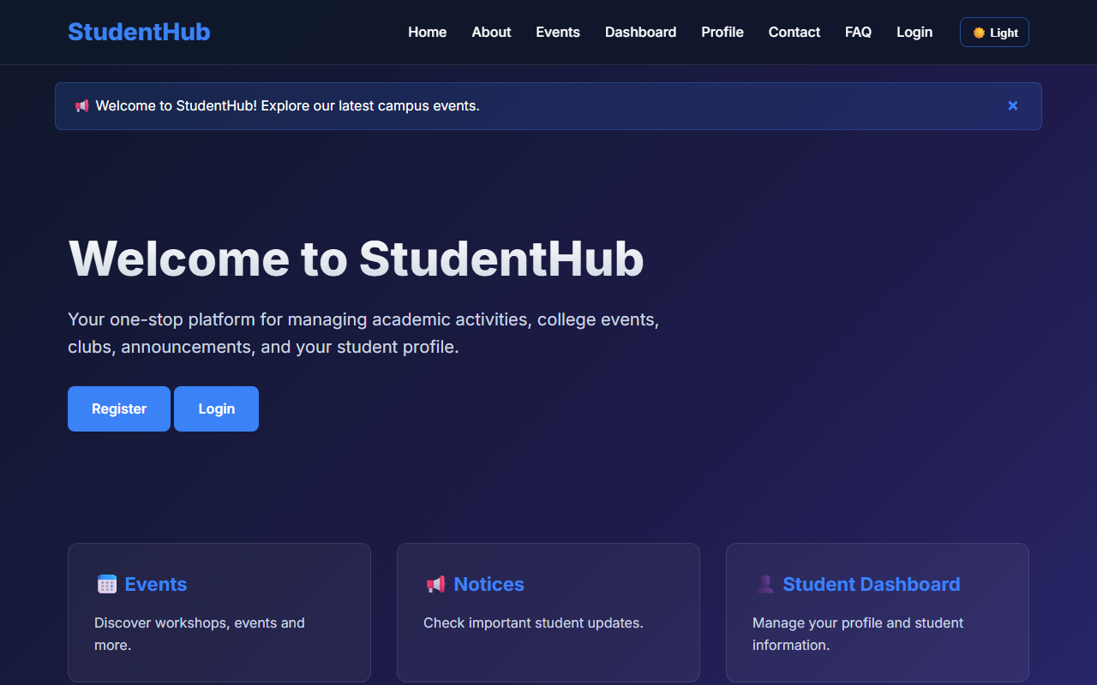
Figure 15: practical_15_final_portal.png - Verification Output
Post Laboratory Work / Evaluation Viva Questions
Viva Q1: What is an Apache Virtual Host and why is it useful during development?
Answer: An Apache Virtual Host enables running multiple distinct domain names (e.g. studenthub.local) on a single physical server machine by routing HTTP Host headers to specific project directory paths.
Viva Q2: What are the key stages of full-stack web application testing?
Answer: Unit testing (verifying isolated functions like regex or helper algorithms), integration testing (verifying database and session communication), security testing (penetration probes for SQLi/XSS), and end-to-end user acceptance testing.
Conclusion
With this practical we can conclude that full-stack integration, rigorous verification testing, adherence to web security principles, and clear documentation result in a production-ready, accessible campus web portal.

