DESIGN DOCS

- /ingest endpoints - Ingest api where we parse pdf and extract metadata and embed chunks and store them seperately for minimizing future operations.
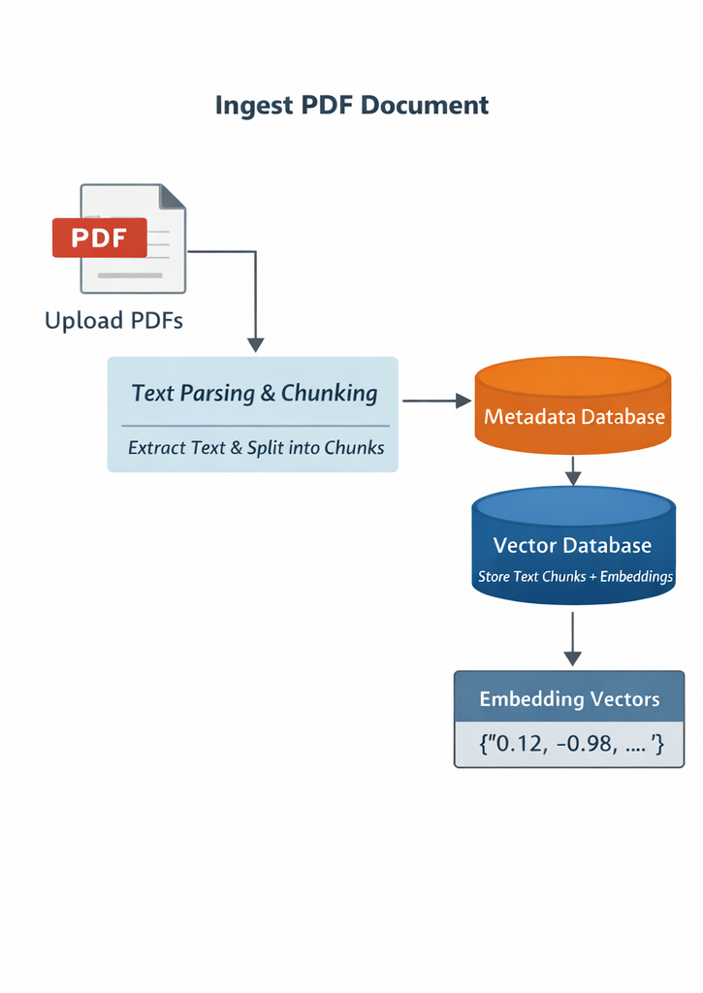
ingestion of a pdf.

- Endpoint /ask, /ask/stream a, /audit behaviour.
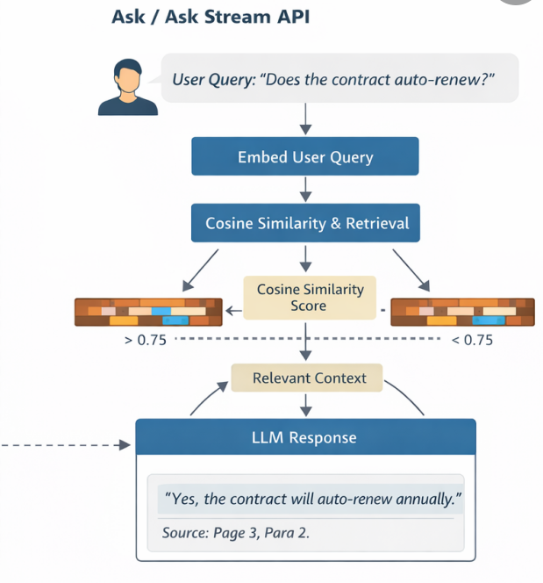
3) /extract - this api just fetches metadata from db.

- /healthz , /metric -> just retrieve a response with minimal data.

Security Notes:
All sensitive credentials must be stored in .env file .
.env must be excluded from version control via .gitignore.

