

COMPUTER AIDED CIRCUIT DRAWING
(113SB)

Project Report
DESIGN AND SIMULATION OF AN RC PHASE SHIFT OSCILLATOR USING KiCad SOFTWARE

NAME: HARSHIL R. SHAH
ID: 24EL041
BATCH: C04
ELCTRONICS BRANCH

RC Phase Shift Oscillator - KiCad Project Report

1. Introduction
The RC Phase Shift Oscillator is a type of oscillator circuit that uses a combination of resistors and capacitors to produce a sine wave output. It typically consists of an amplifier (usually a transistor or op-amp) and a feedback network with three RC stages that provide a 180° phase shift. Combined with the 180° phase shift from the amplifier, it completes the 360° required for sustained oscillations.
This project involves designing the RC Phase Shift Oscillator using KiCad 6, an open-source EDA tool, and simulating the waveform, generating PCB layout, Gerber files, and viewing the final design in 3D.

2. Schematic Design Steps

Step 1: Creating a New Project
Open KiCad 6 and create a new project with a suitable name, e.g., RC_Oscillator.

Step 2: Opening the Schematic Editor
Open the *.kicad_sch file and click on 'Schematic Editor' to begin the circuit design.

Step 3: Adding Components
Press 'A' or use the 'Place → Add Symbol' tool to add components:
- NPN Transistor (e.g., BC547)
- Resistors (R)
- Capacitors (C)
- DC Power Supply (VCC)
- Ground symbol (GND)

Step 4: Connecting Components
Use the ‘Place Wire’ tool (Shortcut: 'W') to connect all components as per the RC phase shift oscillator design.

Step 5: Annotating the Schematic
Click on Tools → Annotate Schematic.
Let KiCad assign unique reference designators to all components (R1, R2, Q1, etc.).
Click 'Annotate' → 'Close'.

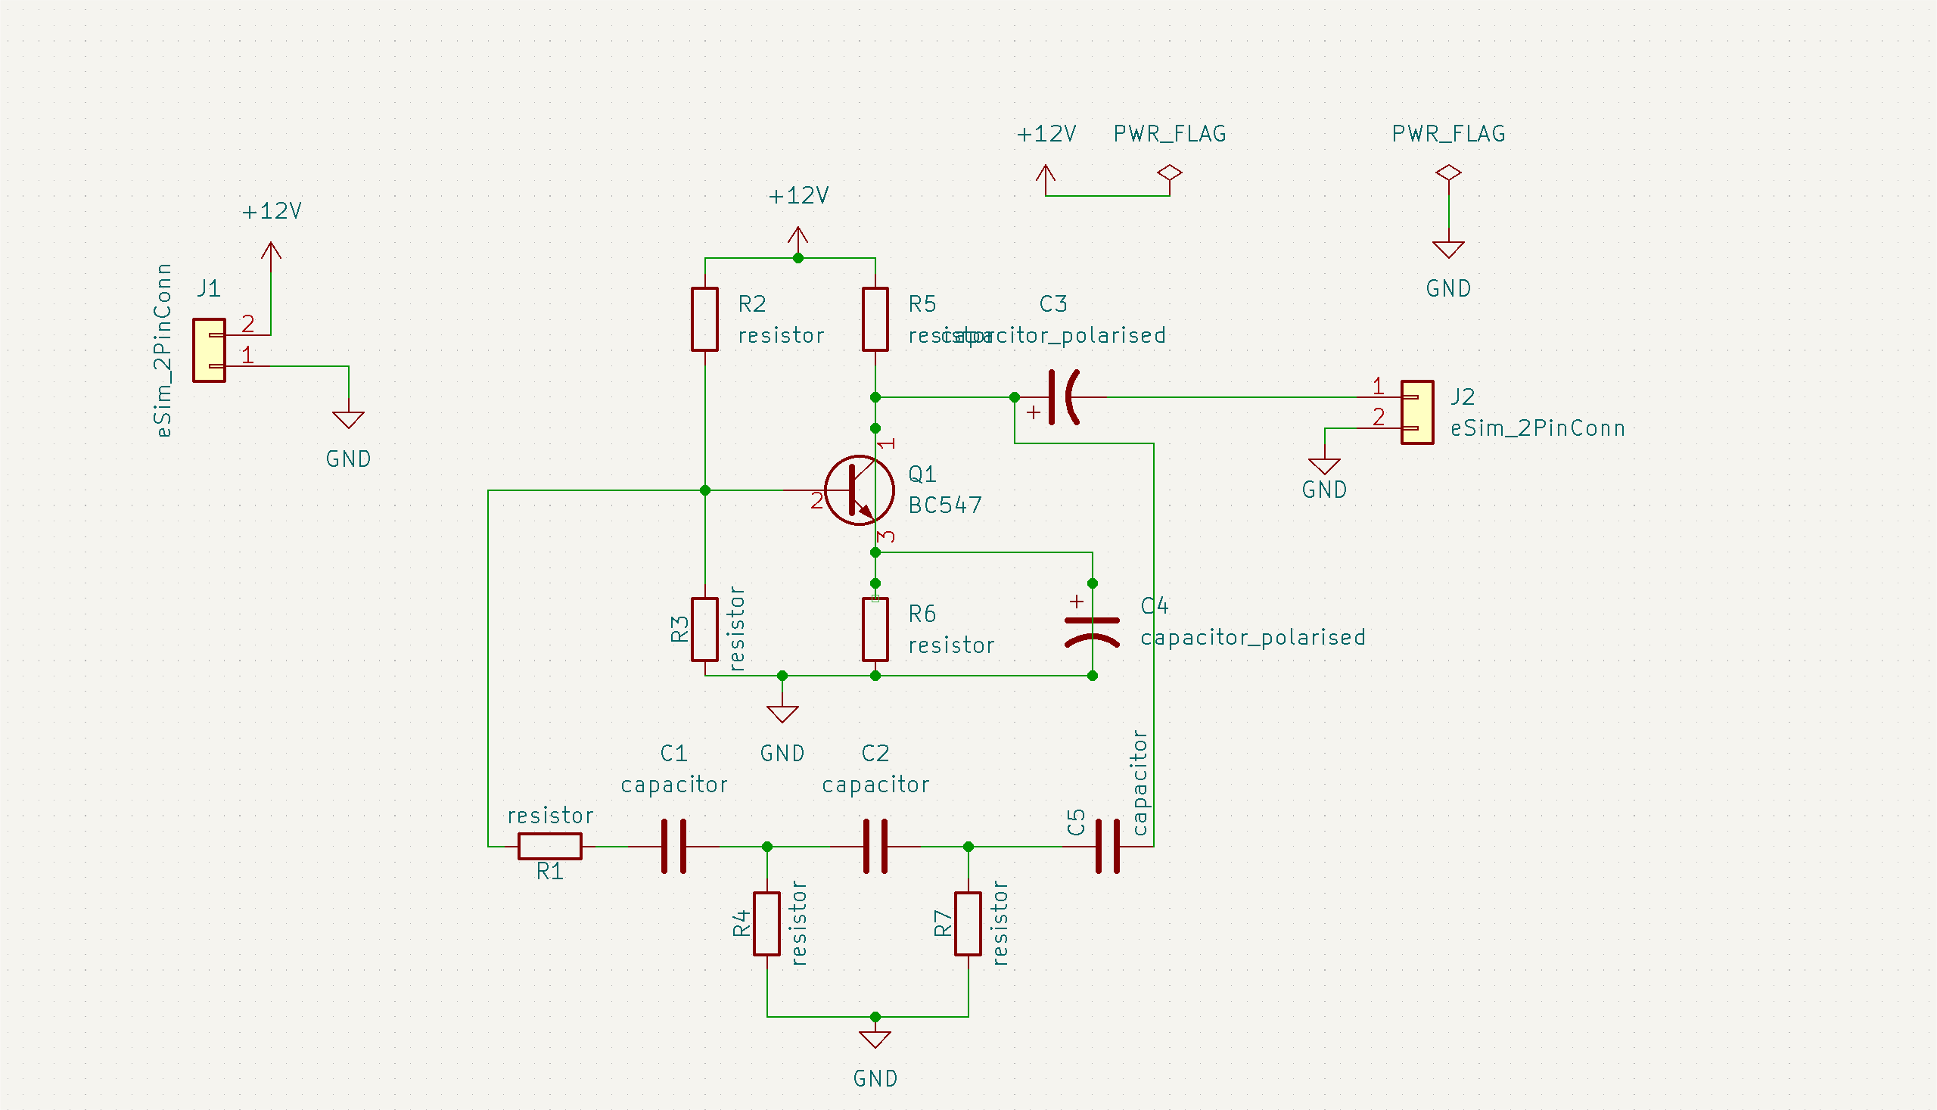

3. Electrical Rules Check (ERC)
Go to Inspect → Electrical Rules Checker.
Fix any issues (e.g., missing power flags or unconnected pins).
Run ERC again until no errors remain.

4. Output Waveform
The output waveform is taken across the collector of the transistor and should be a sine wave (or nearly sinusoidal depending on component accuracy and simulation).
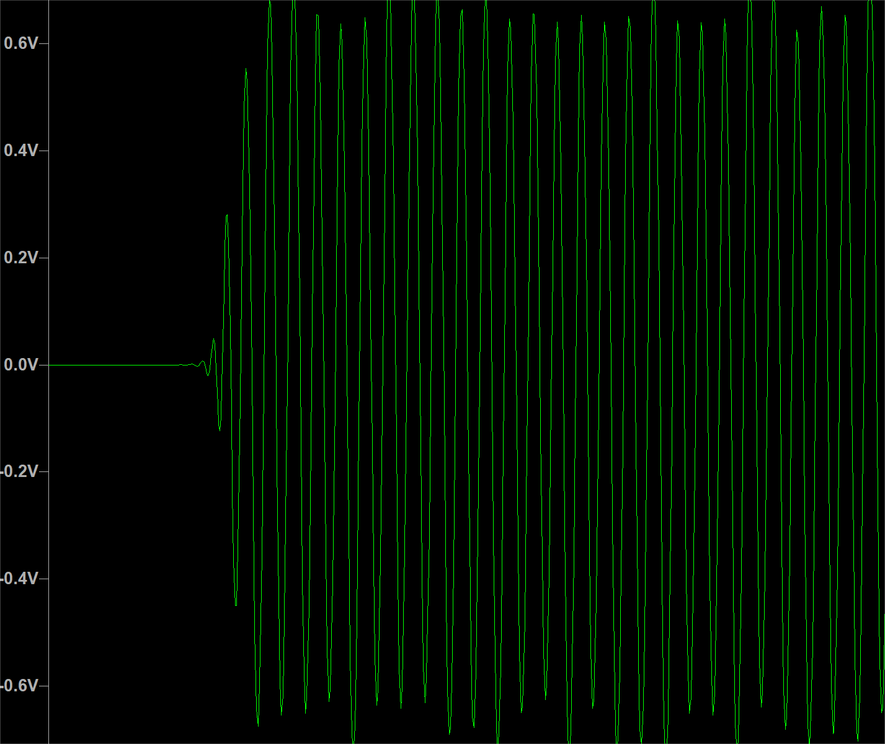

5. Footprint Assignment

Step 1: Assigning Footprints
Open the Symbol Editor or use Tools → Assign Footprints.
For each component (resistor, transistor, capacitor), select the appropriate footprint 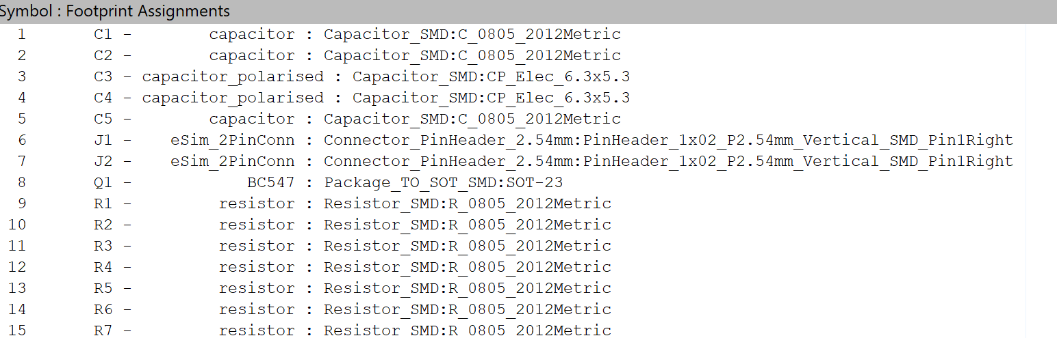

Step 2: Save and Update Schematic
Save and click 'Update PCB from Schematic' to push the changes to PCB layout.

6. PCB Layout and Gerber File

Step 1: Arrange Components
Open PCB Editor and arrange components on the board layout for optimal routing.

Step 2: Route Traces
Use the Route Tracks (X) tool to connect pads as per the netlist.

Step 3: Edge Cuts
Draw the board boundary using Edge.Cuts layer.
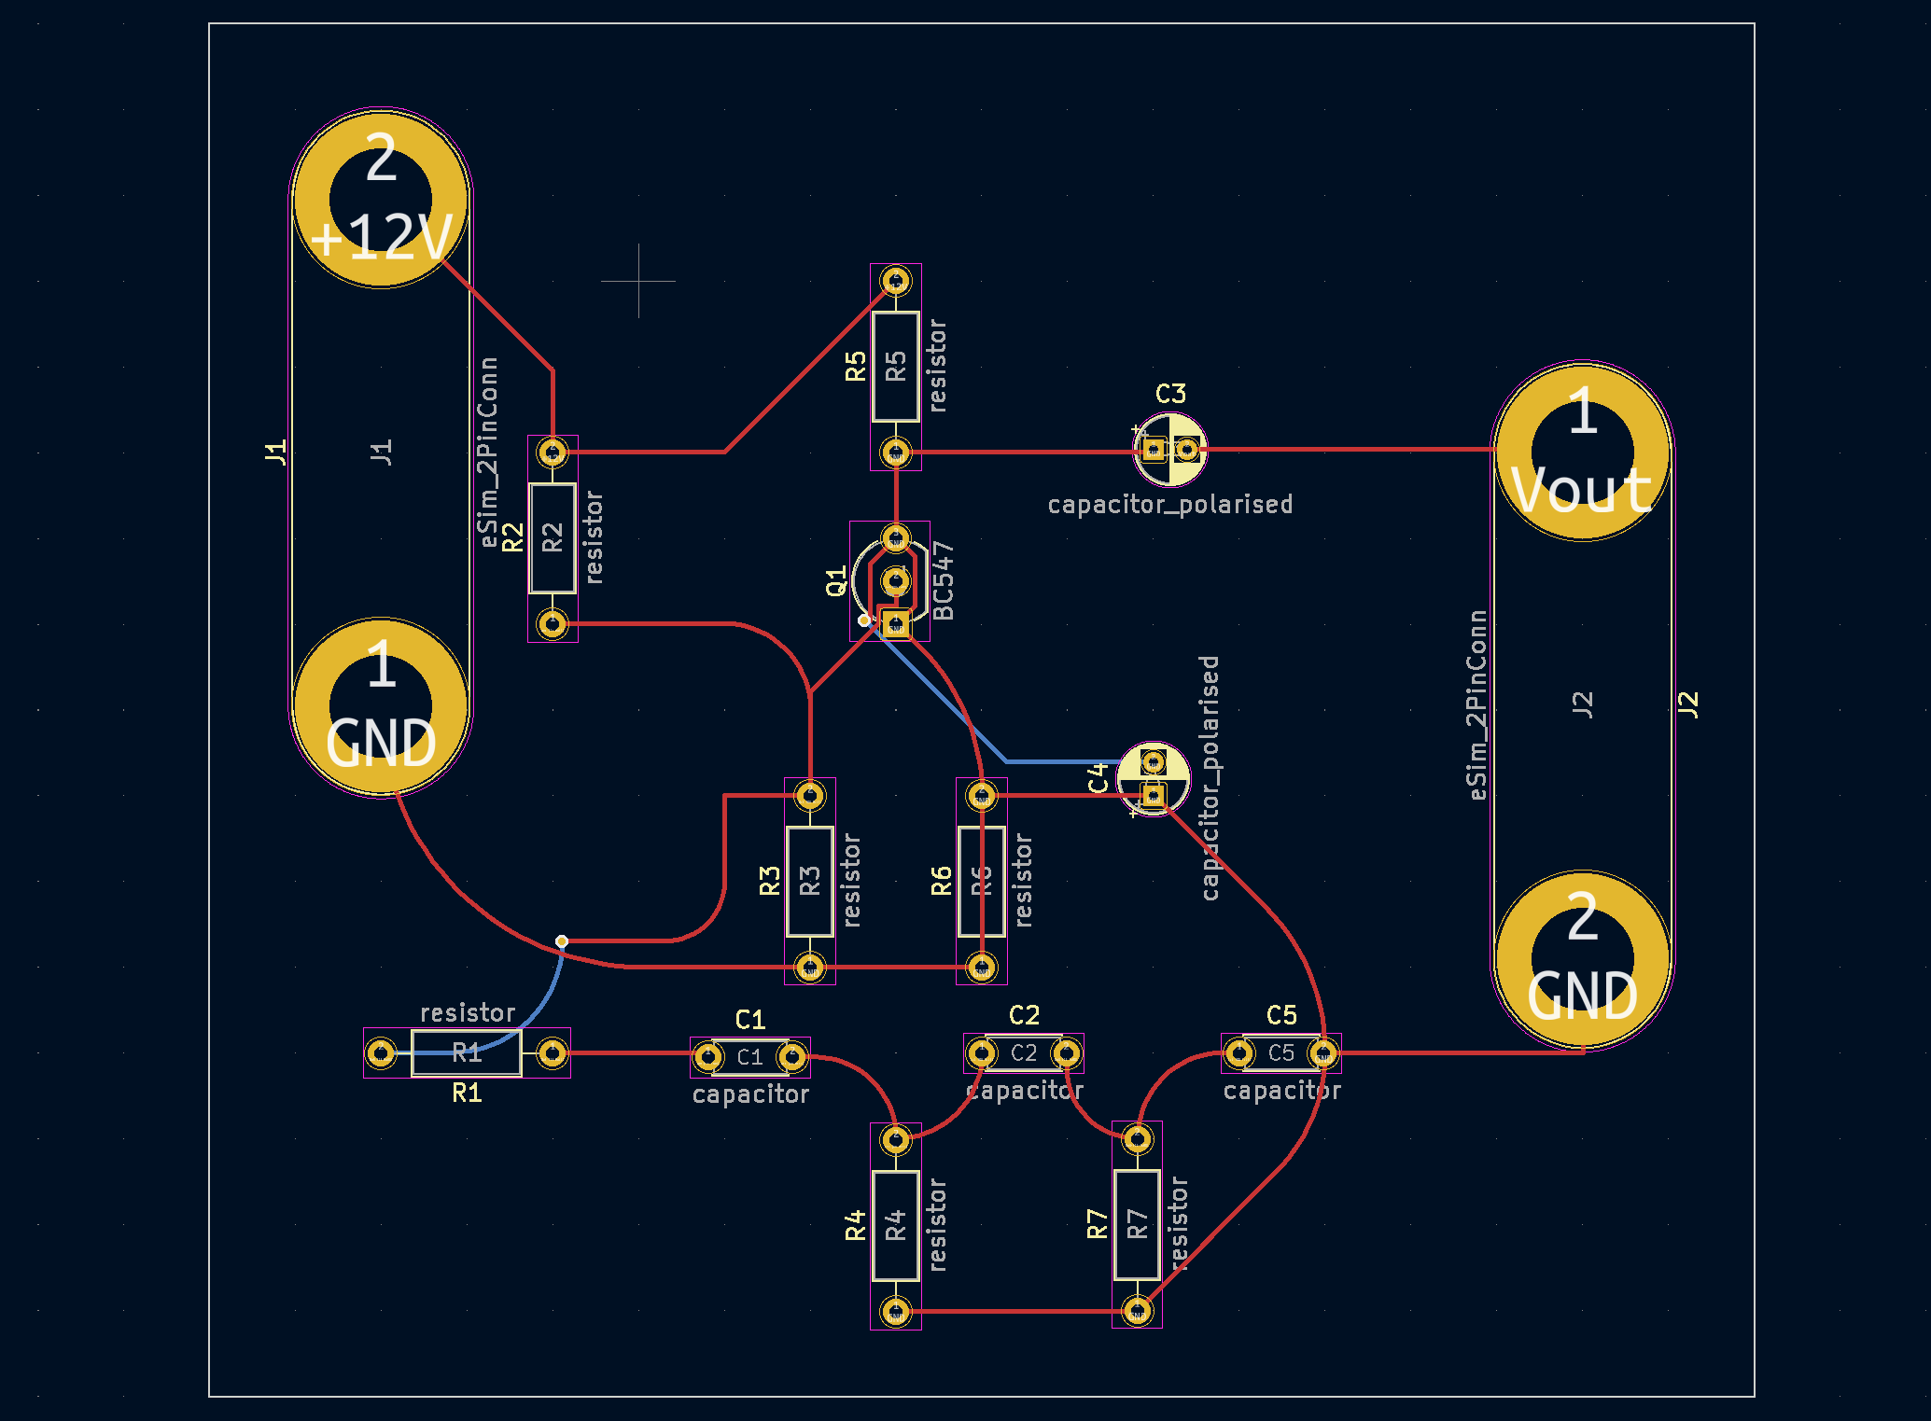

Step 4: Generating Gerber Files
Design Rule Check (DRC): A DRC was performed in the PCB Editor to validate the layout against manufacturing constraints and ensure there were no critical design violations.
Go to File → Plot.
Select Gerber as the output format and check necessary layers (F.Cu, B.Cu, F.SilkS, etc.).
Click Plot, then Generate Drill Files.
Gerber File Generation and Verification
To manufacture the designed RC Phase Shift Oscillator PCB, Gerber files were generated using KiCad 6. Gerber files are standard format files used to describe the various layers of a PCB such as copper traces, silkscreen, solder mask, and board outline.
The following layers were selected during the generation process:
- F.Cu: Front copper layer (signal routing)
- B.Cu: Back copper layer
- F.Mask / B.Mask: Solder mask for the top and bottom layers
- F.Silkscreen / B.Silkscreen: Component labels and symbols
- Edge.Cuts: Defines the physical board edges
- Drill Files: Indicates the hole locations for component leads and vias
The Gerber generation process was carried out through:
File → Fabrication Outputs → Gerbers in the Pcbnew layout editor, followed by drill file generation.
Once generated, the files were verified using KiCad’s Gerber Viewer to ensure all layers were correctly aligned and present.
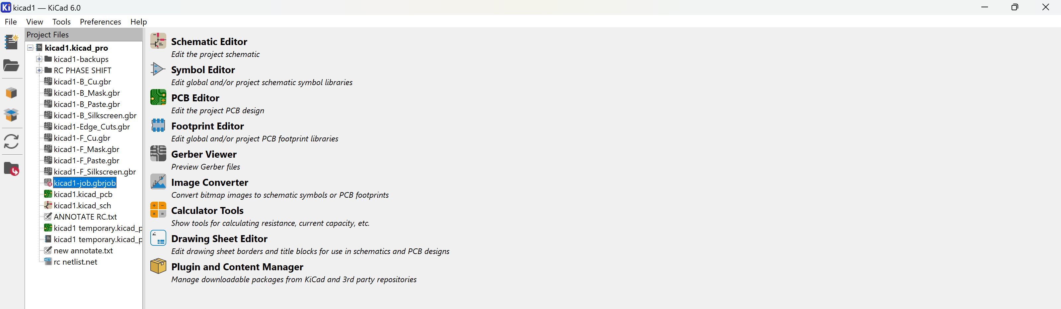
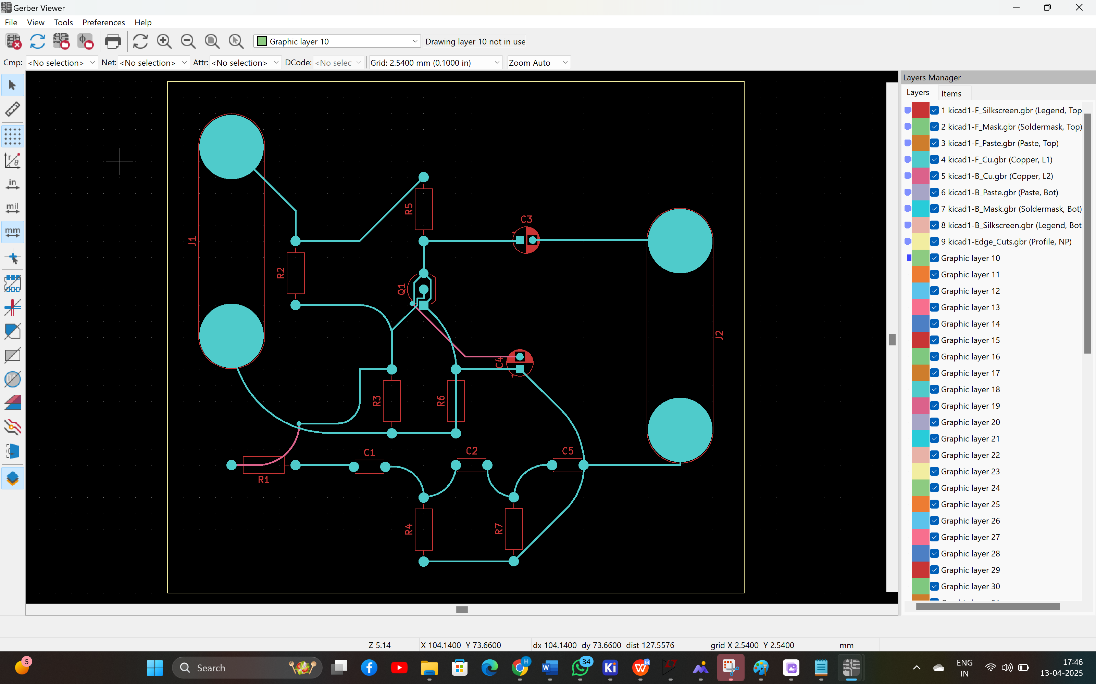

3D PCB View
KiCad provides a realistic 3D rendering of your PCB layout.
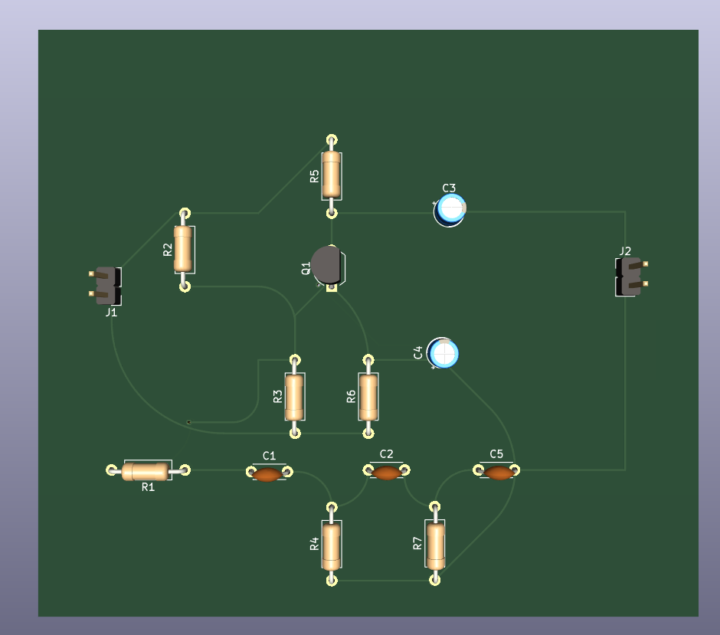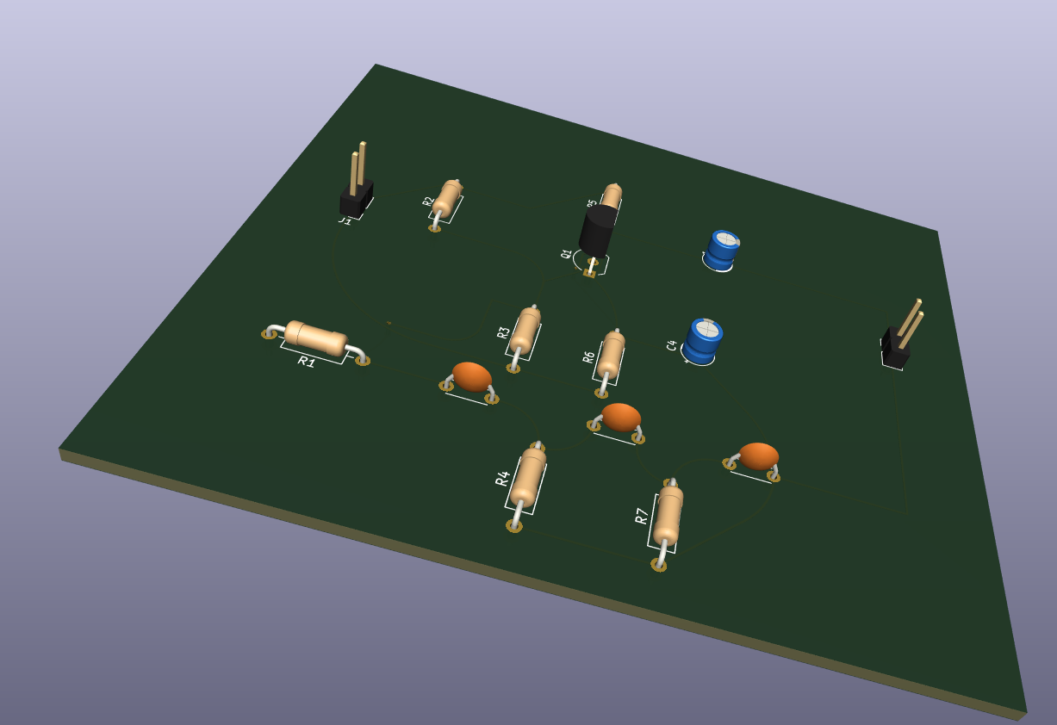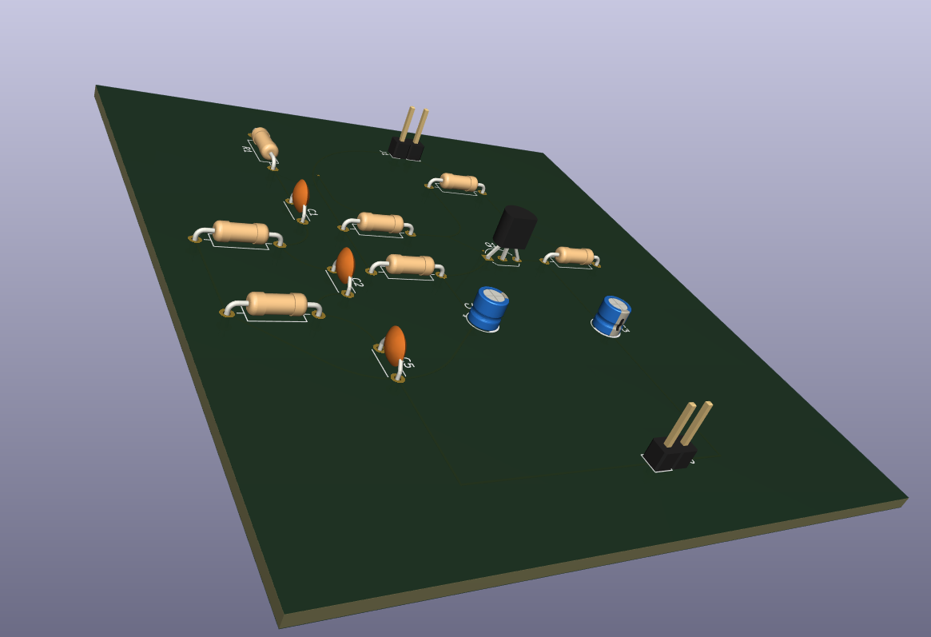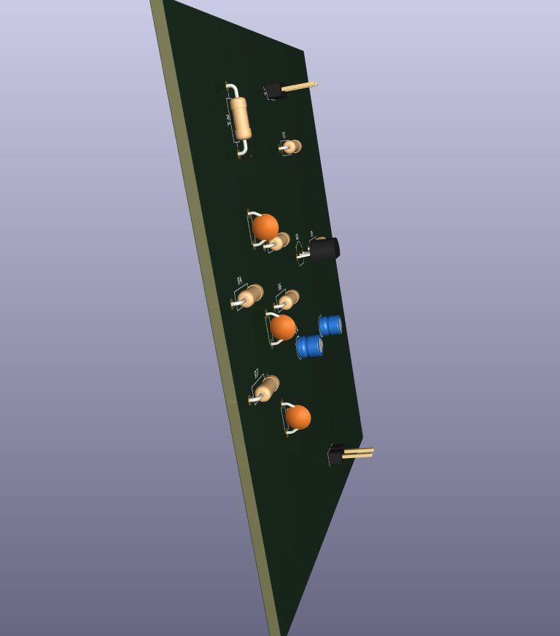

8. Conclusion
In this project, an RC Phase Shift Oscillator was successfully designed and simulated using KiCad 6. The oscillator output was a sine wave, confirming the expected behavior of the circuit.
From the schematic design to PCB layout and 3D view, each stage in KiCad offered a comprehensive set of tools for electronic circuit design. Through this hands-on experience, the following learnings were acquired:
- Understanding oscillator theory and RC phase shift principle.
- Mastery of schematic creation, annotation, footprint assignment.
- Generating PCB layouts and exporting Gerber files.
- Visualization of final product using 3D view.
This project bridges theoretical knowledge with practical EDA software skills essential in modern electronics design.

