IIT JODHPUR



PRINCIPLES OF PROGRAMMING LANGUAGES
CSL3040

Assignment 1

Harshil Kaneria B21CS033
Amisha Kumari B21CS007

Computer Science and Engineering Department

I will walk you through steps how to run the lexical analyzer we coded. First let us go through the constraints it supports.

- Identifier: A string starting with an underscore or a letter and followed by any number
of underscores, letters and digits. Identifiers with two leading underscores (__) are
disallowed
- Keywords: short int float double bool char signed unsigned for while do return void switch break case continue goto long static union default if else
- Signed and unsigned Integer constants such as 45, 10, -1234, +5432, 0, -32, etc.
- Signed and unsigned Floating-point constants such as 1.4, -3.57, 0.72, etc.
- Arithmetic operators: +, -, *, /, %, ++, --
- Assignment operators: =, +=, -=, *=, /=
- Relational operators: <, >, <=, >=, ==
- Special symbols: ( ) ,(comma) [ ] { } ;
- Ignore the text within comments (anything enclosed within /*---*/).

Download the zip file and extract or clone the repository.

Compiling the c++ program:

go to the folder in which we have FSM.cpp file.
Run ‘g++ FSM.cpp’ command in this directory.

Get the output of c++ program:
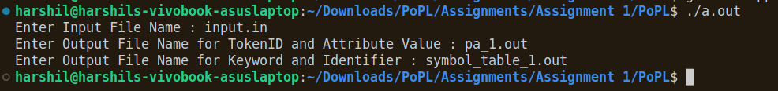

run command ‘./a.out’ in same directory.
Enter input file name , ex: ‘input.in’
Enter output file name for TokenID and Atribute Value , ex : ‘pa_1.out’
Enter output file name for Keyword and Identifier , ex: ‘symbol_table_1.out’

Note: If you have not created the input and output file , first create the files in same directory.

View the output:
TokenID and corresponding values:
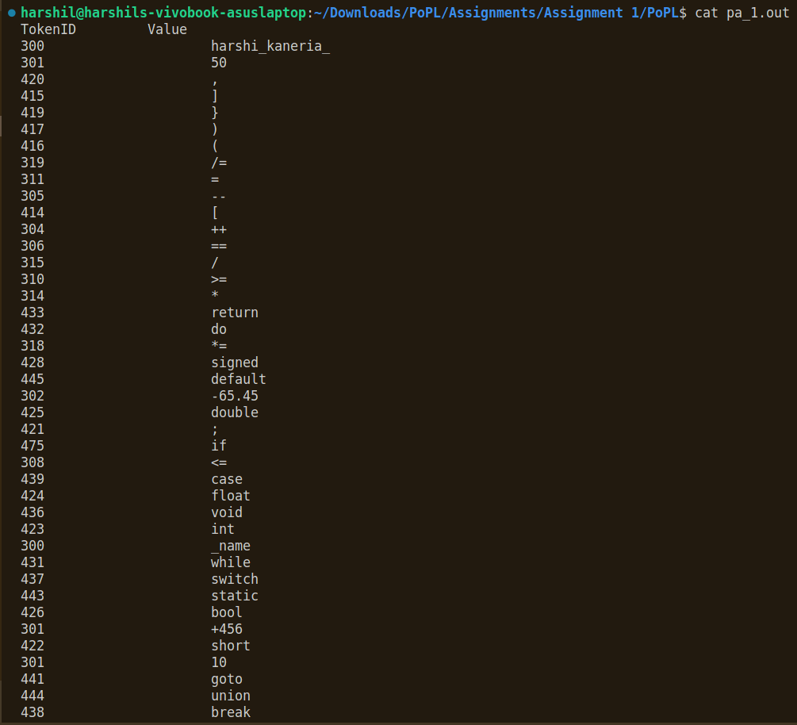

Run the command ‘cat pa_1.out’ i.e cat “output file name” , in the same directory.

Keyword and Indentifier :
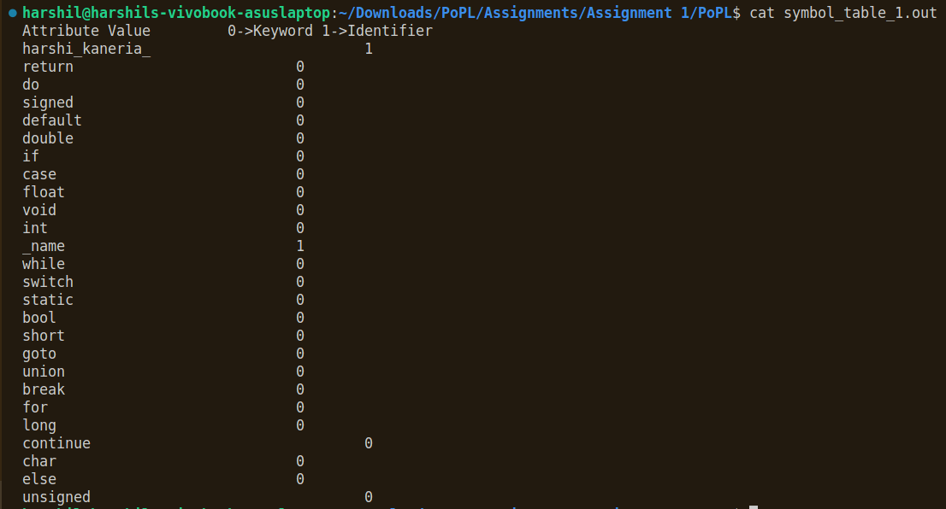

Run the command ‘cat symbol_table_1.out’ i.e cat “output file name” , in the same directory.

