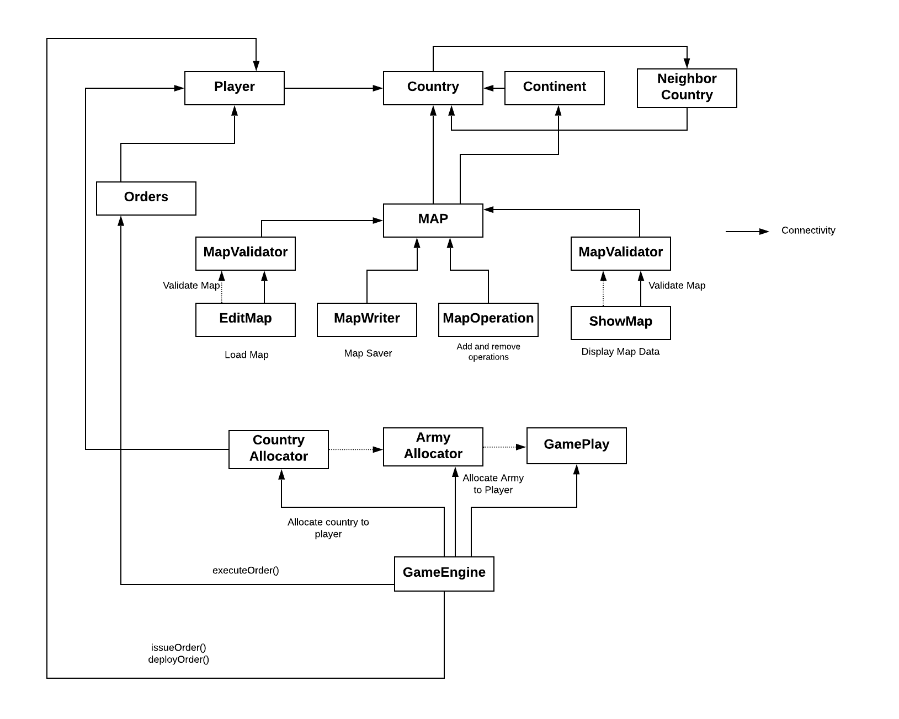

* **Game Flow: -**

1. User can edit exist map by different map operation such as add & remove continent, country and Neighbour country.
2. When the user gives command editmap MapEditor class is called which creates a map as per the user specifications, validates that map using validator class and saves the map through MapSaver class.
3. User can show all map details by showmap command
4. After, load map player list is prepared and user can also add and remove player by command.
5. After this first phase in Game loop take place which is reinforcement phase in which armies assign to each player as per warzone game rule.
6. The second phase is issue orders phase in this phase each armies place in countries as per player command in round robin fashion and reduce the number of armies in the player’s reinforcement pool.

**Issuing order command:**

**deploy countryID num (until all reinforcements have been placed)**

1. Last phase of the game is execute order phase in this phase next order method is called which will enact the order.
2. The effect of a deploy order is to place number of armies on the country

* **Steps to Run the Game: -**

1. loadmap Europe (Here you can use loadmap command to load game again or use Map editor commands to edit map)
2. showmap
3. gameplayer -add P1 -add P2
4. assigncountries
5. loop
   1. deploy <countryname from given list for given player> <value less than listed reinforcement armies>
   2. for eg: deploy Spain 2
6. After loop ends press “n” to exit the loop when asked
7. EXITGAME (to Exit Game Mode)
   1. (Here you can use loadmap command to load game again or use Map editor commands to edit map)
8. EXIT (to exit Game entirely)