**A**

**Project Report On**

**"LIBRARY MANAGMENT "**

(CE244 – Software Group Project-I)



**Prepared by**

HARSHIL RANA (19CE118), HEMIT RANA (19CE119)

JAINIL RANA (19CE120), MANAN SHAH (19CE136)

**Under the Supervision of**

DR. ASHWIN MAKWANA

**Submitted to**

Charotar University of Science & Technology (CHARUSAT)

forthe Partial Fulfillment of the Requirements for the

Degree of Bachelor of Technology (B.Tech.)

for Semester 3

**Submitted at**

****

**Accredited with Grade A by NAAC**

**Accredited with Grade A by KCG**

****

**U & P U. PATEL DEPARTMENT OF COMPUTER ENGINEERING**

**(NBA Accredited)**

**Chandubhai S. Patel Institute of Technology (CSPIT)**

**Faculty of Technology & Engineering (FTE), CHARUSAT**

**At:Changa, Dist: Anand, Pin: 388421.**

**July-December, 2019**

****

**Accredited with Grade A by NAAC**

**Accredited with Grade A by KCG**

**CERTIFICATE**

This is to certify that the report entitled “Plant Communicator” is a bonafied work carried out by **HARSHIL RANA (19ce118), HEMIT RANA (19ce119), JAINIL RANA (19ce120) MANAN SHAH (19ce136)**under the guidance and supervision of **Dr.Ashwin Makawana**for the subject **Software Group Project-I(CE244)** of 3th Semester of Bachelor of Technology in **Computer Engineering** at Faculty of Technology & Engineering (C.S.P.I.T.) – CHARUSAT, Gujarat.

To the best of my knowledge and belief, this work embodies the work of candidates ourselves, has duly been completed, and fulfills the requirement of the ordinance relating to the B.Tech. Degree of the University and is up to the standard in respect of content, presentation and language for being referred to the examiner.

|  |  |
| --- | --- |
| Under the supervision of,  C:\Users\HEMIT\AppData\Local\Microsoft\Windows\INetCache\Content.Word\Ashwin_Sign_Report.jpg  **Dr.Ashwin Makawana**  **Head of Placement Cell**  U & P U. Patel Department of  Computer Engineering C.S.P.I.T.,  CHARUSAT- Changa, Gujarat. |  |
| **Dr. (Prof.) Ritesh Patel**  **Head of department**  U & P U. Patel Department of Computer Engineering  C.S.P.I.T., CHARUSAT- Changa, Gujarat. | |

**Chandubhai S Patel Institute of Technology (CSPIT)**

**Faculty of Technology & Engineering, CHARUSAT**

At: Changa, Ta. Petlad, Dist. Anand, PIN: 388 421. Gujarat

# ABSTRACT

The project titled “Library Management System” is Library management software for monitoring and controlling the transactions in a library. The project is developed in C++ which mainly focuses on basic operations in a library like adding new member, new books, and updating new information , searching books, Rating books as per its condition i.e. torn or nice condition, charging penalty for late submission, also to take a look at history of previous records and facility to borrow and return books. This project is designed & developed to help users maintain and organize library. Our software is easy to use for both beginners and advanced users. Good idea of which are the books borrowed by the members.

.

# ACKNOWLEDGEMENT

We are highly intended to the following personality who have helped us throughout our project and without his support this project would never have been completed. We are extremely thankful to him. We would like to convey our heartful thanks to Dr.Ashwin Makwana who always gave valuable suggestions and guidance for completion of our project.For his support and help we heartily thank him.

# TABLE OF CONTENTS

Abstract………………………………………………………………………………….....i

Acknowledgement…………………………………………………………………………ii

Table of contents………………………………………………………………………….iii

List of Figures…………………………………………………………………………….iv

List of Tables……………………………………………………………………………....v

1.INTRODUCTION……………………………………………………………………….6

1.1. ProjectSummary……………………………………………………………………6

1.2.Purpose: 6

1.3.Scope: 6

1.4.Objective: 7

2.PROJECT MANAGEMENT……………………………………………………………8

2.1Project planning: 8

2.1.1. Project effort and time: 8

2.1.3.Roles and responsibilities: 8

3. SYSTEM REQUIREMENTS STUDY………………………………………………....9

3.1.User characteristics 9

3.2.Hardware and software Requirements for development 9

3.3 Usage………………...…………………………………………………………..…9

4. SYSTEM ANALYSIS………………………………………………………………...10

4.1. Study of current system 10

4.2. Requirements of new system 10

4.3. Featuresof new system 10

4.4. System diagram …..11

5.LIMITATION AND FUTURE ENHANCEMEN……………………………………..13

5.1.Limitations 13

5.2. Future enhancements: 13

6. CONCLUSION AND DISCUSSION………………………………………………..14

6.1 Self-analysis of project viabilities...………………………………………………14

6.1. Problem encountered and possible solutions 14

6.2. Summary of project work 14

7. SCREENSHOTS………………………………………………………………………………………………………15

7.1 Input/Output and Interface Design………………………………………………...15

8. REFERENCES………………………………………………………………………...24

FEEDBACK…………………………………………………………………………….xxv

LIST OF FIGURES

Figure 1 Basic functionalities 10

Figure 2.1 Base flowchart 11

Figure 2.2 Connected flowchart 2 11

Figure 2.3 Connected flowchart 2 12

Figure 2.4 Connected flowchart 3 12

Figure 3 Login Page 15

Figure 4 Main Menu 15

Figure 5 Add Book 16

Figure 6 Display Book 16

Figure 7 Book Search 16

Figure 7.1 Search by ID 17

Figure 7.2 Search by Title 17

Figure 7.3 Search by Category 17

Figure 7.4 Search by Author 17

Figure 7.5 Search by Price Range 18

Figure 7.6 Search by Date 18

Figure 7.7 Search by Name 18

Figure 8 Delete Book 19

Figure 9 Modify Book 20

Figure 10 Show History 20

Figure 11 Search History 21

Figure 11.1 Search History by ID 21

Figure 11.2 Search History by Title 21

Figure 11.3 Search History by Category 22

Figure 11.4 Search History by Author 22

Figure 11.5 Search History by Price Range 22

Figure 11.6 Search History by Date 22

Figure 11.7 Search History by Name 23

# LIST OF TABLES

Table 1 Roles and Responsibilities 10

Table 2 late submission penalty flow 19

# 1.INTRODUCTION

## 1.1. PROJECT SUMMARY:

First we visited a school to annalys the current situation and what improvements are needed in current library system.

We noticed that so many books are torn apart and in bad condition which are submitted by students. Also, students submit books after submission deadline. So we decided to make a project on library management system to solve this problems.

The project is designed for school library in C++.The title of the project is Library Management System. In this project a student can issue one book from library. He has to submit it before 30 days.

Administrator of the project can enter book record, display all, he can modify and dispose record.

This project includes some facilities as registration, search, display, modification etc. This software searches the client data which is store in the record.

The software use for small schools for maintaining their record related to library and cost saving**.**

## 1.2.PURPOSE:

By using library management system, the operation of borrowing and managing inventories is paperless. This system provides a user-friendly data entry. It is also created to ensure that the library items are stored properly in order to maintain their security.

**1.3.SCOPE:**

* Only for specific schools which are having old libraries and paper work system.
* Provide the list of books the users can borrow.
* Facility to reserve books that are available.
* Not fully automatic.
* Providing interface to add or delete books to librarian.

## 1.4.OBJECTIVE:

Objectives of Library Management System (LMS)

a) To build a system that can receive input and generate automatically output in easy way and short time.

b) To build a monitoring system that is able to monitor and manage all library operations efficiently.

c) Give an opportunity to librarians to reduce mistakes that always happen during manual method.

d) To store properly the library items in order to maintain their security.

e) To enter and preserve details of the various issues and keep a track on their returns.

This system will store all the books and members information that consist book numbers, book titles, author name, book prize, book title, no. of pagess and condition of the books to the file. It also provides search function to help students find the book by number of book. Search function will search through the books file to look for the book and view where the book is situated.

This system basically has four types of modules that handle daily activities for the library :

a) Manage and modify Record module

b) Search Record Module

c) Book Borrowing System Module

# 

# 2.PROJECT MANAGEMENT

## 2.1PROJECT PLANNING:

### 2.1.1.Project effort and time:

The project is planned to an appropriate level of the detail. The main purpose is to plan time, cost and resources adequately to estimate the work needed. As with the initiation process group, a failure to adequately plan greatly reduces the project’s chances of successfully accomplishing its goals.

Our project planning generally consists of,

* + - Determine how to plan
    - Developing the scope statement;
    - Selecting the planning team;
    - Identifying deliverables and creating the work breakdown structure;
    - Identifying the activities needed to complete those deliverables and networking the activities in their logical sequence;
    - Estimating the resource requirements for the activities;
    - Estimating time for activities;
    - Developing the schedule;
    - Gaining formal approval to begin work;

### 2.1.2.Roles and responsibilities:

|  |  |
| --- | --- |
| **Developer** | **Roles and responsibilities** |
| 19CE118 | Testing and designing |
| 19CE119 | Designing and coding |
| 19CE120 | Coding, Testing |
| 19CE136 | Designing, Documentation |

Table 1:- Roles and Responsibilities

# 3. SYSTEM REQUIREMENTS STUDY

## 3.1.USER CHARACTERISTICS

* For the administrator user, only librarians have access to view or edit data from the system. Librarian user will handle administrative functions such as decide the number of days allowed for the borrowed books. Users need to enter correct password before they can access to this function. From here, they can add, delete or modified the book.

## 3.2.HARDWARE AND SOFTWARE REQUIREMENTS FOR DEVELOPMENT:

(a) Hardware –

* Administrator machine have complete program
* Processor : intel
* Ram : 512 MB or more than 512MB
* Harddisk : 80 GB or more than 80GB.
* Processor : intel

(b) Software –

* Code blocks IDE OR Dev C++
* Windows 10.
* Programming Language – C++

**3.3.USAGE:**

* Integration of all records of students
* Manage the records systematically
* It can track any information from history
* Manage all information
* Easy to maintain records
* It leads to easy rolling of books.

# 4.SYSTEM ANALYSIS

## 4.1.STUDY OF CURRENT SYSTEM

Currently in most of the libraries, most of the things are done manually.From borrowing books to submitting,everything is done on paper(i.e paperwork).

## 4.2.REQUIREMENTS OF NEW SYSTEM

## Our system reduces human efforts and makes the system more Systematic. So , to make complex paperwork more simpler, our system deals with most of the problems.

## 4.3.FEATURESOF NEW SYSTEM

New features :

Besides book records, our system consists of:

~ Rating of book (according to its condition i.e. torn or in nice condition).

~ Charging penalty for late submission.

~ History of previous records and search in history facility to take a look at previous issuers of books.

FIGURE 1 BASIC FUNCTIONALITIES

## 4.4. SYSTEM DIAGRAM

Figure 2. 1 BASE FLOWCHART

Figure 2. 2 CONNECTED FLOWCHART 1

Figure 2. 3 CONNECTED FLOWCHART 2

Figure 2. 4 CONNECTED FLOWCHART 3

# 5.LIMITATION AND FUTURE ENHANCEMENT

## 5.1.LIMITATIONS:

## This system is suitable for only limited schools.

## Online facility is not available.

## 5.2. FUTURE ENHANCEMENTS:

It is not possible to develop a system that makes all the requirements of the user. User requirements keep changing as the system is being used. Some of the future enhancements that can be done to this system are:

* As the technology emerges, it is possible to upgrade the system and can be adaptable to desired environment.
* Based on the future security issues, security can be improved using emerging technologies.

# 6. CONCLUSION AND DISCUSSION

## 6.1. SELF-ANALYSIS OF PROJECT VIABILITIES

The project was a good way to probe into the unknown aspects of File Handeling. C++ was effectively learnt and different types of functionalities and technology related to it was known.

## 6.2. PROBLEM ENCOUNTERED AND POSSIBLE SOLUTIONS

* During entering the name, we have to check whether the name is entered with correct alphabets.If not then it will show "N/A".
* Data should be entered according to the sequence mentioned.
* For every pc which have low end configuration, our project is completely able to execute.

## 6.3. SUMMARY OF PROJECT WORK

* This “The library Management System” has been computed successfully and was also tested successfully by taking test cases. It is user friendly, and has required options, which can be utilized by the user to perform the desired operations.
* Optimum utilization of resources.The software is developed using C++ as back end in Windows environment. The goals that are achieved by the software are,

Less processing time and getting required information.Simplification of the operations.Efficient management of records.

**7.SCREENSHOTS**

**7.1 INPUT/OUTPUT AND INTERFACE DESIGN:**

**\*\*\*\*\*\*\*\*\*\*\*\*\*\*\*\*\*\*\*\*\*\* log in preview\*\*\*\*\*\*\*\*\*\*\*\*\*\*\*\*\*\*\*\*\*\*\*\***

This functionality will provide security to the system. If entered password is wrong then it will print message “wrong password”.

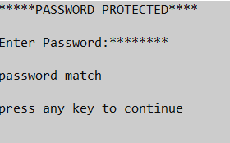

Figure 3 Login Page

**\*\*\*\*\*\*\*\*\*\*\*\*\*\*\*\*\*\*\*\*\*\*\*Main Menu\*\*\*\*\*\*\*\*\*\*\*\*\*\*\*\*\*\*\*\*\*\*\*\*\*\*\***

This preview has choices for main functionalities as given below.

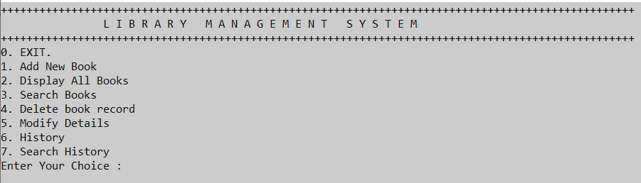

Figure 4 Main Menu

**\*\*\*\*\*\*\*\*\*\*\*\*\*\*\*\*\*\*\*\*\*\*\*add book preview \*\*\*\*\*\*\*\*\*\*\*\*\*\*\*\*\*\*\*\*\*\*\***

This preview has basic entries for book record.

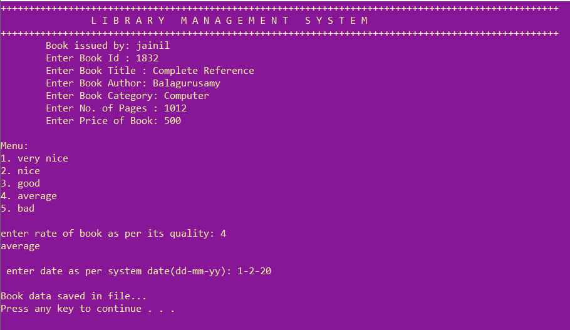

Figure 5 Add Book

**\*\*\*\*\*\*\*\*\*\*\*\*\*\*\*\*\*\*\*\*\*display book preview \*\*\*\*\*\*\*\*\*\*\*\*\*\*\*\*\*\*\*\***

This preview has list of issued book records.

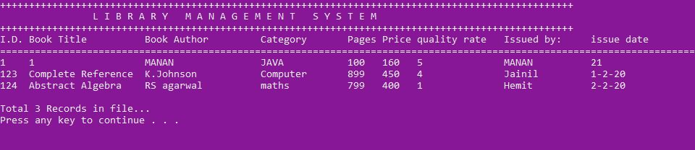

Figure 6 Display Book

**\*\*\*\*\*\*\*\*\*\*\*\*\*\*\*\*search book record main menu preview\*\*\*\*\*\*\*\*\*\*\***

This preview has main menu for search book records of issued books.

It has facility to search book records by ID, name,category etc.

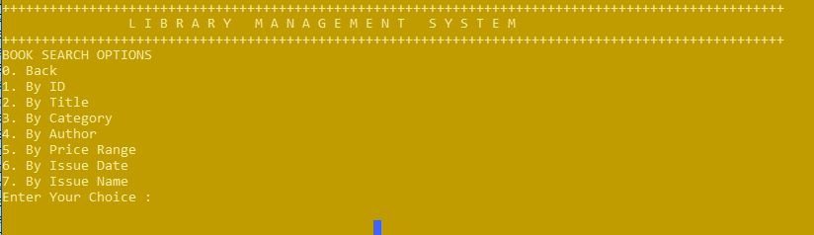

Figure 7 Book Search

**\*\*\*\*\*\*\*\*\*\*\*\*\*\*\*\*\*search book by ID preview\*\*\*\*\*\*\*\*\*\*\*\*\*\*\*\*\*\*\*\*\***

This functionality provides searching of books by ID.

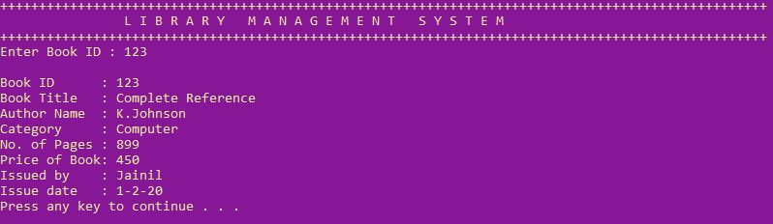

Figure 7.1 Search by ID

**\*\*\*\*\*\*\*\*\*\*\*\*\*\*\*\*search book by title preview\*\*\*\*\*\*\*\*\*\*\*\*\*\*\*\*\*\*\*\*\***

This functionality provides searching of books by its title.

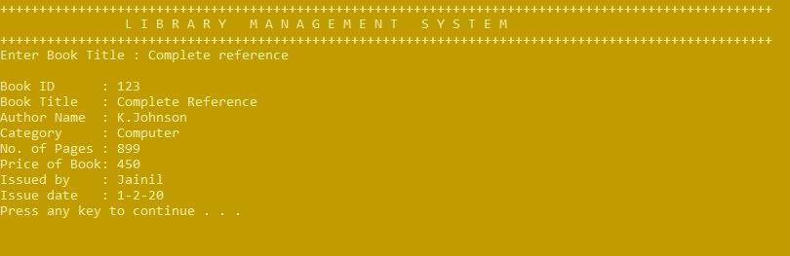

Figure 7.2 Search by Title

**\*\*\*\*\*\*\*\*\*\*\*\*\*\*\*search book by category preview\*\*\*\*\*\*\*\*\*\*\*\*\*\*\*\*\***

This functionality provides searching of books by its category(subject).

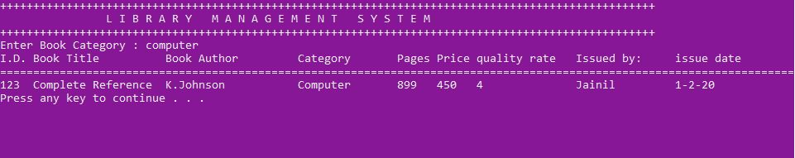

Figure 7.3 Search by Category

**\*\*\*\*\*\*\*\*\*\*\*\*\*\*\*search book by author preview\*\*\*\*\*\*\*\*\*\*\*\*\*\*\*\*\***

This functionality provides searching of books by its author.

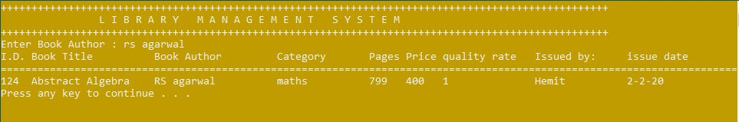

Figure 7.4 Search by Author

**\*\*\*\*\*\*\*\*\*\*\*search book by price range and date preview\*\*\*\*\*\*\*\*\*\*\*\***

This functionality provides searching of books by price ranges.

It will ask to enter minimum price and maximum price.

It will display all books that will have price in that range.

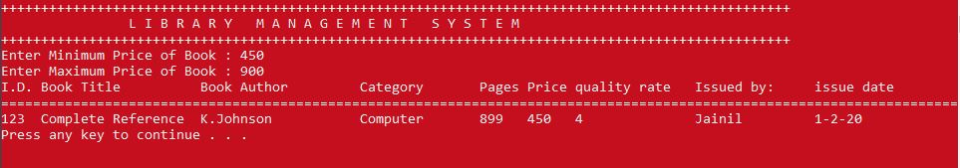

Figure 7.5 Search by Price Range

This functionality provides searching of books by issue date.

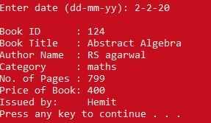

Figure 7.6 Search by Date

**\*\*\*\*\*\*\*\*\*\*\*\*\*\*\*\*search book by name preview\*\*\*\*\*\*\*\*\*\*\*\*\*\*\*\***

This functionality provides searching of books by student name who has issued it.

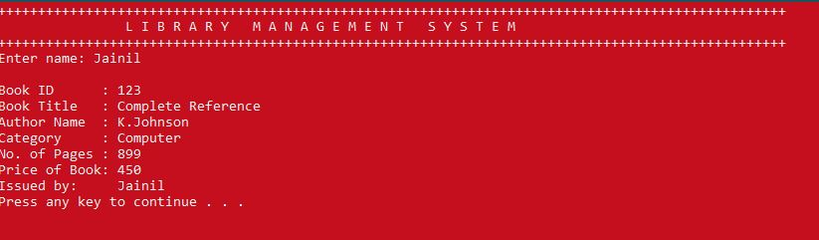

Figure 7.7 Search by Name

**\*\*\*\*\*\*\*\*\*\*\*\*\*\*\*\*Delete book record preview\*\*\*\*\*\*\*\*\*\*\*\*\*\*\*\***

This functionality will delete the record through providing its ID only.

Then it will ask forlate submission. If it is submitted late then it will charge penalty as per number of days. Also has facility to provide current condition of the book at submission time to check the book is torn by student or not.

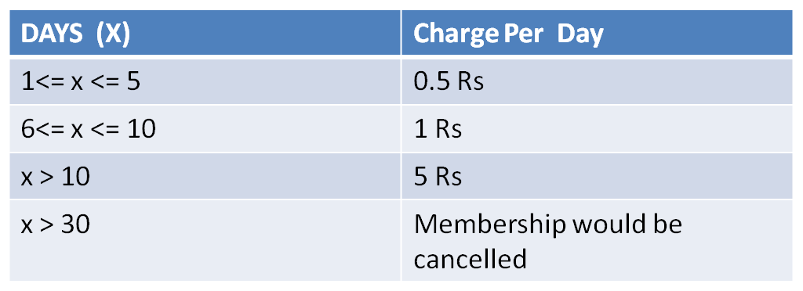

Table 2 late submission penalty flow

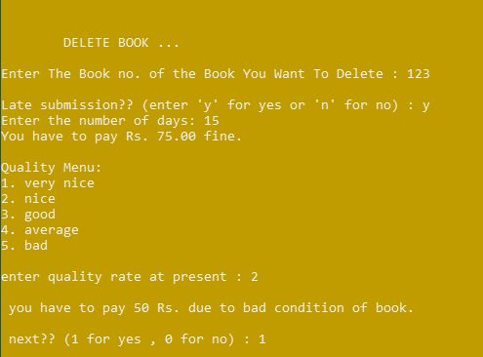

Figure 8 Delete Book

**\*\*\*\*\*\*\*\*\*\*\*\*\*\*\*\*Modify book record preview\*\*\*\*\*\*\*\*\*\*\*\*\*\*\*\***

This functionality will modify the record through providing its ID only.

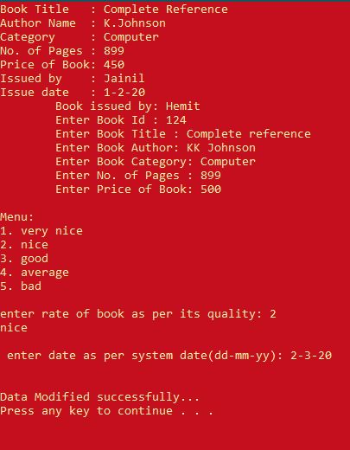

Figure 9 Modify Book

**\*\*\*\*\*\*\*\*\*\*\*\*\*\*\*\*History of book record preview\*\*\*\*\*\*\*\*\*\*\*\*\*\*\*\***

This functionality will show the record of issued books which are deleted after submissions.



Figure 10 Show History

**\*\*\*\*\*\*\*\*\*\*\*\*\*Search in History of book record preview\*\*\*\*\*\*\*\*\*\*\*\*\***

This functionality will show the menu to search the history record of issued books which are deleted after submissions.

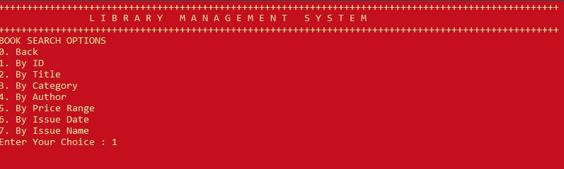

Figure 11 Search History

Following are the previews of all options to search in the history of book records.

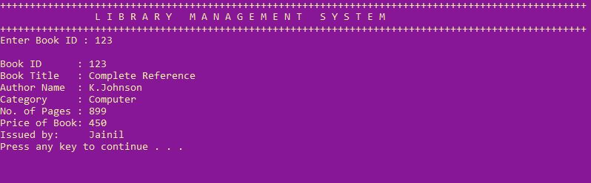

Figure 11.1 Search History by ID

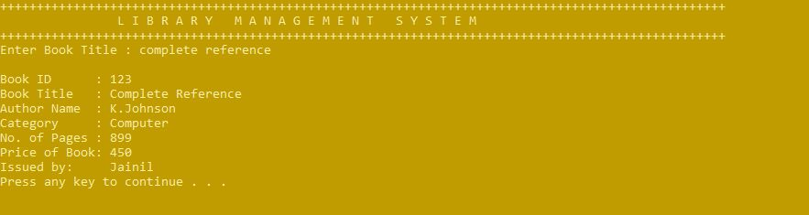

Figure 11.2 Search History by Title



Figure 11.3 Search History by Category

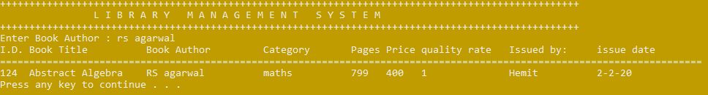

Figure 11.4 Search History by Author



Figure 11.5 Search History by Price



Figure 11.6 Search History by Date



Figure 11.7 Search History by Name

**We have made three file pointers**

1). **books.dat file**: To store current book records.

2). **temp.dat file**: To manage the deleted data and also to replace the current file. After deleting some data in books.dat file, the remaining record is stored in temp.dat file.then previous books.dat file is removed and temp.dat file is renamed as books.dat file. And also deleted record is stored in history.dat file.

3). **history.dat file**: To store the history of book records.

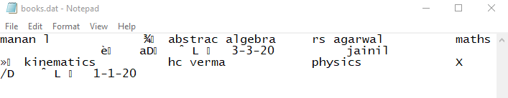

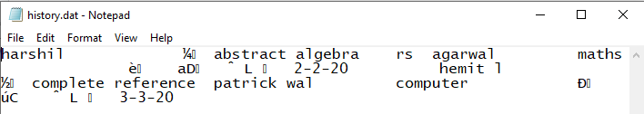

# Here all the data types except string are stored in special characters because it is a data file ( .dat extension)

# 8. REFERENCES

* <https://www.geeksforgeeks.org/file-handling-c-classes/>
* <https://www.tutorialspoint.com/cplusplus/cpp_files_streams.htm>
* <https://www.sciencedirect.com/topics/computer-science/library-management-system>

# FEEDBACK

* To know whether our project is useful or not, we went to a school called “ambe vidhyalaya” so that we could represent our work and get feedback.
* The librarian appreciated our work and also suggested few ideas we could add so that their school find it more helpful and then we added it in our project as “search in history” option.
* She also told that using this .exe file is very straight forward and after involving her suggested ideas into our work, she will accept our project as one of their school component.