An Internship Report
On
"AegisSOC: AI-Assisted SOC Triage Platform"

Prepared by
Patel Harshil Dharmendra(23DCE081)

Under the guidance of
Dr. Parth Goel

A Report Submitted to
Charotar University of Science and Technology
For Partial Fulfillment of the Requirements for the
7th Semester Summer Internship-II (CE446)
Submitted at


Department of Computer Engineering
Devang Patel Institute of Advance Technology and Research
At: Changa, Dist: Anand – 388421
July 2026



CERTIFICATE

This is to certify that the report entitled “AegisSOC: AI-Assisted SOC Triage Platform” is a Bonafide work carried out by Mr. Patel Harshil Dharmendra(23DCE081) under the guidance and supervision of Dr. Parth Goel for the subject CE446 SUMMER INTERNSHIP-II of 7th Semester of Bachelor of Technology in Department of Computer Engineering DEPSTAR at Faculty of Technology & Engineering – CHARUSAT, Gujarat.

To the best of my knowledge and belief, this work embodies the work of candidate himself, has duly been completed, and fulfills the requirement of the ordinance relating to the B.Tech. Degree of the University and is up to the standard in respect of content, presentation and language for being referred to the examiner.

Dr. Parth Goel  Assistant Professor  Department of Computer Science & Engineering  DEPSTAR, CHARUSAT. | Nikunj Bhavsar  HR  Digiesale  Vadodara
Dr. Chirag Patel,
Head of Department,
Department of Computer Engineering,
DEPSTAR, CHARUSAT.
Devang Patel Institute of Advance Technology and Research
At: Changa, Ta. Petlad, Dist. Anand, PIN: 388 421. Gujarat



ACKNOWLEDGEMENT
I express my sincere gratitude to Charotar University of Science and Technology (CHARUSAT) and the Department of Computer Engineering, DEPSTAR, for providing me the opportunity to undertake Summer Internship-II (CE446) as a project-based learning experience.
I am deeply thankful to my internal guide Dr. Parth Goel, Assistant Professor, Department of Computer Science & Engineering, DEPSTAR, CHARUSAT, for his continuous guidance, constructive feedback, and academic support throughout the development of AegisSOC.
I would also like to thank Digiesale, Vadodara, and especially Mr. Nikunj Bhavsar (HR) for facilitating the internship environment and encouraging practical exposure to enterprise-grade software engineering practices.
Finally, I thank my family, friends, and classmates for their motivation and support during this internship.

Patel Harshil Dharmendra
23DCE081

ABSTRACT
Modern Security Operations Centers (SOCs) process millions of telemetry events daily, yet analysts must manually correlate fragmented alerts into coherent attack narratives. This internship project addresses that gap by designing and implementing AegisSOC, an AI-assisted SOC triage platform that ingests multi-source security telemetry, builds a temporal entity graph, detects suspicious activity using deterministic rules and graph analytics, and produces evidence-grounded triage reports for human analysts.
The scope of the internship covered the complete software lifecycle: requirement analysis, microservices architecture design, backend service implementation, React analyst dashboard development, Docker-based deployment, and evaluation using labeled demo scenarios. The platform comprises eleven backend services, a frontend gateway with JWT authentication and role-based access control, and supporting infrastructure including Kafka (Redpanda), Neo4j, PostgreSQL, Redis, and OpenSearch.
Actual work performed included canonical event schema design, Sigma-like detection rule integration, graph-based entity correlation, LLM-assisted (but not LLM-driven) triage summarization with citation grounding, human-in-the-loop response approval workflows, and end-to-end demo scenarios covering phishing-to-ransomware chains, false-positive suppression, and repeat-attacker infrastructure linking.
The conclusion of this work is that a graph-aware, microservices SOC platform can materially improve analyst situational awareness while keeping detection explainable and keeping disruptive response actions under explicit human approval. The implemented system demonstrates production-shaped architecture at internship scale and provides a clear roadmap for horizontal scaling to enterprise telemetry volumes.

TABLE OF CONTENTS
ACKNOWLEDGEMENT i
ABSTRACT ii
LIST OF CONTENTS iii
LIST OF FIGURES iv
LIST OF TABLE…………………………………………………………………...……v
DESCRIPTION OF COMPANY / ORGANIZATION vi
CHAPTER 1 PROJECT DEFINITION 1
1.1 Introduction 1
1.2 Problem Statement 1
1.3 Project Objectives 1
1.4 Scope 1
CHAPTER 2 DESCRIPTION 2
2.1 System Overview 2
2.2 Architecture Layers 2
2.3 Technology Stack 3
CHAPTER 3 SOFTWARE AND HARDWARE REQUIREMENTS 4
3.1 Software Requirements 4
3.2 Hardware Requirements 4
CHAPTER 4 MAJOR FUNCTIONALITY 5
4.1 Microservices 5
4.2 Key Features 5
4.3 Demo Scenarios 5
CHAPTER 5 FLOW CHART 6
5.1 End-to-End Pipeline Flow 6
5.2 Microservices Architecture 6
5.3 Alert-to-Response Sequence 7
CHAPTER 6 SCREENSHOTS OF PROJECT OUTPUT 8
6.1 Alert Queue Dashboard 8
6.2 Cases Management 8
6.3 Case Detail View 8
6.4 Investigation Workspace 9
6.5 Response and Approvals 9
6.6 Approval Modal (Human-in-the-Loop) 9
6.7 Audit Trail 10
6.8 Metrics Dashboard 10
6.9 Replay and Demo Console 11
CHAPTER 7 LIMITATIONS OF PROJECT 12
CHAPTER 8 OUTCOME 13
CHAPTER 9 FUTURE ENHANCEMENT 14
CONCLUSION 15
REFERENCES 16

LIST OF FIGURES
Fig. 5.1 AegisSOC End-to-End Data Flow 9
Fig. 5.2 Microservices Architecture Diagram 10
Fig. 5.3 Alert-to-Response Sequence Diagram 11
Fig. 6.1 Alert Queue Dashboard 12
Fig. 6.2 Cases Management View 13
Fig. 6.3 Case Detail View 14
Fig. 6.4 Investigation Workspace with Attack-Path Graph 15
Fig. 6.5 Response and Approvals Panel 16
Fig. 6.6 Human-in-the-Loop Approval Modal 17
Fig. 6.7 Audit Trail with Expandable Events 18
Fig. 6.8 Operational Metrics Dashboard 19
Fig. 6.9 Replay and Demo Scenario Console 20

LIST OF TABLES
Table 3.1 Software Requirements 6
Table 3.2 Hardware Requirements 6
Table 4.1 Microservices and Responsibilities 7
Table 4.2 Demo Scenarios and Expected Outcomes 8

DESCRIPTION OF COMPANY / ORGANIZATION
Digiesale is a technology-oriented organization based in Vadodara, Gujarat, focused on digital solutions, software services, and practical industry exposure for engineering interns. The company operates in the regional IT ecosystem and collaborates with academic institutions to bridge classroom learning with real-world project execution.
Location and structure: Digiesale is located in Vadodara, a major industrial and educational hub in Gujarat. The organization follows a compact administrative structure suitable for agile software delivery, with functional coordination across human resources, technical mentoring, and project supervision. During this internship, the candidate worked in a project-based mode under organizational supervision while maintaining academic guidance from CHARUSAT.
Main functions: The company's internship framework emphasizes end-to-end software development, including requirement understanding, architecture design, implementation, testing, documentation, and deployment. For this project, the focus was on building a security operations platform aligned with modern SOC workflows and cloud-native engineering practices.
Customer profile and relevance: Digiesale serves clients seeking digital transformation and custom software solutions. The AegisSOC project aligns with the growing market demand for security analytics, SIEM augmentation, and AI-assisted incident response tools that reduce analyst fatigue while preserving auditability and human oversight.

CHAPTER 1 PROJECT DEFINITION
1.1 INTRODUCTION
Security Operations Centers (SOCs) are responsible for detecting, investigating, and responding to cyber threats across enterprise environments. As log volumes grow into hundreds of millions of events per day, analysts struggle to separate true attacks from noise. Traditional SIEM platforms generate alerts but rarely reconstruct full attack paths automatically.
AegisSOC is defined as an AI-assisted SOC triage platform whose primary objective is to transform raw telemetry into readable attack stories. The platform follows a strict design principle: the Large Language Model (LLM) is never the primary detector. Detection is performed by deterministic Sigma-like rules, correlation logic, graph feature extraction, and a calibrated machine learning ensemble. The LLM is invoked only after an alert or case exists, and only to summarize evidence, map MITRE ATT&CK techniques, and draft analyst-facing recommendations.
1.2 PROBLEM STATEMENT
Existing SOC workflows suffer from three recurring problems: (1) alert fatigue caused by high false-positive rates, (2) loss of context because events remain siloed across endpoints, network, identity, and cloud sources, and (3) slow investigation because analysts manually pivot between tools to reconstruct timelines and entity relationships.
1.3 PROJECT OBJECTIVES
• Design a microservices pipeline for ingest → normalize → enrich → graph → detect → case → triage → response.
• Build a temporal entity graph linking users, hosts, processes, files, IPs, domains, and techniques.
• Implement explainable detection using rules, correlation, and graph analytics.
• Provide an analyst dashboard for alert review, investigation, attack-path visualization, and approval workflows.
• Demonstrate end-to-end behavior using labeled synthetic scenarios with ground-truth attack labels.
1.4 SCOPE
The project scope includes eleven backend services, a React analyst console, Docker Compose deployment, sample datasets (2,880+ synthetic events), twenty Sigma-like rules, three demo scenarios, evaluation scripts, and architecture/security documentation. Out of scope for this internship phase are GPU-trained graph neural networks, live external threat-intel connectors, and multi-tenant physical isolation.
CHAPTER 2 DESCRIPTION
2.1 SYSTEM OVERVIEW
AegisSOC follows an event-driven microservices architecture. Telemetry enters through the ingestion service, is normalized into a canonical schema, enriched with ATT&CK tags and threat-intel matches, written into a Neo4j graph, analyzed by the detection engine, clustered into cases, summarized by the LLM triage service, and optionally routed to response playbooks requiring human approval for disruptive actions.
2.2 ARCHITECTURE LAYERS
2.2.1 Data ingestion and streaming layer
The ingestion service accepts raw events from Sysmon, Zeek, Suricata, EDR, Active Directory, CloudTrail, Kubernetes audit logs, and email/phishing sources. Valid events are published to Kafka topics; malformed records are sent to a dead-letter queue (DLQ). Redpanda provides the Kafka-compatible streaming backbone.
2.2.2 Processing and enrichment layer
Normalization maps source-specific fields to CanonicalEvent objects with UTC timestamps and confidence metadata. Enrichment adds asset criticality, identity resolution, MITRE ATT&CK technique tags, and local threat-intel matches cached in Redis.
2.2.3 Graph and detection layer
The graph builder performs entity resolution and upserts typed nodes and edges (e.g., Process spawned Process, Process created File, IP resolved_to Domain). Detection combines Sigma-like rules, temporal correlation, graph features (degree, rare-edge score, path-to-known-bad), and an ensemble scorer. Results are indexed in OpenSearch and emitted as alerts.
2.2.4 Analyst workflow layer
Case management clusters related alerts, maintains timelines, and stores analyst feedback. The frontend gateway exposes a unified JWT-protected API to a React dashboard. LLM triage generates grounded reports with citations. Response policy recommends actions; disruptive actions require approval through the approval service and are logged in the append-only audit trail.
2.3 TECHNOLOGY STACK
Backend services are implemented in Python 3.11 with FastAPI. The frontend uses React, TypeScript, and Vite. Infrastructure components include Docker Compose, PostgreSQL, Neo4j, Redis, OpenSearch, Redpanda, Prometheus, and optional Grafana/OpenTelemetry profiles. Kubernetes manifests and Helm charts are included for production-shaped deployment.

CHAPTER 3 SOFTWARE AND HARDWARE REQUIREMENTS
3.1 SOFTWARE REQUIREMENTS
Component | Requirement
Operating System | Linux/macOS/Windows with Docker support
Docker & Docker Compose | v2.x for full-stack deployment
Python | 3.11+ for backend services and scripts
Node.js & npm | 18+ for React frontend development
Git | Version control and collaboration
Web Browser | Chrome/Firefox/Edge for analyst console
Optional LLM API | OpenAI-compatible key for live triage calls
Table 3.1 Software Requirements
3.2 HARDWARE REQUIREMENTS
Component | Minimum | Recommended
Processor | 4-core CPU | 8-core CPU or Apple Silicon equivalent
RAM | 8 GB | 16 GB or higher
Storage | 20 GB free SSD | 40 GB free SSD
Network | Localhost access for services | Stable internet for LLM API (optional)
Table 3.2 Hardware Requirements

CHAPTER 4 MAJOR FUNCTIONALITY
4.1 MICROSERVICES
Service | Port | Responsibility
ingestion | 8001 | Raw telemetry intake, DLQ, replay API
normalization | 8002 | Canonical event schema mapping
enrichment | 8003 | ATT&CK tagging, intel matching
graph_builder | 8004 | Temporal entity graph writes (Neo4j)
detection | 8005 | Rules, correlation, ensemble scoring
case_management | 8006 | Cases, timelines, analyst feedback
llm_triage | 8007 | Evidence-grounded triage reports
response_policy | 8008 | Playbook/action recommendation
approval | 8009 | Human-in-the-loop approval gate
audit | 8010 | Append-only audit trail
frontend_gateway | 8080 | Public API, JWT auth, RBAC
Table 4.1 Microservices and Responsibilities
4.2 KEY FEATURES
• Multi-source telemetry ingestion with scenario replay for demos and evaluation.
• Temporal entity graph with neighborhood queries and attack-path analysis.
• Sigma-like rule engine with correlation and graph-enhanced risk scoring.
• Case clustering, investigation workspace, timeline, and evidence panels.
• LLM triage reports with groundedness validation and ATT&CK mapping.
• Response recommendations with approval workflow for disruptive actions.
• Prometheus metrics, health checks, and optional Grafana dashboards.
4.3 DEMO SCENARIOS
Scenario | Severity | Purpose
phishing_ransomware_chain | Critical | Full kill chain: phishing → ransomware
benign_admin_false_positive | Low | False-positive suppression demonstration
repeat_attacker_infra | High | Graph memory across historical incidents
Table 4.2 Demo Scenarios and Expected Outcomes

CHAPTER 5 FLOW CHART
5.1 END-TO-END PIPELINE FLOW
The following diagram illustrates the primary data flow from telemetry sources to analyst-facing outputs. Events move through ingestion and normalization, receive enrichment and graph updates, trigger detection, create or update cases, and optionally invoke LLM triage and response workflows.
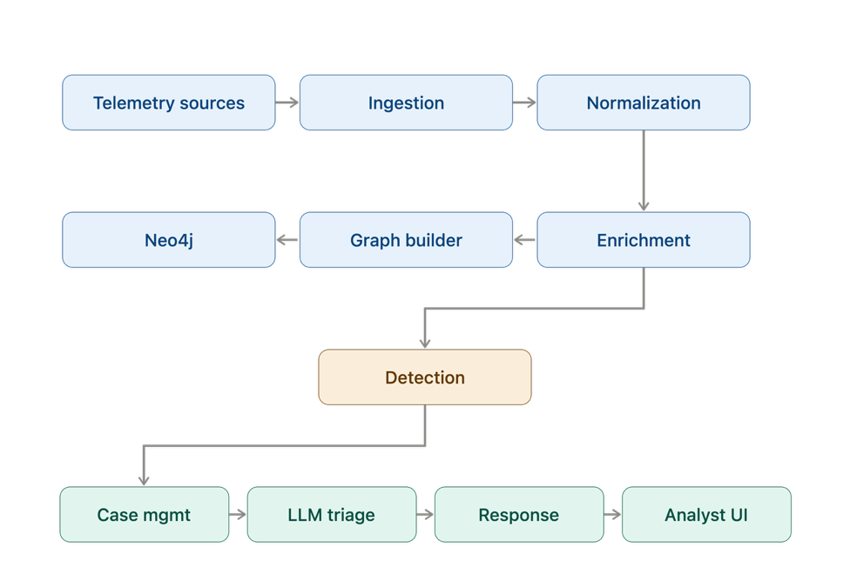
Fig. 5.1 AegisSOC End-to-End Data Flow
5.2 MICROSERVICES ARCHITECTURE
Figure 5.2 shows the eleven backend microservices, frontend gateway, React analyst UI, and supporting data stores (Redpanda, Neo4j, PostgreSQL, OpenSearch) that comprise the AegisSOC deployment topology.
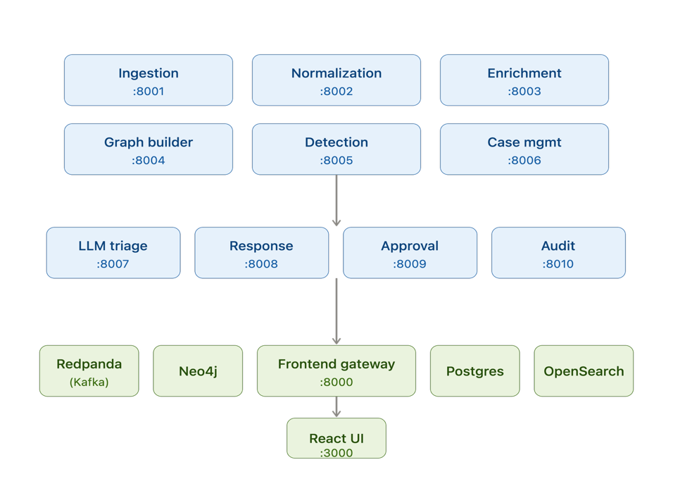
Fig. 5.2 Microservices Architecture Diagram
5.3 ALERT-TO-RESPONSE SEQUENCE
When detection emits an alert, case management clusters it with related alerts. An analyst opens the Investigation Workspace, reviews the attack-path graph and timeline, requests an LLM triage report, evaluates recommended actions, and submits disruptive actions for senior/admin approval. All decisions are recorded in the audit service.
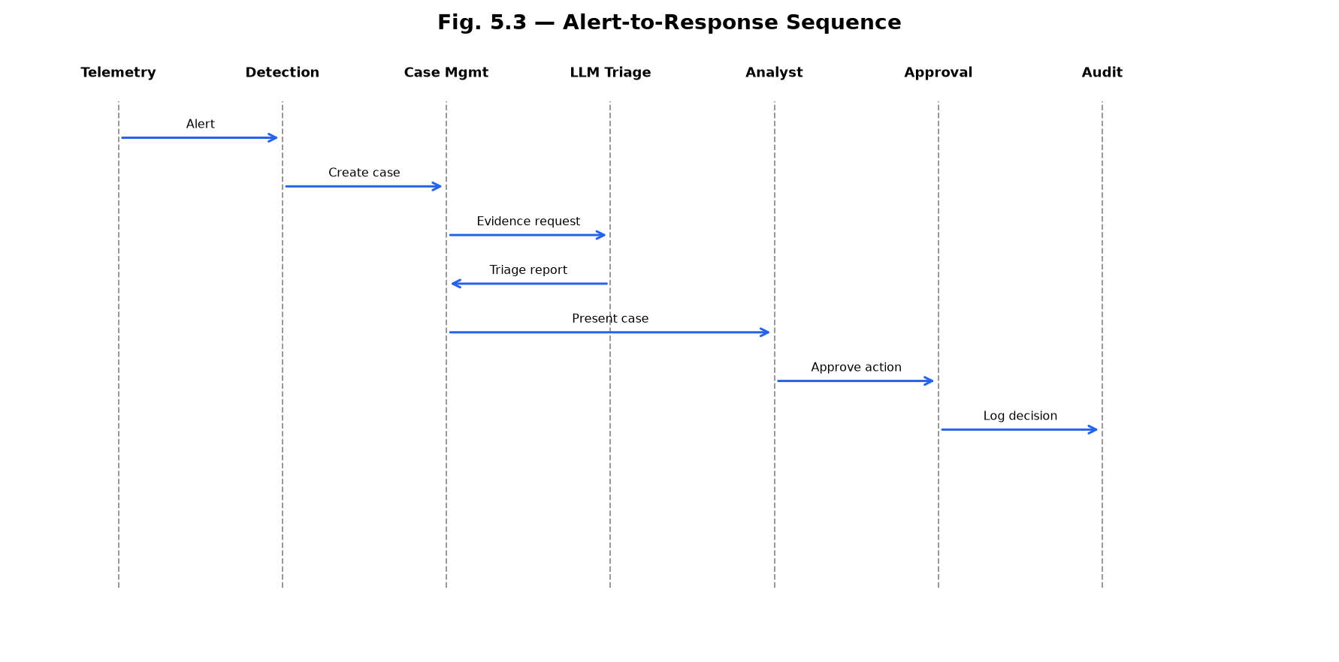
Fig. 5.3 Alert-to-Response Sequence Diagram

CHAPTER 6 SCREENSHOTS OF PROJECT OUTPUT
6.1 ALERT QUEUE DASHBOARD
The Alert Queue presents prioritized alerts ranked by ensemble risk score. Analysts can filter by severity and status, view MITRE ATT&CK technique tags, and click any row to open the Investigation Workspace.
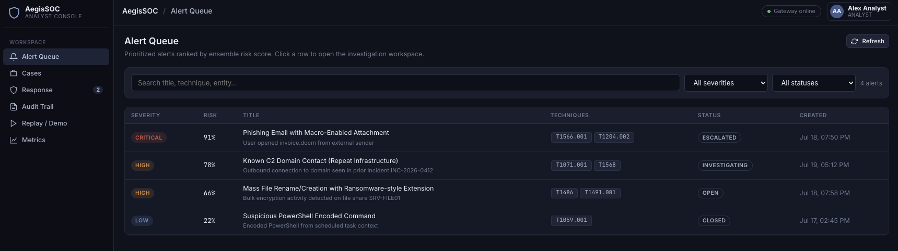
Fig. 6.1 Alert Queue Dashboard
6.2 CASES MANAGEMENT VIEW
The Cases page lists investigation cases clustered from correlated alerts, showing severity, risk percentage, status, assignee, and last-updated timestamp for workflow tracking.
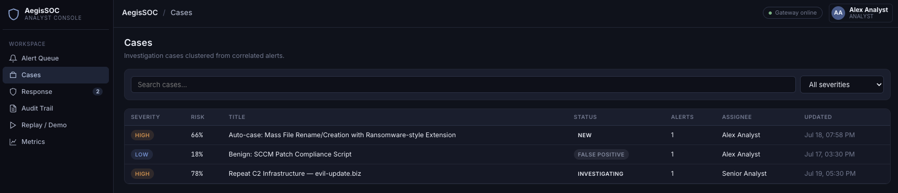
Fig. 6.2 Cases Management View
6.3 CASE DETAIL VIEW
Case Detail provides a summary of the selected incident including risk score, attack story narrative, linked alerts, and mapped MITRE techniques, with a direct link to the Investigation Workspace.
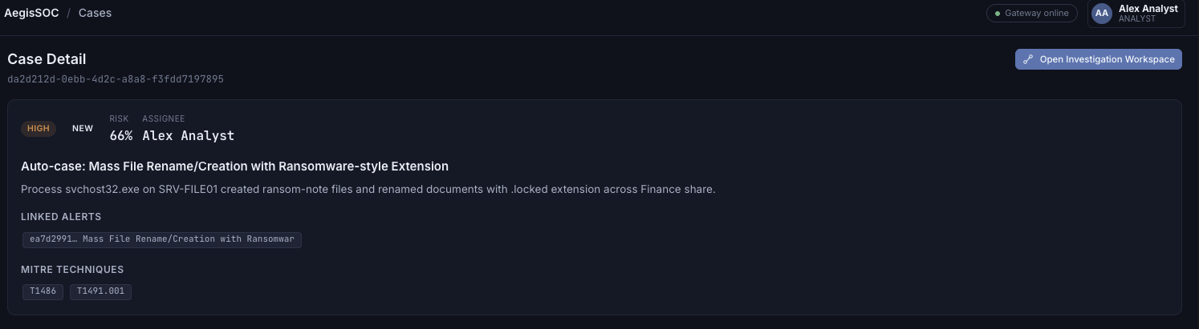
Fig. 6.3 Case Detail View

6.4 INVESTIGATION WORKSPACE WITH ATTACK-PATH GRAPH
The Investigation Workspace combines an interactive attack-path graph (entity nodes and typed edges), LLM triage report with groundedness score, ATT&CK mapping, and containment recommendations.
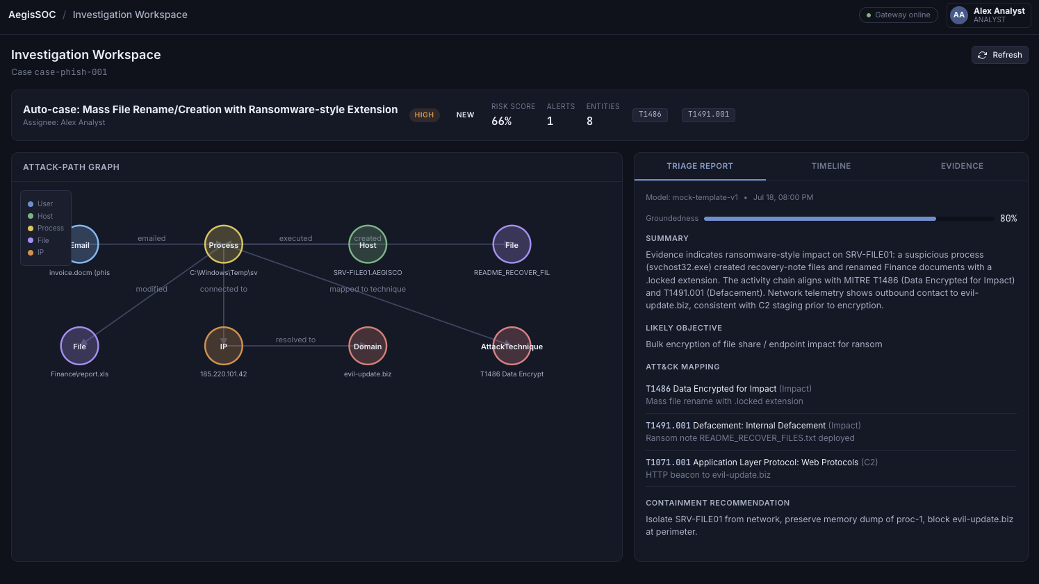
Fig. 6.4 Investigation Workspace with Attack-Path Graph
6.5 RESPONSE AND APPROVALS PANEL
The Response page displays AI-recommended actions such as host isolation and domain blocking. Disruptive actions are flagged and require explicit analyst approval before execution.
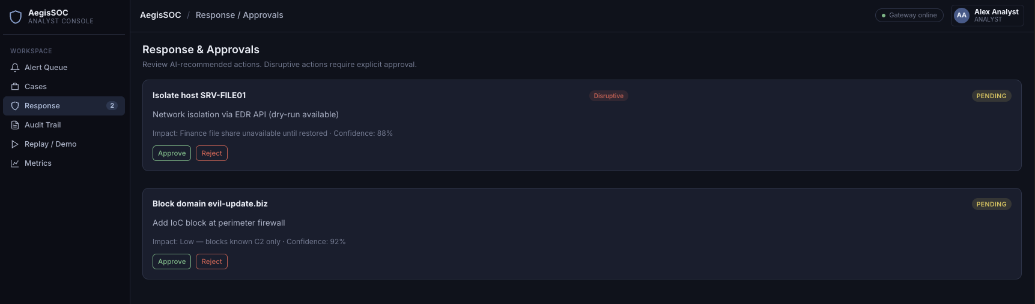
Fig. 6.5 Response and Approvals Panel
6.6 HUMAN-IN-THE-LOOP APPROVAL MODAL
The approval modal enforces human-in-the-loop governance: analysts review impact summary, toggle dry-run mode, document rationale, and confirm or cancel disruptive response actions.
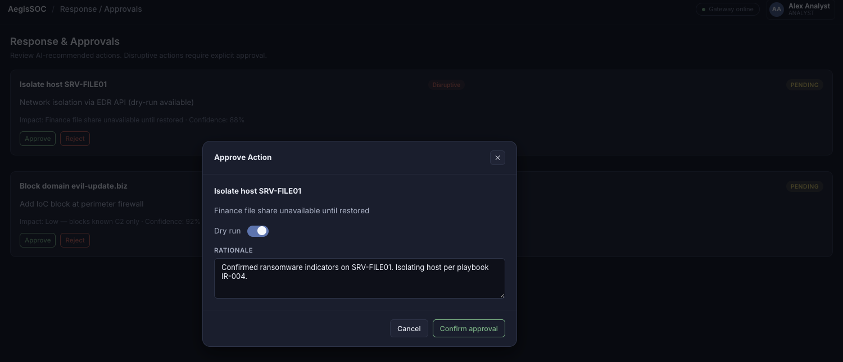
Fig. 6.6 Human-in-the-Loop Approval Modal
6.7 AUDIT TRAIL WITH EXPANDABLE EVENTS
The Audit Trail provides an append-only log of system and analyst actions including triage report generation, alert creation, and case decisions, with expandable JSON detail per event.
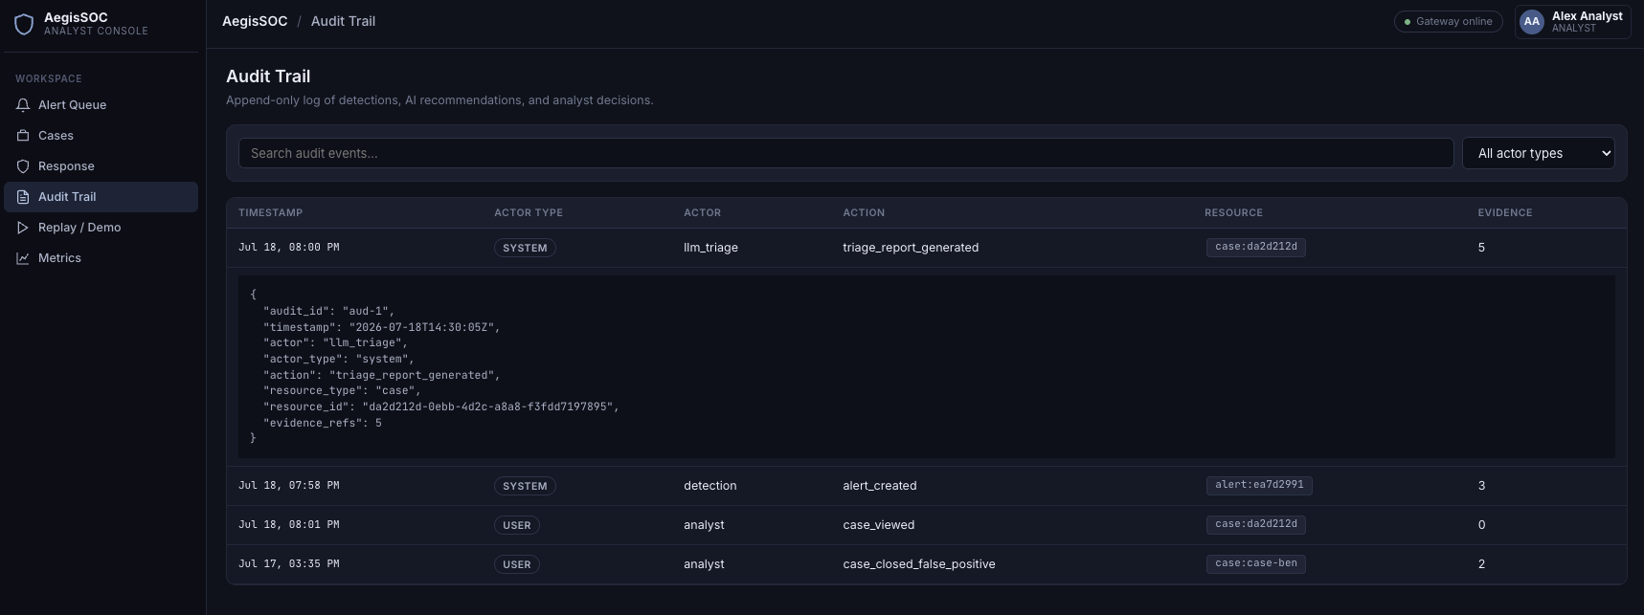
Fig. 6.7 Audit Trail with Expandable Events
6.8 OPERATIONAL METRICS DASHBOARD
The Metrics dashboard shows Prometheus-style operational KPIs across ingestion throughput, detection precision, case triage latency, LLM groundedness, and pending response approvals.
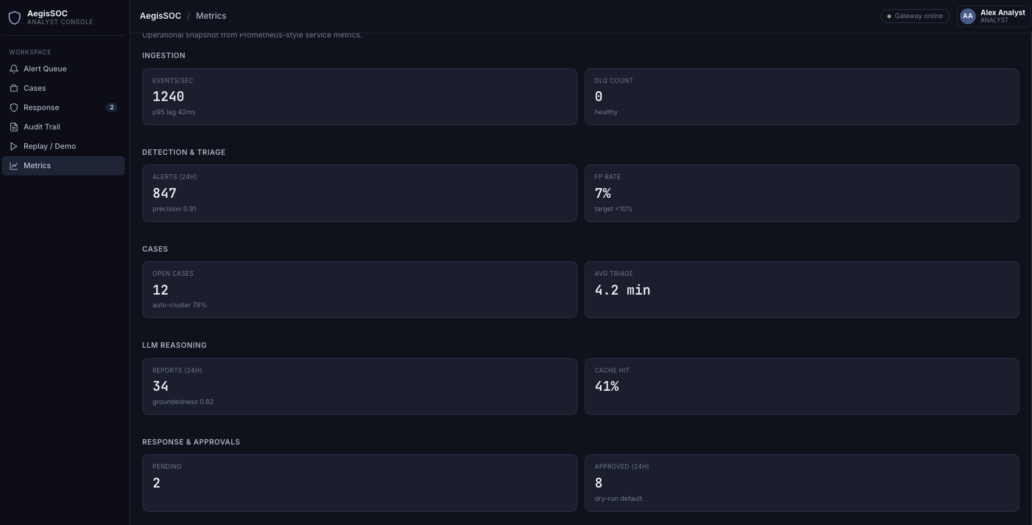
Fig. 6.8 Operational Metrics Dashboard
6.9 REPLAY AND DEMO SCENARIO CONSOLE
The Replay page executes three canonical demo scenarios (phishing-ransomware, benign false-positive, repeat attacker infrastructure) to validate end-to-end pipeline behavior.
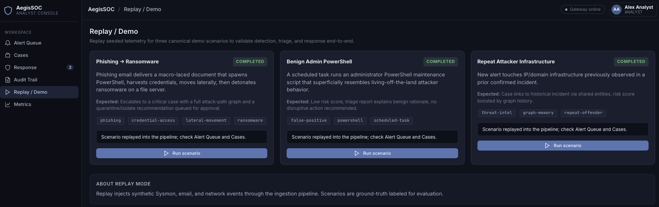
Fig. 6.9 Replay and Demo Scenario Console

CHAPTER 7 LIMITATIONS OF PROJECT
Although AegisSOC implements production-shaped architecture, several limitations remain appropriate for an internship-scale deployment:
• Graph ML uses a lightweight GraphSAGE-style numpy scorer rather than a GPU-trained heterogeneous GNN.
• Live VirusTotal/OpenCTI connectors are optional stubs; local JSON intel feeds are used by default.
• Prompt-injection defenses are heuristic pattern filters rather than a dedicated classifier.
• Tenant isolation is logical (tenant_id scoping) rather than physically isolated infrastructure.
• Online reinforcement learning is not enabled; response ranking uses offline-evaluated contextual bandits.
• Local Docker Compose deployment does not demonstrate 100M logs/day throughput without horizontal scaling.

CHAPTER 8 OUTCOME
The AegisSOC internship project successfully delivered a working SOC triage platform with the following outcomes:
• Eleven backend microservices and a React analyst dashboard running in Docker Compose.
• End-to-end demo scenarios covering ransomware chains, false positives, and repeat-attacker graph memory.
• Evidence-grounded LLM triage integrated without compromising deterministic detection.
• Human-in-the-loop approval workflow for disruptive response actions with audit logging.
• Architecture decision records, threat model, evaluation scripts, and deployment manifests.
• Practical experience in security domain modeling, streaming pipelines, and full-stack integration.
Evaluation scripts measure detection precision/recall, LLM groundedness, and ingestion throughput, providing quantitative evidence of platform behavior beyond manual demo observation.

CHAPTER 9 FUTURE ENHANCEMENT
• Scale Redpanda to a multi-broker cluster with KEDA lag-based autoscaling.
• Migrate Neo4j Community to Causal Cluster or AuraDB with read replicas.
• Integrate live threat-intel feeds (OpenCTI, MISP, VirusTotal) with caching and rate limits.
• Train and deploy a heterogeneous GNN for improved graph-based risk scoring.
• Harden ingestion edge authentication with mTLS and per-source API keys.
• Add SOAR connector integrations for approved response actions beyond dry-run mode.
• Expand RBAC roles (viewer, tenant_admin, playbook_editor) and fine-grained audit search.

CONCLUSION
This internship project resulted in the design and implementation of AegisSOC, a comprehensive AI-assisted SOC triage platform that addresses alert fatigue and investigation latency through graph-aware correlation and evidence-grounded automation. By keeping detection deterministic and restricting the LLM to analyst copilot responsibilities, the system maintains explainability and operational trust.
The completed platform demonstrates a realistic path from telemetry ingestion to human-approved response, supported by documented architecture, security controls, and scalability plans. The experience strengthened skills in microservices engineering, cybersecurity domain modeling, and full-stack delivery — aligning academic learning at CHARUSAT with practical software development exposure at Digiesale.

REFERENCES
[1] MITRE Corporation, "MITRE ATT&CK Framework," https://attack.mitre.org/
[2] Sigma Project, "Sigma Generic Signature Format," https://github.com/SigmaHQ/sigma
[3] FastAPI Documentation, "FastAPI framework, high performance, easy to learn," https://fastapi.tiangolo.com/
[4] Neo4j Inc., "Neo4j Graph Database Documentation," https://neo4j.com/docs/
[5]Apache Software Foundation, "Apache Kafka Documentation,"
https://kafka.apache.org/documentation/
[6] OpenSearch Project, "OpenSearch Documentation," https://opensearch.org/docs/latest/
[7] React Team, "React Documentation," https://react.dev/
[8] Docker Inc., "Docker Documentation," https://docs.docker.com/
[9] NIST, "NIST Cybersecurity Framework," https://www.nist.gov/cyberframework
[10] Redpanda Data, "Redpanda Documentation," https://docs.redpanda.com/

