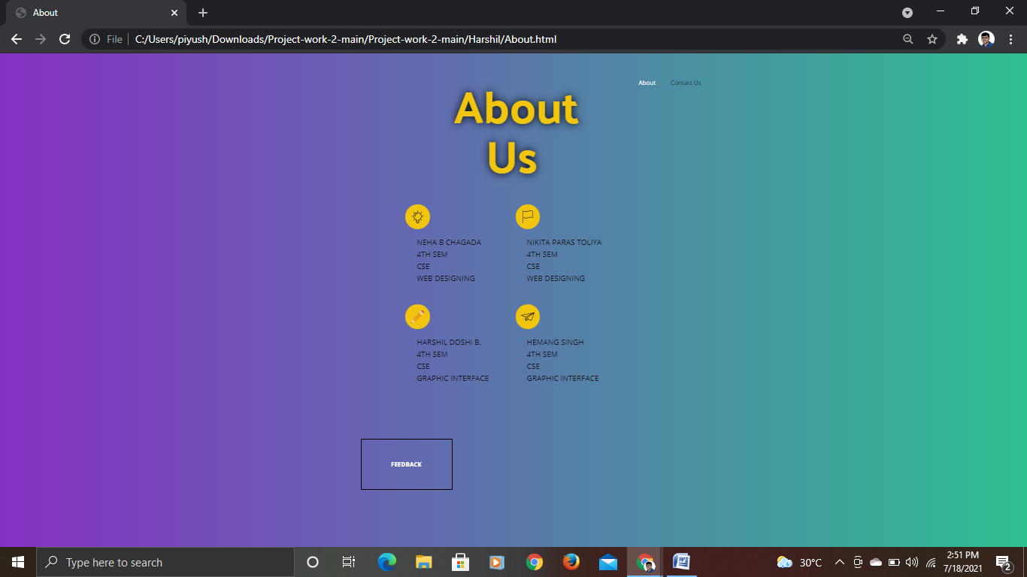

In this page it tells a little about our team members and the part that they have taken in creating the website. There is also feedback form button which on clicking takes us to the feedback page.

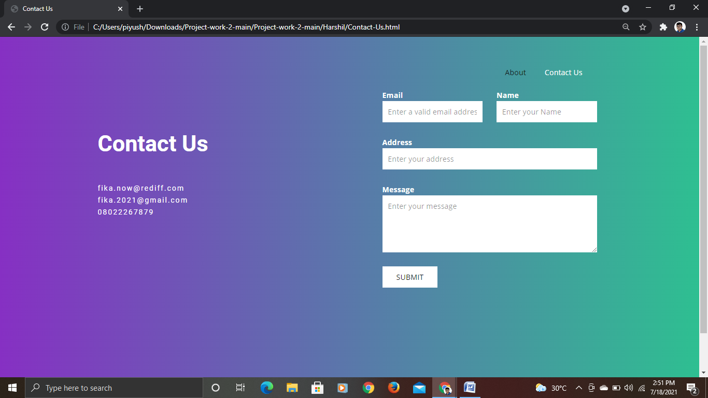

This is the contact us page. Here people who want to give suggestion can write their email id name and address and then the message or suggestion that they want to give us and click on submit. There is our contact number and our mail ids also.

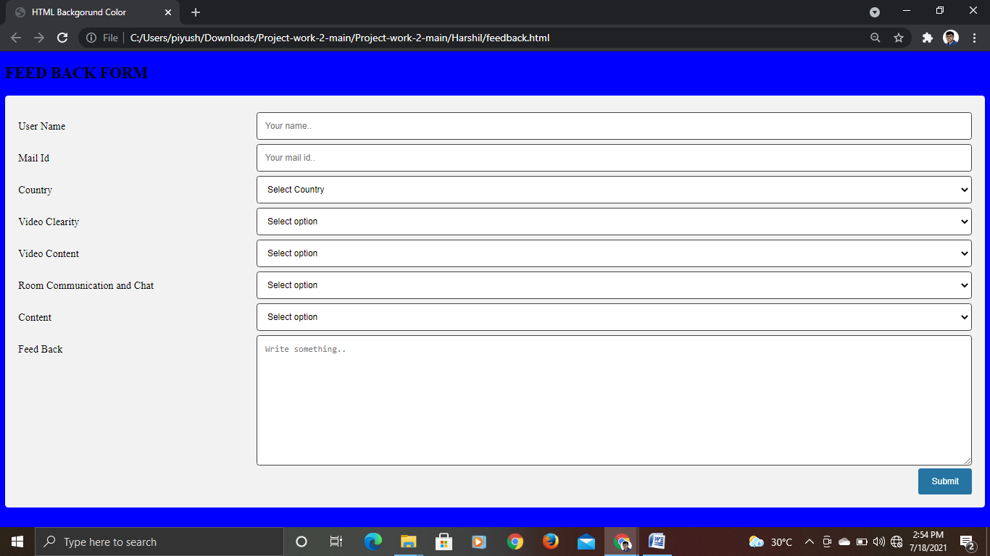

This is the feedback form that opens up clicking the feed back button on the about us page. Here we have username mail id country and the 4 types of queries which we had in our minds. They can give their feedback on the 4 topics and also can write in the general feedback of any movie which they want or anything that the users feel should be put up.