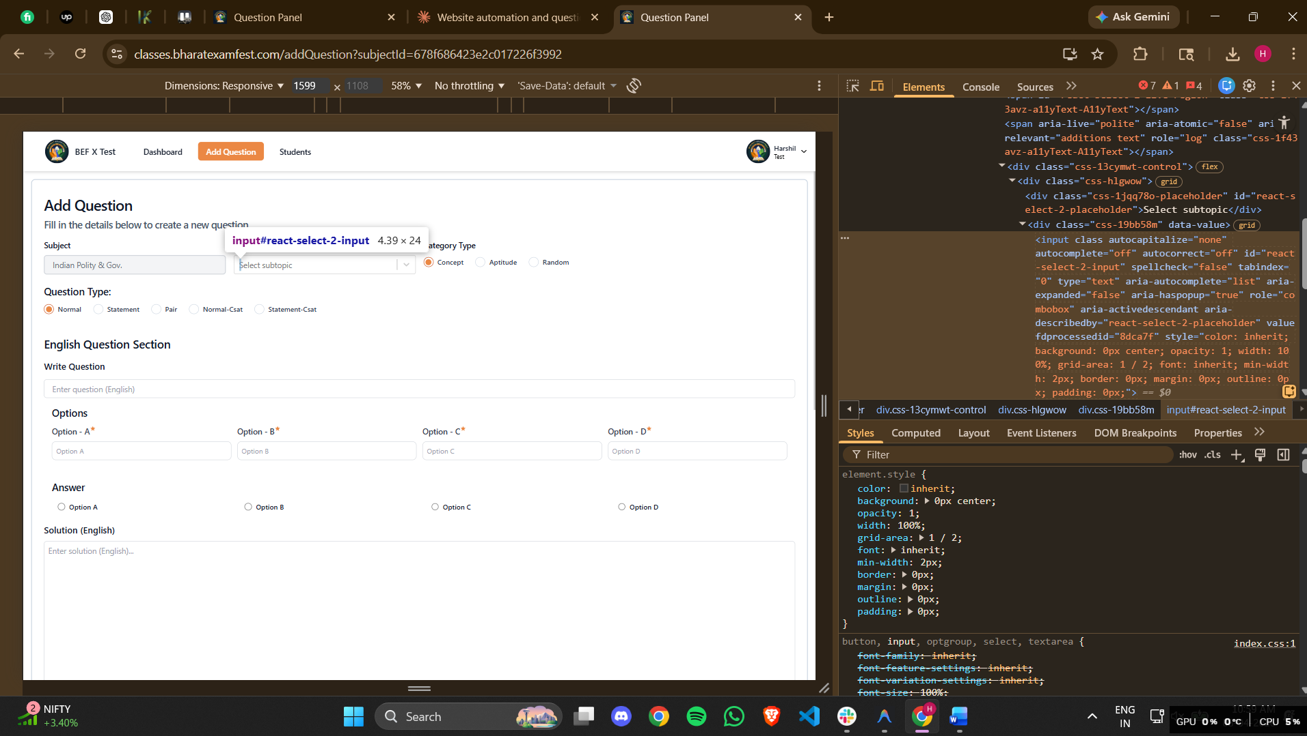
<input class="" autocapitalize="none" autocomplete="off" autocorrect="off" id="react-select-2-input" spellcheck="false" tabindex="0" type="text" aria-autocomplete="list" aria-expanded="false" aria-haspopup="true" role="combobox" aria-activedescendant="" aria-describedby="react-select-2-placeholder" value="" fdprocessedid="8dca7f" style="color: inherit; background: 0px center; opacity: 1; width: 100%; grid-area: 1 / 2; font: inherit; min-width: 2px; border: 0px; margin: 0px; outline: 0px; padding: 0px;">
first here the Subtopic has to be pasted which is given into the question data docs file.

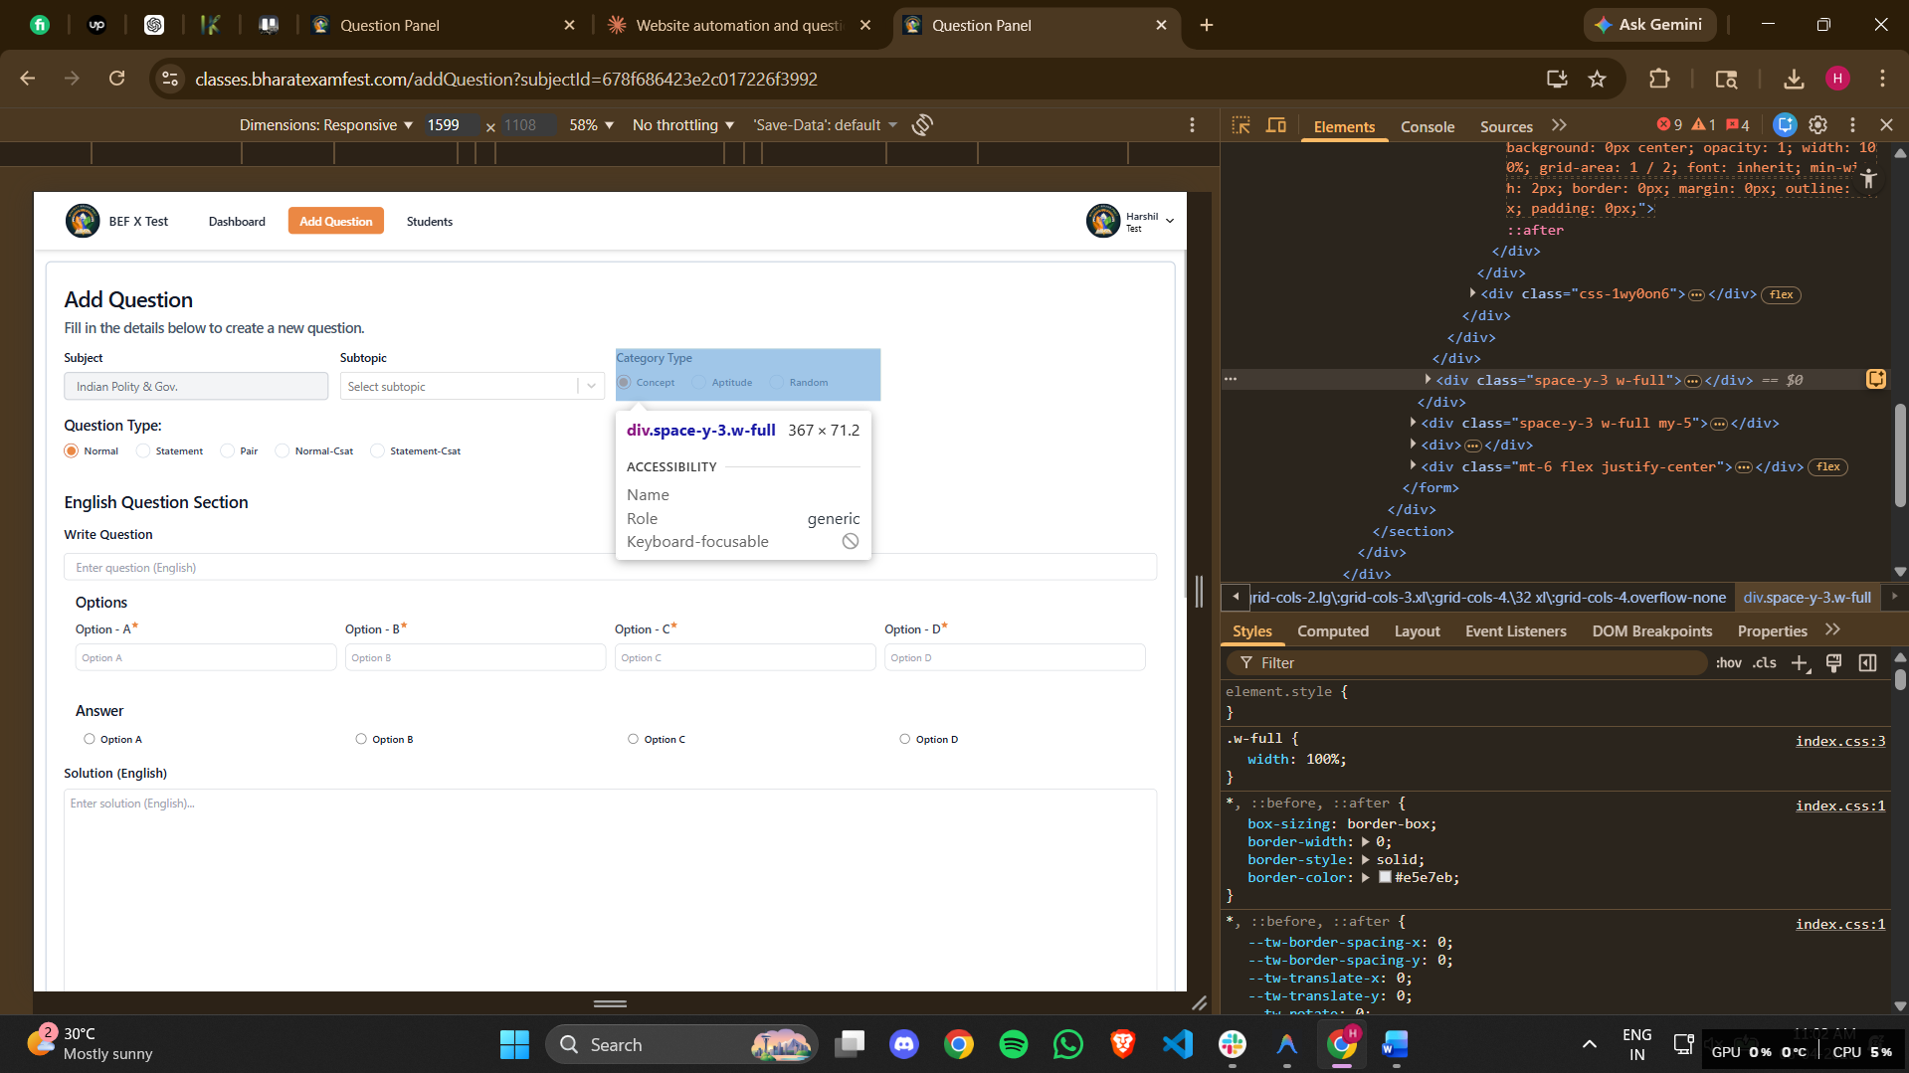
<div class="space-y-3 w-full"><label class="font-medium text-gray-900 text-start capitalize text-md">Category Type</label><div class="flex gap-6"><div class="inline-flex items-center"><label class="relative flex items-center cursor-pointer" for="concept"><input name="categoryType" type="radio" class="peer h-5 w-5 cursor-pointer appearance-none rounded-full border border-slate-300 checked:border-orange-700 transition-all bg-white" id="concept" value="concept" checked=""><span class="absolute bg-[#eb8844] w-3 h-3 rounded-full opacity-0 peer-checked:opacity-100 transition-opacity duration-200 top-1/2 left-1/2 transform -translate-x-1/2 -translate-y-1/2"></span></label><label class="ml-2 text-slate-700 cursor-pointer text-sm capitalize font-semibold" for="concept">concept</label></div><div class="inline-flex items-center"><label class="relative flex items-center cursor-pointer" for="aptitude"><input name="categoryType" type="radio" class="peer h-5 w-5 cursor-pointer appearance-none rounded-full border border-slate-300 checked:border-orange-700 transition-all bg-white" id="aptitude" value="aptitude"><span class="absolute bg-[#eb8844] w-3 h-3 rounded-full opacity-0 peer-checked:opacity-100 transition-opacity duration-200 top-1/2 left-1/2 transform -translate-x-1/2 -translate-y-1/2"></span></label><label class="ml-2 text-slate-700 cursor-pointer text-sm capitalize font-semibold" for="aptitude">aptitude</label></div><div class="inline-flex items-center"><label class="relative flex items-center cursor-pointer" for="random"><input name="categoryType" type="radio" class="peer h-5 w-5 cursor-pointer appearance-none rounded-full border border-slate-300 checked:border-orange-700 transition-all bg-white" id="random" value="random"><span class="absolute bg-[#eb8844] w-3 h-3 rounded-full opacity-0 peer-checked:opacity-100 transition-opacity duration-200 top-1/2 left-1/2 transform -translate-x-1/2 -translate-y-1/2"></span></label><label class="ml-2 text-slate-700 cursor-pointer text-sm capitalize font-semibold" for="random">random</label></div></div></div>
Then from this 3 radio button, one has to be selected according to the info given in the docs file.

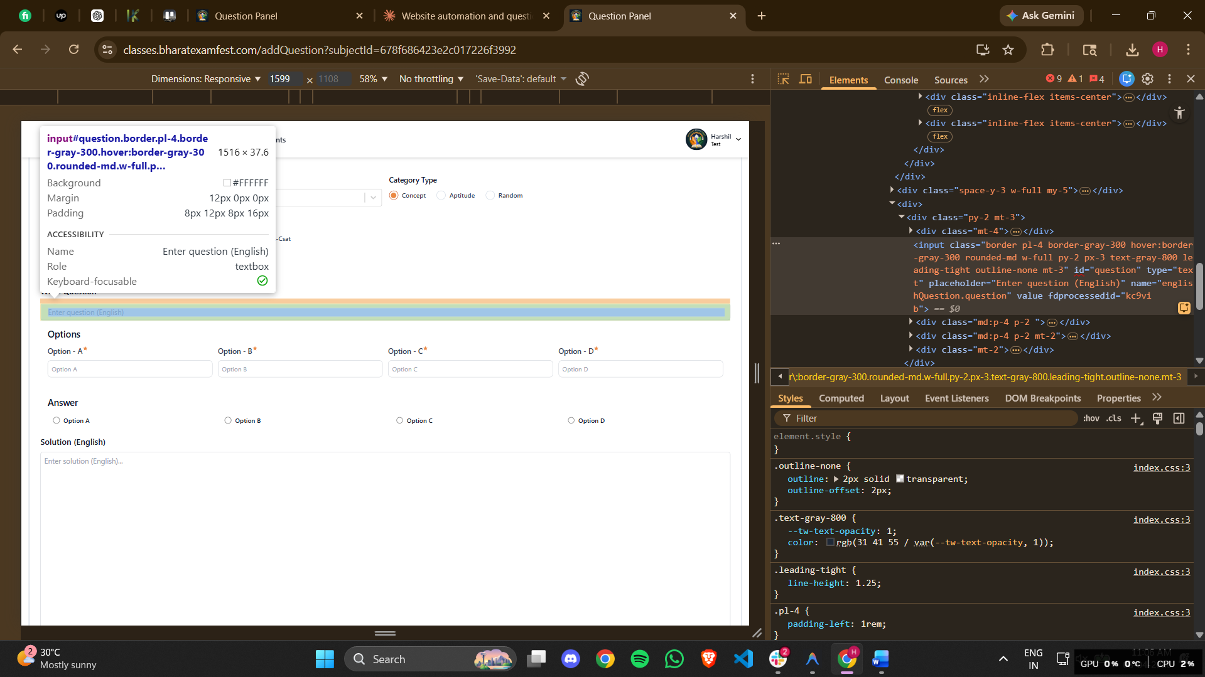
<input class="border pl-4 border-gray-300 hover:border-gray-300 rounded-md w-full py-2 px-3 text-gray-800 leading-tight outline-none mt-3" id="question" type="text" placeholder="Enter question (English)" name="englishQuestion.question" value="" fdprocessedid="kc9vib">
Question has to be added here
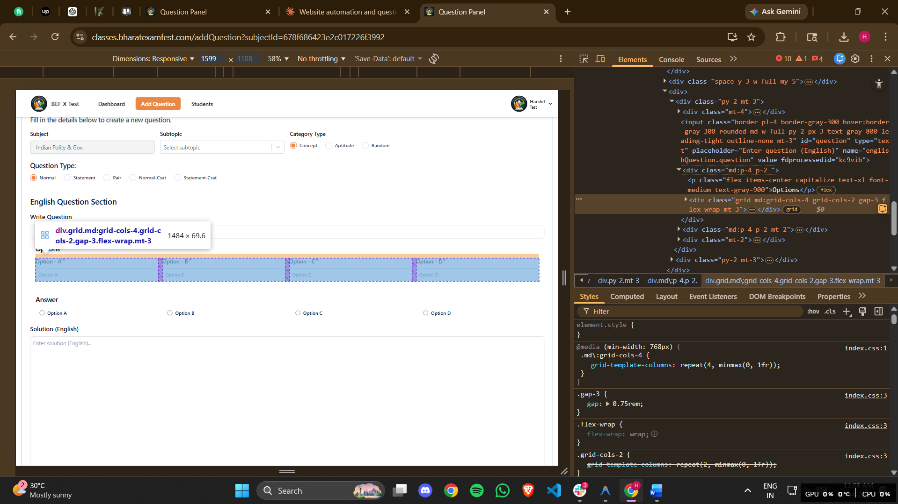
<div class="grid md:grid-cols-4 grid-cols-2 gap-3 flex-wrap mt-3"><div class="relative"><label class="flex mb-2 text-start capitalize text-base font-medium text-gray-700">Option - A<svg stroke="currentColor" fill="currentColor" stroke-width="0" viewBox="0 0 24 24" class="text-[#eb8844] h-3 w-3" height="1em" width="1em" xmlns="http://www.w3.org/2000/svg"><path fill="none" d="M0 0h24v24H0z"></path><path fill="none" d="M0 0h24v24H0z"></path><path d="M12 17.27 18.18 21l-1.64-7.03L22 9.24l-7.19-.61L12 2 9.19 8.63 2 9.24l5.46 4.73L5.82 21z"></path></svg></label><input type="text" name="englishQuestion.options.A" class="block w-full p-2 border rounded-lg bg-white placeholder-gray-400 text-gray-600 border-gray-300 text-sm outline-none" placeholder="Option A" value="" fdprocessedid="vqtmie"></div><div class="relative"><label class="flex mb-2 text-start capitalize text-base font-medium text-gray-700">Option - B<svg stroke="currentColor" fill="currentColor" stroke-width="0" viewBox="0 0 24 24" class="text-[#eb8844] h-3 w-3" height="1em" width="1em" xmlns="http://www.w3.org/2000/svg"><path fill="none" d="M0 0h24v24H0z"></path><path fill="none" d="M0 0h24v24H0z"></path><path d="M12 17.27 18.18 21l-1.64-7.03L22 9.24l-7.19-.61L12 2 9.19 8.63 2 9.24l5.46 4.73L5.82 21z"></path></svg></label><input type="text" name="englishQuestion.options.B" class="block w-full p-2 border rounded-lg bg-white placeholder-gray-400 text-gray-600 border-gray-300 text-sm outline-none" placeholder="Option B" value="" fdprocessedid="ytrykf"></div><div class="relative"><label class="flex mb-2 text-start capitalize text-base font-medium text-gray-700">Option - C<svg stroke="currentColor" fill="currentColor" stroke-width="0" viewBox="0 0 24 24" class="text-[#eb8844] h-3 w-3" height="1em" width="1em" xmlns="http://www.w3.org/2000/svg"><path fill="none" d="M0 0h24v24H0z"></path><path fill="none" d="M0 0h24v24H0z"></path><path d="M12 17.27 18.18 21l-1.64-7.03L22 9.24l-7.19-.61L12 2 9.19 8.63 2 9.24l5.46 4.73L5.82 21z"></path></svg></label><input type="text" name="englishQuestion.options.C" class="block w-full p-2 border rounded-lg bg-white placeholder-gray-400 text-gray-600 border-gray-300 text-sm outline-none" placeholder="Option C" value="" fdprocessedid="tlx4t"></div><div class="relative"><label class="flex mb-2 text-start capitalize text-base font-medium text-gray-700">Option - D<svg stroke="currentColor" fill="currentColor" stroke-width="0" viewBox="0 0 24 24" class="text-[#eb8844] h-3 w-3" height="1em" width="1em" xmlns="http://www.w3.org/2000/svg"><path fill="none" d="M0 0h24v24H0z"></path><path fill="none" d="M0 0h24v24H0z"></path><path d="M12 17.27 18.18 21l-1.64-7.03L22 9.24l-7.19-.61L12 2 9.19 8.63 2 9.24l5.46 4.73L5.82 21z"></path></svg></label><input type="text" name="englishQuestion.options.D" class="block w-full p-2 border rounded-lg bg-white placeholder-gray-400 text-gray-600 border-gray-300 text-sm outline-none" placeholder="Option D" value="" fdprocessedid="u9aqtg"></div></div>
4 options of the questions has to be pasted into this four boxes accordingly.
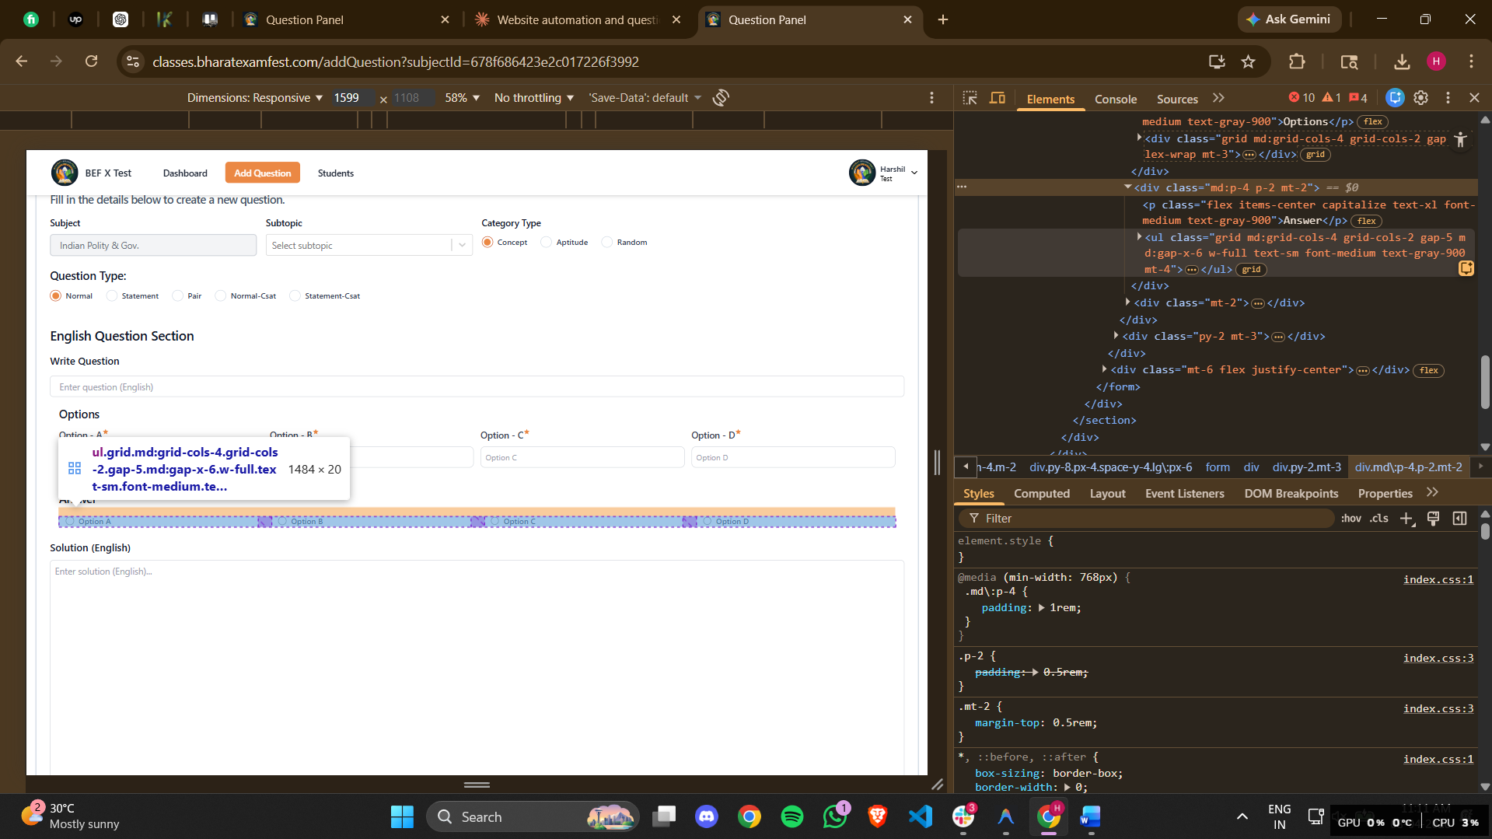
<ul class="grid md:grid-cols-4 grid-cols-2 gap-5 md:gap-x-6 w-full text-sm font-medium text-gray-900 mt-4"><li><div class="flex items-center ps-3"><input id="radioA" type="radio" name="englishQuestion.answer" class="w-4 h-4 text-blue-600 border-gray-300 checked:bg-blue-600 checked:outline-none" value="A"><label for="radioA" class="w-full ms-2 text-sm font-medium text-gray-900 line-clamp-1">Option A</label></div></li><li><div class="flex items-center ps-3"><input id="radioB" type="radio" name="englishQuestion.answer" class="w-4 h-4 text-blue-600 border-gray-300 checked:bg-blue-600 checked:outline-none" value="B"><label for="radioB" class="w-full ms-2 text-sm font-medium text-gray-900 line-clamp-1">Option B</label></div></li><li><div class="flex items-center ps-3"><input id="radioC" type="radio" name="englishQuestion.answer" class="w-4 h-4 text-blue-600 border-gray-300 checked:bg-blue-600 checked:outline-none" value="C"><label for="radioC" class="w-full ms-2 text-sm font-medium text-gray-900 line-clamp-1">Option C</label></div></li><li><div class="flex items-center ps-3"><input id="radioD" type="radio" name="englishQuestion.answer" class="w-4 h-4 text-blue-600 border-gray-300 checked:bg-blue-600 checked:outline-none" value="D"><label for="radioD" class="w-full ms-2 text-sm font-medium text-gray-900 line-clamp-1">Option D</label></div></li></ul>
Then select the right answer from this 4 option.
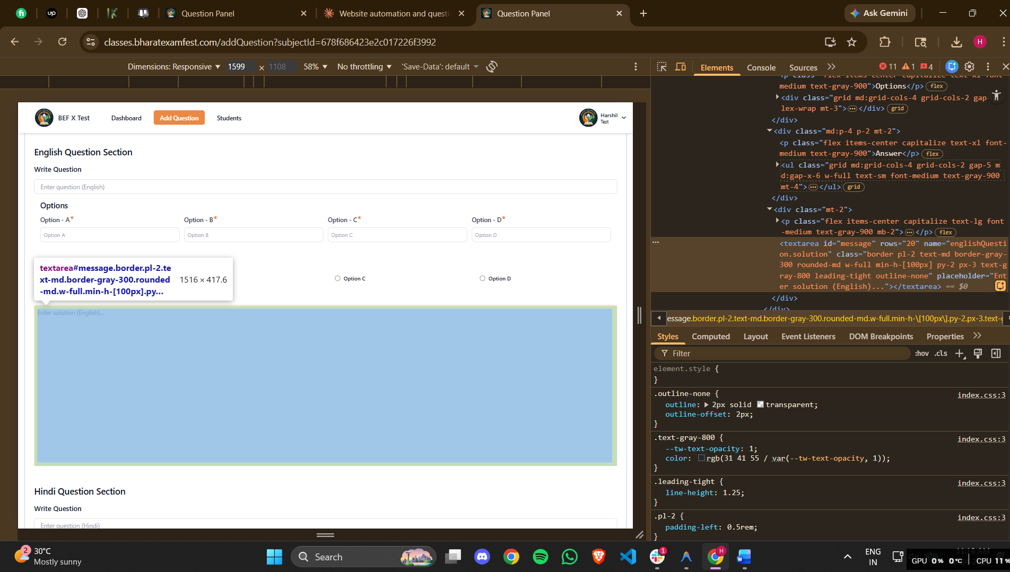
<textarea id="message" rows="20" name="englishQuestion.solution" class="border pl-2 text-md border-gray-300 rounded-md w-full min-h-[100px] py-2 px-3 text-gray-800 leading-tight outline-none" placeholder="Enter solution (English)..."></textarea>
And entre the reason for the right answer here.

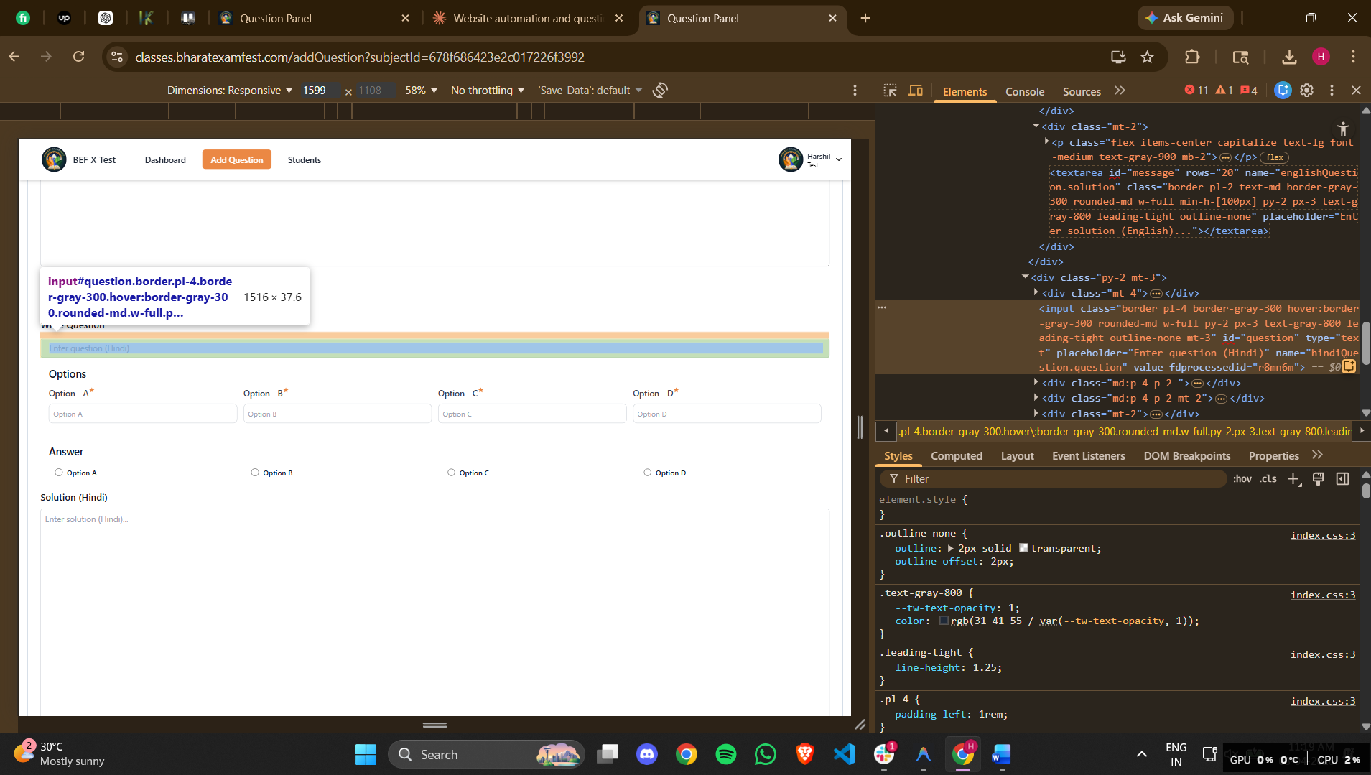
<input class="border pl-4 border-gray-300 hover:border-gray-300 rounded-md w-full py-2 px-3 text-gray-800 leading-tight outline-none mt-3" id="question" type="text" placeholder="Enter question (Hindi)" name="hindiQuestion.question" value="" fdprocessedid="r8mn6m">

Then entre the same question in hindi here.
The process for the hindi question submission is same as the English question submission.
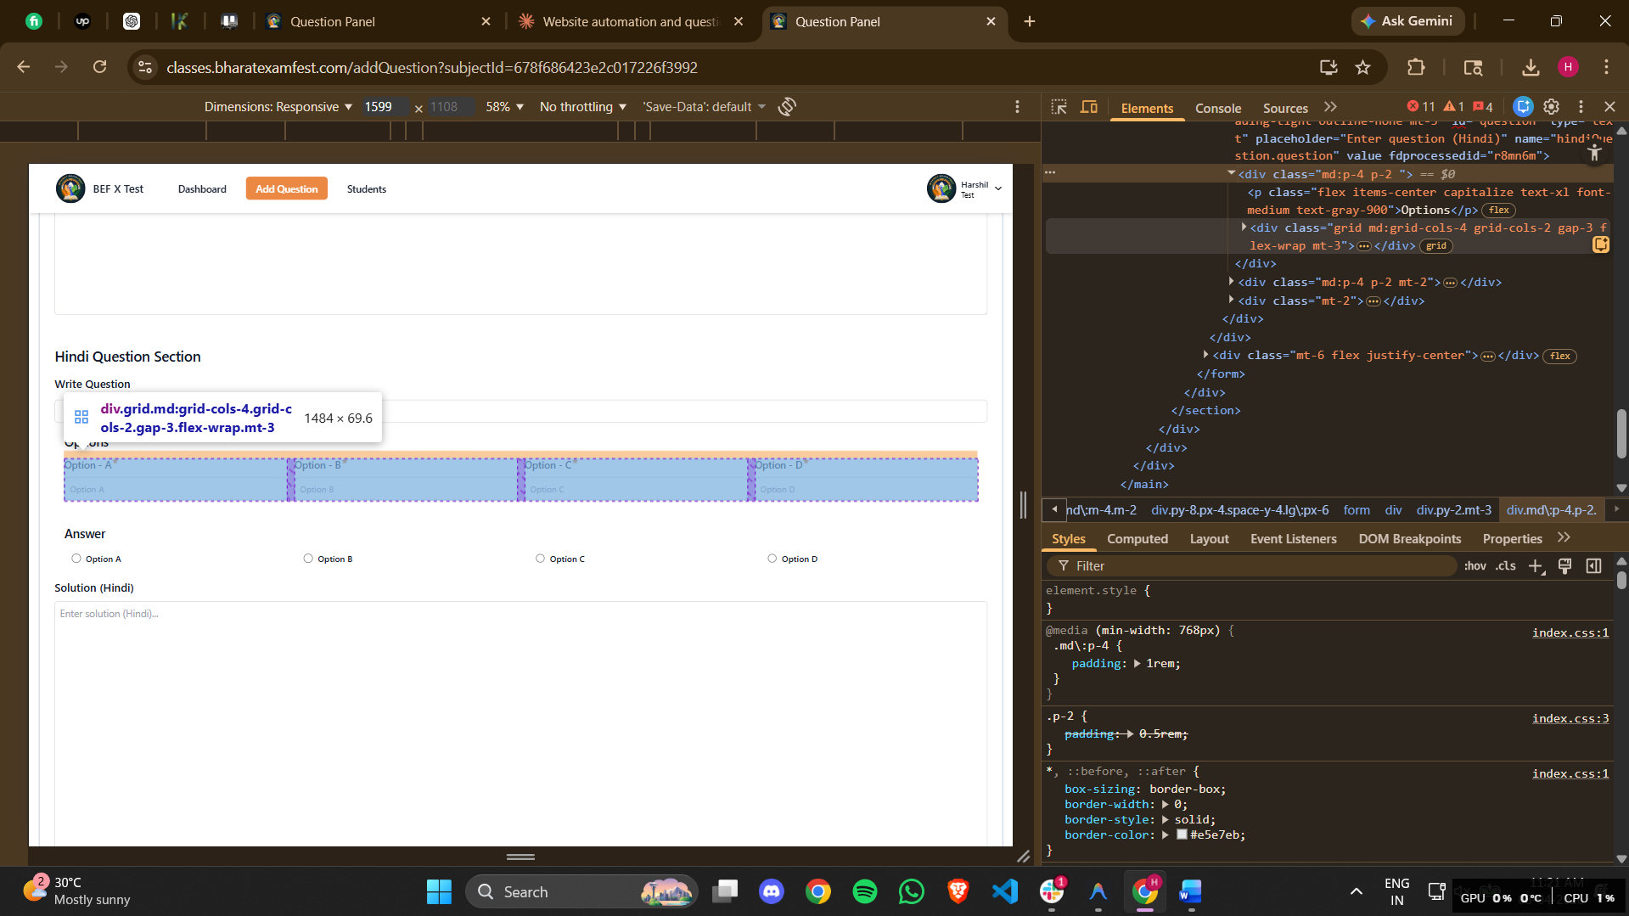
<div class="grid md:grid-cols-4 grid-cols-2 gap-3 flex-wrap mt-3"><div class="relative"><label class="flex mb-2 text-start capitalize text-base font-medium text-gray-700">Option - A<svg stroke="currentColor" fill="currentColor" stroke-width="0" viewBox="0 0 24 24" class="text-[#eb8844] h-3 w-3" height="1em" width="1em" xmlns="http://www.w3.org/2000/svg"><path fill="none" d="M0 0h24v24H0z"></path><path fill="none" d="M0 0h24v24H0z"></path><path d="M12 17.27 18.18 21l-1.64-7.03L22 9.24l-7.19-.61L12 2 9.19 8.63 2 9.24l5.46 4.73L5.82 21z"></path></svg></label><input type="text" name="hindiQuestion.options.A" class="block w-full p-2 border rounded-lg bg-white placeholder-gray-400 text-gray-600 border-gray-300 text-sm outline-none" placeholder="Option A" value="" fdprocessedid="0zbgi"></div><div class="relative"><label class="flex mb-2 text-start capitalize text-base font-medium text-gray-700">Option - B<svg stroke="currentColor" fill="currentColor" stroke-width="0" viewBox="0 0 24 24" class="text-[#eb8844] h-3 w-3" height="1em" width="1em" xmlns="http://www.w3.org/2000/svg"><path fill="none" d="M0 0h24v24H0z"></path><path fill="none" d="M0 0h24v24H0z"></path><path d="M12 17.27 18.18 21l-1.64-7.03L22 9.24l-7.19-.61L12 2 9.19 8.63 2 9.24l5.46 4.73L5.82 21z"></path></svg></label><input type="text" name="hindiQuestion.options.B" class="block w-full p-2 border rounded-lg bg-white placeholder-gray-400 text-gray-600 border-gray-300 text-sm outline-none" placeholder="Option B" value="" fdprocessedid="amixua"></div><div class="relative"><label class="flex mb-2 text-start capitalize text-base font-medium text-gray-700">Option - C<svg stroke="currentColor" fill="currentColor" stroke-width="0" viewBox="0 0 24 24" class="text-[#eb8844] h-3 w-3" height="1em" width="1em" xmlns="http://www.w3.org/2000/svg"><path fill="none" d="M0 0h24v24H0z"></path><path fill="none" d="M0 0h24v24H0z"></path><path d="M12 17.27 18.18 21l-1.64-7.03L22 9.24l-7.19-.61L12 2 9.19 8.63 2 9.24l5.46 4.73L5.82 21z"></path></svg></label><input type="text" name="hindiQuestion.options.C" class="block w-full p-2 border rounded-lg bg-white placeholder-gray-400 text-gray-600 border-gray-300 text-sm outline-none" placeholder="Option C" value="" fdprocessedid="ocah7"></div><div class="relative"><label class="flex mb-2 text-start capitalize text-base font-medium text-gray-700">Option - D<svg stroke="currentColor" fill="currentColor" stroke-width="0" viewBox="0 0 24 24" class="text-[#eb8844] h-3 w-3" height="1em" width="1em" xmlns="http://www.w3.org/2000/svg"><path fill="none" d="M0 0h24v24H0z"></path><path fill="none" d="M0 0h24v24H0z"></path><path d="M12 17.27 18.18 21l-1.64-7.03L22 9.24l-7.19-.61L12 2 9.19 8.63 2 9.24l5.46 4.73L5.82 21z"></path></svg></label><input type="text" name="hindiQuestion.options.D" class="block w-full p-2 border rounded-lg bg-white placeholder-gray-400 text-gray-600 border-gray-300 text-sm outline-none" placeholder="Option D" value="" fdprocessedid="18yqk4"></div></div>
And then add the options of the question here.
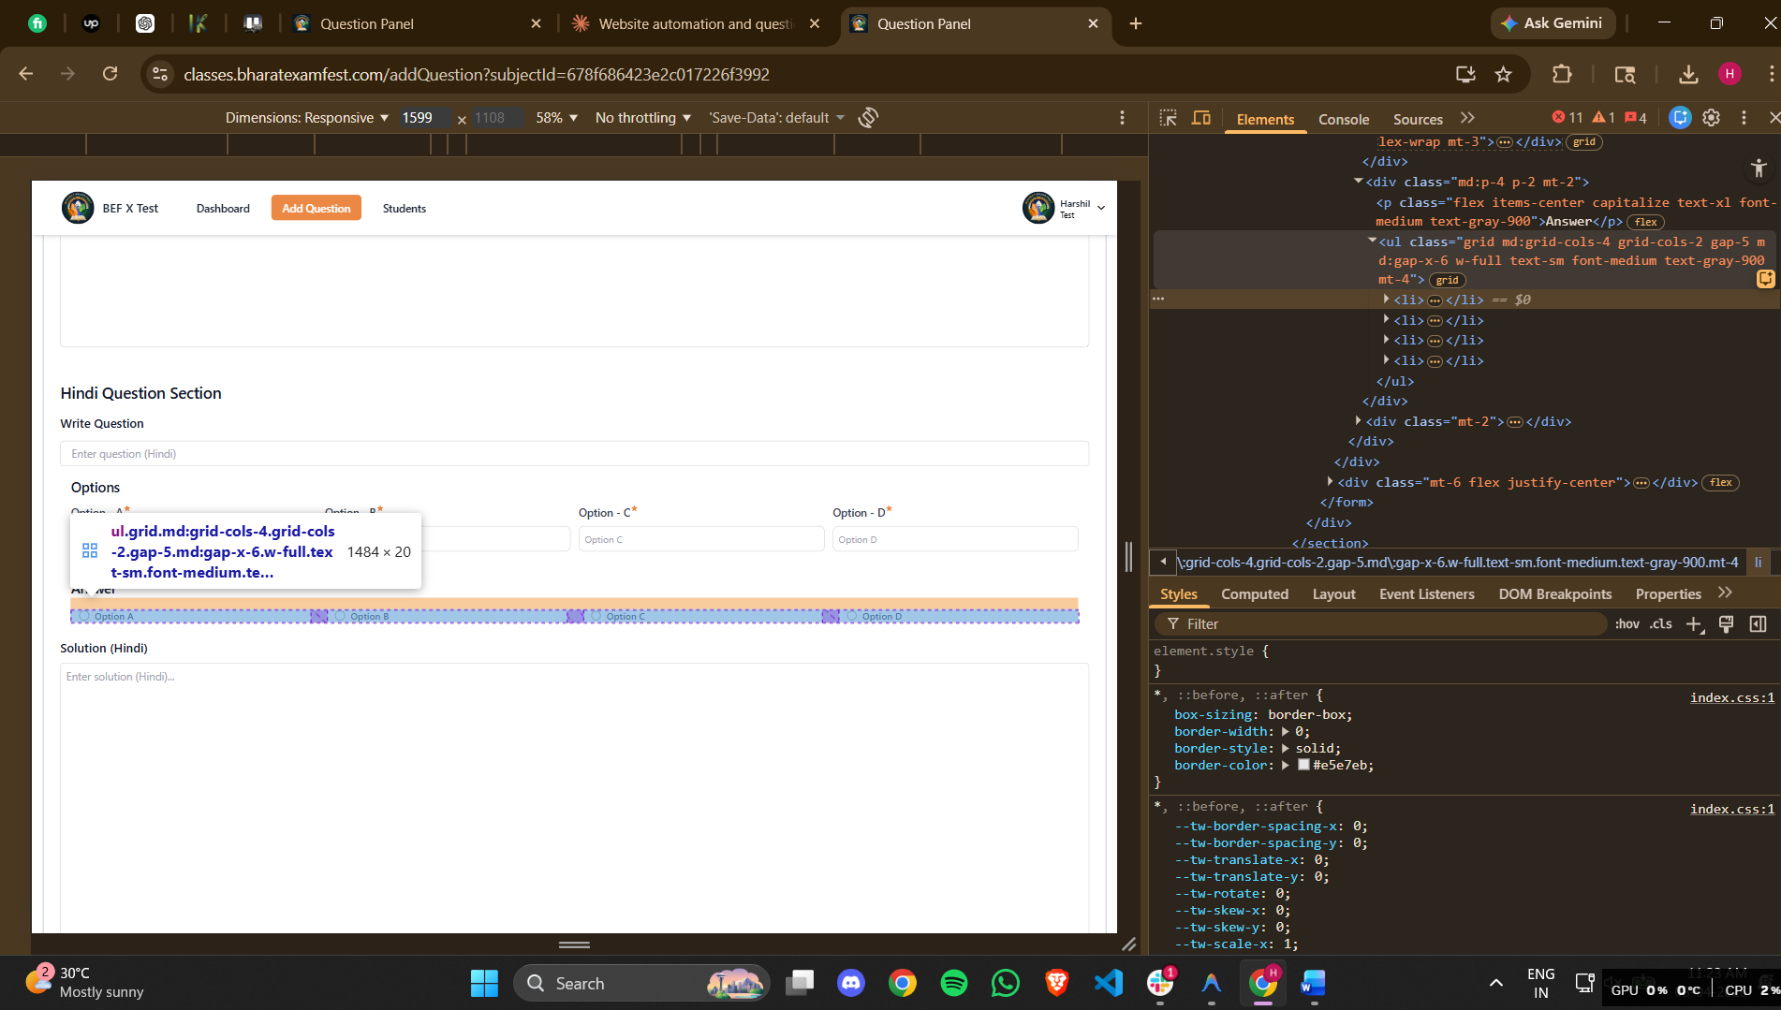
<ul class="grid md:grid-cols-4 grid-cols-2 gap-5 md:gap-x-6 w-full text-sm font-medium text-gray-900 mt-4"><li><div class="flex items-center ps-3"><input id="radioA" type="radio" name="hindiQuestion.answer" class="w-4 h-4 text-blue-600 border-gray-300 checked:bg-blue-600 checked:outline-none" value="A"><label for="radioA" class="w-full ms-2 text-sm font-medium text-gray-900 line-clamp-1">Option A</label></div></li><li><div class="flex items-center ps-3"><input id="radioB" type="radio" name="hindiQuestion.answer" class="w-4 h-4 text-blue-600 border-gray-300 checked:bg-blue-600 checked:outline-none" value="B"><label for="radioB" class="w-full ms-2 text-sm font-medium text-gray-900 line-clamp-1">Option B</label></div></li><li><div class="flex items-center ps-3"><input id="radioC" type="radio" name="hindiQuestion.answer" class="w-4 h-4 text-blue-600 border-gray-300 checked:bg-blue-600 checked:outline-none" value="C"><label for="radioC" class="w-full ms-2 text-sm font-medium text-gray-900 line-clamp-1">Option C</label></div></li><li><div class="flex items-center ps-3"><input id="radioD" type="radio" name="hindiQuestion.answer" class="w-4 h-4 text-blue-600 border-gray-300 checked:bg-blue-600 checked:outline-none" value="D"><label for="radioD" class="w-full ms-2 text-sm font-medium text-gray-900 line-clamp-1">Option D</label></div></li></ul>
Then click the right option from here keep in mind that this answer will be same as the English answer of the same question that has been filled before in this same page.
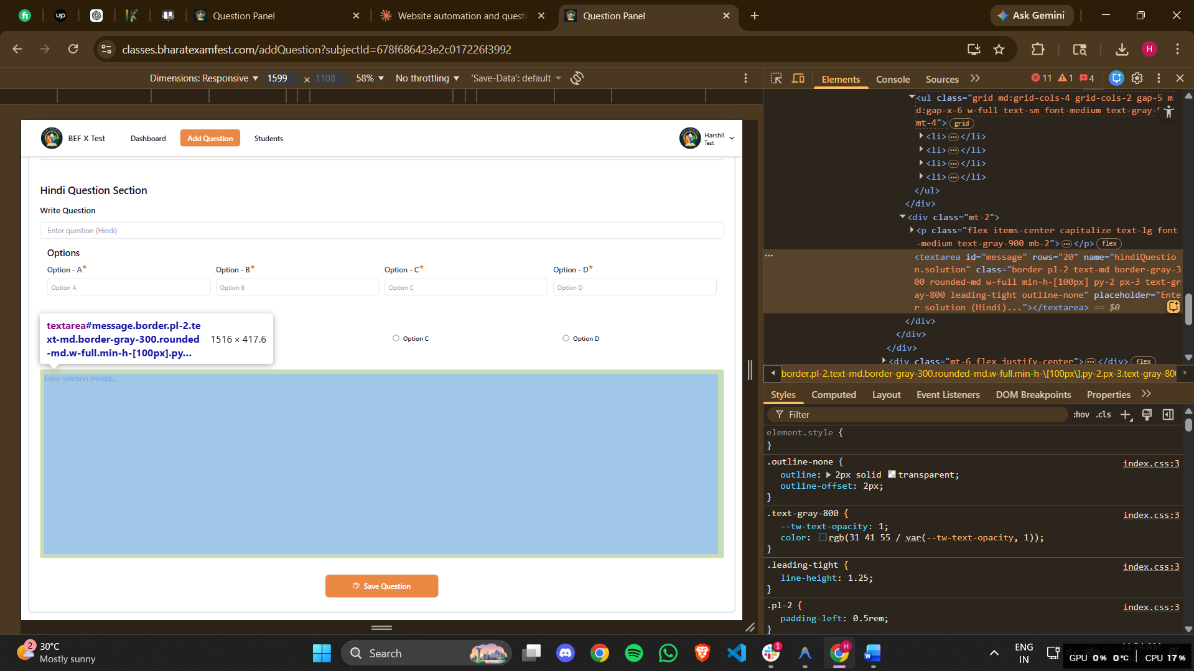
<textarea id="message" rows="20" name="hindiQuestion.solution" class="border pl-2 text-md border-gray-300 rounded-md w-full min-h-[100px] py-2 px-3 text-gray-800 leading-tight outline-none" placeholder="Enter solution (Hindi)..."></textarea>
And the explaination for the answer in hindi will be pasted in here from the docs.

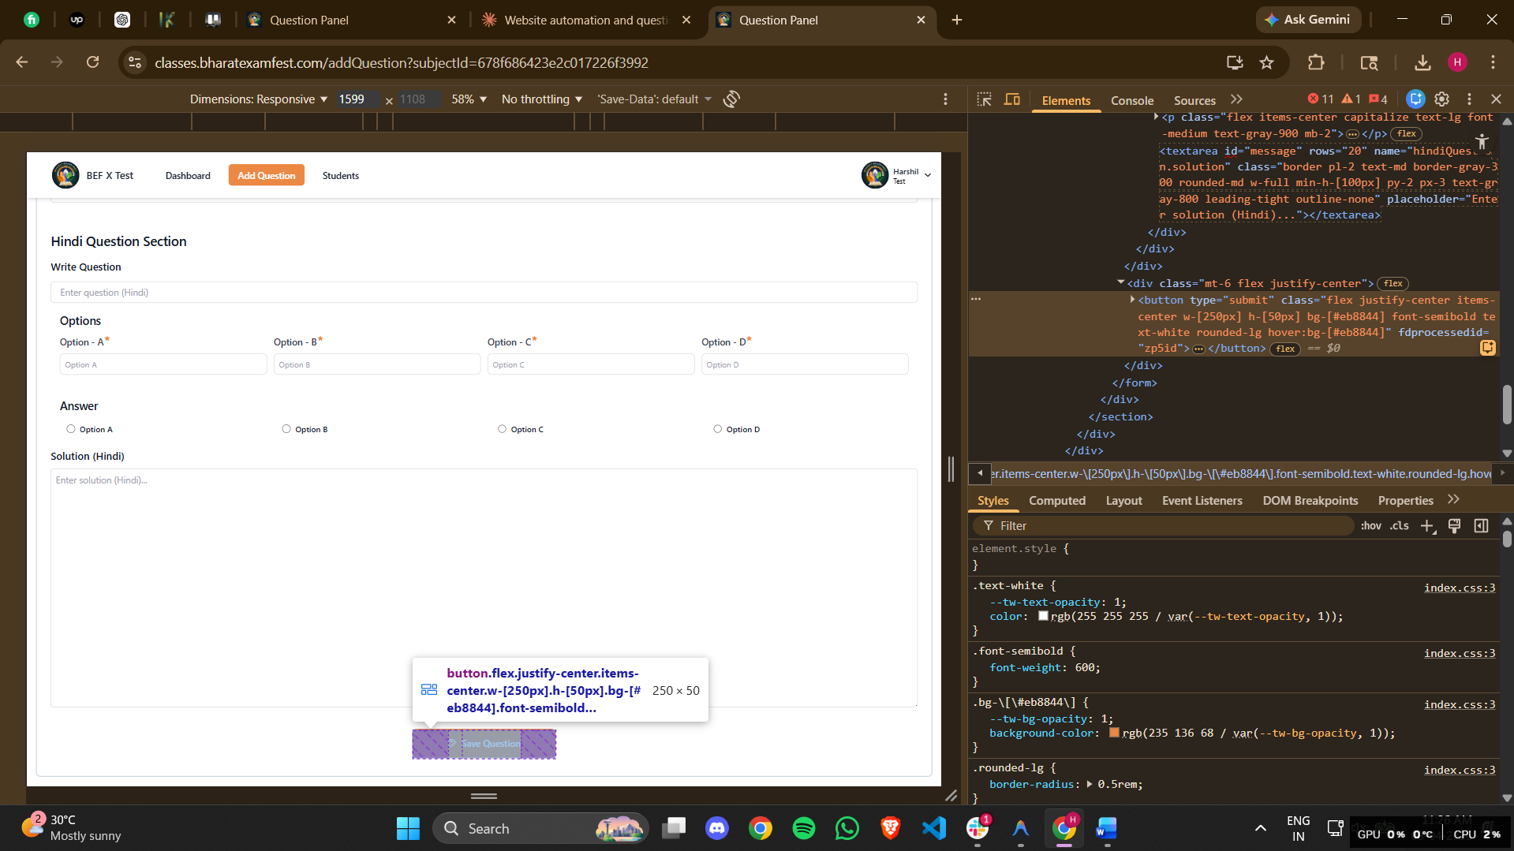
<button type="submit" class="flex justify-center items-center w-[250px] h-[50px] bg-[#eb8844] font-semibold text-white rounded-lg hover:bg-[#eb8844]" fdprocessedid="zp5id"><svg stroke="currentColor" fill="currentColor" stroke-width="0" viewBox="0 0 16 16" class="mr-2" height="1em" width="1em" xmlns="http://www.w3.org/2000/svg"><path fill-rule="evenodd" clip-rule="evenodd" d="M11.04 1.33L12.71 3l.29.71v.33h-.5l-.5.5v-.83l-1.67-1.67H10v4H4v-4H2v10h3l-.5 1H2l-1-1v-10l1-1h8.33l.71.29zM7 5h2V2H7v3zm6.5 0L15 6.5l-.02.69-5.5 5.5-.13.12-.37.37-.1.09-3 1.5-.67-.67 1.5-3 .09-.1.37-.37.12-.13 5.5-5.5h.71zm-6.22 7.24l-.52 1 1.04-.48-.52-.52zm.69-1.03l.79.79 5.15-5.15-.79-.79-5.15 5.15z"></path></svg>Save Question</button>
Then this save button has to be pressed

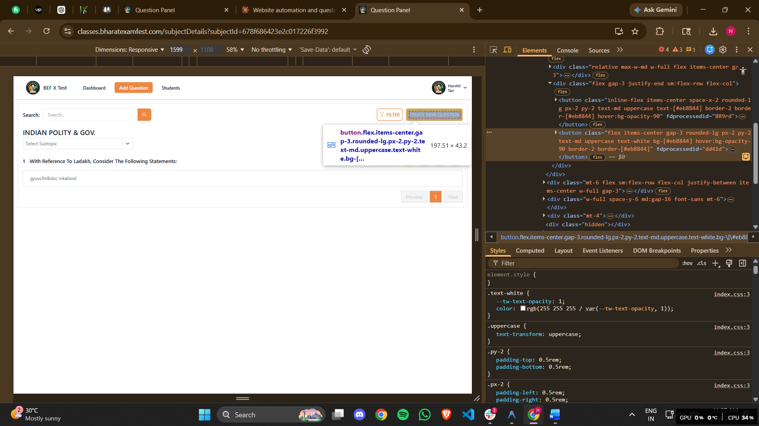
<button class="flex items-center gap-3 rounded-lg px-2 py-2 text-md uppercase text-white bg-[#eb8844] hover:bg-opacity-90 border-2 border-[#eb8844]" fdprocessedid="dd41d"><p class="font-semibold">Create New Question</p></button>
Then this button has to be pressed to go back to the page to create another question.

====================================================================================================================================================================
This process has to be done for the questions in the docs. There will be 1 question per page in the input question docs file. Keep that in mind.

