Now I want to add the functionality of automating the Normal-Csat type of questions too.
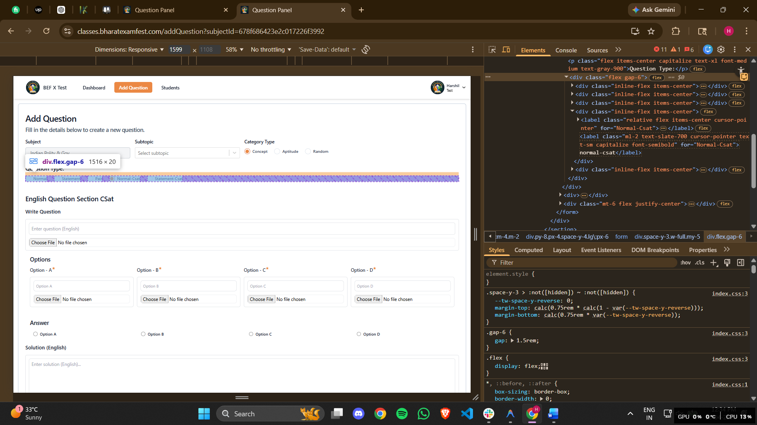
In the Normal-Csat automating this Norml-Csat button has to be clicked.
<div class="inline-flex items-center"><label class="relative flex items-center cursor-pointer" for="Normal-Csat"><input name="questionType" type="radio" class="peer h-5 w-5 cursor-pointer appearance-none rounded-full border border-slate-300 checked:border-orange-700 transition-all bg-white" id="Normal-Csat" value="normal-csat"><span class="absolute bg-[#eb8844] w-3 h-3 rounded-full opacity-0 peer-checked:opacity-100 transition-opacity duration-200 top-1/2 left-1/2 transform -translate-x-1/2 -translate-y-1/2"></span></label><label class="ml-2 text-slate-700 cursor-pointer text-sm capitalize font-semibold" for="Normal-Csat">normal-csat</label></div>
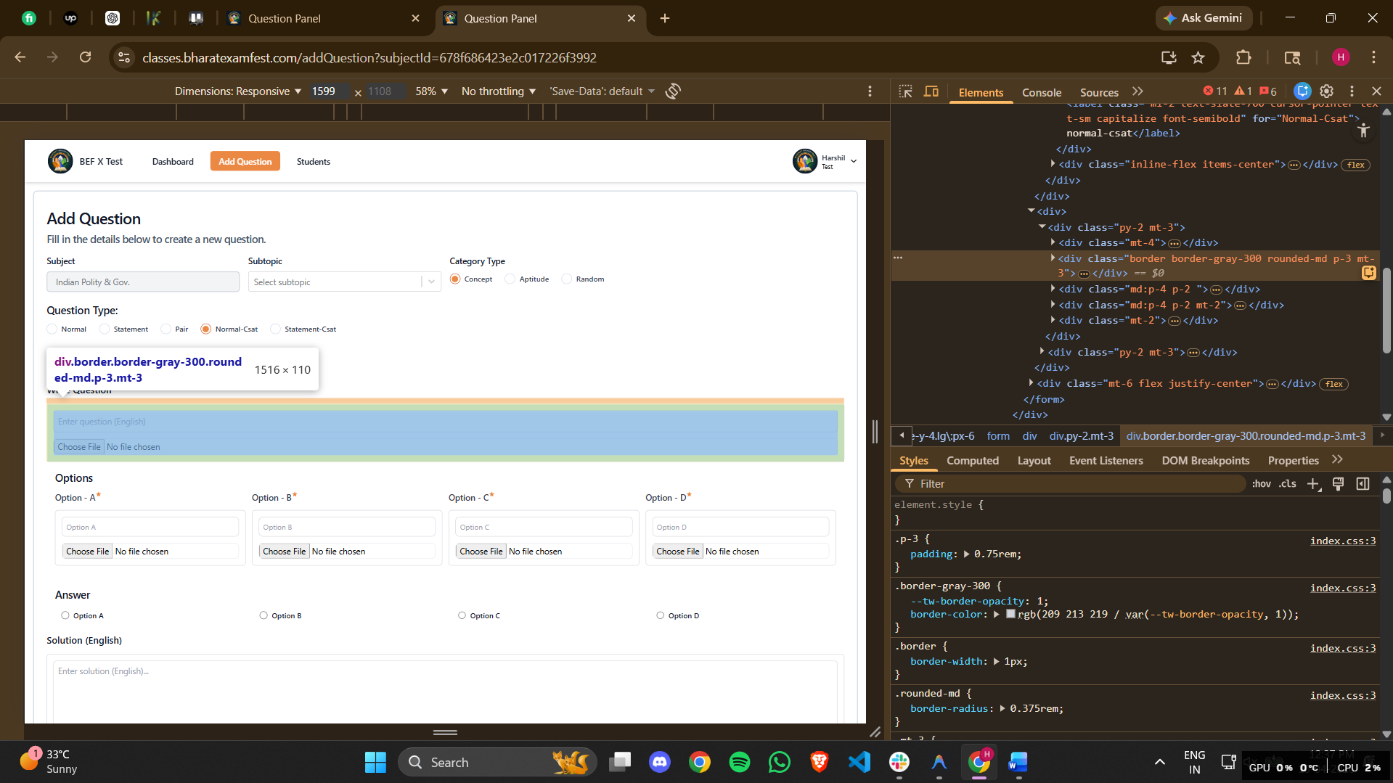
If only text or only image is present in the docs then only one of them has to be pasted if both are present then both should be pasted into the bowes.here is the outerHTML file for that.
<div class="border border-gray-300 rounded-md p-3 mt-3"><input class="border border-gray-300 rounded-md w-full p-2" type="text" name="englishQuestion.question" placeholder="Enter question (English)" value="" fdprocessedid="fo0pts"><div class="mt-3"><input type="file" accept="image/*" class="block border w-full rounded-lg"></div></div>

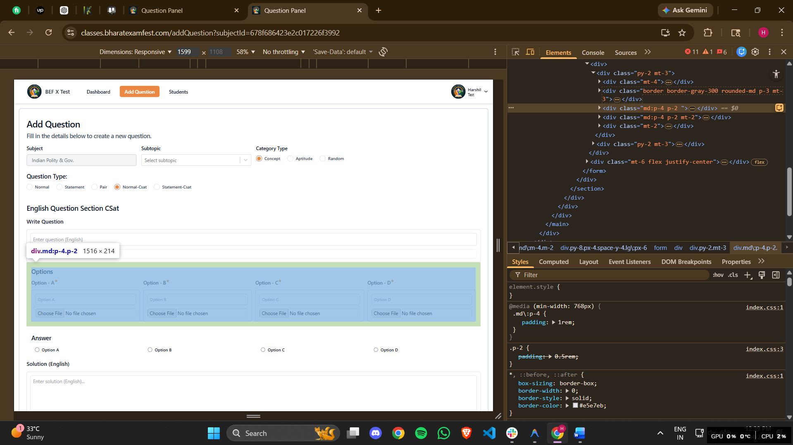
As per the question the options should also paste both image and text if present then both has to be pasted and if the only one of them is present then only one should be pasted into the box.here is the outerHTML file for that.
For option A: <div class="border border-gray-300 rounded-md p-3 mt-3"><input type="text" name="englishQuestion.options.A" class="block w-full p-2 border rounded-lg bg-white placeholder-gray-400 text-gray-600 border-gray-300 text-sm outline-none" placeholder="Option A" value="" fdprocessedid="mjyge6"><div class="mt-3"><input type="file" accept="image/*" class="block border w-full rounded-lg"></div></div>
For option B: <div class="border border-gray-300 rounded-md p-3 mt-3"><input type="text" name="englishQuestion.options.B" class="block w-full p-2 border rounded-lg bg-white placeholder-gray-400 text-gray-600 border-gray-300 text-sm outline-none" placeholder="Option B" value="" fdprocessedid="wfslvp"><div class="mt-3"><input type="file" accept="image/*" class="block border w-full rounded-lg"></div></div>

For option C: <div class="border border-gray-300 rounded-md p-3 mt-3"><input type="text" name="englishQuestion.options.C" class="block w-full p-2 border rounded-lg bg-white placeholder-gray-400 text-gray-600 border-gray-300 text-sm outline-none" placeholder="Option C" value="" fdprocessedid="p94his"><div class="mt-3"><input type="file" accept="image/*" class="block border w-full rounded-lg"></div></div>
For option D: <div class="border border-gray-300 rounded-md p-3 mt-3"><input type="text" name="englishQuestion.options.D" class="block w-full p-2 border rounded-lg bg-white placeholder-gray-400 text-gray-600 border-gray-300 text-sm outline-none" placeholder="Option D" value="" fdprocessedid="k4r4pa"><div class="mt-3"><input type="file" accept="image/*" class="block border w-full rounded-lg"></div></div>
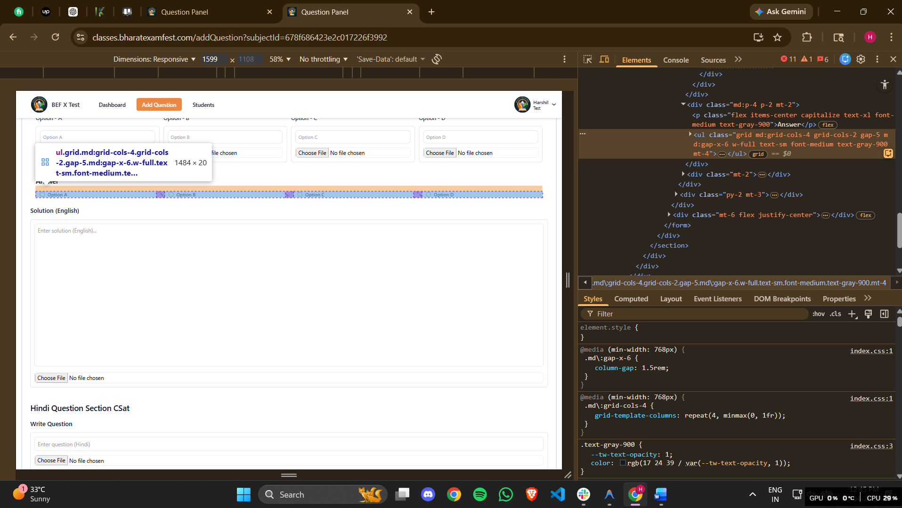
Right answer should be selected from here.
<ul class="grid md:grid-cols-4 grid-cols-2 gap-5 md:gap-x-6 w-full text-sm font-medium text-gray-900 mt-4"><li><div class="flex items-center ps-3"><input id="radioA" type="radio" name="englishQuestion.answer" class="w-4 h-4 text-blue-600 border-gray-300 checked:bg-blue-600 checked:outline-none" value="A"><label for="radioA" class="w-full ms-2 text-sm font-medium text-gray-900 line-clamp-1">Option A</label></div></li><li><div class="flex items-center ps-3"><input id="radioB" type="radio" name="englishQuestion.answer" class="w-4 h-4 text-blue-600 border-gray-300 checked:bg-blue-600 checked:outline-none" value="B"><label for="radioB" class="w-full ms-2 text-sm font-medium text-gray-900 line-clamp-1">Option B</label></div></li><li><div class="flex items-center ps-3"><input id="radioC" type="radio" name="englishQuestion.answer" class="w-4 h-4 text-blue-600 border-gray-300 checked:bg-blue-600 checked:outline-none" value="C"><label for="radioC" class="w-full ms-2 text-sm font-medium text-gray-900 line-clamp-1">Option C</label></div></li><li><div class="flex items-center ps-3"><input id="radioD" type="radio" name="englishQuestion.answer" class="w-4 h-4 text-blue-600 border-gray-300 checked:bg-blue-600 checked:outline-none" value="D"><label for="radioD" class="w-full ms-2 text-sm font-medium text-gray-900 line-clamp-1">Option D</label></div></li></ul>
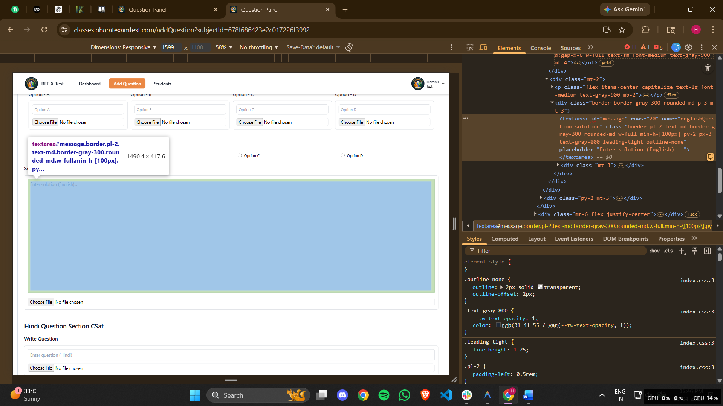
Put text or image of the question here.and put both if both are present.

For text solution: <textarea id="message" rows="20" name="englishQuestion.solution" class="border pl-2 text-md border-gray-300 rounded-md w-full min-h-[100px] py-2 px-3 text-gray-800 leading-tight outline-none" placeholder="Enter solution (English)..."></textarea>
For image solution : <input type="file" accept="image/*" class="block border w-full rounded-lg">
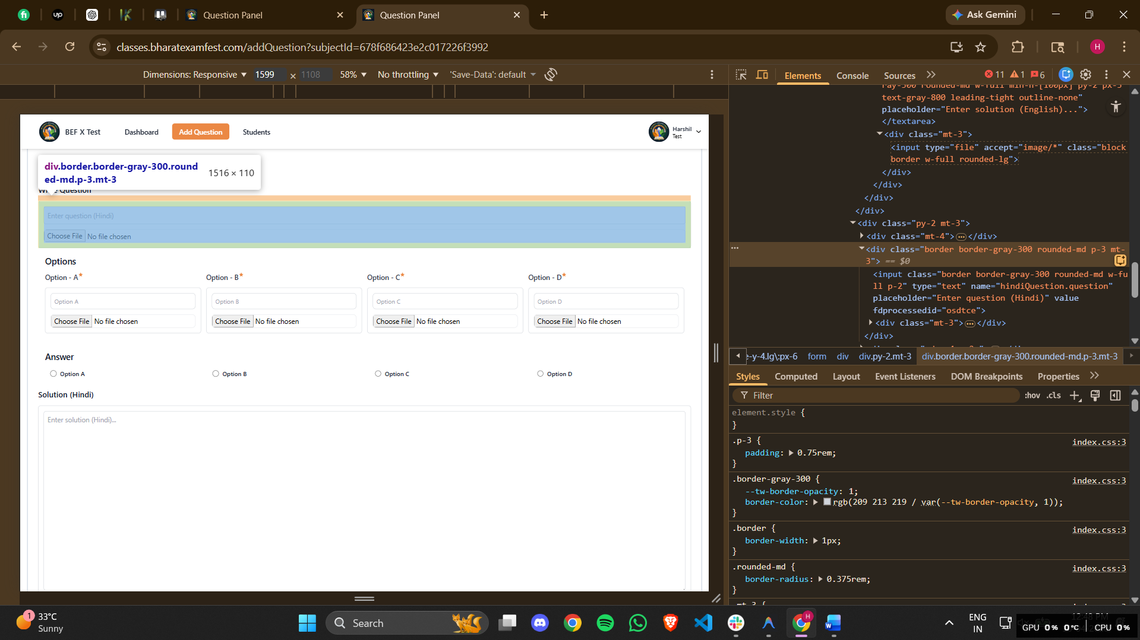
If only text or only image is present in the hindi docs then only one of them has to be pasted if both are present then both should be pasted into the bowes.here is the outerHTML file for that.
<div class="border border-gray-300 rounded-md p-3 mt-3"><input class="border border-gray-300 rounded-md w-full p-2" type="text" name="hindiQuestion.question" placeholder="Enter question (Hindi)" value="" fdprocessedid="osdtce"><div class="mt-3"><input type="file" accept="image/*" class="block border w-full rounded-lg"></div></div>
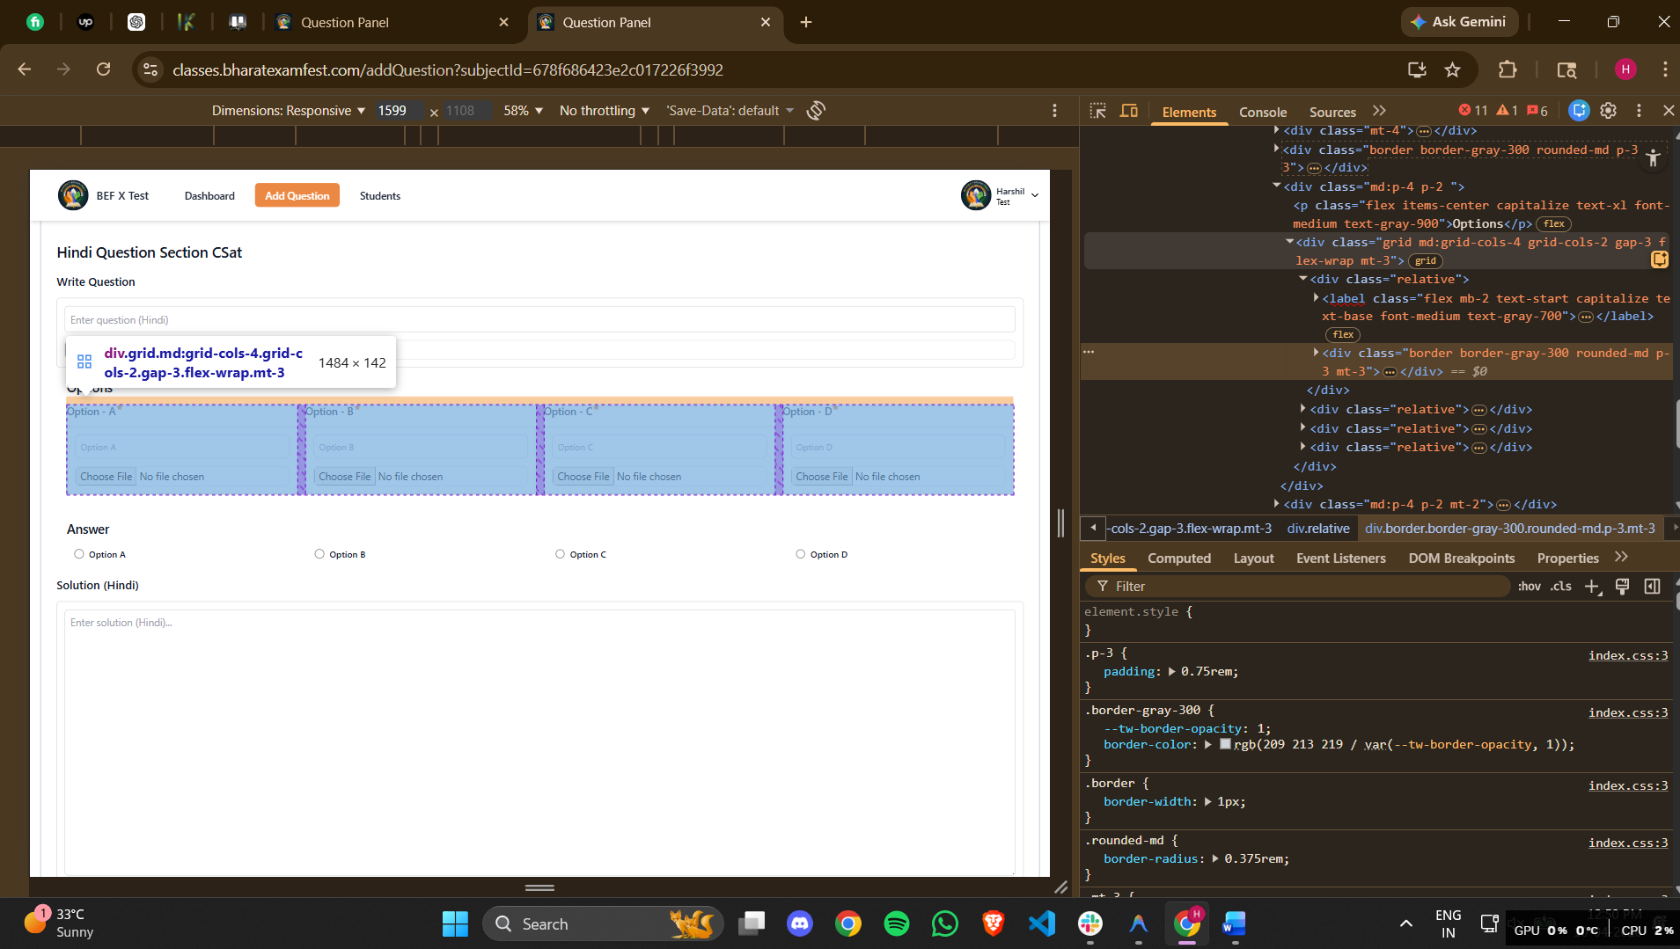
This is for the hindi option selection.here are the outerHTML file for that.
For option A: <div class="border border-gray-300 rounded-md p-3 mt-3"><input type="text" name="hindiQuestion.options.A" class="block w-full p-2 border rounded-lg bg-white placeholder-gray-400 text-gray-600 border-gray-300 text-sm outline-none" placeholder="Option A" value="" fdprocessedid="cayu2j"><div class="mt-3"><input type="file" accept="image/*" class="block border w-full rounded-lg"></div></div>
For option B: <div class="border border-gray-300 rounded-md p-3 mt-3"><input type="text" name="hindiQuestion.options.B" class="block w-full p-2 border rounded-lg bg-white placeholder-gray-400 text-gray-600 border-gray-300 text-sm outline-none" placeholder="Option B" value="" fdprocessedid="c9zqe"><div class="mt-3"><input type="file" accept="image/*" class="block border w-full rounded-lg"></div></div>
For option C: <div class="border border-gray-300 rounded-md p-3 mt-3"><input type="text" name="hindiQuestion.options.C" class="block w-full p-2 border rounded-lg bg-white placeholder-gray-400 text-gray-600 border-gray-300 text-sm outline-none" placeholder="Option C" value="" fdprocessedid="gh6qkc"><div class="mt-3"><input type="file" accept="image/*" class="block border w-full rounded-lg"></div></div>
For option D: <div class="border border-gray-300 rounded-md p-3 mt-3"><input type="text" name="hindiQuestion.options.D" class="block w-full p-2 border rounded-lg bg-white placeholder-gray-400 text-gray-600 border-gray-300 text-sm outline-none" placeholder="Option D" value="" fdprocessedid="oup8t6"><div class="mt-3"><input type="file" accept="image/*" class="block border w-full rounded-lg"></div></div>

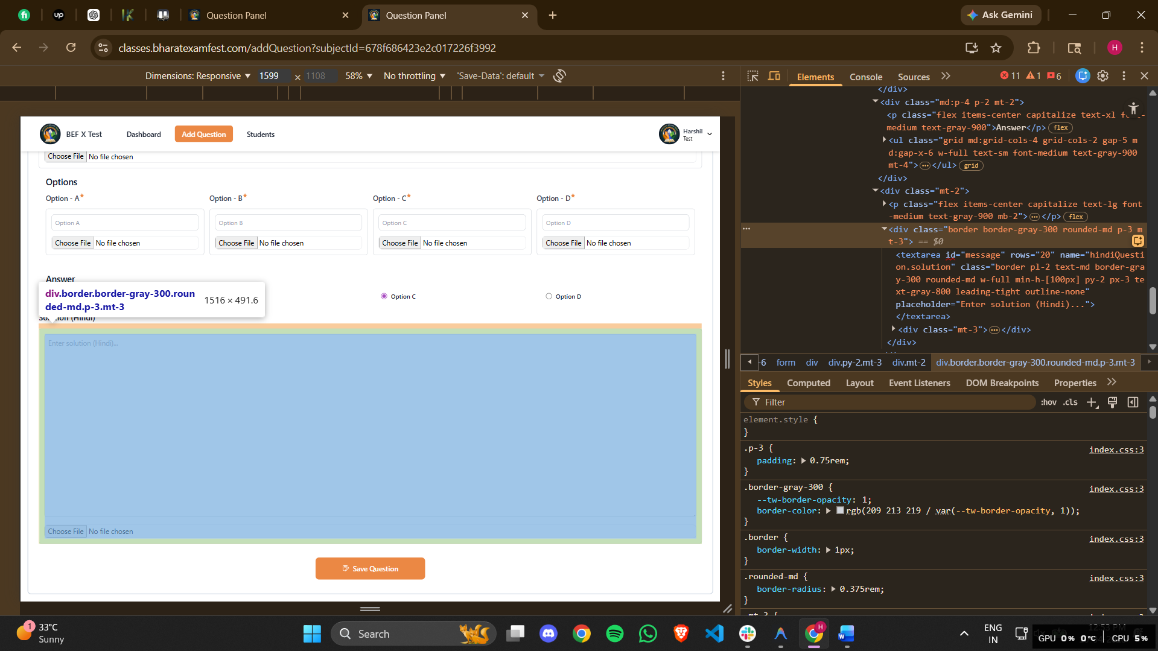
For the solution in hindi.
For text solution in hindi: <textarea id="message" rows="20" name="hindiQuestion.solution" class="border pl-2 text-md border-gray-300 rounded-md w-full min-h-[100px] py-2 px-3 text-gray-800 leading-tight outline-none" placeholder="Enter solution (Hindi)..."></textarea>
For image solution for hindi: <input type="file" accept="image/*" class="block border w-full rounded-lg">
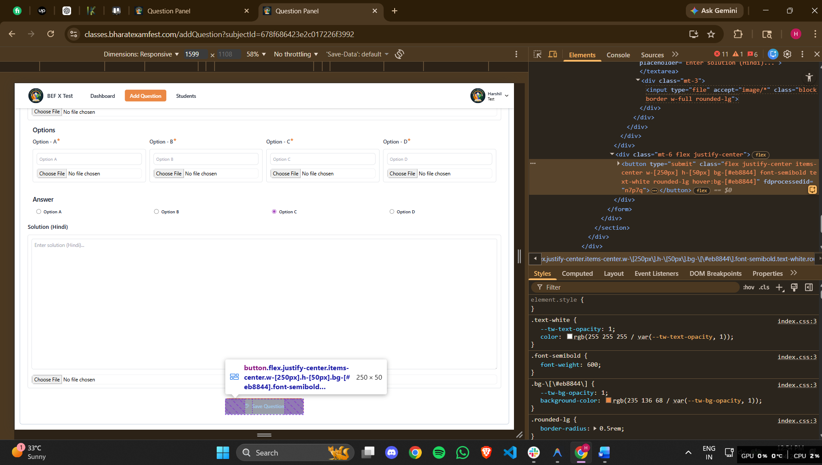
After filling the form completely you have to press the save button.
<button type="submit" class="flex justify-center items-center w-[250px] h-[50px] bg-[#eb8844] font-semibold text-white rounded-lg hover:bg-[#eb8844]" fdprocessedid="n7p7q"><svg stroke="currentColor" fill="currentColor" stroke-width="0" viewBox="0 0 16 16" class="mr-2" height="1em" width="1em" xmlns="http://www.w3.org/2000/svg"><path fill-rule="evenodd" clip-rule="evenodd" d="M11.04 1.33L12.71 3l.29.71v.33h-.5l-.5.5v-.83l-1.67-1.67H10v4H4v-4H2v10h3l-.5 1H2l-1-1v-10l1-1h8.33l.71.29zM7 5h2V2H7v3zm6.5 0L15 6.5l-.02.69-5.5 5.5-.13.12-.37.37-.1.09-3 1.5-.67-.67 1.5-3 .09-.1.37-.37.12-.13 5.5-5.5h.71zm-6.22 7.24l-.52 1 1.04-.48-.52-.52zm.69-1.03l.79.79 5.15-5.15-.79-.79-5.15 5.15z"></path></svg>Save Question</button>
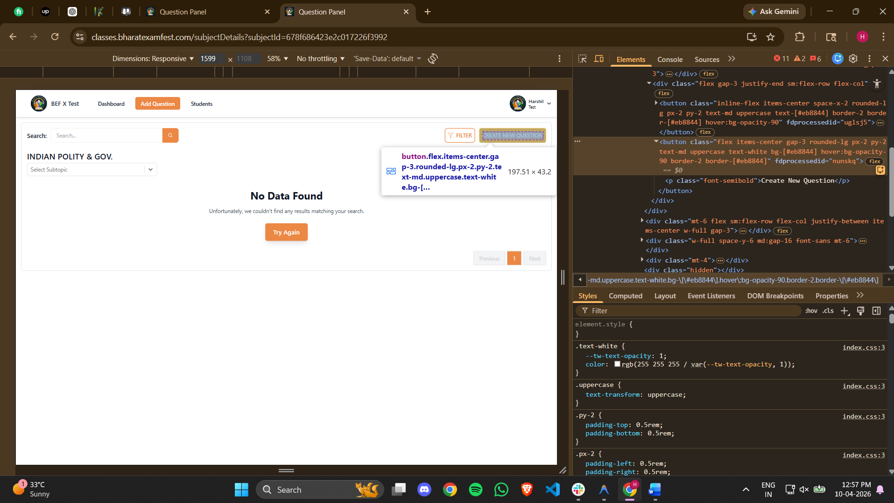
After the save button you have to press this CREATE NEW QUESTION button.
<button class="flex items-center gap-3 rounded-lg px-2 py-2 text-md uppercase text-white bg-[#eb8844] hover:bg-opacity-90 border-2 border-[#eb8844]" fdprocessedid="nunskq"><p class="font-semibold">Create New Question</p></button>

