Now I want to add the automation for the QuestionType: pair. If the pair is selected in the autonation then below I have given the step by step process of what should be done.
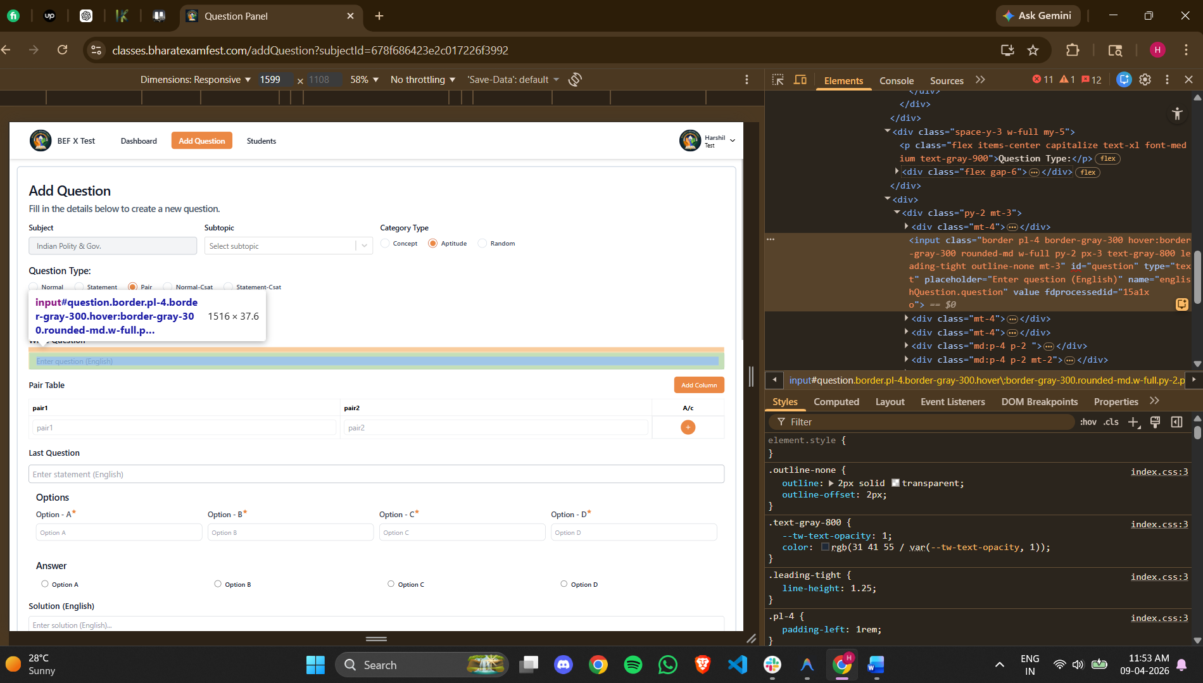
<input class="border pl-4 border-gray-300 hover:border-gray-300 rounded-md w-full py-2 px-3 text-gray-800 leading-tight outline-none mt-3" id="question" type="text" placeholder="Enter question (English)" name="englishQuestion.question" value="" fdprocessedid="15a1xo">
Here the upper question has to be entred.
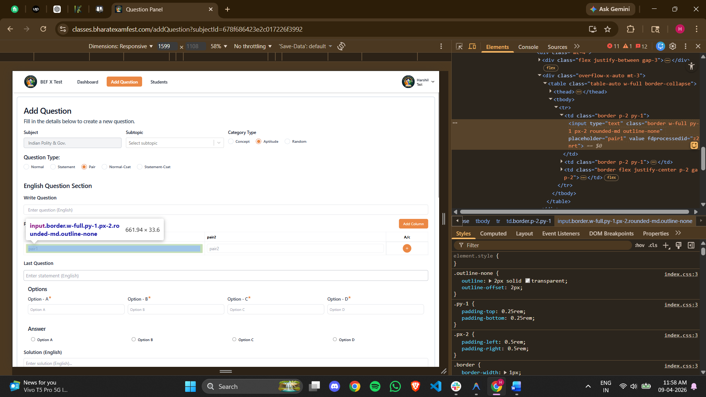
<td class="border p-2 py-1"><input type="text" class="border w-full py-1 px-2 rounded-md outline-none" placeholder="pair1" value="" fdprocessedid="z2nrt"></td>
Here the left side of the pair has to be added.
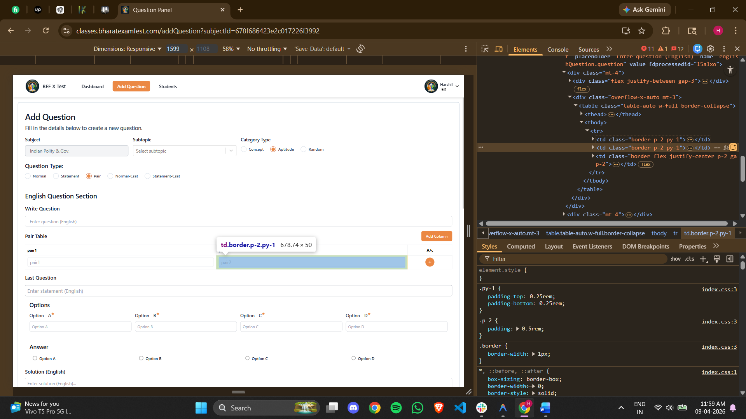
<td class="border p-2 py-1"><input type="text" class="border w-full py-1 px-2 rounded-md outline-none" placeholder="pair2" value="" fdprocessedid="hqzvs"></td>
Here the right side of the first pair has to be added.
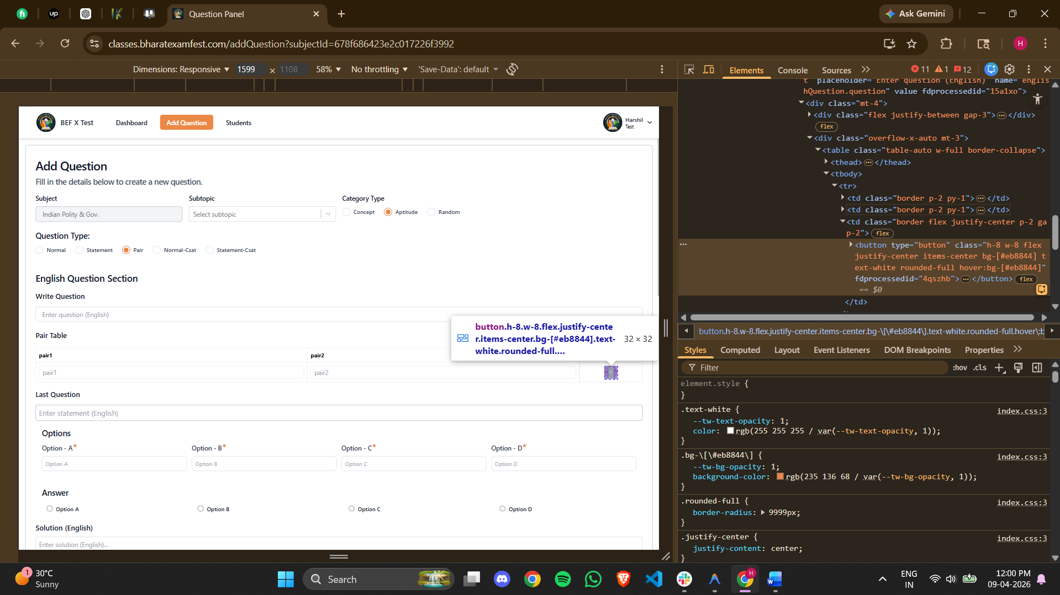
<button type="button" class="h-8 w-8 flex justify-center items-center bg-[#eb8844] text-white rounded-full hover:bg-[#eb8844]" fdprocessedid="4qszhb"><svg stroke="currentColor" fill="currentColor" stroke-width="0" viewBox="0 0 24 24" height="1em" width="1em" xmlns="http://www.w3.org/2000/svg"><path fill="none" d="M0 0h24v24H0z"></path><path d="M19 13h-6v6h-2v-6H5v-2h6V5h2v6h6v2z"></path></svg></button>
If there is more than one pair in the question this has to be pressed.
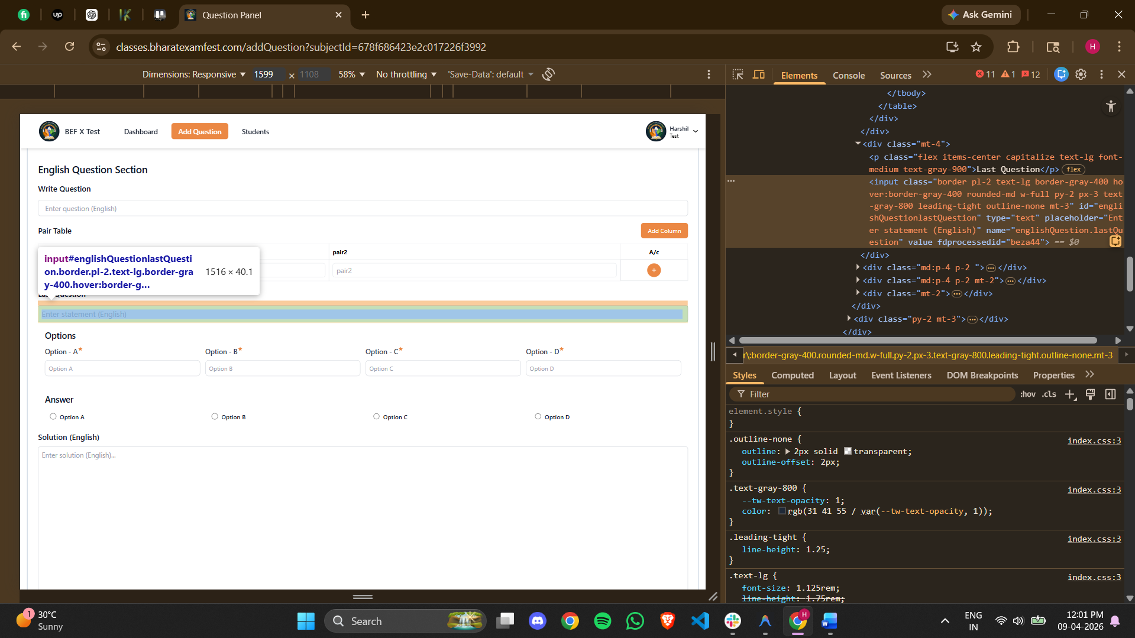
<input class="border pl-2 text-lg border-gray-400 hover:border-gray-400 rounded-md w-full py-2 px-3 text-gray-800 leading-tight outline-none mt-3" id="englishQuestionlastQuestion" type="text" placeholder="Enter statement (English)" name="englishQuestion.lastQuestion" value="" fdprocessedid="beza44">
The lower part of the question has to be pasted here. 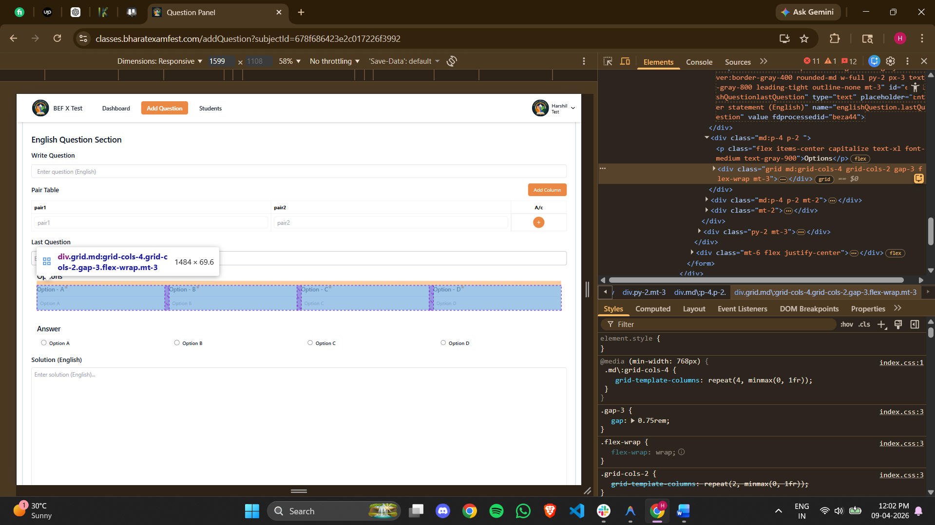
<div class="grid md:grid-cols-4 grid-cols-2 gap-3 flex-wrap mt-3"><div class="relative"><label class="flex mb-2 text-start capitalize text-base font-medium text-gray-700">Option - A<svg stroke="currentColor" fill="currentColor" stroke-width="0" viewBox="0 0 24 24" class="text-[#eb8844] h-3 w-3" height="1em" width="1em" xmlns="http://www.w3.org/2000/svg"><path fill="none" d="M0 0h24v24H0z"></path><path fill="none" d="M0 0h24v24H0z"></path><path d="M12 17.27 18.18 21l-1.64-7.03L22 9.24l-7.19-.61L12 2 9.19 8.63 2 9.24l5.46 4.73L5.82 21z"></path></svg></label><input type="text" name="englishQuestion.options.A" class="block w-full p-2 border rounded-lg bg-white placeholder-gray-400 text-gray-600 border-gray-300 text-sm outline-none" placeholder="Option A" value="" fdprocessedid="8uxdw"></div><div class="relative"><label class="flex mb-2 text-start capitalize text-base font-medium text-gray-700">Option - B<svg stroke="currentColor" fill="currentColor" stroke-width="0" viewBox="0 0 24 24" class="text-[#eb8844] h-3 w-3" height="1em" width="1em" xmlns="http://www.w3.org/2000/svg"><path fill="none" d="M0 0h24v24H0z"></path><path fill="none" d="M0 0h24v24H0z"></path><path d="M12 17.27 18.18 21l-1.64-7.03L22 9.24l-7.19-.61L12 2 9.19 8.63 2 9.24l5.46 4.73L5.82 21z"></path></svg></label><input type="text" name="englishQuestion.options.B" class="block w-full p-2 border rounded-lg bg-white placeholder-gray-400 text-gray-600 border-gray-300 text-sm outline-none" placeholder="Option B" value="" fdprocessedid="by5fjl"></div><div class="relative"><label class="flex mb-2 text-start capitalize text-base font-medium text-gray-700">Option - C<svg stroke="currentColor" fill="currentColor" stroke-width="0" viewBox="0 0 24 24" class="text-[#eb8844] h-3 w-3" height="1em" width="1em" xmlns="http://www.w3.org/2000/svg"><path fill="none" d="M0 0h24v24H0z"></path><path fill="none" d="M0 0h24v24H0z"></path><path d="M12 17.27 18.18 21l-1.64-7.03L22 9.24l-7.19-.61L12 2 9.19 8.63 2 9.24l5.46 4.73L5.82 21z"></path></svg></label><input type="text" name="englishQuestion.options.C" class="block w-full p-2 border rounded-lg bg-white placeholder-gray-400 text-gray-600 border-gray-300 text-sm outline-none" placeholder="Option C" value="" fdprocessedid="z6sn8"></div><div class="relative"><label class="flex mb-2 text-start capitalize text-base font-medium text-gray-700">Option - D<svg stroke="currentColor" fill="currentColor" stroke-width="0" viewBox="0 0 24 24" class="text-[#eb8844] h-3 w-3" height="1em" width="1em" xmlns="http://www.w3.org/2000/svg"><path fill="none" d="M0 0h24v24H0z"></path><path fill="none" d="M0 0h24v24H0z"></path><path d="M12 17.27 18.18 21l-1.64-7.03L22 9.24l-7.19-.61L12 2 9.19 8.63 2 9.24l5.46 4.73L5.82 21z"></path></svg></label><input type="text" name="englishQuestion.options.D" class="block w-full p-2 border rounded-lg bg-white placeholder-gray-400 text-gray-600 border-gray-300 text-sm outline-none" placeholder="Option D" value="" fdprocessedid="3kxfl"></div></div>
Here the option has to be added.
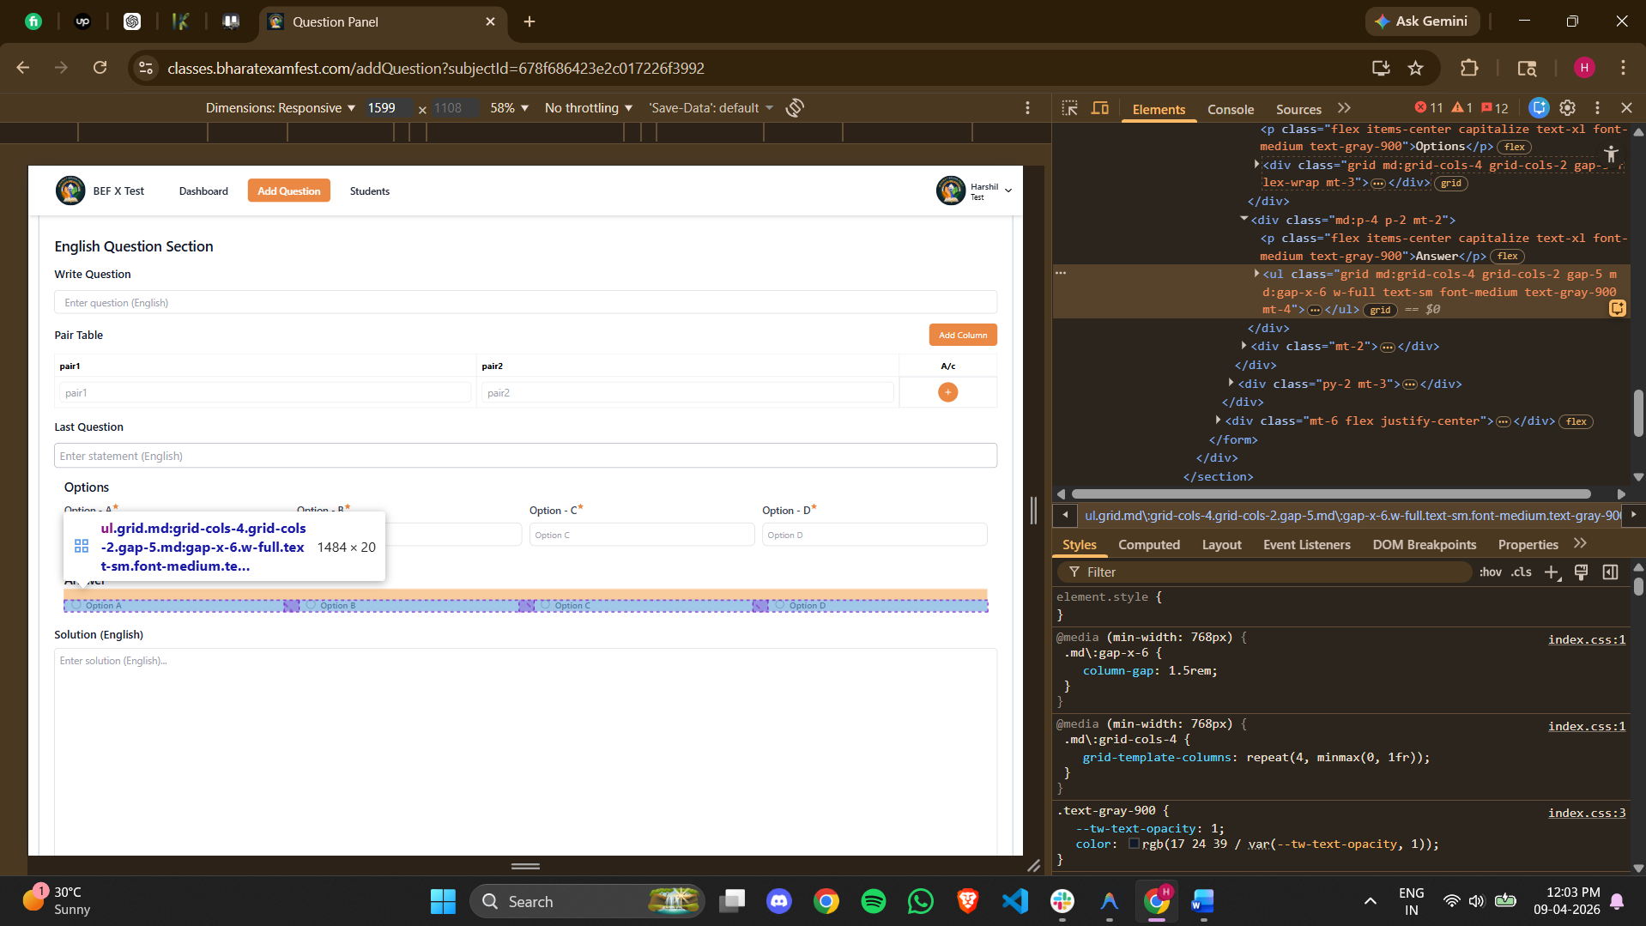
<ul class="grid md:grid-cols-4 grid-cols-2 gap-5 md:gap-x-6 w-full text-sm font-medium text-gray-900 mt-4"><li><div class="flex items-center ps-3"><input id="radioA" type="radio" name="englishQuestion.answer" class="w-4 h-4 text-blue-600 border-gray-300 checked:bg-blue-600 checked:outline-none" value="A"><label for="radioA" class="w-full ms-2 text-sm font-medium text-gray-900 line-clamp-1">Option A</label></div></li><li><div class="flex items-center ps-3"><input id="radioB" type="radio" name="englishQuestion.answer" class="w-4 h-4 text-blue-600 border-gray-300 checked:bg-blue-600 checked:outline-none" value="B"><label for="radioB" class="w-full ms-2 text-sm font-medium text-gray-900 line-clamp-1">Option B</label></div></li><li><div class="flex items-center ps-3"><input id="radioC" type="radio" name="englishQuestion.answer" class="w-4 h-4 text-blue-600 border-gray-300 checked:bg-blue-600 checked:outline-none" value="C"><label for="radioC" class="w-full ms-2 text-sm font-medium text-gray-900 line-clamp-1">Option C</label></div></li><li><div class="flex items-center ps-3"><input id="radioD" type="radio" name="englishQuestion.answer" class="w-4 h-4 text-blue-600 border-gray-300 checked:bg-blue-600 checked:outline-none" value="D"><label for="radioD" class="w-full ms-2 text-sm font-medium text-gray-900 line-clamp-1">Option D</label></div></li></ul>
Right answer should be selected from here.
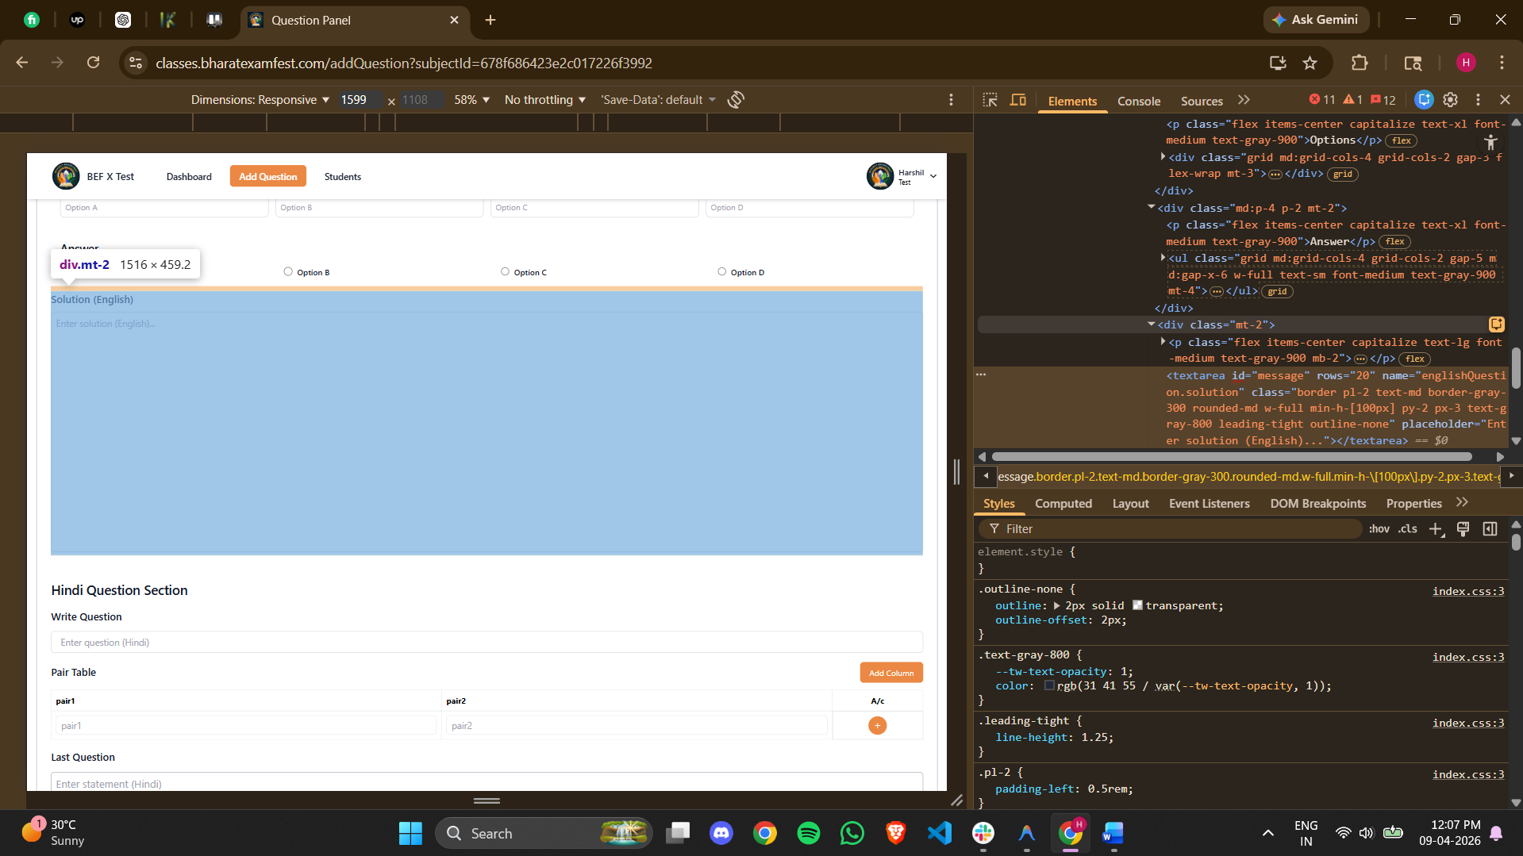
<textarea id="message" rows="20" name="englishQuestion.solution" class="border pl-2 text-md border-gray-300 rounded-md w-full min-h-[100px] py-2 px-3 text-gray-800 leading-tight outline-none" placeholder="Enter solution (English)..."></textarea>
Here the explanation of the question has to be pasted.

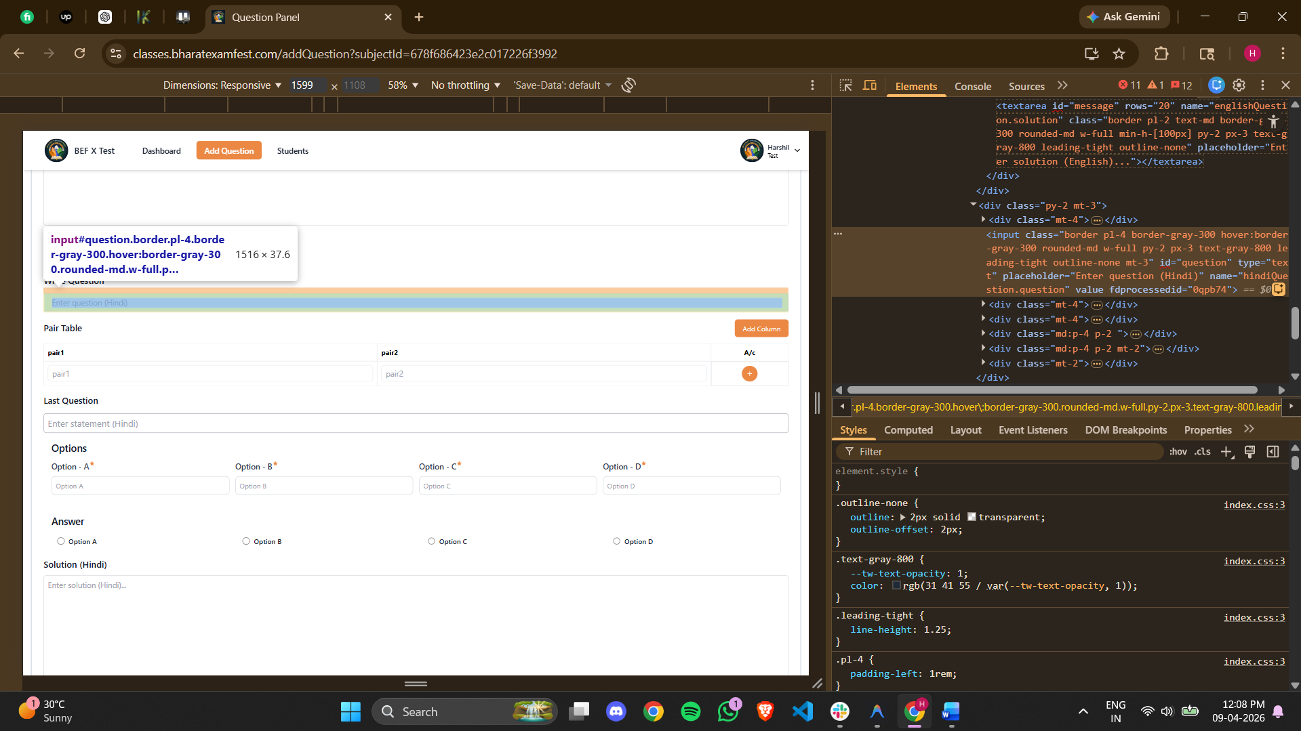
<input class="border pl-4 border-gray-300 hover:border-gray-300 rounded-md w-full py-2 px-3 text-gray-800 leading-tight outline-none mt-3" id="question" type="text" placeholder="Enter question (Hindi)" name="hindiQuestion.question" value="" fdprocessedid="0qpb74">
The hindi upper question should be pasted here.
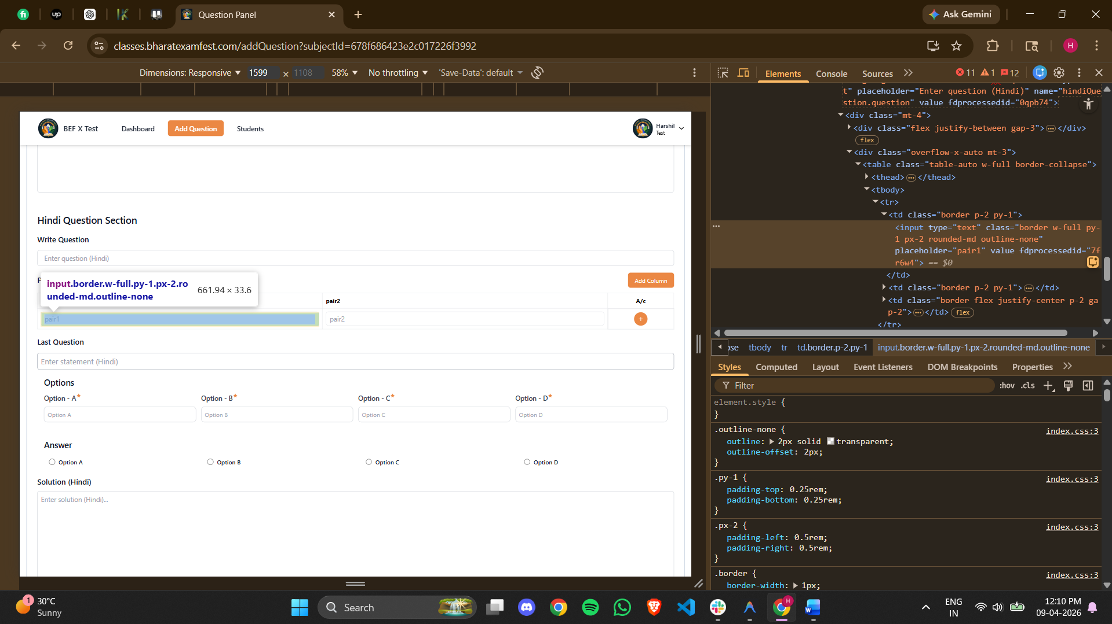
<input type="text" class="border w-full py-1 px-2 rounded-md outline-none" placeholder="pair1" value="" fdprocessedid="7fr6w4">
Here the left side of the pair has to be pated.

<td class="border p-2 py-1"><input type="text" class="border w-full py-1 px-2 rounded-md outline-none" placeholder="pair2" value="" fdprocessedid="wt18e"></td>
Here in pair2 box the right side of the pair has to be pasted.
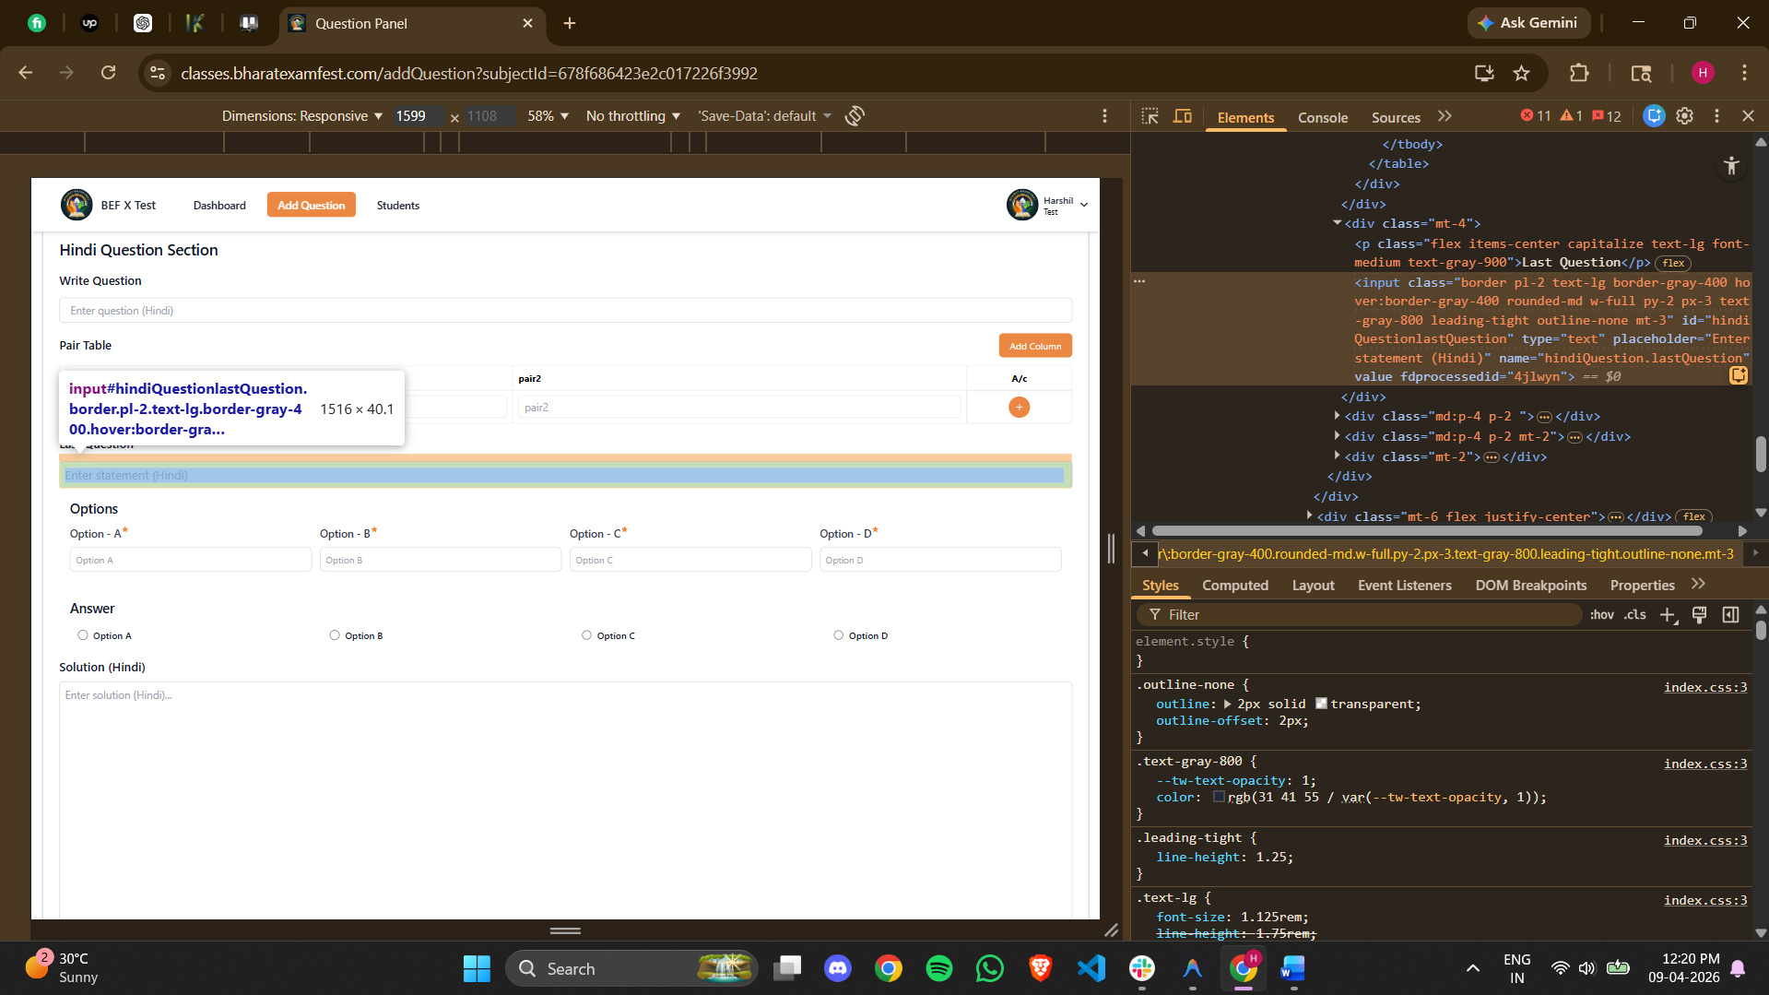
<input class="border pl-2 text-lg border-gray-400 hover:border-gray-400 rounded-md w-full py-2 px-3 text-gray-800 leading-tight outline-none mt-3" id="hindiQuestionlastQuestion" type="text" placeholder="Enter statement (Hindi)" name="hindiQuestion.lastQuestion" value="" fdprocessedid="4jlwyn">
Here the lower part of the question has to be pasted.
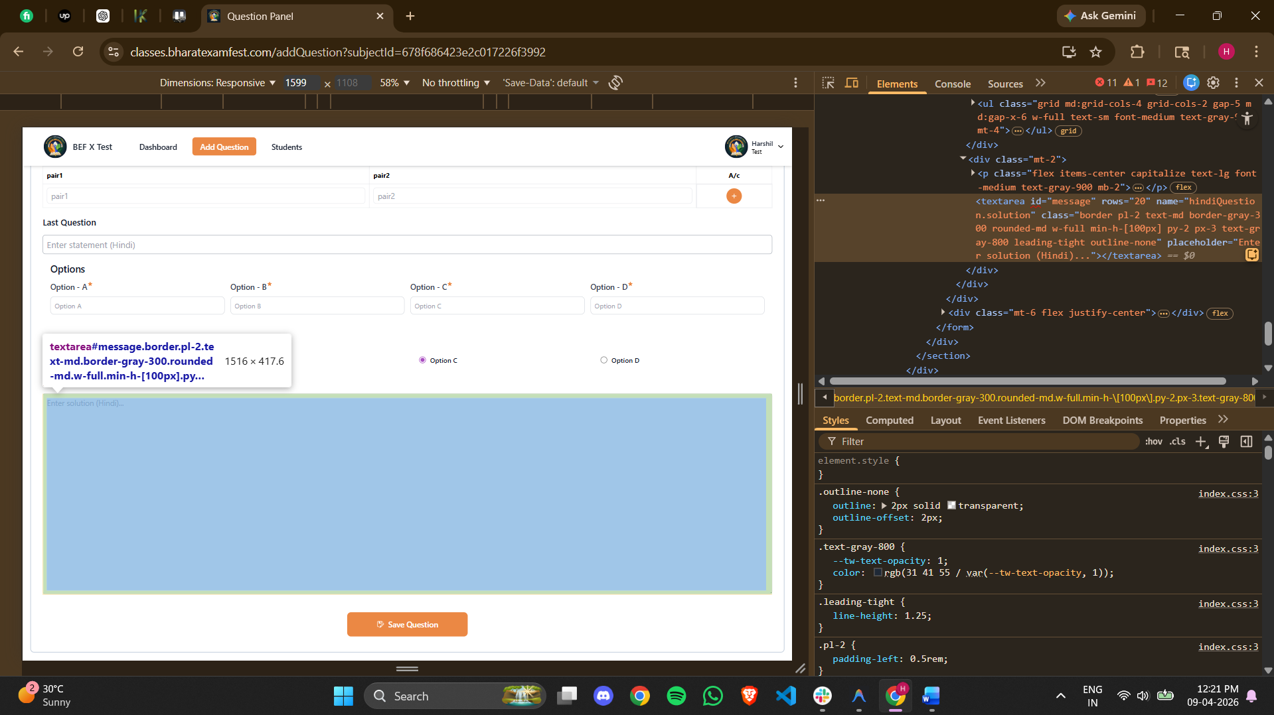
<textarea id="message" rows="20" name="hindiQuestion.solution" class="border pl-2 text-md border-gray-300 rounded-md w-full min-h-[100px] py-2 px-3 text-gray-800 leading-tight outline-none" placeholder="Enter solution (Hindi)..."></textarea>
Here the hindi explanation has to be added.

