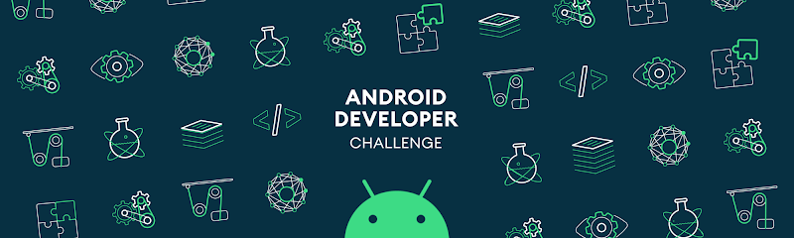

**#AndroidDevChallenge**

**Tell us what your idea is.**

Bloice - A assistance for blind people. My Idea is to make an app for blink people, where app is called via speech from Google assistant like "OK Google, open bloice", when the app is opened, we can perform task with the help of users voice. User can hold camera against any book, newspaper, place, object or anything. We will then convert the image/text/object into speech and let the user know what was the text or object. User can also ask for color, like "what color the car is ?".

**Tell us how you plan on bringing it to life.**

*I was working on this project and I saw #AndroidDevChallenge is live which gave me hope and confidence to speed up the work. We really hope to solve the problem and hope to make this product widely accessible.Sample code is written in Java and currently we are in experimenting phase, trying out different things to make sure the best method is used for the purpose.*

*Google cloud’s vision API is very accurate to do such work.I have added a few code files which I have used till now. It is developed by using MLkit and Google translate.*

*How Google could help us achieve the goal :*

1. *Provide a Mentor for the project*
2. *By advising ways to optimise the ML model*
3. *Help us get a BETA audience*
4. *Free credits/trail for Google APIs until it's released*
5. *Data set for the project*

*Timeline:*

*December 2019:*

* *Documenting and Training Models*
* *Finalising the best possible method for the application*
* *Prototyping*

*January 2020:*

* *Development and Google Vision integration*
* *Implementing UI/UX for the App*

*February 2020 :*

* *Developing the Android application*

*March 2020 :*

* *Beta testing the Android application*

*April 2020 :*

* *Finalising the Android application*
* *Taking User Feedback and Making necessary changes*

**Tell us about you.**

*My name is Harshil Patel and I'm 20 years old developer from the India.I love coding and working on various Android and ML projects. I Have done many android projects so far. I want to make something helpful for users.I want to solve real world problems and make the solutions available to all. Keeping this in mind I would like to open source project for the community.I am also an active member of GDG-Ahmedabad and Google Cloud Community Ahmedabad.*

*Linkedin -* [*https://www.linkedin.com/in/harshil-v-patel/*](https://www.linkedin.com/in/harshil-v-patel/)

*My Projects Link -* [*https://xenonstudio.in/projects*](https://xenonstudio.in/projects)

**Next steps.**

* Be sure to include this cover letter in your GitHub repository
* Your GitHub repository should be tagged #AndroidDevChallenge
* Don’t forget to include other items in your GitHub repository to help us evaluate your submission; you can include prior projects you've worked on, sample code you've already built for this project, or anything else you think could be helpful in evaluating your concept and your ability to build it
* [**The final step is to fill out this form to officially submit your proposal.**](https://docs.google.com/forms/d/e/1FAIpQLSe43koQL33IzgxXQl29Ex3AhFuqd4hQzxLiXREqwRkDGtx1vA/viewform?usp=sf_link)