**Home Work 2**

**D3 Coding Contest**

**Team Members:**

**Harshil Sheth(800833329)**

**iskwak ()**

**DataSet:** Cereals

**Visualization:** Bar graph chart

**D3.js** (or just **D3** for **Data-Driven Documents**) is a JavaScript library that uses digital data to drive the creation and control of dynamic and interactive graphical forms which run in web browsers. It is a tool for data visualization in W3C-compliant computing, making use of the widely implemented Scalable Vector Graphics (SVG), JavaScript, HTML5, and Cascading Style Sheets (CSS3) standards. For example, you can use D3 to generate an HTML table from an array of numbers. Or, use the same data to create an interactive SVG bar chart with smooth transitions and interaction.

In this Coding contest, we have taken a dataset (cereal dataset) of our interest and visualized it using D3.We have modified the existing bar graphs example according to our requirement. Our visualization is interactive and very helpful to the users who wish to buy a cereal depending on particular attributes like calories, protein, fats etc.

**Functions:**

**X-axis:**

This represents the **Cereal Names**.

**Y-axis:**

This represents the **Quantity of Ingredients** present in the corresponding cereal.

**Drop Down List:**

Drop Down list buttons are assigned to all the ingredients by which we can know a value of particular ingredient of all the cereals in our dataset. For example, if the user Selects “Protein” on a Drop Down list button associated with an attribute protein, we get the protein content in all the cereals. By this way user can choose what he/she likes i.e the cereal which is low or high in particular ingredients.

In figure 1 we can see the Dropdownlist buttons for all the ingredients of our dataset which can be chosen according to the users choice.

**Figure 1:**

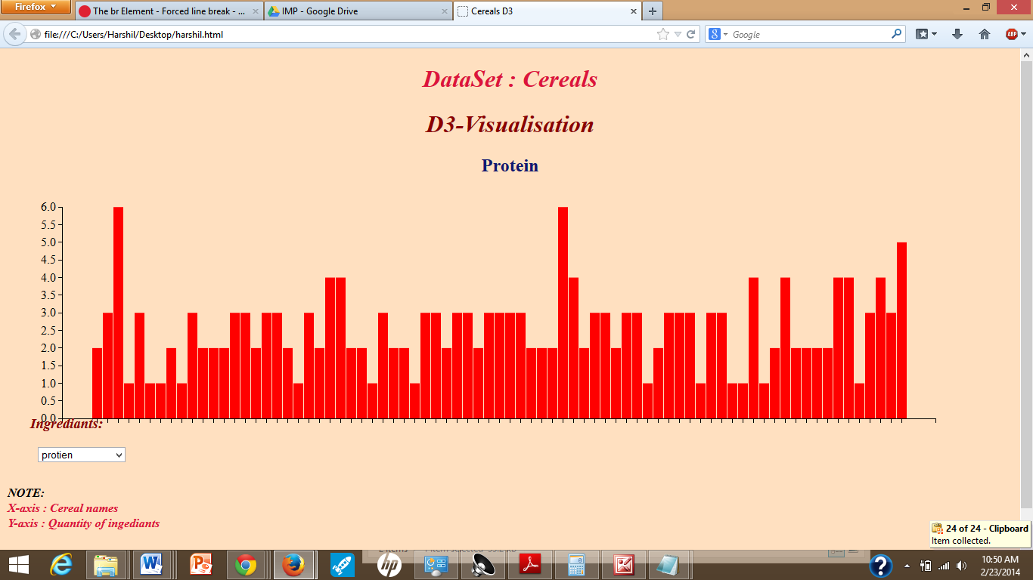

**Mouse Hover:**

If we hover the mouse over each bar in the chart all the information of respective cereal is displayed.

For example we get the information like

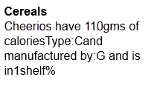

In Figure 2 we can see this type of function.

Figure 2:

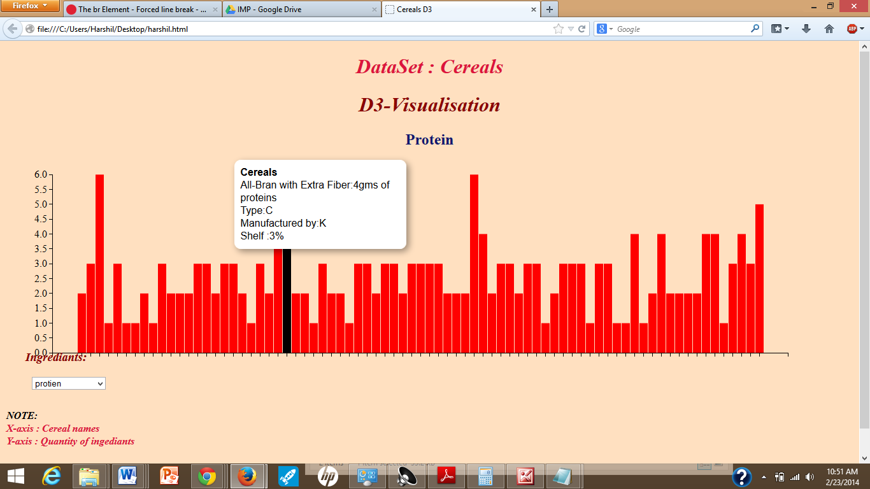

**Changes in code:**

We have taken the basic idea of bargraph and added the extra features like:

* Dropdownlist for each ingredient which the user can select as per his requirements.
* For each selected dropdown list button, separate bar charts are shown depending on the ingredient selected.
* Each ingredient has a different color for its bar chart.
* Y-axis changes depending on the ingredients we select. For example if we select fats, the values of fats are divided on y-axis from the dataset.
* We have added mouse hover function which is more interactive as it displays the Type, Manufacturer, Shelf and the Quantity of the Ingredients selected.