
R.B. Institute of Management Studies(RBIMS)
APPROVED BY AICTE, GOVT. OF INDIA, NEW DELHI
Affiliated with Gujarat Technological University, Ahmedabad Opp. Hiravadi BRTS Stand, Thakkarbapa Nagar, Ahmedabad (Gujarat)



YOUR CARS

Developed By:

Name | Enrollment Number
1. Harshil Sorathiya | 235491105026
2. Viral Panchal | 235491105015


R.B. Institute of Management Studies(RBIMS)
APPROVED BY AICTE, GOVT. OF INDIA, NEW DELHI
Affiliated with Gujarat Technological University, Ahmedabad Opp. Hiravadi BRTS Stand, Thakkarbapa Nagar, Ahmedabad (Gujarat)

Project Report On
Your Cars
SUBMITTED IN PARTIAL FULFILLMENT FOR
AWARD OF DEGREE
IN

Bachelor of Vocational (IT)

Submitted by

Name | Enrollment Number
1. Harshil Sorathiya | 235491105026
2. Viral Panchal | 235491105015


R.B. Institute of Management Studies(RBIMS)
APPROVED BY AICTE, GOVT. OF INDIA, NEW DELHI
Affiliated with Gujarat Technological University, Ahmedabad Opp. Hiravadi BRTS Stand, Thakkarbapa Nagar, Ahmedabad (Gujarat)

(BVOC (IT) Program)
CERTIFICATE

This is to certify that the practical work has been successfully carried out in the laboratory and hence recorded in this journal is the Bonaire work of
Mr. Harshil Sorathiya (235491105026) Of BVOC(IT) Semester 5 laboratory of subject MOBILE APPLICATION DEVELOPMENT PROJECT Using
Android Language with SQLite. He has completed the project successfully during the academic year 2025-2026.

Date: ___________ College Seal
Project Guide Head of Department
PROF.HIMANI KHODIFAD


R.B. Institute of Management Studies(RBIMS)
APPROVED BY AICTE, GOVT. OF INDIA, NEW DELHI
Affiliated with Gujarat Technological University, Ahmedabad Opp. Hiravadi BRTS Stand, Thakkarbapa Nagar, Ahmedabad (Gujarat)

(BVOC (IT) Program)
CERTIFICATE

This is to certify that the practical work has been successfully carried out in the laboratory and hence recorded in this journal is the Bonaire work of
Mr. Viral Panchal (235491105015)Of BVOC(IT) Semester 5 laboratory of subject MOBILE APPLICATION DEVELOPMENT PROJECT Using
Android Language with SQLite. He has completed the project successfully during the academic year 2025-2026.

Date: ___________ College Seal
Project Guide Head of Department
PROF.HIMANI KHODIFAD

STUDENT DECLARATION

We, HARSHIL SORATHIYA, VIRAL PANCHAL , hereby declare that the project work entitled “YOUR CARS” is an authentic piece of work completed by us as part of the Full-Time B.VOC(IT) Programme of our college, affiliated with Gujarat Technological University (GTU), Ahmedabad.
We further declare that the content embodied in this project report is the result of our original work and has not been submitted to any other University or Institute for the fulfillment of the requirement of any other course or program.
In case any part of this work is found to be copied or duplicated from any other source, we shall be solely responsible for the same.
Signature of Students:

HARSHIL SORATHIYA
VIRAL PANCHAL

Place: ___________________
Date: ___________________

ACKNOWLEDGEMENT

We are pleased to present our project report on “YOUR CARS”, completed during the 5th Semester of the B.VOC(IT) Programme affiliated with Gujarat Technological University (GTU), Ahmedabad).
We sincerely thank our project guide Prof. Himani Khodifad for her valuable guidance, encouragement, and support throughout this project.
We are also grateful to our parents, faculty members, and friends for their constant motivation and assistance during the completion of this work,
With since reregards,
HARSHIL_SORATHIYA
VIRAL_PANCHAL

TABLE OF CONTENTS
Sr. No. | Content Title | Subtopics
1. | Introduction | 1.1 Existing System  1.2 Need for the New System  1.3 Objective of the New System  1.4 Problem Definition  1.5 Scope of the Project and Core Components  1.6 Project Profile  1.7 Assumptions and Constraints  1.8 Advantages and Limitations of the Proposed System
2. | Requirement Determination & Analysis | 2.1 Requirement Determination  2.2 Targeted Users
3. | System Design | 3.1 Use Case Diagram  3.2 Class Diagram  3.3 Interaction Diagram  3.4 Activity Diagram  3.5 Data Dictionary
4. | Development | 4.1 Coding Standards  4.2 Screenshots
5. | Application Testing | 5.1 Manual Testing  5.1.1 Test Cases
6. | Proposed Enhancements | —
7. | Conclusion | —
8. | Bibliography | —

Introduction
- This is our B.VOC(IT) 5th Semester final project, developed at our institute as part of the curriculum of Gujarat Technological University (GTU), Ahmedabad). The project is built on the Android platform using Java as the programming language and SQLite as the database for data storage and management.

Project Description
- The YourCars App is an Android-based application designed to bring multiple car brands into a single platform. The system consists of two main panels — Admin and User — each with specific features and responsibilities.

Admin Panel Features:
- Add new cars with complete details such as name, price, brand, and description.
- Update or delete existing car information.
- Manage and view all test drive bookings made by users.
- View a list of all registered users.
- Secure login, registration, and logout functionality.

User Panel Features:
- Register and log in securely to access the app.
- Browse all available cars added by the admin.
- View detailed information about each car (name, brand, price, title, description, and date).
- Book a test drive for any car of interest.
- Logout after completing the session.

Purpose and Benefits:
- Simplifies the process of exploring and booking test drives across multiple car brands in Singal App.
- Eliminates the need to visit different company websites or apps.
- Provides a user-friendly interface for both customers and admins.
- Ensures real-time data management and secure access.

  - Existing System

- Users: Those who wish to explore or book a test drive need to visit multiple car company websites or use separate mobile applications for each brand.
→ This makes the process time-consuming and inconvenient, as users must search across various platforms to compare car models, price, and specifications.

- Administrators: They also face challenges since there is no centralized system to manage cars, users, and test drive bookings.
→ They must update and monitor information manually across different sources, which often leads to inefficiency, data inconsistency, and human errors.

  - Need for the New System

- There is a strong need for a new system that allows users to see cars from many different brands in one app.
- The new system should make it easier for users to view car details, compare prices, and book test drives without opening multiple apps or websites.
- For administrators, this system will help manage all cars, users, and test drive bookings in one place — saving time, improving accuracy, and reducing manual work.

  - Objective of the New System
- To create one Android application that shows cars from different brands in one place.
- To allow users to view full car details such as name, brand, price, description, and date added.
- To let users book a test drive for any car easily .
- To allow the admin to add, update, delete, and manage all cars.
- To provide secure login and registration for both admin and users.
- To design a simple and easy-to-use interface for everyone.

  - Problem Definition

- Existing systems make it difficult for users to compare cars or book test drives from multiple brands in one place.
- There is no unified application that displays cars from various companies and manages test drive scheduling efficiently.
- Our proposed system solves this by building one Android app that combines everything — car listings, brand details, and test drive booking — in a single application.

  - Scope of the Project and Core Components

- Scope:
- The system supports two roles: Admin and User.
- Admins can manage car details, brands, and test drive bookings.
- Users can explore car listings and book test drives only.

- Core Components:
- Admin Module:
  - Register/Login Admin
  - Add, Update, Delete Cars
  - View and Manage Test Drive Requests
  - View Registered Users
  - Logout
- User Module:
  - Register/Login User
  - View Cars by Brand
  - View Car Details (name, brand, price, title, date, description)
  - Book Test Drive (date/time selection)
  - Logout
- Database Module:
  - Stores car details, user details, and test drive bookings.

  - Project Profile
This section gives a technical overview of the project.
Include details such as:
- Project Title : YourCars
- Platform Used: Android
- Programming Language: Java
- Database: SQLite
- Tools/IDE Used: Android Studio
- Operating System: Windows/Android OS
- Type of Application: Mobile App
- Version Control: Bit Bucket
- Team Members and Guide Names :

Project Guide: | PROF.HIMANI KHODIFAD
Name | Enrollment Number
1. Harshil Sorathiya | 235491105026
2. Viral Panchal | 235491105015

  - Assumptions and Constraints

  - Assumptions:
- Admins are authorized to manage cars and bookings.
- The app works offline, except for future enhancements.
- Users have valid registration credentials.

  - Constraints:
- The system requires active internet for all operations.
- Limited to Android platform in the current version.
- Only authorized admins can modify or delete data.

  - Advantages and Limitations of the Proposed System

- Advantages:
  - Centralized platform for viewing cars from multiple brands.
  - Fast access to information
  - Admins can manage all listings and test drive requests easily.
  - Local database management (offline support)
  - Improved communication
  - Simplified process for booking test drives.
- Limitations:
  - Test drive confirmation depends on admin approval.
  - Works only on Android devices
  - No cloud backup
  - Limited user customization

Requirement Determination & Analysis

2.1 Requirement Determination
The requirements for the [your cars] project are divided into Software and Hardware components as well as Client-side and Server-side requirements.

Software Requirements

Category | Details
Front-End | Android (Java)
Back-End / Database | SQLite (local database)
Tools & IDE | Android Studio 4.2.0, Draw.Studio (for diagrams)
Documentation Tools | MS Word 2013, MS PowerPoint 2013

Hardware Requirements

Component | Specification
Processor | 1.80 GHz Core i5 or higher
Primary Memory (RAM) | 8 GB or higher
Secondary Memory (Storage) | 10 GB or higher

Client-Side Requirements

Component | Details
Devices | Android Mobile, Tablet, or any Android device
Connectivity | Internet connection (for updates, if required)

Server-Side Requirements

Component | Details
Devices | Laptop, Desktop
Connectivity | Internet connection (if needed for project testing and report submission)

2.2 Targeted Users
- The YourCars App is primarily designed for individuals who are interested in exploring cars from different brands and booking test drives conveniently through a single Android platform. The application caters to two main categories of users — primary users (customers) and secondary users (administrators).

1. Identify Primary Users
- The primary users of this system are customers who wish to explore and compare cars from various brands.
- These users can browse the car listings added by the admin, view detailed information such as name, brand, price, title, description, and date, and book a test drive for any car they are interested in.
- This eliminates the need to download multiple brand-specific apps or visit several websites, saving time and effort.
- The app provides an easy, centralized, and convenient way for users to explore cars and schedule test drives.

2. Secondary Users
- The secondary users are administrators who manage the system.
- Admins can add, update, and delete car details, view user information, and manage all test drive bookings.
- They ensure that car data is accurate and up to date, and they handle user requests efficiently through the app’s admin panel.

3.Device Usage
- The application is developed for Android smartphones , ensuring accessibility for a wide audience.
- Users only need an internet connection and an Android device to access the system’s features.

4. User Needs & Benefits
- Users can easily explore multiple car brands in one place.
- They can compare cars and directly book test drives without needing to contact different dealerships.
- Admins benefit from simplified management of car listings and booking requests.
- The app improves efficiency, saves time, and enhances the user experience for both customers and dealers.

5. Accessibility Considerations
- The app features a simple and user-friendly interface, making it easy to use for people of all age groups.
- It requires no technical background, ensuring accessibility for general users and car enthusiasts alike.

Summary Paragraph for Report:
- The Multi-Brand Car Test Drive Booking App is primarily targeted at car automobile enthusiasts who want a centralized platform to explore cars and book test drives easily. The administrators or car dealers act as secondary users who manage car listings and booking requests. The app is designed for Android smartphones and tablets, ensuring accessibility and convenience for all users. By using this application, users can compare multiple car brands, view detailed information, and book test drives without the hassle of visiting multiple apps or websites, making the process faster, simpler, and more efficient in daily life.

System Design.

3.1 Use Case Diagram
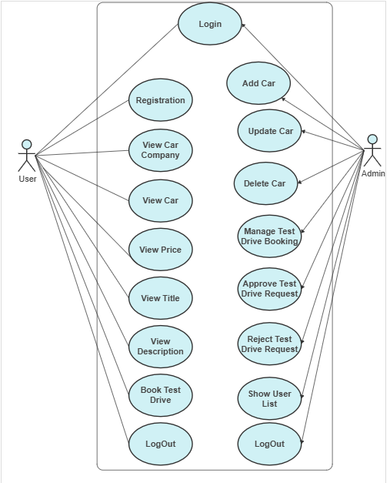
- The Use Case Diagram shows how different actors interact with the Car Application system.
It includes two main actors — Admin and User.
- The Admin can log in, add, update, delete cars, manage test drive bookings, and view registered users.
- The User can register, log in, view cars, check details like name, price, and description, and book test drives.

3.2 Class Diagram
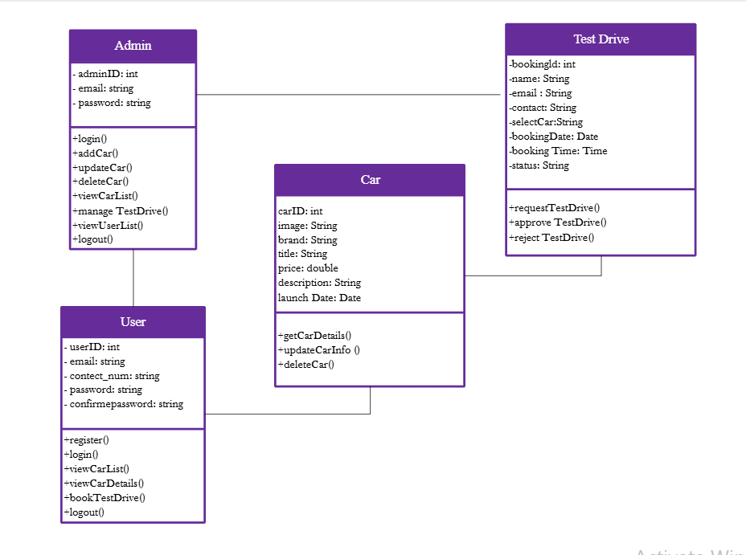
- In this Car Application project, the class diagram represents the interaction between Admin, User, Car, and TestDrive classes, defining how they manage car details, user registrations, and test drive bookings efficiently.

3.3 Interaction Diagram

- Admin Interaction Diagram
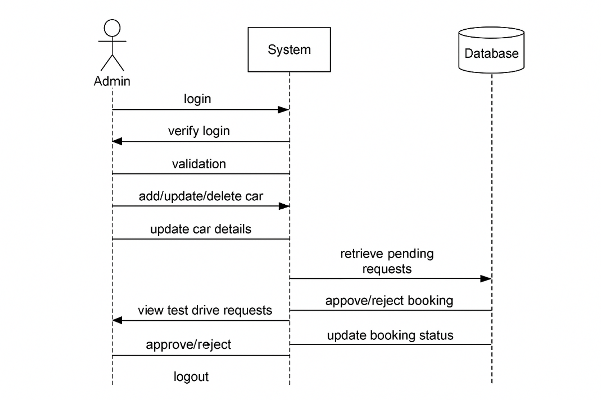

- User Interaction Diagram
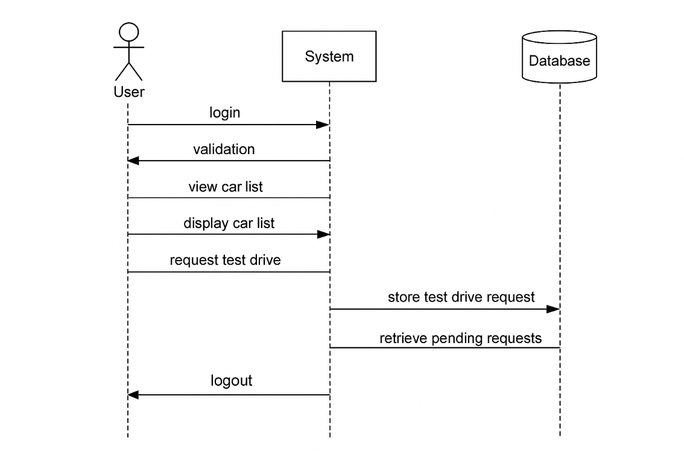

3.4 Activity Diagram

- Admin Activity Diagram
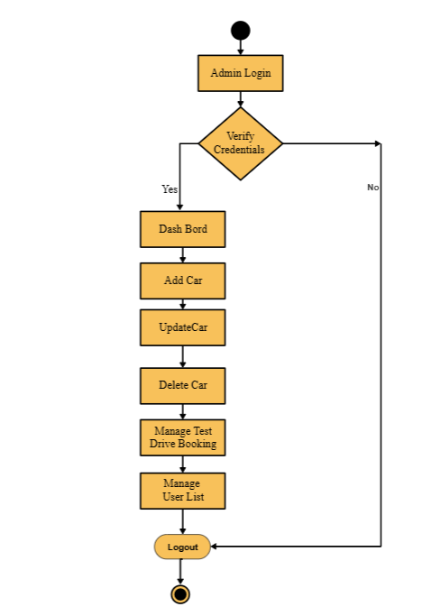

• User Activity Diagram
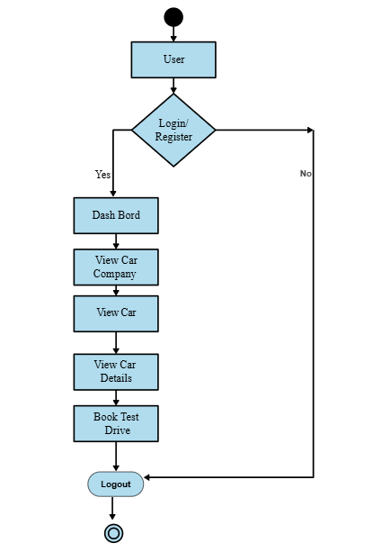

- An Activity Diagram shows the workflow of actions in the system.
In the Car Application, it represents how the Admin (manages cars, users, and test drives) and the User (views cars and books test drives) interact step by step with the system.

3.5 Data Dictionary

Database Name: YourCars.db
Table : 1
Table Name : allusers
Description : This Table Contains Store User Data

Field name | Type
email | TEXT
contact_num | TEXT
password | TEXT

Table : 2
Table Name : CarsModels
Description : This Table Contains Admin Add Cars, Image, Brand, Title, Price, Date, Des.

Field name | Type
COL_ID | INTEGER PRIMARY KEY
COL_IMAGE | BLOB
COL_BRAND | TEXT
COL_TITLE | TEXT
COL_PRICE | TEXT
COL-DATE | TEXT
COL_DESCRIPTION | TEXT
Table : 3
Table Name : Test Drive Bookings
Description : This Table Contains Users Book Test Drive.

Field name | Type
id | INTEGER PRIMARY KEY
name | TEXT
email | TEXT
contact | TEXT
brand | TEXT
date | TEXT
time | TEXT
status | TEXT

Development

4.1 Coding Standards
In this project, standard coding conventions and best practices were followed to make the code readable, reusable, and easy to maintain.
The goal was to write clean, consistent, and error-free code that can be easily understood by other developers or future maintainers.
- Programming Language Used:
  - Java (for Android development)
  - XML (for designing layouts)
- Naming Conventions:
  - Classes: Start with a capital letter (e.g., MainActivity, UserModel).
  - Variables: Use camelCase (e.g., userName, userEmail).
  - Methods: Use verbs in camelCase (e.g., getUserData(), savePost()).
  - Constants: Use all uppercase letters (e.g., DATABASE_NAME, TABLE_ADMIN).

- Commenting Standards:
  - Use // for single-line comments and /*...*/ for multi-line comments.
  - Add comments before methods and complex logic explaining what the code does.
  - Example:
// This method validates user login credentials
public boolean validateUser(String email, String password) {
// Code logic here }
- Indentation and Formatting:
  - Proper indentation should be maintained for better readability.
  - Use 4 spaces or 1 tab for code indentation.
- Error Handling:
  - Use try-catch blocks to handle exceptions gracefully.
  - Example:
try {
db.insert(TABLE_USER, null, values);
} catch (Exception e) {
e.printStackTrace();
}
- Database Naming Standards:
  - Table names in uppercase (e.g., ADMIN, USER, POST).
  - Column names in lowercase (e.g., user_id, email, password).
- Modular Programming:
  - Divide code into smaller methods and classes.
  - Each activity or feature should have a separate class.

4.2 Screenshots

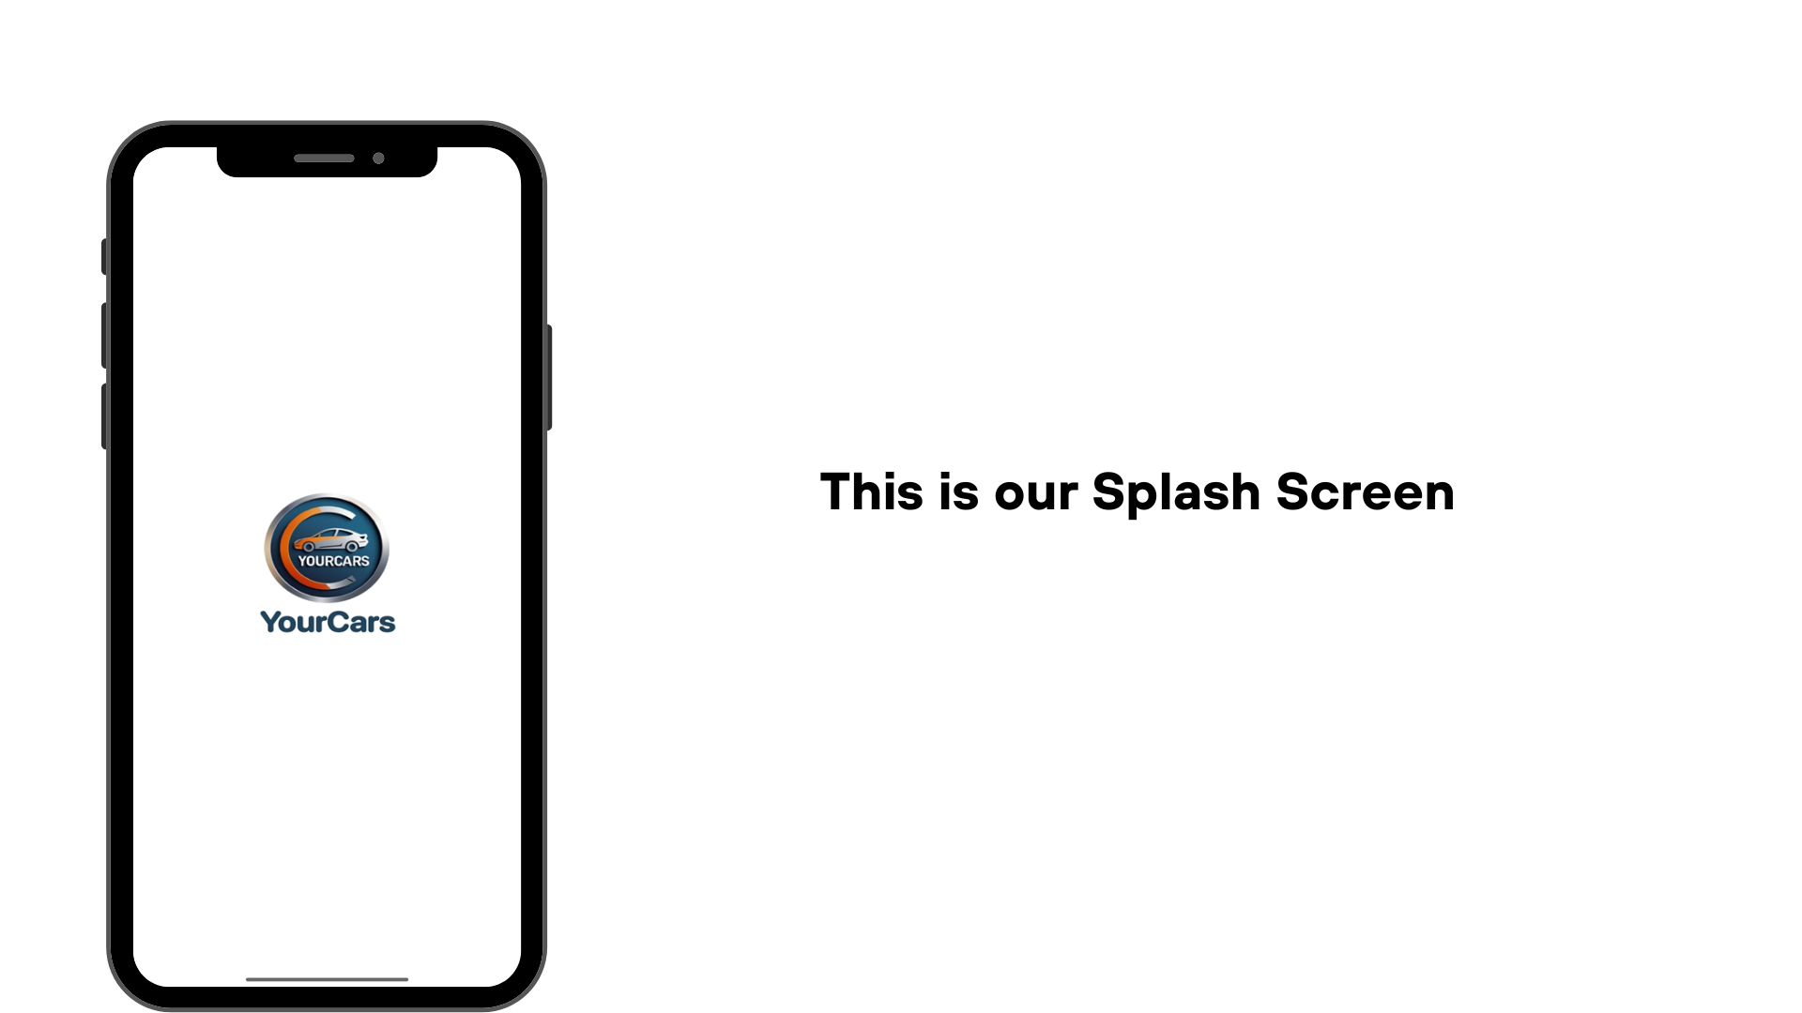

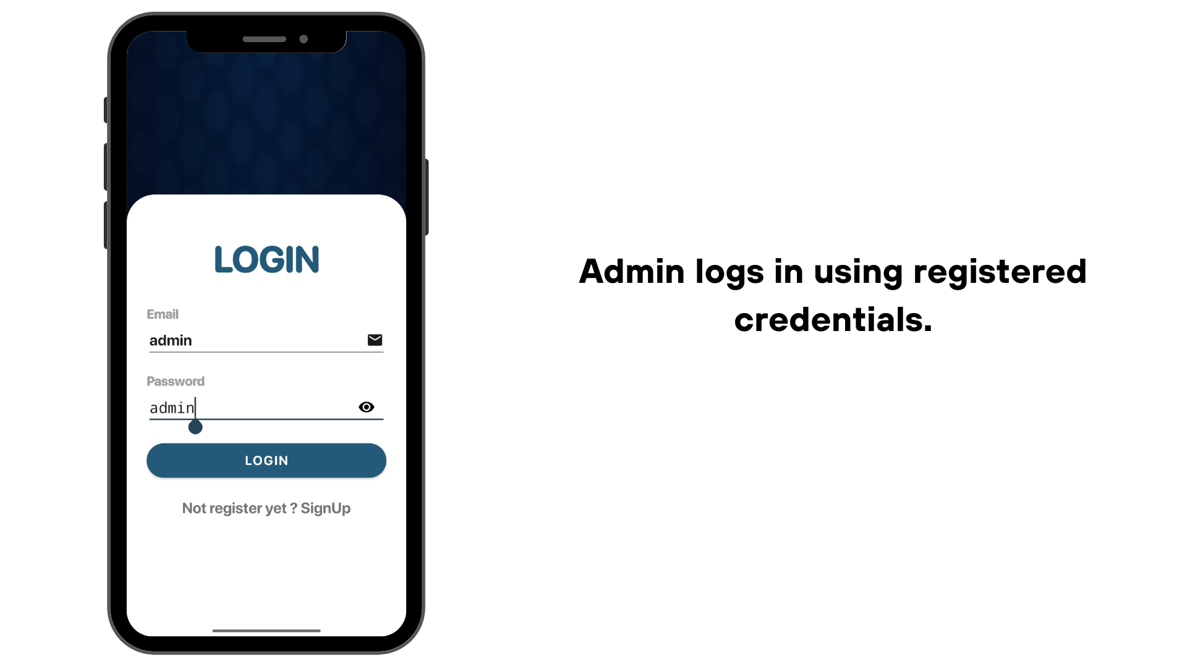

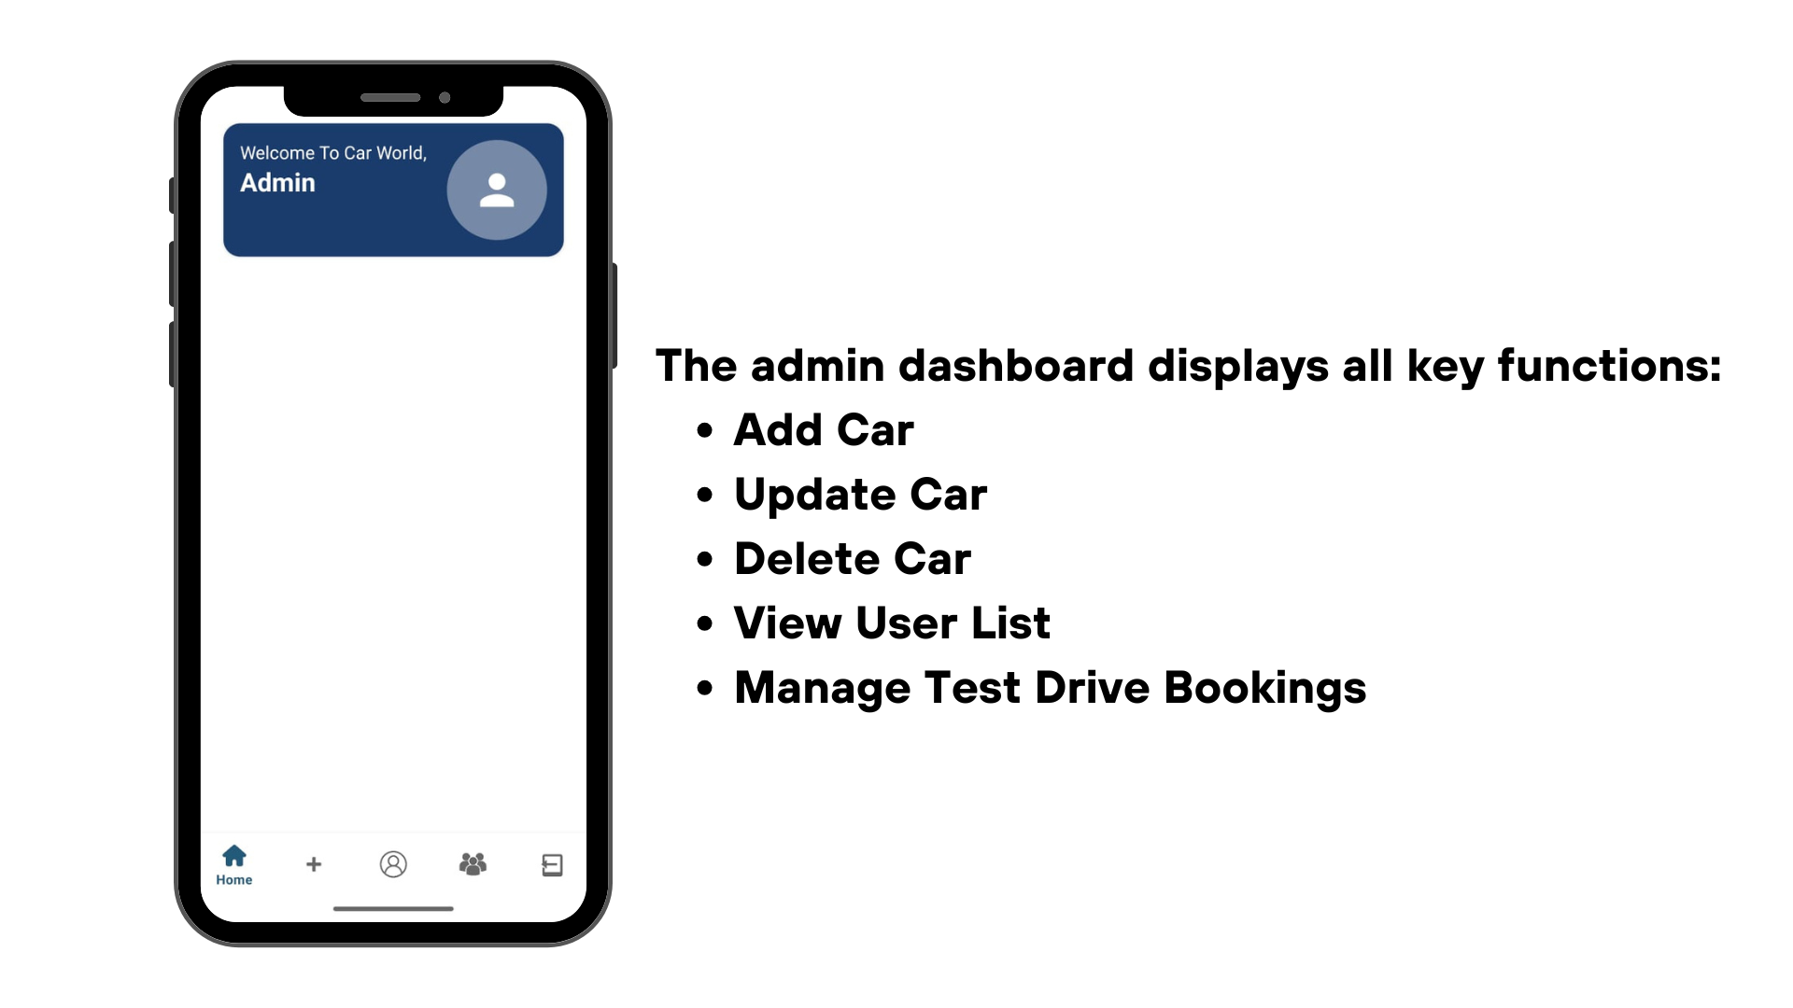
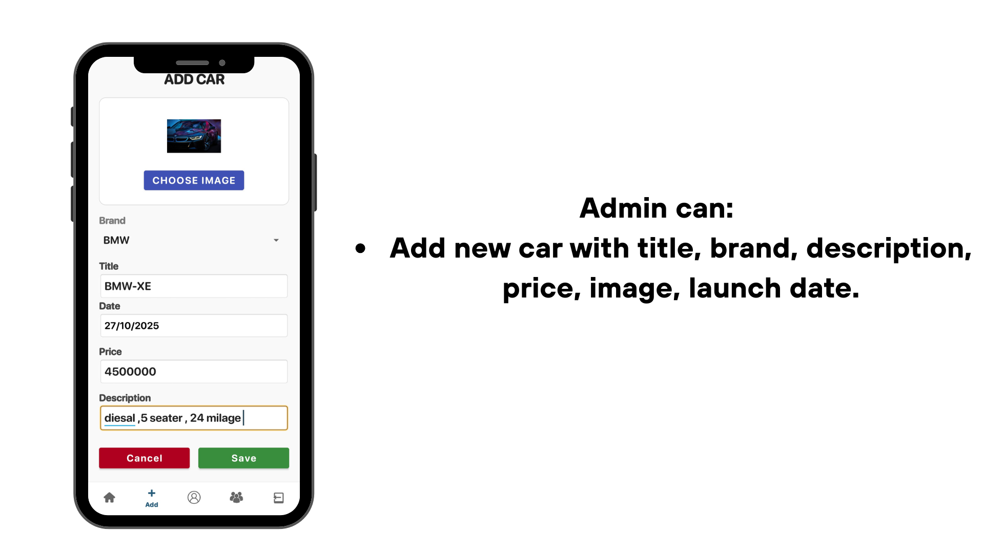
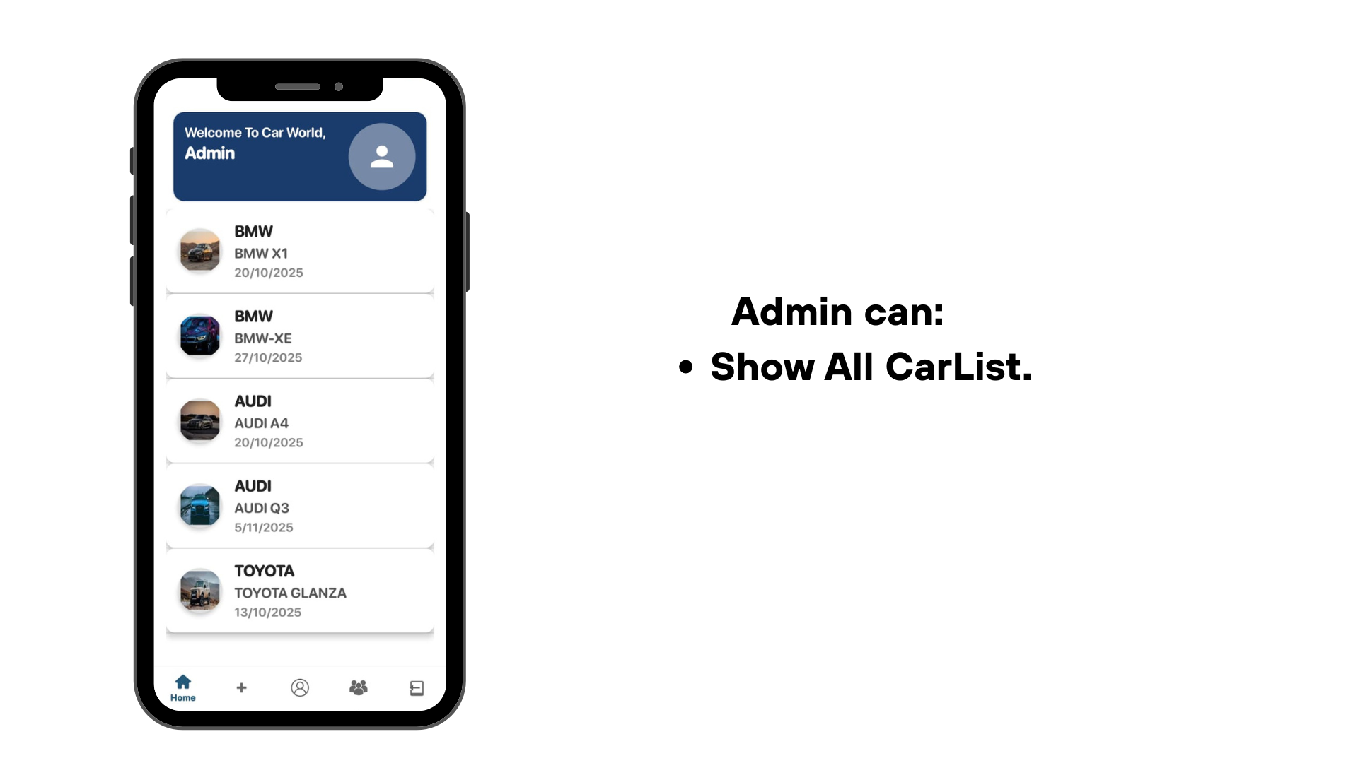
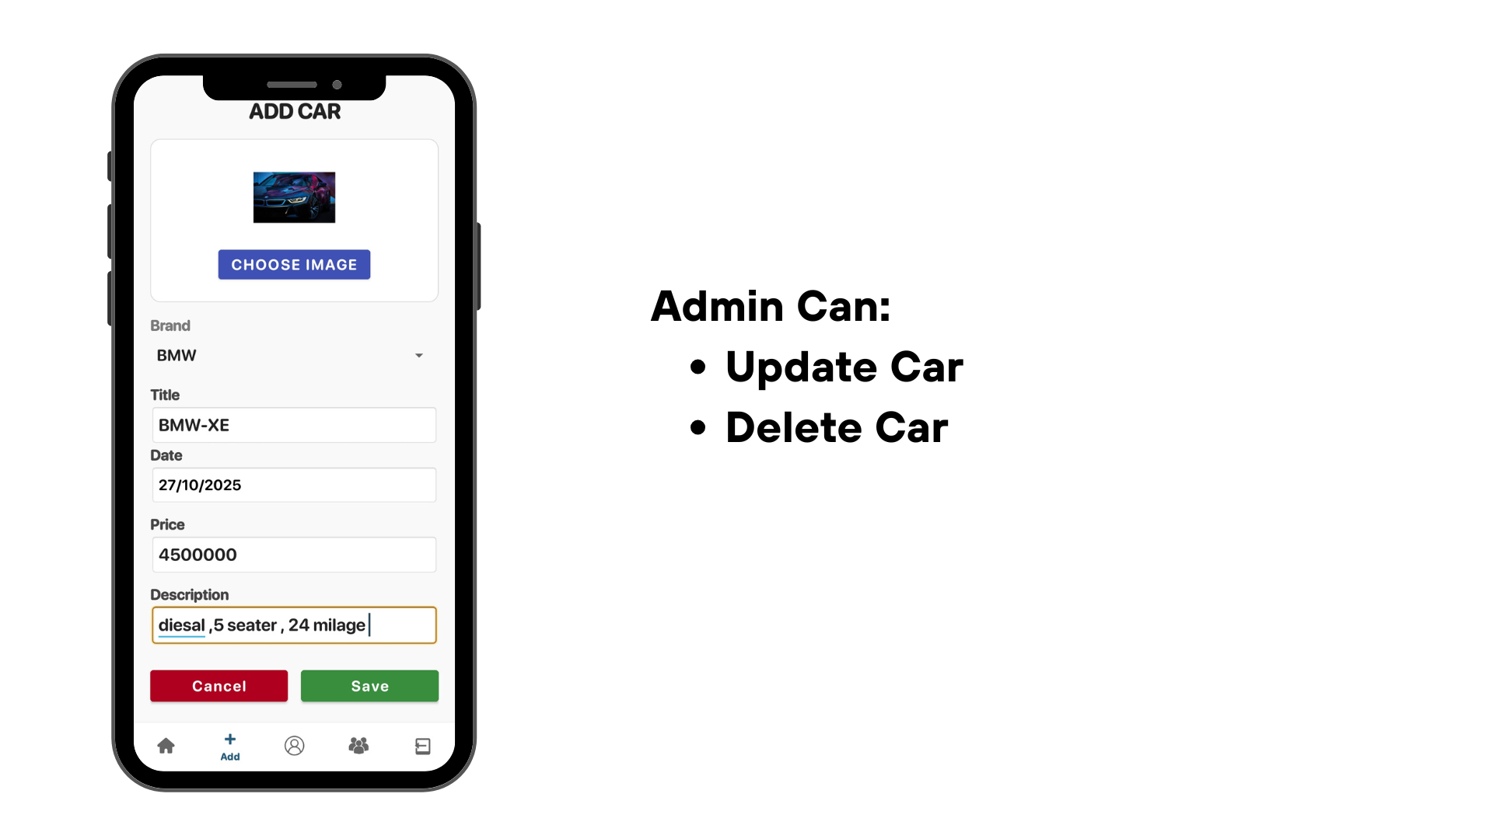

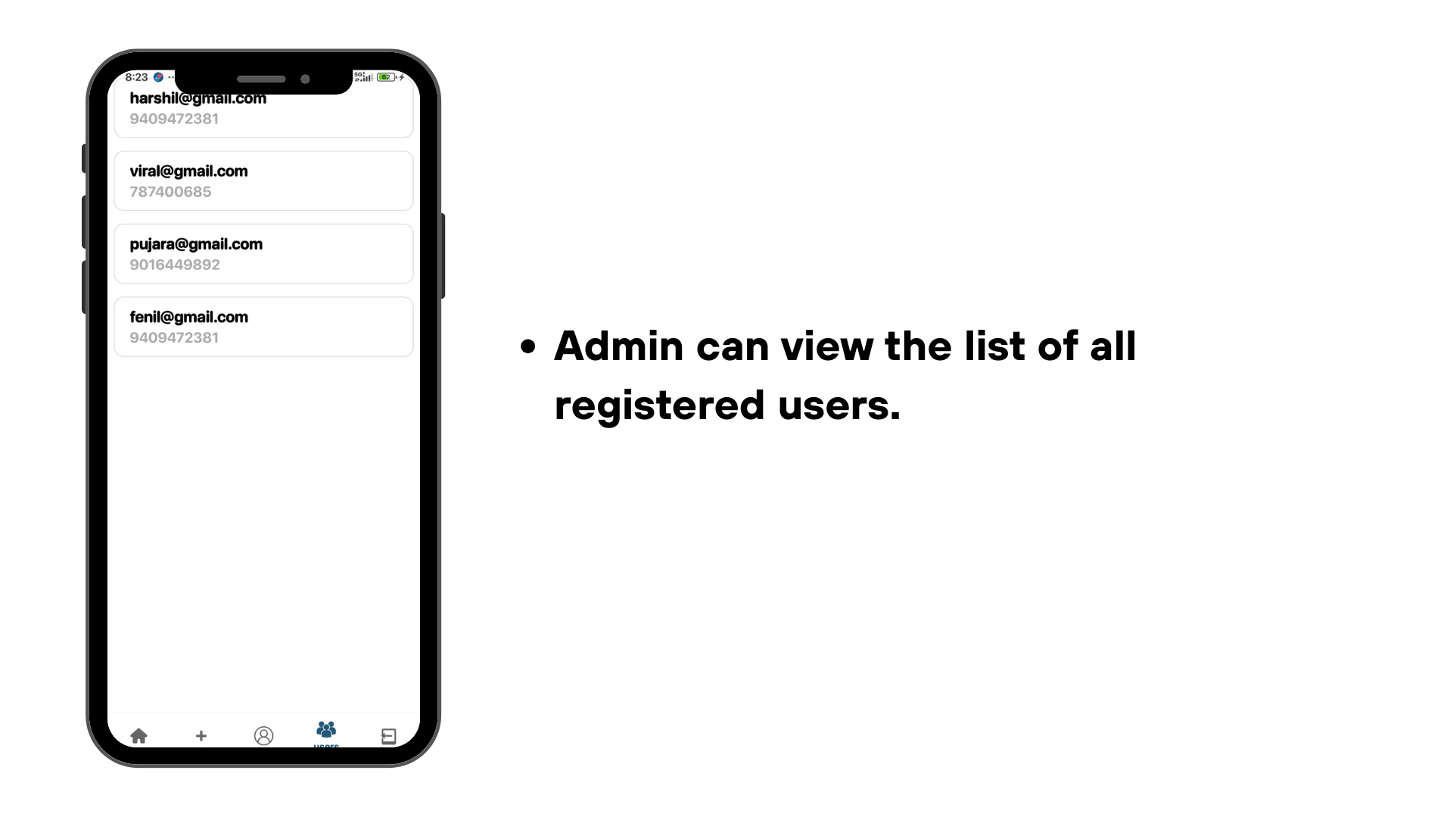
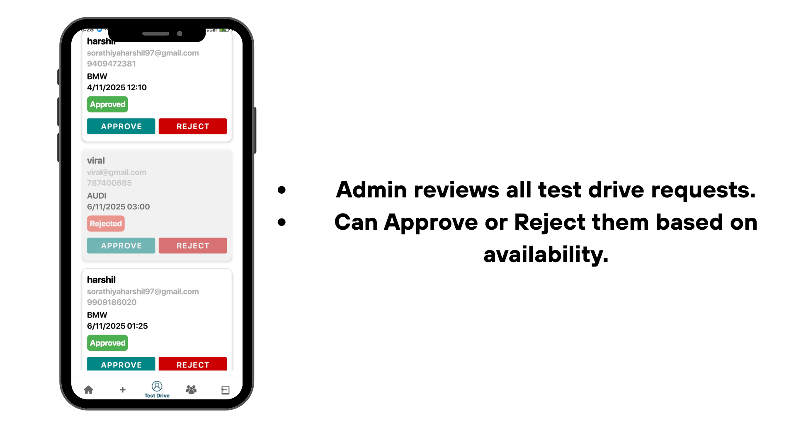
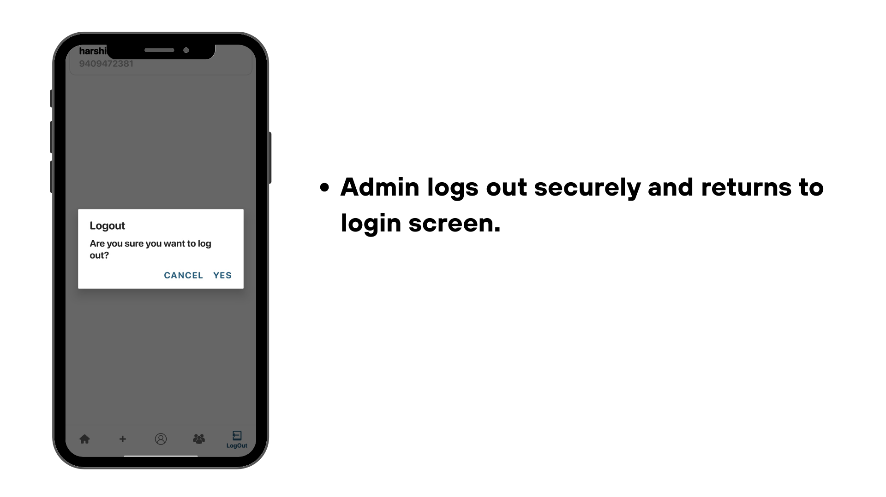
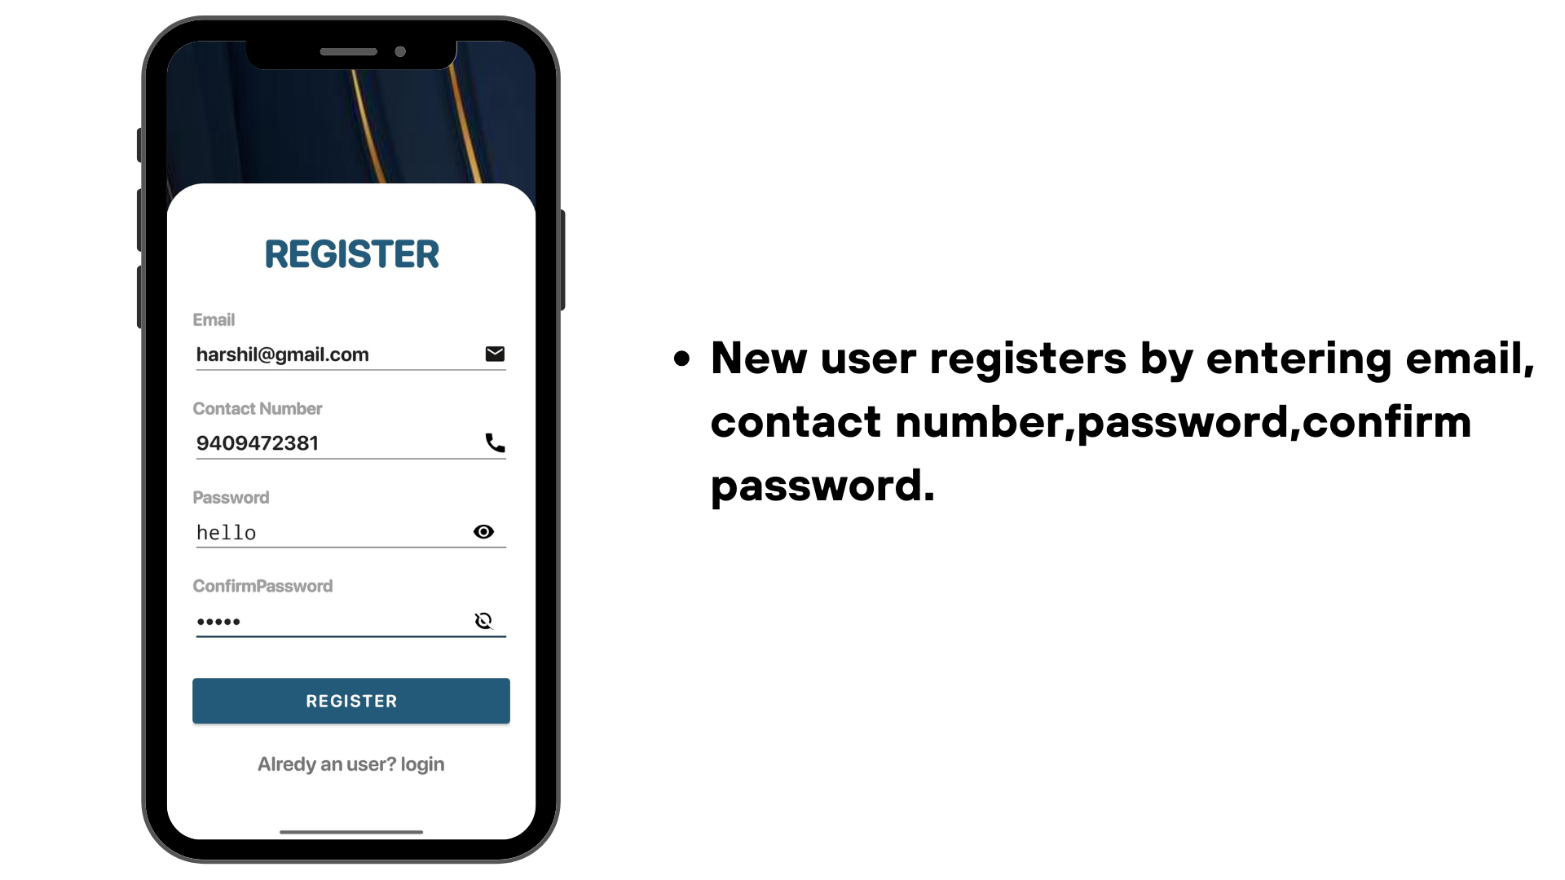

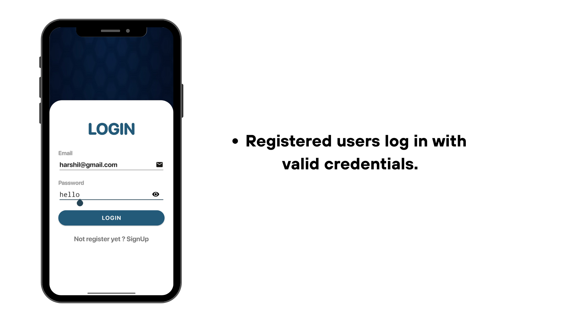
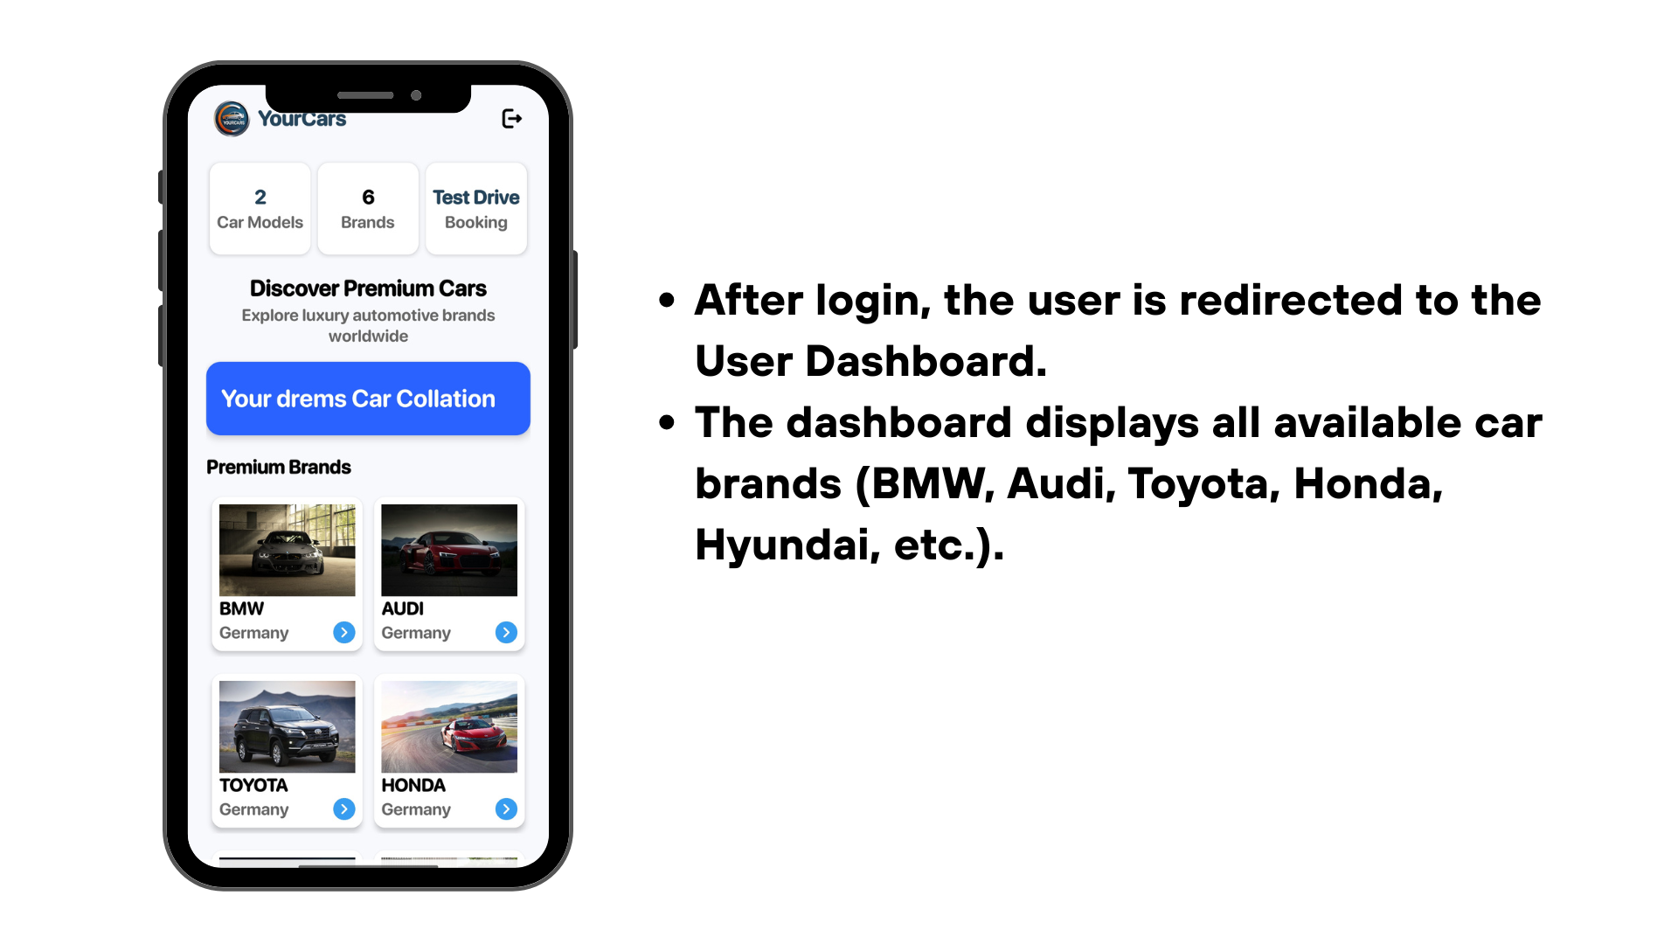

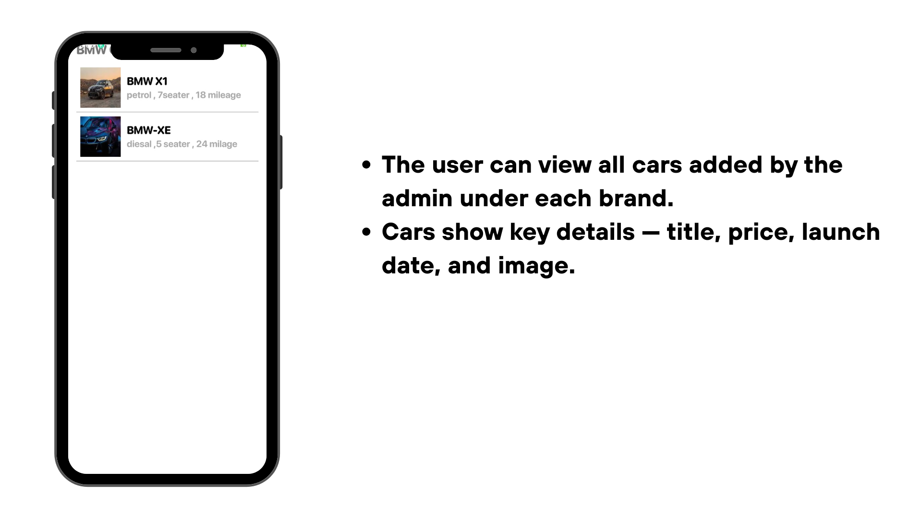
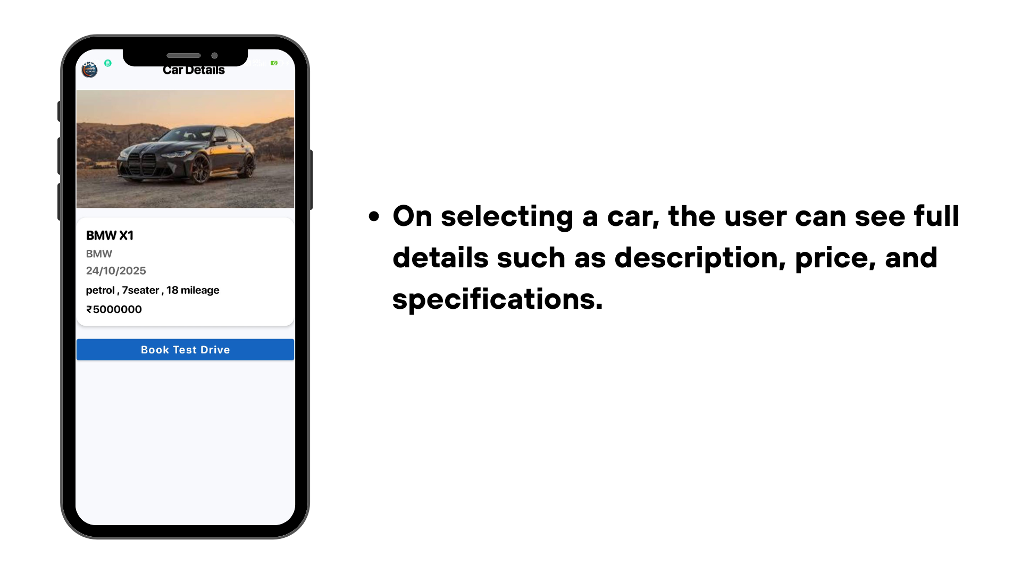

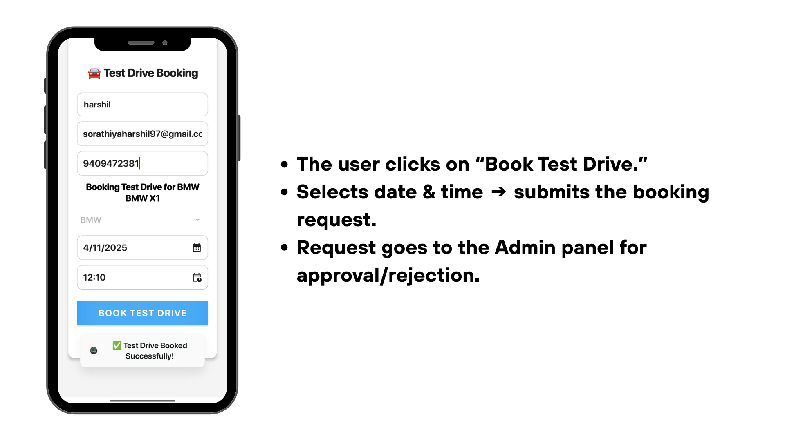
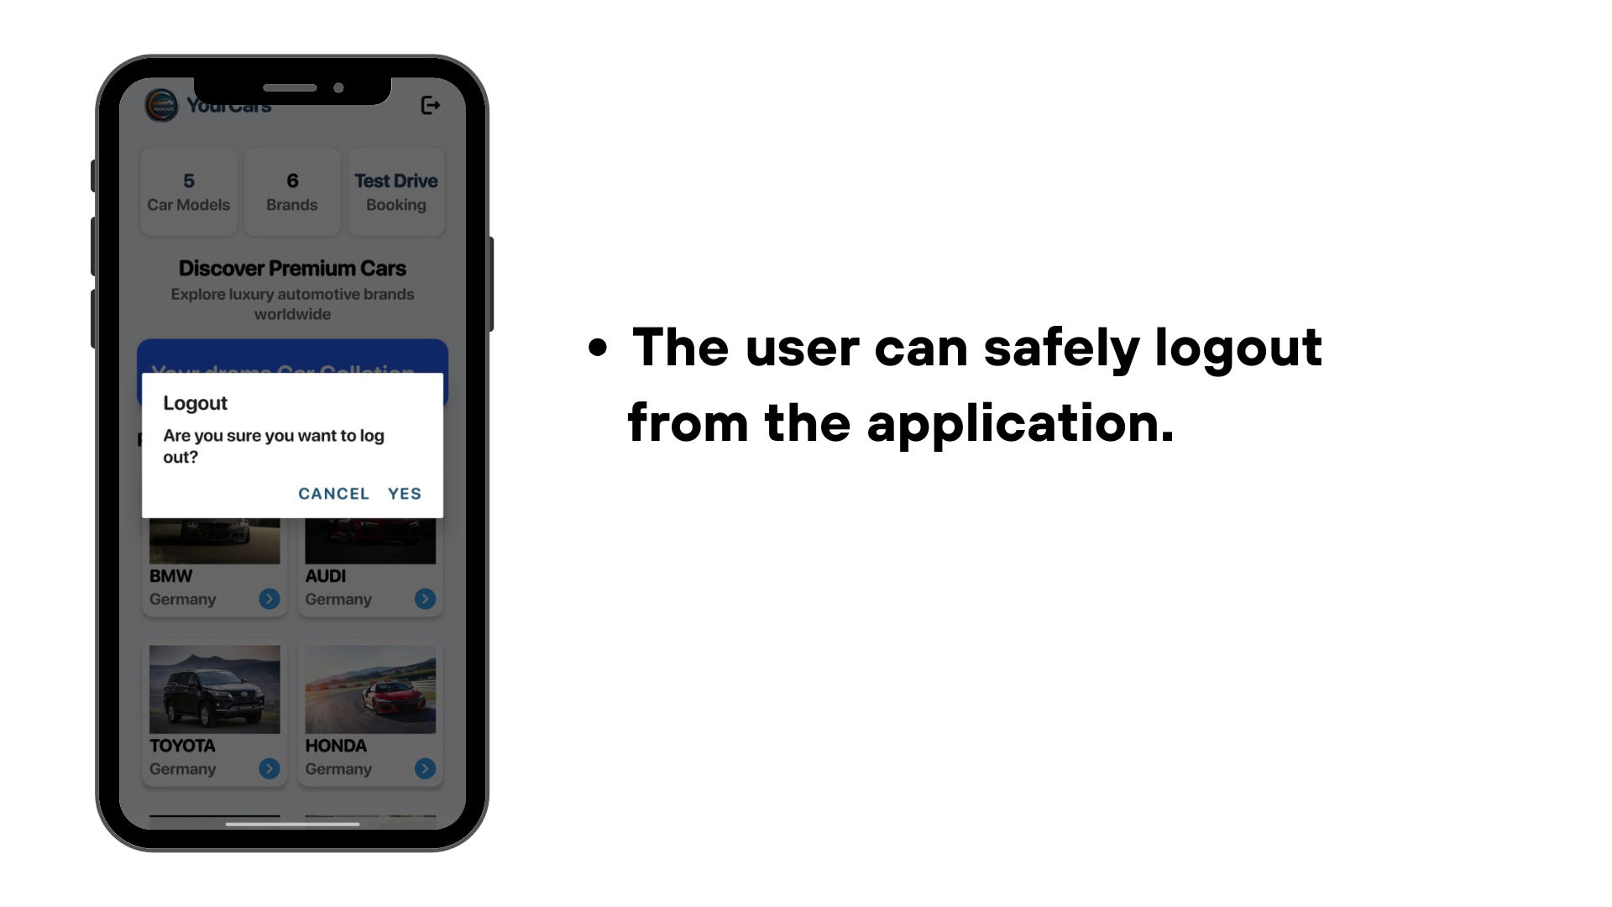

Application Testing

Testing is one of the most crucial phases of software development. It ensures that the application works as expected, meets user requirements, and is free from major defects.
In this project, Manual Testing was carried out to verify the functionality and reliability of the Your Cars.

5.1 Manual Testing
Definition:
Manual Testing is a process in which testers manually execute test cases without using any automation tools. It helps identify defects, usability issues, and functional mismatches in the software system.
Purpose:
To ensure that every module of the Community App works correctly according to the defined requirements.
Key Points:
- Manual testing is done before automation testing.
- It requires human effort but provides detailed insight into app performance and user experience.
- 100% automation is not possible; hence manual testing is essential.
Goal of Manual Testing:
- Verify that the application is error-free.
- Ensure it meets all specified functional requirements.
- Confirm that all defects are fixed and the system is re-tested successfully.
- Deliver a stable, bug-free product to the end users.

5.1.1 Test Cases
A Test Case defines the specific conditions, inputs, and expected results used to verify a particular function of the software.
Each module or screen in the app should have at least one test case.
- Each test case should have a unique ID.
- Write in a table format.
- Include details such as the functionality being tested, test data, steps to execute, and expected vs. actual results.
- Mention the status as Pass or Fail.
case:1
Test Case ID | Module | Test Scenario / Functionality | Preconditions | Test Steps | Test Data | Expected Result | Actual Result | Status
TC-01 | User Module | User Login | User must be registered | 1. Open app  2. Enter email & password  3. Tap Login | Email: valid  Password: valid | User logs in successfully and navigates to Dashboard | Works as expected | Pass
TC-02 | User Module | Invalid Login | User must be registered | 1. Enter wrong password  2. Click Login | wrong password | Error message displayed: "Invalid Credentials" | Works as expected | Pass
TC-03 | User Module | User Registration | User not registered | 1. Go to Register  2. Enter name, email, password  3. Submit | Name, Email, Password | Account created successfully | Works as expected | Pass
TC-04 | User Module | View Car List | User must be logged in | 1. Login  2. Open Home Page | — | Car list displayed with all brands | Works as expected | Pass
TC-05 | User Module | View Car Details | Car list must exist | 1. Tap on any car | Car Name, Brand, Price, Description | Shows full details | Works as expected | Pass
TC-06 | User Module | Book Test Drive | User logged in, car available | 1. Open car details  2. Click “Book Test Drive”  3. Select date/time  4. Submit | Date, Time | Booking saved and sent to Admin | Works as expected | Pass
TC-07 | User Module | Logout | User logged in | 1. Open menu  2. Tap Logout | — | App logs out and returns to Login screen | Works as expected | Fail
TC-08 | Admin Module | Admin Login | Valid admin credentials | 1. Open app  2. Enter admin email & password  3. Tap Login | admin email, password | Admin navigates to Admin Dashboard | Works as expected | Pass
TC-09 | Admin Module | Add Car | Admin logged in | 1. Open Add Car page  2. Enter details  3. Upload image  4. Save | Car name, price, brand, description | Car added into list | Works as expected | Pass
TC-10 | Admin Module | Update Car | Existing car in DB | 1. Select car  2. Tap Edit  3. Update fields  4. Save | Updated values | Car details updated | Works as expected | Fail
TC-11 | Admin Module | Delete Car | Car must exist | 1. Select car  2. Tap Delete | — | Car removed from list | Works as expected | Pass
TC-12 | Admin Module | View Test Drive Requests | User must book a test drive | 1. Open Test Drive menu | — | All bookings visible | Works as expected | Pass
TC-13 | Admin Module | Approve Test Drive | Booking must exist | 1. Select request  2. Click Approve | — | Status updated to Approved | Works as expected | Pass
TC-14 | Admin Module | Reject Test Drive | Booking must exist | 1. Select request  2. Click Reject | — | Status updated to Rejected | Works as expected | Pass
TC-15 | Admin Module | View Users List | Registered users exist | 1. Open Users module | — | Shows all registered users | Works as expected | Pass

Proposed Enhancements

Future Enhancement
The current version of the Car Application allows users to view cars from multiple brands and book test drives easily. In the future, the system can be improved with the following features:
- Online Payment System for secure advance booking.
- Google Maps Integration to locate nearby showrooms.
- Car Comparison Feature to compare models.
- Multi-Language Support for better accessibility.
- Improved Admin Dashboard with analytics and reports.
These enhancements will make the app more intelligent, user-friendly, and efficient for both users and admins.
1. Limitations of Current Version
- The current app allows viewing cars and booking test drives but lacks online payments, notifications, and dealer acessc.

2. Future Features / Add-ons
- Add online payment, car comparison, dealer module, and notification features.

3. Technical Enhancements
- Use cloud databases, improve security, and optimize performance.

4. User Experience Improvements
- Add multi-language support, and a modern user interface.
These updates will make the app faster, smarter, and more user-friendly

Conclusion

1. Project Summary
The Car Application is an Android-based mobile app designed to provide a single platform for users to view cars from multiple brands and book test drives easily. It includes two panels — Admin and User. The admin can add, update, delete cars, manage test drive bookings, and view registered users. Users can explore car details such as name, price, brand, and description, and book test drives conveniently.

2. Achievements
In this project, important features such as Admin and User Login/Registration, Car Management (Add, Update, Delete), Test Drive Booking, and Database Integration using SQLite were successfully implemented. The system meets its objectives by providing a centralized and user-friendly car management and test drive booking platform.

3. Learning Outcome
During the development of this project, I gained valuable experience in Android app development, SQLite integration, UI design, and data handling. I also learned skills in problem-solving, debugging, and testing, along with understanding how to design efficient mobile application architectures.

4. Limitations
The current version does not include features like online payment, push notifications, or car comparison, which can be added in future versions to enhance functionality.

5. Future Scope
In the future, the app can be expanded by adding online payments, AI-based car recommendations, and Google Maps integration to improve performance, accessibility, and user experience.

Bibliography

Purpose of This Section:
The Bibliography section lists all the sources and references used during the development and documentation of the project. It includes books, research papers, and online resources that helped in understanding programming, Android development, database management, and software design concepts.
• Lucidchart – Easy drag-and-drop UML tool
🔗 https://www.lucidchart.com
• Draw.io (diagrams.net) – Free and simple for UML diagrams
🔗 https://app.diagrams.net
• Creately – Great for Class, Activity & Use Case diagrams
🔗 https://www.creately.com
• Visual Paradigm Online – Professional UML design tool
🔗 https://online.visual-paradigm.com
• EdrawMax Online – UML diagram templates available
🔗 https://www.edrawmax.com/online
Example:
- Android Developers Documentation – https://developer.android.com
- Java Programming: The Complete Reference –
- W3Schools – https://www.w3schools.com
- GeeksforGeeks – https://www.geeksforgeeks.org
- TutorialsPoint – https://www.tutorialspoint.com
- Draw.io (diagrams.net) – https://app.diagrams.net



