

AXI(Advanced eXtensible Interface)
The Advanced eXtensible Interface (AXI) is a point-to-point interconnect protocol defined in ARM’s AMBA specification. Unlike older shared-bus protocols such as AHB and ASB, AXI connects masters and slaves through an interconnect fabric (crossbar or NoC), eliminating bus contention and enabling high parallelism.
Key characteristics of AXI include:
- Five independent channels for read and write transactions.
- Independent read and write paths for concurrent operation.
- VALID/READY handshake mechanism on every channel.
- Burst-based transfers supporting multiple data beats per transaction.
- Multiple outstanding transactions with ID-based ordering.
- Out-of-order completion for flexibility and efficiency.
- Scalability from small microcontrollers to high-performance multi-core SoCs.
Because of its high bandwidth, low latency, and flexibility, AXI has become the industry-standard interconnect protocol for performance-critical designs.

AXI channels

Write Address(AW)

Write Data (W)

Write Response (B)

Read Address (AR)

Read Data (R)
SLAVE
MASTER
Address and control
AXI channels have 5 channels:
- AW for signals on the Write Address channel
- AR for signals on the Read Address channel
- W for signals on the Write Data channel
- R for signals on the Read Data channel
- B for signals on the Write Response channel (B stands for buffered, because the response from the slave happens after all writes have complete)

Write data

Write response

Address and control

Read Data

Write Operation:
- The master sends an address on the Write Address (AW) channel and transfers data on the Write Data (W) channel to the slave.
- The slave writes the received data to the specified address. Once the slave has completed the write operation, it responds with a message to the master on the Write Response (B) channel.

Read Operation:
- The master sends the address it wants to read on the Read Address (AR) channel.
- The slave sends the data from the requested address to the master on the Read Data (R) channel.

Each channel is unidirectional, so a separate Write Response channel is needed to pass responses back to the master. However, there is no need for a Read Response channel, because a read response is passed as part of the Read Data channel.

Channel Handshake
AXI4 protocol defines five different channels, and all these channels share the same handshake mechanism that is based on the VALID and READY signals.

Read and write handshakes must adhere to the following rules:
- A source cannot wait for READY to be asserted before asserting VALID.
- A destination can wait for VALID to be asserted before asserting READY.
These rules mean that READY can be asserted before or after VALID, or even at the same time.

Write Transaction:

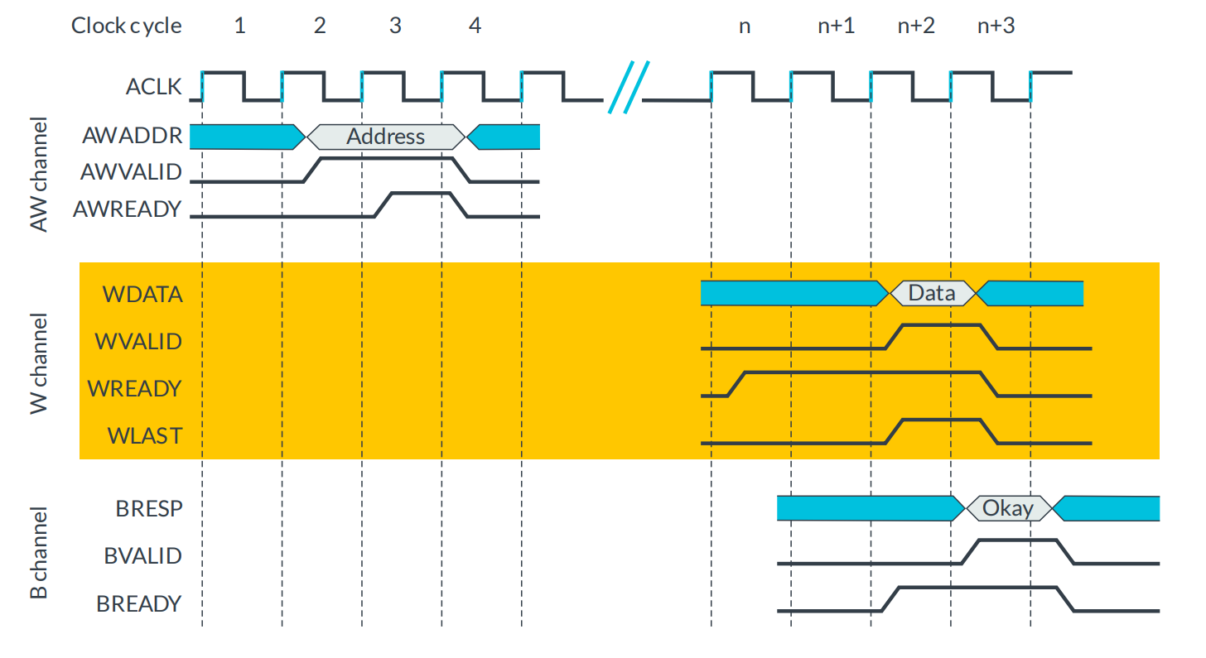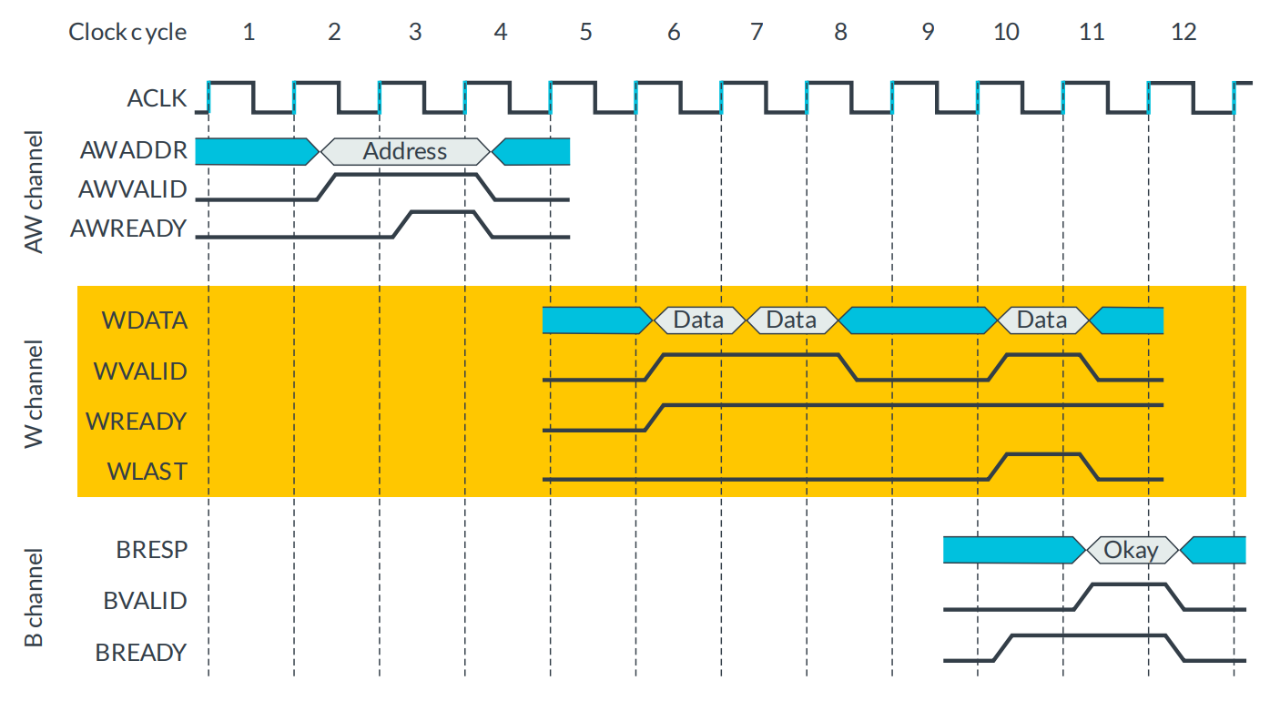

Handshake steps: handshake is where the master communicates the address of the write to the slave.
- The master puts the address on AWADDR and asserts AWVALID in clock cycle
- The slave asserts AWREADY in clock cycle 3 to indicate its ability to receive the address value.
- The handshake completes on the rising edge of clock cycle 4.

- After this first handshake, the master transfers the data to the slave on the Write (W) channel.
- The slave is waiting for data with WREADY set to high in clock cycle n / for multiple data at 6.
- The master puts the data on the WDATA bus and asserts WVALID in clock cycle n+2 / for multiple bit transfer master drives the WLAST high to indicate the final WDATA.
- The handshake completes on the rising edge of clock cycle n+3.

Finally, the slave uses the Write Response (B) channel, to confirm that the write transaction has completed once all WDATA has been received.
1. The master asserts BREADY.
2. The slave drives BRESP to indicate success or failure of the write transaction and asserts BVALID.
For multiple, one single BRESP covers the entire burst.
If the slave decides that any of the transfers contain an error, it must wait until the entire burst has completed before it informs the master that an error occurred.

VALID: Signal must remain asserted, meaning set to high, until the destination accepts the information (sticky signal).

READY: Signal indicates when destination can accept information.

This mechanism is not an asynchronous handshake and requires the rising edge of the clock for the handshake to complete.
Valid
Source

Destination

Ready

Multiple bit data
Single bit data

Read Transaction
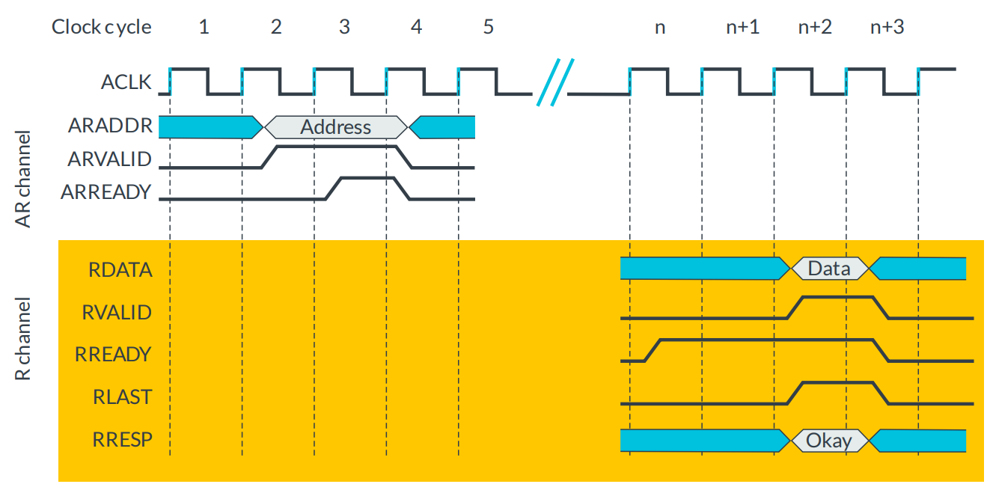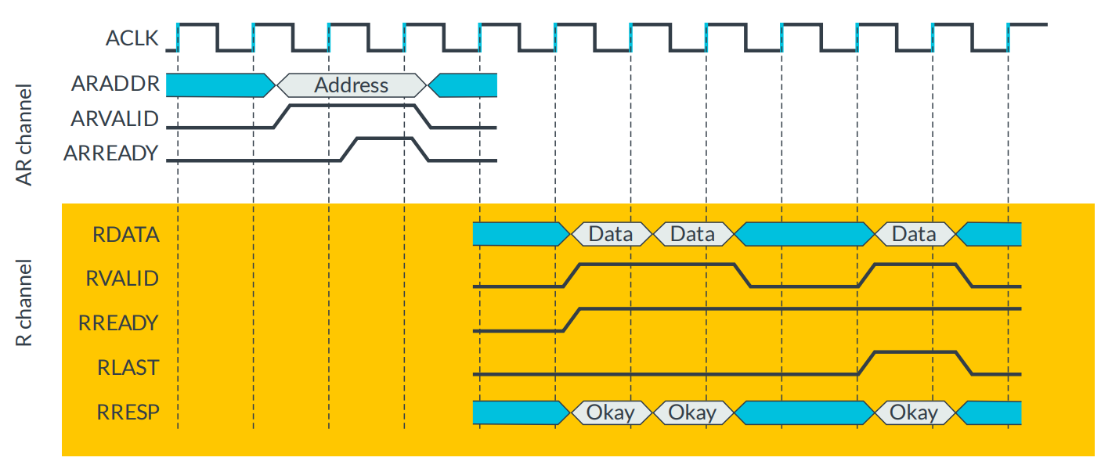

First, there is a handshake on the Read Address (AR) channel
- In clock cycle 2, the master communicates the address of the read to the slave on ARADDR and asserts ARVALID.
- In clock cycle 3, the slave asserts ARREADY to indicate that it is ready to receive the address value.
- The handshake completes on the rising edge of clock cycle 4.

Next, on the Read (R) channel, the slave transfers the data to the master.
- In clock cycle n, the master indicates that it is waiting to receive the data by asserting RREADY.
- The slave retrieves the data and places it on RDATA in clock cycle n+2. In this case, because this is a single data transaction, the slave also sets the RLAST signal to high. At the same time, the slave uses RRESP to indicate the success or failure of the read transaction to the master and asserts RVALID.
- Because RREADY is already asserted by the master, the handshake completes on the rising edge of clock cycle n+3.

One difference between a read transaction and a write transaction is that for a read transaction there is an RRESP response for every transfer in the transaction. This is because, in the write transaction, the slave must send the response as a separate transfer on the B channel. In the read transaction, the slave uses the same channel to send the data back to the master and to indicate the status of the read operation.

If an error is indicated for any of the transfers in the transaction, the full indicated length of the transaction must still be completed. There is no such thing as early burst termination.

Response signaling
For read transactions, the response information from the slave is signaled on the read data channel using RRESP.
For write transactions, the response information is signaled on the write response channel using BRESP.
RRESP and BRESP are both composed of two bits, and the encoding of these signals can transfer four responses,

Response code | Description
00 - OKAY | OKAY indicates that a normal access has been successful. This response can also indicate that an exclusive access has failed. An exclusive access is when more than one master can access a slave at once, but these masters cannot access the same memory range.
01 - EXOKAY | Exclusive access okay, indicates that either the read or write portion of an exclusive access has been successful
10 – SLVERR | Slave error is R is used when the access has reached the slave successfully, but the slave wants to return an error condition to the originating master.
11 - DECERR | Decode error is often generated by an interconnect component to indicate that there is no slave at the transaction address.

