I2C
I²C (Inter-Integrated Circuit) is a two-wire, synchronous, serial communication protocol designed for short-distance, on-board communication between integrated circuits.

It was introduced by Philips (NXP) to minimize:
- Pin count
- Routing complexity
- Hardware cost++

Key features:
- Use only two wires shared bus SCL(serial clock) and SDA(serial data), all devices are sharing this bus only, so need to chip select.
- It supports Multi-Master and Multi-Slave with no bus contention due to open drain signalling.
- Synchronous data transfer as data transfer only using SCLK.
- Half Duplex Communications as only SDA is used for Address, write data, read data and acknowledgment.
- It’s a Bidirectional communication protocol.
- Low pin Count and low Hardware Cost.

I2c speed modes
I2C Mode | Maximum Bit Rate
Standard – mode | 100kbps
Fast-mode | 400kbps
Fast-mode Plus | 1Mbps
High-speed mode | 3.4Mbps
Ultra-Fast mode | 5Mbps (write only mode)

I2C Physical Layer

SCL: SCL is used to synchronously clock data in or out of the target device.
SDA: It is serial data line used to transmit data to or from target devices.

Open DRAIN connections:
SCL and SDA is signals are Open Drain Signalling in which devices can only drive 0(Low) and connect to an NMOS transistors, high logic is achieved with external pull up resistors.
Vdd
Pullup
resistors

SDA / SCL

Because of capacitance on the I2C communication line, the SDA and SCL lines discharge with an exponential settling RC time constant depending on the size of the pullup resistor and capacitance on the I2C bus.
Higher capacitance limits the speed of I2C communication, the number of devices, and the physical distance between devices on the bus.
A smaller pullup resistor has a faster rise time but requires more power for communication. A larger pullup resistor has a slower rise time leading to slower communication but requires less power.

VCC
R R
S1
S2

SDA
SCL
MASTER

When the NMOS turns off, the device stops pulling current, and the pullup resistor pulls the SDA or SCL line to VDD. The pullup resistor pulls the line high. The transition of the open-drain line is slower because line is pulled up against the bus capacitance and is not actively driven.

Device I2C
When the NMOS is on, the device pulls current through the resistor to ground. This pulls the open-drain line low. The transition from high to low for I2C is a fast transition as the NMOS pulls down on SDA or SCL.

www.linkedin.com/in/harshita-harshi-9377891bb
I2C Protocol
I2C START:
I²C communication is initiated by a master device. When the bus is idle (both SDA and SCL are HIGH), the master generates a START condition by pulling SDA from HIGH to LOW while SCL remains HIGH. This transition signals the beginning of an I²C transaction.
After the START condition is issued, the bus is considered busy, and other masters must defer their transmissions. In a multi-master system, if multiple masters initiate a START simultaneously, no conflict occurs as bus ownership is later resolved through bit-wise arbitration during the address and data phases.
I2C STOP:
When master is done with communication, the master generates a STOP condition by pulling SCL from LOW to HIGH and then SDA is release.
SDA

SCL

I2C Start I2C Stop
Data transmission using SDA and SCL :
1 SDA (high-Z) releases the line (NMOS off), allowing the pullup resistor to pull the line to a high level at the sampling time SCL(high)
0 SDA pulls down on the line (NMOS on) at the sampling time SCL(high).
For a valid bit, SDA does not change between a rising edge and the falling edge of SCK for that bit.
- SCL rises → the receiver starts watching SDA
- SCL is high → SDA must stay constant
- SCL falls → that bit is completed
Any time SDA changes during the high period of SCL, the bus interprets it not as data but as a START/STOP signal.
I2C Communication Frame :
Communication will start by sending a START (pulling SDA from HIGH to LOW while SCL remains HIGH):
1st Frame with ACK is for Device address frame, each I2C target device has an associated unique I2C address. If we have frame of 8 bits, then 2⁸ = 256 i2c address is possible, but if we have limited devices then we can use these bits for specific operation, for example, for R/W operation.
At the end of the address byte communication, the target device pulls down the SDA during the SCL pulse to indicate to the controller that the address was received. This is known as an acknowledge (ACK) bit. If the bit is high, this is known as a NACK and there was no ACK (unsuccessful).
2nd Frame with ACK or more frames are for Data Frames . These frames are sent one byte at a time with ACK, and if in any transition if we get NACK, the transmission will be STOP.
Else, At the end of an I²C transfer, the master stops communication by generating a STOP condition
SDA ACK

SCL

D22
D1
R/W
A0
A1
A2
A3
A4
A5
A6

www.linkedin.com/in/harshita-harshi-9377891bb
ADDR_ACK
R_ACK
W_ACK
STOP
WDATA[7:0]
RDATA[7:0]
rd?
Add[7:1] rd

START
Idle

SCL = 0 &
SDA= 0

1. IDLE State
- Default bus condition.
- Both SDA and SCL remain HIGH due to pull-up resistors.
- Master monitors start_req.

2. START State
- Master generates START condition by making SDA goes high to low while SCL is high.
- This indicates beginning of a new transaction and bus ownership by master.

3. ADDR_SHIFT State [7:0]
- The [7:1] represent the Address to which we need to write or read.
- The last bit will indicate the read or write operation, if it is 1 read else if 0 then write.

4. ADDR_ACK State: Master releases SDA, Slave will response through SDA.
- If SDA line is low, Acknowledge(ACK) is received from slave, transaction continuous.
- If SDA line high, Negative acknowledge NACK and we goes directly to STOP state.

5. WDATA_SHIFT State (Write Mode): rd = 0 , SDA driven by Master and SCL toggled for 8 cycles will write the data to register address send on Address shift state.

6. W_ACK State: Master Releases SDA, Slave toggle SDA during 9th clock by making it 0 for ACK.

7. RDATA_SHIFT State (Read Mode): Master will release SDA and Samples SDA during each SCL HIGH.

8. W_ACK State: Master Releases SDA, Slaves SDA during 9th clock by making it 0 for ACK.

9. STOP State:
- Master generates STOP condition by making SDA 0 to 1 while SCL is high.
- Indicates: End of transaction and Bus released

www.linkedin.com/in/harshita-harshi-9377891bb
General call
I2C address reserved the first byte address for general call address.
General call address is used to address all the devices connect to the bus of I2C at the same time.
The second byte will give the command to followed to these devices.
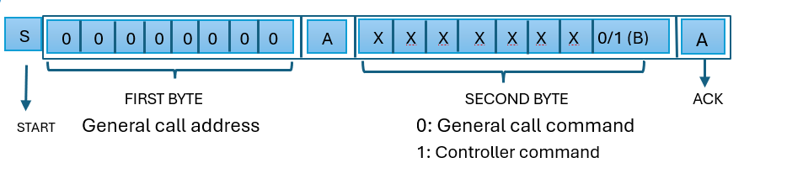
General Call Reset : When second byte is 6, i.e the frame is 06 then we reset all the devices in the I2C bus.

I2C

