SPI (Serial Peripheral Interface)
SPI is a synchronous serial communication interface used for short-distance communication. SPI interface was developed by Motorola to provide full-duplex synchronous serial communication between master and slave devices.
Key features:
- It is a serial and synchronous interface. The synchronous interface means the clock signal is synchronized between both master and slave (Unlike UART communication which is asynchronous).
- Full-duplex communication allowing simultaneous transmit and receive over MOSI and MISO.
- It has only one Master, but Slave can be one or more.
- Configurable clock polarity and phase (CPOL, CPHA) supporting 4 SPI modes (0–3) for flexibility with different peripherals.
- High-speed data transfer, faster than I²C or UART, reaching tens of MHz.
- No addressing mechanism, as slaves are selected only by chip-select lines.
- Flexible frame size, typically 8 bits but can extend to 4, 16, or 32 bits.
- Short-distance communication suited for on-board MCU–peripheral interfacing.
SPI interface:

SS: Select slave or chip select is a line selects the slave to which Master want to transfer data. It is an active low pin.
SCLK: Serial clock generated by the master to slave for synchronizes data transfer.
MOSI: Master out slave in, Output from the Master used to send data to the peripheral device (slave).
MISO: Master in slave out, Output from the peripheral device(slave) used to send data to the Controller(master)
Peripheral output becomes high impedance when SS is not selected.
Clock polarity and Phase:
SPI MODE | CPOL | CPHA | Data is shifted out on | Data is sampled on
0 | 0 | 0 | falling SCLK, and when SS activates | rising SCLK
1 | 0 | 1 | rising SCLK | falling SCLK
2 | 1 | 0 | rising SCLK, and when SS activates | falling SCLK
3 | 1 | 1 | falling SCLK | rising SCLK
Master device also configures two things such as clock polarity and phase according to the data transmission.
CPOL: During the active and idle state of the clock, the CPOL bit defines the clock polarity.
0: SCLK idle LOW and 1: SCLK idle HIGH
CPHA: Bit defines the phase clock. CPHA bit value sets either data will shift/sample on a positive edge of the clock or negative edge of the clock signal. CPHA selects which edge is used for sampling, relative to the first clock edge after CS assertion.
One edge = shift, Opposite edge = sample

+

MOSI
MISO
SS
SCLK MASTER SPI
ss

Q D

Q D

CLK

ss SS
CPOL= 0
CPOL=1
CPHA=0 CPHA=1
Data is set up when SS falls low, Data is set up at the earlier leading edge of SCLK
or at the earlier trailing edge of SCLK

www.linkedin.com/in/harshita-harshi-9377891bb
Controlling Multiple Peripherals:
- Multiple SS: Each device has an independent peripheral select; other signals will be shared between devices.

Advantages
- Easy to implement in RTL/hardware.
- Direct, independent control of each slave.
- Extremely low latency – immediate access to the selected slave.
- One slave failure does not affect others.
Disadvantages
- Requires N SS lines for N slaves → not scalable.
- Increased chip area (more GPIO pads + SS decode logic).
- Routing congestion as many control nets , harder Clock Tree Synthesis (CTS) and timing closure.
- Complex PCB routing with many extra wires.
- Daisy Chaining: Data is sent from one device to other devices in a chain, MISO of one device is connected to the MOSI of next devices with only single.
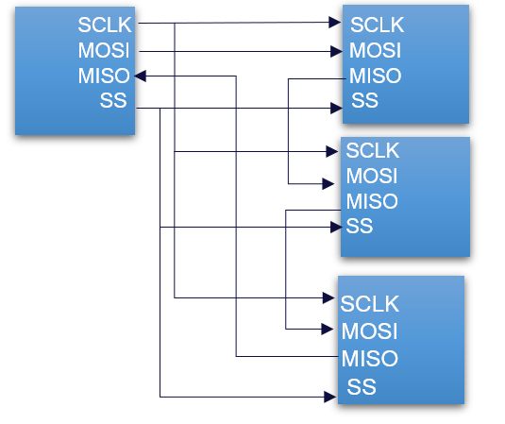

Advantages
- Requires only one SS line → fewer GPIOs, smaller area.
- Cleaner routing and CTS – fewer global signals.
- Highly scalable – easy to add more slaves.
- Ideal for shift-register style peripherals (LED drivers, GPIO expanders).
Disadvantages:
- Higher latency – must shift through all devices to reach the target slave.
- Lower fault tolerance – one bad slave may break the chain.
- More complex RTL design (tracking bit positions across all slaves).
- All slaves shift simultaneously, even if only one needs an update.

SCLK SCLK
MOSI MOSI
MISO MISO
SS1’ SS1’
SCLK
SS2’ MOSI
MISO
SS3’ SS2’
SCLK
MOSI
MISO
SS3’

www.linkedin.com/in/harshita-harshi-9377891bb
Working of SPI
The SPI bus consists of a single master and multiple slave devices.
Step 1: To initiate communication, the master pulls the SS/CS line LOW of the intended slave, which activates only that slave while the others remain inactive and ignore the bus.
Step 2: Once the connection is established, the master drives SCLK, and the active slave reacts to SCLK edges as defined by CPOL/CPHA.
Step 3: On each SPI clock cycle, the master shifts one bit on the configured shift edge, and the slave samples the bit on the configured sample edge, as defined by CPOL/CPHA.
Step 4: Data transfer is full duplex, while the master transmits data on MOSI, the slave simultaneously transmits data on MISO.
Step 5: After the configured number of bits (e.g., 8 bits), the data exchange is complete, and additional frames may follow without deasserting CS if supported.
Step 6: When the transfer is complete, the master deasserts CS, forcing the slave to return to the IDLE state and release the MISO line.
IDLE state :
- CS = inactive
- SCLK = idle (CPOL)
- busy = 0
- Waits for start

LOAD (1 cycle)
- Assert selected CS
- Load TX shift register
- Reset bit counter to [width_bit -1]
- Prepare clock enable
- No SCLK toggling

TRANSFER
- CS = active
- SCLK toggling enabled
- Shift/sample controlled by datapath
- FSM waits for bit_cnt == 0

DONE (1 cycle) when bit_cnt ==0
- Deassert CS
- Disable SCLK
- Pulse done = 1
- Clear busy

www.linkedin.com/in/harshita-harshi-9377891bb
rst
start

bit_cnt == 0
DONE
TRANSFER
LOAD
IDLE

