PRACTICAL NO. :- 1

# NAME : HARSH G. INCHURKAR

# ROLL NO. : 41

# SECTION : 3A

# DATE : 27/07/2024

AIM : Study of anaconda IDE and it’s installation

THEORY :

1. **What is Anaconda?**

*Anaconda is a distribution of the Python and R programming languages for scientific computing (data science, machine learning applications, large-scale data processing, predictive analytics, etc.), that aims to simplify package management and deployment. The distribution includes data-science packages suitable for Windows, Linux, and macOS. It is developed and maintained by Anaconda, Inc., which was founded by Peter Wang and Travis Oliphant in 2012. As an Anaconda, Inc. product, it is also known as Anaconda Distribution or Anaconda Individual Edition, while other products from the company are Anaconda Team Edition and Anaconda Enterprise Edition, neither of which are free.*

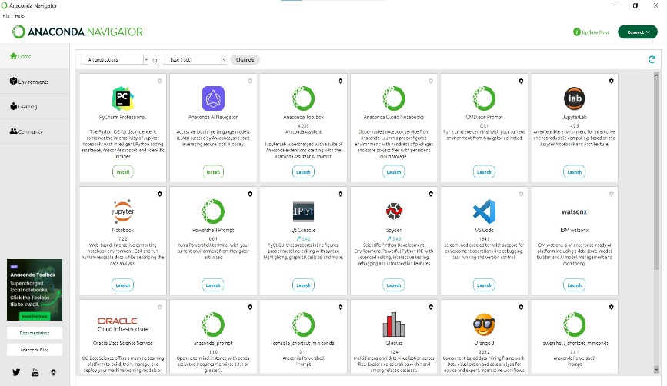

* **Popular Applications to Use in Anaconda**

Anaconda includes several applications, with some of the most commonly used ones being:

1. Jupyter Notebook:

An interactive web-based notebook that allows you to write and run code in real-

time.

2. JupyterLab:

An extension of Jupyter Notebook with additional features like file browsers,

terminals, and support for multiple panes.

3. Spyder:

An open-source scientific IDE specifically designed for data science, with features

like code editing, debugging, and interactive execution.

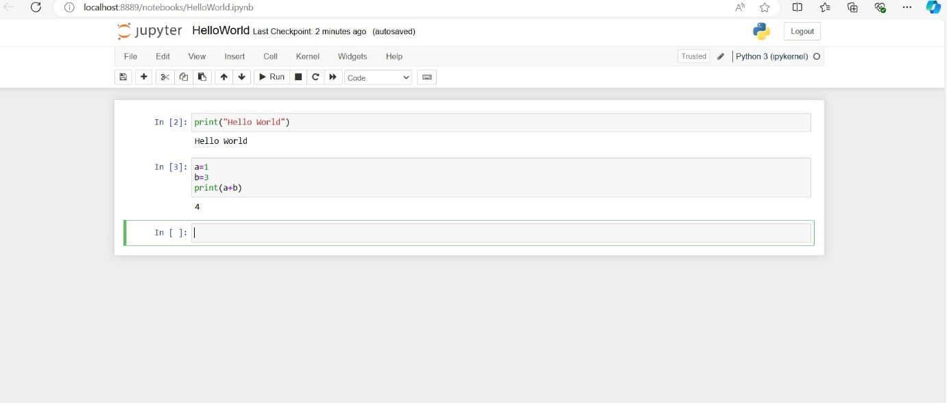

**2. Key Features of Anaconda:**

* **Conda Package Manager**: A tool for managing libraries and environments (similar to pip, but more powerful, as it resolves dependencies automatically).
* **Virtual Environments**: Allows you to create isolated environments for different projects, preventing conflicts between packages.
* **Integrated IDEs**: Comes bundled with:
  + **Jupyter Notebook**: For interactive data analysis and visualization.
  + **Spyder**: A powerful Python IDE for scientific computing.
  + **VS Code (optional)**: Microsoft’s popular code editor, integrated with Anaconda for Python development.
* **Cross-Platform**: Works on Windows, macOS, and Linux.

**3. Installation of Anaconda (Windows Example):**

**Step 1: Download Anaconda**

* Visit the official website: anaconda.com
* Download the installer suitable for your OS (Windows, macOS, or Linux).

**Step 2: Run the Installer**

* Double-click the installer and follow the instructions.
* Choose "Install for me" or "Install for all users".
* Select the option to **add Anaconda to your PATH** (recommended) during installation.

**Step 3: Launch Anaconda Navigator**

* After installation, open **Anaconda Navigator** from the Start menu.
* **Anaconda Navigator** is a GUI that allows you to manage packages, environments, and IDEs (e.g., Jupyter, Spyder).

**Step 4: Verify Installation**

* Open **Anaconda Prompt** (from Start menu) and type:
  + conda --version (to check conda is installed properly)
* Test the package manager by creating an environment:
  + conda create --name myenv python=3.9
  + Activate the environment: conda activate myenv

**4. Using Jupyter and Spyder IDEs:**

* **Jupyter Notebook**: Ideal for data exploration and visualization.
  + Run jupyter notebook in Anaconda Prompt to start it.
* **Spyder IDE**: Best suited for scientific computing and research.
  + Launch it from Anaconda Navigator or Anaconda Prompt.

**5. Managing Packages and Environments:**

* Install packages within an environment using:
  + conda install package_name
* List existing environments with:
  + conda info --envs
* Remove an environment with:
  + conda remove --name myenv --all

**6. Advantages of Anaconda:**

* **Efficient Package Management**: Handles complex dependencies and simplifies environment creation.
* **Data Science Ready**: Pre-installed tools for data manipulation, visualization, and machine learning.
* **Cross-Platform Compatibility**: Consistent development environment across multiple operating systems.

**7. Additional Tools:**

* **Conda-Forge**: A community-driven source of packages that extends the capabilities of Anaconda.
* **Pip Integration**: You can use pip inside conda environments, though it’s recommended to prefer conda packages.