**ARTIFICIAL INTELLIGENCE**

**Phase 3:Data Preprocessing**

**TEAM 5**

**Create a chatbot using python**

**Team member name: HARSHINI S**

**NM_id : au813821244027**

**Dataset:**

Few data from our dataset is shown below,

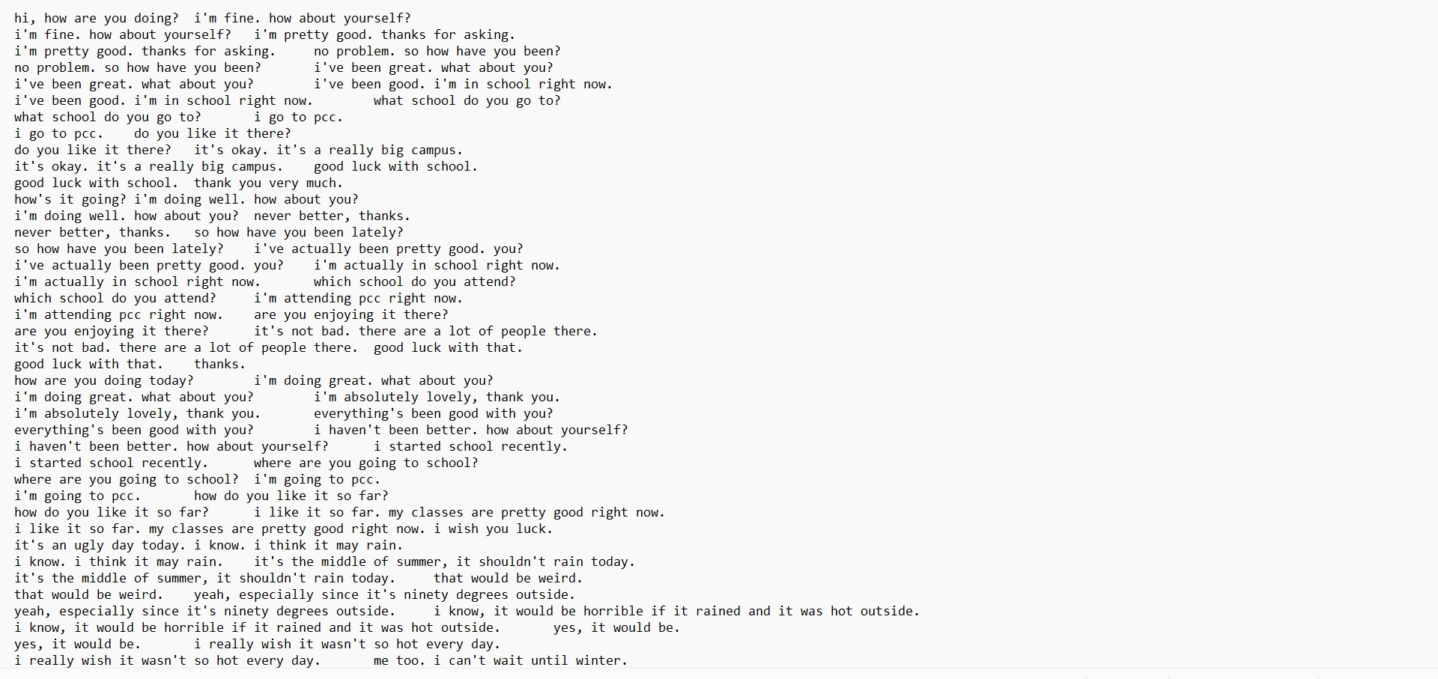

**Python Code for data preprocessing:**

1.Installing spacy and nlkt:

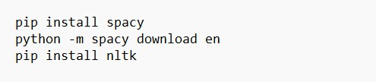

2.Import:

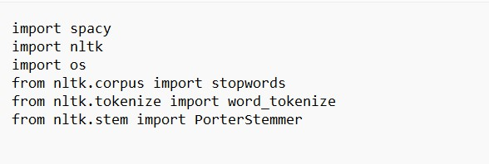

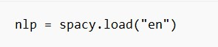

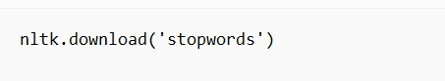

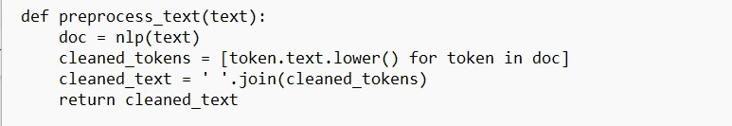

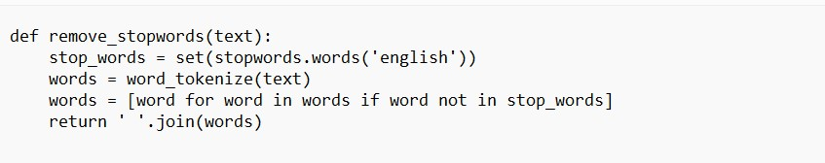

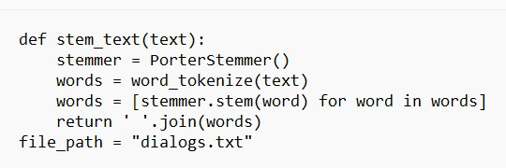

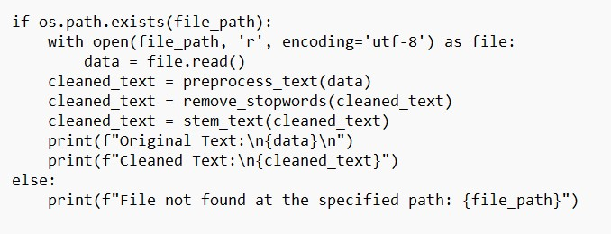

**Dataset Link: [https://www.kaggle.com/datasets/grafstor/simple-dialogs-for-chatbot](https://www.kaggle.com/datasets/grafstor/simple-dialogs-for-chatbot" \t "[object Object])**