**OUTPUT**

**Dashboard:**

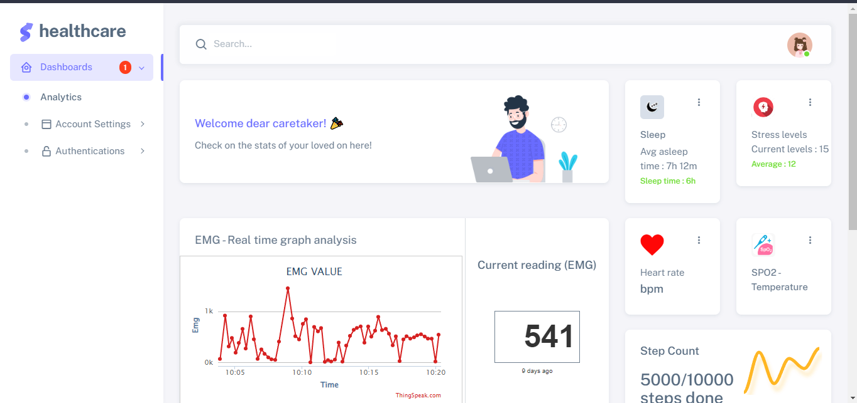

**EMG Value real-time:**

