**Web Technologies CIA Assignment-1**

**HTML vs DHTML vs XHTML**

**Introduction:**

**HTML: Hyper Text Markup Language**

HTML is the standard markup language used to give structure to a website and define content for it. It can be called as the skeleton for web development.

**DHTML: Dynamic HTML**

DHTML is an extension of HTML that adds interactivity and dynamic elements to web pages. It combines HTML, CSS and JavaScript to create more dynamic and interactive user experiences.

**XHTML:** **Extensible Hypertext Markup Language**

XHTML is just a stricter, more XML-based version of HTML.XHTML is HTML defined as an XML application. It is supported by all major browsers

**1.HTML**

* HTML was first created by Tim Berners-Lee, Robert Cailliau, and others starting in **1989.**
* Hypertext means that the document contains **links that allow the reader to jump to other places** in the document or to another document altogether.
* A **Markup Language** is a way that computers speak to each other to control how text is processed and presented. HTML uses tags and **attributes** to achieve this.
* HTML focuses more on structure and content rather than the behaviour of the website.

**Example:**

**Code:**

Output:

**Advantages of HTML:**

* **HTML is simple to understand and implement.**
* **Every browser supports HTML.**
* **HTML is the most search engine friendly.**
* **HTML is lightweight and quick.**
* **HTML is simple to integrate with other languages.**

**Disadvantages of HTML:**

* HTML is a static web programming language. This means that the HTML website pages will remain unchanged until they are physically transformed.
* **Restricted Security.**
* We have to write lengthy code to create simple website pages, which adds complexity.
* HTML is limited in its ability to showcase the content by displaying it in an aesthetically pleasing manner.

**2.DHTML**

* The application of DHTML was introduced by [Microsoft](https://en.wikipedia.org/wiki/Microsoft) with the release of [Internet Explorer 4](https://en.wikipedia.org/wiki/Internet_Explorer_4) in 1997.
* Using DHTML we can create elements that change, move, or update without requiring a full page reload. For example, dropdown menus, image rollovers, and interactive forms are often implemented using DHTML techniques.
* The dynamic characteristic of DHTML is the way it functions while a page is viewed, not in its ability to generate a unique page with each page load.
* Under the DHTML model, there may not be any interaction between the client and server after the page is loaded, all processing happens on the client side.
* DHTML allows authors to add effects to their pages that are otherwise difficult to achieve, by changing the [Document Object Model](https://en.wikipedia.org/wiki/Document_Object_Model) (DOM) and page style.

**Example:**

**Code:**

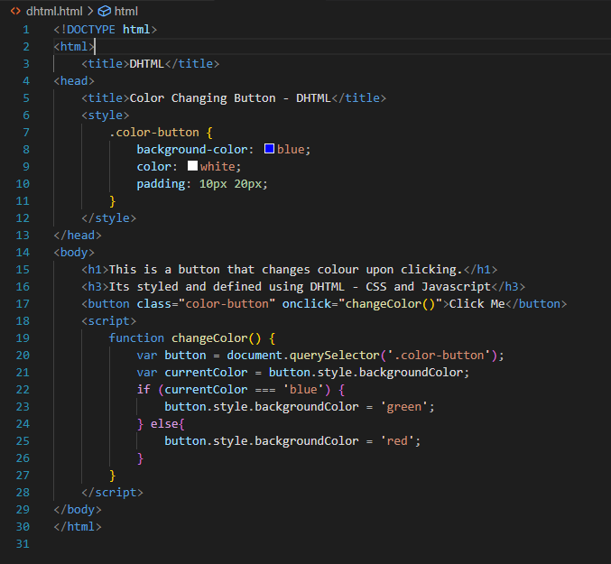

**Output:**

**Advantages of DHTML:**

* Enhanced User Experience: DHTML allows creating interactive and dynamic web pages, providing a more engaging and interactive experience for users.
* Real-time Updates: DHTML enables real-time updates without page reloads, leading to faster and more responsive web applications.
* Rich User Interface: DHTML supports creating rich user interfaces with animations, dropdown menus, image rollovers, and other interactive elements.
* Cross-Browser Compatibility: DHTML is compatible with various web browsers, ensuring a consistent user experience across different platforms.
* Integration with Other Technologies: DHTML can be easily integrated with other web technologies, such as JavaScript frameworks, CSS, and server-side scripts.
* **Top of Form**

**Disadvantages of DTHML:**

* Browser Compatibility: DHTML might not work consistently across all web browsers, leading to compatibility issues and requiring additional testing and tweaks.
* Accessibility Challenges: DHTML elements might pose difficulties for users with disabilities or older devices that don't support advanced interactivity.
* SEO Limitations: Search engines may have difficulty indexing content created dynamically, affecting search engine optimization (SEO) efforts.
* Increased Complexity: Implementing DHTML features can make code more complex and harder to maintain, potentially leading to errors and debugging challenges.

**3.XHTML:**

* XHTMLis part of the family of [XML](https://en.wikipedia.org/wiki/XML) [markup languages](https://en.wikipedia.org/wiki/Markup_language). It mirrors or extends versions of the widely used HTML.
* It was initially released in January 2000.
* XHTML was developed to make HTML more extensible and increase interoperability with other data formats.
* It creates a stricter standard for making web pages, reducing incompatibilities between browsers. So it is compatible for all major browsers.
* It creates a standard that can be used on a variety of different devices without changes.

**Example:**

**Code:**

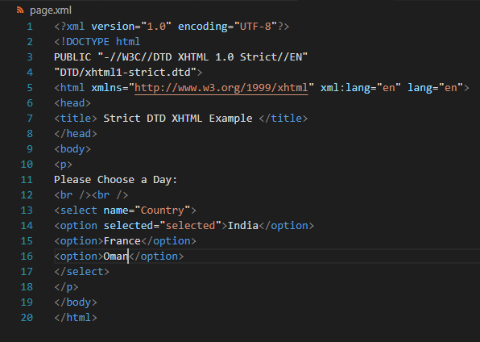

**Output:**

**Advantages of XHTML:**

* Well-Structured: XHTML follows strict rules, making it well-structured and cleaner than traditional HTML, which helps ensure consistency and compatibility across different browsers.
* Cross-Browser Compatibility: Due to its strict syntax, XHTML is more likely to display consistently across various web browsers, reducing the risk of compatibility issues.
* Support for XML Tools: Being based on XML, XHTML can be easily processed by various XML tools and applications, allowing for more advanced data manipulation and integration possibilities.
* Accessibility: XHTML's adherence to XML rules helps developers create more accessible websites that can be easily interpreted by assistive technologies, improving overall web accessibility.
* Future-Proofing: Embracing XHTML sets a good foundation for adopting future web standards and technologies, as it encourages cleaner coding practices and adherence to best practices

**Disadvantages of XHTML:**

* Strict Syntax: The strictness of XHTML can be seen as a disadvantage for those who are used to the more forgiving syntax of traditional HTML, as it requires careful attention to detail and may lead to more errors for beginners.
* Compatibility with Older Browsers: Some older web browsers may not fully support XHTML, which could limit the reach of your website to users on outdated platforms.
* Development Time: Writing XHTML code can be more time-consuming, especially when converting older HTML pages to XHTML, as it involves making sure all elements and attributes adhere to the stricter rules.

**Key Differences:**

**Purpose:**

**XHTML:** XHTML: Similar to HTML, XHTML is used for creating the structure and content of web pages, but it adheres to stricter XML rules, making it more structured and compatible with XML tools.

**HTML:** HTML is used for creating the structure and content of web pages. It defines the layout and elements that make up a webpage.

**DHTML:** DHTML combines HTML,CSS and JavaScript to create dynamic and interactive web pages. It allows elements to be manipulated and updated dynamically without requiring a full page reload.

**Tags:**

**XHTML:** Like HTML, it uses a predefined set of tags to describe the elements of a web page, but it must follow stricter XML syntax rules.

**HTML:** HTML uses a predefined set of tags to describe the elements of a web page.

**DHTML:** DHTML uses HTML and CSS for the page structure and layout, while JavaScript is used for adding interactivity and modifying the page content dynamically.

**Browser Rendering:**

**XML:** XHTML is specifically designed for web browsers like HTML, and its tags are rendered by browsers to display web page content as intended. However, it enforces stricter syntax rules.

**HTML:** HTML is specifically designed for web browsers, and its tags are rendered by browsers to display the content on web pages as intended.

**DHTML:** DHTML utilizes HTML for the page structure, CSS for styling and layout, and JavaScript to dynamically manipulate the HTML content, allowing for interactive and dynamic effects within web pages.

--------x--------