**WEEK 3 – HANDS ON**

**SKILL - Spring Data JPA**

**Create a Eclipse Project using Spring Initializer**

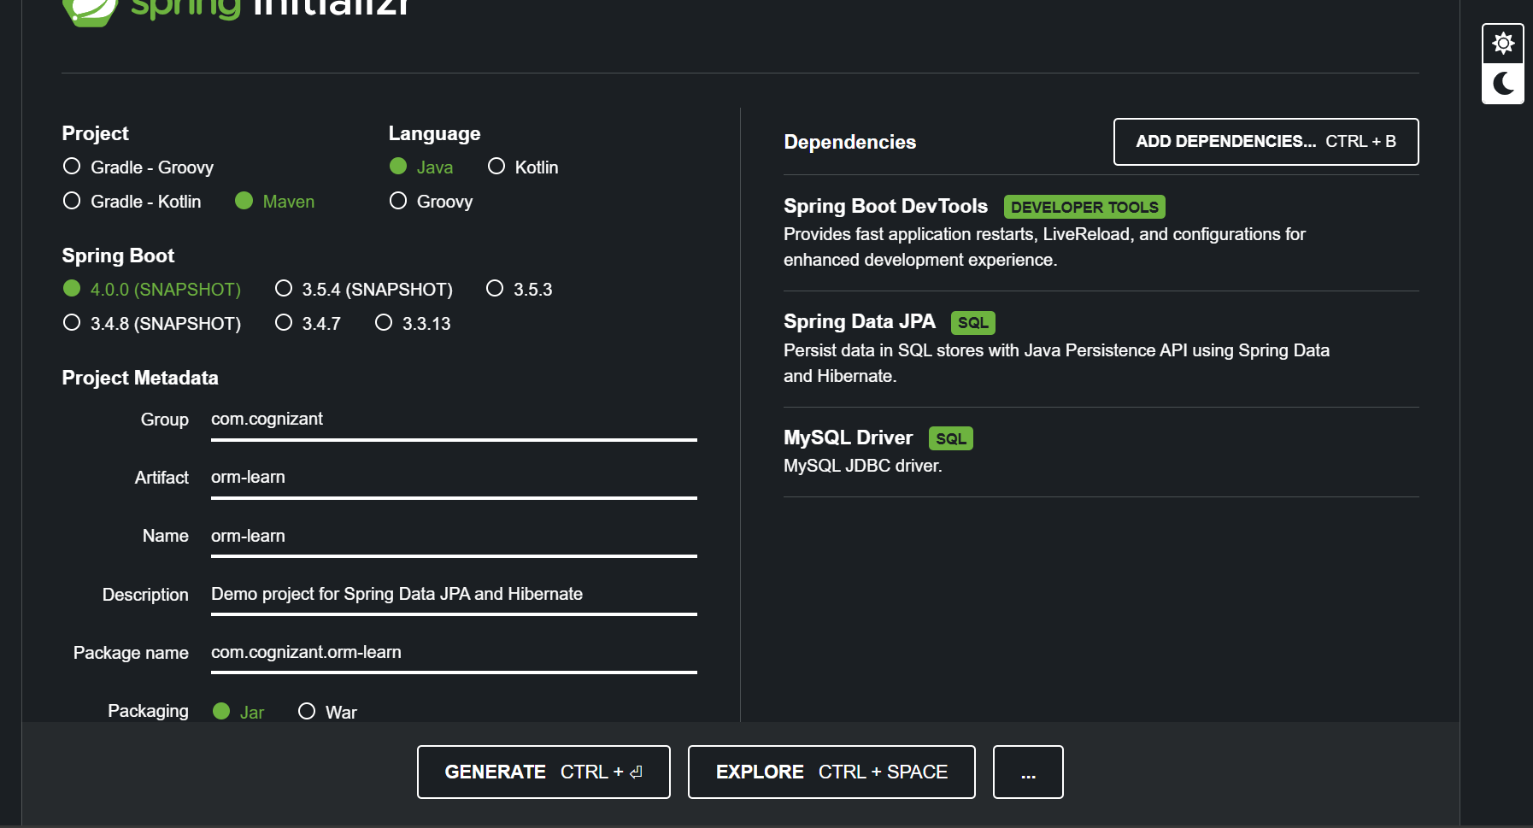

**Country table creation**

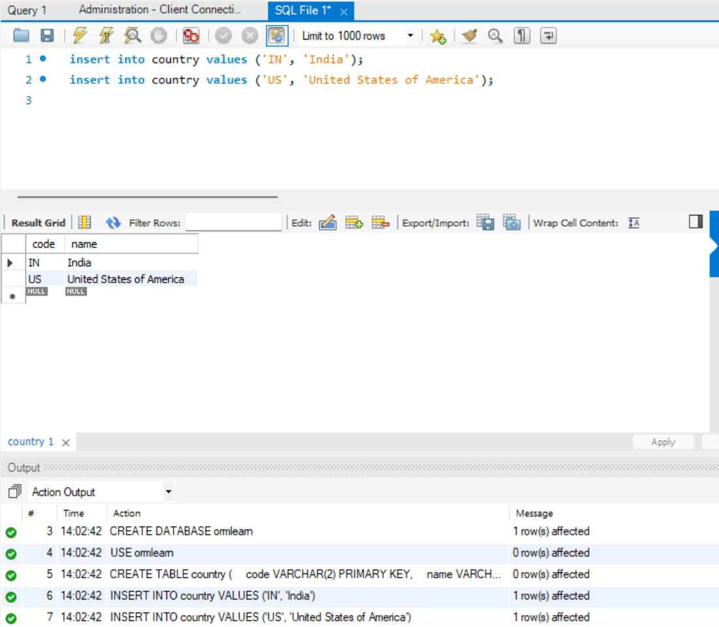

**Application.properties :**

# Logging

logging.level.org.springframework=info

logging.level.com.cognizant=debug

logging.level.org.hibernate.SQL=debug

logging.level.org.hibernate.type.descriptor.sql=trace

# Console format

logging.pattern.console=%d{dd-MM-yy} %d{HH:mm:ss.SSS} %-20.20thread %5p %-25.25logger{25} %25M %4L %m%n

# Database settings

spring.datasource.driver-class-name=com.mysql.cj.jdbc.Driver

spring.datasource.url=jdbc:mysql://localhost:3306/ormlearn

spring.datasource.username=root

spring.datasource.password=root

# Hibernate

spring.jpa.hibernate.ddl-auto=validate

spring.jpa.properties.hibernate.dialect=org.hibernate.dialect.MySQL5Dialect

# Show SQL

spring.jpa.show-sql=true

**Pom.xml :**

<project xmlns="http://maven.apache.org/POM/4.0.0"

xmlns:xsi="http://www.w3.org/2001/XMLSchema-instance"

xsi:schemaLocation="http://maven.apache.org/POM/4.0.0

http://maven.apache.org/xsd/maven-4.0.0.xsd">

<modelVersion>4.0.0</modelVersion>

<!-- Use Spring Boot parent to manage versions -->

<parent>

<groupId>org.springframework.boot</groupId>

<artifactId>spring-boot-starter-parent</artifactId>

<version>2.7.15</version>

<relativePath/> <!-- lookup parent from repository -->

</parent>

<groupId>com.cognizant</groupId>

<artifactId>orm-learn</artifactId>

<version>0.0.1-SNAPSHOT</version>

<name>Demo project for Spring Data JPA and Hibernate</name>

<properties>

<java.version>1.8</java.version>

</properties>

<dependencies>

<!-- Spring Data JPA -->

<dependency>

<groupId>org.springframework.boot</groupId>

<artifactId>spring-boot-starter-data-jpa</artifactId>

</dependency>

<!-- MySQL Connector with version -->

<dependency>

<groupId>mysql</groupId>

<artifactId>mysql-connector-java</artifactId>

<version>8.0.33</version>

<scope>runtime</scope>

</dependency>

<!-- DevTools for auto-reload during development -->

<dependency>

<groupId>org.springframework.boot</groupId>

<artifactId>spring-boot-devtools</artifactId>

<scope>runtime</scope>

</dependency>

<!-- SLF4J logging is included by default in Spring Boot -->

<!-- JUnit + Test support (optional) -->

<dependency>

<groupId>org.springframework.boot</groupId>

<artifactId>spring-boot-starter-test</artifactId>

<scope>test</scope>

</dependency>

</dependencies>

<build>

<plugins>

<!-- Compiler plugin for Java 8 -->

<plugin>

<groupId>org.apache.maven.plugins</groupId>

<artifactId>maven-compiler-plugin</artifactId>

<version>3.8.1</version>

<configuration>

<source>1.8</source>

<target>1.8</target>

</configuration>

</plugin>

<!-- Spring Boot plugin to package the app -->

<plugin>

<groupId>org.springframework.boot</groupId>

<artifactId>spring-boot-maven-plugin</artifactId>

</plugin>

</plugins>

</build>

</project>

**OrmLearnApplication.java :**

package com.cognizant.ormlearn;

import java.util.List;

import com.cognizant.ormlearn.model.Country;

import com.cognizant.ormlearn.service.CountryService;

import org.slf4j.Logger;

import org.slf4j.LoggerFactory;

import org.springframework.boot.SpringApplication;

import org.springframework.boot.autoconfigure.SpringBootApplication;

import org.springframework.context.ApplicationContext;

@SpringBootApplication

public class OrmLearnApplication {

private static final Logger LOGGER = LoggerFactory.getLogger(OrmLearnApplication.class);

private static CountryService countryService;

public static void main(String[] args) {

ApplicationContext context = SpringApplication.run(OrmLearnApplication.class, args);

countryService = context.getBean(CountryService.class);

LOGGER.info("Inside main");

testGetAllCountries();

}

private static void testGetAllCountries() {

LOGGER.info("Start");

System.out.println("TESTING SYSTEM OUT");

List<Country> countries = countryService.getAllCountries();

System.out.println("Countries = " + countries);

LOGGER.debug("countries={}", countries);

LOGGER.info("End");

}

}

**CountryRepository.java :**

package com.cognizant.ormlearn.repository;

import org.springframework.data.jpa.repository.JpaRepository;

import org.springframework.stereotype.Repository;

import com.cognizant.ormlearn.model.Country;

@Repository

public interface CountryRepository extends JpaRepository<Country, String> {

}

**Country.java :**

package com.cognizant.ormlearn.model;

import javax.persistence.*;

@Entity

@Table(name = "country")

public class Country {

@Id

@Column(name = "code")

private String code;

@Column(name = "name")

private String name;

public String getCode() {

return code;

}

public void setCode(String code) {

this.code = code;

}

public String getName() {

return name;

}

public void setName(String name) {

this.name = name;

}

@Override

public String toString() {

return "Country [code=" + code + ", name=" + name + "]";

} }

**CountryService.java :**

package com.cognizant.ormlearn.service;

import java.util.List;

import javax.transaction.Transactional;

import org.springframework.beans.factory.annotation.Autowired;

import org.springframework.stereotype.Service;

import com.cognizant.ormlearn.model.Country;

import com.cognizant.ormlearn.repository.CountryRepository;

@Service

public class CountryService {

@Autowired

private CountryRepository countryRepository;

@Transactional

public List<Country> getAllCountries() {

return countryRepository.findAll();

}

}

**Output :**

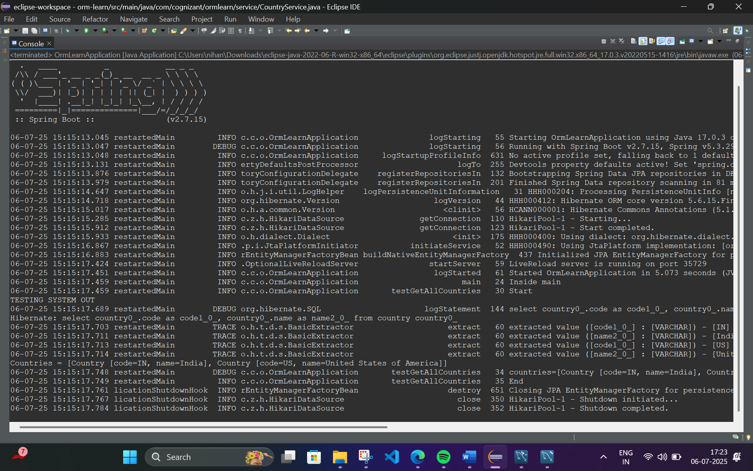

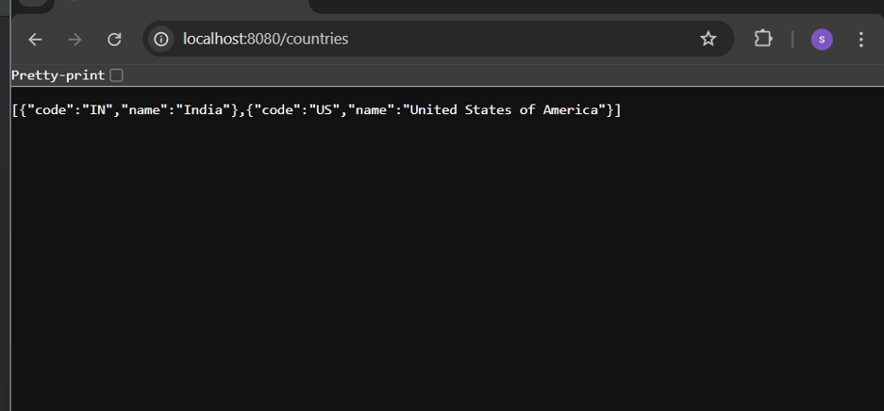

**Difference between JPA, Hibernate and Spring Data JPA**

**Pom.xml :**

<?xml version="1.0" encoding="UTF-8"?>

<project xmlns="http://maven.apache.org/POM/4.0.0" xmlns:xsi="http://www.w3.org/2001/XMLSchema-instance"

xsi:schemaLocation="http://maven.apache.org/POM/4.0.0 https://maven.apache.org/xsd/maven-4.0.0.xsd">

<modelVersion>4.0.0</modelVersion>

<parent>

<groupId>org.springframework.boot</groupId>

<artifactId>spring-boot-starter-parent</artifactId>

<version>3.5.3</version>

<relativePath/> <!-- lookup parent from repository -->

</parent>

<groupId>com.example</groupId>

<artifactId>employee-app</artifactId>

<version>0.0.1-SNAPSHOT</version>

<name>employee-app</name>

<description>Demo project for Spring Boot</description>

<url/>

<licenses>

<license/>

</licenses>

<developers>

<developer/>

</developers>

<scm>

<connection/>

<developerConnection/>

<tag/>

<url/>

</scm>

<properties>

<java.version>17</java.version>

</properties>

<dependencies>

<dependency>

<groupId>org.springframework.boot</groupId>

<artifactId>spring-boot-starter-data-jpa</artifactId>

</dependency>

<dependency>

<groupId>org.springframework.boot</groupId>

<artifactId>spring-boot-starter-web</artifactId>

</dependency>

<dependency>

<groupId>com.mysql</groupId>

<artifactId>mysql-connector-j</artifactId>

<scope>runtime</scope>

</dependency>

<dependency>

<groupId>org.springframework.boot</groupId>

<artifactId>spring-boot-starter-test</artifactId>

<scope>test</scope>

</dependency>

</dependencies>

<build>

<plugins>

<plugin>

<groupId>org.springframework.boot</groupId>

<artifactId>spring-boot-maven-plugin</artifactId>

</plugin>

</plugins>

</build>

</project>

**EmployeeController.java :**

package com.example.employee_app.controller;

import com.example.employee_app.model.Employee;

import com.example.employee_app.service.EmployeeService;

import org.springframework.beans.factory.annotation.Autowired;

import org.springframework.web.bind.annotation.*;

@RestController

@RequestMapping("/employees")

public class EmployeeController {

@Autowired

private EmployeeService employeeService;

@PostMapping("/add")

public String addEmployee(@RequestBody Employee employee) {

employeeService.addEmployee(employee);

return "Employee saved successfully!";

}

@GetMapping("/test")

public String test() {

return "Test working!";

}

}

**EmployeeRepository.java :**

package com.example.employee_app.repository;

import com.example.employee_app.model.Employee;

import org.springframework.data.jpa.repository.JpaRepository;

public interface EmployeeRepository extends JpaRepository<Employee, Integer> {

}

**EmployeeService.java :**

package com.example.employee_app.service;

import com.example.employee_app.model.Employee;

import com.example.employee_app.repository.EmployeeRepository;

import org.springframework.beans.factory.annotation.Autowired;

import org.springframework.stereotype.Service;

import org.springframework.transaction.annotation.Transactional;

@Service

public class EmployeeService {

@Autowired

private EmployeeRepository employeeRepository;

@Transactional

public void addEmployee(Employee employee) {

employeeRepository.save(employee);

}

}

**EmployeeAppApplication.java :**

package com.example.employee_app;

import org.springframework.boot.SpringApplication;

import org.springframework.boot.autoconfigure.SpringBootApplication;

@SpringBootApplication

public class EmployeeAppApplication {

public static void main(String[] args) {

SpringApplication.run(EmployeeAppApplication.class, args);

}

}

**Output :**

