**WEEK 5 – HANDS ON**

**SKILL – MICROSERVICES**

**Creating Microservices for account and loan**

**Create folder named 'microservices' :**

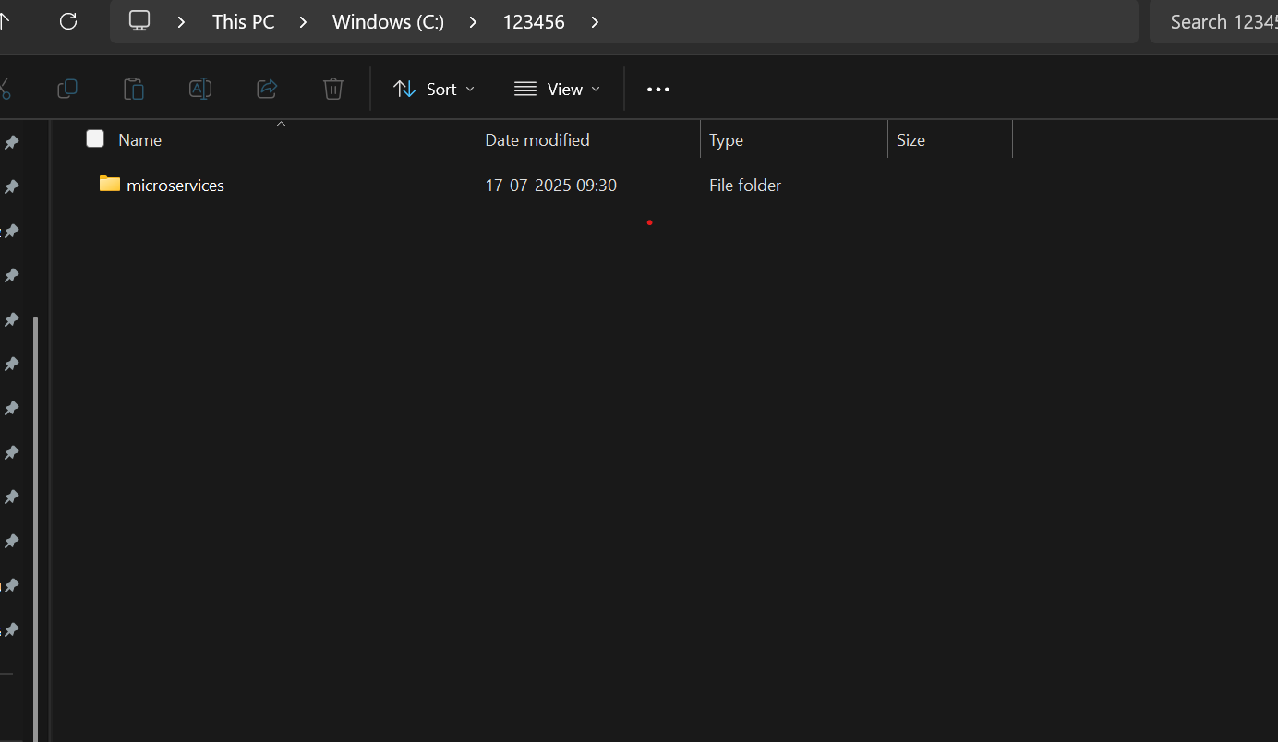

**Generate Project from Spring Initializr :**

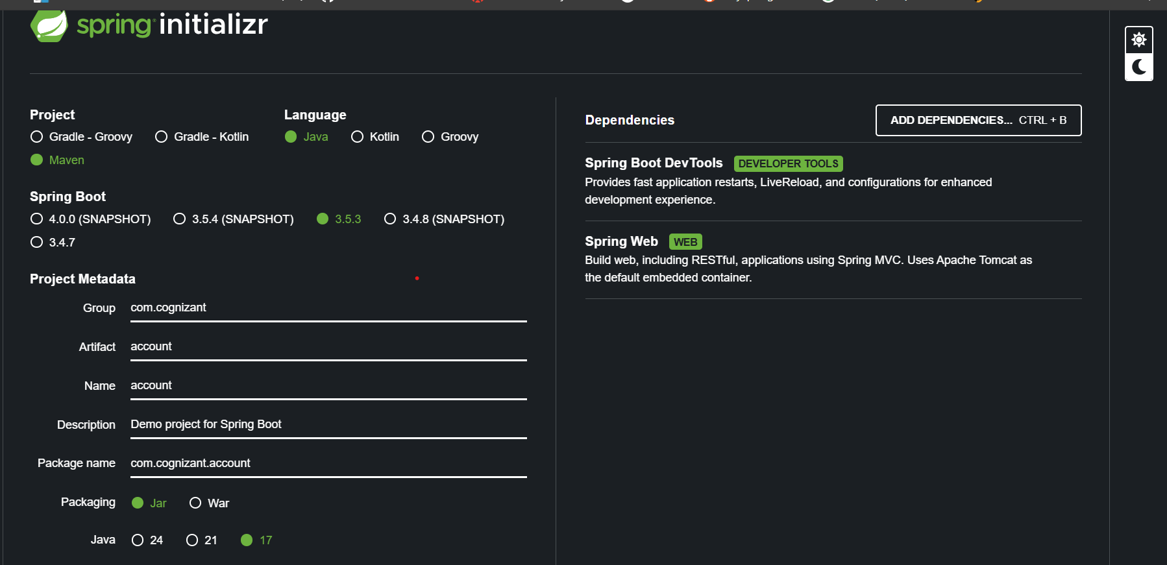

**AccountController.java :**

package com.cognizant.account.controller;

import org.springframework.web.bind.annotation.*;

import java.util.Map;

@RestController

@RequestMapping("/accounts")

public class AccountController {

@GetMapping("/{number}")

public Map<String, Object> getAccountDetails(@PathVariable String number) {

return Map.of(

"number", number,

"type", "savings",

"balance", 234343

);

}

}

**AccountApplication.java :**

package com.cognizant.account;

import org.springframework.boot.SpringApplication;

import org.springframework.boot.autoconfigure.SpringBootApplication;

@SpringBootApplication

public class AccountApplication {

public static void main(String[] args) {

SpringApplication.run(AccountApplication.class, args);

}

}

**Application.properties :**

spring.application.name=account

**OUTPUT :**

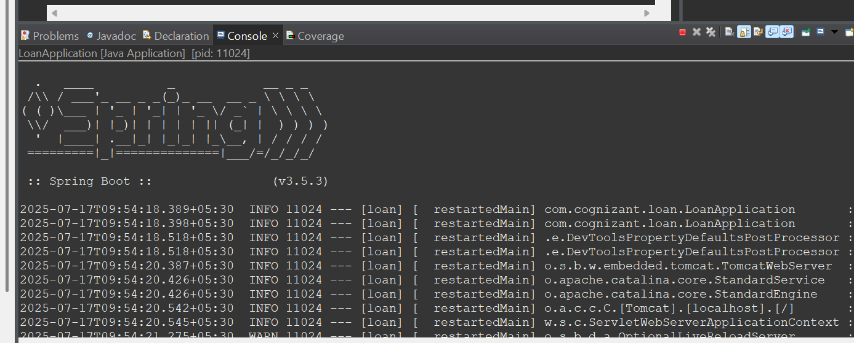

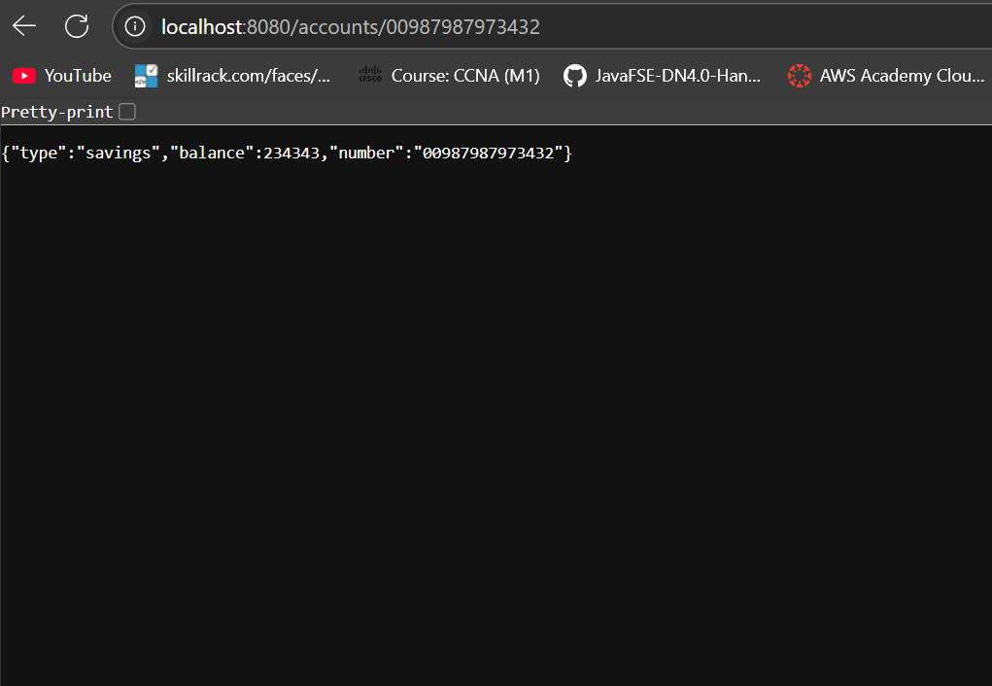

**Loan Microservice Setup :**

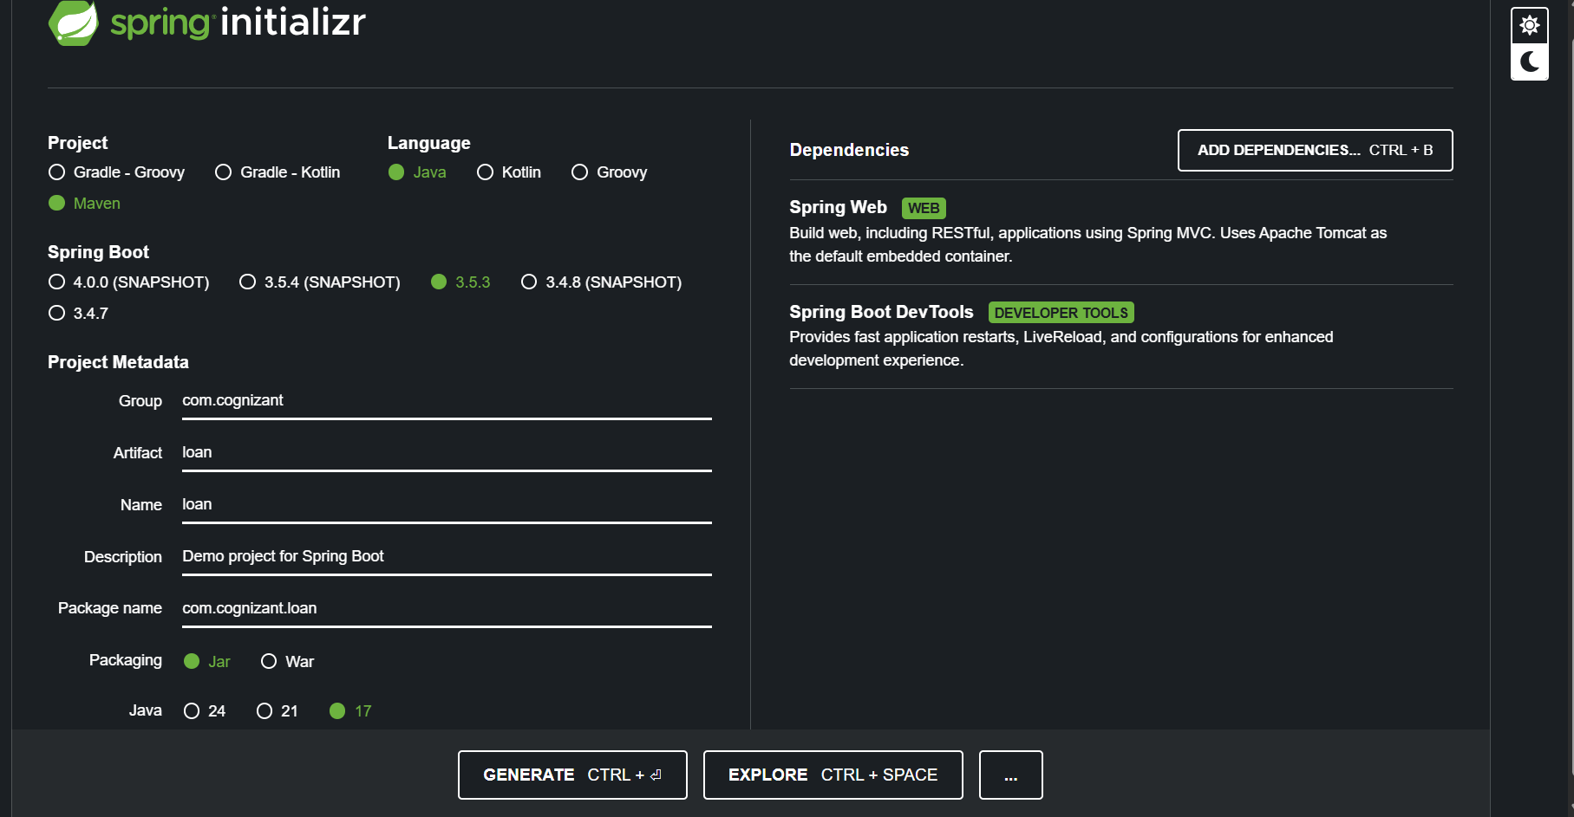

**LoanController.java :**

package com.cognizant.loan.controller;

import org.springframework.web.bind.annotation.*;

import java.util.Map;

@RestController

@RequestMapping("/loans")

public class LoanController {

@GetMapping("/{number}")

public Map<String, Object> getLoanDetails(@PathVariable String number) {

return Map.of(

"number", number,

"type", "car",

"loan", 400000,

"emi", 3258,

"tenure", 18

);

}

}

**OUTPUT :**



