**WEEK 7 – HANDS ON**

**SKILL – REACT**

**EXERCISE 1 :**

Create a React Application named “cricketapp” with the following components:

1. ListofPlayers

Declare an array with 11 players and store details of their names and scores using the map feature of ES6

2. IndianPlayers

a.Display the Odd Team Player and Even Team players using the Destructuring features of ES6

b. Declare two arrays T20players and RanjiTrophy players and merge the two arrays and display them using the Merge feature of ES6

Display these two components in the same home page using a simple if else in the flag variable

[**ListofPlayers.js**](http://listofplayers.js) **:**

import React from 'react';

const ListofPlayers = () => {

const players = [

{ name: 'Virat', score: 95 },

{ name: 'Rohit', score: 88 },

{ name: 'Dhawan', score: 60 },

{ name: 'Pant', score: 45 },

{ name: 'Iyer', score: 72 },

{ name: 'Jadeja', score: 51 },

{ name: 'Ashwin', score: 77 },

{ name: 'Bumrah', score: 40 },

{ name: 'Shami', score: 66 },

{ name: 'Sundar', score: 35 },

{ name: 'Gill', score: 84 }

];

const filteredPlayers = players.filter(p => p.score < 70); // using arrow function

return (

<div>

<h3>All Players:</h3>

<ul>

{players.map((p, i) => (

<li key={i}>{p.name} - {p.score}</li>

))}

</ul>

<h3>Players Scored Below 70:</h3>

<ul>

{filteredPlayers.map((p, i) => (

<li key={i}>{p.name} - {p.score}</li>

))}

</ul>

</div> );};

export default ListofPlayers;

**IndianPlayers.js :**

import React from 'react';

const IndianPlayers = () => {

const T20players = ['Virat', 'Rohit', 'Pant', 'Hardik'];

const RanjiTrophy = ['Rahane', 'Pujara', 'Saha'];

const allPlayers = [...T20players, ...RanjiTrophy]; // Merge using spread operator

const oddTeam = allPlayers.filter((_, i) => i % 2 !== 0);

const evenTeam = allPlayers.filter((_, i) => i % 2 === 0);

return (

<div>

<h3>All Players:</h3>

<p>{allPlayers.join(', ')}</p>

<h3>Odd Team Players:</h3>

<p>{oddTeam.join(', ')}</p>

<h3>Even Team Players:</h3>

<p>{evenTeam.join(', ')}</p>

</div>;};

export default IndianPlayers;

[**App.js**](http://app.js) **:**

import React from 'react';

import ListofPlayers from './ListofPlayers';

import IndianPlayers from './IndianPlayers';

function App() {

const flag = true;

return (

<div className="App">

<h2>Cricket Team Dashboard</h2>

{flag ? <ListofPlayers /> : <IndianPlayers />}

</div> );}

export default App;

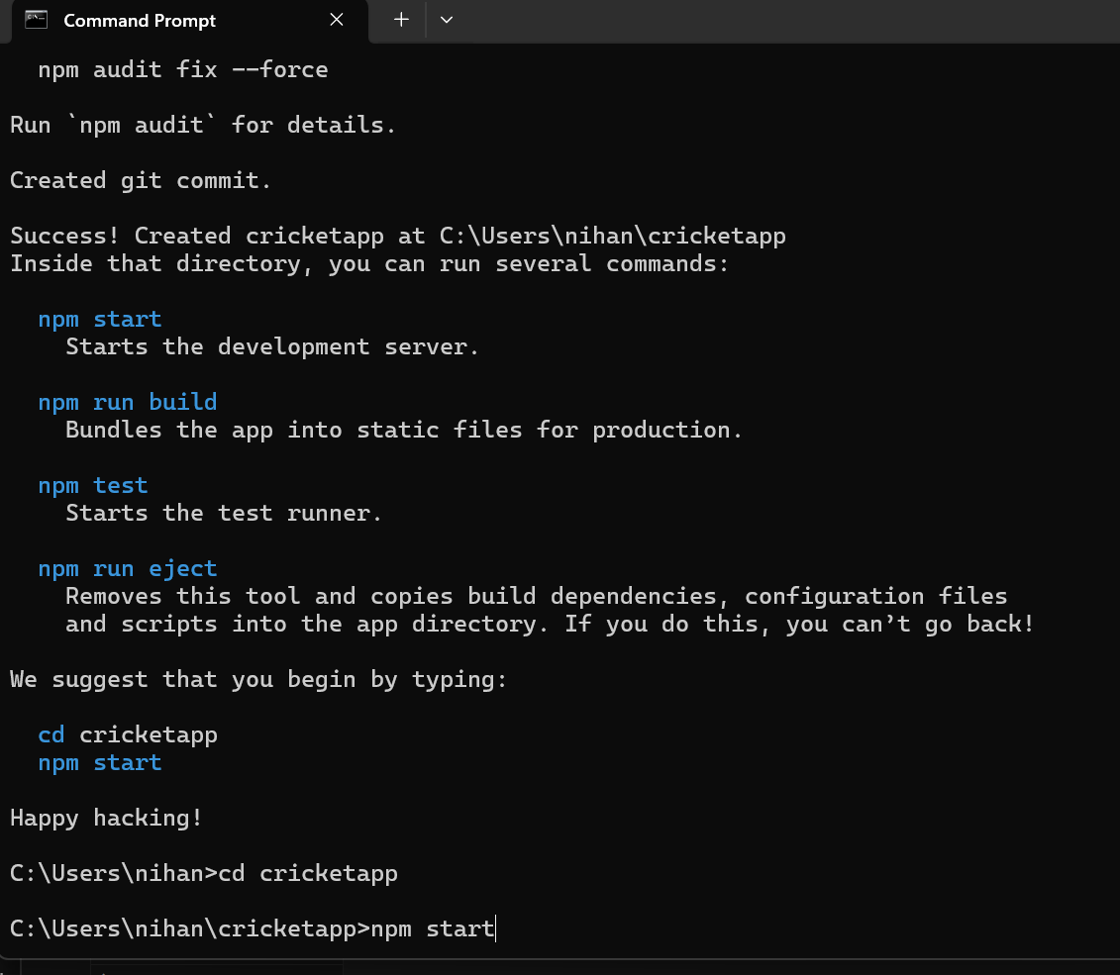

**Output** **:**

If flag = true

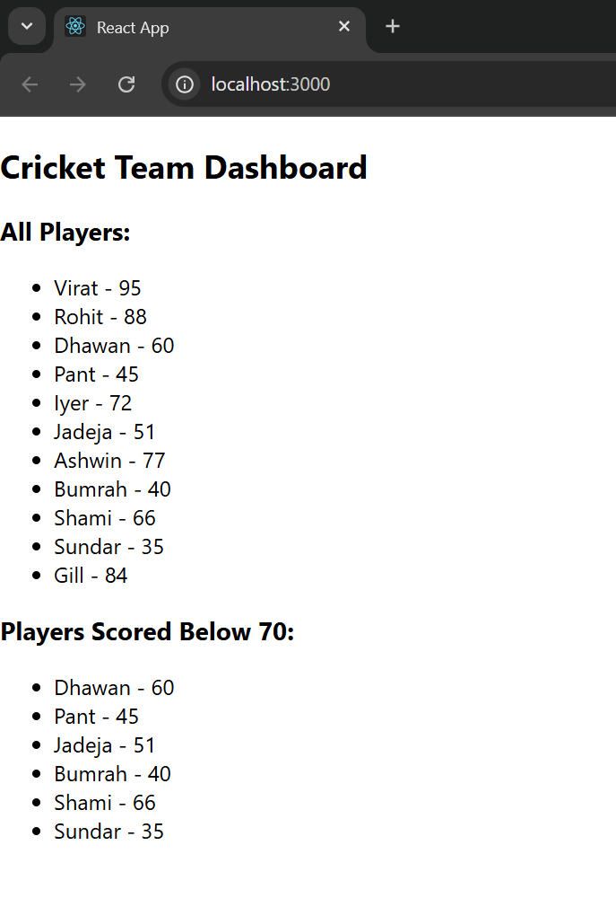

If flag = false

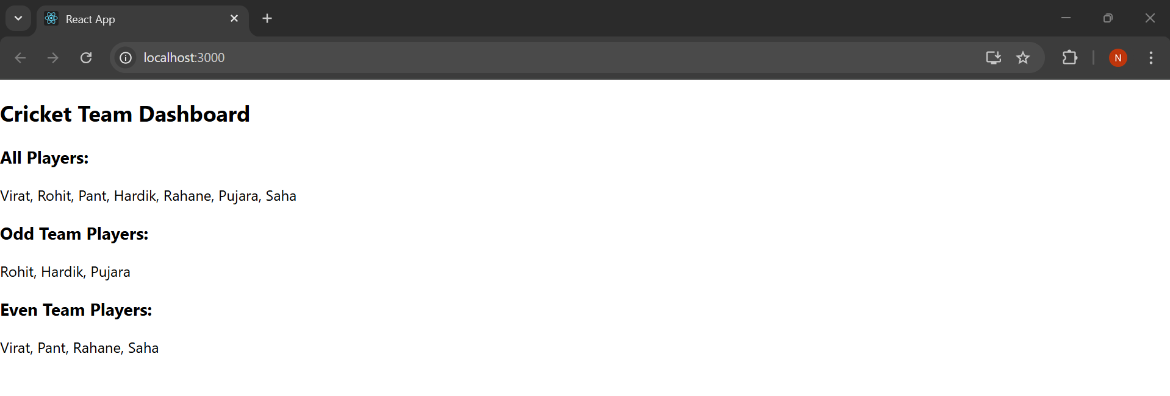

**EXERCISE 2 :**

Create a React Application named “officespacerentalapp” which uses React JSX to create elements, attributes and renders DOM to display the page.

Create an element to display the heading of the page.

Attribute to display the image of the office space

Create an object of office to display the details like Name, Rent and Address.

Create a list of Object and loop through the office space item to display more data.

To apply Css, Display the color of the Rent in Red if it’s below 60000 and in Green if it’s above 60000.

**App.js :**

import React from 'react';

function App() {

const office = {

Name: "DBS",

Rent: 50000,

Address: "Chennai",

Image: "https://th.bing.com/th/id/R.436ca51e2b149e88d754c105ec0b3848?rik=Or8%2buRLPRmuJJg&riu=http%3a%2f%2fwww.virgobc.com%2fwp-content%2fuploads%2f2014%2f02%2fVirgo-Business-Centers-380-Lexington-Avenue-17th-Floor-New-York-NY-10168-212-601-2700-Furnished-Office-Space.jpg&ehk=QXUjb8j9NiFjRu8TKQkokrlchLw03V4EkbDU6hcB2dA%3d&risl=&pid=ImgRaw&r=0"

};

const rentStyle = {

color: office.Rent <= 60000 ? "red" : "green"

};

const containerStyle = {

padding: '20px',

fontFamily: 'Arial',

display: 'flex',

flexDirection: 'column',

alignItems: 'center',

textAlign: 'center'

};

return (

<div style={containerStyle}>

<h1>Office Space , at Affordable Range</h1>

<img src={office.Image} width="30%" alt="Office Space" />

<h2><strong>Name:</strong> {office.Name}</h2>

<h3 style={rentStyle}><strong>Rent: Rs. {office.Rent}</strong></h3>

<h3><strong>Address:</strong> {office.Address}</h3>

</div>

);

}

export default App;

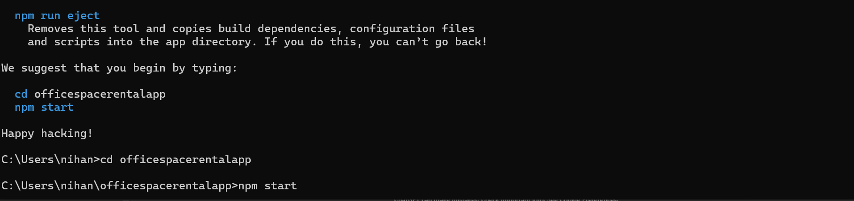

**Output :**

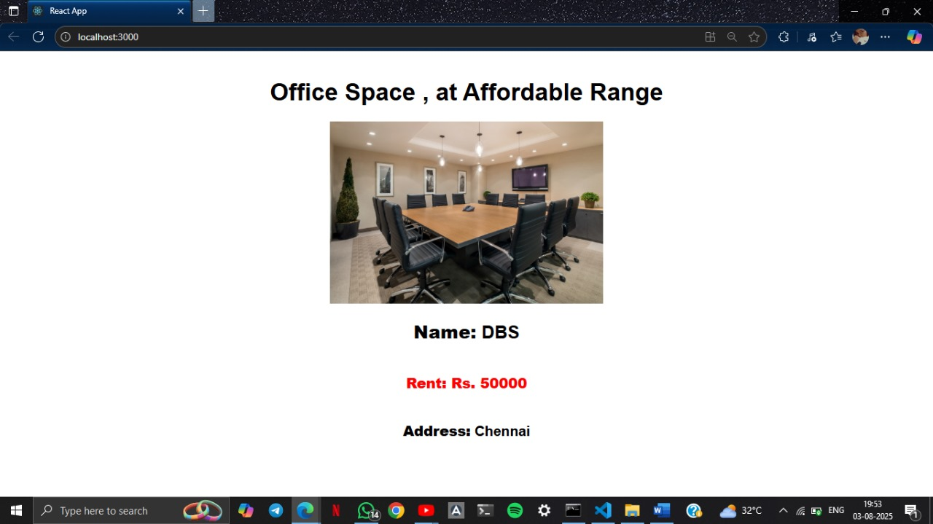

**Exercise 3 :**

Create a React Application “eventexamplesapp” to handle various events of the form elements in HTML.

[**App.js**](http://app.js) **:**

import React, { Component } from 'react';

import CurrencyConvertor from './CurrencyConvertor';

class App extends Component {

constructor(props) {

super(props);

this.state = {

count: 0

};

}

increment = () => {

this.setState(prev => ({ count: prev.count + 1 }));

this.sayHello();

};

decrement = () => {

this.setState(prev => ({ count: prev.count - 1 }));

};

sayHello = () => {

alert("Hello! This is a static message from React.");

};

sayWelcome = (message) => {

alert(`Message: ${message}`);

};

handleClick = (event) => {

alert("I was clicked");

};

render() {

return (

<div style={{ padding: "20px", fontFamily: "Arial" }}>

<h2>React Event Handling Demo</h2>

<h3>Counter: {this.state.count}</h3>

<button onClick={this.increment}>Increment</button>{' '}

<button onClick={this.decrement}>Decrement</button>

<hr />

<button onClick={() => this.sayWelcome("Welcome to the Event Lab!")}>

Say Welcome

</button>

<hr />

<button onClick={this.handleClick}>

Synthetic Event (onClick)

</button>

<hr />

<CurrencyConvertor />

</div>

);

}

}

export default App;

[**CurrencyConvertor.js**](http://currencyconvertor.js) **:**

import React, { Component } from 'react';

class CurrencyConvertor extends Component {

constructor(props) {

super(props);

this.state = {

rupees: '',

euro: ''

};

}

handleInputChange = (event) => {

this.setState({ rupees: event.target.value });

};

handleSubmit = () => {

const { rupees } = this.state;

const euroValue = (parseFloat(rupees) / 90).toFixed(2); // 1 EUR ≈ ₹90

this.setState({ euro: euroValue });

};

render() {

return (

<div style={{ marginTop: '30px' }}>

<h3>Currency Converter (INR → EURO)</h3>

<input

type="number"

value={this.state.rupees}

onChange={this.handleInputChange}

placeholder="Enter amount in INR"

/>{' '}

<button onClick={this.handleSubmit}>Convert</button>

{this.state.euro && (

<p>Equivalent in Euro: €{this.state.euro}</p>

)}

</div>

);

}

}

export default CurrencyConvertor;

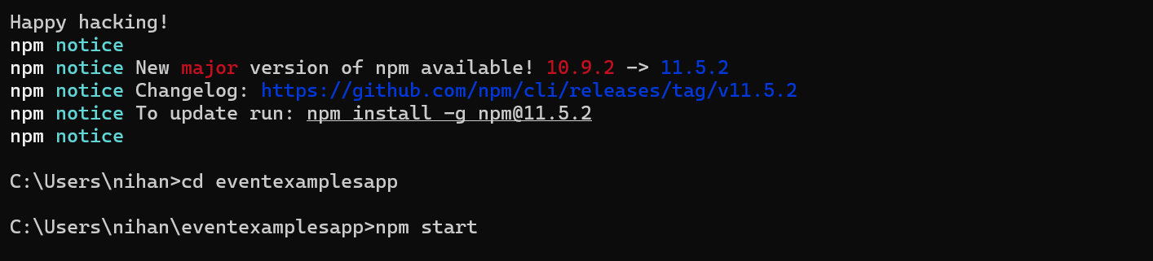

**Output :**

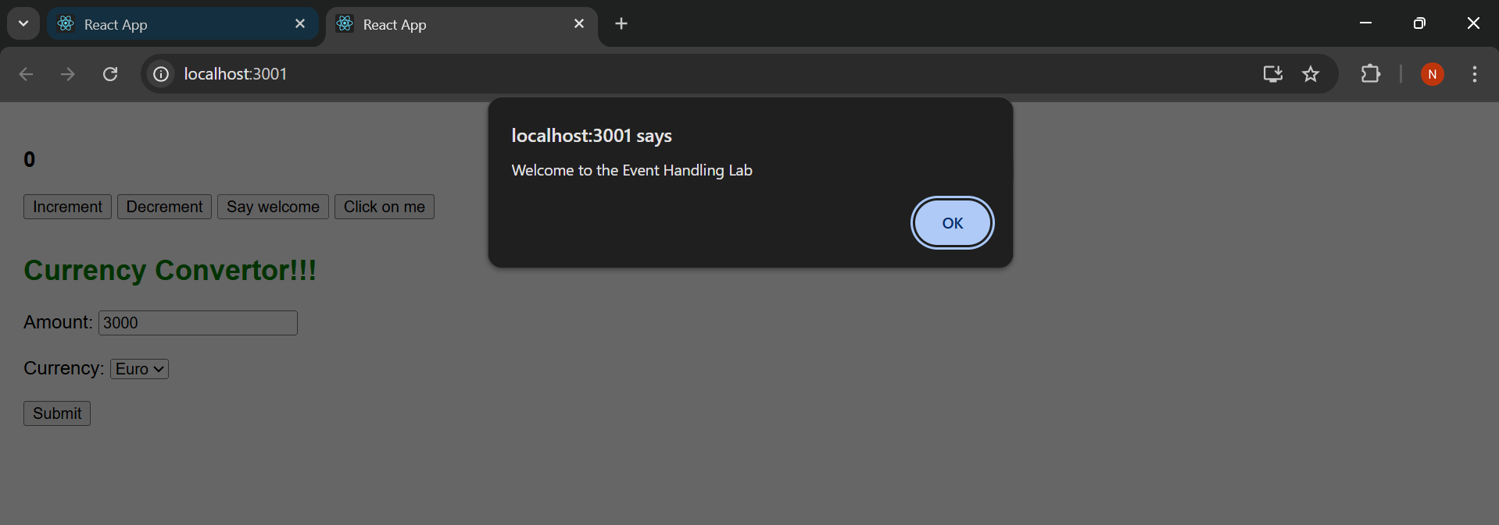

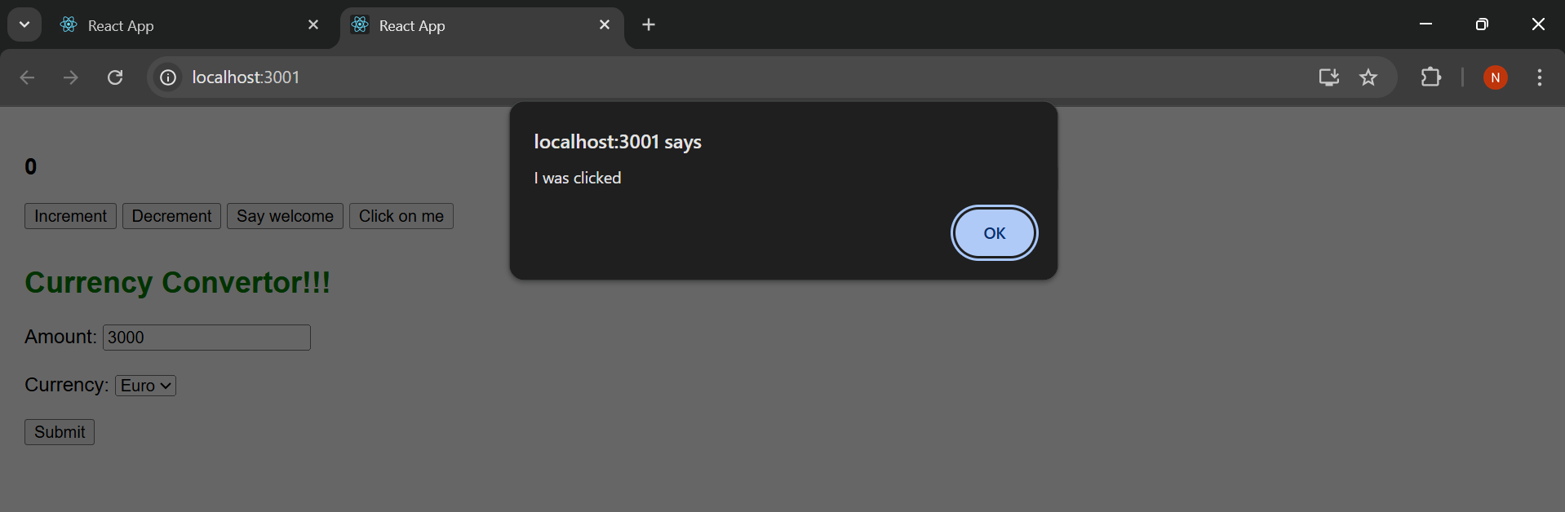

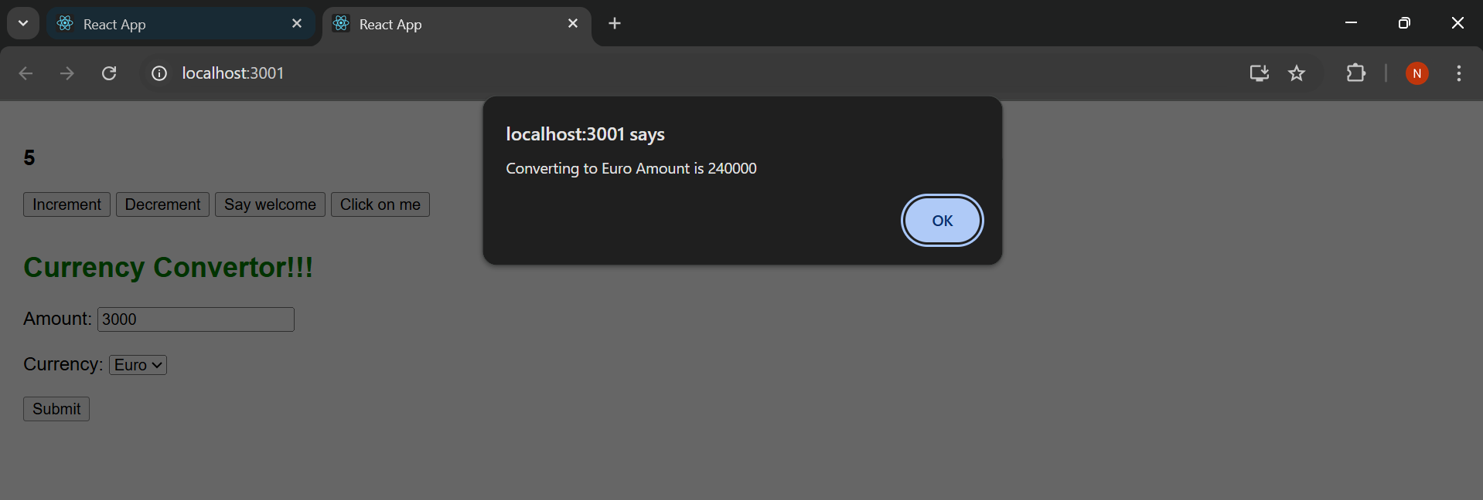

**Exercise 4 :**

Create a React Application named “ticketbookingapp” where the guest user can browse the page where the flight details are displayed whereas the logged in user only can book tickets.

The Login and Logout buttons should accordingly display different pages. Once the user is logged in the User page should be displayed. When the user clicks on Logout, the Guest page should be displayed.

[**Guest.js**](http://guest.js) **:**

import React from 'react';

function Guest() {

return (

<div>

<h2>Welcome Guest!</h2>

</div>

);

}

export default Guest;

[**User.js**](http://user.js)**:**

import React from 'react';

function User() {

return (

<div>

<h2>Welcome Back, User!</h2>

<p>You can now book tickets securely.</p>

<button>Book Now</button>

</div>

);

}

export default User;

[**App.js**](http://app.js) **:**

import React, { Component } from 'react';

class App extends Component {

constructor(props) {

super(props);

this.state = {

isLoggedIn: false

};

}

toggleLogin = () => {

this.setState(prevState => ({

isLoggedIn: !prevState.isLoggedIn

}));

};

render() {

const { isLoggedIn } = this.state;

return (

<div style={{ textAlign: 'center', padding: '50px', fontFamily: 'Arial' }}>

<h2>{isLoggedIn ? 'Welcome User' : 'Welcome Guest'}</h2>

<button onClick={this.toggleLogin}>

{isLoggedIn ? 'Logout' : 'Login'}

</button>

</div>

);

}

}

export default App;

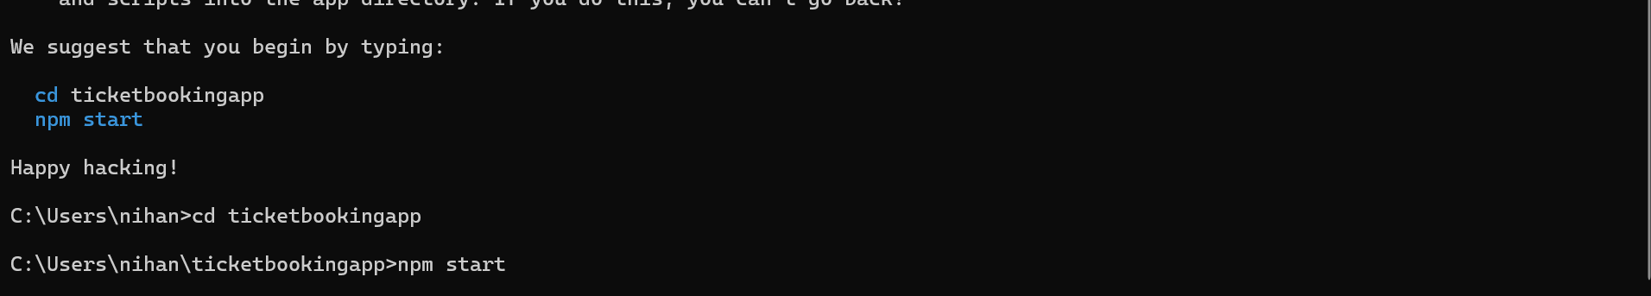

**Output :**

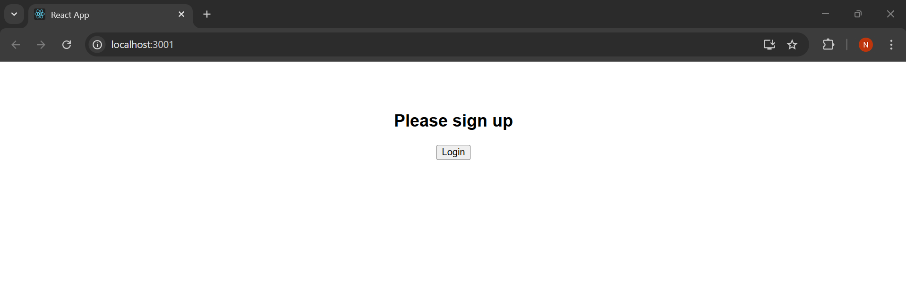

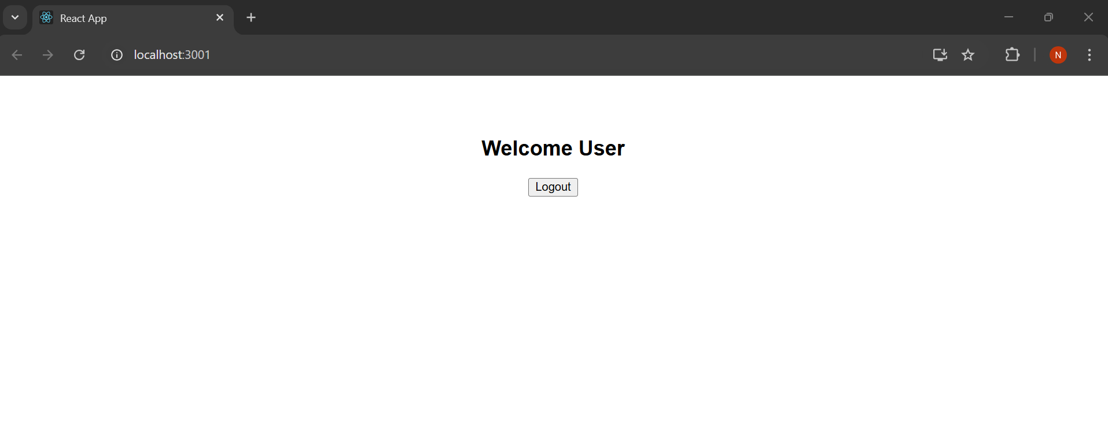

**Exercise 5 :**

Estimated time to complete this lab: **60 minutes.**

Create a React App named “bloggerapp” in with 3 components.

1. Book Details

2. Blog Details

3. Course Details

[**CourseDetails.js**](http://coursedetails.js) **:**

import React from 'react';

function CourseDetails() {

const courses = [

{ name: 'Angular', date: '4/5/2021' },

{ name: 'React', date: '6/3/20201' }

];

return (

<div>

<h2>Course Details</h2>

{courses.map((course, index) => (

<div key={index}>

<h3>{course.name}</h3>

<p>{course.date}</p>

</div>

))}

</div>

);

}

export default CourseDetails;

[**BookDetails.js**](http://bookdetails.js) **:**

import React from 'react';

function BookDetails() {

const books = [

{ title: 'Master React', price: 670 },

{ title: 'Deep Dive into Angular 11', price: 800 },

{ title: 'Mongo Essentials', price: 450 }

];

return (

<div>

<h2>Book Details</h2>

{books.map((book, index) => (

<div key={index}>

<h3>{book.title}</h3>

<p>{book.price}</p>

</div>

))}

</div>

);

}

export default BookDetails;

[**BlogDetails.js**](http://blogdetails.js) **:**

import React from 'react';

function BlogDetails() {

const blogs = [

{

title: 'React Learning',

author: 'Stephen Biz',

content: 'Welcome to learning React!'

},

{

title: 'Installation',

author: 'Schewzdenier',

content: 'You can install React from npm.'

}

];

return (

<div>

<h2>Blog Details</h2>

{blogs.map((blog, index) => (

<div key={index}>

<h3>{blog.title}</h3>

<p><strong>{blog.author}</strong></p>

<p>{blog.content}</p>

</div>

))}

</div>

);

}

export default BlogDetails;

[**App.js**](http://app.js) **:**

import React from 'react';

import CourseDetails from './CourseDetails';

import BookDetails from './BookDetails';

import BlogDetails from './BlogDetails';

function App() {

const layoutStyle = {

display: 'flex',

justifyContent: 'space-around',

padding: '30px',

fontFamily: 'Arial',

alignItems: 'flex-start'

};

const sectionStyle = {

borderLeft: '3px solid green',

paddingLeft: '20px',

minWidth: '250px'

};

return (

<div style={layoutStyle}>

<div style={sectionStyle}>

<CourseDetails />

</div>

<div style={sectionStyle}>

<BookDetails />

</div>

<div style={sectionStyle}>

<BlogDetails />

</div>

</div>

);

}

export default App;

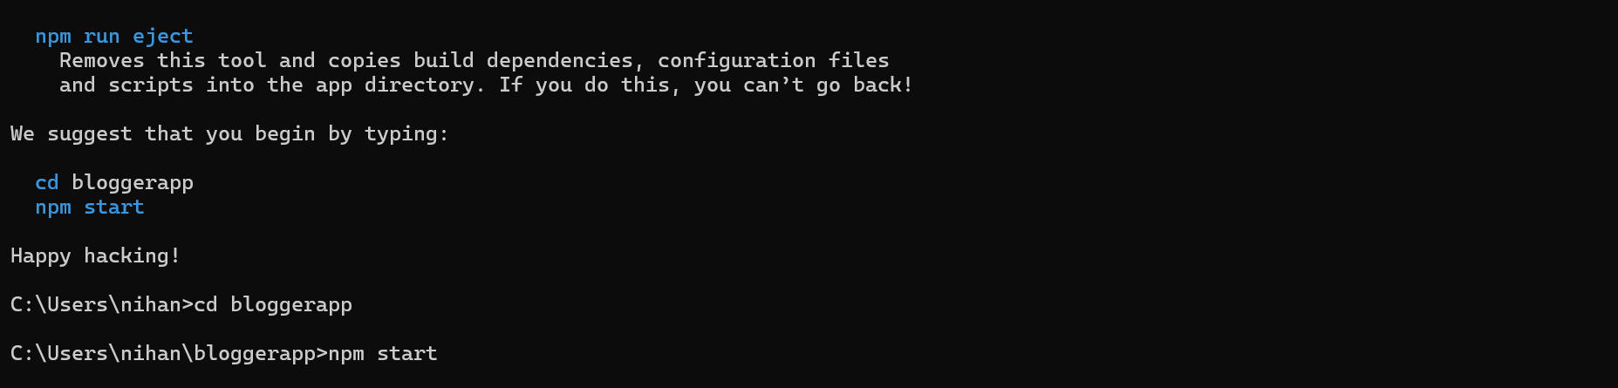

**Output :**

