Server Assignment 3

Screenshot 1: <http://localhost:3000/>

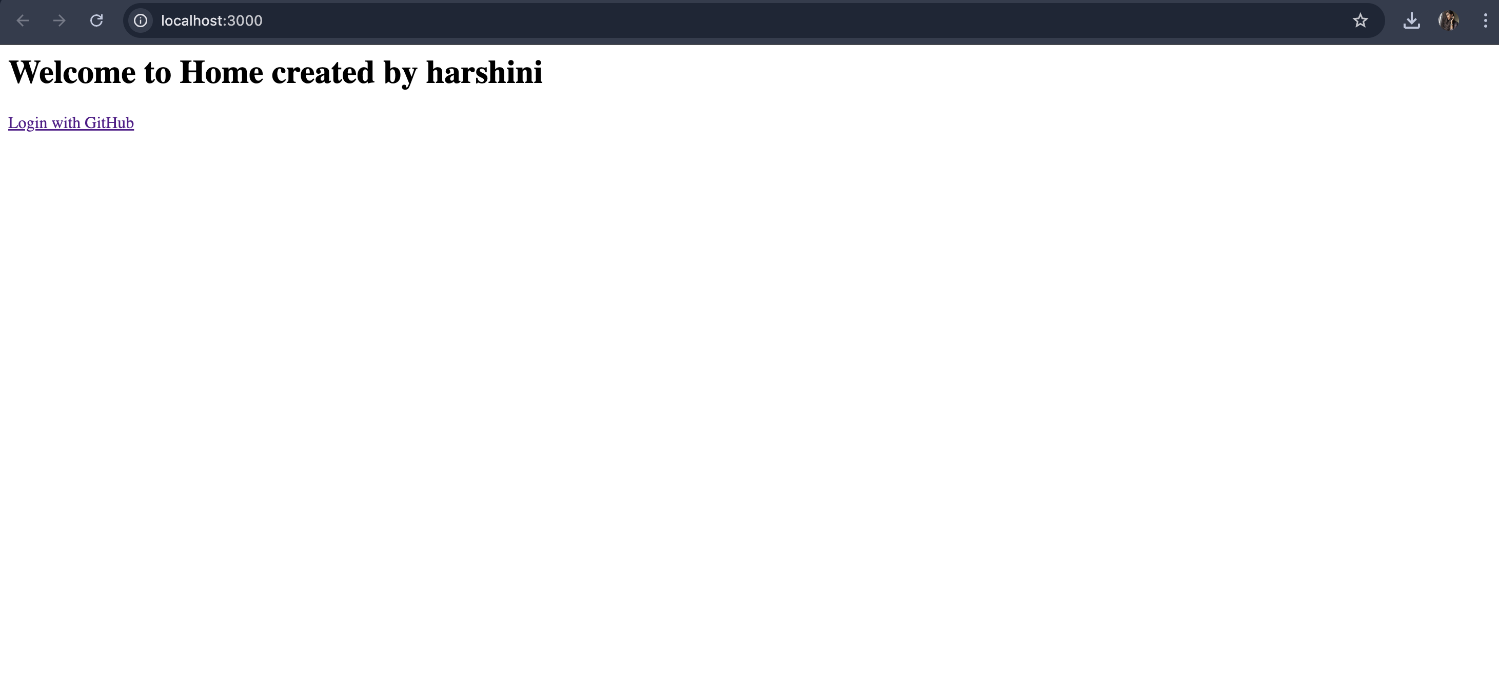

Screenshot 2: Clicking on Login with GitHub

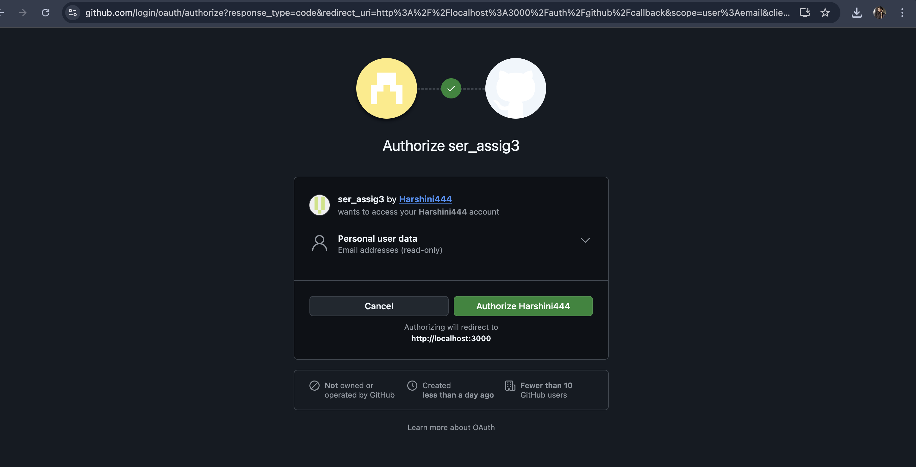

Screenshot 3: while logging in the dashboard is

